Okeanos Explorer ROV Dive Summary
Site Name | NW from Von Damm |  |  |  | 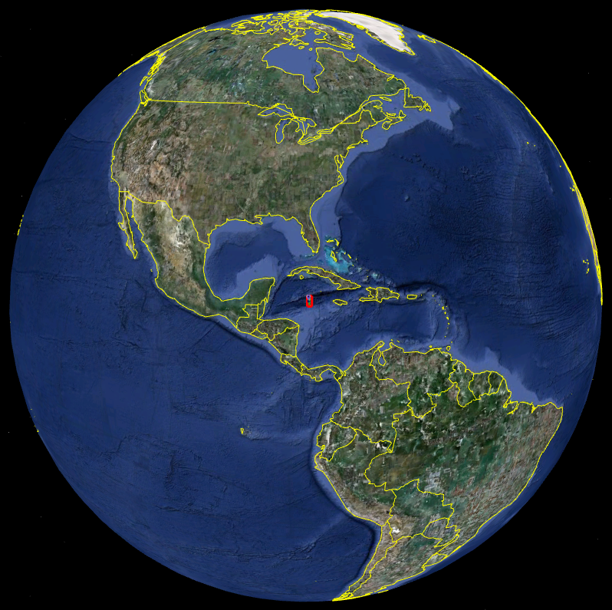
ROV Lead | Dave Lovalvo
General Area Descriptor | 100 km SSW of Grand Cayman Island
ROV Dive Name | Cruise Season |  | Leg |  |  | Dive Number
ROV Dive Name | EX1104 |  | - |  |  | DIVE07
Equipment Deployed | ROV: |  | Little Hercules
Equipment Deployed | Camera Platfom: |  | Seirios
ROV Measurements | CTD |  | Depth |  |  | Altitude
ROV Measurements | Scanning Sonar |  | USBL Position |  |  | Heading
ROV Measurements | Pitch |  | Roll |  |  | HD Camera
ROV Measurements | Low Res Cam 1 |  | Low Res Cam 2
Equipment Malfunctions
ROV Dive Summary  (From processed ROV data) | Dive Summary: EX1104_DIVE07  ^^^^^^^^^^^^^^^^^^^^^^^^^^^^^^^^^^^^^^^^^^^^^^^^^^^  In Water at: 2011-08-10T13:24:38.020000  18°, 22.805' N ; 081°, 47.935' W  Out Water at: 2011-08-10T23:57:22.055000  18°, 22.769' N ; 081°, 48.153' W  Off Bottom at: 2011-08-10T22:23:05.307000  18°, 22.978' N ; 081°, 48.303' W  On Bottom at: 2011-08-10T14:47:26.367000  18°, 22.681' N ; 081°, 47.898' W  Dive duration: 10:32:44  Bottom Time: 7:35:38  Max. depth: 2356.0 m
Special Notes | Click here to enter text.
Scientists Involved  (please provide name / location / affiliation / email) | Chris German (Science team lead), EX, WHOI, cgerman@whoi.edu  Paul Tyler, EX, Uni. Southampton, pat8@noc.soton.ac.uk  Cameron McIntyre, EX, WHOI, cmcintyre@whoi.edu  Diva Amon, URI, Uni. Southampton, dja605@noc.soton.ac.uk  Bobbie John, URI, Uni. Wyoming, BJohn@uwyo.edu  Jameson Clarke, URI, Duke, jamesonclarke@gmail.com  Mike Cheadle, URI, Uni. Wyoming, cheadle@uwyo.edu  Jill McDermott, URI, WHOI, jmcdermott@whoi.edu  Sarah Bennett, Home, NASA JPL, Sarah.A.Bennett@jpl.nasa.gov  Cindy Van Dover, Home, Duke, clv3@duke.edu  Steve Hammond, Newport, PMEL, Stephen.r.hammond@noaa.gov  Julie Meyer, URI, MBL, jmeyer@mbl.edu  Julie Huber, WHOI or Internet1, MBL, jhuber@mbl.edu
Purpose of the Dive
The aim of the dive was to examine ‘bright’ spots that were found on the backscatter of the bathymetry data from the AUTOSUB during JC44. The ROV was due to visit 16 waypoints numbered 3 to 18.
Description of the Dive:
Little Herc was launched at a site to the north of the Spire in the Von Damm field. For most of the dive we travelled over sedimentary material with occasional rock outcrops and individual rocks, many of which were angular. Observed rocks were dominated by dark, hence, mafic compositions, exhibited rectilinear jointing, and layering with units of 10cm in thickness predominant. All the above are consistent with the rock type in all cases being gabbroic – similar to our conclusions from the end of the preceding dive to the SW from the Von Damm cone - although the rock composition could not be unambiguously confirmed from video evidence alone, throughout the dive. No evidence of serpentinized ultramafic rocks was apparent throughout the dive, however. Equally, it was clear that no obvious extrusive volcanic rocks (basalt) were encountered. Immediately to the north and west of the Von Damm mound, the ROV proceeded to each of WP03 (MCR056) to WP09 in turn, and found rocky outcrops at each location, consistent with the sonar data from AUTOSUB, providing further important ground-truthing for such AUV-based exploration techniques (see also Dive 06 summary report). After proceeding as far as WP09, including traversing the length from WP06 to WP07 (MCR062 to MCR063) along the first of 3 generally E-W trending ridges, the ROV proceeded directly across two additional ridges with a similar appearance (none of which exhibited unusual fauna or evidence for fluid flow but did host up to ~1m diameter “sink-holes” in the sediment, perhaps to related to sediment collapse into cavities between underlying blocks/boulders). After ~20 minutes’ traverse across uniform thick biogenic carbonate sediment, the ROV reached WP14 (MCR069), the southern limit of a S-N trending array of bright spots in the AUTOSUB sonar data. Again, this linear array comprised several large blocky (gabbroic-in-appearance) outcrops extending north past WP15 to WP 16. The ROV then turned NW at WP16 (MCR072) to follow along the face of an elongate fault exposing apparent gabbros in the ~8m face (down-thrown to the north) that extended WNW from here, toward WP18 (MCR075). The fauna was typical of that which would be found at these depths: the holothurian Benthodytes typica, tripodfish Bathypterois and the swimming shrimp Sergestes sp. Occasional gorgonian corals were found on rocks.
A few minutes before the end of the dive we spotted a large pycnogonid, Collossendeis on the top of a rocky area with a light cover of sediment with lots of healthy gorgonian octocorals. Some of the gorgonians appeared to have small anemones on them. Conscious that other abundant coral communities (e.g. the coral garden, SW of the central Von Damm cone) had been found to be associated with active fluid flow, a careful examination of this site was commenced which revealed weak diffuse flow around the base of the octocoral emanating from amongst angular rocks (MCR074). Following this initial observation we found furter healthy coral bathed in low diffuse flow. Bacterial mats were noticed in the area, and the ROV temperature sensor was noted to have risen from 4.2°C to 4.8ºC. The ROV moved a short distance further along the fault scarp (MCR075) and found diffuse flow again around the base of another gorgonian. Assorted cnidarians with evidence of microbial mats and diffuse flow, together with sponges and a pycnogonid were also found. Yellow-green colonial octocorals (Family Stolonifera) were noticed on the side and underside of large rocks bathed in diffuse flow (T = 5.2°C). Additional colonies were white but these appeared to be outside the hydrothermal flow. A shrimp (?Alvinocaris ) was noticed in the crevice of two rocks. A comatulid crinoid was seen growing on a Paragorgia (the bubble gum coral). It was hypothesized that the possible loss of color from yellow to white of the octocorals might be due to loss of chemosynthetic bacteria symbionts with yellow being the healthy ones that were in more direct contact with the diffuse hydrothermal flow. Amphipods were found on yellow octocorals as well as on the tips of white filamentous fine tubes (MCR076). As the ROV moved away we saw sponges gigantic 2m tall gorgonian (?Irdigorgia) which was video-recorded. The location of these diffuse flow sites was not only coincident with prior sonar bright spots from the AUTOSUB sonar data but also converged closely with previously identified Eh sensor anomalies recorded during that same AUV-based survey (Connelly et al., in review).

Overall Map of ROV Dive Area |  |  |  | Close-up Map of Main Dive Site
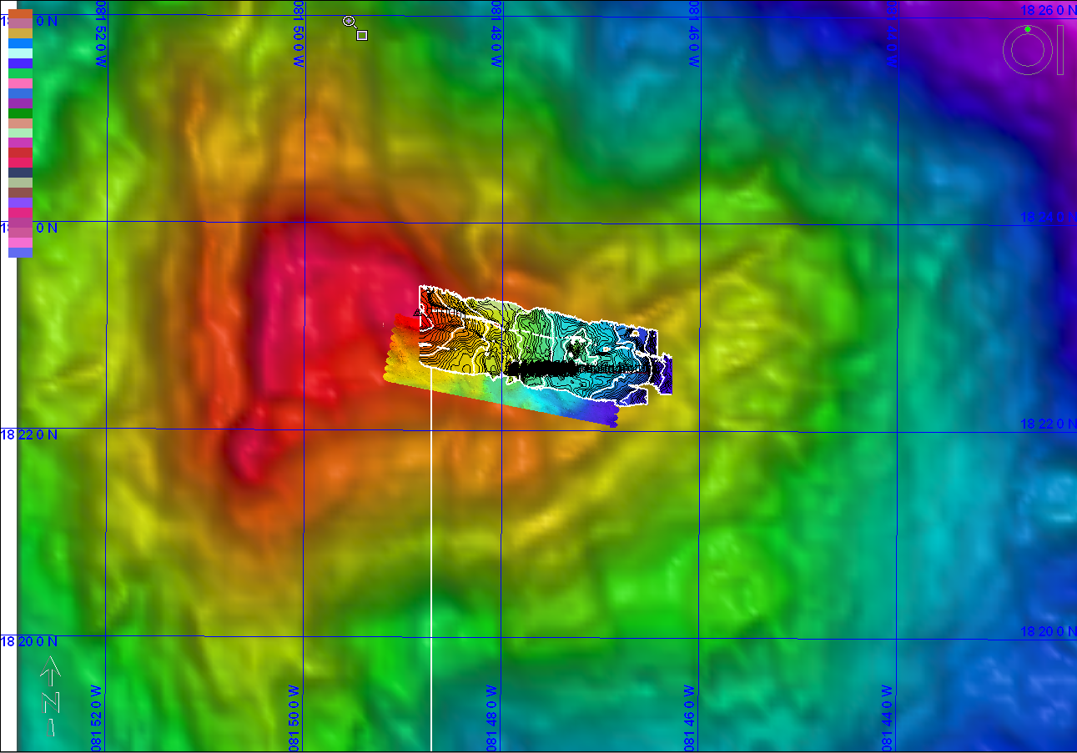
Representative Photos of the Dive
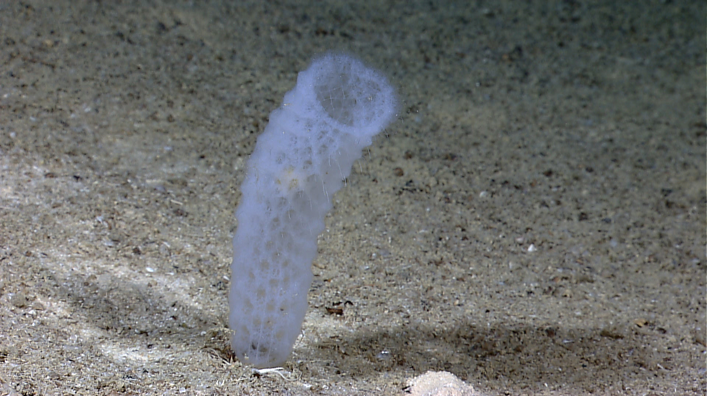 |  |  |  | 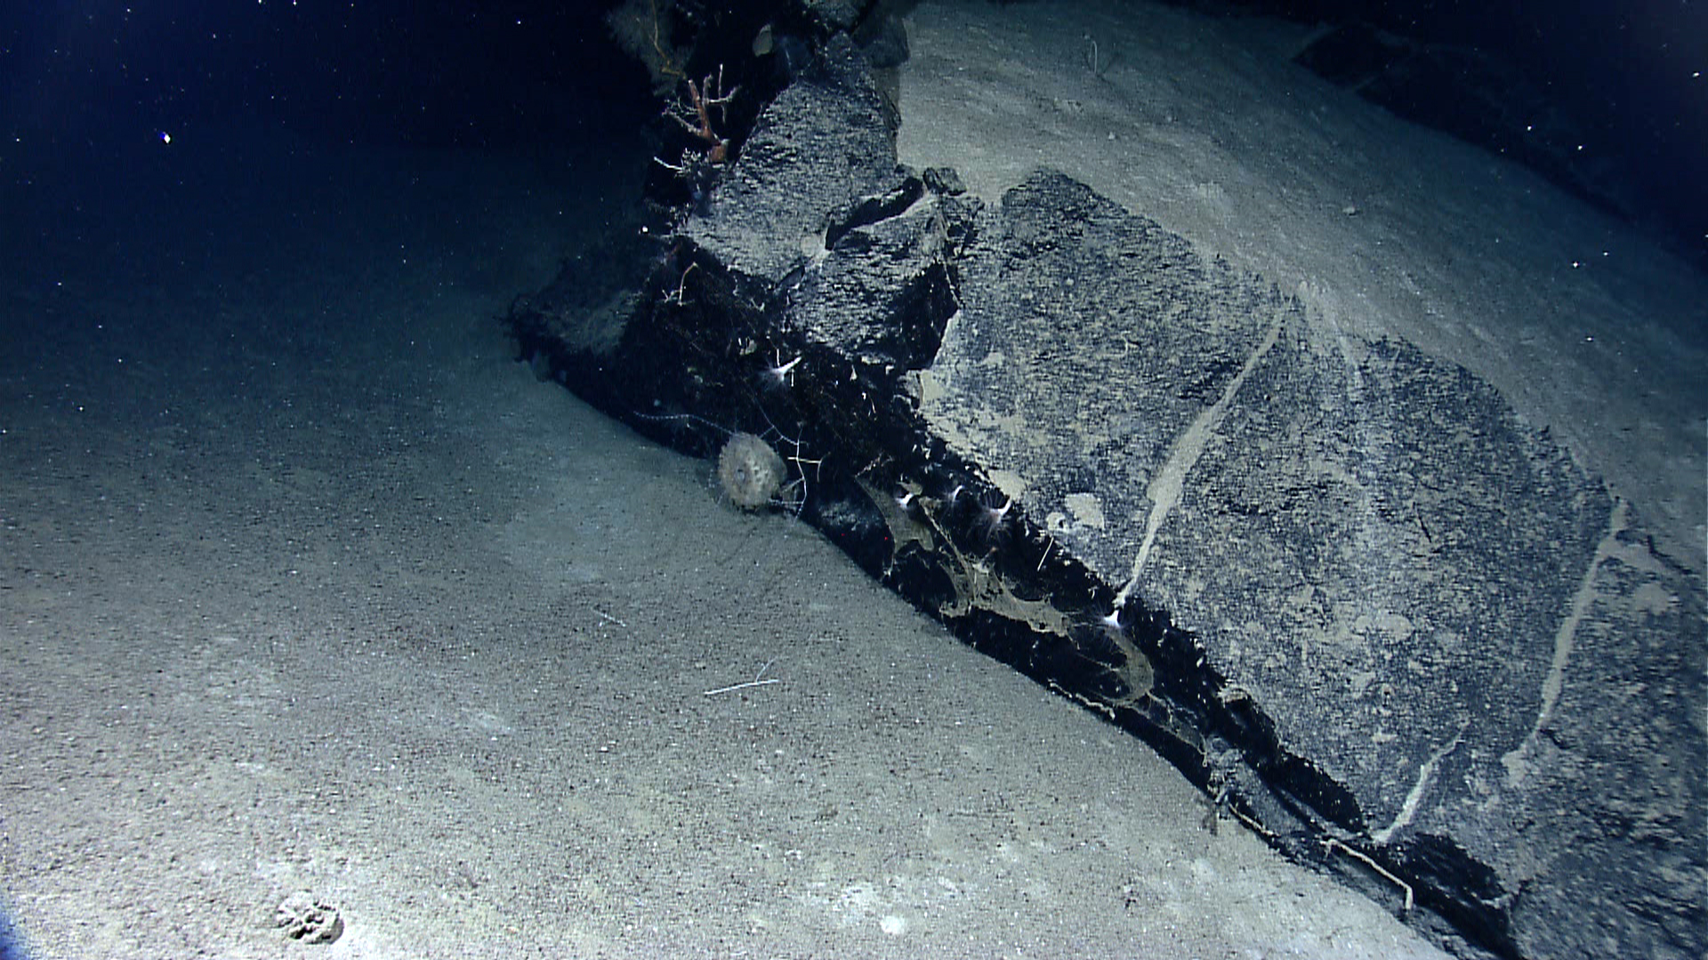
A silica-based sponge known as the Venus Flower Basket |  |  |  | A large outcrop of bed rock with a globular sponge attached
Please direct inquiries to: |  | NOAA Office of Ocean Exploration & Research  1315 East-West Highway (SSMC3 10th Floor)  Silver Spring, MD 20910  (301) 734-1014

