Okeanos Explorer ROV Dive Summary
Site Name | Southern slopes of Mt. Dent |  |  |  | 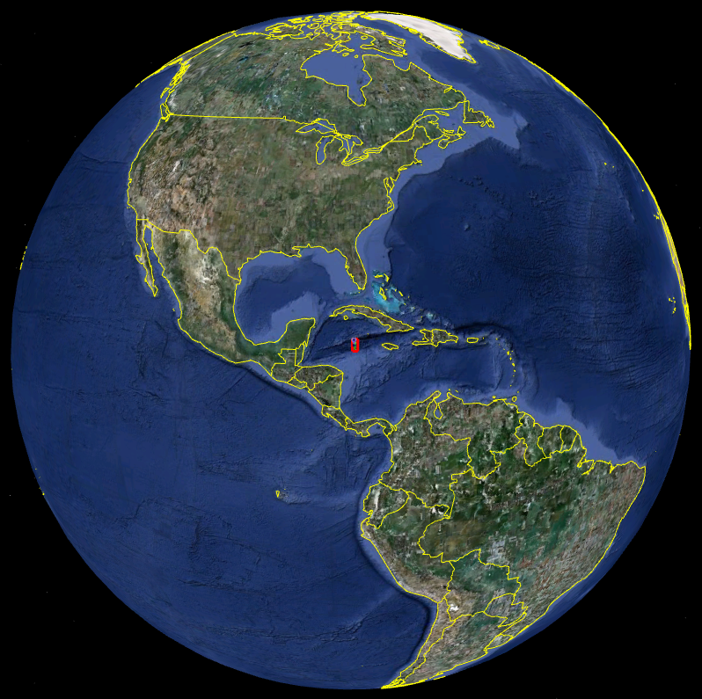
ROV Lead | Dave Lovalvo
General Area Descriptor | 100 km SSW of Grand Cayman Island
ROV Dive Name | Cruise Season |  | Leg |  |  | Dive Number
ROV Dive Name | EX1104 |  | - |  |  | DIVE05
Equipment Deployed | ROV: |  | Little Hercules
Equipment Deployed | Camera Platfom: |  | Seirios
ROV Measurements | CTD |  | Depth |  |  | Altitude
ROV Measurements | Scanning Sonar |  | USBL Position |  |  | Heading
ROV Measurements | Pitch |  | Roll |  |  | HD Camera
ROV Measurements | Low Res Cam 1 |  | Low Res Cam 2
Equipment Malfunctions | Stbd vertran oriented vertically; starboard and port pie connectors switched for dive. ROV Starboard vertran thruster failure during dive.
ROV Dive Summary  (From processed ROV data) | Dive Summary: EX1104_DIVE05  ^^^^^^^^^^^^^^^^^^^^^^^^^^^^^^^^^^^^^^^^^^^^^^^^^^^  In Water at: 2011-08-08T13:46:05.741000  18°, 20.226' N ; 081°, 49.244' W  Out Water at: 2011-08-08T22:54:29.857000  18°, 20.758' N ; 081°, 48.967' W  Off Bottom at: 2011-08-08T20:31:58.209000  18°, 20.743' N ; 081°, 49.420' W  On Bottom at: 2011-08-08T15:52:32.415000  18°, 20.133' N ; 081°, 49.154' W  Dive duration: 9:8:24  Bottom Time: 4:39:25  Max. depth: 3461.8 m
Special Notes | Click here to enter text.
Scientists Involved  (please provide name / location / affiliation / email) | Chris German (Science team lead), EX, WHOI, cgerman@whoi.edu  Paul Tyler, EX, Uni. Southampton, pat8@noc.soton.ac.uk  Cameron McIntyre, EX, WHOI, cmcintyre@whoi.edu  Diva Amon, URI, Uni. Southampton, dja605@noc.soton.ac.uk  Bobbie John, URI, Uni. Wyoming, BJohn@uwyo.edu  Jameson Clarke, URI, Duke, jamesonclarke@gmail.com  Mike Cheadle, URI, Uni. Wyoming, cheadle@uwyo.edu  Jill McDermott, URI, WHOI, jmcdermott@whoi.edu  Sarah Bennett, Home, NASA JPL, Sarah.A.Bennett@jpl.nasa.gov  Cindy Van Dover, Home, Duke, clv3@duke.edu  Santiago Hererra, WHOI, WHOI, shererra@whoi.edu  Chip Breier, URI, WHOI, jbreier@whoi.edu  Teresa Meza, URI, MBL, auburnaugirl@gmail.com  Julie Huber, URI, MBL, jhuber@mbl.edu
Purpose of the Dive
The plan for Dive 05 is to conduct a Geo-Transect from South to North up the South Flank of Mt Dent
Start: 18° 20.155’N, 81° 49.138’W, 3450m
WP: 18° 20.666’N, 81° 49.296’W, 3040m
Continue uphill from there
Overall plan – start deep, head uphill all day. Exact distance to be traversed will understandably depend on steepness of terrain encountered at the seafloor. Overview is to proceed as far upslope as possible in a reasonably straight line with ship and Seirios and take advantage of sonar to identify any particularly bright targets along with the freedom of the tether between Little Herc and Seirios to deviate to port and starboard (West and East, across track) as we move uphill to investigate any specific targets encountered. In the event that we only encounter sediment at any locale with no sonar targets nearby we will just proceed uphill as swiftly as possible.

Description of the Dive:
Little Herc was deployed and landed on seabed at 3461m in biogenic carbonate ooze. After establishment at the seabed Little Herc carried out a video traverse up the Southern Wall of Mt Dent in a direction of 345°. Seirios was oriented approximately due north, with Little Herc “slaloming” to either side beneath to maximize coverage over the seafloor. The dive was guided by sonar from both Little Herc, and Seirios, in addition to imagery from Seirios indicating location of potential outcrop. The seafloor was highly varied, from ooze (up to meters thick), to huge angular boulders up to tens of meters across on steep to overhanging slopes. Exposures of moderately south dipping (<40°), highly foliated (and layered?) rock did crop out at 3441, 3436, 3214, and 3171m. This is likely the detachment fault surface, and some spectacular images were collected. One exposure of likely fault breccia was also noted. On a broad-scale the traverse covered sections with outcrop and huge boulders, up- or down-slope from regions hosting thick sedimentary cover. These variations in sedimented and none (or little) sedimented slopes possibly correlate with the rise and flat bathymetry, or spreading parallel ‘corrugations’ typical of oceanic core complexes, noted on the perspective view in the dive plan along the south wall of Mt Dent. Two outcrops of apparently fine-grained, highly fractured rock with joints normal to a boundary with coarser-grained rocks (dike-like jointing), suggests rare basaltic (?) dikes potentially dipping parallel to any foliation in the host rocks. Toward the end of the dive, meter-scale pock-mark sediment was noted, possibly due to thick biogenic ooze draping huge, angular boulders below.
Fauna observed were distributed infrequently along the dive, and include rare lone fish, red shrimp, gorgonian corals, squat lobster, anemone, and numerous sponges, holothurians, sea grass, and pteropod shells. Star-shaped tracks and deep burrows were also seen but it was not possible to assign these causes to a particular species.

Overall Map of ROV Dive Area |  |  |  | Close-up Map of Main Dive Site
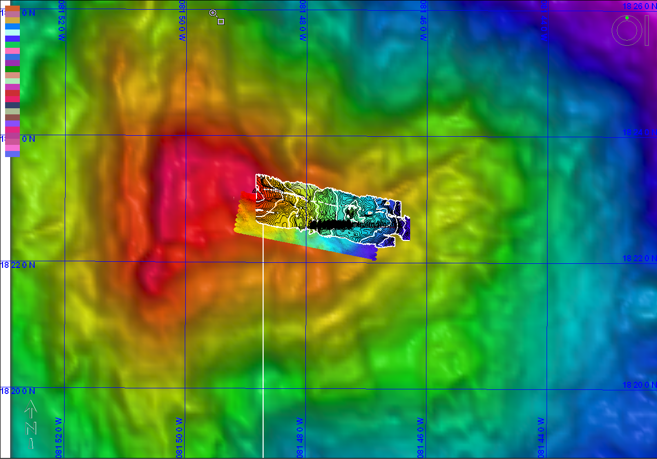 |  |  |  | 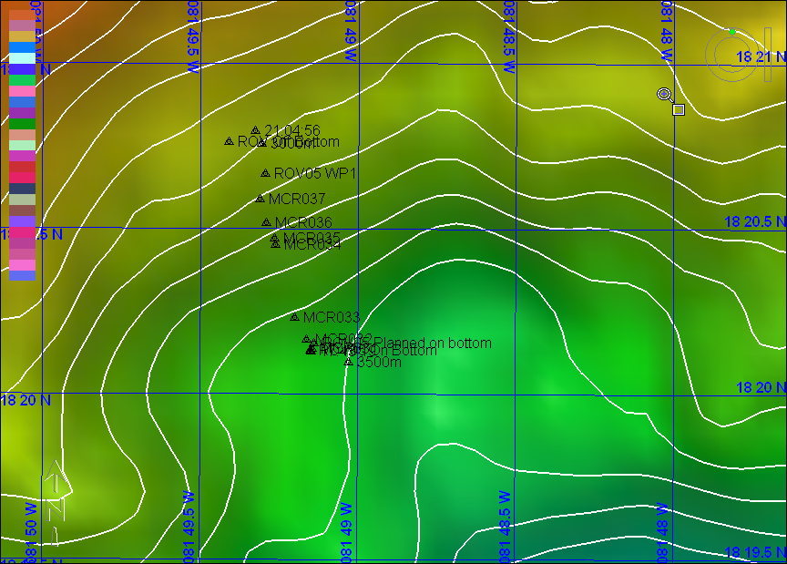
Representative Photos of the Dive
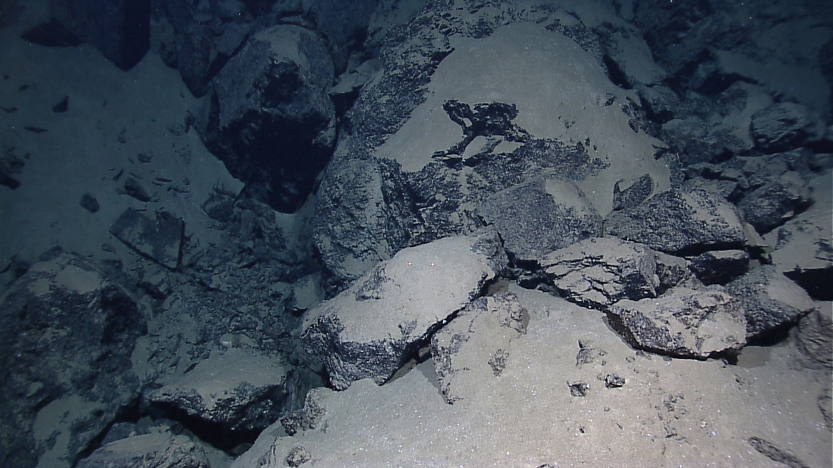 |  |  |  | 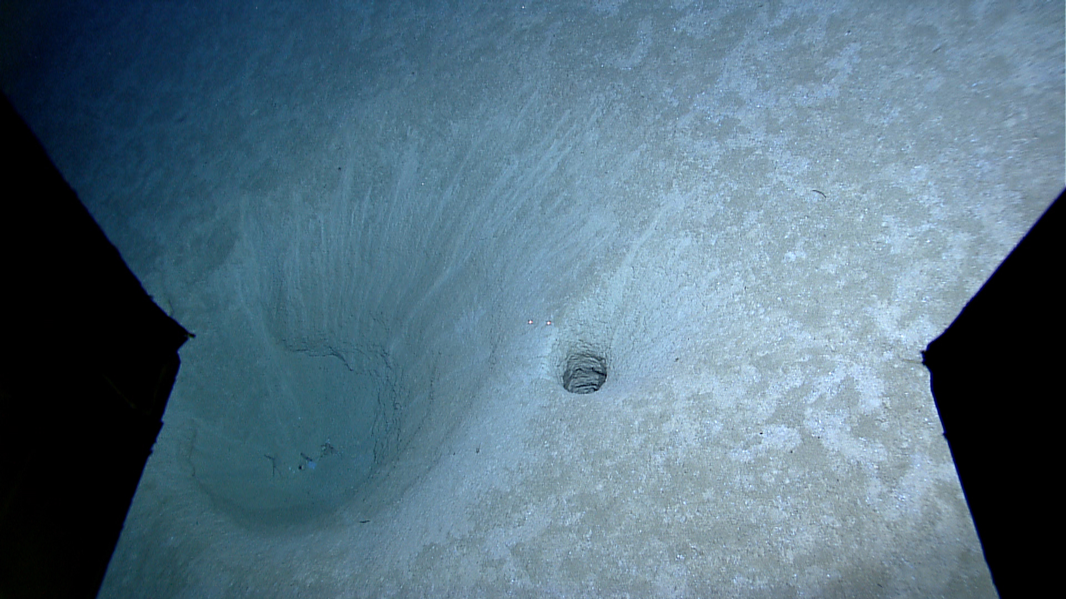
Boulder-strewn seabed on the southern slope of Mount Dent |  |  |  | Enigmatic hollows and holes in the sediment on terraces on the southern side of Mount Dent
Please direct inquiries to: |  | NOAA Office of Ocean Exploration & Research  1315 East-West Highway (SSMC3 10th Floor)  Silver Spring, MD 20910  (301) 734-1014

