Okeanos Explorer ROV Dive Summary
Site Name | Von Damm |  |  |  | 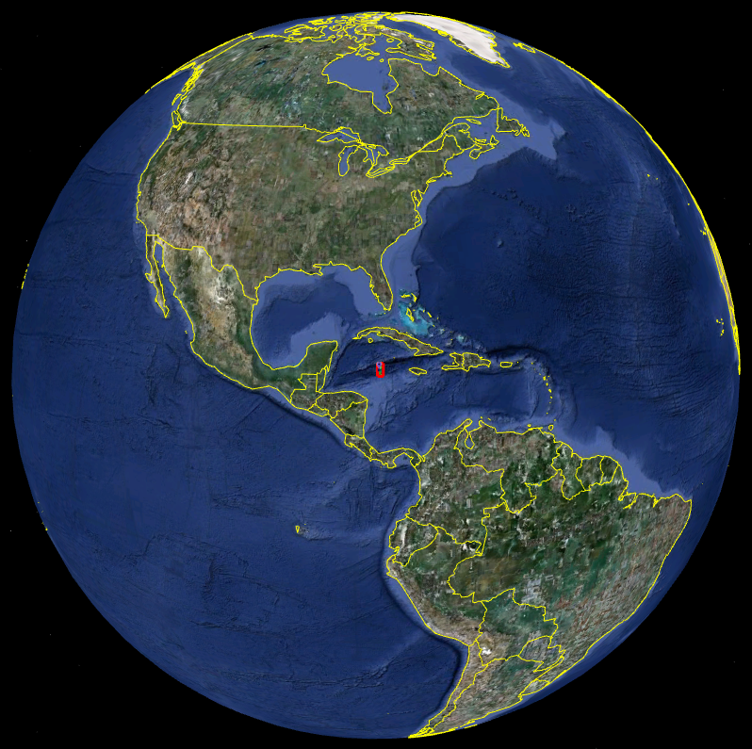
ROV Lead | Dave Lovalvo
General Area Descriptor | 100 km SSW of Grand Cayman Island
ROV Dive Name | Cruise Season |  | Leg |  |  | Dive Number
ROV Dive Name | EX1104 |  | - |  |  | DIVE04
Equipment Deployed | ROV: |  | Little Hercules
Equipment Deployed | Camera Platfom: |  | Seirios
ROV Measurements | CTD |  | Depth |  |  | Altitude
ROV Measurements | Scanning Sonar |  | USBL Position |  |  | Heading
ROV Measurements | Pitch |  | Roll |  |  | HD Camera
ROV Measurements | Low Res Cam 1 |  | Low Res Cam 2
Equipment Malfunctions | ROV Port vertran thruster dead from DIVE 02. Stbd vertran oriented vertically.
ROV Dive Summary  (From processed ROV data) | Dive Summary: EX1104_DIVE04  ^^^^^^^^^^^^^^^^^^^^^^^^^^^^^^^^^^^^^^^^^^^^^^^^^^^  In Water at: 2011-08-07T13:29:48.678000  18°, 22.668' N ; 081°, 47.965' W  Out Water at: 2011-08-07T22:56:28.633000  18°, 22.613' N ; 081°, 47.770' W  Off Bottom at: 2011-08-07T21:03:26.216000  18°, 22.588' N ; 081°, 47.907' W  On Bottom at: 2011-08-07T15:22:47.657000  18°, 22.590' N ; 081°, 47.899' W  Dive duration: 9:26:39  Bottom Time: 5:40:38  Max. depth: 2339.4 m
Special Notes | Click here to enter text.
Scientists Involved  (please provide name / location / affiliation / email) | Chris German (Science team lead), EX, WHOI, cgerman@whoi.edu  Paul Tyler, EX, Uni. Southampton, pat8@noc.soton.ac.uk  Cameron McIntyre, EX, WHOI, cmcintyre@whoi.edu  Julie Huber, WHOI, MBL, jhuber@mbl.edu  Diva Amon, URI, Uni. Southampton, dja605@noc.soton.ac.uk  Bobbie John, URI, Uni. Wyoming, BJohn@uwyo.edu  Jameson Clarke, URI, Duke, jamesonclarke@gmail.com  Mike Cheadle, URI, Uni. Wyoming, cheadle@uwyo.edu  Jill McDermott, URI, WHOI, jmcdermott@whoi.edu  Sarah Bennett, Home, NASA JPL, Sarah.A.Bennett@jpl.nasa.gov  Cindy Van Dover, Home, Duke, clv3@duke.edu  Guy Evans, Home, WHOI, guynevans@yahoo.com  Steve Hammond, Newport, PMEL, Stephen.r.hammond@noaa.gov  Tim Shank, WHOI, WHOI, tshank@whoi.edu  Santiago Hererra, WHOI, WHOI, shererra@whoi.edu
Purpose of the Dive

The plans for Dive 04 are to conduct detailed biological characterization of hotspot areas identified at the Von Damm site and also aim to include an experiment of opportunity for fluid flow:

- Start at central spire for orientation
- Drive East toward markers 19 and 20 to study live tube worm site
- Aim to region of UK marker (bucket lid) to study patches of shrimp there and assess feasibility of fluid flow experiment (Jill McDermott request).
- Head to main spire for detailed biological study.
- If time permits, conduct single transect South and East away from Central Spire along SE trending ridge in Connelly et al map.

Description of the Dive:
Little Herc was deployed and landed at the top of the Von Damm hydrothermal site at 2292m depth. From that point the ROV proceeded towards the northeast to find the patch of tubeworms located on 6th August. This was rapidly located and a substantial and useful amount of time was spent carefully video-recording the tubes (waypoint MCR027), many of which on first sight appeared to be empty but careful examination showed that the obturaculum (the ‘plug’) was closing the end of the tube, providing clear indication that each such tubeworm was alive. Careful examination was made as to how the distal end of the worm tube penetrated the sediment. On completion of this study, Little Herc moved back towards the Spire, video-documenting patches of shrimp and small gastropods. Near the main Spire, Little Herc was set up to measure the flow of hydrothermal fluid out of a 5-6cm orifice on the side of the main Spire (MCR028). This was completed successfully. Little Herc then proceeded back uphill to the Spire where careful video-based observation was undertaken of both the dominant shrimp species and associated shrimp-types. Little Herc also re-located a large 1m diameter orifice (the ‘Hole’ MCR030) emitting hot hydrothermal fluid on the North side of the central spire and continued to video this feature, even though the turbulence created by the hot water rising up the uppermost flanks of the central Spire was considerable. Toward the end of the dive, Little Herc flew over the top of the spire registering a temperature of 14 degrees Celcius, 2 meters above its summit (2290m ROV depth). Near the orifice was a patch of ? Alvinocaris many with eggs in their ovaries and some incubating eggs on the legs of their abdomen. The ROV video-captured a large area of the Spire before returning to the surface.

Overall Map of ROV Dive Area |  |  |  | Close-up Map of Main Dive Site
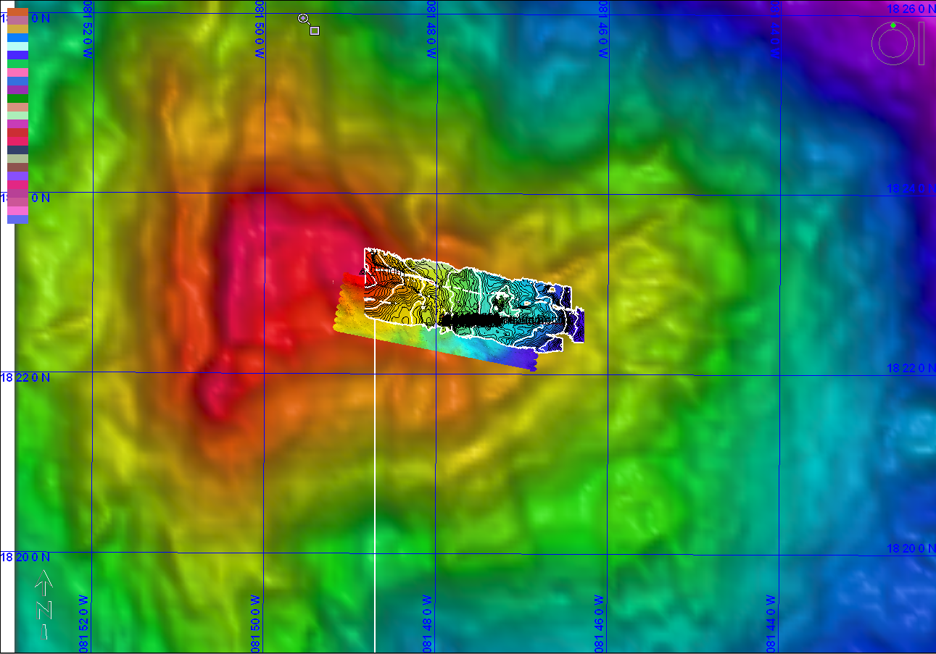 |  |  |  | 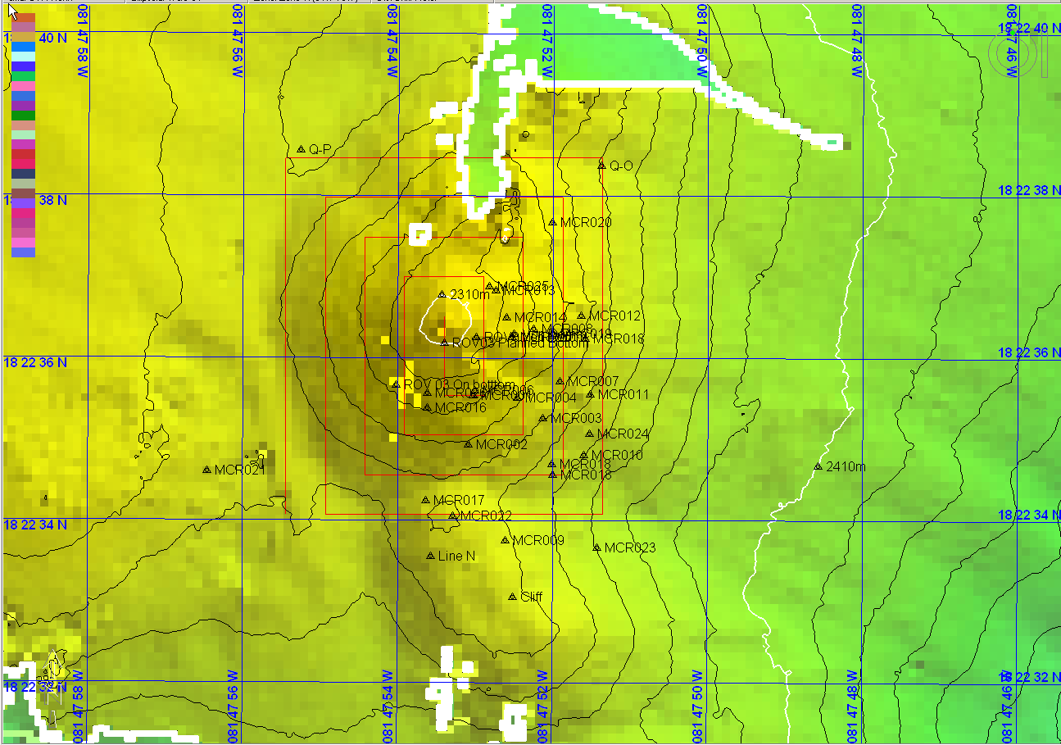
 |  |  |  | Bathymetry courtesy of D.P.Connelly et al.
Representative Photos of the Dive
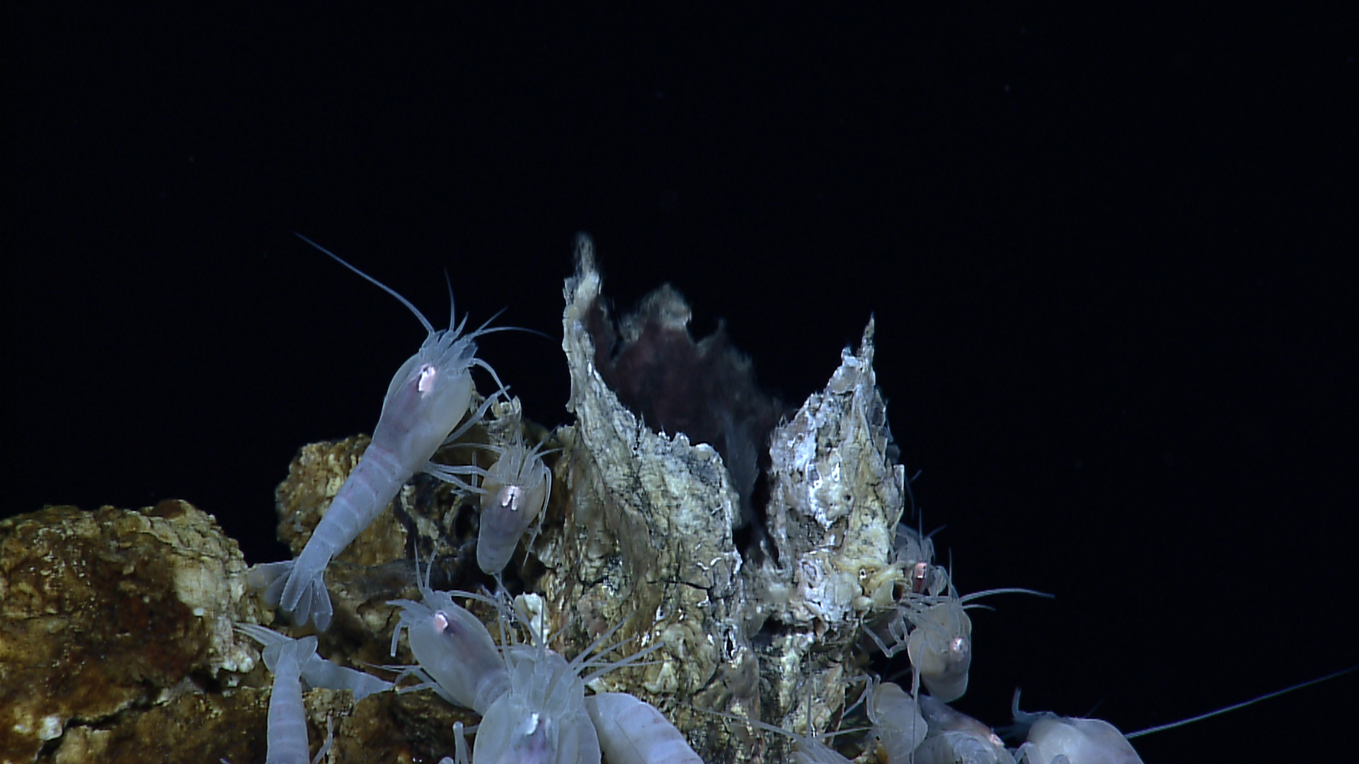 |  |  |  | 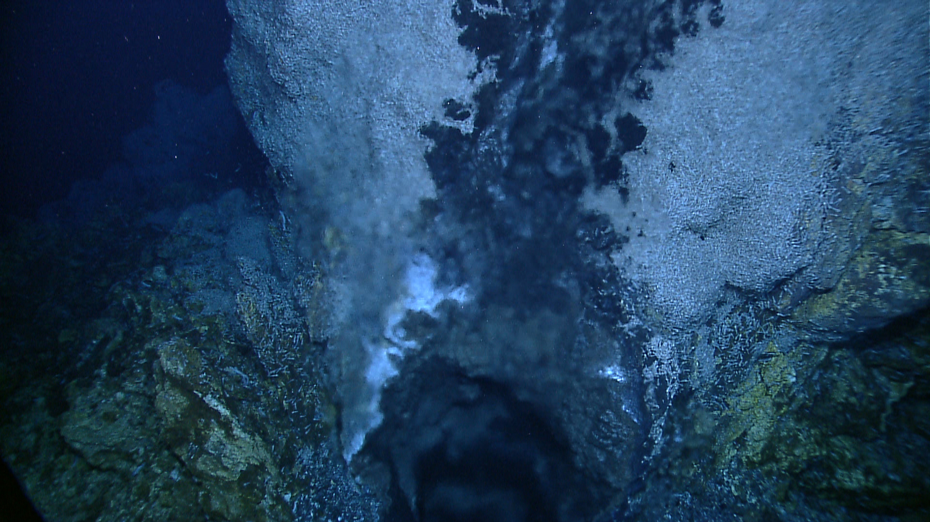
The hydrothermal shrimp Rimicaris right next to a small chimney of about 6cm diameter |  |  |  | Looking down the main ~1m diameter orifice near the summit of the ~8m chimney spire at the center of the Von Damm field from which hot, clear, hydrothermal fluid billows.
Please direct inquiries to: |  | NOAA Office of Ocean Exploration & Research  1315 East-West Highway (SSMC3 10th Floor)  Silver Spring, MD 20910  (301) 734-1014

