Okeanos Explorer ROV Dive Summary
Site Name | Von Damm |  |  |  | 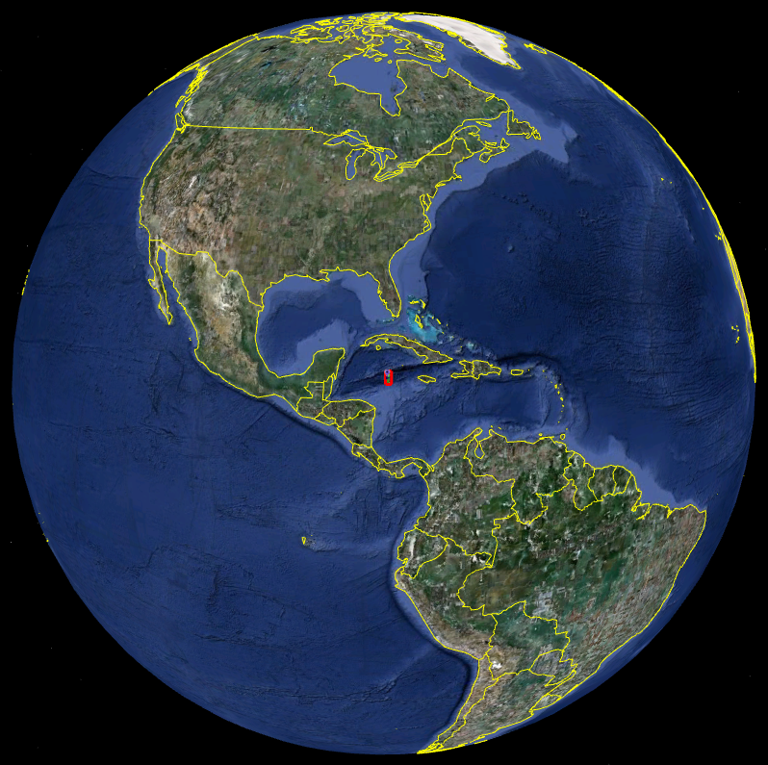
ROV Lead | Dave Lovalvo
General Area Descriptor | 100 km SSW of Grand Cayman Island
ROV Dive Name | Cruise Season |  | Leg |  |  | Dive Number
ROV Dive Name | EX1104 |  | - |  |  | DIVE02
Equipment Deployed | ROV: |  | Little Hercules
Equipment Deployed | Camera Platfom: |  | Seirios
ROV Measurements | CTD |  | Depth |  |  | Altitude
ROV Measurements | Scanning Sonar |  | USBL Position |  |  | Heading
ROV Measurements | Pitch |  | Roll |  |  | HD Camera
ROV Measurements | Low Res Cam 1 |  | Low Res Cam 2
Equipment Malfunctions | Port vertran died at 1100m. Dive Aborted. Vehicles Returned to Surface
ROV Dive Summary  (From processed ROV data) | Dive Summary: EX1104_DIVE02  ^^^^^^^^^^^^^^^^^^^^^^^^^^^^^^^^^^^^^^^^^^^^^^^^^^^  In Water at: 2011-08-06 T13:21:00  18°, 22.667' N ; 081°, 47.864' W  Out Water at: 2011-08-06 T15:40:00  18°, 22.359' N ; 081°, 47.780' W  Off Bottom at: NA  On Bottom at: NA  Dive duration: 2:19:00  Bottom Time: NA  Max. depth: 1192m
Special Notes | Little Herc was deployed but at 1000m there appeared to be a problem and Little Herc was recovered to deck for mechanical attention.
Scientists Involved
(please provide name / location / affiliation / email)
Purpose of the Dive
Description of the Dive:
Little Herc was deployed but at 1000m there appeared to be a problem and Little Herc was recovered to deck for mechanical attention.
Overall Map of ROV Dive Area |  |  |  | Close-up Map of Main Dive Site
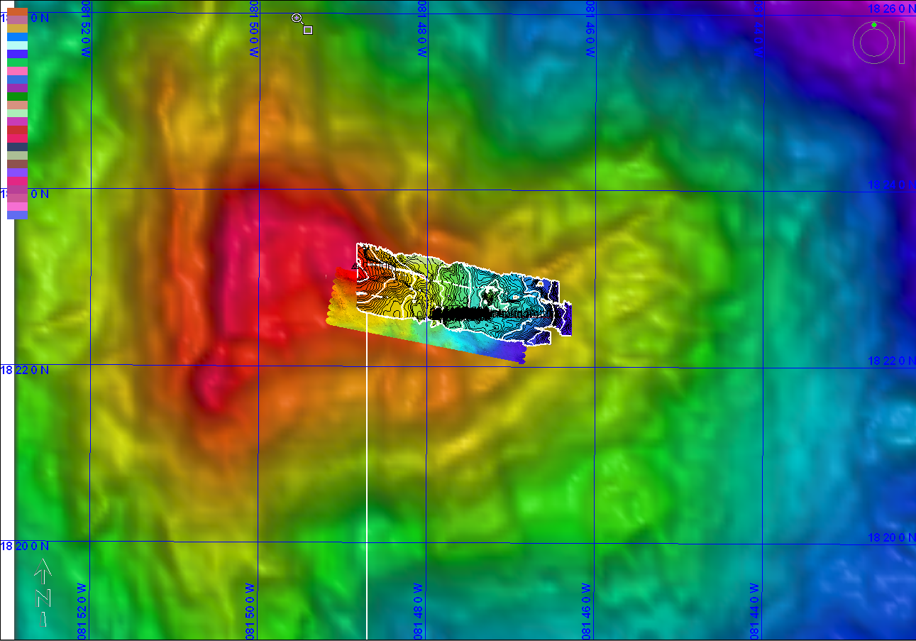
Representative Photos of the Dive
No images were recorded |  |  |  | xxx
Please direct inquiries to: |  | NOAA Office of Ocean Exploration & Research  1315 East-West Highway (SSMC3 10th Floor)  Silver Spring, MD 20910  (301) 734-1014

