CTD Cast Name |  |   Cruise |  |  |  |  |  | CTD Number |  |  | Date
 |  | EX1104
Expedition Coordinator/  Science Team Lead |  | Kelley Elliott/Chris German |  |  |  |  |  |  | 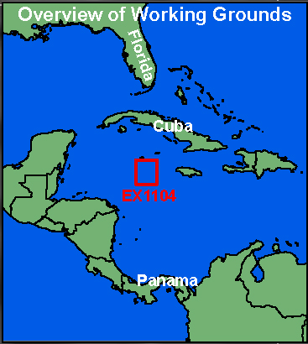
General Area Descriptor
Site Name
Type of CTD Operation |  | Vertical Cast
 |  | Tow-Yo
Target Position
Deployment  Time & Location |  | UTC Time
 |  | Latitude |  |  | º |  |  |  |  |  |  |  | ‘ |  |  | N
 |  | Longitude |  |  | º |  |  |  |  |  |  |  | ‘ |  |  | W
Time & Location  At Depth |  | UTC Time |  |  | Target Depth/Range
 |  | Latitude |  |  | º |  |  |  |  |  |  |  |  | ‘ |  |  | N
 |  | Longitude |  |  | º |  |  |  |  |  |  |  |  | ‘ |  |  | W
Recovery  Time & Location |  | UTC Time |  |  | Maximum Depth (m)
 |  | Latitude |  |  | º |  |  |  |  |  |  | ‘ |  |  | N
 |  | Longitude |  |  | º |  |  |  |  |  |  | ‘ |  |  | W
CTD Sensor  Data Acquired |  | CTD P 0905 T1 5001 T2 5017 C1 3449 C2 3451
 |  | ORP 08 Votage Channel 05
 |  | LSS 12790 Voltage Channel 02 LSS 12791 Voltage Channel 06
 |  | Dissolved Oxygen Voltage Channel __ Altimeter Voltage Channel 00
 |  | Other (specify) ____________ Voltage Channel __ ____________ Voltage Channel __
Water Samples Collected? |  | Yes No If Yes, Number of Bottles Tripped: _____________
Sample  Processing |  | Sample Type(s): ___________________________________________________________
 |  | Processed on board Preserved Chemicals ___________________________
 |  | None Room Temp Storage -80 Freezer -20 Freezer Refrigerator
Data Archival |  | Tethys FTP site
Equipment Malfunctions
Special Notes
Scientists Involved  (name / location / affiliation / email) |  | cgerman@whoi.edu & cmcintyre@whoi.edu (WHOI)  Sarah.A.Bennett@jpl.nasa.gov (NASA-JPL), Sharon.l.Walker@noaa.gov & Edward.Baker@noaa.gov (NOAA-PMEL)
Purpose of the CTD operation:
Description of the Data/Results:
Overall Map of CTD Cast Area | Screen Grab of Data
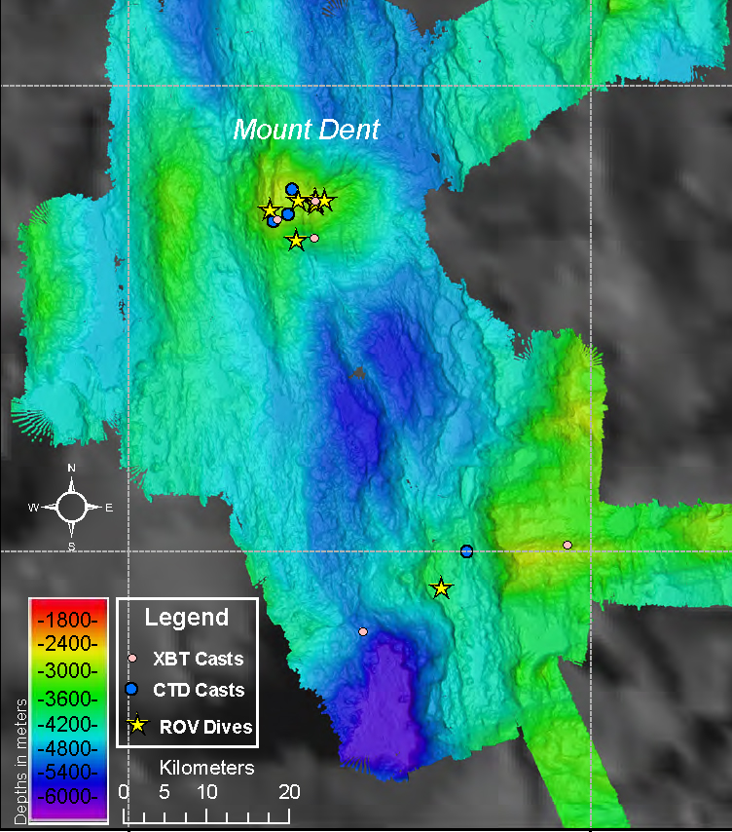
Overview of Cast site | SeaSave Data Acquisition Screen
Please direct inquiries to: | NOAA Office of Ocean Exploration & Research  1315 East-West Highway (SSMC3 10th Floor)  Silver Spring, MD 20910  (301) 734-1014

