anCTD Cast Name |  |   Cruise |  |  |  |  |  | CTD Number |  |  | Date
 |  | EX1104 |  |  |  |  |  | CTD07 |  |  | 8/14/11
Expedition Coordinator/  Science Team Lead |  | Kelley Elliott/Chris German |  |  |  |  |  |  | 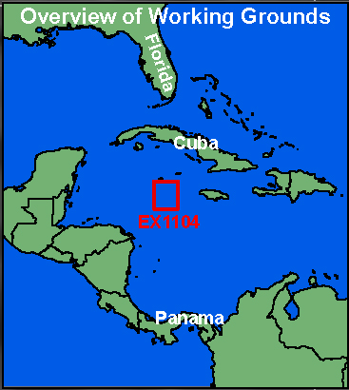
General Area Descriptor |  | Cayman Islands
Site Name |  | Mt Doom
Type of CTD Operation |  | Vertical Cast Po-Go
 |  | Tow-Yo Combination
Target Position |  | 18° 22.59’N
 |  | 081° 47.91’W
Deployment  Time & Location |  | UTC Time | 2351
 |  | Latitude | 18 |  | º | 22.59 |  |  |  |  |  |  | ‘ |  |  | N
 |  | Longitude | 81 |  | º | 47.896 |  |  |  |  |  |  | ‘ |  |  | W
Time & Location  At Depth |  | UTC Time | 0037 |  | Target Depth/Range |  |  |  |  | 2300/20 mab
 |  | Latitude | 18 |  | º |  | 22.589 |  |  |  |  |  |  | ‘ |  |  | N
 |  | Longitude | 81 |  | º |  | 47.896 |  |  |  |  |  |  | ‘ |  |  | W
Recovery  Time & Location |  | UTC Time | 0358 |  | Maximum Depth (m) |  |  |  |  | 2324
 |  | Latitude | 18 |  | º | 22.589 |  |  |  |  |  | ‘ |  |  | N
 |  | Longitude | 81 |  | º | 47.900 |  |  |  |  |  | ‘ |  |  | W
CTD Sensor  Data Acquired |  | CTD P 0905 T1 5001 T2 5017 C1 3449 C2 3451
 |  | ORP 08 Votage Channel 05
 |  | LSS 12790 Voltage Channel 02 LSS 12791 Voltage Channel 06
 |  | Dissolved Oxygen Voltage Channel __ Altimeter Voltage Channel 00
 |  | Other (specify) ____________ Voltage Channel __ ____________ Voltage Channel __
Water Samples Collected? |  | Yes No If Yes, Number of Bottles Tripped: ____20_________
Sample  Processing |  | Sample Type(s): ___Methane, TOC, Microbes (cell counts)_________________________
 |  | Processed on board Preserved Chemicals __Formalin________________
 |  | None Room Temp Storage -80 Freezer -20 Freezer Refrigerator
Data Archival |  | Tethys FTP site
Equipment Malfunctions | None.
Special Notes | Forgot bottle vs. carousel position is offset by USBL placement. Double-dip required, 2000-2200m.
Scientists Involved  (name / location / affiliation / email) |  | cgerman@whoi.edu & cmcintyre@whoi.edu (WHOI), jhuber (MBL, Sarah.A.Bennett@jpl.nasa.gov (NASA-JPL)
Purpose of the CTD operation: C-org cycling and plume exploration above Van Damm site.
Description of the Data/Results:
Stunning. No LSS signal but lots in ORP sensor.
CH₄ Analyses very high. 3 plumes.
Also, positive near bottom T° anomalies.
Overall Map of CTD Cast Area | Screen Grab of Data
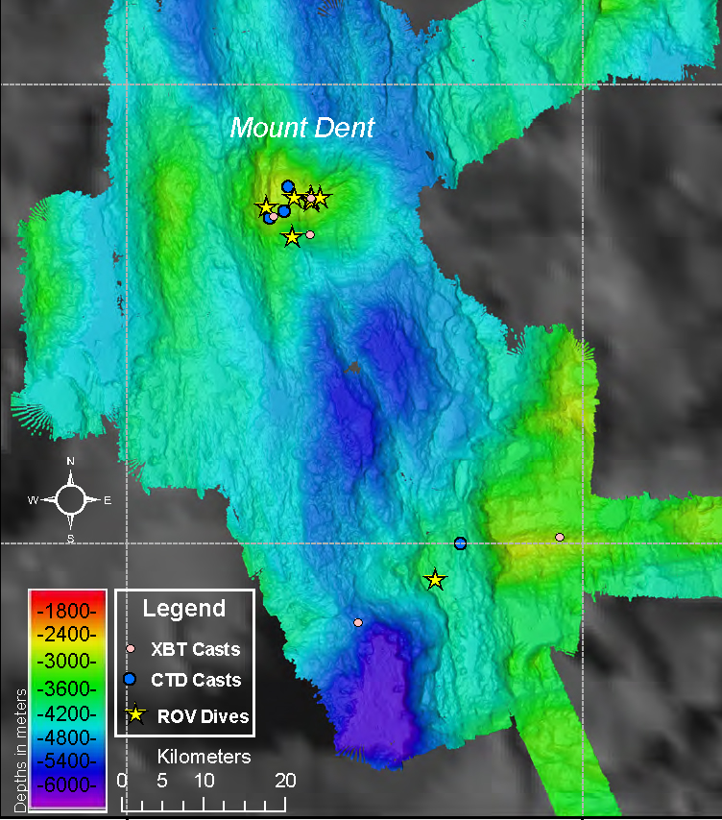 | 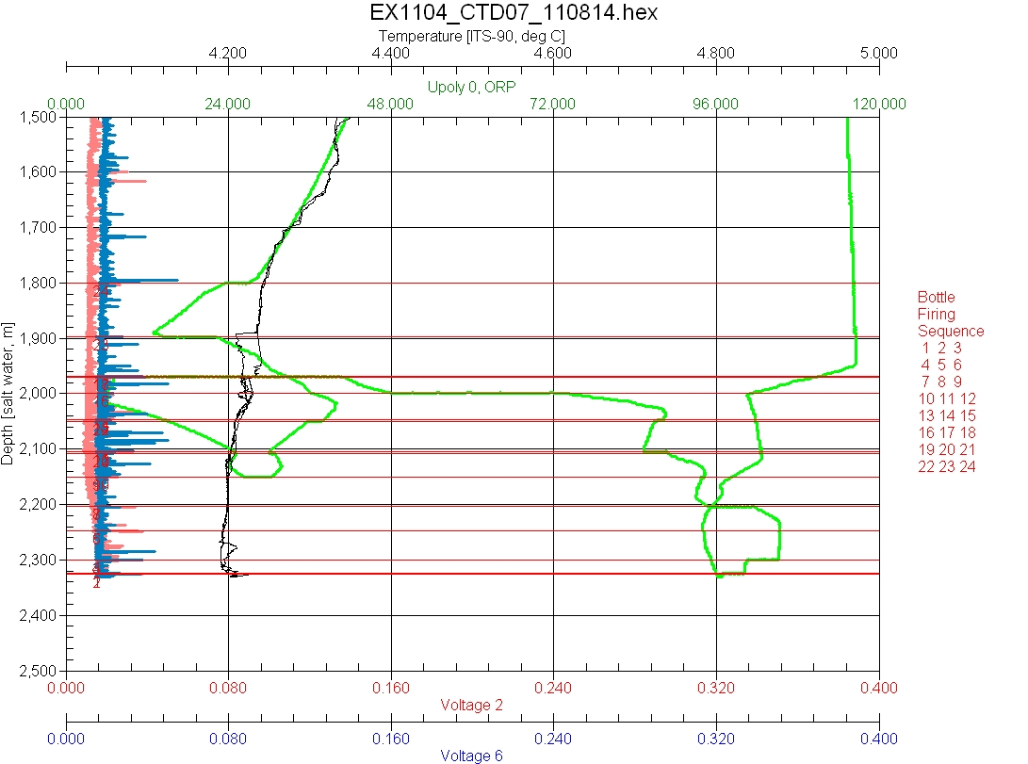
Overview of Cast site | SeaSave Data Acquisition Screen
Please direct inquiries to: | NOAA Office of Ocean Exploration & Research  1315 East-West Highway (SSMC3 10th Floor)  Silver Spring, MD 20910  (301) 734-1014

