CTD Cast Name |  |   Cruise |  |  |  |  |  | CTD Number |  |  | Date
 |  | EX1104 |  |  |  |  |  | CTD01 |  |  | 08/03/11
Expedition Coordinator/  Science Team Lead |  | Kelley Elliott/Chris German |  |  |  |  |  |  | 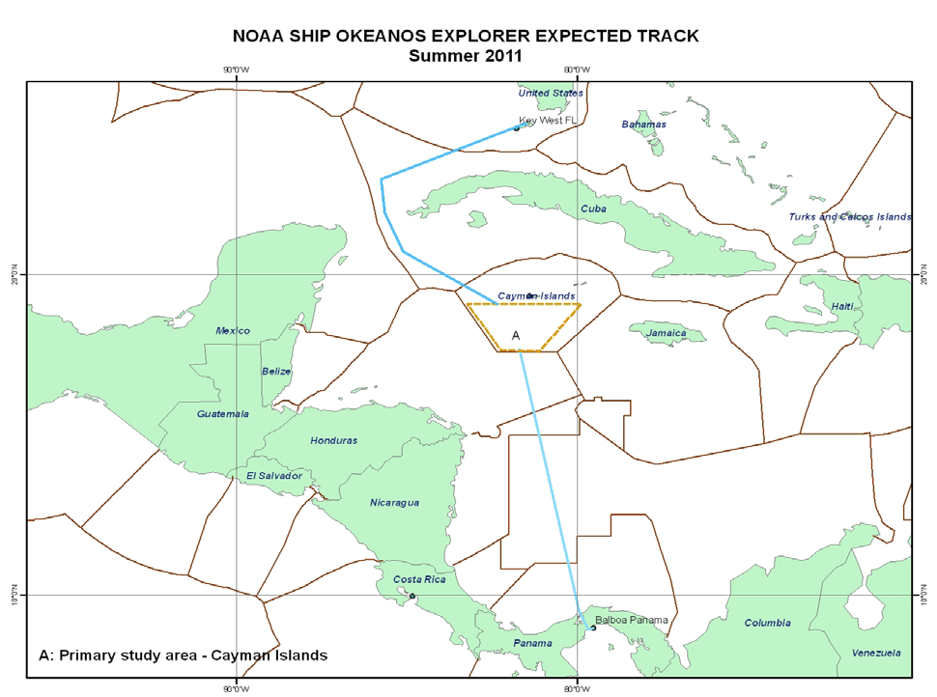
General Area Descriptor |  | North of Panama
Site Name |  | Caribbean
Type of CTD Operation |  | Vertical Cast
 |  | Tow-Yo
Target Position |  | >1000m |  | Along transit
Deployment  Time & Location |  | UTC Time | 1728
 |  | Latitude | 10 |  | º | 55.428 |  |  |  |  |  |  | ‘ |  |  | N
 |  | Longitude | 80 |  | º | 11.910 |  |  |  |  |  |  | ‘ |  |  | W
Time & Location  At Depth |  | UTC Time | 174839 |  | Target Depth/Range |  |  |  |  | 1000 m
 |  | Latitude | 10 |  | º |  | 55.807 |  |  |  |  |  |  | ‘ |  |  | N
 |  | Longitude | 80 |  | º |  | 11.995 |  |  |  |  |  |  | ‘ |  |  | W
Recovery  Time & Location |  | UTC Time | 1825 |  | Maximum Depth (m) |  |  |  |  | 1000
 |  | Latitude | 10 |  | º | 56.406 |  |  |  |  |  | ‘ |  |  | N
 |  | Longitude | 80 |  | º | 12.036 |  |  |  |  |  | ‘ |  |  | W
CTD Sensor  Data Acquired |  | CTD P 0905 T1 5001 T2 5017 C1 3449 C2 3451
 |  | ORP 08 Votage Channel 05
 |  | LSS 12790 Voltage Channel 02 LSS 12791 Voltage Channel 06
 |  | Dissolved Oxygen Voltage Channel __ Altimeter Voltage Channel 00
 |  | Other (specify) ____________ Voltage Channel __ ____________ Voltage Channel __
Water Samples Collected? |  | Yes No If Yes, Number of Bottles Tripped: ___20________
Sample  Processing |  | Sample Type(s): ____Shipboard Dissolved Methane______________________________
 |  | Method: Processed on EX Preserved, Chemicals used ____________ None
 |  | Storage: None Room Temp Storage -80 Freezer -20 Freezer
Data Archival |  | Tethys FTP site
Equipment Malfunctions | None.
Special Notes | None.
Scientists Involved  (name / location / affiliation / email) |  | cgerman@whoi.edu & cmcintyre@whoi.edu (WHOI)  Sarah.A.Bennett@jpl.nasa.gov (NASA-JPL), Sharon.l.Walker@noaa.gov & Edward.Baker@noaa.gov (NOAA-PMEL)
Purpose of the CTD operation: 1) Collect water samples to test Gas Chromatograph operation on ship. 2) Acquire data to test shore-based processing pipeline at NASA-JPL.
Description of the Data/Results:
Vertical cast to 1000m. All real time data look good. Data processing pipeline ashore was tested and verified by science lead, back aboard ship. All niskin bottles fired correctly and yielded good samples for methane analysis.
Overall Map of CTD Cast Area | Screen Grab of Data
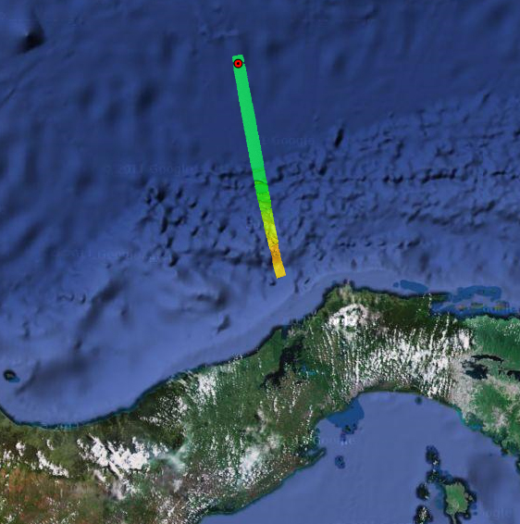 | 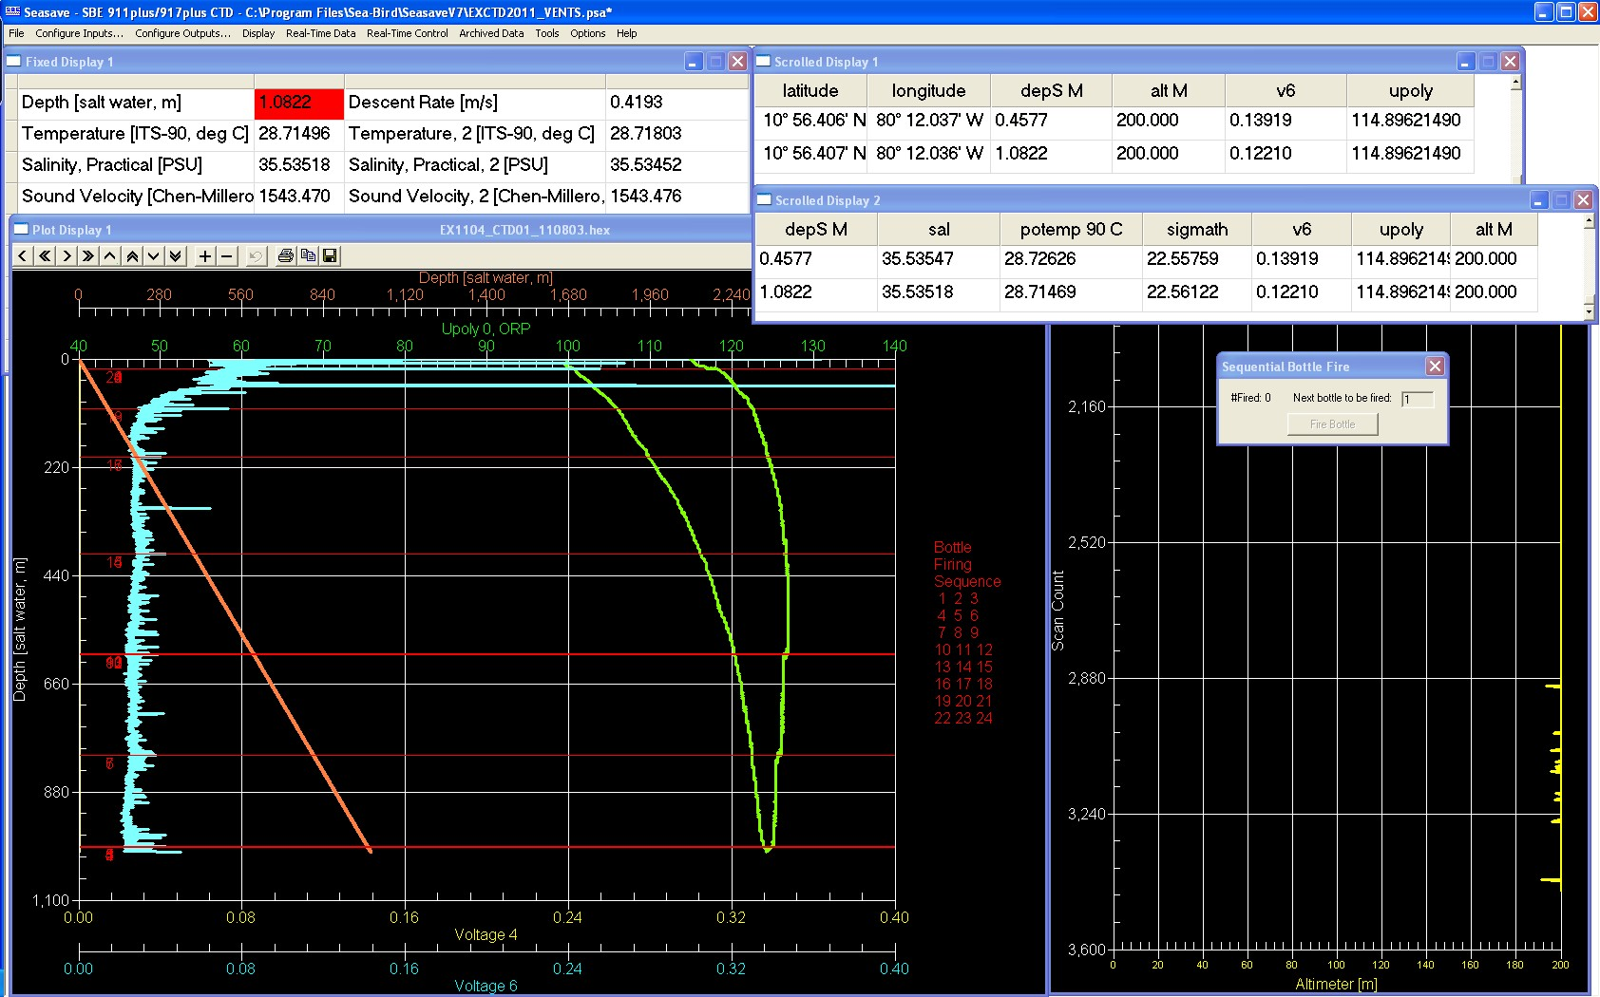
Overview of Cast site | SeaSave Data Acquisition Screen
Please direct inquiries to: | NOAA Office of Ocean Exploration & Research  1315 East-West Highway (SSMC3 10th Floor)  Silver Spring, MD 20910  (301) 734-1014

