

Draft Project Instructions
Date Submitted: Monday July 15 , 2011
Platform: NOAA Ship Okeanos Explorer
Cruise Number: EX-11-04
Project Title: Mid-Cayman Rise Exploration
Cruise Dates: August 02 – August 18, 2011

Prepared by: Kelley Elliott
Office of Ocean Exploration & Research

Approved by: ________________________ Dated: __________________
Craig W. Russell
Program Manager
Office of Ocean Exploration & Research

Approved by: ________________________ Dated: ________________
Captain David Score, NOAA
Commanding Officer
Marine Operations Center – Atlantic

- Overview

- Cruise Plan Period
This cruise plan covers the ships transit and underway data collection from Balboa, Panama (departing August 2, 2011) to the project operating area at the Mid-Cayman Rise, and finally to Key West, FL. Underway data will be collected during transits to and from the operating area in all coastal states (permit pending) except Columbia and Cuba. Primary mapping, CTD and ROV operations will be conducted in Cayman Islands waters under British jurisdiction.

- Operating Area

The primary operating area will be in British national waters in the vicinity of the Cayman Islands. Significant transits through other coastal state EEZ’s are required to get to and from the primary operating area.

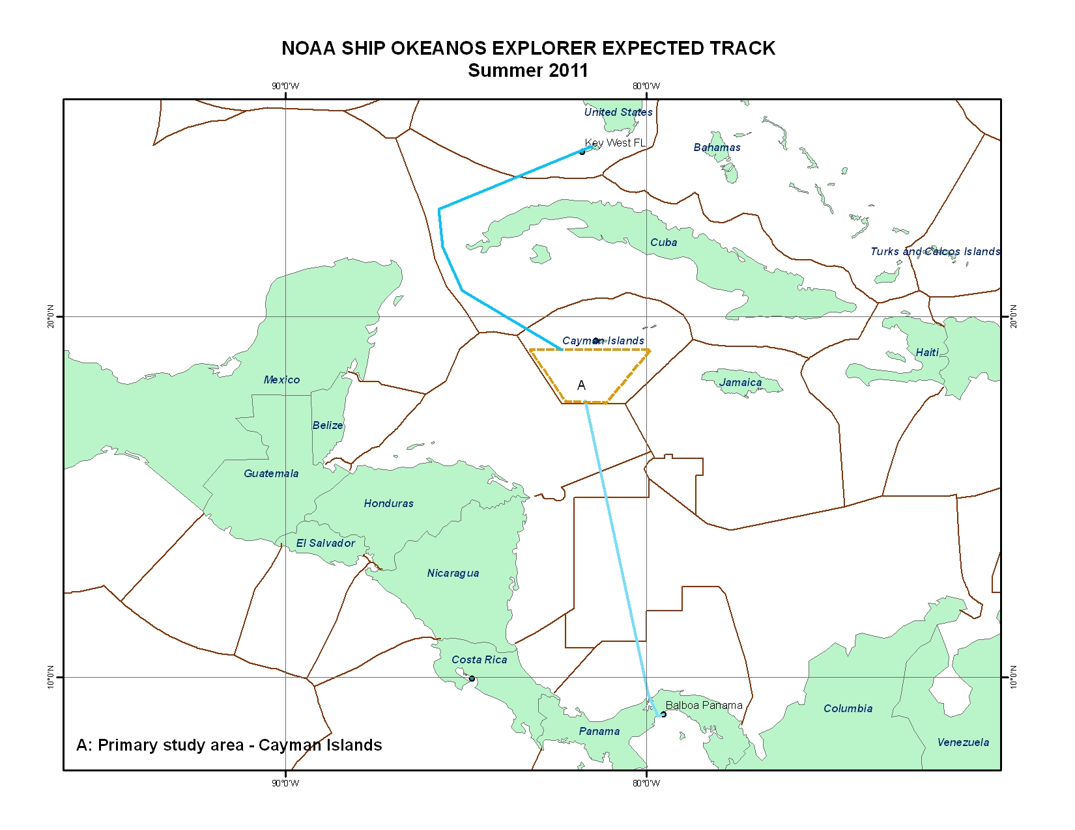
Figure 1. Depiction of general ship track including transit from Balboa, Panama to the primary operating area, and the transit to Key West, Florida. The dotted line represents flexible operating area boundaries in the vicinity of the Cayman Islands. Polygon A corresponds to the geographic area highlighted in Figure 2 below. The solid brown lines depict EEZ boundaries. The actual cruise tracks may vary.

General Transit Waypoints (Approximate)
Point ID | Latitude (N) | Longitude (W) | Depth
T1 | 10.9989 | -80.2801 | Approximate entrance to Columbia EEZ
T2 | 14.9900 | -81.0782 | Approximate exit of Columbia EEZ, Entrance to Nicaragua
T3 | 15.7039 | -81.2791 | Approximate exit of Nicaragua EEZ, Entrance to Honduras EEZ
T4 | 17.5857 | -81.6723 | Approximate exit of Honduras EEZ, Entrance to Cayman Islands EEZ
T5 | 17.6580 | -81.6885 | Approximate entrance to primary operations area (see figure 2)
T6 | 19.1283 | -82.0299 | Approximate exit of primary operations area (northwest corner, figure 2)
T7 | 19.7611 | -83.1746 | Approximate entrance to Cuban EEZ
T8 | 23.8765 | -83.5657 | Approximate exit of Cuban EEZ
Table 1: General waypoints for the transit from Balboa, Panama to
the Mid-Cayman Rise operating area, and on to Key West, Florida. The actual cruise tracks and way points may vary.

MSR Permit Request Operating Area
Point ID | Latitude (N) | Longitude (W) | Notes
SE | 17.65497713 | -81.14671815 | Southeast corner
NE | 19.12083723 | -79.98551435 | Northeast corner
NW | 19.12398889 | -83.09545811 | Northwest corner
SW | 17.65358101 | -82.17019371 | Southwest corner
Table 2: Boundary coordinates for the operating area submitted to State as part of the Marine Scientific Research (MSR) permit request (polygon A in figure one, white polygon in Figure 2)

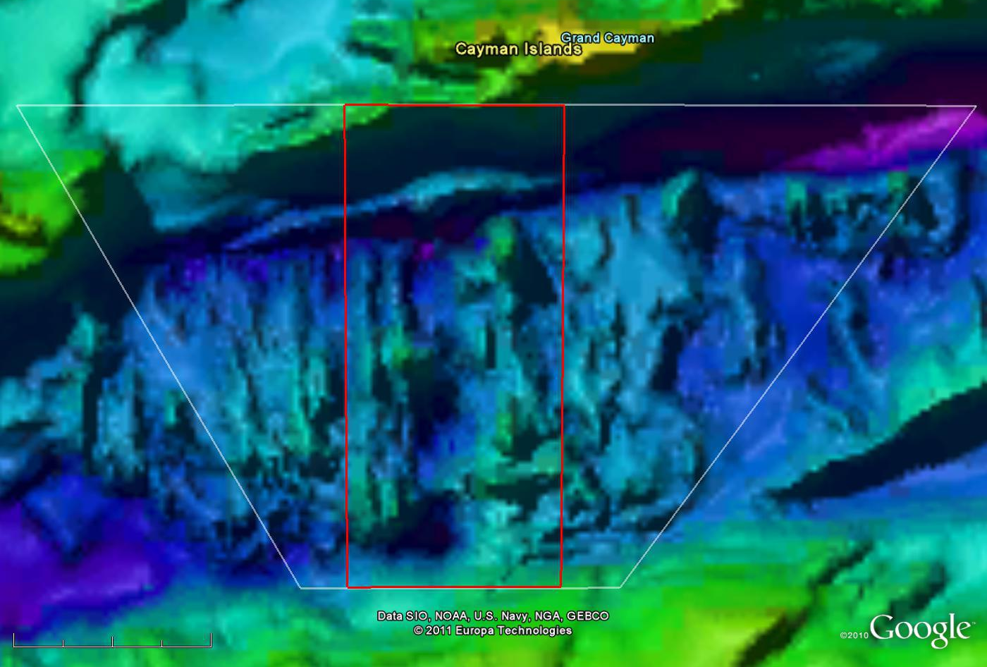
68km

Figure 2.Closer look at the Google Earth image of the Mid-Cayman Rise (MCR) operating region highlighted in the yellow polygon in Figure 1. The white line represents the operating area outlined in the MSR permit request; The red box outlines the focused area of operation. Image created in GoogleEarth. Not for navigation.

Focused Operations Area
Point ID | Latitude (N) | Longitude (W) | Notes
OpsSW | 17.65707971 | -82.01973782 | Southwest corner
OpsSE | 17.65940439 | -81.33510327 | Southeast corner
OpsNE | 19.12734844 | -81.32265185 | Northeast corner
OpsNW | 19.12828654 | -82.02988574 | Northwest corner
Table 3: Boundary coordinates for focused operations to be conducted during EX1104 (This is represented by the red box in Figures 2 and 3).

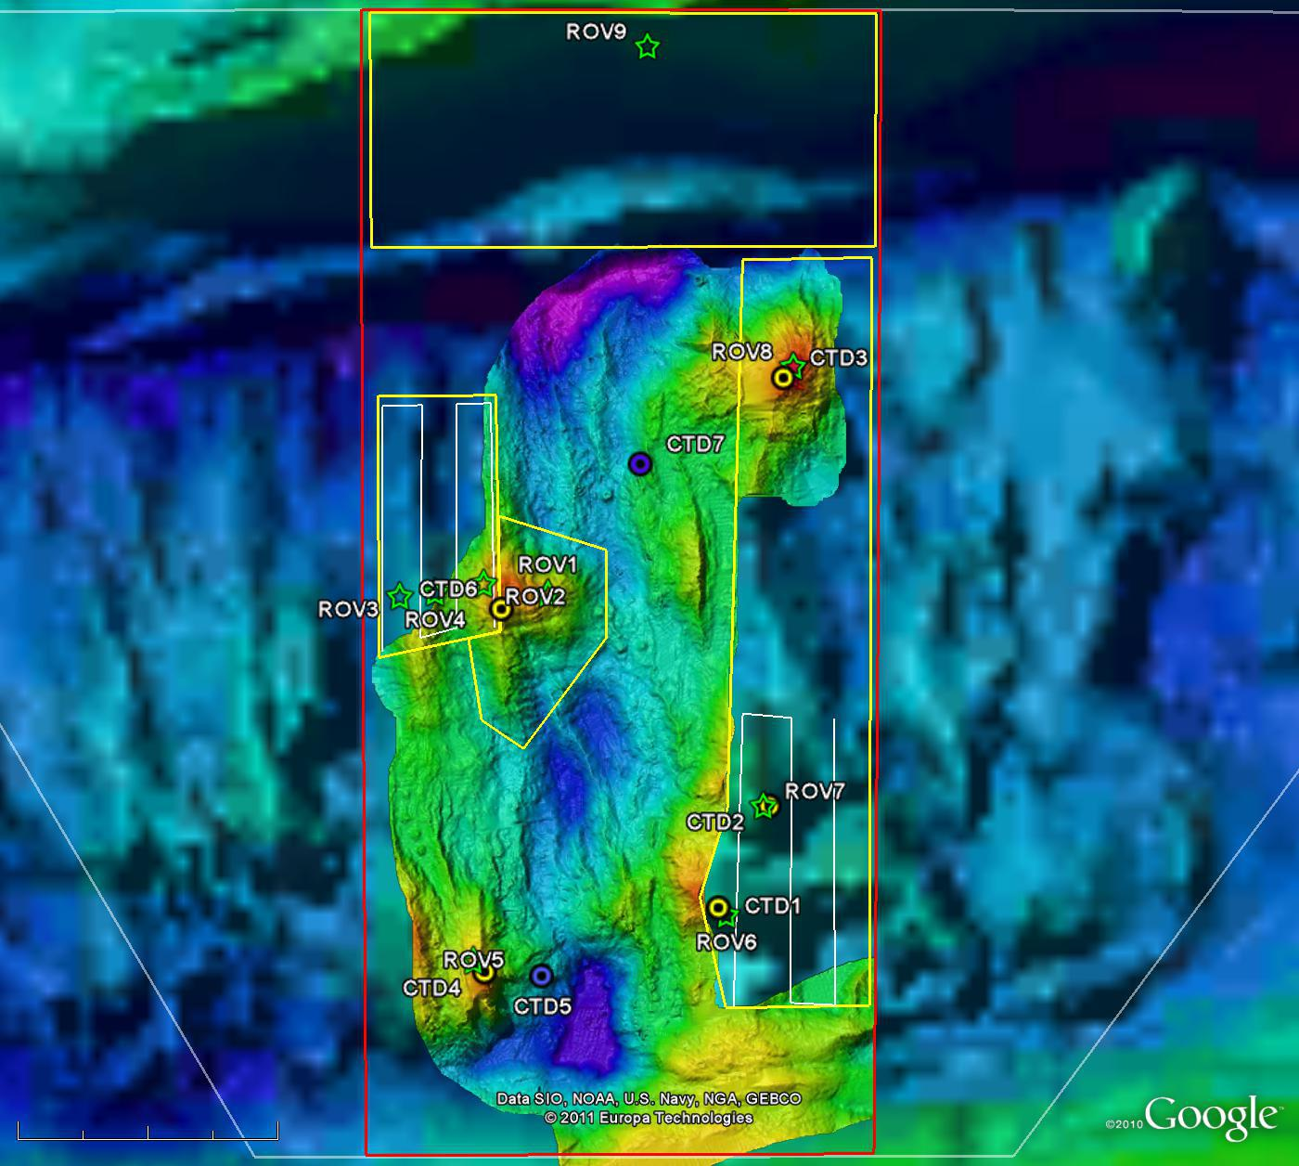
37km

kmkm
3
1
2a
2b
Mount Dent
Cayman Trough Fracture Zone
Figure 3. Projected EX1104 focused operations area. The yellow polygons outline priority mapping areas; the yellow and blue dots show the approximate location of potential CTD casts; and the green stars show the approximate location of possible ROV dives. The high resolution imagery was acquired with funding from the French government and has been provided for operations and planning purposes. Image created in GoogleEarth. Not for navigation.

Mapping Area 1
Point ID | Latitude (N) | Longitude (W) | Notes
1SW2 | 17.98948491 | -81.56963025 | Mapping Area 1, SW point 2
1SW | 17.84785928 | -81.53484869 | Mapping Area 1, SW Corner
1SE | 17.85062757 | -81.34122519 | Mapping Area 1, SE Corner
1NE | 18.80897012 | -81.33680620 | Mapping Area 1, NE Corner
1NW | 18.80609674 | -81.51146130 | Mapping Area 1, NW Corner
1SW3 | 18.10381852 | -81.53268935 | Mapping Area 1, SW point 3
Mapping Area 2a
Point ID | Latitude (N) | Longitude (W) | Notes
2aSE | 18.33031809 | -81.83939224 | Mapping area 2a, SE corner
2aNE | 18.63244594 | -81.84505589 | Mapping area 2a, NE corner
2aNW | 18.63166044 | -82.00491981 | Mapping area 2a, NW corner
2aSW | 18.29657317 | -82.00215541 | Mapping area 2a, SW corner
Mapping Area 2b
Point ID | Latitude (N) | Longitude (W) | Notes
2bNW1 | 18.33031865 | -81.83850737 | Mapping area 2b, Northwest point
2bNE2 | 18.32105930 | -81.88183627 | Mapping area 2b, Northeast point
2bSW5 | 18.21642717 | -81.86374925 | Mapping area 2b, Southwest point
2bSE4 | 18.18056124 | -81.80718024 | Mapping area 2b, Southeast point
2bE3 | 18.32196206 | -81.69611678 | Mapping area 2b, Eastern point
2bW7 | 18.43451591 | -81.69523817 | Mapping area 2b, Western point
2bW6 | 18.47834235 | -81.84171338 | Mapping area 2b, Western point
Mapping Area 3
Point ID | Latitude (N) | Longitude (W) | Notes
3NE | 19.12313468 | -81.32934969 | Mapping Area 3, NE Corner
3NW | 19.12512576 | -82.01763798 | Mapping Area 3, NW Corner
3SW | 18.82189293 | -82.01432524 | Mapping Area 3, SW Corner
3SE | 18.82331704 | -81.33144906 | Mapping Area 3, SE Corner
Table 4: Boundary coordinates of priority mapping areas for EX1104
(This is represented by the yellow polygons in Figure 3).

CTD Cast Locations (Approximate)
Point ID | Latitude (N) | Longitude (W) | Depth
CTD 1 | 17.97854407 | -81.54274563 | TBD
CTD 2 | 18.10897791 | -81.47430323 | TBD
CTD 3 | 18.25558105 | -81.59799939 | TBD
CTD 4 | 17.89590742 | -81.85767764 | TBD
CTD 5 | 17.89095368 | -81.78086998 | TBD
CTD 6 | 18.36105126 | -81.83514043 | TBD
CTD 7 | 18.54666667 | -81.64783901 | TBD
Table 5: Approximate location of potential CTD casts
(This is represented by the yellow and blue dots in Figure 3).

Potential ROV Dive Sites (Approximate)
Point ID | Latitude (N) | Longitude (W) | Depth
ROV 1 | 18.37918194 | -81.77402128 | TBD
ROV 2 | 18.39211861 | -81.86083715 | TBD
ROV 3 | 18.37563294 | -81.97417846 | TBD
ROV 4 | 18.38089005 | -81.92657575 | TBD
ROV 5 | 17.90886193 | -81.87440669 | TBD
ROV 6 | 17.96812935 | -81.53361935 | TBD
ROV 7 | 18.10765553 | -81.48387684 | TBD
ROV 8 | 18.67015882 | -81.44267415 | TBD
ROV 9 | 19.08147946 | -81.63986916 | TBD
Table 6: Approximate location of potential ROV dives
(This is represented by the green stars in Figure 3).
- Summary of Objectives
Transit to and from the primary operating area

NOAA Ship Okeanos Explorer will collect underway multibeam and meteorological/ oceanographic (METOC) data during the transit to and from the primary area of operations at the Mid-Cayman Rise, except while in Columbia and Cuba’s EEZ (no clearance request was submitted). The projected cruise track displayed in Figure 1 is provided as general guides for the transit. Deviation from this is acceptable assuming that the final waypoints do not add considerable time to the transit.

Objectives during the transit to and from the operating area include:
- Collection of EM302 data in coastal state waters for countries who have accepted the submitted Marine Research Clearance request.
- Collect METOC data
- Test and ensure telepresence communications
- Test ship-to-shore collaboration tools (e.g. Okeanos Explorer portal, ftp site)
- See the Data Management Plan (pending)

Mid-Cayman Rise Exploration

These operations are expected to cover 10 days and 11-12 nights. Primary objectives include utilization of the full suite of Okeanos Explorer capabilities (i.e., ROV, mapping, CTD and telepresence). Daytime operations will largely focus on ROV dives to explore targets identified using multibeam bathymetry (existing and acquired by NOAA Ship Okeanos Explorer) and CTD/rosette data. Evening/night operations will focus on acquiring multibeam data and conducting CTD/rosette operations. Operations are subject to change based on actual or potential discoveries.

  - Science
    - Locate, precisely, the first hydrothermal field (Von Damm) to be found on Mt Dent, characterize its geologic setting and use the ROV to obtain the first high quality HD video of both the site and who's living there.
    - Explore the rest of the summit of Mt Dent to understand its geologic setting and, ideally, locate a 2nd hydrothermal field (Europa) that we have preliminary evidence for (predicted to be of a Lost City type) that we can compare and contrast with the first site (Von Damm)
    - Continue mapping off-axis to define the size and shape of the multiple other "Oceanic Core Complexes (OCCs)" that are geologically similar to Mt Dent, and line the walls of the Mid Cayman Rise.
    - Use the CTD system, its in situ sensors, and shipboard analysis of samples for their dissolved methane concentrations to seek for tell-tale signs of additional hydrothermal sources that may be hosted elsewhere along the Mid-Cayman Rise, including on top of the other OCCs we will map.
    - Track any additional hydrothermal sites to source using the CTD and ROV in concert.
    - Use the ROV to explore the top of at least one other OCC, even if we do not find evidence for more hydrothermal activity
    - Map the north wall of the Cayman Trough fracture zone, immediately north of the Mid Cayman Rise
    - Explore the cliff face of the Cayman Trough fracture zone using the ROV to examine what rock-types are exposed and what animals make a living clinging to the cliff face

  - ROV
    - Daytime ROV dives on exploration targets
    - Ongoing training of pilots
    - Ongoing system familiarization and training

  - Telepresence (VSAT 20 Mbps ship-to-shore; 1.54 Mbps shore–to-ship)
    - Test data and information sharing tools between ship and shore
      - Okeanos Explorer Image Gallery
      - ProBrowse
    - Continue to apply and refine SOP’s
      - Okeanos Explorer Portal
      - Okeanos Explorer FTP Site
      - iChat instant messaging
      - Okeanos Explorer Image Gallery
      - iChat eventlog chat room
      - ProBrowse
    - Ongoing system familiarization and training

  - Mapping operations
    - Conduct mapping operations of priority mapping areas identified by the science team
    - Continue cross training of ROV/mapping personnel

  - CTD operations
    - Conduct vertical casts on exploration targets
    - Process water samples for methane using gas chromatograph
    - Preserve water samples for post-cruise microbe and total carbon analysis (see appendix x)
    - Conduct CTD Tow-Yo operations if requested during cruise

  - Communications between ship and shore

    - Test the engagement of scientists via internet1 if this becomes available, and the internet1-based collaboration tools

  - URI Exploration Command Center
    - Test the newly refurbished Exploration Command Center at URI
    - Train scientists how to use the online collaboration tools and technologies to conduct remote science; refine SOPs
    - Test the shore-side development of video products during an Okeanos Explorer Expedition
    - Test and refine new SOPs and products focused on providing situational awareness for operations, education & outreach
    - Test and refine shore-side web coordination SOPs
    - Ongoing system familiarization and training

  - Data management
    - See the Data Management Plan (will be submitted in Appendix # with the final cruise plan).
    - Deliver all data acquired within coastal state boundaries to the coastal state within 30 days of cruise completion.

  - Education and Outreach
    - Possible telepresence event August 8th (backup date August 9th) with media availability at the URI/ISC ECC. Senator Whitehouse and others from the RI delegation to give an early welcome to Okeanos Explorer as she gets closer to homeporting in Davisville, RI. Live feeds would be streamed to shore, and someone on the ship would be speak to shore-side participants from the control room. Live feeds from E/V Nautilus may be streamed to URI’s ISC as well.
    - During the cruise, OER personnel will collect underwater and topside video for overall NOAA use and for potential use in a National Geographic Television series. There may be specific times when we consider altering operations to ensure the best footage is obtained. Expedition Coordinator and ROV team leader will work with the ship to plan and execute the operations and related activities (e.g., interviews, etc)

- Participating Institutions
National Oceanic and Atmospheric Administration (NOAA) Office of Ocean Exploration and Research (OER) 1315 East-West Hwy, Silver Spring, Maryland 20910

University of Rhode Island, Graduate School of Oceanography, Inner Space Center, Narragansett, Rhode Island, 02882

Woods Hole Oceanographic Institution MS24 Clark Laboratory, Woods Hole, MA 02543-1049

NOAA Pacific Marine Environmental Lab 7600 Sand Point Way NE, Seattle, WA 98115

Indonesia Agency for Marine and Fisheries Research Ministry of Marine Affairs and Fisheries (KKP) Jl Pasir Putih I Ancol Timur Jakarta Utara 14430 DKI Jakarta, Indonesia

Indonesia Agency for the Assessment and Application of Technology (BPPT) Technology Center for Marine Survey Jalan MH. Thamrin 8, BPPT Building I, 18th Floor, Jakarta Pusat, Indonesia 10340

University of New Hampshire (UNH) Center for Coastal and Ocean Mapping (CCOM)
24 Colovos Road, Durham, NH 03824 USA

Embassy of the United States – Jakarta, Indonesia Jl. Medan Merdeka Selatan No. 3 – 5
Jakarta 10110, Indonesia

University Corporation for Atmospheric Research (UCAR), Joint Office for Science Support (JOSS) PO Box 3000 Boulder, CO 80307

National Oceanography Centre, Southampton, University of Southampton Waterfront Campus, European Way, Southampton SO14 3ZH

Duke University Marine Lab, 135 Duke Marine Lab Road, Beaufort, NC 28516

University of Wyoming, Geology & Geophysics Department, 1000 E. University Ave. Laramie, WY 82071

Marine Biological Laboratory, 7 MBL Street, Woods Hole, MA 02543
- Personnel (Science Party)
The staffing plans for each leg will be developed and submitted with the final cruise plan. Current drafts are subject to change. Assume all 19 mission berths will be utilized by OER mission personnel during the cruise.
 | NAME | AFFILIATION | ROLE |  | M/F |  | STATUS |  | ON PREVIOUS LEG
1 | Kelley Elliott | OER | Expedition Coordinator | F |  | US Citizen |  | N
2 | Chris German | WHOI | Science Team Lead | M |  | UK Citizen/  P. Resident |  | N
3 | Dave Lovalvo | OER | ROV Team Lead | M |  | US Citizen |  | Y
4 | Meme Lobecker | OER | Mapping Team Lead | F |  | US Citizen |  | N
5 | Webb Pinner | OER | Telepresence lead | M |  | US Citizen |  | Y
6 | Dave Wright | UCAR | ROV Pilot/Co-pilot | M |  | US Citizen |  | Y
7 | Tom Kok | UCAR | ROV Pilot/Co-pilot | M |  | US Citizen |  | Y
8 | Bobby Mohr | UCAR | ROV Pilot/Co-pilot | M |  | US Citizen |  | Y
9 | Brian Bingham | UCAR | ROV Pilot/Co-pilot | M |  | US Citizen |  | Y
10 | Karl McLetchie | UCAR | ROV Pilot/Co-pilot | M |  | US Citizen |  | Y
11 | Jeff Williams | UCAR | ROV Pilot/Co-pilot | M |  | US Citizen |  | Y
12 | Vincent Howard | UCAR | ROV Nav/Mechanical Engineer | M |  | US Citizen |  | Y
13 | John Mefford | UCAR | ROV Nav/Mechanical Engineer | M |  | US Citizen |  | N
14 | Roland Brian | UCAR | ROV Video Engineer | M |  | US Citizen |  | Y
15 | Joe Biscotti | UCAR | ROV Video Engineer | M |  | US Citizen |  | Y
16 | Brian Brinkman | UCAR | ROV Video Engineer | M |  | US Citizen |  | Y
17 | Gregg Diffendale | UCAR | Data | M |  | US Citizen |  | Y
18 | Paul Tyler | NOC | Scientist | M |  | UK Citizen |  | N
19 | Cameron McIntyre | WHOI | Science Technician | M |  | Australian Citizen |  | N
Table 7: Full list of the science party and their affiliation

Shore-side Participants (Location and duration of participation will vary):
NAME |  | INSTITUTION | US CITIZEN | NOTE
Catalina | Martinez | NOAA | Y | ECC Coordinator
Keeley | Belva | NOAA | Y | Web Coordinator
Mike | Cheadle | U. Wyoming |  | Geologist
Barbara | John | U. Wyoming |  | Geologist
Jeff | Seewald | WHOI |  | Water chemistry
Jill | McDermott | WHOI |  | One of Jeff’s colleagues
Julie | Huber | MBL |  | Biologist
Julie | Smith | MBL |  | Biologist
Cindy | Van Dover | Duke |  | Biologist
Jameson | Clarke | Duke |  | Cindy’s PhD Student
Diva | Amon | NOC | N | UK Scientist, Benthic biologist
TBD |  |  | N | Indonesian Scientist
Max | Coleman | NASA JPL |  | Participate via I2 at NASA JPL
Sara | Bennett | NASA JPL |  | Participate via I2 at NASA JPL
Brendan | Reeser | NOAA NCDDC |  | OER Data Team
Table 8: Draft list of the shore-side science participants to be based at the URI ISC during EX1104 (unless otherwise noted). Not all will participate for the entire duration of the cruise.

- Administrative
Key Points of Contact

Ship Operations  Marine Operations Center, Atlantic (MOA)  439 West York Street  Norfolk, VA 23510-1145  Telephone: (757) 441-6776  Fax: (757) 441-6495 | Marine Operations Center, Pacific (MOP)  2002 SE Marine Science Drive  Newport, OR 97365  Telephone: (541) 867-8700  Fax: (206) 553-1109
Chief, Operations Division, Atlantic (MOA)  LCDR Jennifer Pralgo  Telephone: 757-441-6716  E-mail: ChiefOps.MOA@noaa.gov | Chief, Operations Division, Pacific (MOP)  CDR Michael Hopkins  Telephone: (206) 553-8705  Email: ChiefOps.MOP@noaa.gov

Mission Operations

Kelley Elliott, Expedition Manager  NOAA Ocean Exploration and Research  Phone: (301) 734-1024/ (703) 927-5449  Email: Kelley.Elliott@noaa.gov | CDR Robert Kamphaus, NOAA  Commanding Officer  NOAA Ship Okeanos Explorer  Phone: (401) 378-8284  Email: CO.Explorer@noaa.gov
LT Megan Nadeau, Field Operations Officer
NOAA Ship Okeanos Explorer
Phone: (207) 240-0957
E-mail: OPS.Explorer@noaa.gov

Other Mission Contacts

Craig Russell, EX Program Manager  NOAA Ocean Exploration & Research  Phone: 206-526-4803 / 206-518-1068  E-mail: Craig.Russell@noaa.gov | John McDonough, Deputy Director  NOAA Ocean Exploration & Research  Phone: 301-734-1023 / 240-676-5206  E-mail: John.McDonough@noaa.gov
Meme Lobecker, Mapping Lead  NOAA Ocean Exploration & Research (ERT, Inc.)  Phone: 603-862-1475/ 301-938-8460  E-mail: elizabeth.lobecker@noaa.gov | Dave Lovalvo, ROV Program Manager  Eastern Oceanics  Phone: 203-246-5531  Email: eo@wispwest.com
Webb Pinner, Systems Engineer  NOAA Ocean Exploration & Research (2020, Inc.)  Phone: 401-749-9322  Email: webb.pinner@noaa.gov |  | Catalina Martinez, EX Expedition Coordinator  NOAA Ocean Exploration & Research  Phone: 401-874-6250 (o)/ 401-330-9662 (c)  Email: Catalina.martinez@noaa.gov

Shipments

Be sure to send an email to Okeanos Explorer Operations Officer OPS.Explorer@noaa.gov indicating the size and number of items being shipped and the name of the person it is being shipped to.

Okeanos Explorer
C/O MLS Panama/Norton Lilly
Air Sea Cargo Express
Panama City, Panama
+507 236 8411
Please ensure copies of all documents forwarded topanama@mlscorporation.com.

- Diplomatic Clearances
This cruise involves Marine Scientific Research (MSR) in waters under the jurisdiction of Panama, Nicaragua, Honduras, the Cayman Islands and United States. Diplomatic clearance to conduct MSR in these countries has been requested. An MSR clearance request for Cuba and Columbia will not be submitted.

Cayman Islands
A request to conduct MSR within 12nm of the Cayman Islands was submitted to the State Department on June 2, 2011. Clearance was granted by the Maritime Policy Unit (legal advisors) of the Foreign and Commonwealth Office of the United Kingdom on June 10, 2011 (document reference 049/2011). Clearance for Okeanos Explorer (F2011-43) to conduct MSR from August 1-31, 2011 was granted subject to the conditions outlined in the clearance (Appendix X).

This requires that all pertinent data collected in Cayman Island waters be delivered to the coastal state.

The primary area of operations for this expedition involves MSR in water under the jurisdiction of the Cayman Islands. Full mapping, CTD, ROV and telepresence operations are planned, and correlating datasets collected. We will have a UK Citizen onboard as the science team lead, coordinating a broader team of scientists who will be remotely engaged in the cruise in real-time from shore through the use of telepresence technology. Additional scientists from the UK’s National Oceanography Center will be fully engaged in the expedition as part of the core science team, both on board the ship and remotely participating in real-time from shore.

As of July 12, 2011 all requested Marine Scientific Research (MSR) clearances in other foreign waters are pending. The following clearances were originally submitted on April 27, 2011:
- Panama – within 12nm from shore. This requires that all pertinent data collected in Panama waters be delivered to the coastal state. Only underway data (e.g., multibeam, METOC data) is planned to be collected;
- Nicaragua - between 12 and 200nm from shore. This requires that all pertinent data collected in Nicaragua waters be delivered to the coastal state. Only underway data (e.g., multibeam, met data) is planned to be collected;
- Honduras - between 12 and 200nm from shore. This requires that all pertinent data collected in Honduras waters be delivered to the coastal state. Only underway data (e.g., multibeam, met data) is planned to be collected;

Coastal state data distribution
Data acquired in coastal state waters will be packaged together and provided to the coastal state through official routes within 30 days following the completion of MSR.

- Licenses and Permits
The OER program is looking into permit and license requirements.
II. Operations

- Cruise Plan Itinerary

Date | Operations | Remarks
07/28/2011 | Ship arrives at Balboa, Panama | Any shipments to the ship in panama to be addressed to (shipping address pending).  Port agent pending.
07/31/2011 | Mission participants arrival completed
08/02/2011 | Departure from Balboa, Panama | Transit through Panama Canal
~ 08/03/2011 | Entering Columbia EEZ | Secure all the sensors
~ 08/04/2011 | Entering Nicaragua EEZ | Turn on all the sensors (pending clearance)
~ 08/04/2011 | Entering Honduras EEZ | Package Nicaragua state data
~ 08/04/2011 | Entering Cayman Island EEZ | Package Honduras state data
~ 08/04/2011 | Entering primary operations area | Commence mapping in box 1
~ 08/04-08/05/2011 | Mapping operations in box 1 | See table 4/figure 3
~ 08/05/2011 | First ROV dive, anticipated at Mount Dent | See table 6/figure 3
~08/05-08/06/2011 | Mapping/CTD operations in box 2a | See figure 3, tables 4-5
~ 08/05-08/15/2011 | Continue ROV dive operations during the day and mapping /CTD operations at night | See tables 4-6/figure 3
08/08 or 08/09/2011 | Telepresence event | Media event between ship and shore on August 8th or 9th with the URI ECC. Live feeds would be streamed to shore, and someone on the ship would speak to shore-side participants from the control room.
~ 08/15/2011 | Start transit to Key West
~ 08/15/2011 | Entering CUBA EEZ | Secure all sensors
~ 08/17/2011 | Entering US EEZ | Turn on all the sensors
08/18/2011 | Arrive Key West, FL | Secure all the sensors
08/18-19/2011 | Prepare the ship for mission party departure | Securing the ROV, cleaning the mission space, offload science equipment and ship samples, etc
- Staging and de-staging:

A methane prospecting survey of opportunity involving use of a gas chromatograph will be conducted during this cruise. This requires cylinders of nitrogen and air that were purchased (versus rented as is usually done) and delivered to the ship in Costa Rica on July 6, 2011. The MSDS forms were provided to the ship prior to loading. These tanks will be securely stored until the EX1104 cruise.
The Gas Chromotograph, hydrogen gas generator and 2 small cylinders of compressed nitrogen (with trace concentrations of methane) will be sent to the ship for arrival and loading in Balboa, Panama between July 28 and August 1, 2011. Two additional requests for water sample preservation have also been made by the science team; one requires hydrochloric acid to be sent to the ship in this same time period. The science team is making shipping arrangements. A list of HAZMATs, associated MSDS forms, and buffer materials will be provided prior to or at the time of loading.

Offloading of all science gear, and shipment of water samples will take place August 18-19 following arrive in Key West, FL.

- Dive Plan (SCUBA)
NOT APPLICABLE TO THIS CRUISE
- Applicable Restrictions
NOT APPLICABLE TO THIS CRUISE
III. Equipment
- Equipment and capabilities provided by the ship
- Kongsberg Simrad EM 302 Multibeam Echosounder (MBES)
- Kongsberg Simrad EK60 Deepwater Echosounder (SBES)
- Knudsen 3260 Sub-bottom profiler (SBP)
- LHM Sippican XBT (various probes)
- Seabird SBE 911Plus CTD
- Light Scattering Sensor (LSS)
- Oxidation-Reduction Potential (ORP)
- Dissolved Oxygen (DO) sensor
- Altimeter Sensor
- Seabird SBE 50 CTD Stand
- CNAV GPS
- POS/MV
- Seabird SBE-45 (Micro TSG)
- Kongsberg Dynamic Positioning-1 System
- NetApp mapping storage system
- CARIS HIPS Software
- IVS Fledermaus Software
- SIS Software
- Hypack Software
- Scientific Computing System (SCS)
- ECDIS
- Met/Wx Sensor Package
- Telepresence System
- VSAT High-Speed link
- Cruise Information Management System (CIMS)
- Little Hercules ROV
- Seirios Camera Platform

- Equipment and capabilities provided by the scientists
- Gas chromatograph
- Hydrogen gas generator
- Chemicals and equipment for preservation of water samples
IV. Hazardous Materials
- Policy and Compliance
All HAZMAT brought aboard by visiting scientists for EX1104 operations will comply with MOCDOC 15, Fleet Environmental Compliance #07, Hazardous Material and Hazardous Waste Management Requirements for Visiting Scientists, released July 2002.
Hazardous Materials (HAZMAT) Anticipated to be brought aboard by science

    - Hydrochloric Acid (HCl), 12 M – Quantity: 500 ml stored in a glass bottle.
    - Compressed Nitrogen – Quantity: Size T or K compressed gas cylinder, approximately 4.5’ tall and 10” wide, weighing ~80lbs
    - Compressed Air – Quantity: Size T or K compressed gas cylinder, approximately 4.5’ tall and 10” wide, weighing ~80lbs
    - Two 1 liter cylinders of compressed nitrogen at relatively low pressure (~200 PSIA), containing trace concentrations of methane (~100ppm). These will be used for calibration of the gas chromatograph detector. (At this concentration of methane, the gases are non-flammable due to the balance being nitrogen. Due to the relatively small cylinder size (~1 liter) and quantity of gas contained within (~14 liters), they do not represent a suffocation risk for normal laboratory conditions.)

Neutralizing agents, buffers and/or absorbents required for HAZMAT

    - Hydrochloric Acid (HCl): Sodium bicarbonate (Baking soda) for neutralizing spills. Kitty litter for adsorbing the liquid. A “spill kit” has been requested.

See Appendix X for HAZMAT material safety data sheets (MSDS).

Guest scientists and the Expedition Coordinator are responsible for ensuring the HAZMAT are listed, packaged, labeled and transported in compliance with DOT regulations
- Radioactive Isotopes
NOT APPLICABLE TO THIS CRUISE
- Inventory
Okeanos Explorer has the following chemicals onboard for scientific use:
- Formaldehyde 37% solution – Quantity: (2) 2L
- Formaldehyde 37% solution – Quantity: (1) 3.8L
- Formalin 10% solution – Quantity: (7) 1L
- Ethyl Alcohol 190 Proof – Quantity: (1) 5 gal
V. Additional Projects
- Supplementary ("Piggyback") Projects
“Shipboard methane determination during exploration of the Mid-Cayman Spreading Center”
Buoyant plumes of high temperature hydrothermal fluids rise hundreds of meters above the seafloor before being dispersed laterally by deep-ocean currents. In part, due to their high initial methane (CH4) concentrations, such plumes can be traced over long distances (tens of km) through the water column (e.g. Lilley et al., 1995). The science goal is to conduct shipboard dissolved CH4 analysis on seawater samples collected with the CTD rosette. The objective is to identify hydrothermal vent plumes in the water column, in order to identify seafloor targets for further exploration and identification of active vent fields. See appendix X for more detailed information.
Sampling for Total Organic Carbon (sample acquired during the cruise, processed post-cruise)
Scientists are interested in Total Organic Carbon (TOC) because hydrothermal systems represent a biological niche which has been considered independent from the rest of the ocean. However, hydrothermal systems can act as a transport mechanism of organic carbon from within the crust and surrounding areas of diffuse flow, out into the water column. Very few studies exist on the presence of organic carbon in hydrothermal plumes. A participating scientist has carried out two studies, one at the East Pacific Rise (EPR) and one at the Loihi Seamount. At the EPR, she found very little elevation in DOC, but at Loihi the DOC concentrations were elevated. She thinks this is due to differences in the chemistry and biology of these two environments. If different venting environments in the Cayman Trough are explored, it would be interesting to compare the plumes from different sites for organic carbon. This in itself will be an interesting study, but would also guide scientists on their return to the Mid Cayman Rise in 2012. See appendix X for more detailed information.
Total Cell Counts (sample acquired during the cruise, processed post-cruise)
Microbial communities are often enriched in hydrothermal plumes, meaning the number of cells is elevated above background seawater due to all the energy sources in the plume, making them another good indicator of hydrothermal activity. We like to visually examine the fluids with microscopy to look for particles and interesting cells, as well as count the cells and compare them to background seawater. During our plume search, any sample that has any indication of a plume should be preserved, as well as the 2-3 samples on either side of it, to get background levels. See appendix X for more detailed information.
- NOAA Fleet Ancillary Projects
NOT APPLICABLE TO THIS CRUISE

VI. Disposition of Data and Reports
- Data Responsibilities
All data acquired on Okeanos Explorer will be provided to the public archives without proprietary rights. All data management activities shall be executed in accordance with NAO 212-15, Management of Environmental and Geospatial Data and Information [http://www.corporateservices.noaa.gov/ames/NAOs/Chap_212/naos_212_15.html].

Ship Responsibilities
The Commanding Officer is responsible for all data collected for missions until those data have been transferred to mission party designees. Data transfers will be documented on NOAA Form 61-29. Reporting and sending copies of project data to NESDIS (ROSCOP form) is the responsibility of OER.

NOAA OER Responsibilities
The Expedition Coordinator will work with the Okeanos Explorer Operations Officer to ensure data pipeline protocols are followed for final archive of all data acquired. The full data management plan is included in appendix X (will be submitted with Final Cruise Plan) to this cruise plan.

Deliverables
  - At sea
      - Daily plans of the Day (POD)
      - Daily situation reports (SITREPS)
      - Daily mapping progress bathymetry files
      - ROV tracklines
      - Raw video clips from ROV dives, onboard cameras
      - Still image frame grabs from underwater video; topside still images
      - Daily “eventlog” files, including hourly updates detailing ongoing ship operations
      - Regular cruise logs providing the context of a given day at sea or at an ECC
  - Post cruise
      - Refined SOPs for all pertinent operational activities
      - Assessments of all activities
      - Provide applicable data to Coastal States in accordance with State Department Marine Science Research permit
  - Science
- Multibeam and XBT raw and processed data, a full description is available in the data management plan.
- ROV dive site maps
- ROV dive summaries
- CTD/rosette operation summaries
- Results of water sample processing for methane
- HD footage archived at the NOAA Central Library
- Highlight Video Imagery with descriptive captions
- Highlight still imagery with descriptive captions
- Raw CTD Data
- Quick Look Report
- Mapping Data Report
- Cruise Report

Archive
- The Program and ship will work together to ensure documentation and
stewardship of acquired data sets in accordance with NAO 212-15. The Cruise Information Management System is the primary tool used to accomplish this activity.

- Pre and Post Cruise Meeting
Pre-Cruise Meeting
Prior to departure, the Expedition Coordinator will conduct a meeting of the scientific party to inform them of cruise objectives. Some vessel protocols, e.g., meals, watches, etiquette, etc. will be presented by the ship’s Operations Officer.
Post-Cruise Meeting
Upon completion of the cruise, a meeting will be held (unless prior alternate arrangements are made) and attended by the ship Survey Technicians, the Expedition Coordinator and members of the scientific party to review the cruise. Concerns regarding safety, efficiency, and suggestions for improvements for future cruises should be discussed.
Shipboard Meetings
Daily Operations Briefing meetings will be held at 1500 in the forward lounge to review the current day, and define operations, associated requirements and staffing needs for the following day. A Plan of the Day (POD) will be posted each evening for the next day in specified locations throughout the ship. A safety brief and overview of POD will occur on the Bridge each morning at 0800. Daily Situation Reports (SITREPS) will be posted as well and shared daily through e-mail and/or the Okeanos Explorer PLONE site (http://terra.gso.uri.edu/NOAAShipOkeanosExplorer).
- Ship Operation Evaluation Report
Within seven days of the completion of the cruise, a Ship Operation Evaluation form is to be completed by the Expedition Coordinator. The preferred method of transmittal of this form is via email to OMAO.Customer.Satisfation@noaa.gov. If email is not an option, a hard copy may be forwarded to:
Director, NOAA Marine and Aviation Operations
NOAA Office of Marine and Aviation Operations
8403 Colesville Road, Suite 500
Silver Spring, MD 20910

VII. Miscellaneous
- Meals and Berthing
Meals and berthing are required for up to 19 scientists. Meals will be served 3 times daily beginning one hour before scheduled departure, extending throughout the cruise, and ending two hours after the termination of the cruise. Since the watch schedule is split between day and night, the night watch may often miss daytime meals and will require adequate food and beverages (for example a variety of sandwich items, cheeses, fruit, milk, juices) during what are not typically meal hours. Special dietary requirements for scientific participants will be made available to the ship’s command at least twenty one days prior to the survey (e.g., Expedition Coordinator is allergic to fin fish).
Berthing requirements, including number and gender of the scientific party, will be provided to the ship by the Expedition Coordinator. The Expedition Coordinator and Operations Officer will work together on a detailed berthing plan to accommodate the gender mix of the scientific party taking into consideration the current make-up of the ship’s complement. The Expedition Coordinator is responsible for ensuring the scientific berthing spaces are left in the condition in which they were received; for stripping bedding and linen return; and for the return of any room keys which were issued. The Expedition Coordinator is also responsible for the cleanliness of the laboratory spaces and the storage areas utilized by the scientific party, both during the cruise and at its conclusion prior to departing the ship.
All NOAA scientists will have proper travel orders when assigned to any NOAA ship. The Expedition Coordinator will ensure that all non-NOAA or non-Federal scientists aboard also have proper orders. It is the responsibility of the Expedition Coordinator to ensure that the entire scientific party has a mechanism in place to provide lodging and food and to be reimbursed for these costs in the event that the ship becomes uninhabitable and/or the galley is closed during any part of the scheduled project.
All persons boarding NOAA vessels give implied consent to comply with all safety and security policies and regulations which are administered by the Commanding Officer. All spaces and equipment on the vessel are subject to inspection or search at any time. All personnel must comply with OMAO's Drug and Alcohol Policy which forbids the possession and/or use of illegal drugs and alcohol aboard NOAA Vessels.
- Medical Forms and Emergency Contacts
The NOAA Health Services Questionnaire (NHSQ, Revised: 08/08) must be completed in advance by each participating scientist. The NHSQ can be obtained from the Expedition Coordinator or the NOAA website at NOAA HEALTH SERVICES QUESTIONNAIRE. The completed form should be sent to the Regional Director of Health Services at Marine Operations Center. The participant can mail, fax, or scan the form into an email using the contact information below. The NHSQ should reach the Health Services Office no later than 4 weeks prior to the cruise to allow time for the participant to obtain and submit additional information that health services might require before clearance to sail can be granted. Please contact MOC Health Services with any questions regarding eligibility or completion of the NHSQ. Be sure to include proof of tuberculosis (TB) testing, sign and date the form, and indicate the ship or ships the participant will be sailing on. Clearances are valid for 2 years for personnel under age 50 and 1 year for age 50 and over. All PPD’s expire after one year from the date of administration. The participant will receive an email notice when medically cleared to sail if a legible email address is provided on the NHSQ.
Contact information:
Regional Director of Health Services
Marine Operations Center – Atlantic
439 W. York Street
Norfolk, VA 23510
Telephone 757.441.6320
Fax 757.441.3760
E-mail: MOA.Health.Services@noaa.gov
Prior to departure, the Expedition Coordinator must provide a listing of emergency contacts to the Operations Officer for all members of the scientific party, with the following information: name, address, relationship to member, and telephone number.
Emergency contact form is included as Appendix A.
- Shipboard Safety
Wearing open-toed footwear or shoes that do not completely enclose the foot (such as sandals or clogs) outside of private berthing areas is not permitted. Steel-toed shoes are required to participate in any work dealing with suspended loads, including CTD deployments and recovery. The ship does not provide steel-toed boots. Hard hats are also required when working with suspended loads. Work vests are required when working near open railings and during small boat launch and recovery operations. Hard hats and work vests will be provided by the ship when required.
Operational Risk Management: For every operation to be conducted aboard the ship (NOAA-wide initiative), risk management procedures will be followed. For each operation, risks will be identified and assessed for probability and severity. Risk mitigation strategies / measures will be investigated and implemented where possible. After mitigation, the residual risk will have to be assessed to make Go-No Go decisions for the operations. Particularly with new operations, risk assessment will be ongoing and updated as necessary. This does not only apply to over-the-side operations, but to everyday tasks aboard the vessel that pose risk to personnel and property.
- CTD (and other pertinent) ORM documents will be followed by all personnel working on board Okeanos Explorer
- All personnel on board are in the position of calling a halt to operations/activities in the event of a safety concern.
- Communications
A daily situation report (SITREP) on operations prepared by the Expedition Coordinator will be relayed to the program office. Sometimes it is necessary for the Expedition Coordinator to communicate with another vessel, aircraft, or shore facility. Through various modes of communication, the ship is able to maintain contact with the Marine Operations Center on an as needed basis. These methods will be made available to the Expedition Coordinator upon request, in order to conduct official business. The ship’s primary means of communication with the Marine Operations Center is via e-mail and the Very Small Aperture Terminal (VSAT) link. Standard VSAT bandwidth at 128kbs is shared by all vessels staff and the science team at no charge. Increased bandwidth in 30 day increments is available on the VSAT systems at increased cost to the scientific party. If increased bandwidth is being considered, program accounting is required it must be arranged at least 30 days in advance.
Specific information on how to contact the NOAA Ship Okeanos Explorer and all other fleet vessels can be found at: http://www.moc.noaa.gov/phone.htm

Important Telephone and Facsimile Numbers and E-mail Addresses

Ocean Exploration and Research (OER):
OER Program Administration:
Phone: (301) 734-1010
Fax: (301) 713-4252
E-mail: Firstname.Lastname@noaa.gov

University of New Hampshire, Center for Coastal and Ocean Mapping
Phone: (603) 862-3438
Fax: (603) 862-0839

NOAA Ship Okeanos Explorer - Telephone methods listed in order of increasing expense:

Okeanos Explorer Cellular:
Ship (401) 932-4114
OOD (401) 378-7414

Okeanos Explorer Iridium:
(808) 659-9179

Okeanos Explorer INMARSAT B
Line 1: 011-872-764-852-328
Line 2: 011-872-764-852-329

Voice Over IP (VoIP) Phone:
301-713-7772 (expect a delay once picked up by directory)

E-Mail: Ops.Explorer@noaa.gov (mention the person’s name in SUBJECT field) expeditioncoordinator.explorer@noaa.gov - For dissemination of all hands emails by Expedition Coordinator while on board. See ET for password.

- IT Security
Any computer that will be hooked into the ship's network must comply with the NMAO Fleet IT Security Policy prior to establishing a direct connection to the NOAA WAN. Requirements include, but are not limited to:

- Installation of the latest virus definition (.DAT) file on all systems and performance of a virus scan on each system.
- Installation of the latest critical operating system security patches.
- No external public Internet Service Provider (ISP) connections.

Completion of these requirements prior to boarding the ship is preferable.
Non-NOAA personnel using the ship's computers or connecting their own computers to the ship's network must complete NOAA’s IT Security Awareness Course within 3 days of embarking.
- Foreign National Guests Access to OMAO Facilities and Platforms
All foreign national access to the vessel shall be in accordance with NAO 207-12 and RADM De Bow’s March 16, 2006 memo. OER is currently working with Yolanda Cooper on FNG requirements.
The following are basic requirements. Full compliance with NAO 207-12 is required.
Responsibilities of the Expedition Coordinator:
- Provide the Commanding Officer with the e-mail generated by the FRNS granting approval for the foreign national guest’s visit. This e-mail will identify the guest’s DSN and will serve as evidence that the requirements of NAO 207-12 have been complied with.
- Escorts – The Expedition Coordinator is responsible to provide escorts to comply with NAO 207-12 Section 5.10, or as required by the vessel’s DOC/OSY Regional Security Officer. The Foreign National Guest escort for this expedition is TBD. Jeremy Potter is listed in the interim for paperwork purposes.
- Ensure all non-foreign national members of the scientific party receive the briefing on Espionage Indicators (NAO 207-12) at least annually or as required by the servicing Regional Security Officer.
- Export Control - The NEFSC currently neither possesses nor utilizes technologies that are subject to Export Administration Regulations (EAR).
The Commanding Officer and the Expedition Coordinator will work together to implement any access controls necessary to ensure no unlicensed export occurs of any controlled technology onboard regardless of ownership.
Responsibilities of the Commanding Officer:
- Ensure only those foreign nationals with DOC/OSY clearance are granted access.
- Deny access to OMAO platforms and facilities by foreign nationals from countries controlled for anti-terrorism (AT) reasons and individuals from Cuba or Iran without written NMAO approval and compliance with export and sanction regulations.
- Ensure foreign national access is permitted only if unlicensed deemed export is not likely to occur.
- Ensure receipt from the Expedition Coordinator or the DSN of the FRNS e-mail granting approval for the foreign national guest’s visit.
- Ensure Foreign Port Officials, e.g., Pilots, immigration officials, receive escorted access in accordance with maritime custom to facilitate the vessel’s visit to foreign ports.
- Export Control - 8 weeks in advance of the cruise, provide the Expedition Coordinator with a current inventory of OMAO controlled technology onboard the vessel and a copy of the vessel Technology Access Control Plan (TACP). Also notify the Expedition Coordinator of any OMAO-sponsored foreign nationals that will be onboard while program equipment is aboard so that the Expedition Coordinator can take steps to prevent unlicensed export of Program controlled technology. The Commanding Officer and the Expedition Coordinator will work together to implement any access controls necessary to ensure no unlicensed export occurs of any controlled technology onboard regardless of ownership.
- Ensure all OMAO personnel onboard receive the briefing on Espionage Indicators (NAO 207-12) at least annually or as required by the servicing Regional Security Officer.
Responsibilities of the Foreign National Sponsor:
- Export Control - The foreign national’s sponsor is responsible for obtaining any required export licenses and complying with any conditions of those licenses prior to the foreign national being provided access to the controlled technology onboard regardless of the technology’s ownership.
- The DSN of the foreign national shall assign an on-board Program individual, who will be responsible for the foreign national while on board. The identified individual must be a U.S. citizen, NOAA (or DOC) employee. According to DOC/OSY, this requirement cannot be altered.
- Ensure completion and submission of the Certification of Conditions and Responsibilities for a Foreign National Guest as required by NAO 207-12 Section 5.03.h.

- Foreign Port Entry/Exit Requirements and Visas
Panama Entry/Exit Requirements: Tocumen International Airport (PTY), just outside Panama City, is the closest airport to the Okeanos Explorer port of call in Balboa, Panama. U.S. citizens traveling by air to and from Panama must present a valid passport when entering or re-entering the United States. Sea travelers must have a valid U.S. passport. Travelers must present a passport valid for at least three months. U.S. citizens entering Panama as tourists will be charged $5.00 for a tourist card when they purchase their travel ticket. As of April, 2010, U.S. tourists are allowed to stay in Panama for 180 days, without extension. Travelers can also obtain a multiple entry visa from a Panamanian embassy or consulate before traveling to Panama. Further information may be obtained from the Embassy of Panama, 2862 McGill Terrace NW, Washington, DC 20009, tel. (202) 483-1407, or the Panamanian consulates in Atlanta, Boston, Chicago, Honolulu, Houston, Los Angeles, Miami, New Orleans, New York, Philadelphia, San Diego, San Francisco, San Juan or Tampa.

U.S. citizens transiting the Panama Canal as passengers, regardless of their intention to disembark from the ship or not do not need to obtain visas, or pay any fees. U.S. State Department: http://travel.state.gov/travel/cis_pa_tw/cis/cis_994.html#entry_requirements

***NOTE: The areas EX1104 personnel will enter in Panama have a low risk of malaria. Personnel should see their medical provider for consideration of prophylactic medication.***

Appendix A

EMERGENCY DATA SHEET
NOAA OKEANOS EXPLORER

PRINT CLEARLY

NAME: __________________________________________________________
(Last, First, Middle)

Mailing Address ____________________________________________________

_____________________________________________________

_____________________________________________________
(Other than the ship address)

Phone (Home) _________________________________________________________

(Cell) ___________________________________________________________

Date of Birth ___________________________________________________________

Emergency Contact: _____________________________________________________
(Name and Relationship)

Address: ______________________________________________________________

______________________________________________________________

_______________________________________________________________

Phone (Home) ____________________________________________________

(Work) ____________________________________________________

(Cell) _____________________________________________________

Email: ________________________________________________________________

Signature __________________________________ Date _______________________

