Okeanos Explorer ROV Dive Summary
Site Name | Off-axis sulfide mounds |  |  |  | 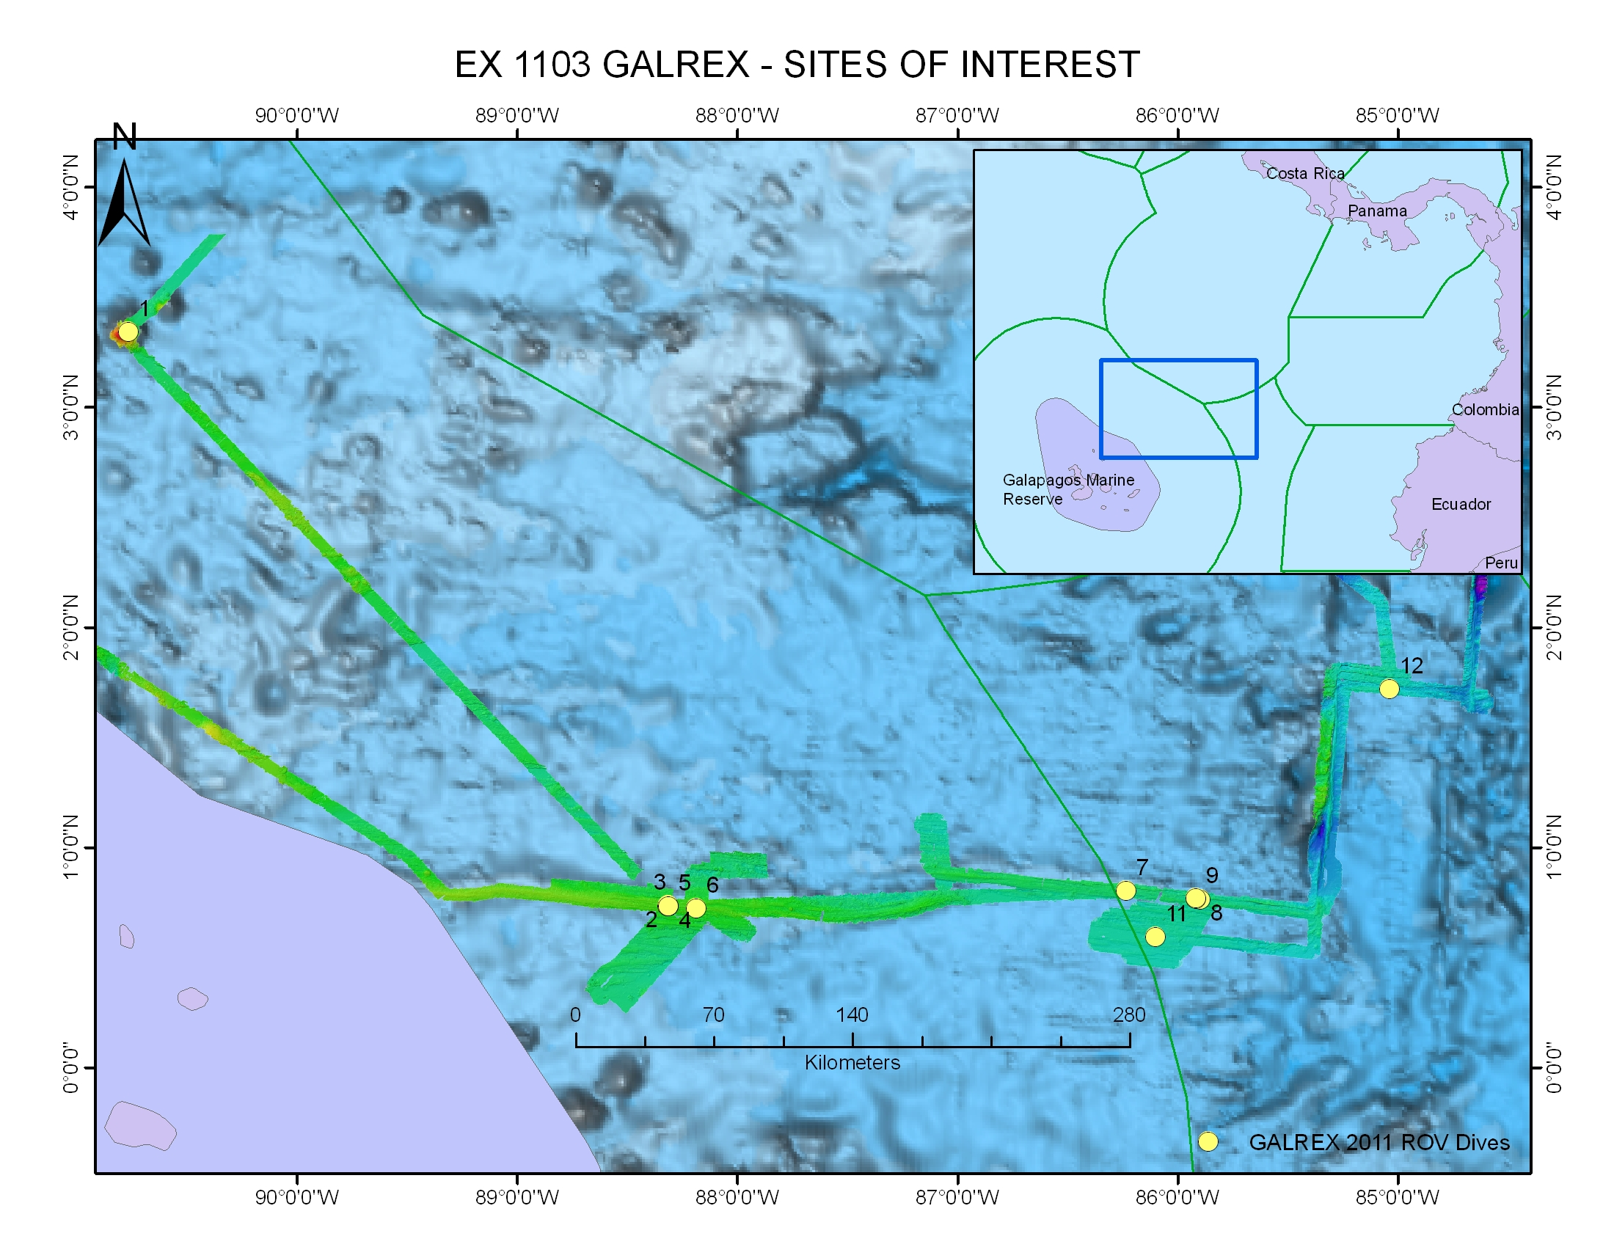
ROV Lead/  Expedition Coordinator | Dave Lovalvo/  Jeremy Potter
General Area Descriptor | X km NX of x Island, Galapagos Islands
ROV Dive Name | Cruise Season |  | Leg |  |  | Dive Number
 | EX1103 |  | 2 |  |  | DIVE09
Equipment Deployed | ROV: |  | Little Hercules
 | Camera Platfom: |  | Seirios
ROV Measurements | CTD |  | Depth |  |  | Altitude
 | Scanning Sonar |  | USBL Position |  |  | Heading
 | Pitch |  | Roll |  |  | HD Camera
 | Low Res Cam 1 |  | Low Res Cam 2
Equipment Malfunctions | None
ROV Dive Summary  (From processed ROV data) | Dive Summary: EX1103L2_DIVE11  ^^^^^^^^^^^^^^^^^^^^^^^^^^^^^^^^^^^^^^^^^^^^^^^^^^^  In Water at: 2011-07-24T14:18:15.439000  00°, 35.824' N ; 086°, 05.761' W  Out Water at: 2011-07-24T21:59:51.537000  00°, 35.734' N ; 086°, 05.871' W  Off Bottom at: 2011-07-24T20:06:38.275000  00°, 35.812' N ; 086°, 05.891' W  On Bottom at: 2011-07-24T16:24:36.362000  00°, 35.696' N ; 086°, 05.737' W  Dive duration: 7:41:36  Bottom Time: 3:42:1  Max. depth: 2716.9 m
Special Notes | Click here to enter text.
Scientists Involved  (please provide name / location / affiliation / email) | Timothy M. Shank/ Okeanos Explorer Lead Scientist/WHOI/tshank@whoi.edu  Edward T. Baker/NOAA-PMEL, Washington/Edward.baker@noaa.gov  Robert W. Embley/NOAA-PMEL, Oregon/Robert.w.embley@noaa.gov  Stephen Hammond/ NOAA-PMEL, Oregon/Stephen.r.hammond@noaa.gov  James F. Holden/ UMASS Amherst/jholden@microbio.umass.edu  Scott White/University of South Carolina/swhite@geol.sc.edu  Sharon L. Walker/ NOAA-PMEL, Washington/sharon.l.walker@noaa.gov  Santiago Herrera/ WHOI Exploration Command Center/WHOI/sherrera@whoi.edu  T. Jennifer Lin/UMASS Amherst/tjennlin@gmail.com  Catriona Munro/ WHOI Exploration Command Center /WHOI/catmunro89 @gmail.com  Taylor Heyl/ WHOI Exploration Command Center/WHOI/theyl@whoi.edu  Lucy C. Stewart/ UMASS Amherst/lsteweart@cns.umass.edu  Mashkoor Malik/ NOAA Office of Ocean Exploration & Research/mashkoor.malik@noaa.gov  Meme Lobecker/ NOAA Office of Ocean Exploration & Research/ Elizabeth.Lobecker@noaa.gov
Purpose of the Dive
To locate and explore the Off-Axis Sulfide Mounds.
Description of the Dive:
Little Hercules surveyed a gently sloping mound with corals, sponges, holothurians and imaged yellow mineral deposits in sediments before continuing to the NE to the next cluster of sulfide mounds. ROV then headed west to follow a line of sonar targets and found mounds with similar faunal composition and more yellow staining around cracks/orifices at the base of rocky outcrops. Sponges were abundant at the top of the mound. Little Hercules explored to the west and traversed over a mound similar to ones seen previously with fractured crust and Mn staining, before turning North. Here, Little Hercules imaged on old clam shell that appeared to be ~8 cm in length with no trail marks nearby. The surrounding sediment was platy and meter-high mounds were observed with no staining or sulfide.
Overall Map of ROV Dive Area |  |  |  | Close-up Map of Main Dive Site
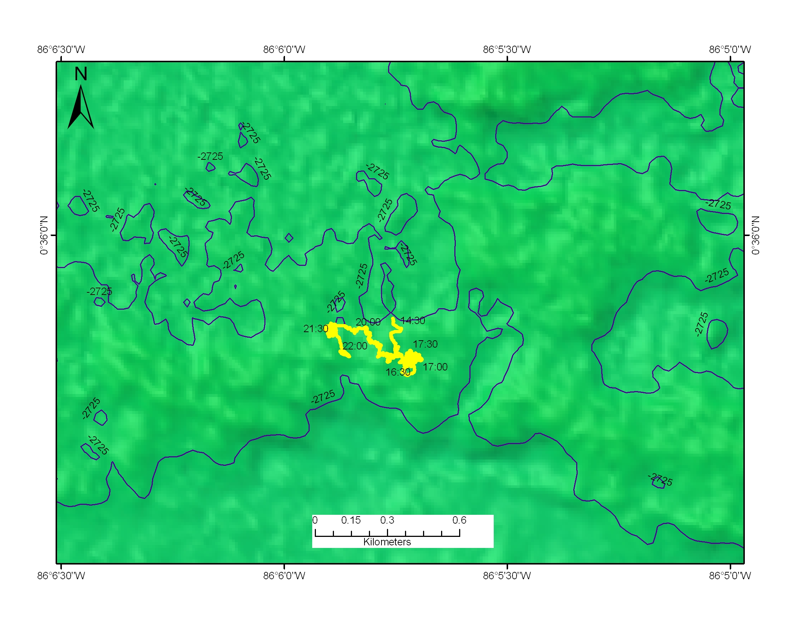 |  |  |  | 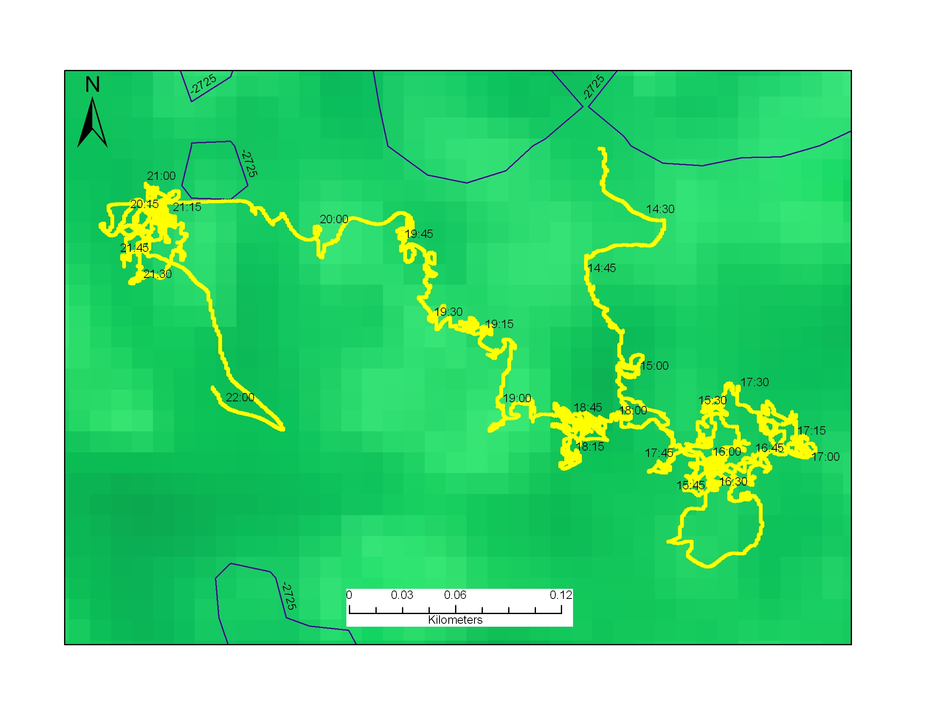
Representative Photos of the Dive
xxx |  |  |  | xxx
Please direct inquiries to: |  | NOAA Office of Ocean Exploration & Research  1315 East-West Highway (SSMC3 10th Floor)  Silver Spring, MD 20910  (301) 734-1014

