Okeanos Explorer ROV Dive Summary
Site Name | 4aE |  |  |  | 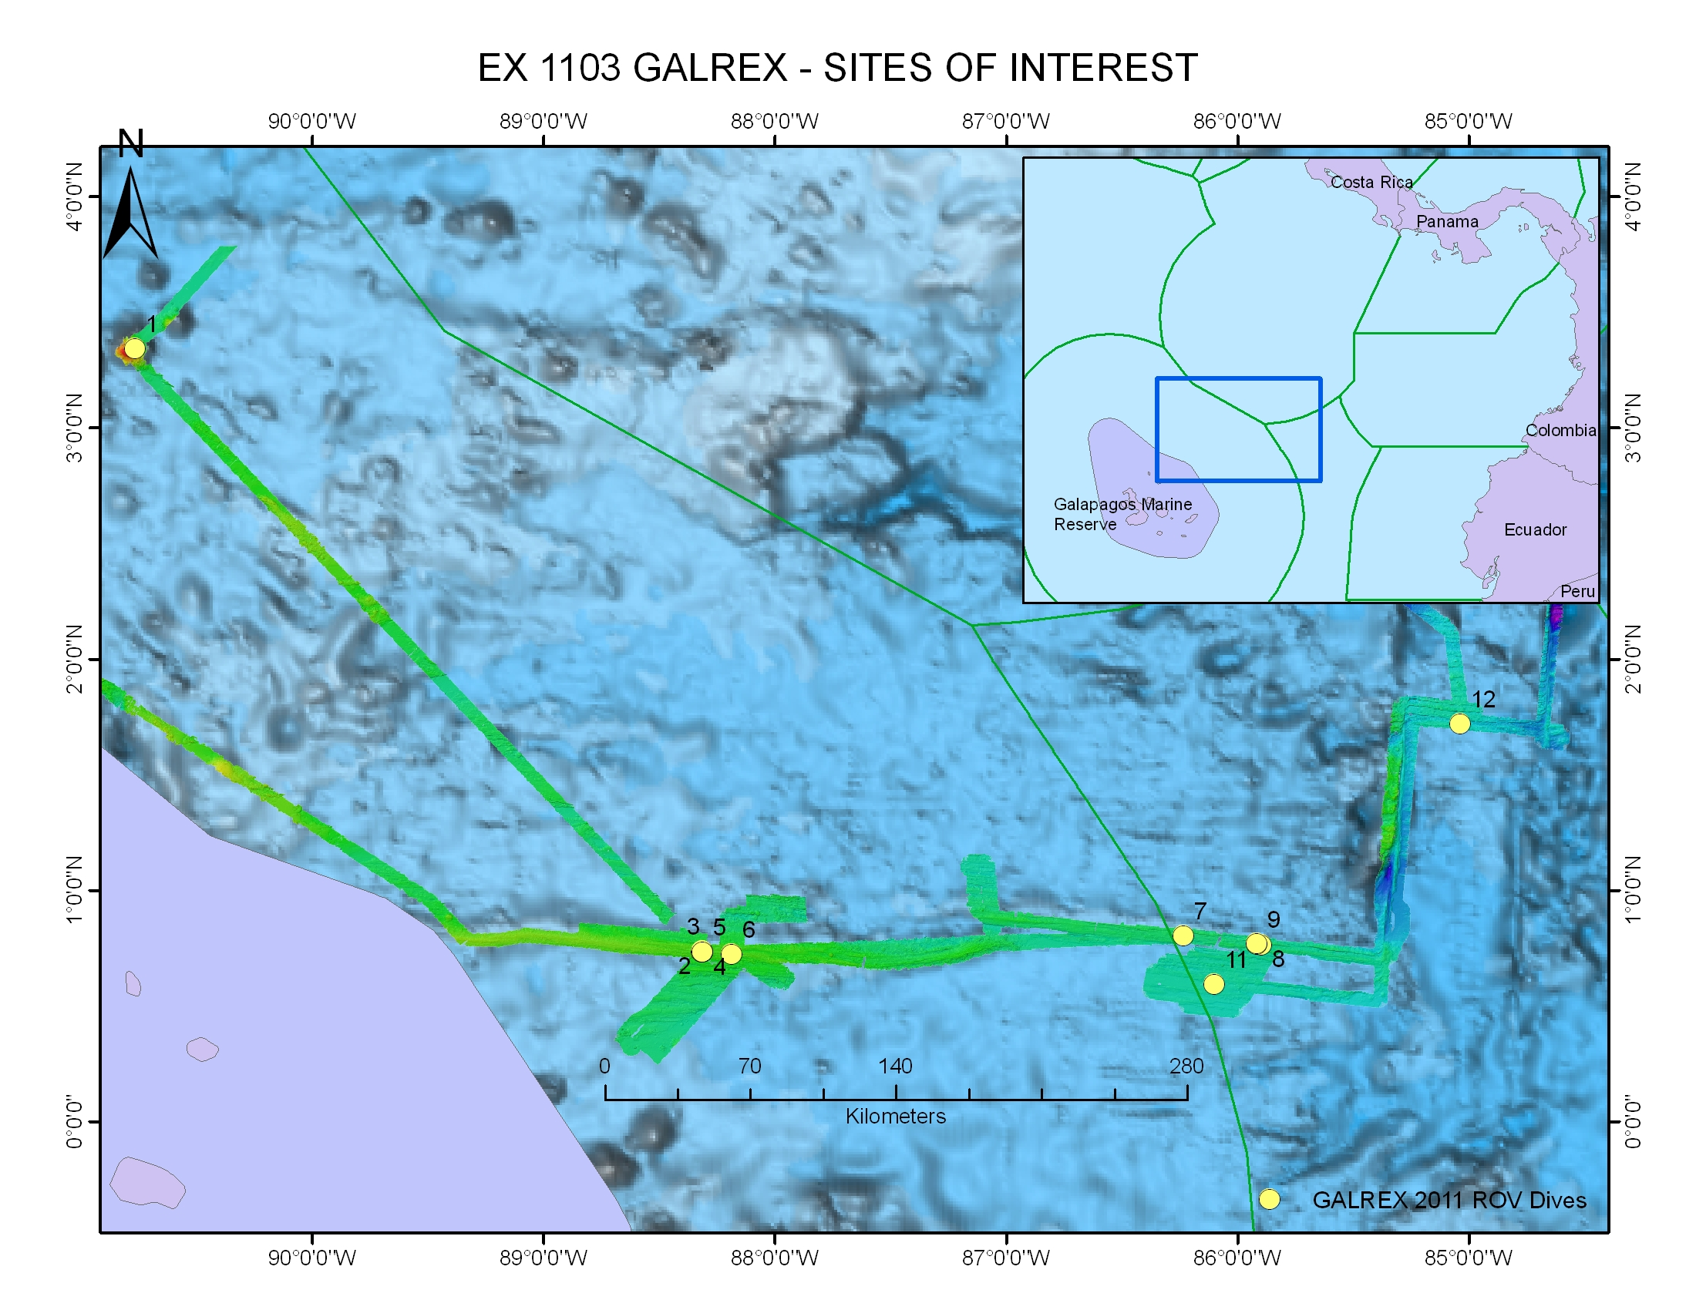
ROV Lead/  Expedition Coordinator | Dave Lovalvo/  Jeremy Potter
General Area Descriptor | Site 4aE, X km NX of x Island, Galapagos Islands
ROV Dive Name | Cruise Season |  | Leg |  |  | Dive Number
 | EX1103 |  | 2 |  |  | DIVE08
Equipment Deployed | ROV: |  | Little Hercules
 | Camera Platfom: |  | Seirios
ROV Measurements | CTD |  | Depth |  |  | Altitude
 | Scanning Sonar |  | USBL Position |  |  | Heading
 | Pitch |  | Roll |  |  | HD Camera
 | Low Res Cam 1 |  | Low Res Cam 2
Equipment Malfunctions | None
ROV Dive Summary  (From processed ROV data) | ^^^^^^^^^^^^^^^^^^^^^^^^^^^^^^^^^^^^^^^^^^^^^^^^^^^  In Water at: 2011-07-21T14:35:27.034000  00°, 45.950' N ; 085°, 53.678' W  Out Water at: 2011-07-22T00:02:44.059000  00°, 46.062' N ; 085°, 53.686' W  Off Bottom at: 2011-07-21T22:21:43.614000  00°, 46.078' N ; 085°, 53.732' W  On Bottom at: 2011-07-21T16:31:22.528000  00°, 45.998' N ; 085°, 53.712' W  Dive duration: 9:27:17  Bottom Time: 5:50:21  Max. depth: 2607.4 m
Special Notes | Click here to enter text.
Scientists Involved  (please provide name / location / affiliation / email) | Timothy M. Shank/ Okeanos Explorer Lead Scientist/WHOI/tshank@whoi.edu  Edward T. Baker/NOAA-PMEL, Washington/Edward.baker@noaa.gov  Robert W. Embley/NOAA-PMEL, Oregon/Robert.w.embley@noaa.gov  Stephen Hammond/ NOAA-PMEL, Oregon/Stephen.r.hammond@noaa.gov  James F. Holden/ UMASS Amherst/jholden@microbio.umass.edu  Scott White/University of South Carolina/swhite@geol.sc.edu  Sharon L. Walker/ NOAA-PMEL, Washington/sharon.l.walker@noaa.gov  Santiago Herrera/ WHOI Exploration Command Center/WHOI/sherrera@whoi.edu  T. Jennifer Lin/UMASS Amherst/tjennlin@gmail.com  Catriona Munro/ WHOI Exploration Command Center /WHOI/catmunro89 @gmail.com  Taylor Heyl/ WHOI Exploration Command Center/WHOI/theyl@whoi.edu  Lucy C. Stewart/ UMASS Amherst/lsteweart@cns.umass.edu  Mashkoor Malik/ NOAA Office of Ocean Exploration & Research/mashkoor.malik@noaa.gov  Meme Lobecker/ NOAA Office of Ocean Exploration & Research/ Elizabeth.Lobecker@noaa.gov
Purpose of the Dive

To dive below a high hydrothermal plume signal discovered during the last leg of this expedition now referred to as “4a”. This is an unexplored region, but multibeam surveys suggest that there is a well-defined axial volcanic ridge with walls separated by approximately 500 meters.
Description of the Dive:
We began this dive by landing 100 meters to the east of the 4aEast plume target and proceeding to the west, traversing across broken pillow lava heavily covered with sediment. Little Hercules then began moving north, discovered a fissure and began an E-W transit for exploration. The fissure was characterized by a northern wall higher than a Southern wall with pillow lavas on either side, and a talus slope at the base. Little Hercules continued traversing over heavily sedimented pillow and lobate lavas before coming to the end of the dive without locating any active hydrothermal vent areas.
Overall Map of ROV Dive Area |  |  |  | Close-up Map of Main Dive Site
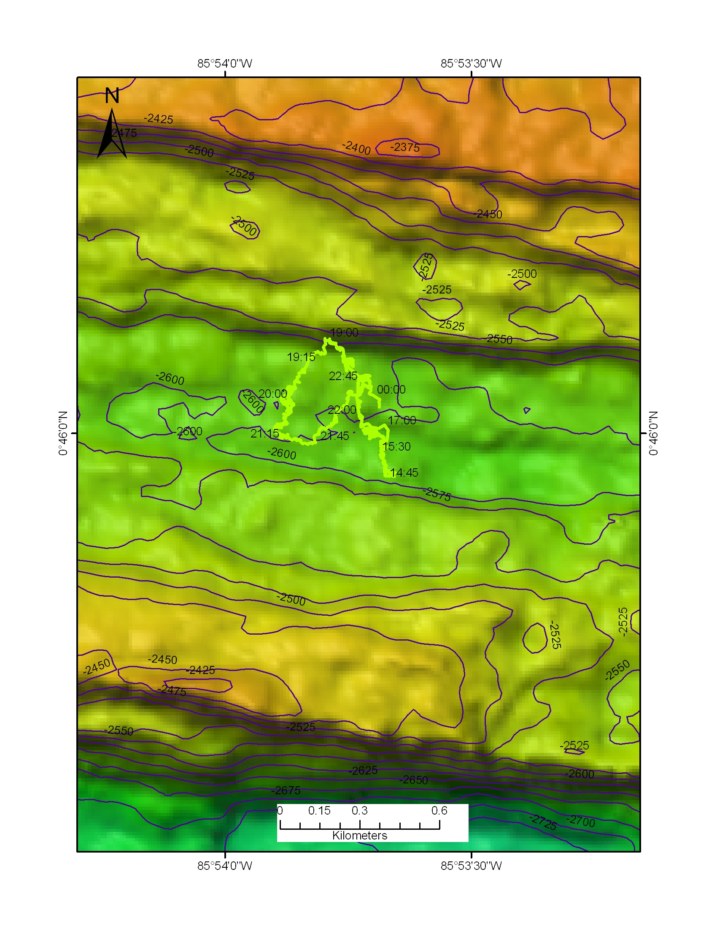 |  |  |  | 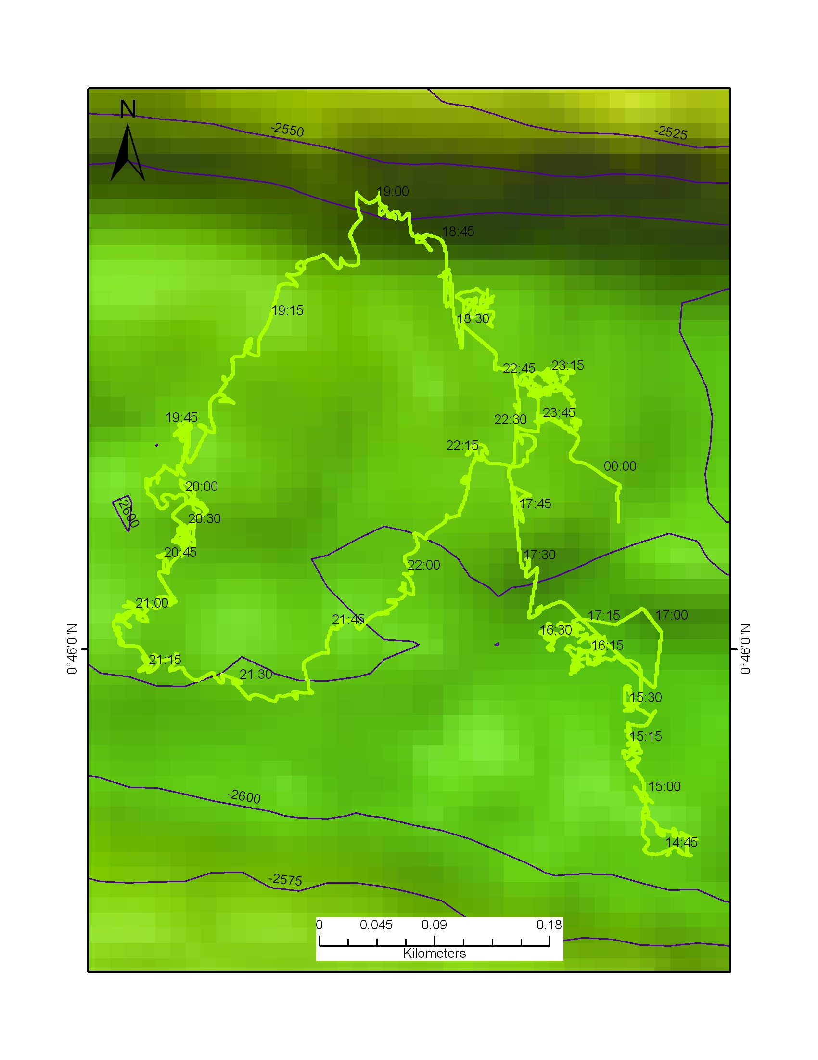
Representative Photos of the Dive
xxx |  |  |  | xxx
Please direct inquiries to: |  | NOAA Office of Ocean Exploration & Research  1315 East-West Highway (SSMC3 10th Floor)  Silver Spring, MD 20910  (301) 734-1014

