Okeanos Explorer ROV Dive Summary
Site Name | Rosebud |  |  |  | 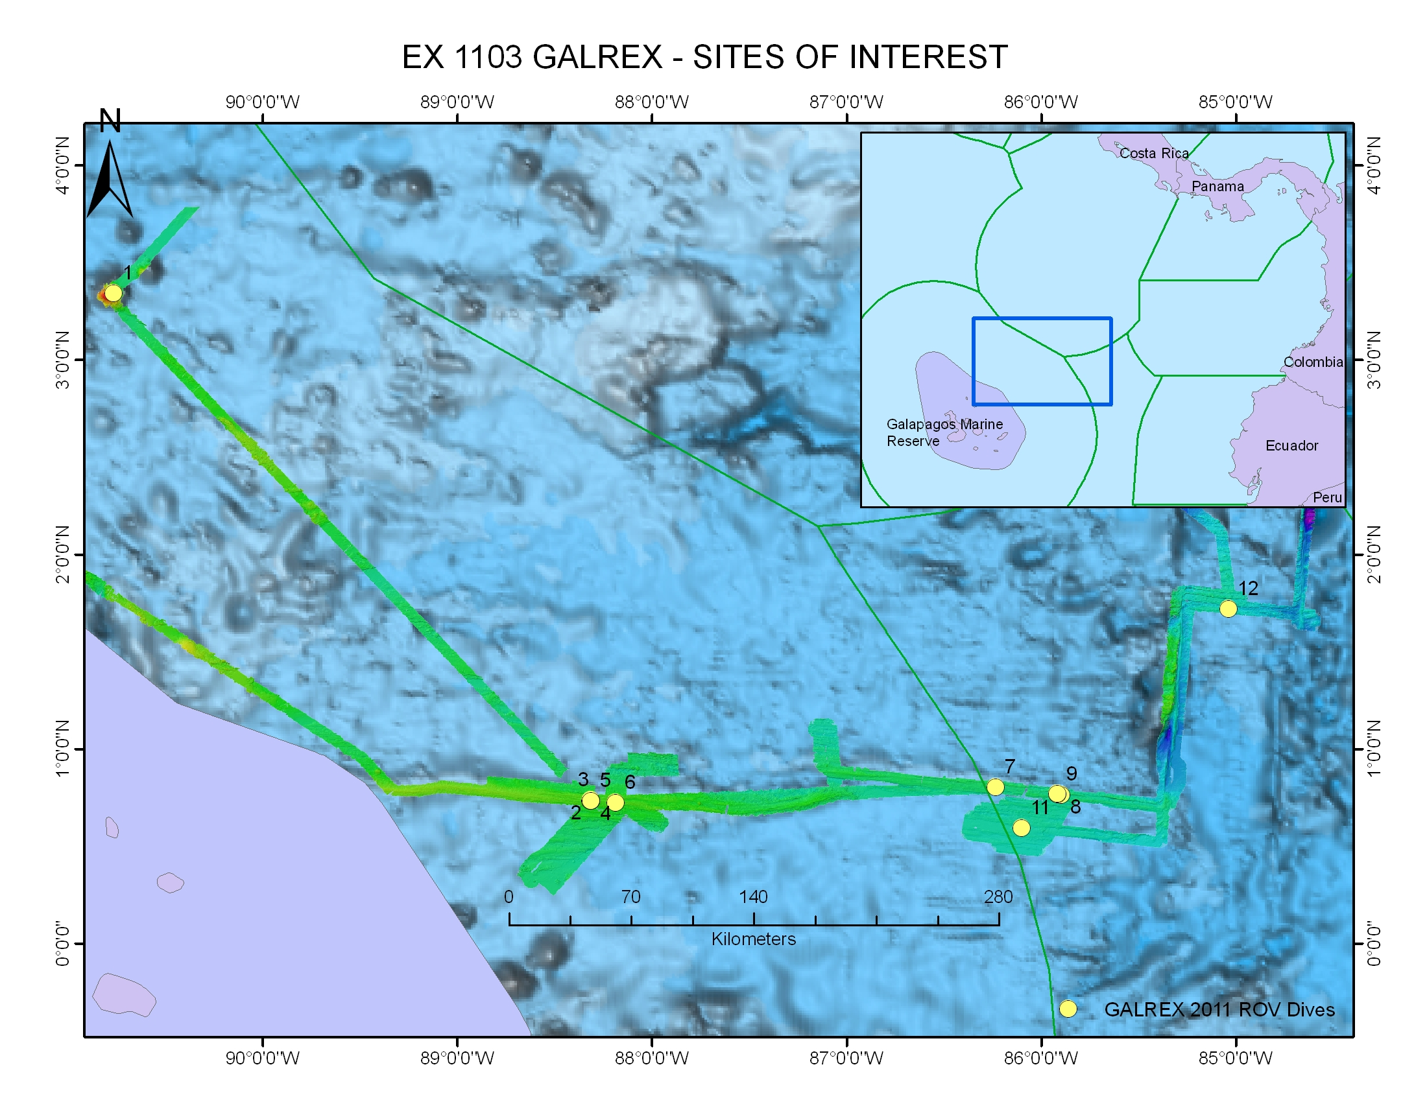
ROV Lead/  Expedition Coordinator | Dave Lovalvo/  Jeremy Potter
General Area Descriptor | Rosebud hydrothermal vent site,  X km NX of x Island, Galapagos Islands
ROV Dive Name | Cruise Season |  | Leg |  |  | Dive Number
 | EX1103 |  | 2 |  |  | DIVE07
Equipment Deployed | ROV: |  | Little Hercules
 | Camera Platfom: |  | Seirios
ROV Measurements | CTD |  | Depth |  |  | Altitude
 | Scanning Sonar |  | USBL Position |  |  | Heading
 | Pitch |  | Roll |  |  | HD Camera
 | Low Res Cam 1 |  | Low Res Cam 2
Equipment Malfunctions | None
ROV Dive Summary  (From processed ROV data) | Dive Summary: DIVE07_20110720  ^^^^^^^^^^^^^^^^^^^^^^^^^^^^^^^^^^^^^^^^^^^^^^^^^^^  In Water at: 2011-07-20T14:26:06.171000  00°, 48.427' N ; 086°, 13.749' W  Out Water at: 2011-07-20T22:40:53.324000  00°, 48.315' N ; 086°, 13.563' W  Off Bottom at: 2011-07-20T20:51:08.594000  00°, 48.376' N ; 086°, 13.641' W  On Bottom at: 2011-07-20T16:25:51.436000  00°, 48.312' N ; 086°, 13.644' W  Dive duration: 8:14:47  Bottom Time: 4:25:17  Max. depth: 2449.7 m
Special Notes | Click here to enter text.
Scientists Involved  (please provide name / location / affiliation / email) | Timothy M. Shank/ Okeanos Explorer Lead Scientist/WHOI/tshank@whoi.edu  Edward T. Baker/NOAA-PMEL, Washington/Edward.baker@noaa.gov  Robert W. Embley/NOAA-PMEL, Oregon/Robert.w.embley@noaa.gov  Stephen Hammond/ NOAA-PMEL, Oregon/Stephen.r.hammond@noaa.gov  James F. Holden/ UMASS Amherst/jholden@microbio.umass.edu  Scott White/University of South Carolina/swhite@geol.sc.edu  Sharon L. Walker/ NOAA-PMEL, Washington/sharon.l.walker@noaa.gov  Santiago Herrera/ WHOI Exploration Command Center/WHOI/sherrera@whoi.edu  T. Jennifer Lin/UMASS Amherst/tjennlin@gmail.com  Catriona Munro/ WHOI Exploration Command Center /WHOI/catmunro89 @gmail.com  Taylor Heyl/ WHOI Exploration Command Center/WHOI/theyl@whoi.edu  Lucy C. Stewart/ UMASS Amherst/lsteweart@cns.umass.edu  Mashkoor Malik/ NOAA Office of Ocean Exploration & Research/mashkoor.malik@noaa.gov  Meme Lobecker/ NOAA Office of Ocean Exploration & Research/ Elizabeth.Lobecker@noaa.gov
Purpose of the Dive
To locate an area that hosts the Rosebud hydrothermal vent site at 2450m for further exploration of the Rift in this region, which will likely be along east -west trending fissures just north of the field. Rosebud has not been visited since 2005, when Riftia tubeworms and bathymodiolid mussels dominated vent openings. The field was 60m x 40m with white seafloor markers, "A" and "B" on the eastern side, "F" and "L" centrally located, and "C" on the western side.

Description of the Dive:
On this descent, we saw an abundance of squid- down to at least 500m as well as what appear to be larvaceans/ctenophores. Once on the seafloor, we observed collapsed margins and traversed over a North-south running unsedimented lobate lava flow. Little Hercules continued to follow along collapsed features, over pillow lavas with multiple dandelion siphonophores but no sites of active hydrothermal venting were found during this dive. The lack of biota and presence of vitreous sheet flows suggests that this site may have experienced an eruption subsequent to the last previous dive at the site in 2005.
Overall Map of ROV Dive Area |  |  |  | Close-up Map of Main Dive Site
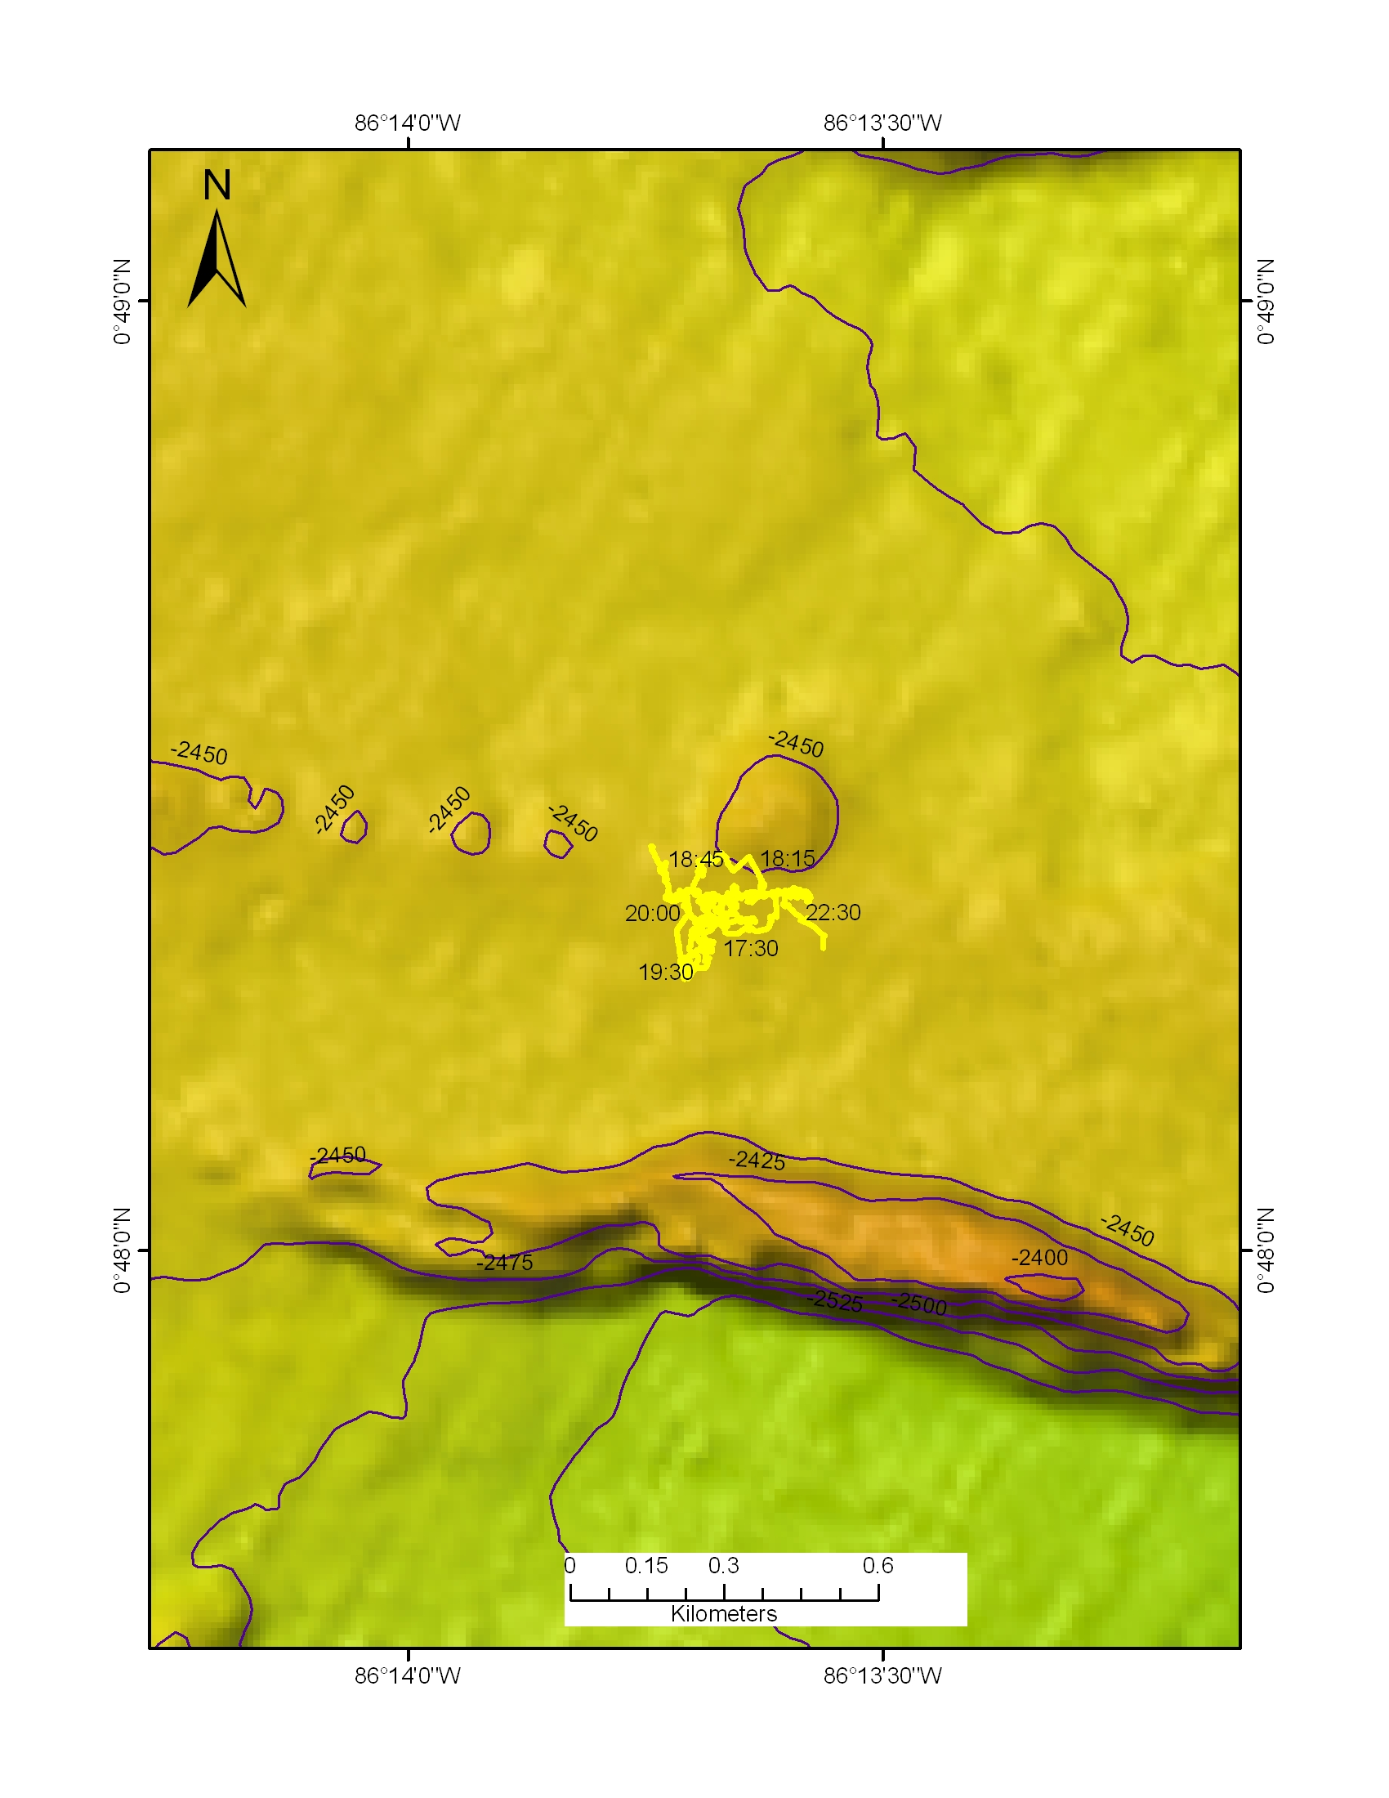 |  |  |  | 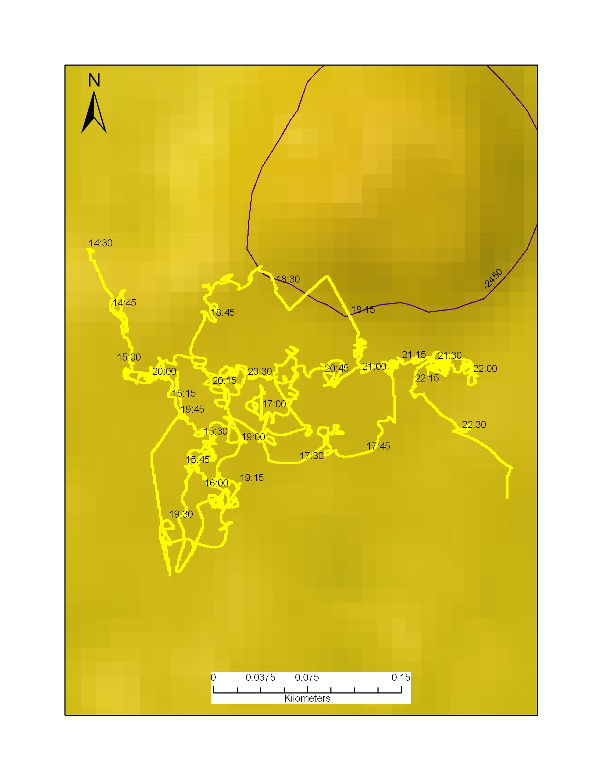
Representative Photos of the Dive
xxx |  |  |  | xxx
Please direct inquiries to: |  | NOAA Office of Ocean Exploration & Research  1315 East-West Highway (SSMC3 10th Floor)  Silver Spring, MD 20910  (301) 734-1014

