Okeanos Explorer ROV Dive Summary
Site Name | Site 2c |  |  |  | 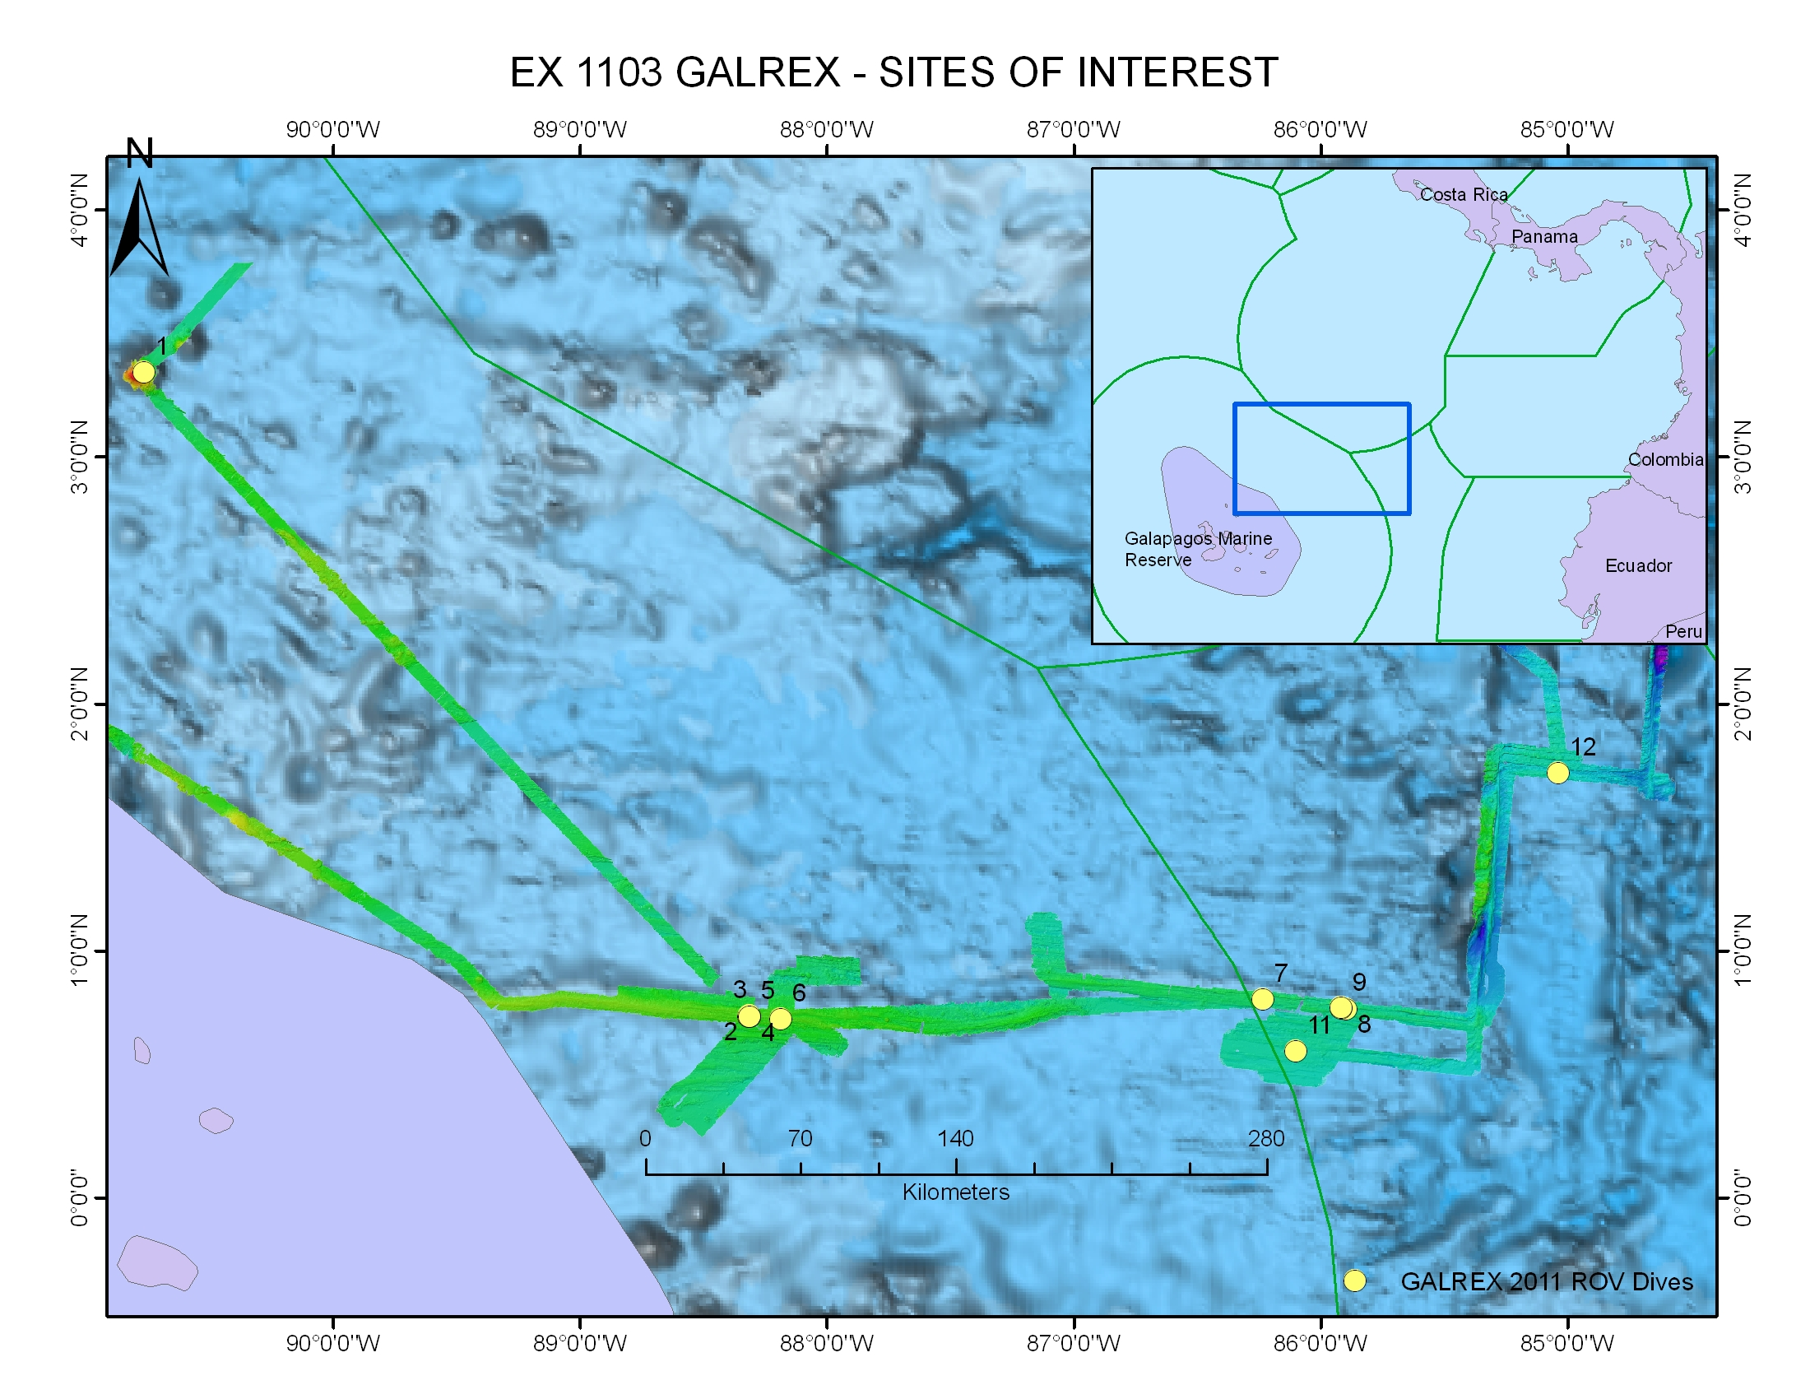
ROV Lead/  Expedition Coordinator | Dave Lovalvo/  Jeremy Potter
General Area Descriptor | Site 2c, X km NX of x Island, Galapagos Islands
ROV Dive Name | Cruise Season |  | Leg |  |  | Dive Number
 | EX1103 |  | 2 |  |  | DIVE06
Equipment Deployed | ROV: |  | Little Hercules
 | Camera Platfom: |  | Seirios
ROV Measurements | CTD |  | Depth |  |  | Altitude
 | Scanning Sonar |  | USBL Position |  |  | Heading
 | Pitch |  | Roll |  |  | HD Camera
 | Low Res Cam 1 |  | Low Res Cam 2
Equipment Malfunctions | None
ROV Dive Summary  (From processed ROV data) | Dive Summary: EX1103_DIVE06  ^^^^^^^^^^^^^^^^^^^^^^^^^^^^^^^^^^^^^^^^^^^^^^^^^^^  In Water at: 2011-07-19T14:34:17.298000  00°, 43.522' N ; 088°, 10.973' W  Out Water at: 2011-07-20T00:09:40.770000  00°, 43.708' N ; 088°, 10.920' W  Off Bottom at: 2011-07-19T22:50:33.349000  00°, 43.743' N ; 088°, 10.962' W  On Bottom at: 2011-07-19T16:20:54.507000  00°, 43.549' N ; 088°, 10.936' W  Dive duration: 9:35:23  Bottom Time: 6:29:38  Max. depth: 1975.1 m
Special Notes | Click here to enter text.
Scientists Involved  (please provide name / location / affiliation / email) | Timothy M. Shank/ Okeanos Explorer Lead Scientist/WHOI/tshank@whoi.edu  Edward T. Baker/NOAA-PMEL, Washington/Edward.baker@noaa.gov  Robert W. Embley/NOAA-PMEL, Oregon/Robert.w.embley@noaa.gov  Stephen Hammond/ NOAA-PMEL, Oregon/Stephen.r.hammond@noaa.gov  James F. Holden/ UMASS Amherst/jholden@microbio.umass.edu  Scott White/University of South Carolina/swhite@geol.sc.edu  Sharon L. Walker/ NOAA-PMEL, Washington/sharon.l.walker@noaa.gov  Santiago Herrera/ WHOI Exploration Command Center/WHOI/sherrera@whoi.edu  T. Jennifer Lin/UMASS Amherst/tjennlin@gmail.com  Catriona Munro/ WHOI Exploration Command Center /WHOI/catmunro89 @gmail.com  Taylor Heyl/ WHOI Exploration Command Center/WHOI/theyl@whoi.edu  Lucy C. Stewart/ UMASS Amherst/lsteweart@cns.umass.edu  Mashkoor Malik/ NOAA Office of Ocean Exploration & Research/mashkoor.malik@noaa.gov  Meme Lobecker/ NOAA Office of Ocean Exploration & Research/ Elizabeth.Lobecker@noaa.gov
Purpose of the Dive
The goal of dive 06 was to begin exploration at approximately 1980m on the southwestern margin of the axial ridge and proceed northeast upslope to the top of the ridge and the EX1103 Plume Target 2C area, before continuing to the east.
Description of the Dive:
At the start of this dive, structured smokey water was observed at 15 meters off the seafloor. Once on bottom, Little Hercules proceeded upslope to the top of the volcanic ridge over older sedimented pillow lavas and came upon a fissure with diffuse venting at 1941 meters depth. No mobile fauna was observed but there were some attached small animals, likely sponges. We then moved downslope through water still smokey and continued to the NE to look for more active/recent flows. At the bottom of a graben, there was an increase in particulates in the water and staining along rock margins. Little Hercules came over a promontory moved further south, following a fissure in order to regain the graben. We imaged the bottom of the graben and defined the northern wall, observing contacts on the bottom with thin fresher flows and lobates with sediment pockets. Diffuse hydrothermal venting was observed among old pillow and lobate lavas at 1960 meters depth, white bacterial mats were found in cracks, and slight hydrothermal flow could be seen from small patches of white staining between lobate lavas. This extensive field of diffuse flow extended beyond Little Hercules’ tether to the N with more intense hydrothermal venting northward. The water was filled with flocculent particles and there were no obvious sessile vent animals except for sponges. Once it was clear that this diffuse venting might extend 20-30 m to the east, we directed an E-W and N-S transit to look at the dimensions of the field before completing the dive.

Overall Map of ROV Dive Area |  |  |  | Close-up Map of Main Dive Site
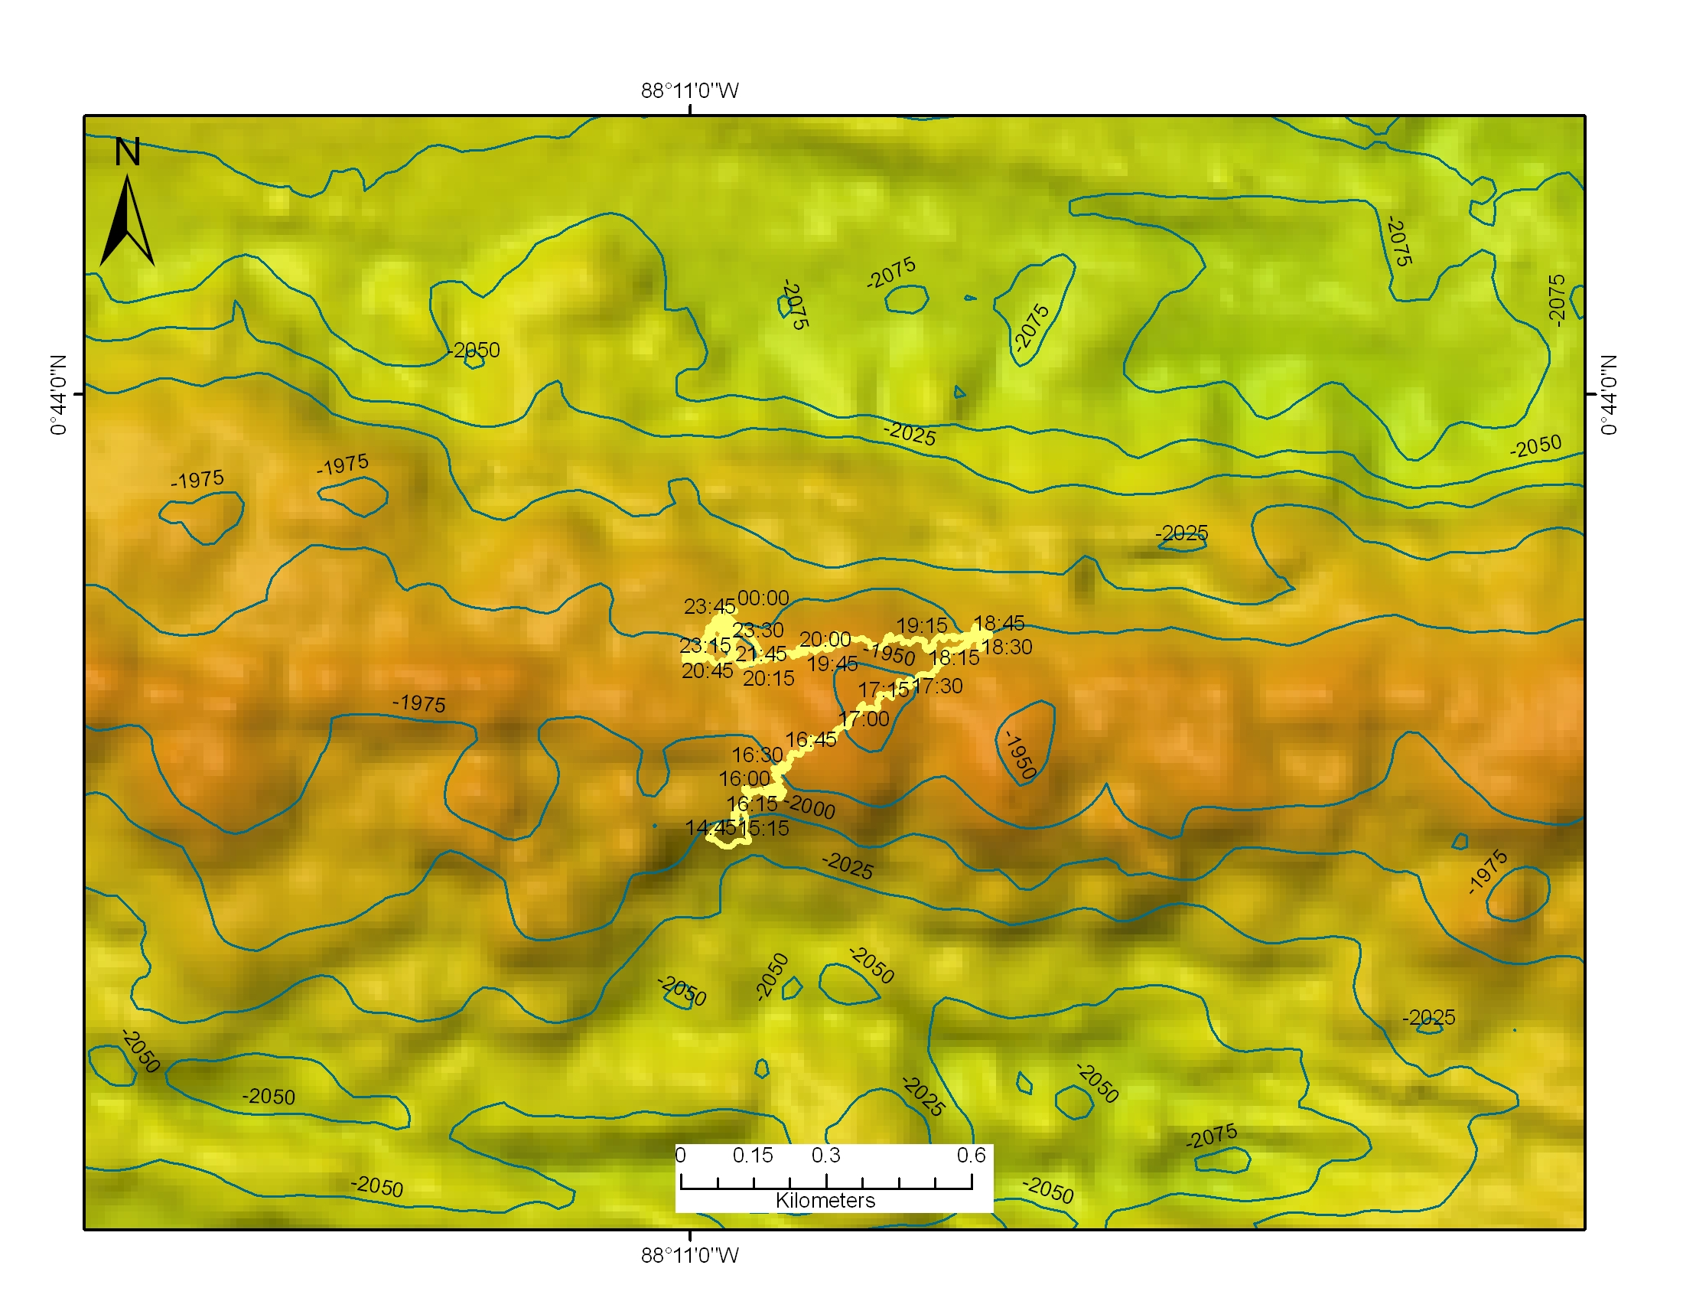 |  |  |  | 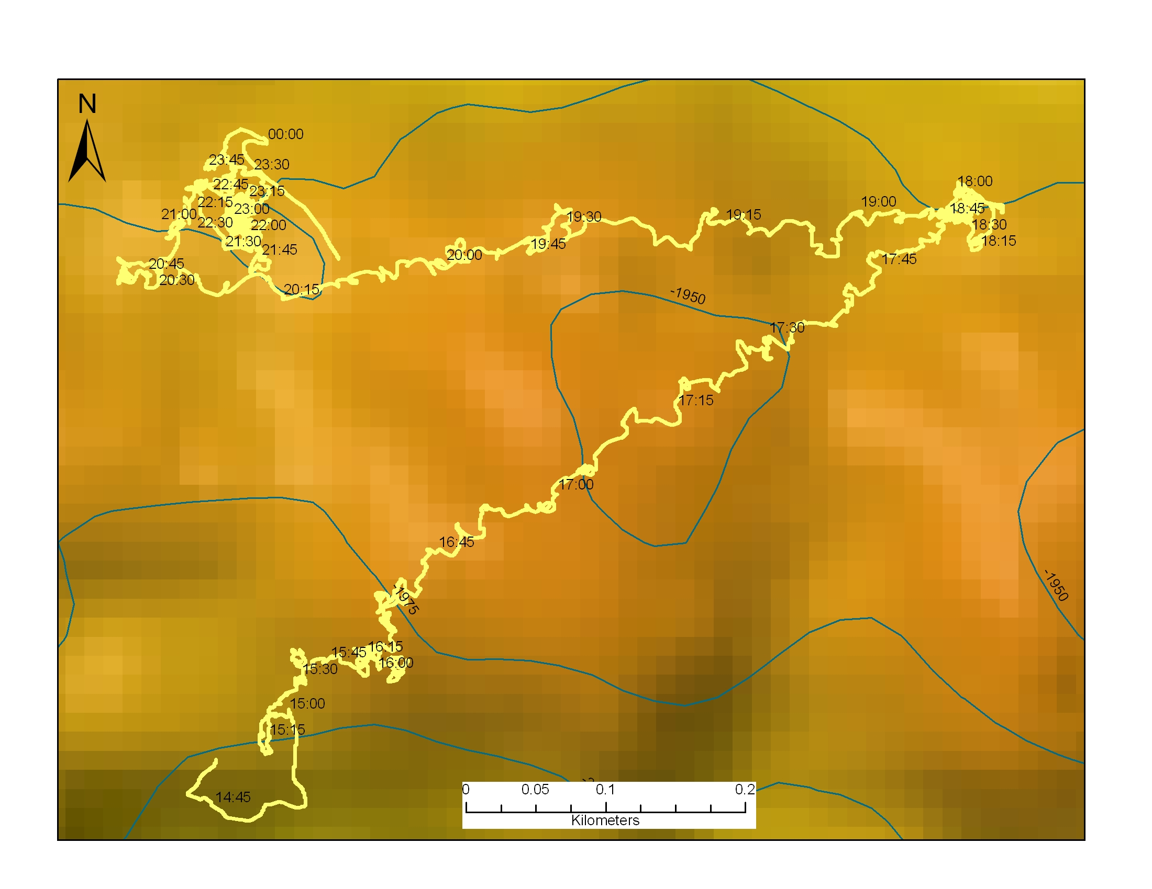
Representative Photos of the Dive
xxx |  |  |  | xxx
Please direct inquiries to: |  | NOAA Office of Ocean Exploration & Research  1315 East-West Highway (SSMC3 10th Floor)  Silver Spring, MD 20910  (301) 734-1014

