Okeanos Explorer ROV Dive Summary
Site Name | Site 2a |  |  |  | 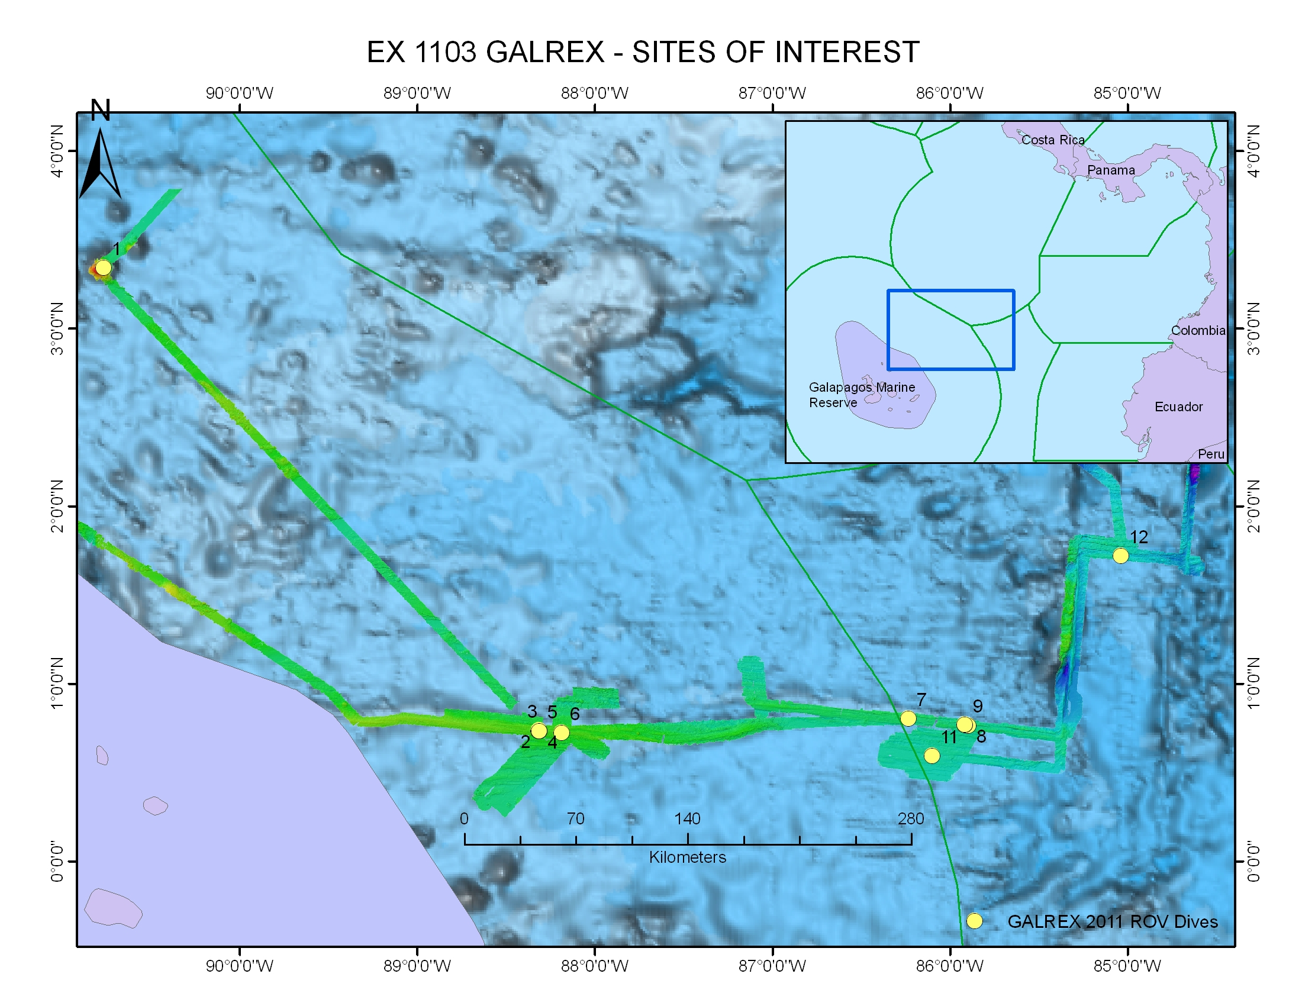
ROV Lead/  Expedition Coordinator | Dave Lovalvo/  Jeremy Potter
General Area Descriptor | Site 2a, X km NX of x Island, near the Galapagos Islands
ROV Dive Name | Cruise Season |  | Leg |  |  | Dive Number
 | EX1103 |  | 2 |  |  | DIVE05
Equipment Deployed | ROV: |  | Little Hercules
 | Camera Platfom: |  | Seirios
ROV Measurements | CTD |  | Depth |  |  | Altitude
 | Scanning Sonar |  | USBL Position |  |  | Heading
 | Pitch |  | Roll |  |  | HD Camera
 | Low Res Cam 1 |  | Low Res Cam 2
Equipment Malfunctions | None
ROV Dive Summary  (From processed ROV data) | Dive Summary: EX1103L2_DIVE05  ^^^^^^^^^^^^^^^^^^^^^^^^^^^^^^^^^^^^^^^^^^^^^^^^^^^  In Water at: 2011-07-18T15:20:49.479000  00°, 44.230' N ; 088°, 18.619' W  Out Water at: 2011-07-18T23:15:18.244000  00°, 44.281' N ; 088°, 17.987' W  Off Bottom at: 2011-07-18T22:35:15.791000  00°, 44.264' N ; 088°, 18.004' W  On Bottom at: 2011-07-18T16:53:31.597000  00°, 44.267' N ; 088°, 18.478' W  Dive duration: 7:54:28  Bottom Time: 5:41:44  Max. depth: 1972.0 m
Special Notes | Click here to enter text.
Scientists Involved  (please provide name / location / affiliation / email) | Timothy M. Shank/ Okeanos Explorer Lead Scientist/WHOI/tshank@whoi.edu  Edward T. Baker/NOAA-PMEL, Washington/Edward.baker@noaa.gov  Robert W. Embley/NOAA-PMEL, Oregon/Robert.w.embley@noaa.gov  Stephen Hammond/ NOAA-PMEL, Oregon/Stephen.r.hammond@noaa.gov  James F. Holden/ UMASS Amherst/jholden@microbio.umass.edu  Scott White/University of South Carolina/swhite@geol.sc.edu  Sharon L. Walker/ NOAA-PMEL, Washington/sharon.l.walker@noaa.gov  Santiago Herrera/ WHOI Exploration Command Center/WHOI/sherrera@whoi.edu  T. Jennifer Lin/UMASS Amherst/tjennlin@gmail.com  Catriona Munro/ WHOI Exploration Command Center /WHOI/catmunro89 @gmail.com  Taylor Heyl/ WHOI Exploration Command Center/WHOI/theyl@whoi.edu  Lucy C. Stewart/ UMASS Amherst/lsteweart@cns.umass.edu  Mashkoor Malik/ NOAA Office of Ocean Exploration & Research/mashkoor.malik@noaa.gov  Meme Lobecker/ NOAA Office of Ocean Exploration & Research/ Elizabeth.Lobecker@noaa.gov
Purpose of the Dive
The purpose of this dive was to target a hydrothermally active area discovered during dive 04 that may have not been fully explored. From there, we plan to move east of the massive inactive sulfide towers located at the end of the dive 04 to explore to the East/Southeast in the axial graben.

Description of the Dive:
Once on bottom, Little Hercules moved through murky water over pillow lavas covered with sediment slightly east of the diffuse vent site discovered on dive 04. We relocated the diffuse vent site and paused at the northern extent of the field to image clear venting and white microbial mat material between lobate lavas. We then moved East and discovered another site with diffuse vent fluid flowing from cracks between truncated lobates in a graben wall. This area north to south was about 15 meters wide, with the most vigorous flow on the south side. Both diffuse venting sites, separated by 9 meters, were characterized by young lavas and intense diffuse flow through the surrounding basaltic rock with only a few mobile species that were vent specific. A large line of inactive chimneys was seen on pillow-based promontories in the axial graben and Little Hercules began moving to the NE to regain the graben and then traverse E-SE along the southern wall. Just before the end of the dive, Little Hercules found an extensive field of young lavas with Fe staining and diffuse venting between lobate lava but there was no more time for exploration further to the East.

Overall Map of ROV Dive Area |  |  |  | Close-up Map of Main Dive Site
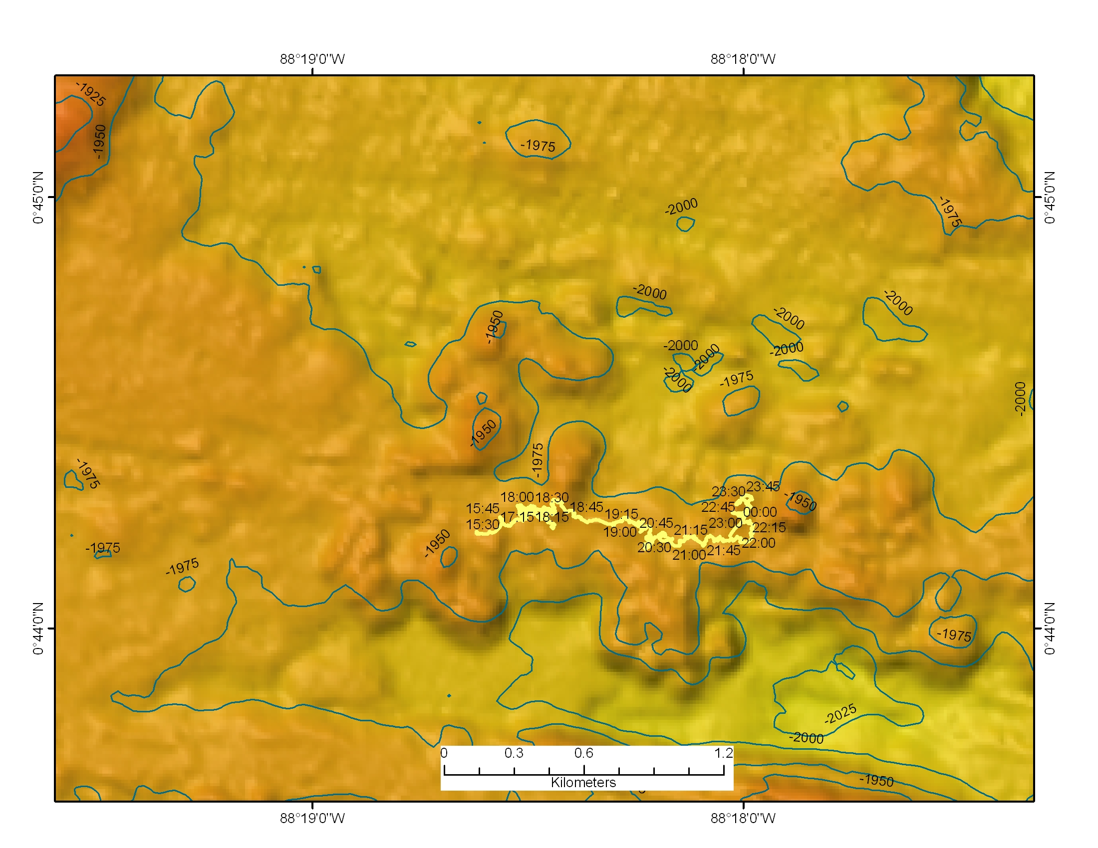 |  |  |  | 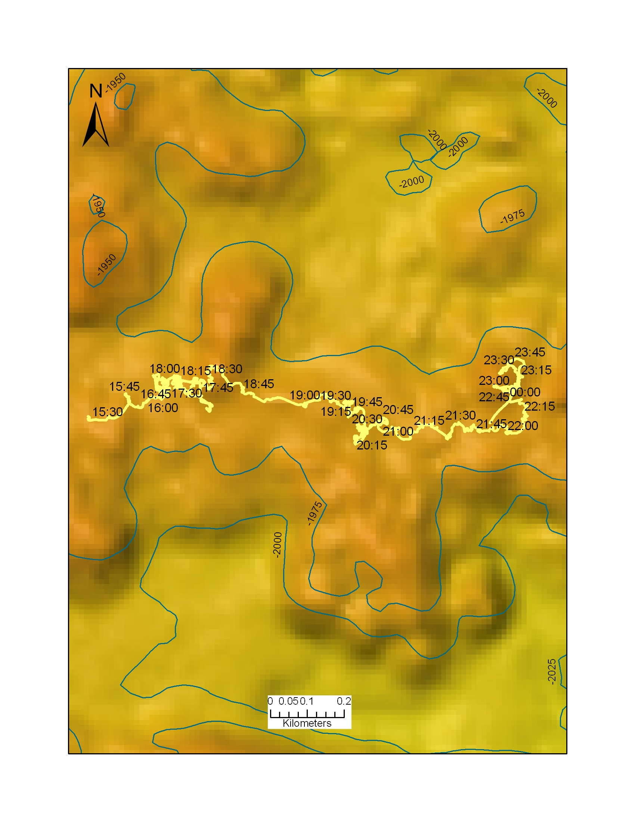
Representative Photos of the Dive
xxx |  |  |  | xxx
Please direct inquiries to: |  | NOAA Office of Ocean Exploration & Research  1315 East-West Highway (SSMC3 10th Floor)  Silver Spring, MD 20910  (301) 734-1014

