Okeanos Explorer ROV Dive Summary
Site Name | 2a |  |  |  | 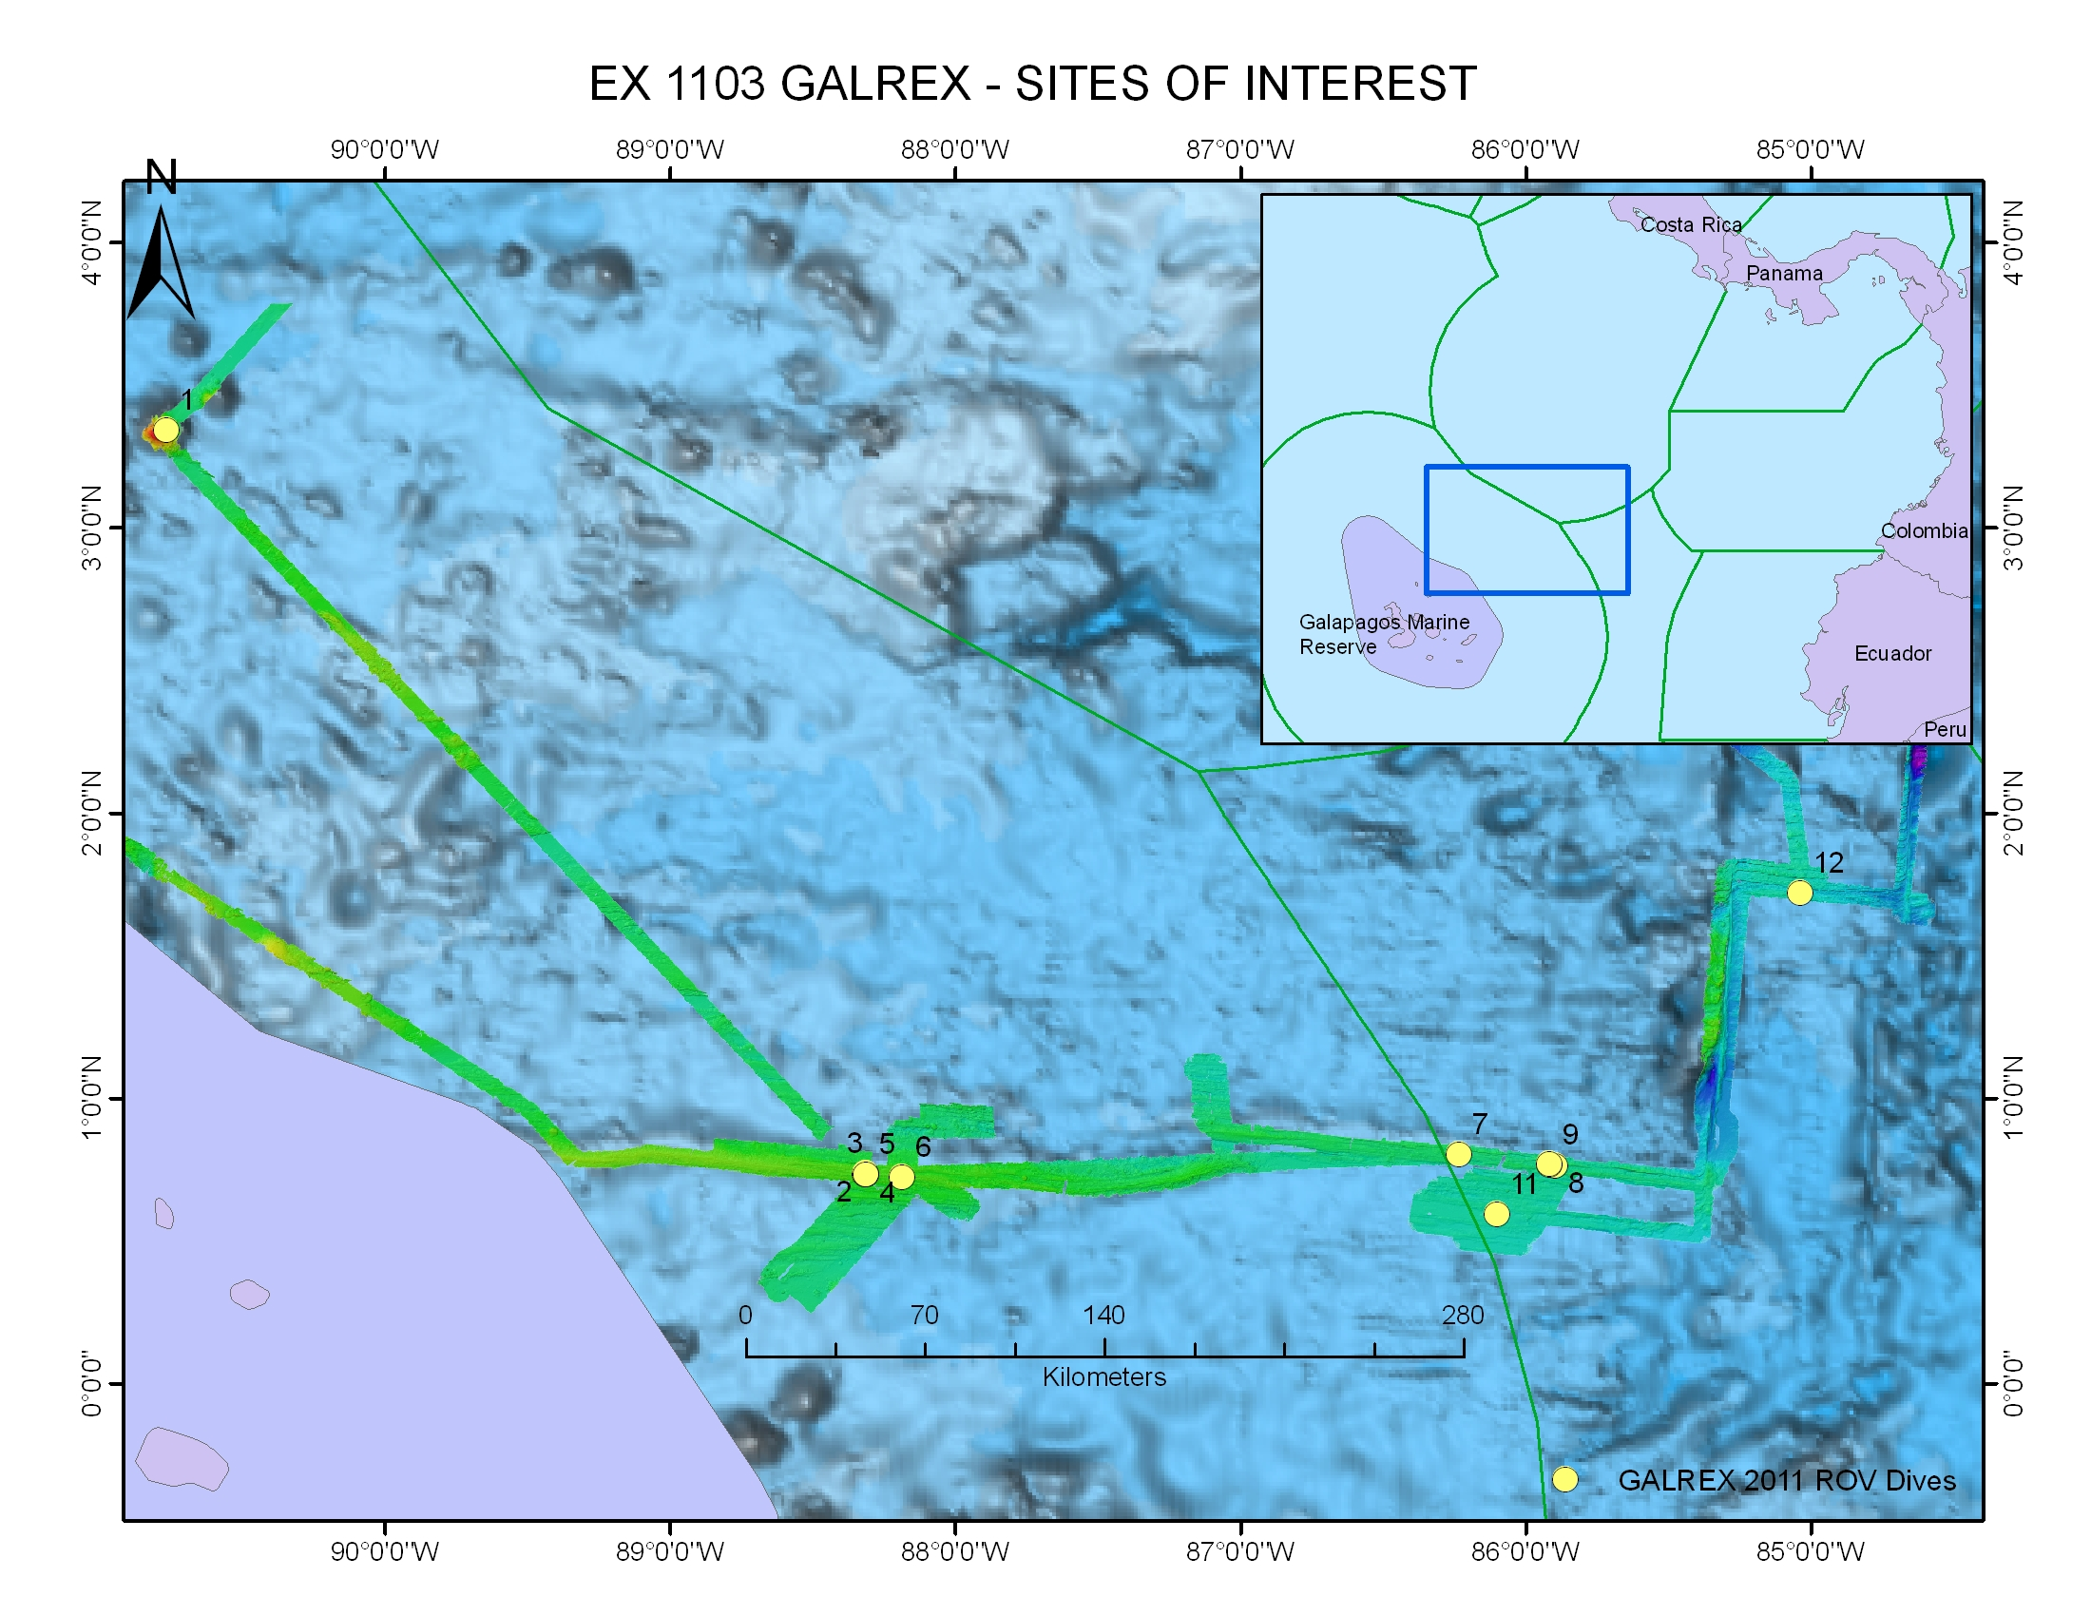
ROV Lead/  Expedition Coordinator | Dave Lovalvo/  Jeremy Potter
General Area Descriptor | Site 2a, X km NX of x Island, Galapagos Islands
ROV Dive Name | Cruise Season |  | Leg |  |  | Dive Number
 | EX1103 |  | 2 |  |  | DIVE03
Equipment Deployed | ROV: |  | Little Hercules
 | Camera Platfom: |  | Seirios
ROV Measurements | CTD |  | Depth |  |  | Altitude
 | Scanning Sonar |  | USBL Position |  |  | Heading
 | Pitch |  | Roll |  |  | HD Camera
 | Low Res Cam 1 |  | Low Res Cam 2
Equipment Malfunctions | None
ROV Dive Summary  (From processed ROV data) | Dive Summary: EX1103L2_DIVE03  ^^^^^^^^^^^^^^^^^^^^^^^^^^^^^^^^^^^^^^^^^^^^^^^^^^^  In Water at: 2011-07-16T14:28:27.687000  00°, 44.322' N ; 088°, 18.728' W  Out Water at: 2011-07-16T22:37:11.620000  00°, 44.161' N ; 088°, 18.559' W  Off Bottom at: 2011-07-16T21:04:48.084000  00°, 44.278' N ; 088°, 18.591' W  On Bottom at: 2011-07-16T14:56:16.948000  00°, 44.334' N ; 088°, 18.660' W  Dive duration: 8:8:43  Bottom Time: 6:8:31  Max. depth: 1970.8 m
Special Notes | Click here to enter text.
Scientists Involved  (please provide name / location / affiliation / email) | Timothy M. Shank/ Okeanos Explorer Lead Scientist/WHOI/tshank@whoi.edu  Edward T. Baker/NOAA-PMEL, Washington/Edward.baker@noaa.gov  Robert W. Embley/NOAA-PMEL, Oregon/Robert.w.embley@noaa.gov  Stephen Hammond/ NOAA-PMEL, Oregon/Stephen.r.hammond@noaa.gov  James F. Holden/ UMASS Amherst/jholden@microbio.umass.edu  Scott White/University of South Carolina/swhite@geol.sc.edu  Sharon L. Walker/ NOAA-PMEL, Washington/sharon.l.walker@noaa.gov  Santiago Herrera/ WHOI Exploration Command Center/WHOI/sherrera@whoi.edu  T. Jennifer Lin/UMASS Amherst/tjennlin@gmail.com  Catriona Munro/ WHOI Exploration Command Center /WHOI/catmunro89 @gmail.com  Taylor Heyl/ WHOI Exploration Command Center/WHOI/theyl@whoi.edu  Lucy C. Stewart/ UMASS Amherst/lsteweart@cns.umass.edu  Mashkoor Malik/ NOAA Office of Ocean Exploration & Research/mashkoor.malik@noaa.gov  Meme Lobecker/ NOAA Office of Ocean Exploration & Research/ Elizabeth.Lobecker@noaa.gov
Purpose of the Dive
Site 2a has light-scattering properties dozens of meters off the seafloor and a strong hydrothermal plume signal was located here during the first leg of this expedition. The goal of this dive was to explore an area near 1970 meters where fresh lava flows were observed at the end of Dive 02 and to continue exploration for active hydrothermal venting.
Description of the Dive:
During our third ROV dive on the Galápagos Rift, we continued searching for active hydrothermal vents. We came across recent lobate flow with hydrothermal staining and continued to move SW on this flow toward a ridge. Hydrothermal alteration of pillow lavas appeared more extensive in this region. Once on top of the ridge, there was speculation that this feature was a north-facing broken talus mound or wall and that there would be more hydrothermal activity to the west of our current location. As we moved west, low volume warm venting could be seen and particles in the water that were likely to be bacterial sulfur flocculent. Traversing over younger lava flow on our way north toward "Little Hercules smoke target”, we passed a recent lava contact and the water remained murky with no sessile fauna and a decrease in hydrothermal staining. We came upon a 1 m wide fissure, floored with talus and pillow lava on either side and continued to follow the fissure with an increase in sediment, before turning to follow the fissure to the east. Towering hydrothermal sulfide spires appeared, lined west-to-east within the graben; remnants of past black smoker chimneys with scars in the rock where colonies of tubeworms once lived.
Overall Map of ROV Dive Area |  |  |  | Close-up Map of Main Dive Site
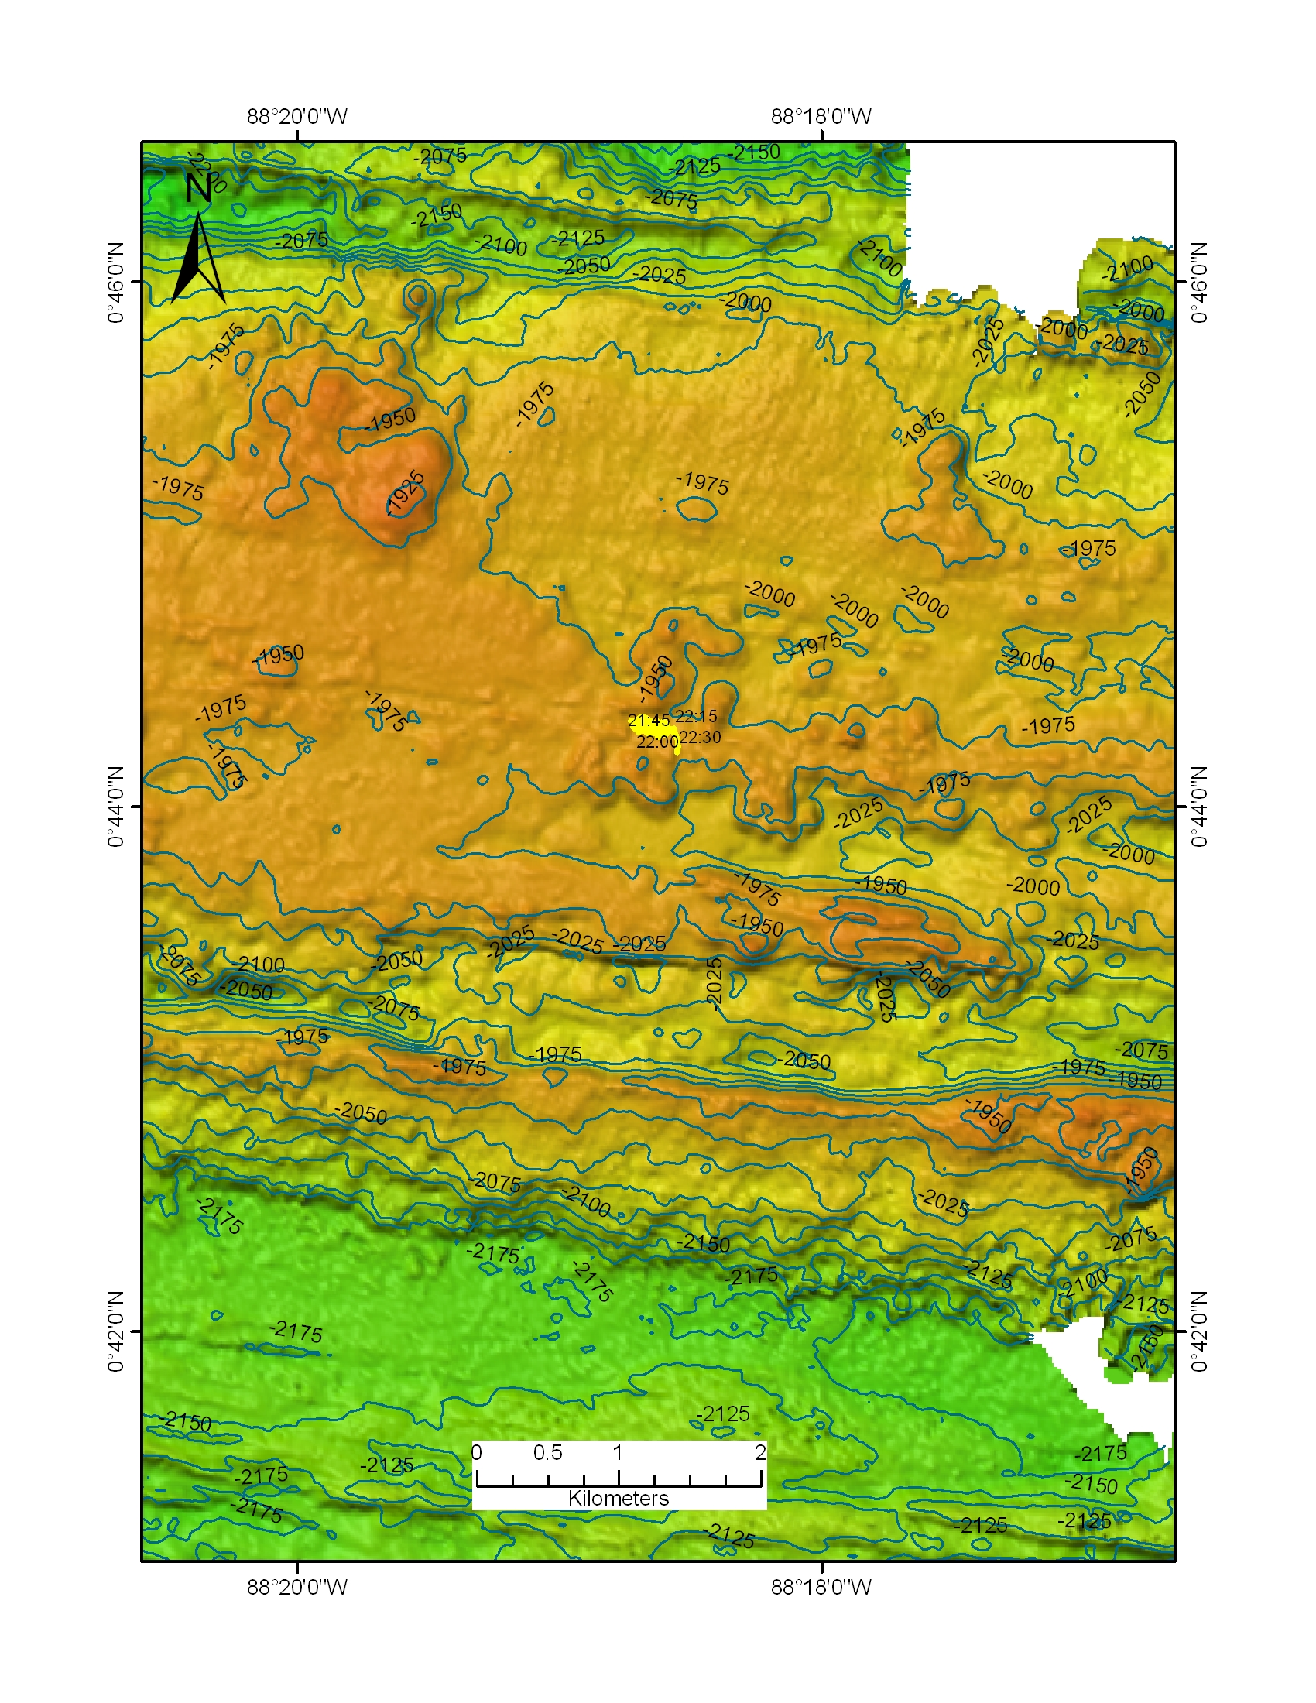 |  |  |  | 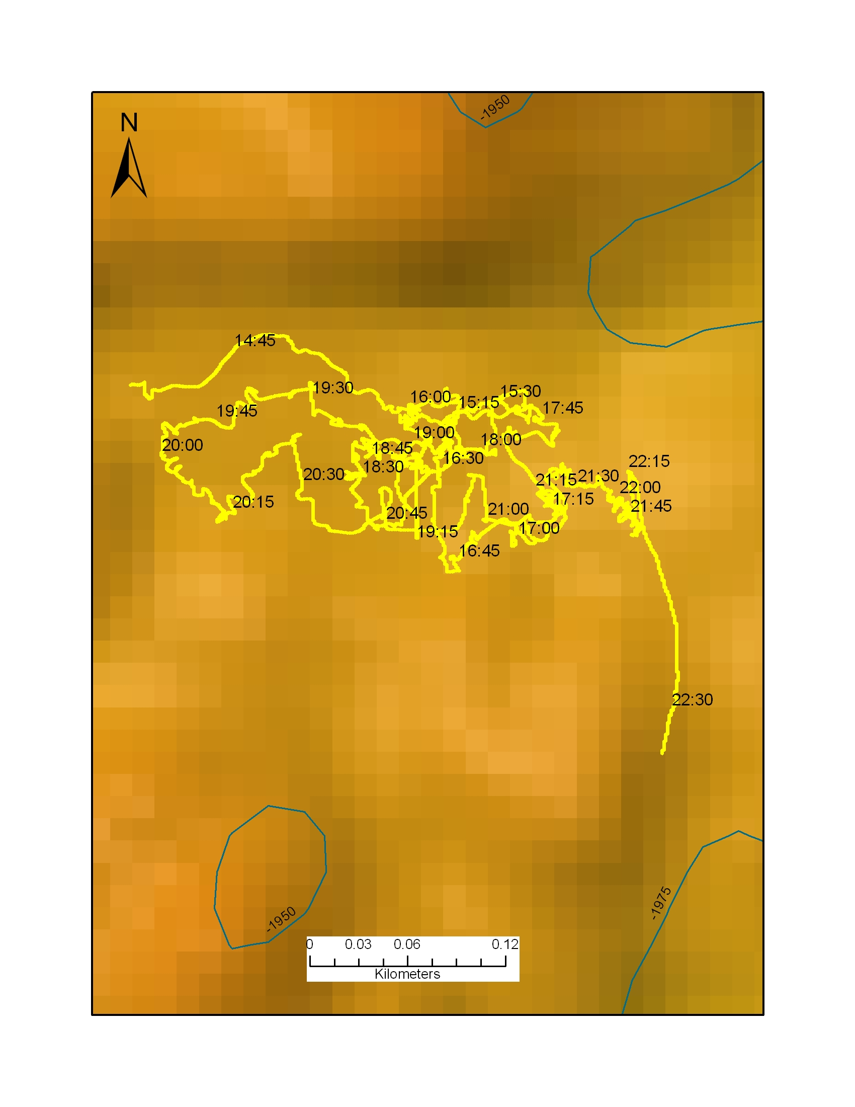
Representative Photos of the Dive
xxx |  |  |  | xxx
Please direct inquiries to: |  | NOAA Office of Ocean Exploration & Research  1315 East-West Highway (SSMC3 10th Floor)  Silver Spring, MD 20910  (301) 734-1014

