Okeanos Explorer ROV Dive Summary
Site Name | Site of strong hydrothermal signal |  |  |  | 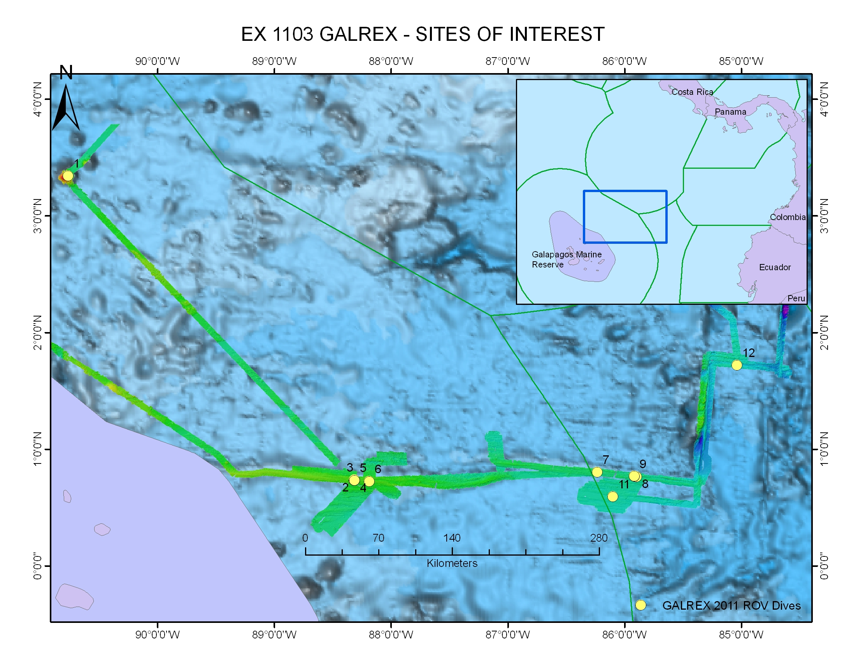
ROV Lead/  Expedition Coordinator | Dave Lovalvo/  Jeremy Potter
General Area Descriptor | Galapagos Rift, , X km NX of x Island, Galapagos Islands
ROV Dive Name | Cruise Season |  | Leg |  |  | Dive Number
 | EX1103 |  | 2 |  |  | DIVE02
Equipment Deployed | ROV: |  | Little Hercules
 | Camera Platfom: |  | Seirios
ROV Measurements | CTD |  | Depth |  |  | Altitude
 | Scanning Sonar |  | USBL Position |  |  | Heading
 | Pitch |  | Roll |  |  | HD Camera
 | Low Res Cam 1 |  | Low Res Cam 2
Equipment Malfunctions | None
ROV Dive Summary  (From processed ROV data) | Dive Summary: EX1103L2_DIVE02  ^^^^^^^^^^^^^^^^^^^^^^^^^^^^^^^^^^^^^^^^^^^^^^^^^^^  In Water at: 2011-07-15T17:30:13.458000  00°, 44.095' N ; 088°, 18.953' W  Out Water at: 2011-07-16T01:38:10.054000  00°, 44.037' N ; 088°, 18.453' W  Off Bottom at: 2011-07-16T00:06:18.673000  00°, 44.284' N ; 088°, 18.628' W  On Bottom at: 2011-07-15T17:42:43.713000  00°, 44.082' N ; 088°, 18.948' W  Dive duration: 8:7:56  Bottom Time: 6:23:34  Max. depth: 1976.8 m
Special Notes | Click here to enter text.
Scientists Involved  (please provide name / location / affiliation / email) | Timothy M. Shank/ Okeanos Explorer Lead Scientist/WHOI/tshank@whoi.edu  Edward T. Baker/NOAA-PMEL, Washington/Edward.baker@noaa.gov  Robert W. Embley/NOAA-PMEL, Oregon/Robert.w.embley@noaa.gov  Stephen Hammond/ NOAA-PMEL, Oregon/Stephen.r.hammond@noaa.gov  James F. Holden/ UMASS Amherst/jholden@microbio.umass.edu  Scott White/University of South Carolina/swhite@geol.sc.edu  Sharon L. Walker/ NOAA-PMEL, Washington/sharon.l.walker@noaa.gov  Santiago Herrera/ WHOI Exploration Command Center/WHOI/sherrera@whoi.edu  T. Jennifer Lin/UMASS Amherst/tjennlin@gmail.com  Catriona Munro/ WHOI Exploration Command Center /WHOI/catmunro89 @gmail.com  Taylor Heyl/ WHOI Exploration Command Center/WHOI/theyl@whoi.edu  Lucy C. Stewart/ UMASS Amherst/lsteweart@cns.umass.edu  Mashkoor Malik/ NOAA Office of Ocean Exploration & Research/mashkoor.malik@noaa.gov  Meme Lobecker/ NOAA Office of Ocean Exploration & Research/ Elizabeth.Lobecker@noaa.gov
Purpose of the Dive
To descend with the ROV Little Hercules to a site on the Galapagos Rift where strong hydrothermal plume signals were detected few weeks ago, and traverse toward WP2- Plume target 2a, exploring the vicinity for hydrothermal activity.
Description of the Dive:
At the start of this dive, we transited NE over pillow mounds in an area of 1 meter collapses with small pillars displaying bathtub rings. Little Hercules then moved 200 meters to the north to locate the extent of the linear collapses and the northern boundary. We traversed toward Plume target 2a and explored the vicinity, transiting across a graben structure and confirming the northern margin of that structure. Little Hercules came across a new lava flow within a broad 10 meter fissure; black fresh flow about 1-3 meters into the fissure with iron-oxide staining on the flow breaks and pillow margins. Just prior to seeing this new flow in the fissure, we located a contact between younger lava and much older material. The dive ended by looking at and imaging a wall of truncated pillow lava.

Overall Map of ROV Dive Area |  |  |  | Close-up Map of Main Dive Site
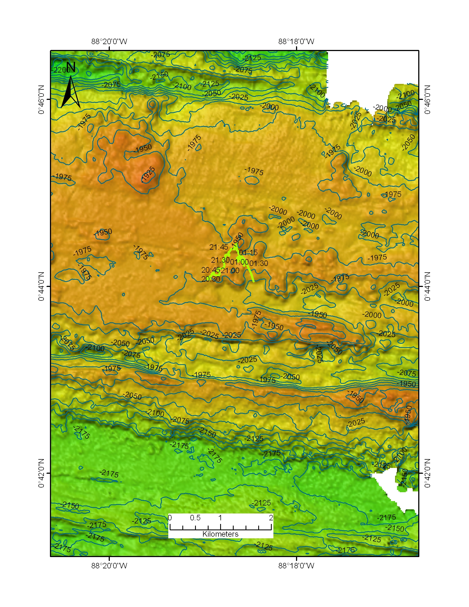 |  |  |  | 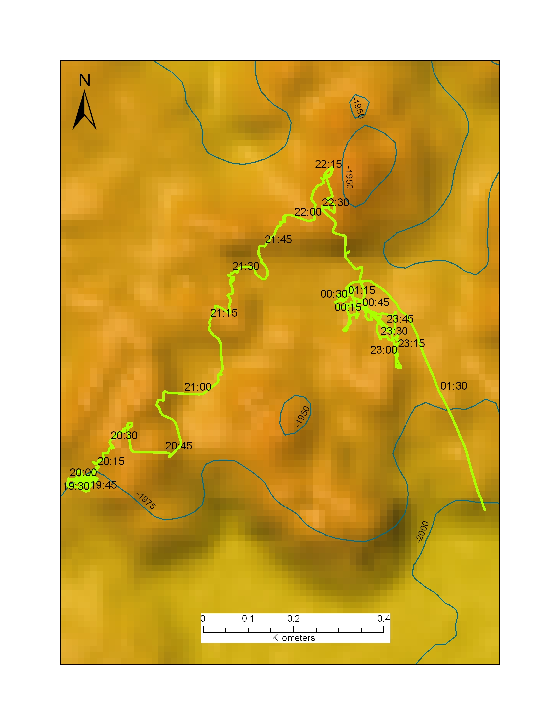
Representative Photos of the Dive
xxx |  |  |  | xxx
Please direct inquiries to: |  | NOAA Office of Ocean Exploration & Research  1315 East-West Highway (SSMC3 10th Floor)  Silver Spring, MD 20910  (301) 734-1014

