Okeanos Explorer ROV Dive Summary
Site Name | Paramount Seamounts |  |  |  | 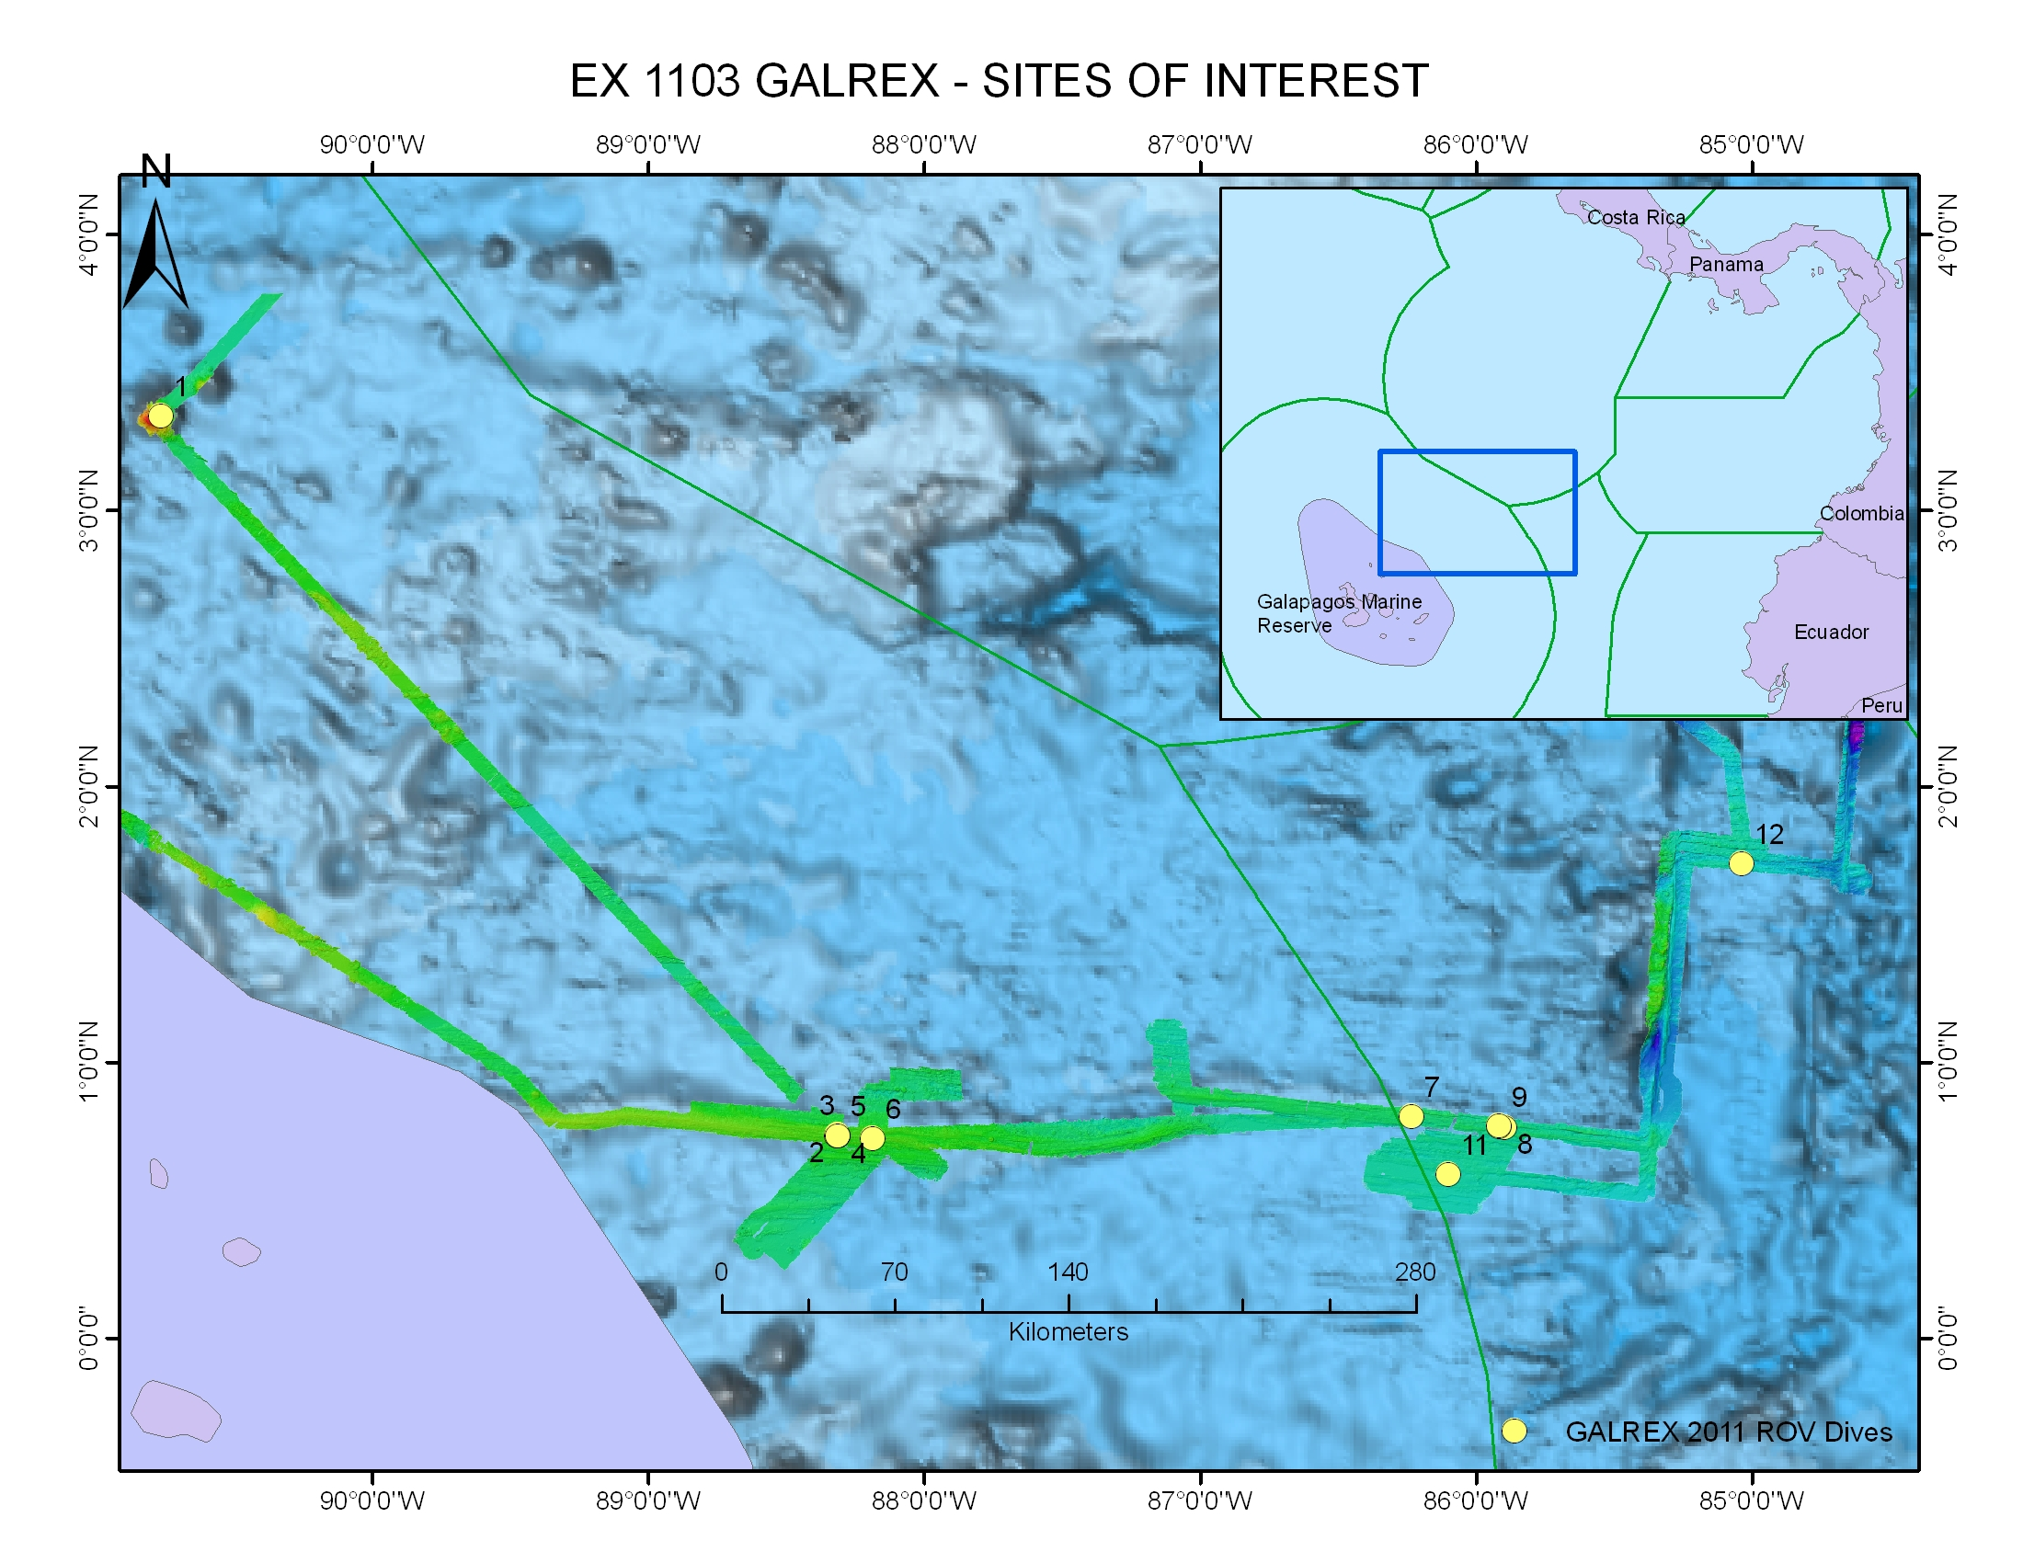
ROV Lead/  Expedition Coordinator | Dave Lovalvo/  Jeremy Potter
General Area Descriptor | Paramount Seamount, X km NX of x Island,  Galapagos Islands
ROV Dive Name | Cruise Season |  | Leg |  |  | Dive Number
 | EX1103 |  | 2 |  |  | DIVE01
Equipment Deployed | ROV: |  | Little Hercules
 | Camera Platfom: |  | Seirios
ROV Measurements | CTD |  | Depth |  |  | Altitude
 | Scanning Sonar |  | USBL Position |  |  | Heading
 | Pitch |  | Roll |  |  | HD Camera
 | Low Res Cam 1 |  | Low Res Cam 2
Equipment Malfunctions | None
ROV Dive Summary  (From processed ROV data) | Dive Summary: EX1103L2_Dive01  ^^^^^^^^^^^^^^^^^^^^^^^^^^^^^^^^^^^^^^^^^^^^^^^^^^^  In Water at: 2011-07-14T07:51:23.078000  03°, 20.804' N ; 090°, 45.949' W  Out Water at: 2011-07-14T15:34:16.705000  03°, 20.071' N ; 090°, 46.715' W  Off Bottom at: 2011-07-14T15:06:36.632000  03°, 20.452' N ; 090°, 46.496' W  On Bottom at: 2011-07-14T08:22:34.309000  03°, 20.834' N ; 090°, 45.950' W  Dive duration: 7:42:53  Bottom Time: 6:44:2  Max. depth: 597.6 m
Special Notes | Click here to enter text.
Scientists Involved  (please provide name / location / affiliation / email) | Timothy M. Shank/ Okeanos Explorer Lead Scientist/WHOI/tshank@whoi.edu  Edward T. Baker/NOAA-PMEL, Washington/Edward.baker@noaa.gov  Robert W. Embley/NOAA-PMEL, Oregon/Robert.w.embley@noaa.gov  Stephen Hammond/ NOAA-PMEL, Oregon/Stephen.r.hammond@noaa.gov  James F. Holden/ UMASS Amherst/jholden@microbio.umass.edu  Scott White/University of South Carolina/swhite@geol.sc.edu  Sharon L. Walker/ NOAA-PMEL, Washington/sharon.l.walker@noaa.gov  Santiago Herrera/ WHOI Exploration Command Center/WHOI/sherrera@whoi.edu  T. Jennifer Lin/UMASS Amherst/tjennlin@gmail.com  Catriona Munro/ WHOI Exploration Command Center /WHOI/catmunro89 @gmail.com  Taylor Heyl/ WHOI Exploration Command Center/WHOI/theyl@whoi.edu  Lucy C. Stewart/ UMASS Amherst/lsteweart@cns.umass.edu  Mashkoor Malik/ NOAA Office of Ocean Exploration & Research/mashkoor.malik@noaa.gov  Meme Lobecker/ NOAA Office of Ocean Exploration & Research/ Elizabeth.Lobecker@noaa.gov
Purpose of the Dive
The location of this dive on the eastern side of Paramount seamount at approximately 600 meters depth was chosen based on multibeam, backscatter and current data. The goal was to characterize the biological communities on the Seamount, and make comparisons with 2010 INDEX expedition to the Sangihe Talaud region in Indonesia.

Description of the Dive:
The ROV Little Hercules began this dive at approximately 800 meters depth and moved upslope to explore the rim of the seamount. We transited to the west toward a large promontory 8 meters away. As we moved upslope, there was an increase in abundance of organisms and a general trend of high abundance of corals, but with low diversity. The summit margin was characterized by a high abundance of white brachiopods and pink brittle stars in the 400 meter shallow zone along the summit margin. Multiple ophiuroids. brachiopods, and white sponges were found on a sediment-covered seafloor with occasional isolated cobbles and small boulders and brittle stars were observed on a red rocky substrate, hypothesized to be fossil shallow-water corals.
Overall Map of ROV Dive Area |  |  |  | Close-up Map of Main Dive Site
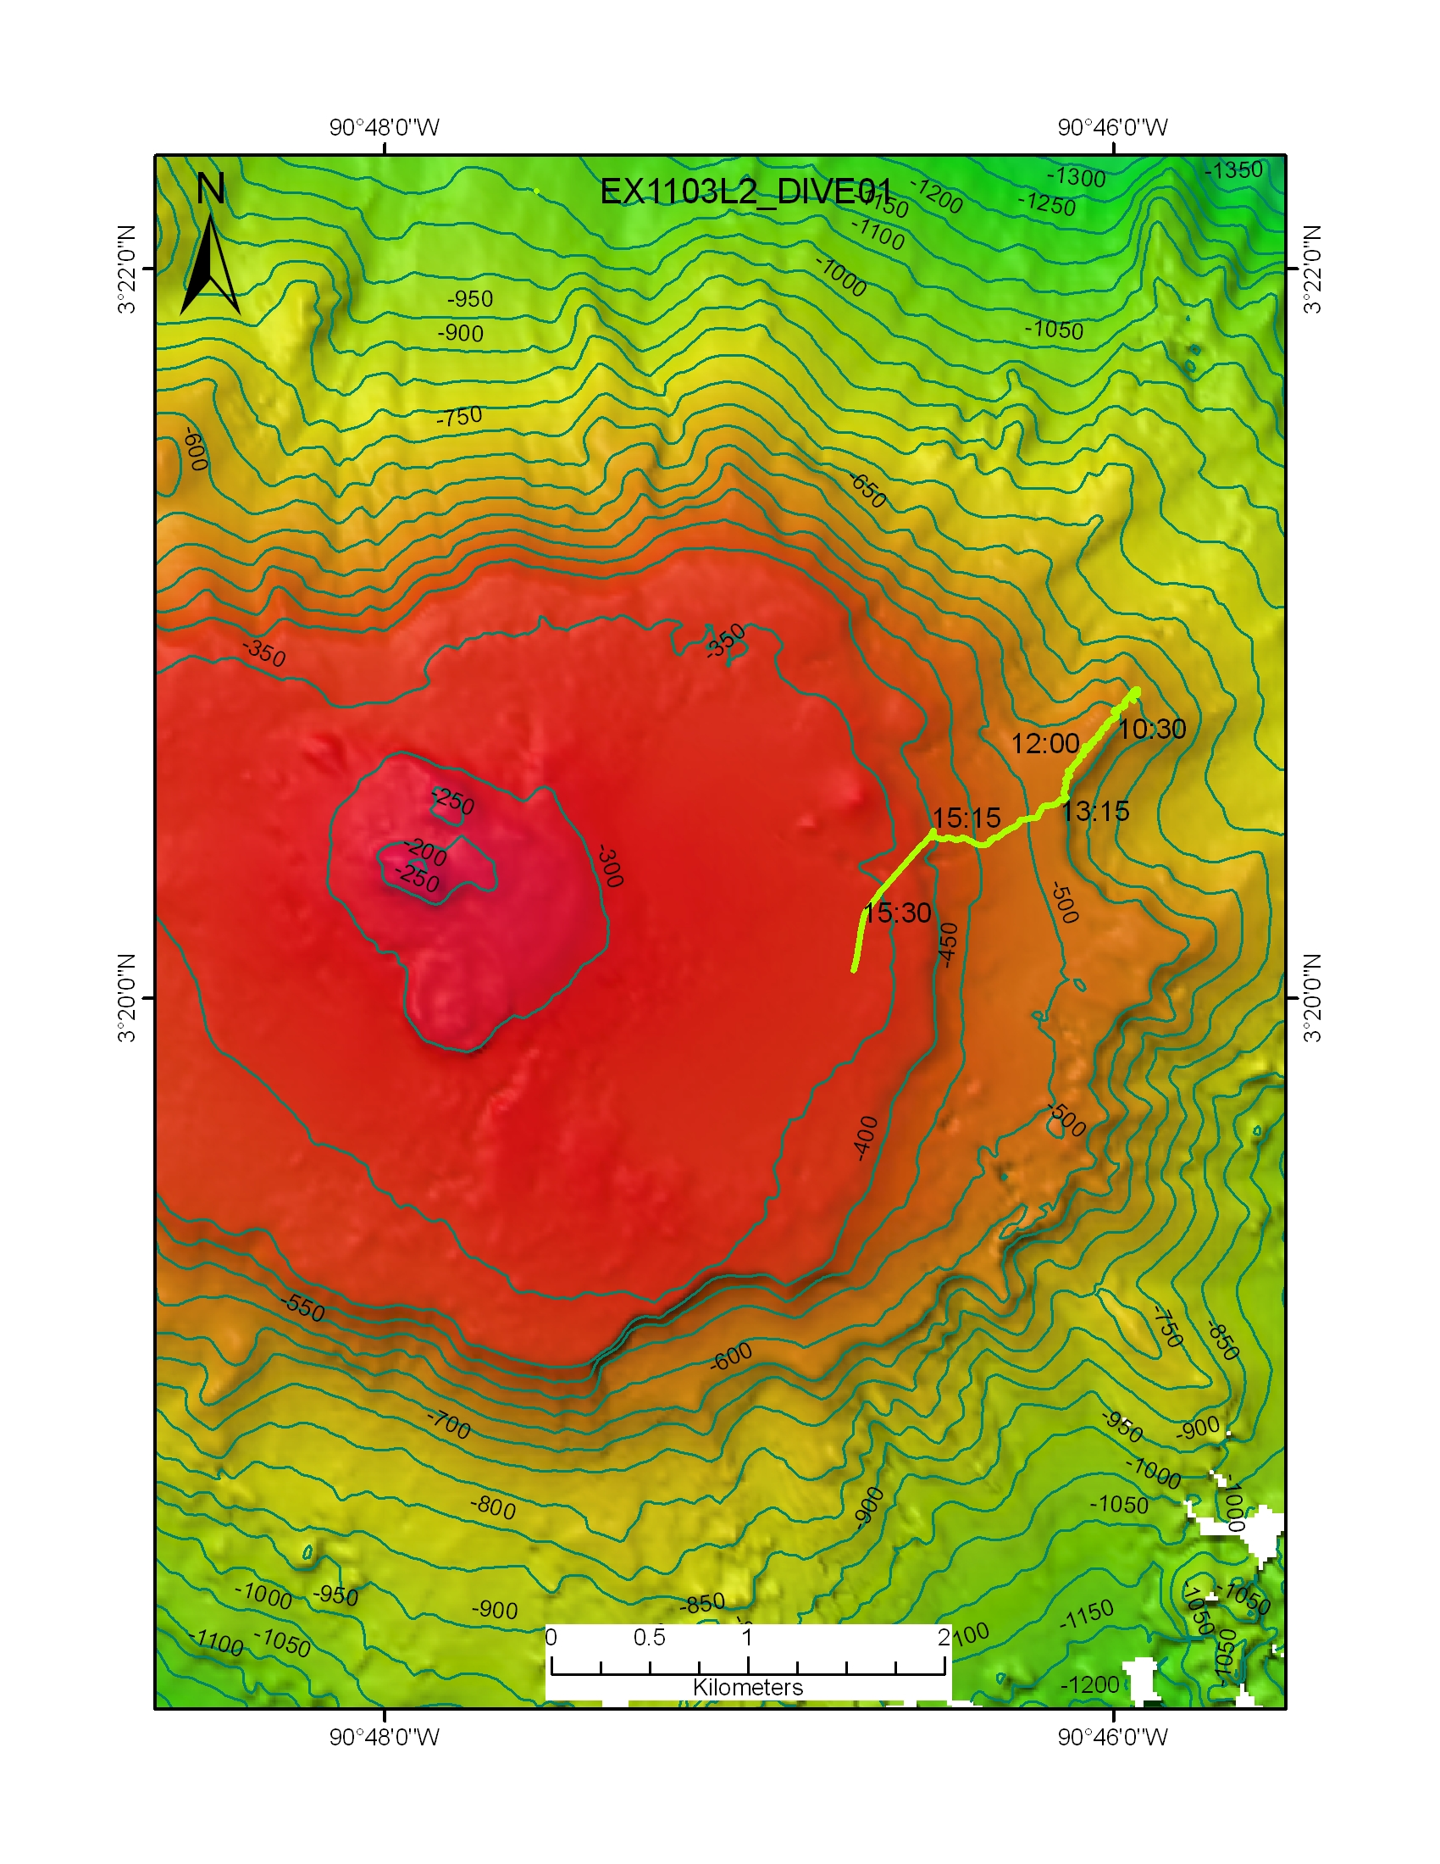 |  |  |  | 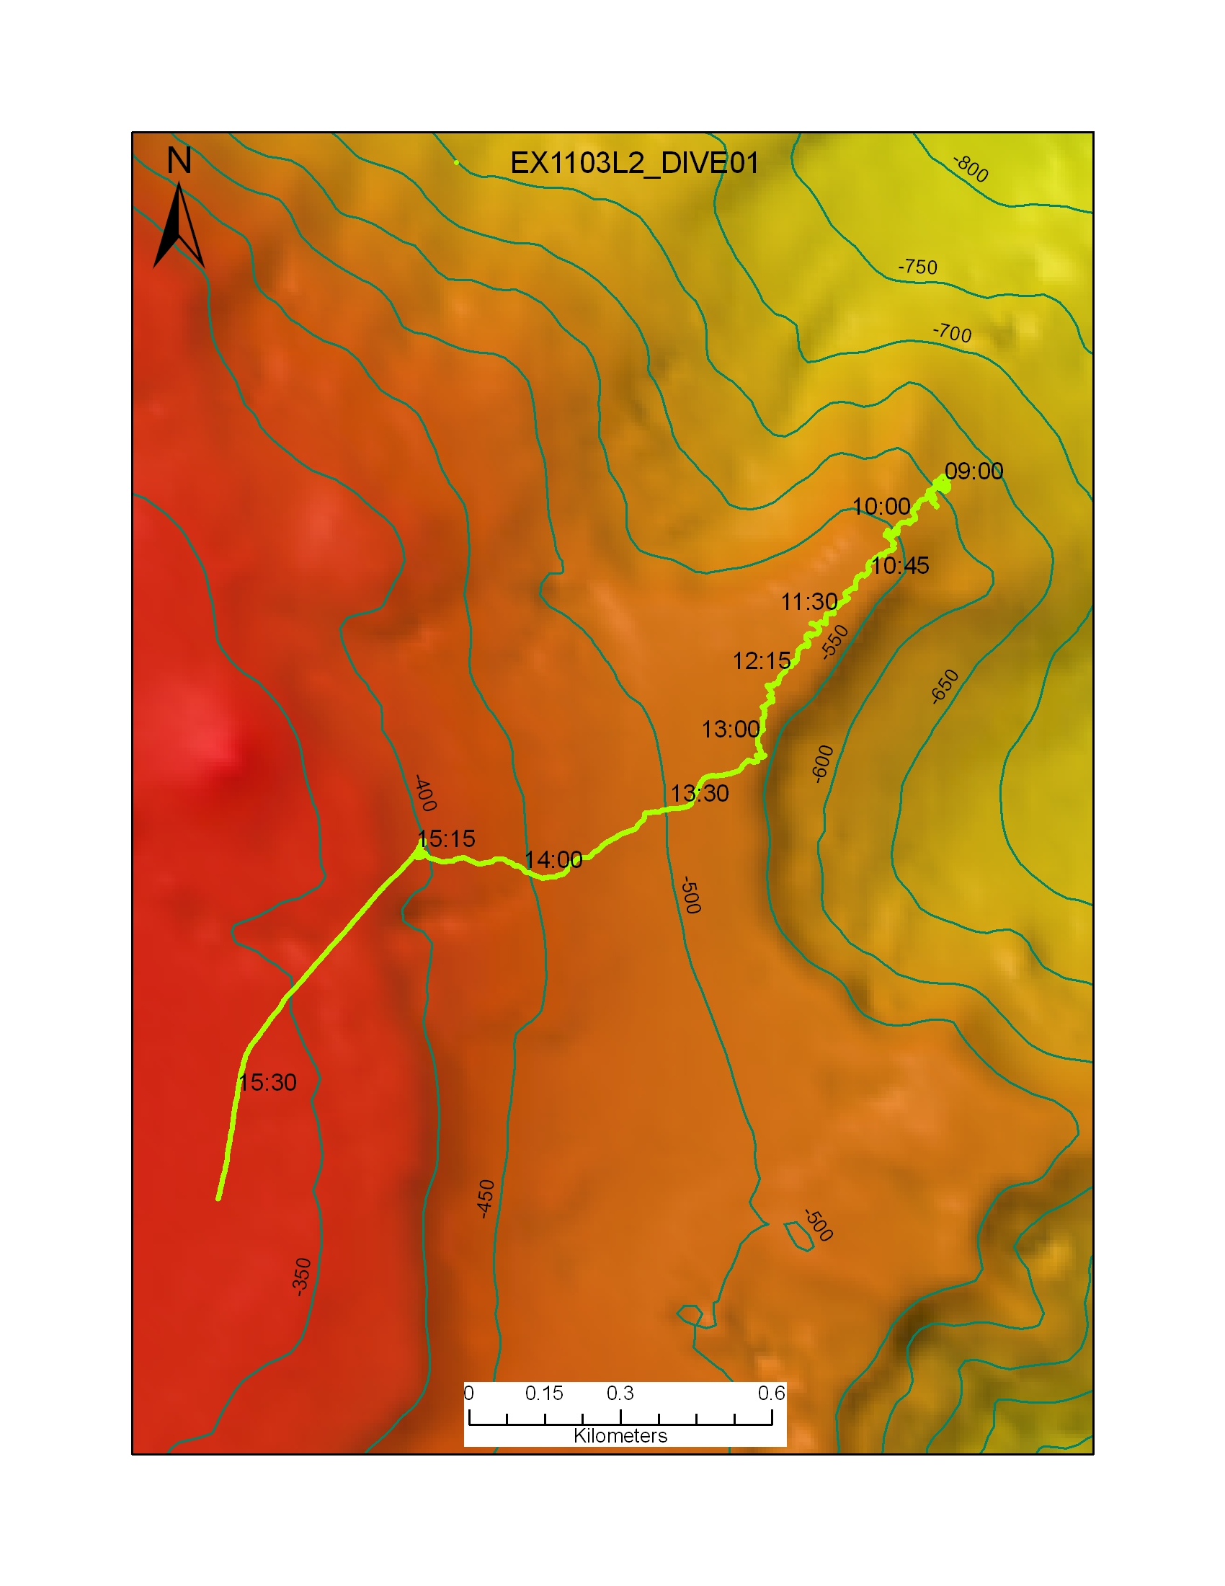
Representative Photos of the Dive
xxx |  |  |  | xxx
Please direct inquiries to: |  | NOAA Office of Ocean Exploration & Research  1315 East-West Highway (SSMC3 10th Floor)  Silver Spring, MD 20910  (301) 734-1014

