Okeanos Explorer ROV Dive Summary
Site Name | Ecuadorian Rift (EcRift) |  |  |  | 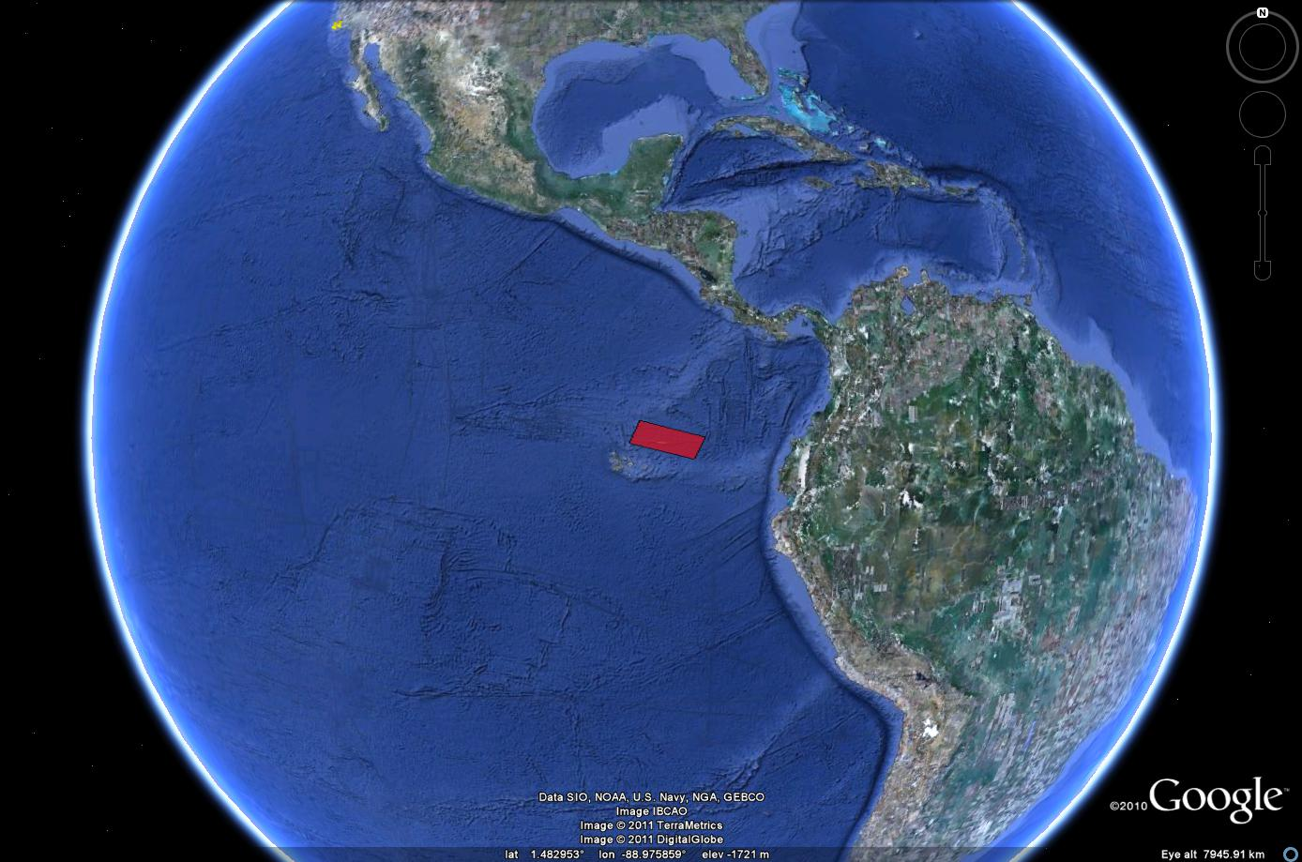
ROV Lead | Dave Lovalvo
General Area Descriptor | X km NX of x, Island, Galapagos Islands
ROV Dive Name | Cruise Season |  | Leg |  |  | Dive Number
 | EX1103 |  | 2 |  |  | DIVE12
Equipment Deployed | ROV: |  | Little Hercules
 | Camera Platfom: |  | Seirios
ROV Measurements | CTD |  | Depth |  |  | Altitude
 | Scanning Sonar |  | USBL Position |  |  | Heading
 | Pitch |  | Roll |  |  | HD Camera
 | Low Res Cam 1 |  | Low Res Cam 2
Equipment Malfunctions | None
ROV Dive Summary  (From processed ROV data) | Dive Summary: EX1103L2_DIVE12_20110725  ^^^^^^^^^^^^^^^^^^^^^^^^^^^^^^^^^^^^^^^^^^^^^^^^^^^  In Water at: 2011-07-25T14:24:40.987000  01°, 43.879' N ; 085°, 01.952' W  Out Water at: 2011-07-25T22:15:46.006000  01°, 43.809' N ; 085°, 01.838' W  Off Bottom at: 2011-07-25T20:39:06.242000  01°, 43.818' N ; 085°, 01.849' W  On Bottom at: 2011-07-25T16:30:36.551000  01°, 43.829' N ; 085°, 01.985' W  Dive duration: 7:51:5  Bottom Time: 4:8:29  Max. depth: 2878.9 m
Special Notes | Click here to enter text.
Scientists Involved
(please provide name / location / affiliation / email)
Purpose of the Dive
Description of the Dive:
Overall Map of ROV Dive Area |  |  |  | Close-up Map of Main Dive Site
Representative Photos of the Dive
xxx |  |  |  | xxx
Please direct inquiries to: |  | NOAA Office of Ocean Exploration & Research  1315 East-West Highway (SSMC3 10th Floor)  Silver Spring, MD 20910  (301) 734-1014

