Okeanos Explorer ROV Dive Summary
Site Name | 4aW |  |  |  | 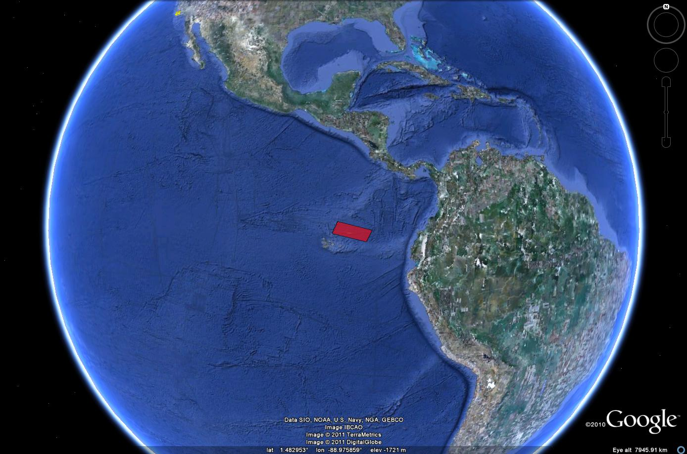
ROV Lead | Dave Lovalvo
General Area Descriptor | X km NX of x, Island, Galapagos Islands
ROV Dive Name | Cruise Season |  | Leg |  |  | Dive Number
 | EX1103 |  | 2 |  |  | DIVE09
Equipment Deployed | ROV: |  | Little Hercules
 | Camera Platfom: |  | Seirios
ROV Measurements | CTD |  | Depth |  |  | Altitude
 | Scanning Sonar |  | USBL Position |  |  | Heading
 | Pitch |  | Roll |  |  | HD Camera
 | Low Res Cam 1 |  | Low Res Cam 2
Equipment Malfunctions | None
ROV Dive Summary  (From processed ROV data) | Dive Summary: EX1103L2_DIVE10  ^^^^^^^^^^^^^^^^^^^^^^^^^^^^^^^^^^^^^^^^^^^^^^^^^^^  In Water at: 2011-07-23T14:23:27.400000  00°, 46.316' N ; 085°, 54.769' W  Out Water at: 2011-07-23T23:41:50.570000  00°, 45.679' N ; 085°, 54.783' W  Off Bottom at: 2011-07-23T21:04:14.335000  00°, 46.202' N ; 085°, 54.988' W  On Bottom at: 2011-07-23T16:15:53.912000  00°, 46.183' N ; 085°, 54.731' W  Dive duration: 9:18:23  Bottom Time: 4:48:20  Max. depth: 2566.5 m
Special Notes | Click here to enter text.
Scientists Involved
(please provide name / location / affiliation / email)
Purpose of the Dive
Description of the Dive:
Overall Map of ROV Dive Area |  |  |  | Close-up Map of Main Dive Site
Representative Photos of the Dive
xxx |  |  |  | xxx
Please direct inquiries to: |  | NOAA Office of Ocean Exploration & Research  1315 East-West Highway (SSMC3 10th Floor)  Silver Spring, MD 20910  (301) 734-1014

