Okeanos Explorer ROV Dive Summary
Site Name | Rosebud |  |  |  | 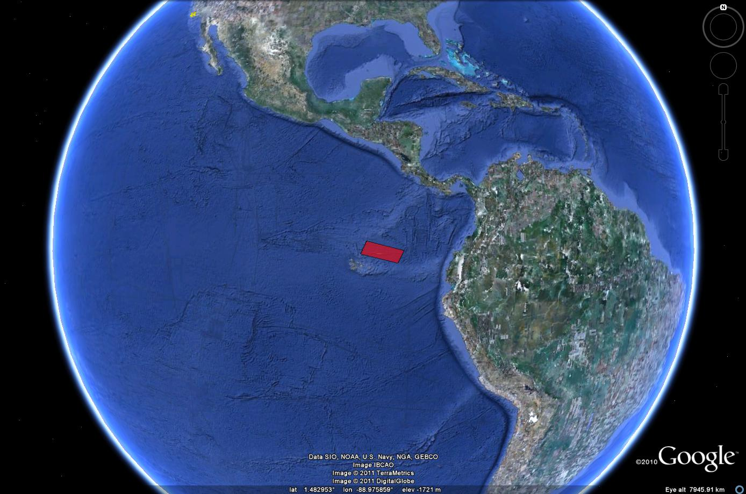
ROV Lead | Dave Lovalvo
General Area Descriptor | X km NX of x, Island, Galapagos Islands
ROV Dive Name | Cruise Season |  | Leg |  |  | Dive Number
 | EX1103 |  | 2 |  |  | DIVE07
Equipment Deployed | ROV: |  | Little Hercules
 | Camera Platfom: |  | Seirios
ROV Measurements | CTD |  | Depth |  |  | Altitude
 | Scanning Sonar |  | USBL Position |  |  | Heading
 | Pitch |  | Roll |  |  | HD Camera
 | Low Res Cam 1 |  | Low Res Cam 2
Equipment Malfunctions | None
ROV Dive Summary  (From processed ROV data) | Dive Summary: DIVE07_20110720  ^^^^^^^^^^^^^^^^^^^^^^^^^^^^^^^^^^^^^^^^^^^^^^^^^^^  In Water at: 2011-07-20T14:26:06.171000  00°, 48.427' N ; 086°, 13.749' W  Out Water at: 2011-07-20T22:40:53.324000  00°, 48.315' N ; 086°, 13.563' W  Off Bottom at: 2011-07-20T20:51:08.594000  00°, 48.376' N ; 086°, 13.641' W  On Bottom at: 2011-07-20T16:25:51.436000  00°, 48.312' N ; 086°, 13.644' W  Dive duration: 8:14:47  Bottom Time: 4:25:17  Max. depth: 2449.7 m
Special Notes | Click here to enter text.
Scientists Involved
(please provide name / location / affiliation / email)
Purpose of the Dive
Description of the Dive:
Overall Map of ROV Dive Area |  |  |  | Close-up Map of Main Dive Site
Representative Photos of the Dive
xxx |  |  |  | xxx
Please direct inquiries to: |  | NOAA Office of Ocean Exploration & Research  1315 East-West Highway (SSMC3 10th Floor)  Silver Spring, MD 20910  (301) 734-1014

