Okeanos Explorer ROV Dive Summary
Site Name | Paramount Seamounts |  |  |  | 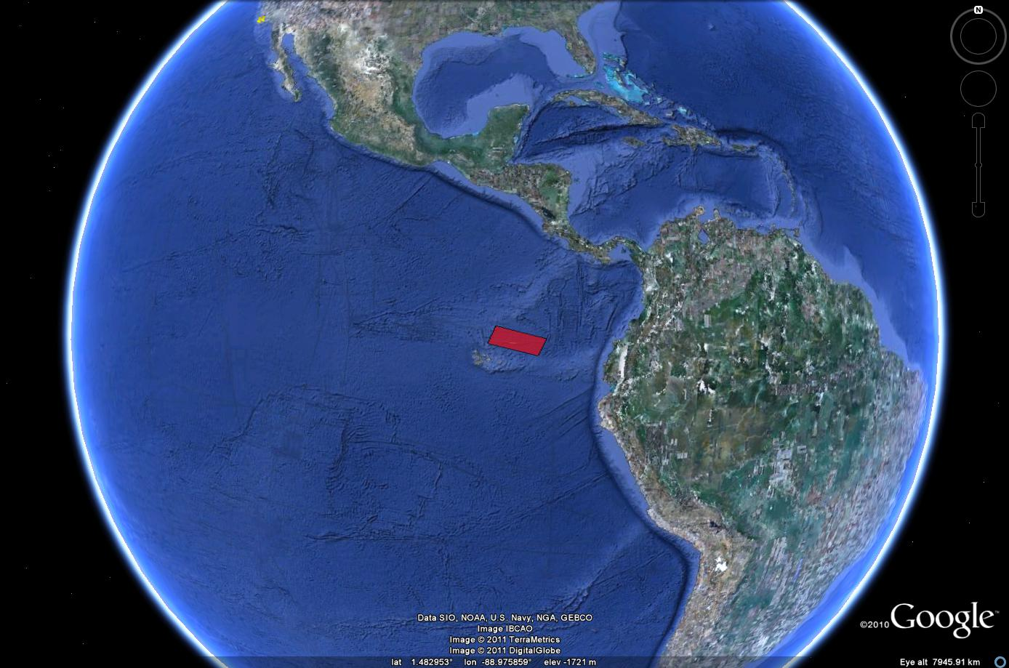
ROV Lead | Dave Lovalvo
General Area Descriptor | X km NX of x, Island, Galapagos Islands
ROV Dive Name | Cruise Season |  | Leg |  |  | Dive Number
 | EX1103 |  | 2 |  |  | DIVE01
Equipment Deployed | ROV: |  | Little Hercules
 | Camera Platfom: |  | Seirios
ROV Measurements | CTD |  | Depth |  |  | Altitude
 | Scanning Sonar |  | USBL Position |  |  | Heading
 | Pitch |  | Roll |  |  | HD Camera
 | Low Res Cam 1 |  | Low Res Cam 2
Equipment Malfunctions | None
ROV Dive Summary  (From processed ROV data) | Dive Summary: EX1103L2_Dive01  ^^^^^^^^^^^^^^^^^^^^^^^^^^^^^^^^^^^^^^^^^^^^^^^^^^^  In Water at: 2011-07-14T07:51:23.078000  03°, 20.804' N ; 090°, 45.949' W  Out Water at: 2011-07-14T15:34:16.705000  03°, 20.071' N ; 090°, 46.715' W  Off Bottom at: 2011-07-14T15:06:36.632000  03°, 20.452' N ; 090°, 46.496' W  On Bottom at: 2011-07-14T08:22:34.309000  03°, 20.834' N ; 090°, 45.950' W  Dive duration: 7:42:53  Bottom Time: 6:44:2  Max. depth: 597.6 m
Special Notes | Click here to enter text.
Scientists Involved
(please provide name / location / affiliation / email)
Purpose of the Dive
Description of the Dive:
Overall Map of ROV Dive Area |  |  |  | Close-up Map of Main Dive Site
Representative Photos of the Dive
xxx |  |  |  | xxx
Please direct inquiries to: |  | NOAA Office of Ocean Exploration & Research  1315 East-West Highway (SSMC3 10th Floor)  Silver Spring, MD 20910  (301) 734-1014

