Appendix
Overview
The Okeanos Explorer’s EM 302 multibeam system mapped more than 8000 linear km of the seafloor during the EX1003 and EX1005 transits in summer 2010. The two cruise legs followed parallel approximately followed a great circle path between Guam and O’ahu with a central beam separation about 12 km. This allowed for mapping of adjacent but non-overlapping regions on the seafloor. Following are five of the many features of interest along the transit path.
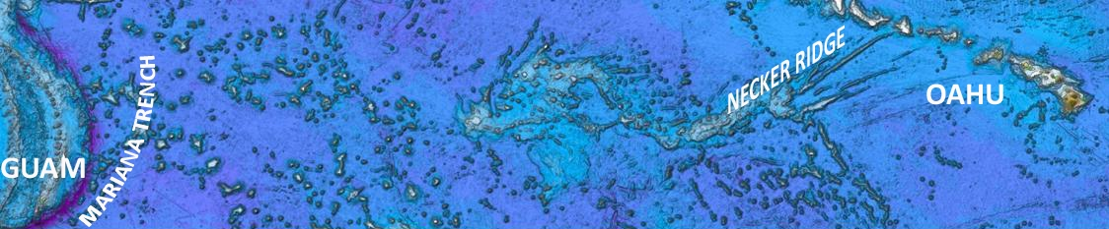

Mariana Trench Repot by Shannon Hoy
A. Mariana Trench (14.30°N, 147.3°E)
Shannon’s trench report goes here.

Features of Interest by Brian Shiro
B1. Landslides (15.57°N, 152.07°E)
Both transits passed over a large flat-topped guyot about 500 km east of the Mariana Trench. The feature is about 20 km wide at the top and 50 km across at the base in the east-west direction. The steep-walled cliffs seem to have been shaped by numerous landslides. Large fault scarps, slump blocks, debris aprons, and boulder fields are visible on both sides of the feature. Landslides are the second most common cause of tsunamis, so understanding the processes that lead to slope failure in the submarine environment could have important natural hazard implications.
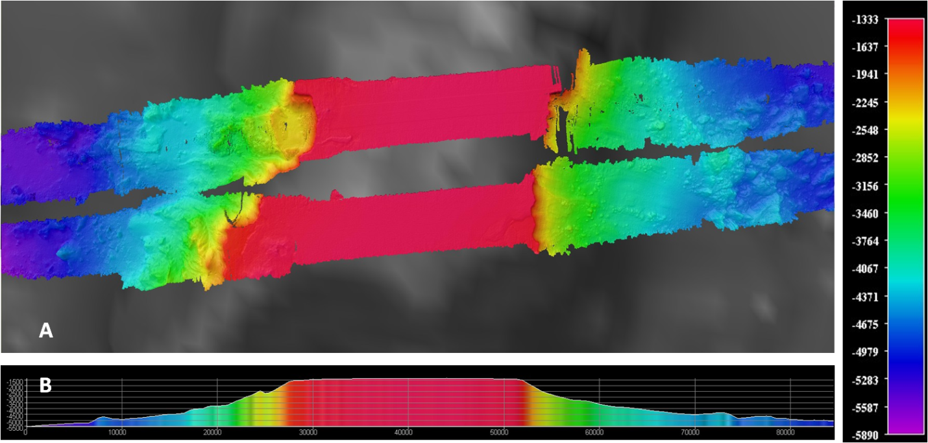
Figure 1: Plan (A) and Profile (B) views of the guyot. EX1003 transit swath above and EX1005 transit swatch below.
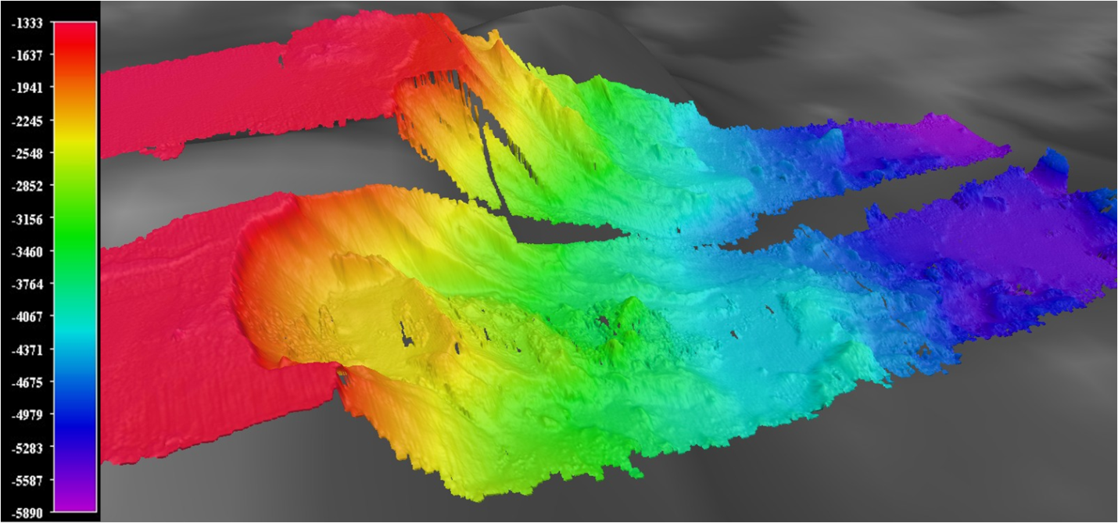
Figure 2: Landslide perspective view looking towards the southwest on the west face, vertical exaggeration 3.
B2. Volcano (18.68°N, 166.85°E)
On the EX1005 leg, we discovered a small cinder cone with a well-defined central crater. The cone rises about 500 meters above the local 4900-meter surface. This feature is not visible in the Smith and Sandwell bathymetry and may be a new discovery. The cone’s high degree of symmetry and lack of obvious erosional modification may indicate it is still active. Submarine hot spots that produce volcanos also form hydrothermal vents that support diverse ecosystems, so this may be worth further study.
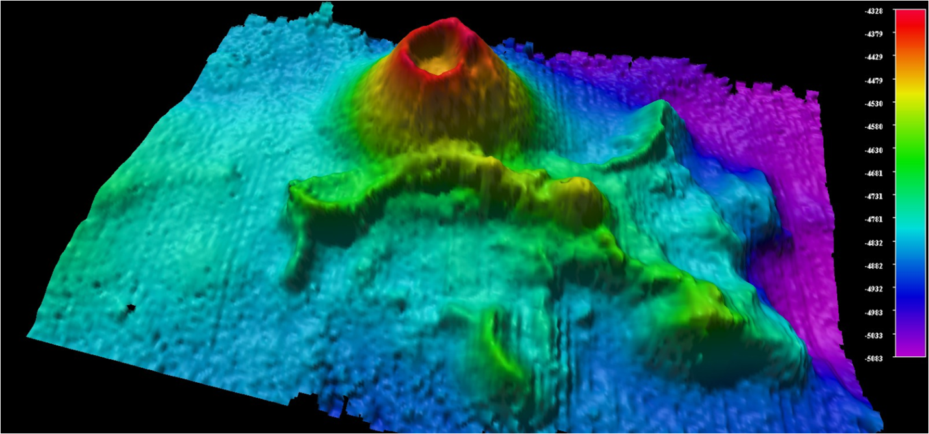
Figure 3: Cinder cone perspective view towards the northwest, vertical exaggeration 3
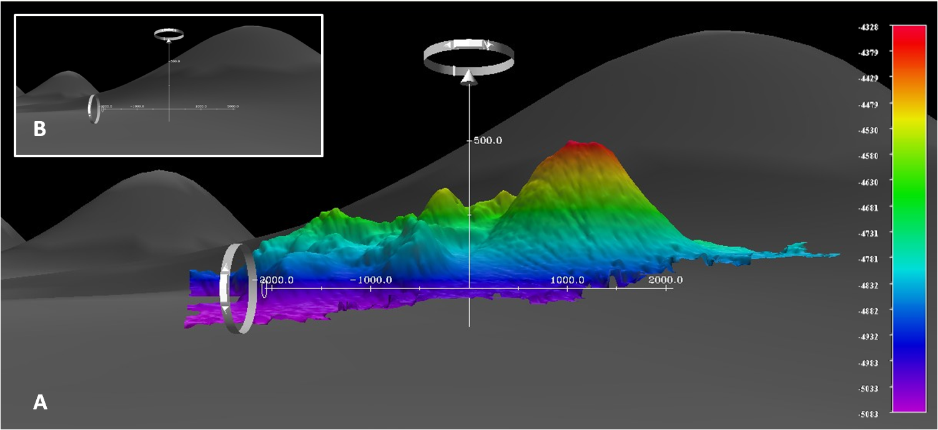
Figure 4: Side view of the cone looking south (A) compared to Smith and Sandwell bathymetry (B), vertical exaggeration 3

B3. Paleoshorelines (19.50°N, 171.60°E)
About midway through the transit, we crossed the Mid-Pacific Mountains, which is a rise containing a large number of seamounts, guyots, and former islands. A chain of up to six horizontal benches spanning 2-4 kilometers each is evident along the western edge of one guyot. They are separated by distinct vertical drops of 200-300 meters at the 5100, 4700, 4500, 4200, 3900, and 3500-meter levels. These appear to be former shorelines that record the sinking of the former island. The paleoshorelines observed here likely represent the rise in sea level during the end of the last ice age, so studying them can give us clues to how climate change has happened in the past.
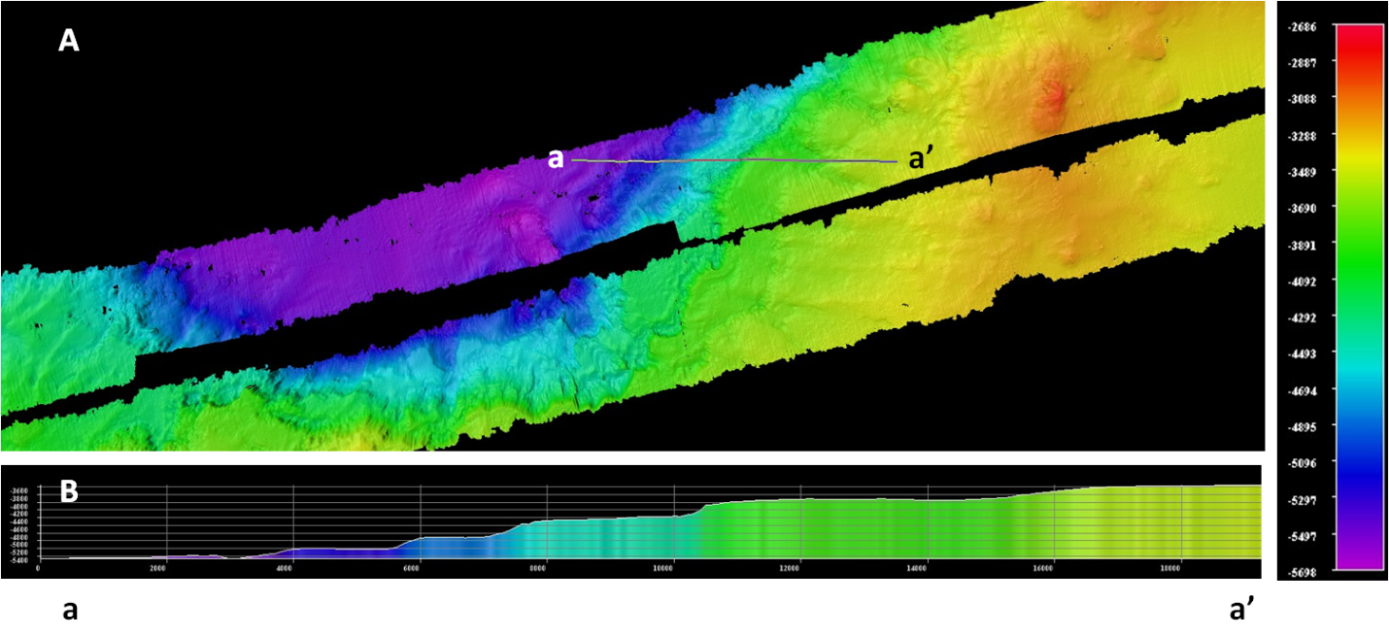
Figure 5: Plan (A) and Profile (B) views of the paleoshorelines
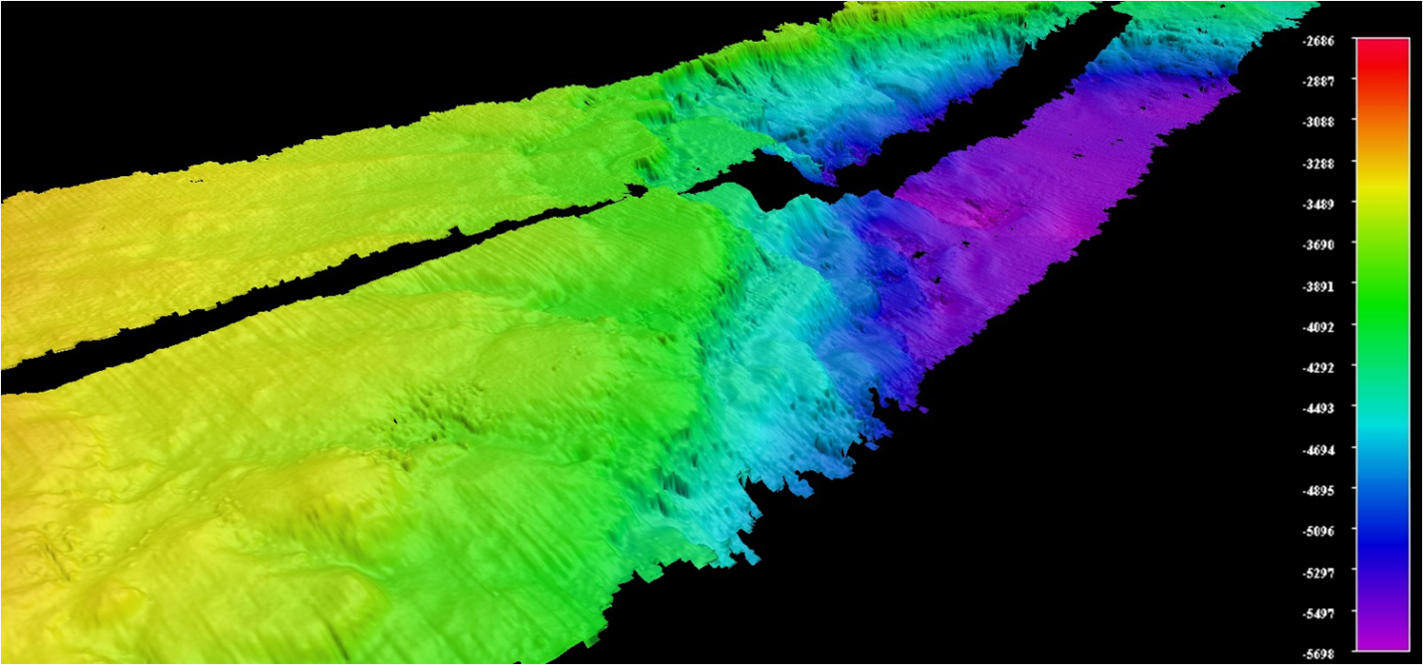
Figure 6: Paleoshorelines perspective view looking towards the southwest, vertical exaggeration 2.5
Necker Ridge Report by Jack Payette
C. Necker Ridge (21.15°N, 168.53°W)
Jack’s report goes here.

