Okeanos Explorer ROV Dive Form
Site Name | Zona Senja |  |  |  |  |  |  | 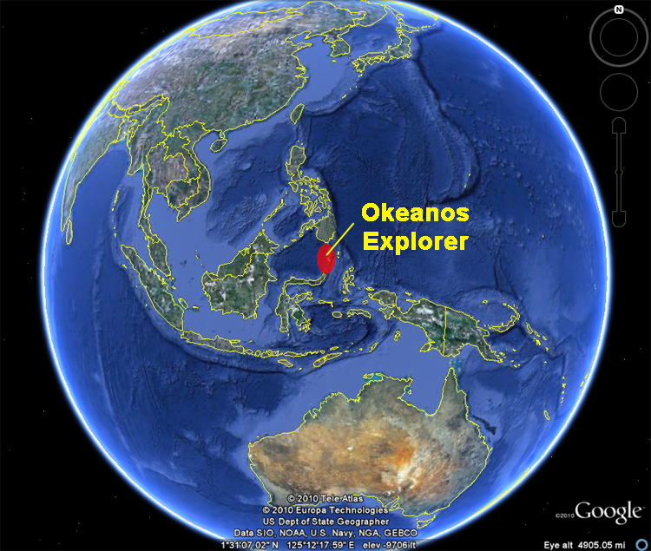
ROV Lead | Dave Lovalvo
General Area Descriptor | 430 km N of Bitung, Indonesia
UTC Date & Time | Deployment |  | 8/1/2010 10:18 PM
UTC Date & Time | Recovery |  | 8/2/2008 5:17 AM
Bottom Time  [HH:MM] | 06:25
Landing  Time & Location | UTC Time | 22:24 |  |  |  |  |  |  | Depth [m] |  | 311
Landing  Time & Location | Latitude | 4 |  |  | º | 53.471816 |  |  |  |  |  | ‘ |  | N
Landing  Time & Location | Longitude | 127 |  |  | º | 0.90364 |  |  |  |  |  | ‘ |  | E
Off Bottom  Time & Location | UTC Time | 04:49 |  |  |  |  |  |  | Depth [m] |  | 280
Off Bottom  Time & Location | Latitude | 4 |  |  | º | 53.148848 |  |  |  |  |  |  | ‘ | N
Off Bottom  Time & Location | Longitude | 127 |  |  | º | 1.050401 |  |  |  |  |  |  | ‘ | E
ROV Dive Name | Cruise Season |  |  | Leg |  |  |  |  |  | Dive Number
ROV Dive Name | EX1004 |  |  | LEG03 |  |  |  |  |  | ROV10 (23)
Equipment Deployed | ROV: |  |  | Little Hercules
Equipment Deployed | Camera Platfom: |  |  | Phoenix Camera Platform
ROV Measurements | CTD |  |  | Depth |  |  |  |  |  | Altitude
ROV Measurements | Scanning Sonar |  |  | USBL Position |  |  |  |  |  | Heading
ROV Measurements | Pitch |  |  | Roll |  |  |  |  |  | HD Camera
ROV Measurements | Low Res Cam 1 |  |  | Low Res Cam 2
Equipment Malfunctions | None
Special Notes | Click here to enter text.
Scientists Involved  (please provide name / location / affiliation / email) | Santiago Herrera (on-board Science Lead), EX, WHOI, sherrera@whoi.edu  Tim Shank (on-shore Science Lead), ECC Jakarta, WHOI, tshank@whoi.edu  Eleanor Bors, ECC Seattle, WHOI, ekbors@gmail.com  Catriona Munro, WHOI, WHOI, c.munro@ucl.ac.uk  Elizabeth Sibert , WHOI, WHOI, esibert@ucsd.edu  Rainer Troa, EX, renertroa@gmail.com  Dustin Schomagel, U. Victoria, U. Victoria, dbs@uvic.ca
Purpose of the Dive: To explore: 1) life in the “low-light” zone below 200m but not deeper than 400 meters; 2) deep-sea faunal diversity at depths between those typically visited in this region (and other regions)- below scuba depth yet shallower than depths we have been exploring; and 3) for comparison of diversity to these deeper and shallower sites. An additional goal of this exploration is to provide essential grist for identifying the distributional patterns of biodiversity/chemistry/geology at depths between 200-400 meters, a zone in this region on the eastern side of the Talaud Ridge.
Description of the Dive:
This was dive number 23 (10th of this third leg). The name of the site was "Zona Senja". Launch coordinates were 127d 0.906’ E 4d 53.4702’ N, the depth at bottom was 323m. We started at the base of a wall-ridge located climbed along the northeastern wall to a depth of 270m. We then moved laterally to the east on this same depth contour. After that we continued upslope toward the south along the eastern edge of the ridge top until reaching a summit at 250m. From there we moved east down slope until we reached the end of bottom time.

At the beginning of the dive (at 320m) there was low angle slope - greater than 50% rock cover. There seemed to be a higher variation in the types of rocks (ie. more color variation and size) than at previous sites. Impressive assemblages of communities in this place accompanied very high abundances and diversities. Fauna was different from what we have seen so far in the deeper sites explored during this expedition. Big fragments of basalt were covered with high abundances of suspension feeders. Sessile fauna also densely populated terraces of cemented sand. Temperature was 9.5C salinity 34.45. At 286-300m we experienced strong shimmering in water related to a marked thermocline. Temperature oscillated +/- 3C herea and there was a rapid change from 9C to 12C. No significant changes in faunal composition were detected with this change in temperature. The seafloor became predominantly clay-carbonate (pyroclastic tuff) with rounded cobbles dispersed along the margins and in depressions as we came shallower. Not much sessile fauna was seen on it. However high abundances of mobile fauna and burrowing fauna were observed. Temperature reached 13-14C at 250m. Strong downwelling current coming from the SW was experienced during the whole dive. It had a speed of 0.6 knots as measured before leaving the bottom, but it seemed significantly stronger at several points in which the ROV could barely cover some ground.

No apparent significant change in faunal composition was observed along the depth/temperature gradient. The observed changes in the abundances of sessile fauna seemed related to hard substrate availability. In general 90% of the rocks on sediments and clay-like substrate had sessile fauna on them. Paragorgiids and sponges were the only taxa that increased in abundance with decreasing depth. Stylasterid corals seemed to decrease in size and species composition. Dominant sessile fauna were Paramuricids, Paragorgiids, Primnoids, Sylasterids and crinoids. A couple of chrysogorgiids and antipatharians were observed in the deeper region. And a scleractinian matrix-forming colony was observed at a mid-depth.

Other dominant mobile fauna include squat lobsters, fish, various species of shirmp, fish, octopuses, pagurids with actinarian associates and ophiuroids. We likely saw 5 or 6 species of fish, "gobbies" abundant, also singletons observed included batfish, and a red white-spotted fish with striped fins. One type of octopus was found through depth range. At least 6 species of shrimp and ~8 species of crabs were observed. At least 3 of these were observed associates on corals. Ophiuroids- at least 6 as associates on corals and three with no host; at least 3 seastar morphs. Pagurids with anemones (3 morphs?) were found throughout.
Fish, octopuses and crustaceans had very large eyes, and most fauna had very bright and or cryptic patterns/colorations. This could be indicative of importance of visual interactions at this depth due to the availability of tenuous light and the possibility of vertical migrations.
Overall Map of ROV Dive Area |  |  |  |  |  |  | Close-up Map of Main Dive Site
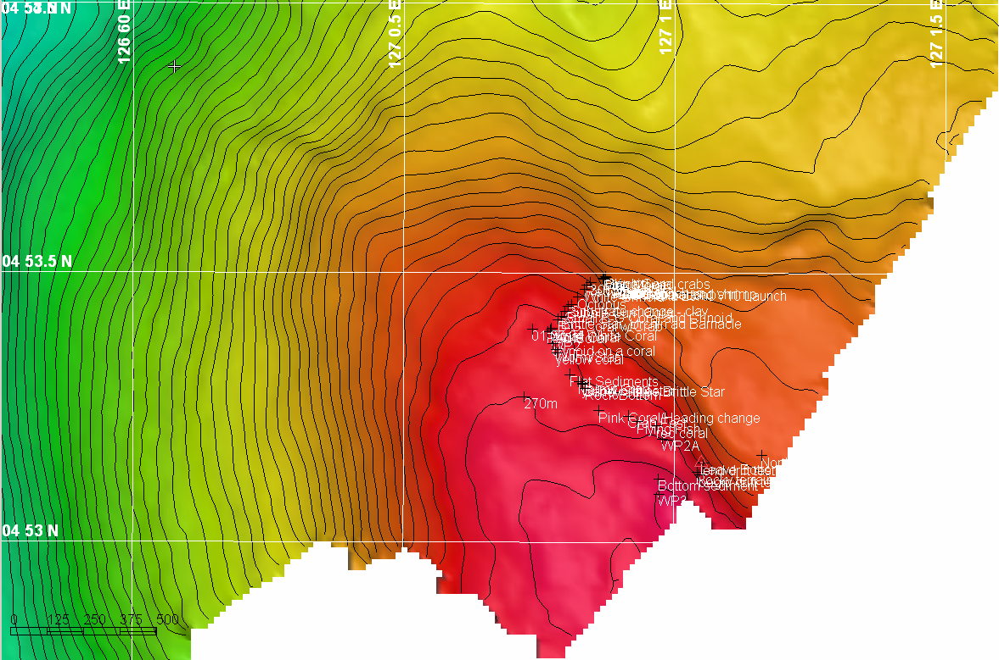 |  |  |  |  |  |  | 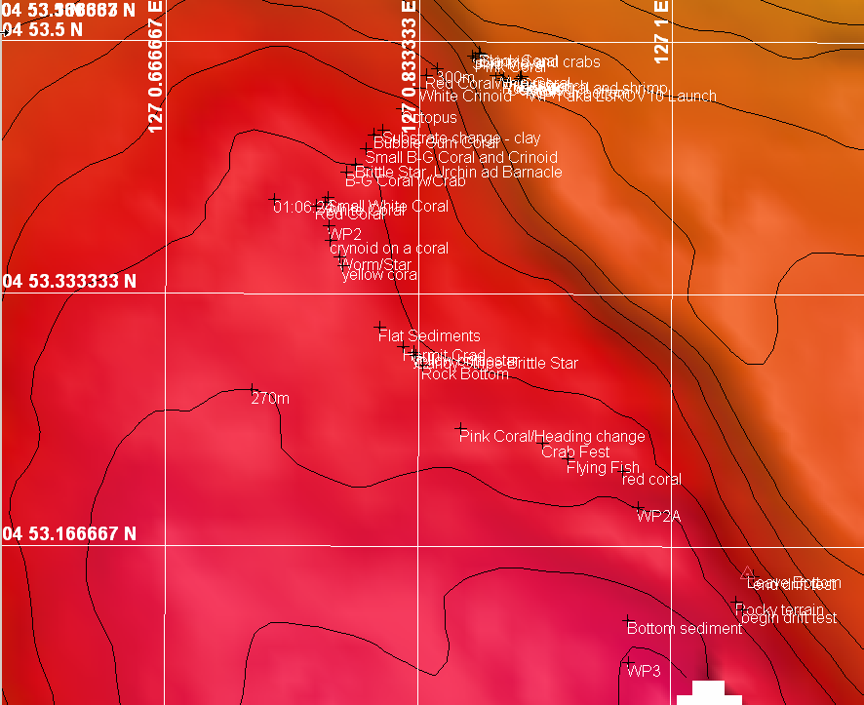
Representative Photos of the Dive
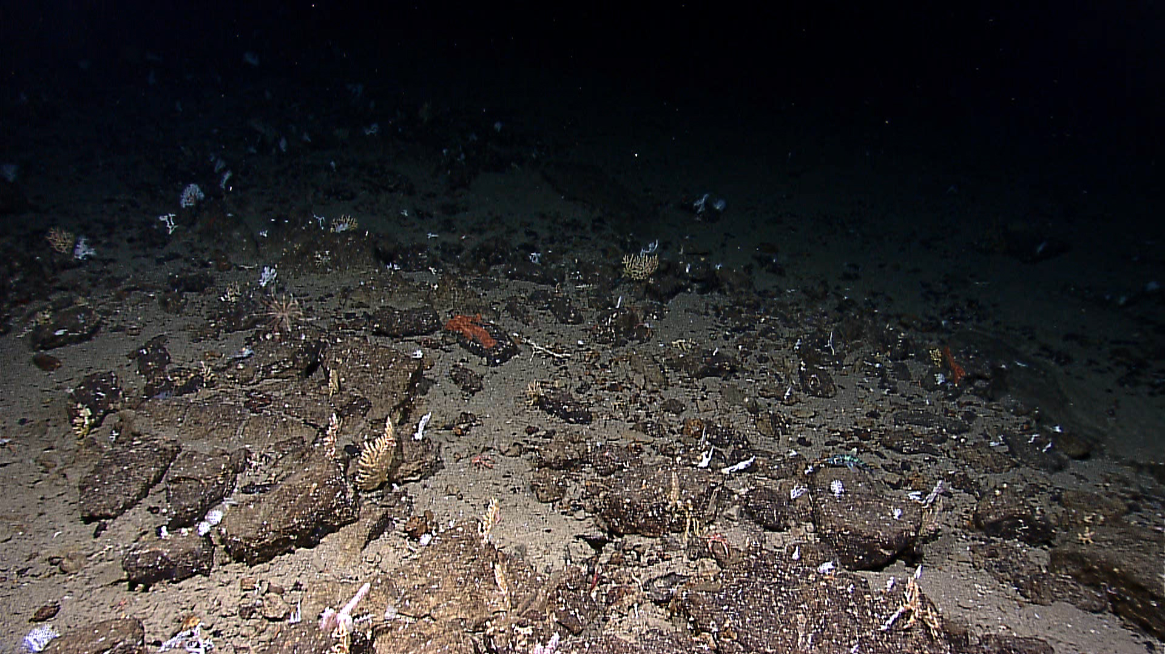 |  |  |  |  |  |  | 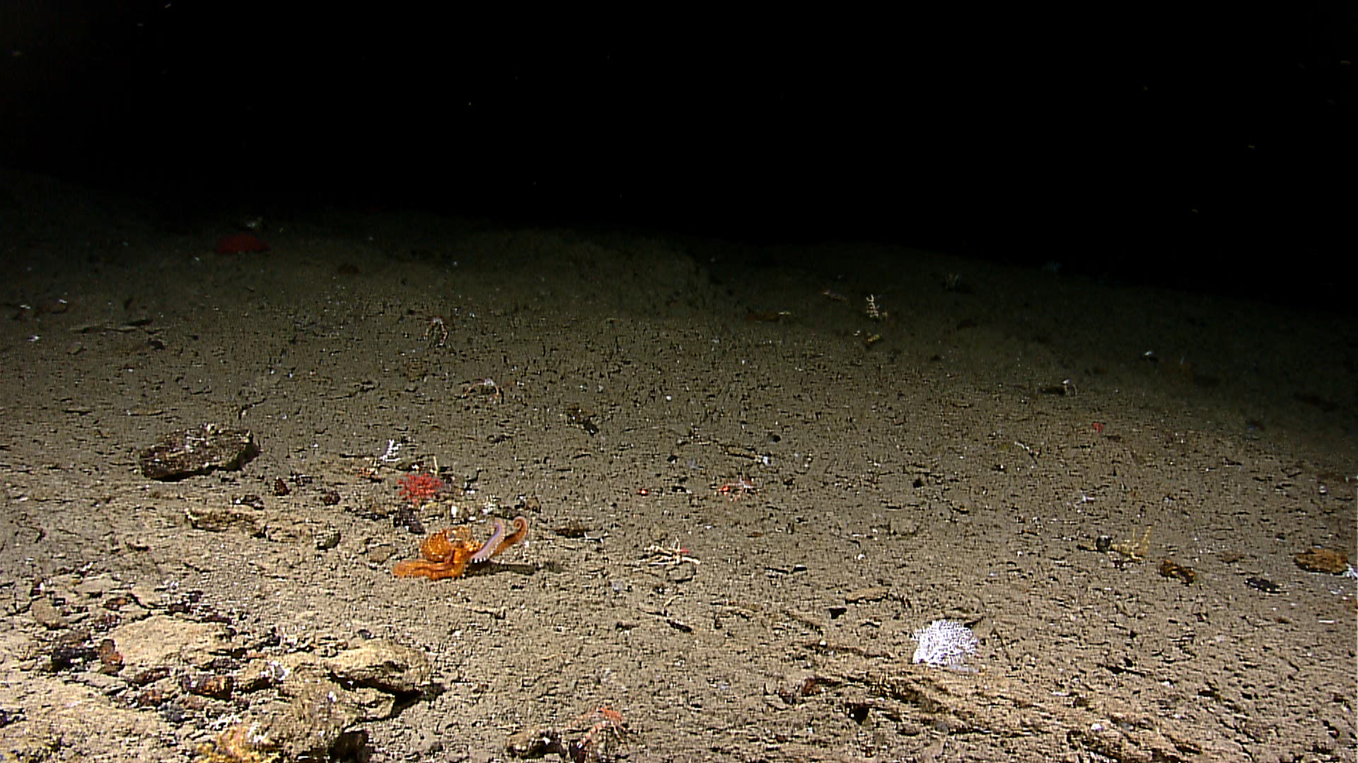
20100802_00h01m23s16_ROVHD_CORAL_FLYOVER  Impressive assemblages of rich communities were observed. Big fragments of basalt were covered with high abundances of suspension feeders. Sessile fauna densely populated terraces of cemented sand. |  |  |  |  |  |  | 20100802_00h59m24s11_ROVHD_HUNTING_OCTOPUS  The seafloor became predominantly clay-carbonate (pyroclastic tuff) with rounded cobbles dispersed along the margins and in depressions as we came shallower. Not much sessile fauna was seen on it. However high abundances of mobile fauna and burrowing fauna were observed.
Please direct inquiries to: |  | NOAA Office of Ocean Exploration & Research  1315 East-West Highway (SSMC3 10th Floor)  Silver Spring, MD 20910  (301) 734-1014

