Okeanos Explorer ROV Dive Form
Site Name | Site G |  |  |  |  |  |  | 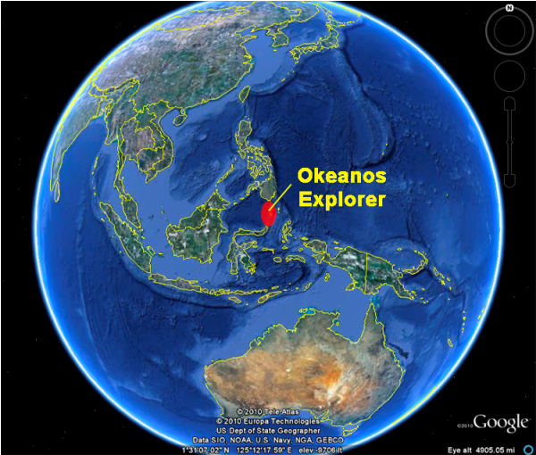
ROV Lead | Dave Lovalvo
General Area Descriptor | 100km N of Bitung, Indonesia
UTC Date & Time | Deployment |  | 7/26/2010 12:13 AM
UTC Date & Time | Recovery |  | 7/26/2008 8:46 AM
Bottom Time  [HH:MM] | 04:50
Landing  Time & Location | UTC Time | 02:15 |  |  |  |  |  |  | Depth [m] |  | 2105
Landing  Time & Location | Latitude | 2 |  |  | º | 16.137868 |  |  |  |  |  | ‘ |  | N
Landing  Time & Location | Longitude | 124 |  |  | º | 49.061981 |  |  |  |  |  | ‘ |  | E
Off Bottom  Time & Location | UTC Time | 07:05 |  |  |  |  |  |  | Depth [m] |  | 1961
Off Bottom  Time & Location | Latitude | 2 |  |  | º | 16.190017 |  |  |  |  |  |  | ‘ | N
Off Bottom  Time & Location | Longitude | 124 |  |  | º | 49.37548 |  |  |  |  |  |  | ‘ | E
ROV Dive Name | Cruise Season |  |  | Leg |  |  |  |  |  | Dive Number
ROV Dive Name | EX1004 |  |  | LEG03 |  |  |  |  |  | ROV04 (17)
Equipment Deployed | ROV: |  |  | Little Hercules
Equipment Deployed | Camera Platfom: |  |  | Phoenix Camera Platform
ROV Measurements | CTD |  |  | Depth |  |  |  |  |  | Altitude
ROV Measurements | Scanning Sonar |  |  | USBL Position |  |  |  |  |  | Heading
ROV Measurements | Pitch |  |  | Roll |  |  |  |  |  | HD Camera
ROV Measurements | Low Res Cam 1 |  |  | Low Res Cam 2
Equipment Malfunctions | None
Special Notes | Click here to enter text.
Scientists Involved  (please provide name / location / affiliation / email) | Santiago Herrera (on-board Science Lead), EX, WHOI, sherrera@whoi.edu  Tim Shank (on-shore Science Lead), USA, WHOI, tshank@whoi.edu  Eleanor Bors, ECC Seattle, WHOI, ekbors@gmail.com  Catriona Munro, WHOI, WHOI, c.munro@ucl.ac.uk  Elizabeth Sibert , WHOI, WHOI, esibert@ucsd.edu  Verena Tunnicliffe, U. Victoria, U. Victoria verenat@uvic.ca  Rainer Troa, EX, renertroa@gmail.com
Purpose of the Dive: To explore unexplored areas on the summit of Site G, and of potential hard bottom in this region of the south to compare to site “T” and sites in the north over depth zones.
Description of the Dive:
The dive started at the summit of a knoll located SW of the main cone of target G (WP1). Depth at that point was 2108m, water temp 3.60, salinity 34.58. The bottom was completely covered with sediments, with the exception of one rocky outcrop. Abundances and diversity of epifauna were very low. Mostly dominated by ophiuroids, xenophyophores, a couple of octocorals (pennatulaceans) and two remarkable fish. On the rocky outcrop there was a concentrated amount of biomass. Black corals were dominiant and many ophiuroids were seen on the rock surface. Current at this place had a heading of 335deg and a speed of 0.1 knots.

As we moved NE toward WP2 we descended to about 2200m and then started ascending again as we reached the base of the main cone of volcano G. The bottom along the way was completely covered with sediments, with the exception of one large rocky outcrop. Abundances and diversity of epifauna were very low on the sediments. Mostly dominated by ophiuroids and xenophyophores. On the rocky outcrop there was a extremely high concentration of biomass. Multiple species of black corals, bamboo corals and crinoids were dominiant and many ophiuroids were seen on the rock surface.

We started climbing up hill over a steep slope as we moved E toward WP3. The hard bottom area, and diversity and abundance of epifauna increased gradually with decreasing depth. A dominant southward downwelling current was observed. On the hard bottom substrates the fauna was similar as the one found in the deeper outcrops.

In general the diversity was significantly lower than, for example, site K. But the localized abundances of fauna on hard substrates were very high. It is also noteworthy that the sizes of most organisms were quite large. This could be taken as indicative of an ecosystem not limited by food but by availability of substrates. As a side point, no individuals of Anthomastus, stylasterids or scleractinian corals were observed at volcano G in either of the two dives.
Overall Map of ROV Dive Area |  |  |  |  |  |  | Close-up Map of Main Dive Site
+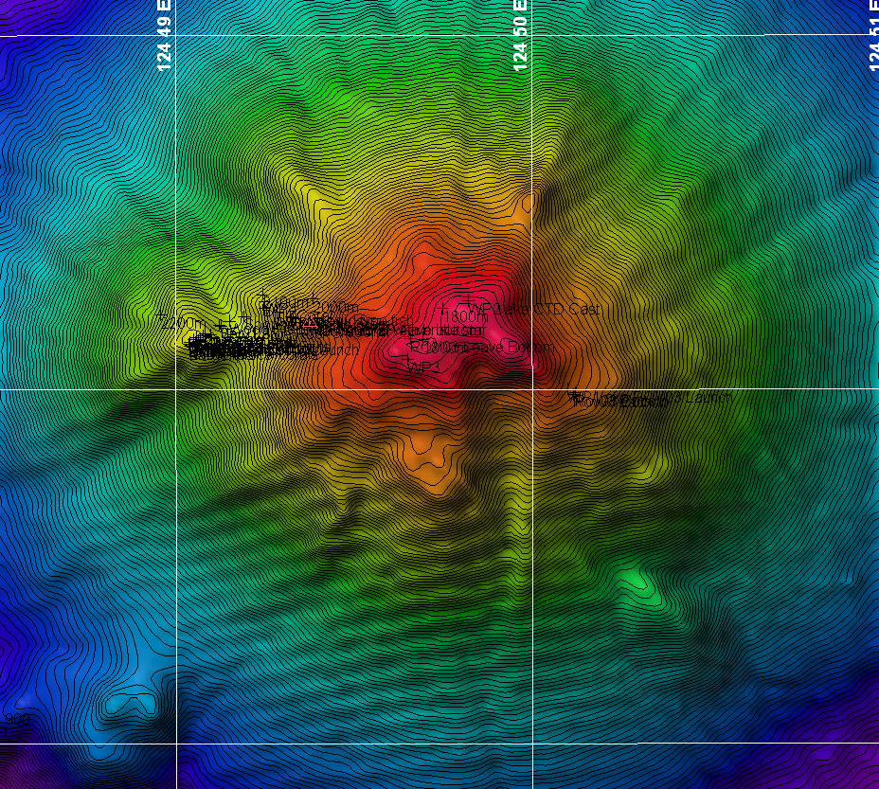 |  |  |  |  |  |  | 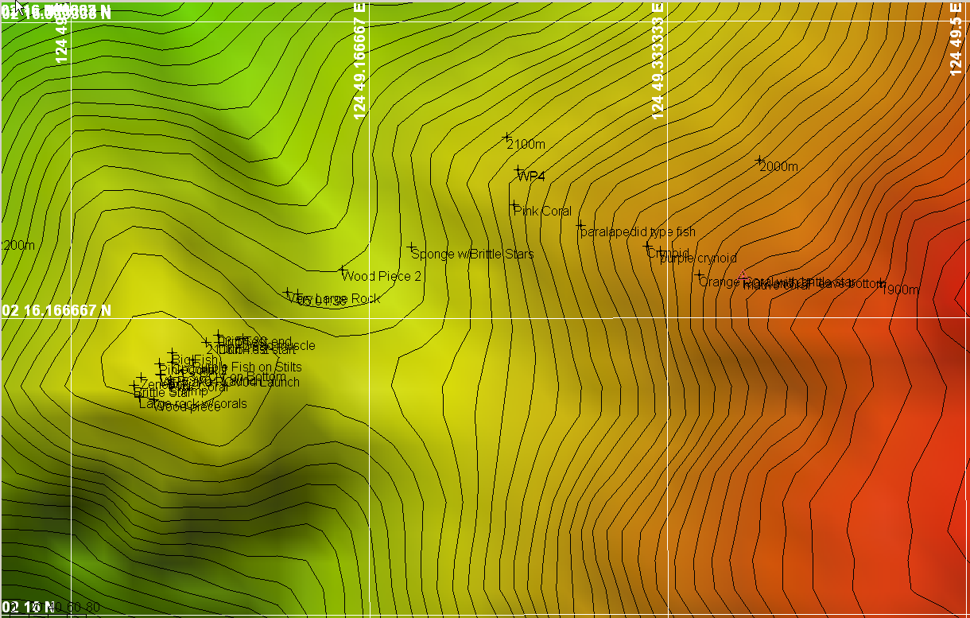
Overview of Site G |  |  |  |  |  |  | Hypack screen grab of dive Targets

Representative Photos of the Dive
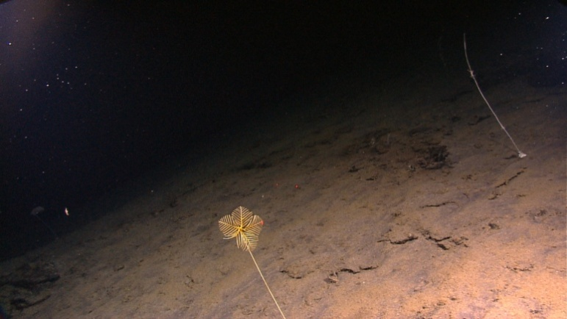 |  | 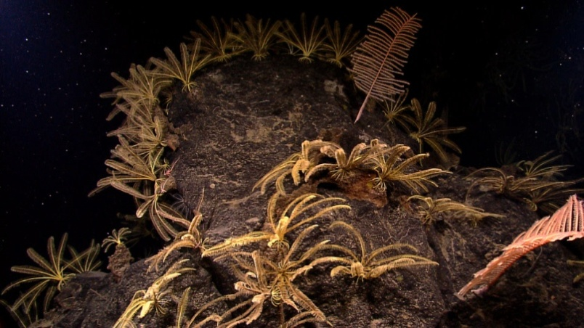
20100726_06h18m35s16_ROVHD_YELLOW_CORAL  The bottom along the way was completely covered with sediments, with the exception of one large rocky outcrop. Abundances and diversity of epifauna were very low on the sediments. |  | 20100726_05h03m05s16_ROVHD_ROCK_DETAIL  In general the diversity was significantly lower than, for example, site K. But the localized abundances of fauna on hard substrates were very high.
Please direct inquiries to: | NOAA Office of Ocean Exploration & Research  1315 East-West Highway (SSMC3 10th Floor)  Silver Spring, MD 20910  (301) 734-1014

