NOAA Okeanos Explorer Program

MAPPING REPORT

EX1004 Leg 2
Exploration, Indonesia

June 24 to July 14, 2010
Bitung to Bitung

Report Contributors:
Mashkoor Malik, LT Nicola VerPlanck, Elaine Stuart, Colleen Peters, Joel DeMello, Tom Kok, Karl McLetchie

July 26, 2010
NOAA Office of Ocean Exploration and Research
1315 East-West Hwy, SSMC3, #10210
Silver Spring, MD 20910




Introduction

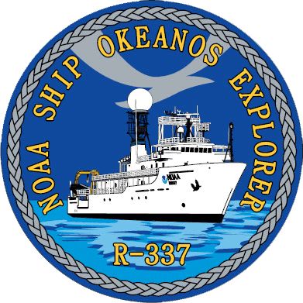


The Okeanos Explorer Program

Commissioned in August 2008, the NOAA Ship Okeanos Explorer is the nation’s only federal vessel dedicated to ocean exploration. With 95% of the world’s oceans left unexplored, the ship’s unique combination of scientific and technological tools positions it to systematically explore new areas of our largely unknown ocean. These explorations will generate scientific questions leading to further scientific inquiries.

Using a high-definition multibeam sonar with water column capabilities, a deep water remotely operated vehicle, and telepresence technology, Okeanos Explorer provides NOAA the ability to foster scientific developments by identifying new targets in real time, diving on those targets shortly after initial detection, then sending this information back to shore for immediate near-real-time collaboration with scientists and experts at Exploration Command Centers around the world. The subsequent transparent and rapid dissemination of information-rich products to the scientific community ensures that discoveries are immediately available to experts in relevant disciplines for better understanding.

Through the Okeanos Explorer Program, NOAA’s Office of Ocean Exploration and Research provides the nation with important capabilities to discover and investigate new ocean areas and phenomena, conduct the basic research required to document discoveries, and seamlessly disseminate data and information-rich products to a multitude of users. The program strives to develop technological solutions and innovative applications to critical problems in undersea exploration and to provide resources for developing, testing, and transitioning solutions to meet these needs.

Okeanos Explorer Management – a unique partnership within NOAA

NOAA Ship Okeanos Explorer is operated, managed and maintained by NOAA’s Office of Marine and Aviation Operations, which includes commissioned officers of the NOAA Corps and civilian wage mariners. NOAA’s Office of Ocean Exploration and Research is responsible for operating the cutting-edge ocean exploration systems on the vessel. It is the only federal ship dedicated to systematic exploration of the planet’s largely unknown ocean.

Table of Contents
1. Introduction 2
2. Report Purpose 3
3. Cruise Objectives 4
4. Participating Personnel 5
5. Mapping Statistics 5
6. Mapping Sonar Setup 6
May 2010 Patch test results 6
7. Data Acquisition and Processing Summary 7
8. Cruise Calendar 9
9. Daily Cruise Log 10
10. References 16
11. Appendices 17
Appendix A: Field Products 17
Potential Discovery Report 17
Appendix B: Tables of Data Collected 19
Sound Velocity Profile Log (XBT) 23
CTD File Log 24
ROV Dive Locations 24
Appendix C: List of acronyms 25
Appendix D: EM 302 PU Parameters 26
Appendix E: Software versions in use during EX1004 Leg 2 32

Report Purpose

The purpose of this report is to briefly describe the data acquisition and processing of the EM 302 multibeam system during EX1004 Leg 2 cruise (June 24 – July 14, 2010). For details about the setup of the various mapping equipment /sensors, please refer to ‘NOAA Ship Okeanos Explorer Mapping Readiness Report 2010’ which can be obtained from the ship. Also, please note that this report covers only the EM 302 multibeam mapping activities conducted during this cruise. Considerable other activities including Conductivity Temperature Depth (CTD) casts, Remotely Operated Vehicle (ROV) dives, and education and outreach activities were conducted which may be referred to in this report. Details will be provided an overall cruise report (forth coming).

The crew of the NOAA Ship Okeanos Explorer is greatly appreciated for their efforts in helping make the cruise a success.

Cruise Objectives

This cruise was the first of the series of cruises conducted in cooperation between the US and Indonesian governments. INDEX-SATAL 2010 (Indonesia Exploration–Sangihe Talaud Region) expedition is aimed at exploration of an area approved by the Indonesian government north of Sulawesi Island, Indonesia (Figure 1). This area will be referred to in this report as the INDEX-SATAL 2010 exploration area. The INDEX-SATAL 2010 area extends from 2° N to 6° 24’ N and 124° 45’ E to 128° E covering an area of ~ 31,000 square miles. The coordinates of INDEX-SATAL exploration area are provided in Table 1.

Scientists from the US and Indonesia participated in the expedition onboard and through telepresence technology with Exploration Command Centers (ECCs) established in Seattle and Jakarta.

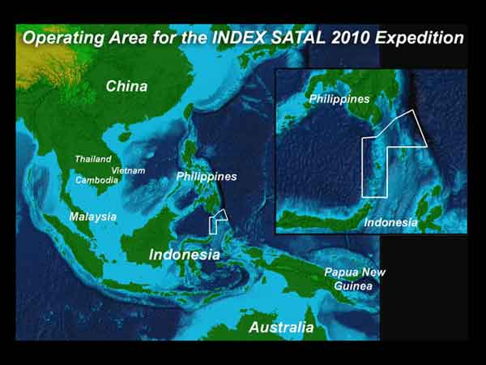
Figure 1. Location of INDEX-SATAL 2010 exploration area outlined as white polygon in the above image. Image credit: NOAA.

Table 1. Coordinates of INDEX-SATAL 2010 exploration area as depicted in Figure 1.
Point ID | Longitude (E) | Latitude (N)
1 | 126° 0’ 0” | 2° 0' 0"
2 | 124° 45' 36" | 2° 0' 0"
3 | 126° 0' 0" | 4° 30' 0"
4 | 128° 0' 0" | 4° 30' 0"
5 | 127° 17' 59.99" | 6° 24' 0"
6 | 126° 24' 0" | 5° 54' 0"
7 | 125° 30' 0" | 5° 0' 0"
8 | 124° 45' 0" | 4° 57' 0"

Remote Science: A new paradigm

Equipped with a high speed internet connection, the NOAA Ship Okeanos Explorer is capable of streaming live video and data to shore, commonly referred to as telepresence. This capability, along with shore based ECCs, allow shorebased scientists to talk directly with shipboard personnel. This partnership allows for real-time collaboration between shore side and ship-based participants to make decisions on where the ship’s efforts would be focused i.e. on areas and targets of particular interest. EX1004 Leg 2 was the first cruise during which onboard scientists collaborated with shore based scientists at ECCs in Seattle and Jakarta during real-time multibeam mapping and ROV operations.

John Sherrin (University of Victoria, Canada) and Xerandy (Indonesian Agency of Technology Assessment and Application-BPPT) participated in this cruise as the science representatives onboard. Dr. Jim Holden acted as designated lead scientist for this cruise based at the ECC in Jakarta. As such, scientists onboard and ashore worked closely based on the data and information that were made available through host of collaboration tools including designated FTP servers, and live broadcast of ROV video and computer screens. A Geotiff image, IVS SD object and a ASCII gridded text file were provided on a daily basis to the ECCs through the FTP site to keep the ECCs up to date about the EM302 mapping results.

Participating Personnel

NAME | ROLE | AFFILIATION
CDR Joseph Pica | Commanding Officer | NOAA Corps
Jeremy Potter | Expedition Coordinator | NOAA OER
LT Nicola VerPlanck | Field Operations Officer | NOAA Corps
Jim Holden | Designated senior Scientist (Jakarta ECC) | Jakarta (PMEL)
Elaine Stuart | Senior Survey Technician | NOAA OMAO
Colleen Peters | Senior Survey Technician | NOAA OMAO
Joel DeMello | Mapping Watchstander | NOAA OER/UCAR Intern
Tom Kok | Mapping Watchstander | NOAA OER/UCAR Intern
Karl McLetchie | Mapping Watchstander | NOAA OER/UCAR Intern
Mashkoor Malik | Mapping Team Lead | NOAA OER (ERT, Inc.)
John Sherrin | US Science Lead | University of Victoria, Canada
Xerandy | Indonesian Science Lead | Indonesian Agency of Technology Assessment and Application (BPPT)
Major Muddan Zayadi | Indonesian Navy Observer | Indonesian Navy (TNI)

Mapping Statistics
Dates | June 24 – July 14, 2010
Linear km mapped | 4247 km
Square km mapped | 3157 km²
Number of bathymetric multibeam files | 158
Number of water column backscatter files | 43
Data volume of raw multibeam data files | 25.3 GB
Number of XBT casts | 37
Number of CTD casts (not including ROV CTD) | 13

Mapping Sonar Setup

NOAA Ship Okeanos Explorer (EX) is equipped with a 30 kHz Kongsberg EM 302 multibeam sonar and a 3.5 kHz Knudsen sub-bottom profiler (SBP 3260). During this cruise EM 302 bottom bathymetric and backscatter data were collected. Additionally, EM 302 water column data were continuously monitored by mapping watch standers and the water column data were logged when the mapping watch standers observed water column targets in the water column data.

The ship used a POS MV ver. 4 to record and correct the multibeam data for any ship’s motion. C-NAV GPS system provided DGPS correctors with position accuracy expected to be better than 2.0 m.

All the corrections (motion, sound speed profile, sound speed at sonar head, draft, sensor offsets) were applied during real time data acquisition in Kongsberg data acquisition software Seafloor Information System (SIS) ver. 3.6.4 build 176. Expendable bathythermograph (XBT) casts (Deep Blue, max depth 760 m) were taken every six hours and in between when needed. The XBT cast data were converted to SIS compliant format using NOAA in house tool for XBT processing: Velocipy. Please consult Appendix A, for details about parameters and settings used for EM 302 data acquisition.

A Built in System Test (BIST) conducted before departure indicated a transmit board (#16) defective. The transmit board was replaced with an onboard spare board before departure on June 24, 2010. A BIST conducted after the transmit board replacement indicated that all the transmit boards were passing the BISTs, but the same board (#16) failed the BIST test conducted on the following day (25 June, 2010). The EM 302, in-spite of one defective transmit board, provided good quality data during the initial tests soon after arriving in the approved mapping area. Based on these initial tests it was decided that the ship would continue its mapping mission. The affects of the defective transmit board on the data quality were assessed throughout the cruise by comparing this cruise data with earlier cruises. However, no apparent loss of data quality was observed. Kongsbserg, Inc. was also contacted about recurring problems with the failed transmit board.

May 2010 Patch test results

Angular offsets (based on a patch test conducted in May 2010) are tabulated below. For complete processing unit setup (PU Setup) utilized for the cruise, please refer to Appendix A.

Table 2. Angular offsets for Transmit (TX) and Receive (RX) transducer as determined during a patch test conducted in May 2010.
 | Roll | Pitch | Heading
Tx Transducer | 0.0 | 0.0 | 359.98
Rx Transducer | 0.0 | 0.0 | 0.03
Attitude | 0.0 | -0.80 | 0.0

Data Acquisition and Processing Summary

The primary purpose of the multibeam data during this expedition was to provide baseline maps for further exploration using the CTD and ROV. The cruise instructions (Ref. A) had to be modified during this cruise to adapt to the changes in operational priorities and loss of time that had previously been dedicated to mapping during EX1004 Leg 1. As a consequence, the mapping plan was adjusted to first cover the area which is shown in the over view image (Figure 2) as the EX2 mapping box which was deemed of value for further ROV and CTD work. To maximize the use of all the resources available onboard, it was decided that the ship would conduct mapping operations during the night and ROV and CTD casts would be conducted during the day. As the cruise progressed, the targets for CTD casts and ROV dives were refined in collaboration with the Seattle and Jakarta ECCs with shifting focus of operations to the EX1 mapping box for a significant amount of time (July 4-10, 2010). The ship then resumed work in EX2 mapping box on July 11, 2010. .

As shown in Figure 2, the overall operating box was the area approved by the Indonesian government for this exploration cruise. No data were acquired outside this approved box.

Although several CTD casts were conducted during this cruise, this report will not provide details about data analysis of CTD casts. As the CTD data were primarily used to locate positions of the hydrothermal vents, multibeam sonar water column data, when available, were analyzed further on these locations to infer if the plume structure was visible in the MB water column data. However, no water column targets were detected in the locations of the CTD casts. The locations of the CTD casts are provided in Table 8c of this report.

Onboard processing of bathymetric data was done in CARIS HIPS ver. 6.1 where the data were cleaned in ‘Swath Editor’ and ‘Subset Editor’. No tidal corrections were applied during post processing; however, no appreciable differences were observed between different lines by not applying tidal corrections. A nominal grid cell size of 50 m was chosen for the bathymetric grids. Onboard processing of bottom and water column backscatter data was conducted using Geocoder and IVS Fledermaus respectively but was limited only to a few specific targets. Detailed processing of bottom and water column backscatter data for the whole cruise was not attempted onboard.

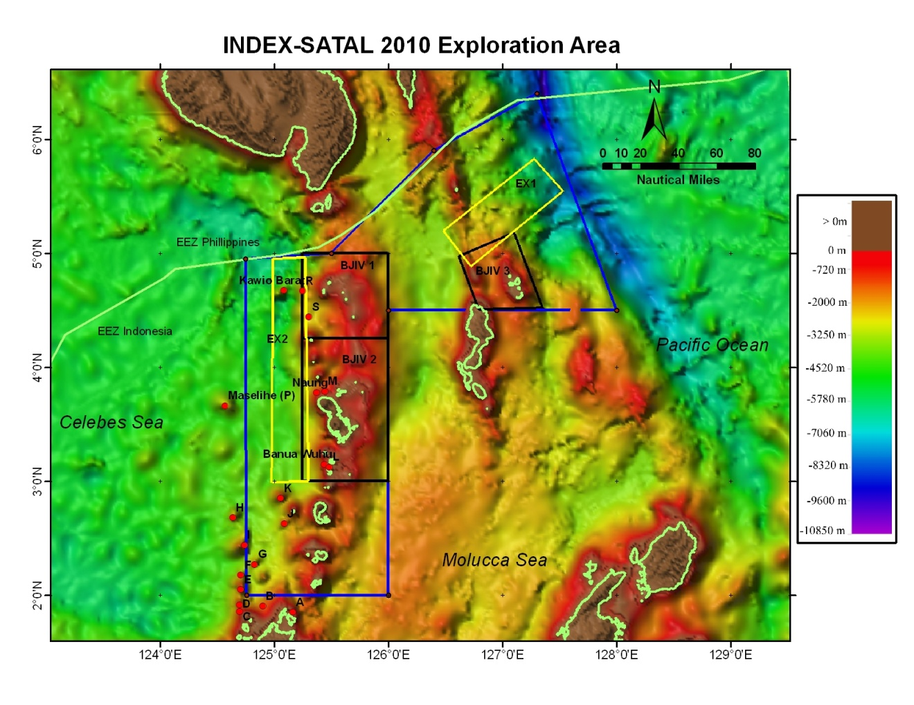
Figure 2. The overall exploration area during EX1004 Leg II. Mapping areas indicated by the yellow outline were the primary focus for the mapping operations referred to as EX2 and EX1 mapping boxes respectively (Ref A). The targets described by Ref B in the vicinity of INDEX-SATAL 2010 operating area are shown also. Background bathymetric data is from satellite derived bathymetry (Ref D). R/V Baruna Jaya IV (BJIV) mapping priority areas are shown as BJIV 1-3.

For detailed reports about CTD casts and ROV dive site, the reader is requested to consult those relevant data reports. The Indonesian research vessel Baruna Jaya IV (BJIV) will be operating in INDEX-SATAL 2010 exploration area later this year. The priority mapping areas for BJIV are shown in Figure 2 as BJIV 1-3 for reference. No mapping data from BJIV was available during this leg.

Several of the sites referred in this report are named as defined by McConachy et al, 2004. [Reference B]. For consistency, those same names of the sites were utilized for this report.

A total of 4247.14 linear km (2293.27 linear miles) were mapped during this cruise covering an area of 8178.9 mi² within the approved INDEX-SATAL 2010 exploration area. The exploration area was comprised of several islands around which very shallow water depths were observed. The seafloor away from the islands slowly deepens to water depths reaching ~ 5000 m (as observed in EX2 mapping area). The maximum water depth was observed in the eastern area o f EX1 mapping box where the maximum depth recorded was ~ 7000 m.

Multibeam mapping results overview – bathymetric data
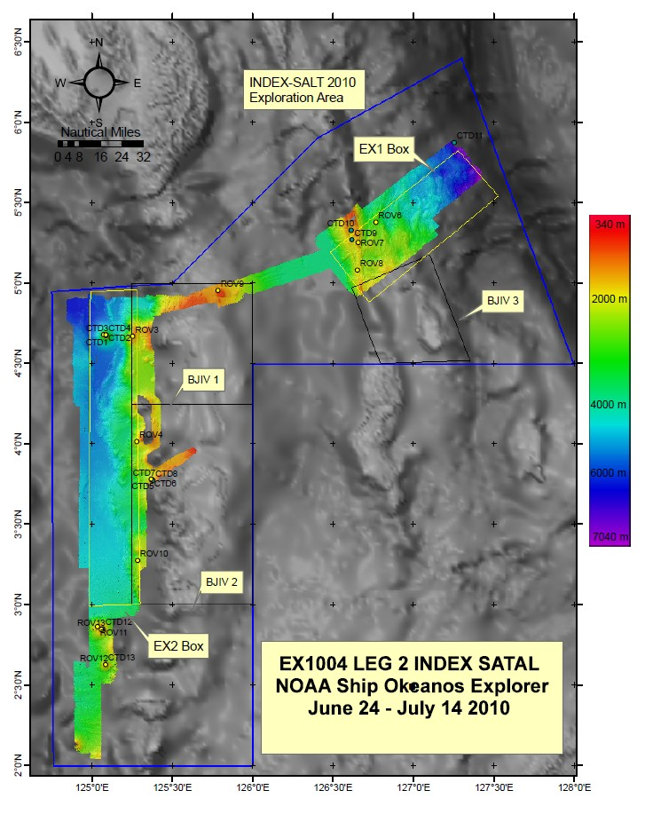
Figure 3. Overview of the EM302 multibeam bathymetric results (50 m grid) during EX1004 Leg 2 cruise. EM302 data grid compiled in Fledermaus, background data is from satellite derived bathymetry. Figure compiled in ArcMap.

Cruise Calendar

June 2010
Mon | Tue | Wed | Thu | Fri | Sat | Sun
 |  |  | 24  Departed Bitung. Arrived working grounds 1600  Started mapping operations 1630. | 25  Conducted mapping in the western boundary of the EX2 mapping area | 26  Continue mapping in the EX2 mapping area. Passed over Kawio Barat | 27  Conducted CTD casts over Kawio- Barat from 0800-1700. Resumed mapping overnight
28  Continued mapping in south eastern portion of EX2 mapping area | 29  0800-Conducted ROV dive over Kawio Barat (#1). Conducted CTD ops till 1900. Resumed Mapping in EX2 mapping area | 30  Conducted ROV dive (#2) over Kawio Barat. Resumed mapping west of EX2 mapping area during night
July 2010
 |  |  | 1  Conducted ROV dive over target R.  (#3)  Resumed mapping in the shallow areas between the islands. | 2  Conducted ROV dive  (#4)  Conducted two cross lines over the bathymetric data collected so far. | 3  Conducted ROV dive over target Naung.  (#5)  At 1800 ship transited towards mapping area EX1 | 4  Conducted mapping operations in EX1 area.
5  Conducted ROV dive.  #6 | 6  Conducted ROV dive #7  Resumed mapping. Conducted CTD cast #10 | 7  Conducted mapping in the deeper areas of EX1 box | 8  Conducted ROV dive | 9  Conducted ROV dive  In the area transit from EX1 to EX2 box. Transited to EX1 box | 10  Conducted ROV dive in EX2 box | 11  Conducted ROV dive over target K
12  Conducted ROV dive over target J. Overnight mapped in the south western area of approved exploration box | 13  Conducted ROV dive over target K again. Secured all sensors while outside the approved exploration area. | 14  Arrived Bitung, Indonesia

Daily Cruise Log

(ALL TIMES LOCAL Guam Time)

June 24, 2010

Departed Bitung, Indonesia. Working towards northern boundary of EX2 box. Observed some interesting features on the seafloor which look like scours on the seafloor with depths of ~ 20 m and widths of 200 – 400 m. Shown below in Figure 4.

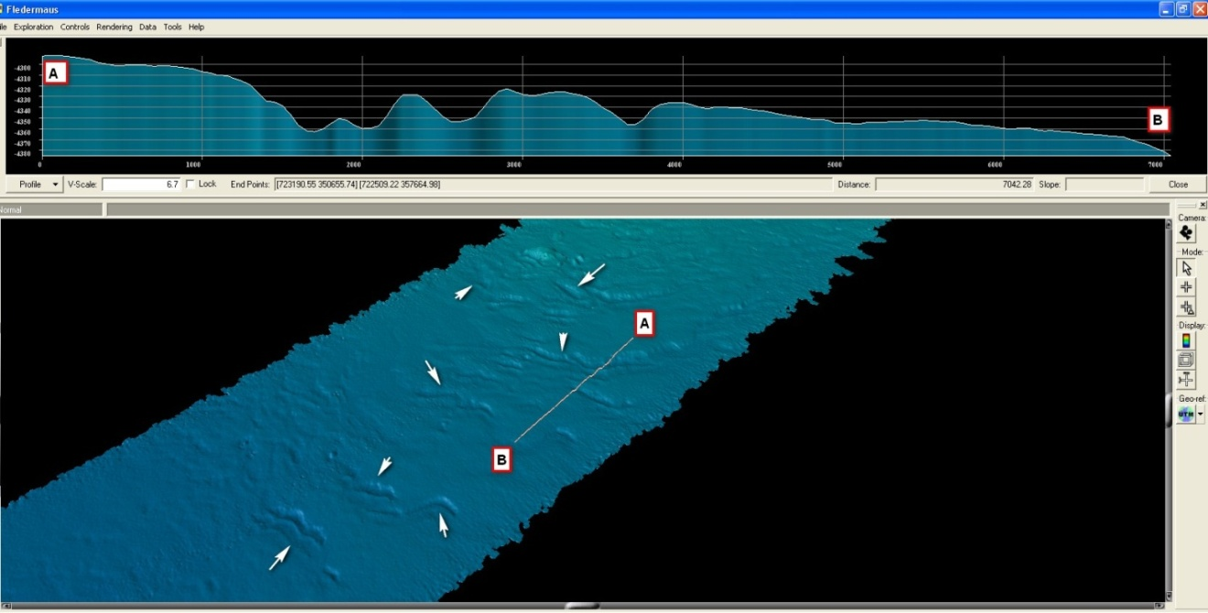
Figure 4. Scour-like features observed in multibeam bathymetry on 24 June, 2010. Screengrab from Fledermaus. Image credit: NOAA.

June 25, 2010

Conducted first two passes over Kawio Barat. Water column data over Kawio Barat collected. No water column targets observed in the water column. The Jakarta ECC (Michael Purawdi) notified ship of a potential plume site in location 4.6370 N 125.0504 E. Upon further observation of the water column data no targets were located in the water column. A screen grab of the stacked beams are provided below in Figure 5.

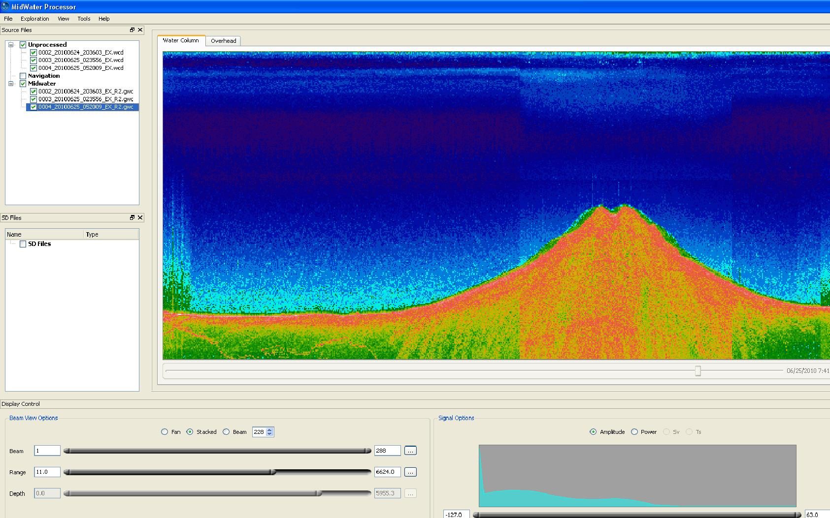
Figure 5. Screengrab of EM302 multibeam water column data of submarine volcano Kawio Barat shown in FM Midwater (IVS Fledermaus version 7). Image credit: NOAA.

June 26, 2010

Continued mapping in the exploration box. No sign of water column targets in the water column data during a second and third pass over Kawio Barat.

June 27, 2010

Finished 3rd line in the yellow exploration box and ran 4th line to half of the line distance to turn back and run the 5th line back to Kawio Barat to be at Kawio Barat at 0800 to conduct CTD operations over Kawio Barat.

June 28, 2010

Conducted CTD operations over Kawio Barat observing plume signals in the CTD data. Resumed mapping operations during night time. Completed processing of the data. Observed a feature which appears to rise more than 1500 m above the seafloor not shown in the satellite derived bathymetry. See Figure 6 below. This feature is presumed a previously unknown seamount. A potential discovery report was drafted with complete details (attached as Appendix B).

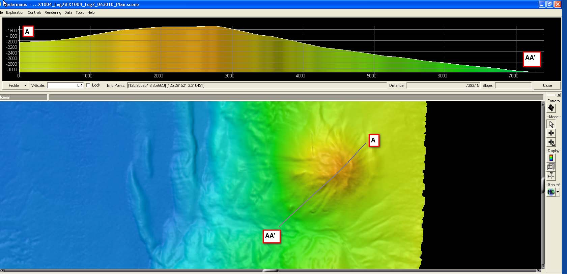
Figure 6. EM302 multibeam bathymetry of potential discovery, a 1500+ meter high seamount. Data shown in IVS Fledermaus. Image credit: NOAA.

June 29, 2010

Conducted ROV Dive over Kawio Barat observing several interesting features. Towards the end of the dive, heavy smoke and reduced visibility showed that ROV is very close to the source of the plume. Resumed mapping operations during night.

June 30, 2010

Conducted ROV operations over Kawio Barat which showed spectacular images of the smokers and chimneys. Water column data from multibeam did not show these features. Resumed mapping operations during night.

July 1, 2010

Conducted ROV operations on a feature east of Kawio Barat depth ~ 1000 m. Referred as target R in the ROV dive map. Transited to south over night to conduct mapping operations between the islands in shallow waters.

July 2, 2010

During today’s launch of ROV, EM 302 was turned on to test if ROV and Camera sled will be picked up by EM 302 in the water column data. The EM 302 successfully picked up the ROV all the way down to the depth of ~ 1650. A discrepancy was observed between the across track depth (shown as a number in across track window) and the depth inferred in the water column target based on visual seafloor. Looks like the number in the cross track does not show the depth at the nadir. Also a lot of water column particulate material were observed as ROV descended to the seafloor. However, any quantitative analysis of scattering particles in the water column is difficult from the ROV data alone.

July 3, 2010

Conducted ROV dive over site Naung. Started transit towards EX1 box after completion of the dive.

July 4, 2010

Arrived in vicinity of EX1 mapping area and started mapping operations.

July 5, 2010

Conducted ROV dive.

July 6, 2010

Started having issues with the XBT launcher. The ETs found out that the connector on the fantail is not working. Spares have been ordered and will be available for next leg.

July 7, 2010

Conducted ROV dive, resumed mapping during night.

July 8, 2010

Conducted ROV dive, resumed mapping during night.

July 9, 2010

Conducted ROV dive over the shallow area plateau like feature which was detected during transit from EX2 box to EX1 box.

July 10, 2010

Conducted ROV dive over sedimented area in EX2 box. Overnight ran the lines over target K and J.

July 11, 2010

Conducted ROV dive over target K. While passing over the dive site observed water column target in the multibeam sonar water column target (line #133) as shown in the figure below. ROV dive site ~ 600 m east of this observation but did not observe any anomaly in the ROV data. See Figure 7.

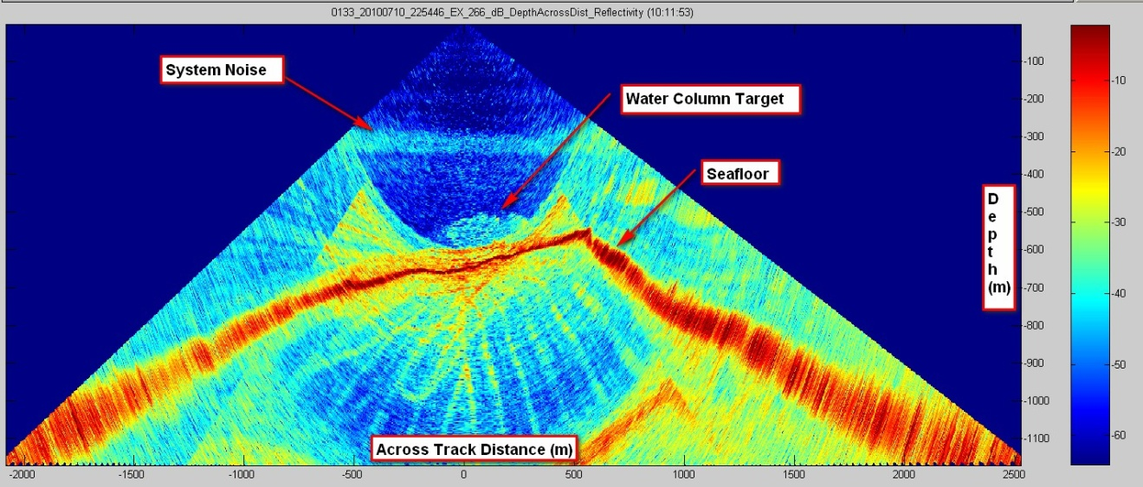
Figure 7. Water column target observed on July 11, 2010 at Site K. Data shown in FM Midwater (IVS Fledermaus version 7) water column data processing software. Image credit: NOAA.

July 12, 2010

Conducted ROV dive over target J.

July 13, 2010

Conducted ROV dive over target K again. Observed the water column target in EM 302 water column data. Description of the feature is shown below in Figure 8.

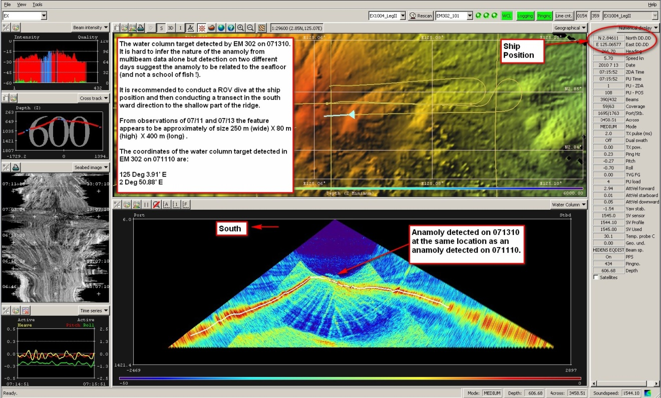
Figure 8. Screengrab showing water column target observed on July 13, 2010 at Site K. Data shown in Kongsberg SIS data acquisition software. Image credit: NOAA.

References

- John McDonough, Captain Michael Devany, Catalina Martinez, Cruise Instructions EX1004 Leg 1, 2 and 3.

- T F McConachy, H. Permana, R A Binns, I Zulkarnain, J M Parr, C J Yeats, N D Hananto, B Priadi, S Burhannuddine and E P Utomo, Recent investigations of Submarine Hydrothermal Activity in Indonesia, PACRIIM 2004, Adelaide, SA 19-22 September, 2004.

- NOAA Ship Okeanos Explorer Mapping Readiness Report, 2010. Available on request from the ship. Email contact: ops.explorer@noaa.gov.

- Smith, W. H. F., and D. T. Sandwell, Global seafloor topography from satellite altimetry and ship depth soundings, Science, v. 277, p. 1957-1962, 26 Sept., 1997.

Appendices

Appendix A: Field Products

Potential Discovery Report

===============================================================
NOAA OFFICE OF OCEAN EXPLORATION AND RESEARCH
NOAA SHIP OKEANOS EXPLORER
POTENTIAL DISCOVERY (DISCO-P) REPORT - SEAMOUNT
July 1, 2010

Prepared By: Submitted To:
NOAA Ship Okeanos Explorer NOAA Office of Ocean Exploration
Mapping Team Jeremy Potter (OER)
Team Lead: Mashkoor Malik Expedition Coordinator
===============================================================
CRUISE: EX1004 Leg 2  INDEX-SATAL 2010 CRUISE | DATE/TIME FILED:  July 1, 2010 / 0900 GMT  Location of potential discovery:  North of Bitung, Indonesia about 200 km  In location 3.34305 N 125.29062 E
VESSEL:
NOAA Ship Okeanos Explorer (EX)

===============================================================
SUMMARY:

A structure on the seafloor was detected around 2000 on June 27, 2010, while mapping in the INDEX-SATAL approved exploration area. The structure appears to be an underwater seamount with shallowest depth of ~ 1490 m below sea level. The adjacent seafloor to the north-northeast of the structure lies at ~ 2000-2200 m while the seafloor to the south-southwest lies at water depth of greater than 3000 m making the maximum height of the top of the structure rising more than 1500 m from adjacent seafloor. No existing data other than Sandwell and Smith seafloor Topography are available onboard to verify if this is a new discovery. Sandwell and Smith seafloor topography; however, does not appear to show this structure.

===============================================================
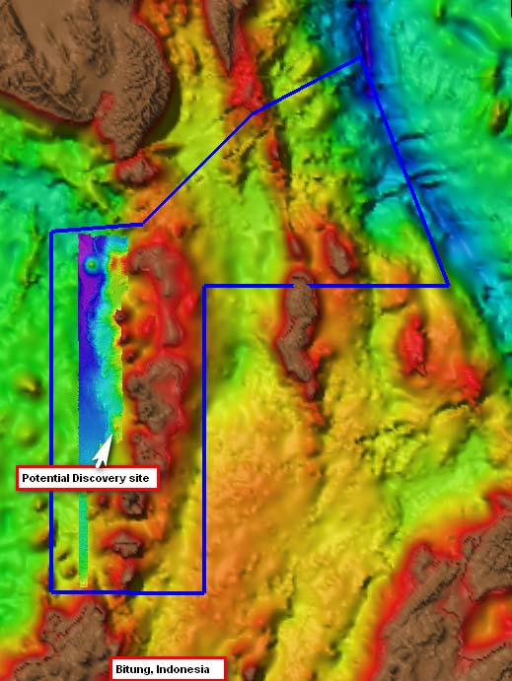
DISCUSSION:

Figure 1: Location map of the potential seamount showing background bathymetry from Sandwell and Smith seafloor topography overlaid with the multibeam data collected during EX1004 Leg 2. Image credit NOAA.

The underwater seamount was found while conducting INDEX-SATAL 2010 exploration of the approved areas for the exploration using Kongsberg EM 302 multibeam sonar. The data were processed in CARIS HIPS and brought into Fledermaus for visualization and measurements.

No existing data available onboard showed this structure but more detailed scientific vetting is required before this find can be labeled as discovery.

Figure 2: Bathymetric profile across the potential seamount showing a rise of more than 1500 m from adjacent seafloor. Image from IVS Fledermaus ver. 6. Image credit NOAA.
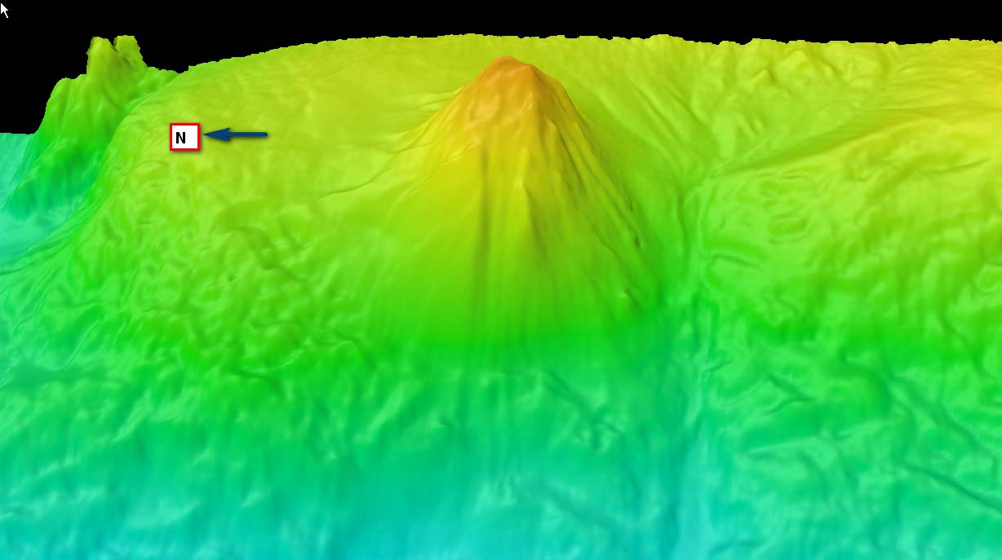

Figure 3: Perspective view of the structure created using IVS Fledermaus with sun illumination from northwest with 3 times vertical exaggeration. Image shows a view looking east. Image credit NOAA.

===============================================================
FURTHER WORK BEING PLANNED:

There is a possibility of conducing CTD casts and ROV dives on this site during the current cruise. At the time of writing of this report no further data have been collected at the site.
===============================================================
COMMENTS:

Discoveries are a cornerstone of EX work. Protocols still need to be designated for presenting the news of discoveries, soliciting pertinent help from shore based scientists, communicating the results to the public/scientists and determining individual responsibilities within OER and onboard the EX. The ship based mapping team has taken the initiative to compile a preliminary report describing a new find which has discovery potential (DISCO-P). It is hoped that this report will initialize the chain of events that are required to handle new discoveries.

===============================================================
=========END OF DISCOVERY POTENTIAL REPORT===================
===============================================================

Appendix B: Tables of Data Collected

EX1004 LEG 2 MULTIBEAM
BATHYMETRY / BOTTOM BACKSCATTER FILES
Note: WCD in comments section indicates water column data also collected to separate .wcd file
Cruise Day No | Date (GMT) | MB Line Filename | Location | SIS Survey Name | Comments
1 | 6/24/2010 | 0000_20100624_083556_EX.all | Transit to Box EX2 | EX1004_LegII
1 | 6/24/2010 | 0001_20100624_143556_EX.all | Box EX2 | EX1004_LegII
1 | 6/24/2010 | 0002_20100624_203603_EX.all | Box EX2 | EX1004_LegII | WCD
2 | 6/25/2010 | 0003_20100625_023556_EX.all | Box EX2 | EX1004_LegII | WCD
2 | 6/25/2010 | 0004_20100625_052009_EX.all | Box EX2 | EX1004_LegII | WCD
2 | 6/25/2010 | 0005_20100625_112011_EX.all | Box EX2 | EX1004_LegII
2 | 6/25/2010 | 0006_20100625_172007_EX.all | Box EX2 | EX1004_LegII
2 | 6/25/2010 | 0007_20100625_191551_EX.all | Box EX2 | EX1004_LegII
2 | 6/25/2010 | 0008_20100625_193721_EX.all | Box EX2 | EX1004_LegII
 |  | 0009 | Box EX2 | EX1004_LegII | SIS skipped to line 10, no data for line 9
3 | 6/26/2010 | 0010_20100626_000938_EX.all | Box EX2 | EX1004_LegII | WCD
3 | 6/26/2010 | 0011_20100626_060932_EX.all | Box EX2 | EX1004_LegII | WCD
3 | 6/26/2010 | 0012_20100626_081740_EX.all | Box EX2 | EX1004_LegII
3 | 6/26/2010 | 0013_20100626_092439_EX.all | Box EX2 | EX1004_LegII | Not Processed
3 | 6/26/2010 | 0014_20100626_095422_EX.all | Box EX2 | EX1004_LegII | WCD
3 | 6/26/2010 | 0015_20100626_155420_EX.all | Box EX2 | EX1004_LegII
3 | 6/26/2010 | 0016_20100626_164845_EX.all | Box EX2 | EX1004_LegII | Turn
3 | 6/26/2010 | 0017_20100626_171313_EX.all | Box EX2 | EX1004_LegII | WCD
3 | 6/26/2010 | 0018_20100626_223459_EX.all | Box EX2 |  | Not processed –Turn  WCD
3 | 6/26/2010 | 0019_20100626_223727_EX.all | Box EX2 | EX1004_LegII | WCD
3 | 6/26/2010 | 0020_20100626_232606_EX.all | Box EX2 | EX1004_LegII | Transit to CTD  WCD
4 | 6/27/2010 | 0021_20100627_110455_EX.all | Box EX2 | EX1004_LegII
4 | 6/27/2010 | 0022_20100627_131414_EX.all | Box EX2 | EX1004_LegII
5 | 6/28/2010 | 0023_20100627_191414_EX.all | Box EX2 | EX1004_LegII
5 | 6/28/2010 | 0024_20100628_002308_EX.all | Box EX2 | EX1004_LegII
5 | 6/28/2010 | 0025_20100628_004332_EX.all | Box EX2 | EX1004_LegII
5 | 6/28/2010 | 0026_20100628_050153_EX.all | Box EX2 | EX1004_LegII
5 | 6/28/2010 | 0027_20100628_052516_EX.all | Box EX2 | EX1004_LegII
5 | 6/28/2010 | 0028_20100628_093225_EX.all | Box EX2 | EX1004_LegII
5 | 6/28/2010 | 0029_20100628_102612_EX.all | Box EX2 | EX1004_LegII
5 | 6/28/2010 | 0030_20100628_160017_EX.all | Box EX2 | EX1004_LegII | Jog around island
5 | 6/28/2010 | 0031_20100628_171656_EX.all | Box EX2 | EX1004_LegII | WCD
5 | 6/28/2010 | 0032_20100628_212540_EX.all | Box EX2 | EX1004_LegII | Transit to line
6 | 6/29/2010 | 0033_20100629_141135_EX.all | Box EX2 | EX1004_LegII | Holiday fill
6 | 6/29/2010 | 0034_20100629_145931_EX.all | Box EX2 | EX1004_LegII | Holiday fill
6 | 6/29/2010 | 0035_20100629_151957_EX.all | Box EX2 | EX1004_LegII | Holiday Fill  WCD
6 | 6/29/2010 | 0036_20100629_174910_EX.all | Box EX2 | EX1004_LegII | WCD
6 | 6/29/2010 | 0037_20100629_225420_EX.all | Box EX2 | EX1004_LegII | Not Processed- Turn  WCD
7 | 6/30/2010 | 0038_20100630_110000_EX.all | Box EX2 | EX1004_LegII
7 | 6/30/2010 | 0039_20100630_154151_EX.all | Box EX2 | EX1004_LegII
7 | 6/30/2010 | 0040_20100630_160559_EX.all | Box EX2 | EX1004_LegII
7 | 6/30/2010 | 0041_20100630_210250_EX.all | Box EX2 | EX1004_LegII
7 | 6/30/2010 | 0042_20100630_220112_EX.all | Box EX2 | EX1004_LegII
8 | 7/1/2010 | 0043_20100701_100210_EX.all | Box EX2 | EX1004_LegII
8 | 7/1/2010 | 0044_20100701_103947_EX.all | Box EX2 | EX1004_LegII
8 | 7/1/2010 | 0045_20100701_115254_EX.all | Box EX2 | EX1004_LegII
8 | 7/1/2010 | 0046_20100701_130115_EX.all | Box EX2 | EX1004_LegII
8 | 7/1/2010 | 0047_20100701_132518_EX.all | Box EX2 | EX1004_LegII
8 | 7/1/2010 | 0048_20100701_150613_EX.all | Box EX2 | EX1004_LegII
8 | 7/1/2010 | 0049_20100701_154503_EX.all | Box EX2 | EX1004_LegII
8 | 7/1/2010 | 0050_20100701_160852_EX.all | Box EX2 | EX1004_LegII | Turn  WCD
8 | 7/1/2010 | 0051_20100701_162924_EX.all | Box EX2 | EX1004_LegII | WCD
8 | 7/1/2010 | 0052_20100701_170322_EX.all | Box EX2 | EX1004_LegII | WCD
8 | 7/1/2010 | 0053_20100701_171249_EX.all | Box EX2 | EX1004_LegII | WCD
8 | 7/1/2010 | 0054_20100701_192634_EX.all | Box EX2 | EX1004_LegII | WCD
8 | 7/1/2010 | 0055_20100701_193244_EX.all | Box EX2 | EX1004_LegII | WCD
8 | 7/1/2010 | 0056_20100701_215117_EX.all | Box EX2 | EX1004_LegII | WCD
8 | 7/2/2010 | 0057_20100702_002106_EX.all | Box EX2 | EX1004_LegII | WCD
9 | 7/2/2010 | 0058_20100702_142850_EX.all | Box EX2 | EX1004_LegII | Cross line
9 | 7/2/2010 | 0059_20100702_175600_EX.all | Box EX2 | EX1004_LegII | Turn
9 | 7/2/2010 | 0060_20100702_185046_EX.all | Box EX2 | EX1004_LegII | Cross line
9 | 7/2/2010 | 0061_20100702_215740_EX.all | Box EX2 | EX1004_LegII | WCD
9 | 7/2/2010 | 0062_20100702_230355_EX.all | Box EX2 | EX1004_LegII | WCD
10 | 7/3/2010 | 0063_20100703_152131_EX.all | Transit to Box EX1 | EX1004_LegII
10 | 7/3/2010 | 0064_20100703_153522_EX.all | Transit to Box EX1 | EX1004_LegII
10 | 7/3/2010 | 0065_20100703_173256_EX.all | Transit to Box EX1 | EX1004_LegII
10 | 7/3/2010 | 0066_20100703_182836_EX.all | Transit to Box EX1 | EX1004_LegII
10 | 7/3/2010 | 0067_20100703_191344_EX.all | Transit to Box EX1 | EX1004_LegII
11 | 7/4/2010 | 0068_20100704_002501_EX.all | Box EX1 | EX1004_LegII
11 | 7/4/2010 | 0069_20100704_062500_EX.all | Box EX1 | EX1004_LegII
11 | 7/4/2010 | 0070_20100704_073014_EX.all | Box EX1 | EX1004_LegII
11 | 7/4/2010 | 0071_20100704_075754_EX.all | Box EX1 | EX1004_LegII
11 | 7/4/2010 | 0072_20100704_135750_EX.all | Box EX1 | EX1004_LegII
11 | 7/4/2010 | 0073_20100704_153009_EX.all | Box EX1 | EX1004_LegII | Not Processed
11 | 7/4/2010 | 0074_20100704_155738_EX.all | Box EX1 | EX1004_LegII
11 | 7/4/2010 | 0075_20100704_194647_EX.all | Box EX1 | EX1004_LegII
11 | 7/4/1010 | 0076_20100704_202509_EX.all | Box EX1 | EX1004_LegII
11 | 7/4/1010 | 0077_20100704_222645_EX.all | Box EX1 | EX1004_LegII
12 | 7/5/1010 | 0078_20100705_105639_EX.all | Box EX1 | EX1004_LegII
12 | 7/5/1010 | 0079_20100705_130028_EX.all | Box EX1 | EX1004_LegII
12 | 7/5/1010 | 0080_20100705_132918_EX.all | Box EX1 | EX1004_LegII
12 | 7/5/2010 | 0081_20100705_173238_EX.all | Box EX1 | EX1004_LegII
12 | 7/5/2010 | 0082_20100705_175853_EX.all | Box EX1 | EX1004_LegII
12 | 7/5/2010 | 0083_20100705_215108_EX.all | Box EX1 | EX1004_LegII
13 | 7/6/2010 | 0084_20100706_141345_EX.all | Box EX1 | EX1004_LegII
13 | 7/6/2010 | 0085_20100706_162757_EX.all | Box EX1 | EX1004_LegII
13 | 7/6/2010 | 0086_20100706_165221_EX.all | Box EX1 | EX1004_LegII
13 | 7/6/2010 | 0087_20100706_200634_EX.all | Box EX1 | EX1004_LegII
13 | 7/6/2010 | 0088_20100706_200922_EX.all | Box EX1 | EX1004_LegII
14 | 7/7/2010 | 0089_20100707_053149_EX.all | Box EX1 | EX1004_LegII
14 | 7/7/2010 | 0090_20100707_055021_EX.all | Box EX1 | EX1004_LegII
14 | 7/7/2010 | 0091_20100707_092110_EX.all | Box EX1 | EX1004_LegII
14 | 7/7/2010 | 0092_20100707_095651_EX.all | Box EX1 | EX1004_LegII
14 | 7/7/2010 | 0093_20100707_130542_EX.all | Box EX1 | EX1004_LegII
14 | 7/7/2010 | 0094_20100707_133312_EX.all | Box EX1 | EX1004_LegII
14 | 7/7/2010 | 0095_20100707_170142_EX.all | Box EX1 | EX1004_LegII
14 | 7/7/2010 | 0096_20100707_174951_EX.all | Box EX1 | EX1004_LegII
14 | 7/7/2010 | 0097_20100707_175206_EX.all | Box EX1 | EX1004_LegII
14 | 7/7/2010 | 0098_20100707_221913_EX.all | Box EX1 | EX1004_LegII
15 | 7/8/2010 | 0099_20100708_095657_EX.all | Box EX1 | EX1004_LegII
15 | 7/8/2010 | 0100_20100708_113239_EX.all | Box EX1 | EX1004_LegII
15 | 7/8/2010 | 0101_20100708_113541_EX.all | Transit to Box EX2 | EX1004_LegII
15 | 7/8/2010 | 0102_20100708_151650_EX.all | Transit to Box EX2 | EX1004_LegII
15 | 7/8/2010 | 0103_20100708_155930_EX.all | Transit to Box EX2 | EX1004_LegII | WCD
15 | 7/8/2010 | 0104_20100708_172056_EX.all | Transit to Box EX2 | EX1004_LegII | WCD
15 | 7/8/2010 | 0105_20100708_175603_EX.all | Transit to Box EX2 | EX1004_LegII | WCD
15 | 7/8/2010 | 0106_20100708_180558_EX.all | Transit to Box EX2 | EX1004_LegII | WCD
15 | 7/8/2010 | 0107_20100708_201520_EX.all | Transit to Box EX2 | EX1004_LegII | WCD
15 | 7/8/2010 | 0108_20100708_203134_EX.all | Transit to Box EX2 | EX1004_LegII | WCD
15 | 7/8/2010 | 0109_20100708_210135_EX.all | Transit to Box EX2 | EX1004_LegII | Not processed  WCD
15 | 7/8/2010 | 0110_20100708_210146_EX.all | Transit to Box EX2 | EX1004_LegII | WCD
15 | 7/8/2010 | 0111_20100708_211154_EX.all | Transit to Box EX2 | EX1004_LegII | WCD
15 | 7/8/2010 | 0112_20100708_221100_EX.all | Transit to Box EX2 | EX1004_LegII
15 | 7/8/2010 | 0113_20100708_222729_EX.all | Transit to Box EX2 | EX1004_LegII
15 | 7/8/2010 | 0114_20100708_231235_EX.all | Transit to Box EX2 | EX1004_LegII | not processed
16 | 7/9/2010 | 0115_20100709_083427_EX.all | Transit to Box EX2 | EX1004_LegII
16 | 7/9/2010 | 0116_20100709_135812_EX.all | Box EX2 | EX1004_LegII | WCD
16 | 7/9/2010 | 0117_20100709_195808_EX.all | Box EX2 | EX1004_LegII
16 | 7/9/2010 | 0118_20100709_212211_EX.all | Box EX2 | EX1004_LegII
16 | 7/9/2010 | 0119_20100709_212734_EX.all | Box EX2 | EX1004_LegII
17 | 7/10/2010 | 0120_20100710_093427_EX.all | Box EX2 | EX1004_LegII
17 | 7/10/2010 | 0121_20100710_112510_EX.all | Box EX2 | EX1004_LegII
17 | 7/10/2010 | 0122_20100710_115056_EX.all | Box EX2 | EX1004_LegII
17 | 7/10/2010 | 0123_20100710_134751_EX.all | Box EX2 | EX1004_LegII
17 | 7/10/2010 | 0124_20100710_152136_EX.all | Box EX2 | EX1004_LegII
17 | 7/10/2010 | 0125_20100710_162824_EX.all | Box EX2 | EX1004_LegII | WCD
17 | 7/10/2010 | 0126_20100710_171455_EX.all | Box EX2 | EX1004_LegII
17 | 7/10/2010 | 0127_20100710_185722_EX.all | Box EX2 | EX1004_LegII
17 | 7/10/2010 | 0128_20100710_192118_EX.all | Box EX2 | EX1004_LegII
17 | 7/10/2010 | 0129_20100710_211721_EX.all | Box EX2 | EX1004_LegII
17 | 7/10/2010 | 0130_20100710_213644_EX.all | Box EX2 | EX1004_LegII
17 | 7/10/2010 | 0131_20100710_215146_EX.all | Box EX2 | EX1004_LegII
17 | 7/10/2010 | 0132_20100710_222837_EX.all | Box EX2 | EX1004_LegII
17 | 7/10/2010 | 0133_20100710_225446_EX.all | Box EX2 | EX1004_LegII | WCD Water column target observed over target K
17 | 7/10/2010 | 0134_20100710_233055_EX.all | Box EX2 | EX1004_LegII | WCD
18 | 7/11/2010 | 0135_20100711_142441_EX.all | Box EX2 | EX1004_LegII
18 | 7/11/2010 | 0136_20100711_154552_EX.all | Box EX2 | EX1004_LegII
18 | 7/11/2010 | 0137_20100711_175139_EX.all | Box EX2 | EX1004_LegII
18 | 7/11/2010 | 0138_20100711_180928_EX.all | Box EX2 | EX1004_LegII
18 | 7/11/2010 | 0139_20100711_200254_EX.all | Box EX2 | EX1004_LegII
18 | 7/11/2010 | 0140_20100711_202317_EX.all | Box EX2 | EX1004_LegII
18 | 7/11/2010 | 0141_20100711_215532_EX.all | Box EX2 | EX1004_LegII
18 | 7/11/2010 | 0142_20100711_220314_EX.all | Box EX2 | EX1004_LegII
18 | 7/12/2010 | 0143_20100712_090847_EX.all | Box EX2 | EX1004_LegII
18 | 7/12/2010 | 0144_20100712_094919_EX.all | Box EX2 | EX1004_LegII
18 | 7/12/2010 | 0145_20100712_130735_EX.all | Box EX2 | EX1004_LegII
18 | 7/12/2010 | 0146_20100712_133637_EX.all | Box EX2 | EX1004_LegII
18 | 7/12/2010 | 0147_20100712_170426_EX.all | Box EX2 | EX1004_LegII
18 | 7/12/2010 | 0148_20100712_170856_EX.all | Box EX2 | EX1004_LegII
18 | 7/12/2010 | 0149_20100712_182150_EX.all | Box EX2 | EX1004_LegII
18 | 7/12/2010 | 0150_20100712_191808_EX.all | Box EX2 | EX1004_LegII
18 | 7/12/2010 | 0151_20100712_194329_EX.all | Box EX2 | EX1004_LegII
19 | 7/13/2010 | 0152_20100713_064333_EX.all | Box EX2 | EX1004_LegII
19 | 7/13/2010 | 0153_20100713_065620_EX.all | Box EX2 | EX1004_LegII
19 | 7/13/2010 | 0154_20100713_071440_EX.all | Box EX2 | EX1004_LegII
19 | 7/13/2010 | 0155_20100713_071858_EX.all | Box EX2 | EX1004_LegII
19 | 7/13/2010 | 0156_20100713_091420_EX.all | Box EX2 | EX1004_LegII
19 | 7/13/2010 | 0157_20100713_115542_EX.all | Box EX2 | EX1004_LegII
19 | 7/13/2010 | 0158_20100713_120138_EX.all | Box EX2 | EX1004_LegII

Sound Velocity Profile Log (XBT)
EX1004 LEG 2 SOUND VELOCITY FILES
DATE (GMT) | TIME (GMT) | XBT/CTD FILE NAME | LAT (WGS84) | LONG (WGS84)
6/24/2010 | 8:23:32 | XBT_062410_01.asvp | 2.0389 | 125.0198893
6/24/2010 | 16:14:42 | XBT_062410_02.asvp | 3.1383 | 125.0132
6/24/2010 | 22:38:00 | XBT_062410_03.asvp | 4.0422 | 125.0057
6/25/2010 | 4:23:00 | XBT_062510_04.asvp | 4.8605 | 124.9990
6/25/2010 | 10:34:38 | XBT_062510_05.asvp | 4.1823 | 125.0540853
6/25/2010 | 16:47:16 | XBT_062510_06.asvp | 3.3104 | 125.0611817
6/26/2010 | 22:39:00 | XBT_062510_07.asvp | 3.3940 | 125.1101
6/26/2010 | 04:39:15 | XBT_062610_08.asvp | 4.2511 | 125.1028972
6/26/2010 | 10:48:09 | XBT_062610_09.asvp | 4.7843 | 125.1485515
6/262010 | 16:38:18 | XBT_062610_10.asvp | 3.9467 | 125.155013
6/27/2010 | 10:58:00 | CTD_062710_01.asvp | 4.6762 | 125.0852
6/27/2010 | 16:36:54 | XBT_062710_11.asvp | 4.4036 | 125.2468098
6/27/2010 | 22:32:19 | XBT_062710_12.asvp | 3.5587 | 125.255599
6/28/2010 | 5:18:15 | XBT_062810_13.asvp | 3.9327 | 125.1639973
6/28/2010 | 10:35:29 | XBT_062810_14.asvp | 3.2772 | 125.3060
6/28/2010 | 17:53 | XBT_062810_15.asvp | 4.4009 | 125.296208
6/29/2010 | 9:51:48 | CTD_062910_02.asvp | 4.6762 | 125.0852
6/29/2010 | 18:08:00 | XBT_062910_16.asvp | 4.8465 | 125.3438
6/30/2010 | 0:21:56 | ROV_063010_01.asvp | 4.6748 | 125.0871
6/30/2010 | 17:06:04 | XBT_063010_17.asvp | 4.4062 | 124.9120932
7/1/2010 |  | ROV_070110_02.asvp | 4.6683 | 125.2542
7/1/2010 | 16:36:02 | XBT_070110_18.asvp | 3.8355 | 125.356722
7/2/2010 | 11:00:08 | CTD_070210_03.asvp | 3.7780 | 125.3705
7/3/2010 | 15:11 | XBT_070310_19.asvp | 4.8550 | 125.3195313
7/3/2010 | 22:35:10 | XBT_070410_20-1.asvp | 5.1119 | 126.252767
7/3/2010 | 6:38 | XBT_070410_21.asvp | 5.7445 | 127.1764
7/3/2010 | 10:12 | XBT_070410_23.asvp | 5.6053 | 127.0812988
7/5/2010 | 0:30 | ROV_070510_03.asvp | 5.3721 | 126.7716
7/6/2010 | 11:59:56 | CTD_070610_04.asvp | 5.3268 | 126.6131667
7/7/2010 | 0:32:12 | CTD_070710_11.asvp | 5.8723 | 127.2533333
7/7/2010 | 10:36:53 | XBT_070710_29.asvp | 5.5159 | 127.127067
7/8/2010 | 0:27:00 | ROV_070810_04.asvp | 5.0793 | 126.6552
7/9/2010 | 0:29 | ROV_070910_05.asvp | 4.9493 | 125.7783
7/9/2010 | 15:58 | XBT_071010_33.asvp | 3.9998 | 124.9534
7/10/2010 | 2:24 | ROV_071010_06.asvp | 3.26821 | 125.29090
7/10/2010 | 11:59 | XBT_071010_36.asvp | 2.59567 | 125.06305
7/11/2010 | 12:46 | CTD_071110_13.asvp | 2.62666 | 125.0863
7/12/2010 | 00:27 | ROV_071210_12.asvp | 2.62466 | 125.08633

CTD File Log
EX1004 LEG 2 CTD FILES
CTD Cast Station | Date | Latitude (N) | Longitude (E)
EX1004L2_01 | 62710 | 4.6762 | 125.0852
EX1004L2-02 | 62910 | 4.6723 | 125.0868
EX1004L2-03 | 62910 | 4.6760 | 125.0870
EX1004L2-04 | 62910 | 4.6778 | 125.0875
EX1004L2-05 | 70210 | 3.7780 | 125.3705
EX1004L2-06 | 70210 | 3.7757 | 125.3718
EX1004L2-07 | 70210 | 3.7738 | 125.3743
EX1004L2-08 | 70210 | 3.7715 | 125.3792
EX1004L2-09 | 70610 | 5.2675 | 126.6175
EX1004L2-10 | 70610 | 5.3268 | 126.6132
EX1004L2-11 | 70710 | 5.8723 | 127.2533
EX1004L2-12 | 71109 | 2.8480 | 125.0680
EX1004L2-13 | 71109 | 2.6267 | 125.0863

ROV Dive Locations
EX1004 LEG 2 ROV DIVE LOCATIONS
Dive Number # | Date (GMT) | Latitude (N) | Longitude (E)
1 | 062910 | 4.6785 | 125.0730
2 | 063010 | 4.6765 | 125.0873
3 | 070110 | 4.6683 | 125.2542
4 | 070210 | 4.0127 | 125.2800
5 | 070310 | 3.7788 | 125.3697
6 | 070510 | 5.3773 | 126.7669
7 | 070610 | 5.2494 | 126.6563
8 | 070810 | 5.0780 | 126.6521
9 | 070910 | 4.9512 | 125.7848
10 | 071010 | 3.3413 | 125.2817
11 | 071110 | 2.8627 | 125.0343
12 | 071210 | 2.6247 | 125.0863
13 | 071310 | 2.8442 | 125.0584

Appendix C: List of acronyms

BIST – Built In System Test
BJIV – Baruna Jaya IV
BPPT - Badan Pengkajian Dan Penerapan Teknologi (Indonesian Agency for the Assessment and Application Technology) CO – Commanding Officer
CDR - Commander
CIMS – Cruise Information Management System
CO – Commanding Officer
CTD – conductivity temperature and depth
CW – continuous wave
dB – decibels
DGPS –Differential Global Positioning System
DTM – digital terrain model
ECS – Extended Continental Shelf
EEZ –Exclusive Economic Zone
ET – Electronics Technician
EX – NOAA Ship Okeanos Explorer
FM – frequency modulation
FOO – Field Operations Officer
INDEX-SATAL – Indonesia Exploration–Sangihe Talaud Region
kHz - kilohertz
Km – kilometers
KM – Kongsberg Maritime AS
Kt(s) – knots
LT – Lieutenant
Ma – megaannum
MBES – multibeam echosounder
NCDDC – National Coastal Data Development Center
NGDC – National Geophysical Data Center
NOAA – National Oceanic and Atmospheric Administration
NODC – National Oceanographic Data Center
OER – Office of Ocean Exploration and Research
OMAO – Office of Marine and Aviation Operations
PMEL – Pacific Marine Environmental Laboratory
ROV – Remotely Operated Vehicle
RX – receive
SST – Senior Survey Technician
SV – sound velocity
TNI –Tentara Nasional Indonesia (Indonesian Navy)
TRU – transmit and receive unit
TSG - thermosalinograph
TX – transmit
UNCLOS – United Nations Convention on the Law of the Sea
UNH-CCOM/JHC – University of New Hampshire Center for Coastal and Ocean Mapping / Joint Hydrographic Center
UPS – uninterruptable power supply
USBL – ultra-short base line
WD – water depth
XBT – expendable bathythermograph

Appendix D: EM 302 PU Parameters

#// Database Parameters

#// Seafloor Information System
#// Kongsberg Maritime AS
#// Saved: 2010.07.14 05:01:52

#// Build info:
#* SIS: [Version: 3.6.4, Build: 174 , DBVersion 16.0 CD generated: Mon Mar 30 2009 14:00:00]
[Fox ver = 1.6.29]
[db ver = 16, proc = 16.0]
[OTL = 4.0.-95]
[ACE ver = 5.5]
[Coin ver = 2.4.4]
[Simage ver = 1.6.2a]
[Dime ver = DIME v0.9]
[STLPort ver = 513]
[FreeType ver = 2.1.9]
[TIFF ver = 3.8.2]
[GeoTIFF ver = 1230]
[GridEngine ver = 2.3.0]

#* Language [3] #// Current language, 1-Norwegian, 2-German,3-English, 4-Spanish

#* Type [302]
#* Serial no. [101]
#* Number of heads [2]
#* System descriptor [50331648] #// 03000000

#// *********************************************************************
#// Installation parameters

#{ Input Setup #// All Input setup parameters

#{ COM1 #// Link settings.

#{ Com. settings #// Serial line parameter settings.
#* Baud rate: [9600]
#* Data bits [8]
#* Stop bits: [1]
#* Parity: [NONE]
#} Com. settings

#{ Position #// Position input settings.
#* None [1] [0]
#* GGK [1] [0]
#* GGA [1] [1]
#* GGA_RTK [1] [0]
#* SIMRAD90 [1] [0]
#} Position

#{ Input Formats #// Format input settings.
#* Attitude [0] [0]
#* MK39 Mod2 Attitude, [0] [0]
#* ZDA Clock [1] [1]
#* HDT Heading [0] [0]
#* SKR82 Heading [0] [0]
#* DBS Depth [1] [0]
#* DBT Depth [1] [0]
#* EA500 Depth [0] [0]
#* ROV. depth [1] [0]
#* Height, special purp [1] [0]
#* Ethernet AttVel [0] [0]
#} Input Formats

#} COM1

#{ COM2 #// Link settings.

#{ Com. settings #// Serial line parameter settings.
#* Baud rate: [19200]
#* Data bits [8]
#* Stop bits: [1]
#* Parity: [NONE]
#} Com. settings

#{ Position #// Position input settings.
#* None [0] [1]
#* GGK [0] [0]
#* GGA [0] [0]
#* GGA_RTK [0] [0]
#* SIMRAD90 [0] [0]
#} Position

#{ Input Formats #// Format input settings.
#* Attitude [1] [1]
#* MK39 Mod2 Attitude, [0] [0]
#* ZDA Clock [0] [0]
#* HDT Heading [0] [0]
#* SKR82 Heading [0] [0]
#* DBS Depth [0] [0]
#* DBT Depth [0] [0]
#* EA500 Depth [0] [0]
#* ROV. depth [0] [0]
#* Height, special purp [0] [0]
#* Ethernet AttVel [0] [0]
#} Input Formats

#} COM2

#{ COM3 #// Link settings.

#{ Com. settings #// Serial line parameter settings.
#* Baud rate: [4800]
#* Data bits [8]
#* Stop bits: [1]
#* Parity: [NONE]
#} Com. settings

#{ Position #// Position input settings.
#* None [1] [1]
#* GGK [1] [0]
#* GGA [1] [0]
#* GGA_RTK [1] [0]
#* SIMRAD90 [1] [0]
#} Position

#{ Input Formats #// Format input settings.
#* Attitude [0] [0]
#* MK39 Mod2 Attitude, [0] [0]
#* ZDA Clock [0] [0]
#* HDT Heading [1] [1]
#* SKR82 Heading [0] [0]
#* DBS Depth [1] [0]
#* DBT Depth [1] [0]
#* EA500 Depth [0] [0]
#* ROV. depth [1] [0]
#* Height, special purp [1] [0]
#* Ethernet AttVel [0] [0]
#} Input Formats

#} COM3

#{ COM4 #// Link settings.

#{ Com. settings #// Serial line parameter settings.
#* Baud rate: [9600]
#* Data bits [8]
#* Stop bits: [1]
#* Parity: [NONE]
#} Com. settings

#{ Position #// Position input settings.
#* None [1] [1]
#* GGK [1] [0]
#* GGA [1] [0]
#* GGA_RTK [1] [0]
#* SIMRAD90 [1] [0]
#} Position

#{ Input Formats #// Format input settings.
#* Attitude [0] [0]
#* MK39 Mod2 Attitude, [0] [0]
#* ZDA Clock [0] [0]
#* HDT Heading [0] [0]
#* SKR82 Heading [0] [0]
#* DBS Depth [1] [0]
#* DBT Depth [1] [0]
#* EA500 Depth [0] [0]
#* ROV. depth [1] [0]
#* Height, special purp [1] [0]
#* Ethernet AttVel [0] [0]
#} Input Formats

#} COM4

#{ UDP2 #// Link settings.

#{ Com. settings #// Serial line parameter settings.
#// N/A
#} Com. settings

#{ Position #// Position input settings.
#* None [1] [1]
#* GGK [1] [0]
#* GGA [1] [0]
#* GGA_RTK [1] [0]
#* SIMRAD90 [1] [0]
#} Position

#{ Input Formats #// Format input settings.
#* Attitude [0] [0]
#* MK39 Mod2 Attitude, [0] [0]
#* ZDA Clock [0] [0]
#* HDT Heading [0] [0]
#* SKR82 Heading [0] [0]
#* DBS Depth [0] [0]
#* DBT Depth [0] [0]
#* EA500 Depth [1] [0]
#* ROV. depth [0] [0]
#* Height, special purp [0] [0]
#* Ethernet AttVel [0] [0]
#} Input Formats

#} UDP2

#{ UDP3 #// Link settings.

#{ Com. settings #// Serial line parameter settings.
#// N/A
#} Com. settings

#{ Position #// Position input settings.
#* None [0] [1]
#* GGK [0] [0]
#* GGA [0] [0]
#* GGA_RTK [0] [0]
#* SIMRAD90 [0] [0]
#} Position

#{ Input Formats #// Format input settings.
#* Attitude [0] [0]
#* MK39 Mod2 Attitude, [0] [0]
#* ZDA Clock [0] [0]
#* HDT Heading [1] [0]
#* SKR82 Heading [0] [0]
#* DBS Depth [1] [0]
#* DBT Depth [1] [0]
#* EA500 Depth [0] [0]
#* ROV. depth [1] [0]
#* Height, special purp [1] [0]
#* Ethernet AttVel [0] [0]
#} Input Formats

#} UDP3

#{ UDP4 #// Link settings.

#{ Com. settings #// Serial line parameter settings.
#// N/A
#} Com. settings

#{ Position #// Position input settings.
#* None [0] [1]
#* GGK [0] [0]
#* GGA [0] [0]
#* GGA_RTK [0] [0]
#* SIMRAD90 [0] [0]
#} Position

#{ Input Formats #// Format input settings.
#* Attitude [1] [0]
#* MK39 Mod2 Attitude, [0] [0]
#* ZDA Clock [0] [0]
#* HDT Heading [1] [0]
#* SKR82 Heading [0] [0]
#* DBS Depth [1] [0]
#* DBT Depth [1] [0]
#* EA500 Depth [0] [0]
#* ROV. depth [1] [0]
#* Height, special purp [1] [0]
#* Ethernet AttVel [0] [0]
#} Input Formats

#} UDP4

#{ UDP5 #// Link settings.

#{ Com. settings #// Serial line parameter settings.
#// N/A
#} Com. settings

#{ Position #// Position input settings.
#* None [0] [0]
#* GGK [0] [0]
#* GGA [0] [0]
#* GGA_RTK [0] [0]
#* SIMRAD90 [0] [0]
#} Position

#{ Input Formats #// Format input settings.
#* Attitude [0] [0]
#* MK39 Mod2 Attitude, [0] [0]
#* ZDA Clock [0] [0]
#* HDT Heading [0] [0]
#* SKR82 Heading [0] [0]
#* DBS Depth [0] [0]
#* DBT Depth [0] [0]
#* EA500 Depth [0] [0]
#* ROV. depth [0] [0]
#* Height, special purp [0] [0]
#* Ethernet AttVel [1] [1]
#} Input Formats

#{ Attitude Velocity settings #// Only relevant for UDP5 on EM122, EM302 and EM710, currently
#* Attitude 1 [1] [1]
#* Attitude 2 [1] [0]
#* Use Ethernet 2 [1] [1]
#* Port: [5602]
#* IP addr.: [192.168.2.20]
#* Net mask: [255.255.255.0]
#} Attitude Velocity settings

#} UDP5

#{ Misc. #// Misc. input settings.
#* External Trigger [1] [0]
#} Misc.

#} Input Setup

#{ Output Setup #// All Output setup parameters

#* PU broadcast enable [1] [1]
#* Log watercolumn to s [1] [1]

#{ Host UDP1 #// Host UDP1 Port: 16100

#{ Datagram subscription #//
#* Depth [0] [0]
#* Raw range and beam a [0] [0]
#* Seabed Image [0] [0]
#* Central Beams [0] [0]
#* Position [0] [0]
#* Attitude [0] [0]
#* Heading [0] [0]
#* Height [0] [0]
#* Clock [0] [0]
#* Single beam echosoun [0] [0]
#* Sound Speed Profile [0] [1]
#* Runtime Parameters [0] [1]
#* Installation Paramet [0] [1]
#* BIST Reply [0] [1]
#* Status parameters [0] [1]
#* PU Broadcast [0] [0]
#* Stave Display [0] [0]
#* Water Column [0] [0]
#* Internal, Range Data [0] [0]
#* Internal, Scope Data [0] [0]
#} Datagram subscription

#} Host UDP1

#{ Host UDP2 #// Host UDP2 Port: 16101

#{ Datagram subscription #//
#* Depth [1] [1]
#* Raw range and beam a [1] [1]
#* Seabed Image [1] [1]
#* Central Beams [1] [0]
#* Position [1] [1]
#* Attitude [1] [1]
#* Heading [1] [1]
#* Height [1] [1]
#* Clock [1] [1]
#* Single beam echosoun [1] [1]
#* Sound Speed Profile [0] [1]
#* Runtime Parameters [0] [1]
#* Installation Paramet [0] [1]
#* BIST Reply [1] [1]
#* Status parameters [0] [1]
#* PU Broadcast [1] [0]
#* Stave Display [0] [1]
#* Water Column [0] [1]
#* Internal, Range Data [1] [0]
#* Internal, Scope Data [1] [0]
#} Datagram subscription

#} Host UDP2

#{ Host UDP3 #// Host UDP3 Port: 16102

#{ Datagram subscription #//
#* Depth [0] [1]
#* Raw range and beam a [0] [0]
#* Seabed Image [0] [0]
#* Central Beams [0] [0]
#* Position [0] [0]
#* Attitude [0] [1]
#* Heading [0] [0]
#* Height [0] [1]
#* Clock [0] [0]
#* Single beam echosoun [0] [1]
#* Sound Speed Profile [0] [1]
#* Runtime Parameters [0] [0]
#* Installation Paramet [0] [1]
#* BIST Reply [0] [0]
#* Status parameters [0] [0]
#* PU Broadcast [0] [0]
#* Stave Display [0] [0]
#* Water Column [0] [0]
#* Internal, Range Data [0] [0]
#* Internal, Scope Data [0] [1]
#} Datagram subscription

#} Host UDP3

#{ Host UDP4 #// Host UDP4 Port 16103

#{ Datagram subscription #//
#* Depth [1] [1]
#* Raw range and beam a [1] [0]
#* Seabed Image [1] [0]
#* Central Beams [1] [0]
#* Position [1] [0]
#* Attitude [1] [0]
#* Heading [1] [0]
#* Height [1] [0]
#* Clock [1] [0]
#* Single beam echosoun [1] [0]
#* Sound Speed Profile [1] [0]
#* Runtime Parameters [1] [0]
#* Installation Paramet [1] [0]
#* BIST Reply [1] [0]
#* Status parameters [1] [0]
#* PU Broadcast [1] [0]
#* Stave Display [1] [0]
#* Water Column [1] [0]
#* Internal, Range Data [1] [0]
#* Internal, Scope Data [1] [0]
#} Datagram subscription

#} Host UDP4

#{ Watercolumn #// Host UDP4 Port 16103

#{ Datagram subscription #//
#* Depth [1] [1]
#* Raw range and beam a [1] [1]
#* Seabed Image [1] [1]
#* Central Beams [1] [0]
#* Position [1] [1]
#* Attitude [1] [1]
#* Heading [1] [1]
#* Height [1] [1]
#* Clock [1] [1]
#* Single beam echosoun [1] [1]
#* Sound Speed Profile [1] [1]
#* Runtime Parameters [1] [1]
#* Installation Paramet [1] [1]
#* BIST Reply [1] [1]
#* Status parameters [1] [1]
#* PU Broadcast [1] [0]
#* Stave Display [1] [0]
#* Water Column [1] [1]
#* Internal, Range Data [1] [0]
#* Internal, Scope Data [1] [0]
#} Datagram subscription

#} Watercolumn

#} Output Setup

#{ Clock Setup #// All Clock setup parameters

#{ Clock #// All clock settings.
#* Source: [1] #// External ZDA Clock
#* 1PPS Clock Synch. [1] [1]
#* Offset (sec.): [0]
#} Clock

#} Clock Setup

#{ Settings #// Sensor setup parameters

#{ Positioning System Settings #// Position related settings.

#{ COM1 #// Positioning System Ports:
#* P1T [0] #// System
#* P1M [0] #// Enable position motion correction
#* P1D [0.000] #// Position delay (sec.):
#* P1G [WGS84] #// Datum:
#* P1Q [1] #// Enable
#* Pos. qual. indicator [] #//
#} COM1

#} Positioning System Settings

#{ Motion Sensor Settings #// Motion related settings.

#{ COM2 #// Motion Sensor Ports:
#* MRP [RP] #// Rotation (POSMV/MRU)
#* MSD [0] #// Motion Delay (msec.):
#* MAS [1.00] #// Motion Sensor Roll Scaling:
#} COM2

#} Motion Sensor Settings

#{ Active Sensors #//
#* APS [0] [COM1] #// Position:
#* ARO [2] [COM2] #// Motion:
#* AHE [2] [COM2] #// Motion:
#* AHS [3] [COM3] #// Heading:
#} Active Sensors

#} Settings

#{ Locations #// All location parameters

#{ Location offset (m) #//

#{ Pos, COM1: #//
#* P1X [0.00] #// Forward (X)
#* P1Y [0.00] #// Starboard (Y)
#* P1Z [0.00] #// Downward (Z)
#} Pos, COM1:

#{ Pos, COM3: #//
#* P2X [0.00] #// Forward (X)
#* P2Y [0.00] #// Starboard (Y)
#* P2Z [0.00] #// Downward (Z)
#} Pos, COM3:

#{ Pos, COM4/UDP2: #//
#* P3X [0.00] #// Forward (X)
#* P3Y [0.00] #// Starboard (Y)
#* P3Z [0.00] #// Downward (Z)
#} Pos, COM4/UDP2:

#{ TX Transducer: #//
#* S1X [6.147] #// Forward (X)
#* S1Y [1.822] #// Starboard (Y)
#* S1Z [6.796] #// Downward (Z)
#} TX Transducer:

#{ RX Transducer: #//
#* S2X [2.497] #// Forward (X)
#* S2Y [2.481] #// Starboard (Y)
#* S2Z [6.790] #// Downward (Z)
#} RX Transducer:

#{ Attitude 1, COM2: #//
#* MSX [0.00] #// Forward (X)
#* MSY [0.00] #// Starboard (Y)
#* MSZ [0.00] #// Downward (Z)
#} Attitude 1, COM2:

#{ Attitude 2, COM3: #//
#* NSX [0.00] #// Forward (X)
#* NSY [0.00] #// Starboard (Y)
#* NSZ [0.00] #// Downward (Z)
#} Attitude 2, COM3:

#{ Waterline: #//
#* WLZ [1.838] #// Downward (Z)
#} Waterline:

#} Location offset (m)

#} Locations

#{ Angular Offsets #// All angular offset parameters

#{ Offset angles (deg.) #//

#{ TX Transducer: #//
#* S1R [0.00] #// Roll
#* S1P [0.00] #// Pitch
#* S1H [359.98] #// Heading
#} TX Transducer:

#{ RX Transducer: #//
#* S2R [0.00] #// Roll
#* S2P [0.00] #// Pitch
#* S2H [0.03] #// Heading
#} RX Transducer:

#{ Attitude 1, COM2: #//
#* MSR [0.00] #// Roll
#* MSP [-0.80] #// Pitch
#* MSG [0.00] #// Heading
#} Attitude 1, COM2:

#{ Attitude 2, COM3: #//
#* NSR [0.00] #// Roll
#* NSP [0.00] #// Pitch
#* NSG [0.00] #// Heading
#} Attitude 2, COM3:

#{ Stand-alone Heading: #//
#* GCG [0.00] #// Heading
#} Stand-alone Heading:

#} Offset angles (deg.)

#} Angular Offsets

#{ ROV. Specific #// All ROV specific parameters

#{ Depth/Pressure Sensor #//
#* DSF [1.00] #// Scaling:
#* DSO [0.00] #// Offset:
#* DSD [0.00] #// Delay:
#* DSH [NI] #// Disable Heave Sensor
#} Depth/Pressure Sensor

#} ROV. Specific

#{ System Parameters #// All system parameters

#{ System Gain Offset #//
#* GO1 [0.0] #// BS Offset (dB)
#} System Gain Offset

#{ Opening angles #//
#* S1S [0] #// TX Opening angle:
#* S2S [1] #// RX Opening angle:
#} Opening angles

#} System Parameters

#// *********************************************************************
#// Runtime parameters

#{ Sounder Main #//

#{ Sector Coverage #//

#{ Max. angle (deg.): #//
#* MPA [75] #// Port
#* MSA [75] #// Starboard
#} Max. angle (deg.):

#{ Max. Coverage (m): #//
#* MPC [5000] #// Port
#* MSC [5000] #// Starboard
#} Max. Coverage (m):

#* ACM [1] #// Angular Coverage mode: AUTO
#* BSP [2] #// Beam Spacing: HIDENS EQDIST

#} Sector Coverage

#{ Depth Settings #//
#* FDE [3000] #// Force Depth (m)
#* MID [50] #// Min. Depth (m):
#* MAD [7000] #// Max. Depth (m):
#* DSM [0] #// Dual swath mode: OFF
#* PMO [0] #// Ping Mode: AUTO
#* FME [1] #// FM enable
#} Depth Settings

#{ Stabilization #//
#* YPS [1] #// Pitch stabilization
#* TXA [2] #// Along Direction (deg.):

#{ Yaw Stabilization #//
#* YSM [2] #// Mode: REL. MEAN HEADING
#* YMA [300] #// Heading:
#* HFI [1] #// Heading filter: MEDIUM
#} Yaw Stabilization

#} Stabilization
#} Sounder Main

#{ Sound Speed #//

#{ Sound Speed at Transducer #//
#* SHS [0] #// Source SENSOR
#* SST [15000] #// Sound Speed (dm/sec.):
#* Sensor Offset (m/sec [0] #//
#* Filter (sec.): [5] #//
#} Sound Speed at Transducer

#} Sound Speed

#{ Filter and Gains #//

#{ Filtering #//
#* SFS [2] #// Spike Filter Strength: MEDIUM
#* PEF [0] #// Penetration Filter Strength: OFF
#* RGS [1] #// Range Gate: NORMAL
#* SLF [1] #// Slope
#* AEF [1] #// Aeration
#* STF [1] #// Sector Tracking
#* IFF [1] #// Interference
#} Filtering

#{ Absorption Coefficient #//
#* ABC [6.224] #// 31.5 kHz
#} Absorption Coefficient

#{ Normal incidence sector #//
#* TCA [6] #// Angle from nadir (deg.):
#} Normal incidence sector

#{ Mammal protection #//
#* TXP [0] #// TX power level (dB): Max.
#* SSR [0] #// Soft startup ramp time (min.):
#} Mammal protection
#} Filter and Gains

#{ Data Cleaning #//
#* Active rule: [STANDARD] #//
#{ STANDARD #//
#* PingProc.maxPingCountRadius [10]
#* PingProc.radiusFactor [0.050000]
#* PingProc.medianFactor [1.500000]
#* PingProc.beamNumberRadius [3]
#* PingProc.sufficientPointCount [40]
#* PingProc.neighborhoodType [Elliptical]
#* PingProc.timeRule.use [false]
#* PingProc.overhangRule.use [false]
#* PingProc.medianRule.use [false]
#* PingProc.medianRule.depthFactor [0.050000]
#* PingProc.medianRule.minPointCount [6]
#* PingProc.quantileRule.use [false]
#* PingProc.quantileRule.quantile [0.100000]
#* PingProc.quantileRule.scaleFactor [6.000000]
#* PingProc.quantileRule.minPointCount [40]
#* GridProc.minPoints [8]
#* GridProc.depthFactor [0.200000]
#* GridProc.removeTooFewPoints [false]
#* GridProc.surfaceFitting.surfaceDegree [1]
#* GridProc.surfaceFitting.tukeyConstant [6.000000]
#* GridProc.surfaceFitting.maxIteration [10]
#* GridProc.surfaceFitting.convCriterion [0.010000]
#* GridProc.surfaceDistanceDepthRule.use [false]
#* GridProc.surfaceDistanceDepthRule.depthFactor [0.050000]
#* GridProc.surfaceDistancePointRule.use [false]
#* GridProc.surfaceDistancePointRule.scaleFactor [1.000000]
#* GridProc.surfaceDistanceUnitRule.use [false]
#* GridProc.surfaceDistanceUnitRule.scaleFactor [1.000000]
#* GridProc.surfaceDistanceStDevRule.use [false]
#* GridProc.surfaceDistanceStDevRule.scaleFactor [2.000000]
#* GridProc.surfaceAngleRule.use [false]
#* GridProc.surfaceAngleRule.minAngle [20.000000]
#* SonarProc.use [false]
#* SonarProc.gridSizeFactor [4]
#* SonarProc.mergerType [Average]
#* SonarProc.interpolatorType [TopHat]
#* SonarProc.interpolatorRadius [1]
#* SonarProc.fillInOnly [true]
#} STANDARD

#{ Seabed Image Processing #//
#* Seabed Image Process [1] [0]
#} Seabed Image Processing
#} Data Cleaning

#{ Advanced param. #//
#} Advanced param.

Appendix E: Software versions in use during EX1004 Leg 2

Software | Version | Purpose
CARIS HIPS and SIPS | 6.1 Service Pack 2 | Multibeam processing
ECDIS |  | Ship line keeping
ESRI – ArcMap | 9.3 | Map products
Fledermaus | 6.7.0h Build 419 Professional | Multibeam QC, Line planning
Fledermaus | 7.2.0 Build 411 Professional, 32 bit Edition
Hypack | 9.0.0.22 | Survey planning
Hypack | 9.0.4.0 | Realtime monitoring
Kongsberg SIS (installed 2/12/10) | 3.6.4 build 174 | EM302 data acquisition
Velocipy (NOAA) | 10.7 | XBT, ROV CTD processing
Velociwin (NOAA) | 8.92 | XBT processing

