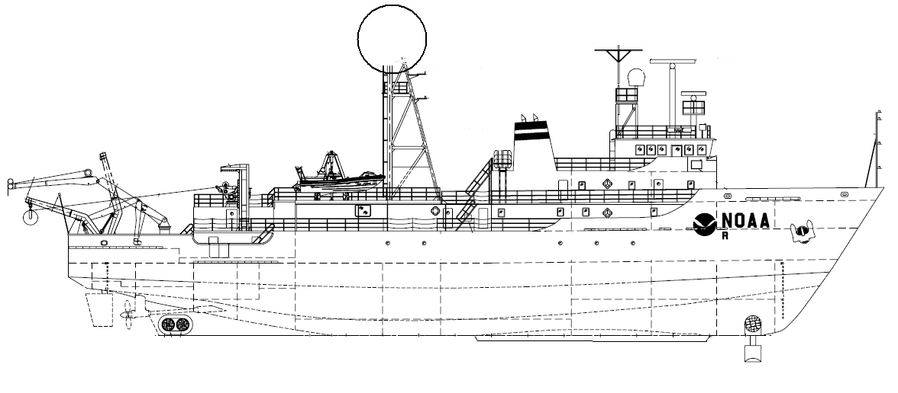
NOAA SHIP OKEANOS EXPLORER R-337
“America’s Ship for Ocean Exploration”

EX0909 Mapping Field Trials
Leg 1
Necker Ridge

August 21, 2009 to Sept 3, 2009
Honolulu, HI to Honolulu, HI

CRUISE REPORT
By
Mashkoor Malik, Nicola Verplanck, Elizabeth Lobecker, Elaine Stuart, Jessica Sheehan, Andrea LeBarage, Jonathan Hunt and Benjamin Colello



1. Purpose

The purpose of the cruise report is to briefly describe the data acquisition and processing with out going into very detailed setup of the multibeam and ancillary sensors. For details about setup of the various equipment / sensors please refer to ‘NOAA Ship Okeanos Explorer Readiness Report’ which can be obtained from the ship.

2. Participating personnel

CDR Joe Pica | Ship’s Master
Mashkoor Malik | Expedition coordinator
LT Nicola Verplanck | Field Operations Officer
Elaine Stuart | Senior Survey Technician
Jessica Sheehan | Survey Technician
Andrea LeBarge | Mapping watch stander
Jonathan Hunt | Mapping watch stander
Elizabeth Lobecker | Mapping watch stander
Benjamin Colello | Mapping watch stander

3. Mapping sonar setup

NOAA Okeanos Explorer (EX) is equipped with a 30 kHz Kongsberg EM 302 multibeam sonar and a 3.5 kHz Knudsen sub-bottom profiler (SBP 3260). During this cruise EM 302 bottom bathymetric and backscatter data were collected. Additional water column data logging was turned on where interesting features were observed in the water column.

The ship used a POS MV ver. 4 to record and correct the multibeam data for any motion. C-NAV GPS system provided DGPS correctors with position accuracy expected to be better than 2.0m.

All the corrections (motion, sound speed profile, sound speed at sonar head, draft, sensor offsets) are applied during real time data acquisition in SIS ver. 1.04. XBT casts (Deep Blue, max depth 760 m) were taken every 6 hours (0000, 0600, 1200 and 1800 local time) and in between if needed. XBT cast data were converted to SIS compliant format using NOAA Velociwin ver. 8.92 Plus.

During July 2009 the ship reported one of the transmit boards defective. Till the departure of the ship from Honolulu, HI on 22 August, 2009 the replacement board was not available, therefore for the duration of the cruise, one of the transmit board remained non-operational. The Built In System Test (BIST) results conducted before departure show the transmit board # 15 as non-functional. The EM 302, in-spite of one defective transmit board provided good quality data during the initial tests soon after departing Honolulu, HI. Based on these initial tests it was decided that ship will continue its mapping mission over Necker Ridge. The affects of the defective transmit board on the data quality was assessed through out the cruise by comparing this cruise data with earlier cruises. In presence of heavy seas, the data showed residual motion artifacts but it could not be determined conclusively if these artifacts are due to the defective transmit board. The ship expects to receive the replacement board once back in Honolulu, HI and further tests are being planned to ensure that these data quality issues are addressed after replacement of the defective TX board.

Data acquisition plan

The data were collected during transit from Honolulu, HI to working grounds (22-23 August) in vicinity of Necker Ridge. Active data acquisition in working grounds was carried out 24 August -31 August September, 2009.

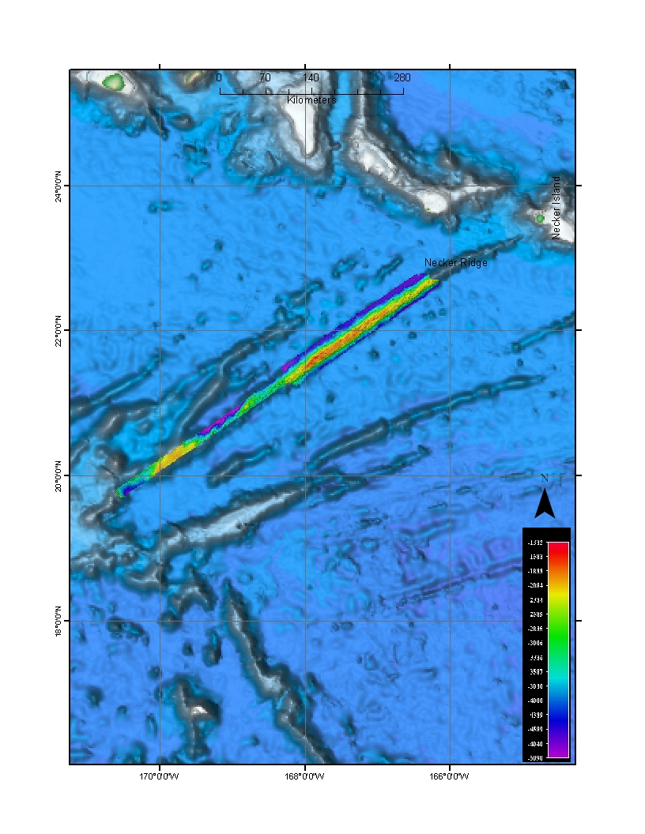
The lines were planned to run parallel to the Necker Ridge with nominal line spacing of 6000 m.

Figure 1: Overview of the Necker Ridge Extended Continental Shelf (ECS) mapping area. Small survey area is the high priority area. The boundaries of the monument are drawn as points and intersect the NE section of Necker Ridge.
A patch test was completed on 25 August the in northern section of the Necker ridge. The last patch test was carried out in May 2009 and similar results were obtained for this patch test. The track lines used for the patch test are tabulated in table 1. Only roll, pitch and Navigation time delay offsets were checked during current patch test, see the patch test results in table 2.

Date | Line | SOG (Knots) | Hdg | Seas | Comments
082509 | 0000_20090825_214655_EX | 8 | 324 | 4-6 | Flat / Up-slope
082509 | 0001_20090825_233851_EX | - | Turn | 4-6 | Turn data
082509 | 0002_20090825_234647_EX | 8 | 143 | 4-6 | Down-slope / Flat
082509 | 0003_20090826_014019_EX | 8 | Turn | 4-5 | Turn data
082509 | 0004_20090826_015042_EX | 8 | 324 | 4-5 | Flat
082509 | 0005_20090826_022217_EX | 4 | 337 | 4-6 | Up-Slope
Table 1: Survey lines utilized for the patch test

Patch Tests Results | Roll | Pitch | Navigation time
May 2009 results | 0 | -0.7 | 0
August 2009 results | 0 | -0.7 | 0

Table 2: Patch tests results

A cross line was collected over the ridge after the completion of the patch test.

Data acquisition and processing:

The data quality was observed to degrade in depths greater than 3500 m where excessive artifacts were observed. Different settings were changed to see if the data quality can be improved including increasing the beam width for transmit beam to 1 deg from 0.5 deg. 1 deg transmit beam with High density equi-distant mode (HIDENEQDIST) mode provided the best quality data in depths greater than 3500 m. In areas over the ridge where the depth was < 3500 m, 0.5 deg transmit beam was utilized to improve the resolution of resulting bathymetric data.

Angular offsets are tabulated as below. For complete processing unit setup (PU Setup) utilized for the cruise, please refer to Appendix A.

 | Roll | Pitch | Heading
Tx Transducer | 0.0 | 0.0 | 359.98
Rx Transducer | 0.0 | 0.0 | 0.03
Attitude | 0 | -0.7 | 0.0

Table 3: Angular offsets for Transmit (TX) and Receive (RX) transducer.

Onboard processing of bathymetric data was done in CARIS HIPS ver. 6.1 during which the data were cleaned in ‘Swath Editor’ and ‘Subset Editor’. No tidal corrections were applied during post processing, however, no appreciable differences were observed between different lines by not applying tidal corrections. A nominal grid cell size of 50 m was chosen for the bathymetric grids.

The cross lines yielded a favorable comparison between main scheme lines and cross lines.
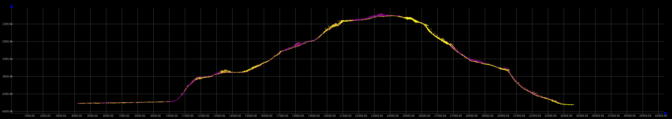

Figure 2: Screen grab of subset editor in CARIS HIPS showing agreement of cross lines (yellow) with main scheme lines (Purple). Image credit: NOAA

Onboard processing of bottom backscatter data was conducted using UNH research tool ‘Geocoder’. The results obtained during fair weather are encouraging but during the days when the weather was choppy, a lot of bubble sweep down issues degraded bottom backscatter data quality severely. At the time of filing of this report, we are not sure whether the weather effects can be taken care of during post processing. Also the ship is expected to contact Kongsberg, Inc regarding these backscatter artifacts. Also there were some degradation of backscatter data quality in the outer STBD beams (Figure 4). This cruise is the first time, EX has used ‘Geocoder’ to process backscatter data and it is yet-to-determined if this degradation of data quality in outer STBD beams is due to data acquisition problems or an artifact of how data are being processed in Geocoder.

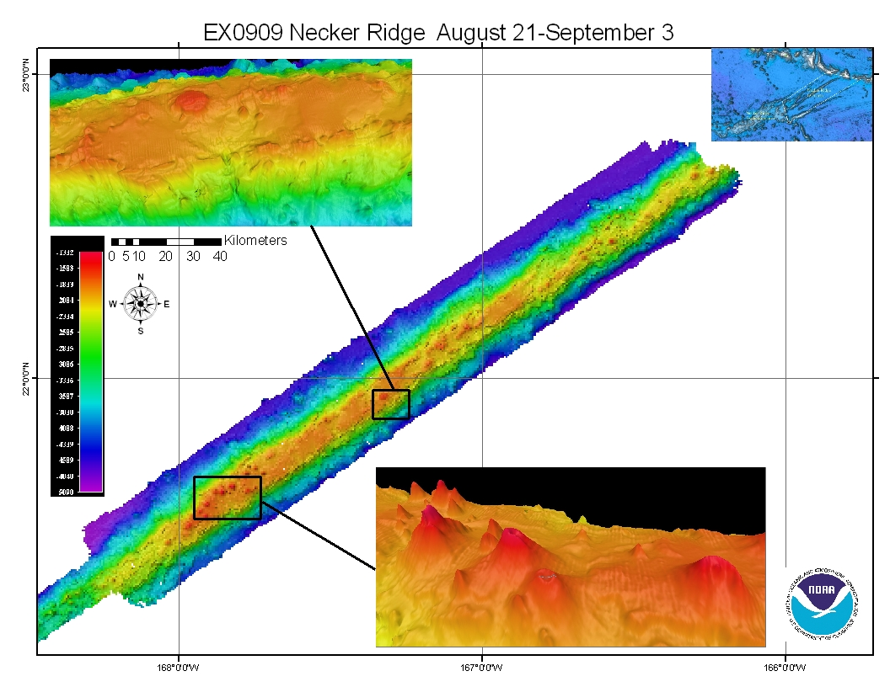

Figure 3: Images of the final grids (at 50 m) cell size resolution. Shown as insets few of the interesting features observed in Northern Necker Ridge area. Small volcanoes with ~ 500 m diameter visible above is one of the few volcanoes observed in the data.

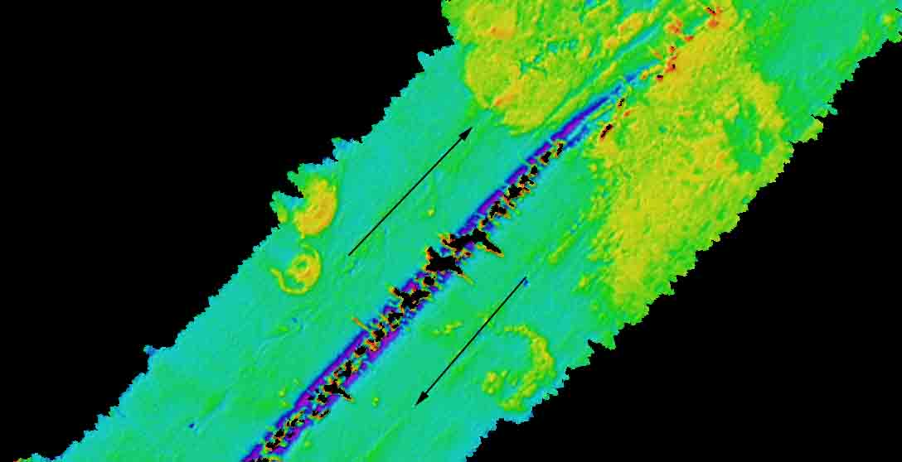

Figure 4: Backscatter mosaic results with 40 m grid cell size. Degradation of backscatter data in STBD outer beams is clearly visible which is more severe in the deeper areas (depth > 3500 m). The direction of track-lines is shown with arrows.
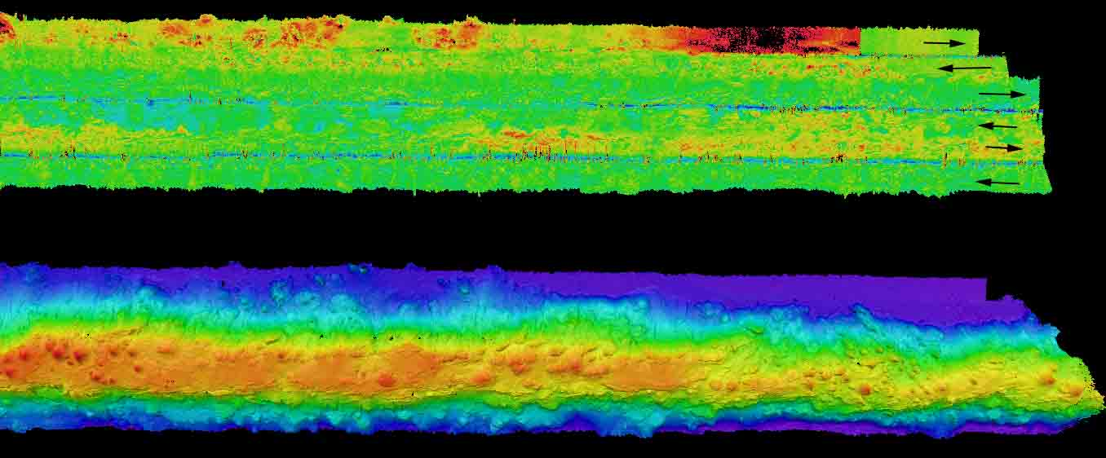

Figure 5: Co-located backscatter (upper panel) and depth (lower panel) showing the North western part of the Necker Ridge. The directions of 6 lines run in this area are shown in the upper panel. STBD beam along track artifacts and bubble sweep down artifacts (visible in the upper most track line) are apparent in backscatter data.

4. Cruise Calendar

August 2009
Mon | Tue | Wed | Thu | Fri | Sat | Sun
 |  | 19  Mission party boarded the ship | 20  Orientation and training for the mission party | 21  Steering gear test offshore Honolulu. Returned to dock for fueling | 22  0900 Departed Honolulu, HI | 23  Transit to Necker Ridge patch test site
24  Steering gear failure. Trouble shooting; back track to Honolulu for 1 day | 25  CTD cast ~ 4700 m  Patch test on Necker Ridge  Commence main scheme lines | 26  Continue mapping Necker Ridge. | 27  Continue mapping Necker Ridge | 28  Continue mapping Necker Ridge | 29  Continue mapping Necker Ridge | 30  Continue mapping Necker Ridge
31
Completed main-scheme survey over Necker Ridge.
Conducted Trouble shooting tests to determine cause of ribbings
September 2009
Mon | Tue | Wed | Thu | Fri | Sat | Sun
 | 1  Transit to Honolulu | 2  Transit to Honolulu | 3  Arrival Honolulu | 4 | 5 | 6

5. Daily cruise log

(ALL TIMES LOCAL HDT)

19 August 2009
Mission party boarded the ship

21 August 2009
Ship left harbor ~ 0945 to conduct steering gear test offshore Honolulu, HI. Ship returned ~ to Pearl Harbor Fueling dock for fueling. Fueling operations continued till 1830.

22 August 2009
Ship left harbor ~ 0900 for Necker Ridge. The data quality was determined to be deteriorating with increasing depths. A lot of data artifacts were observed. Different settings were tested to determine best possible data quality achievable. It was found that 1 deg transmit beam width provided best possible data in deep water.

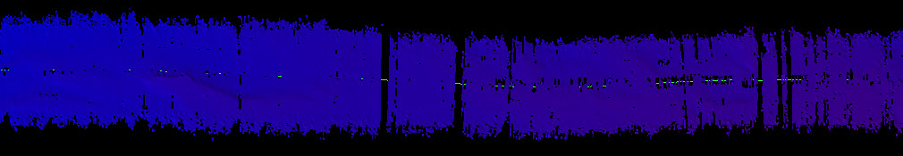

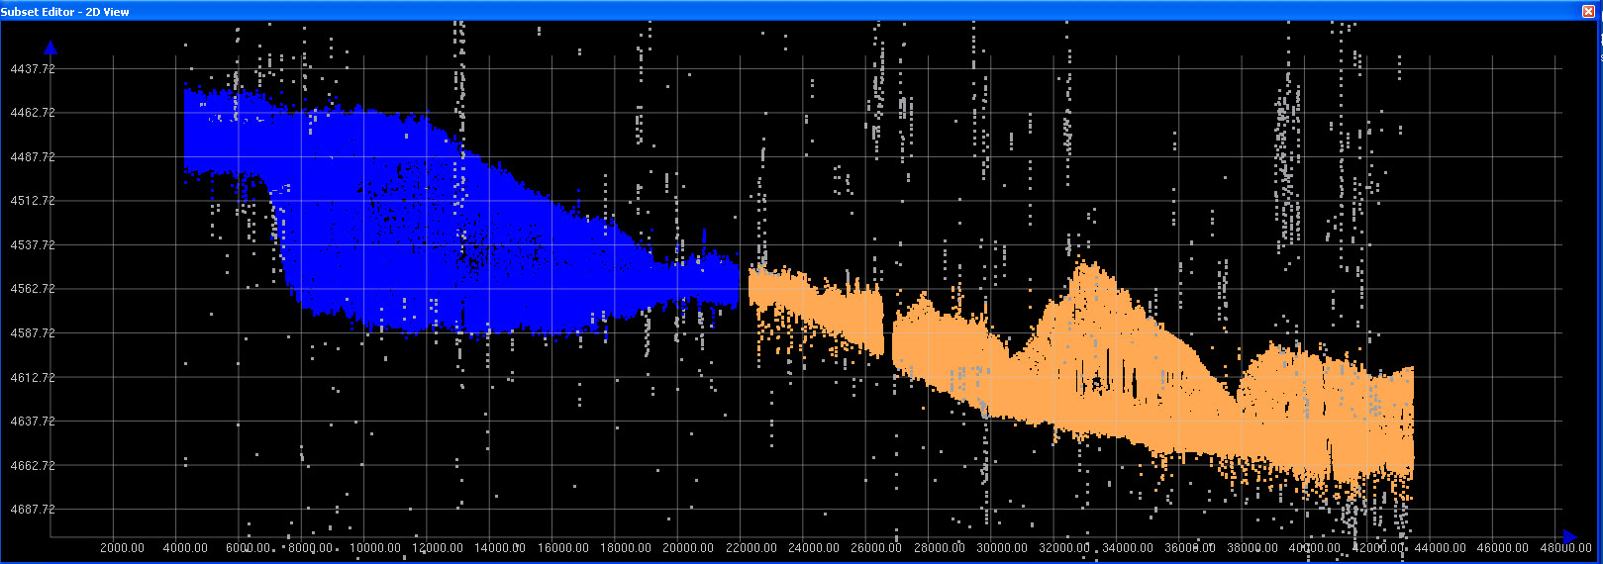

Figure 5a: Screen grabs of the grids (upper panel). The line on the right side of the panel was run by 0.5 deg transmit opening angle. The line on the left side of the panel was run by 1 deg transmit opening angle. The panel on the bottom show a screen capture from the Subset editor showing that line with 0.5 deg transmit opening angle appears to be more noisier. The orange, blue and grey colors show sounding points from line with 0.5 deg transmit opening angle, 1 deg transmit opening angles and the points that were manually rejected in the HIPS subset editor (water depth approximately 4500m).

23 August, 2009 - In transit to Necker Ridge
2230 Steering gear failed. Ship unable to maintain control of rudders; Ship holding station over night

24 August, 2009
Ship moving towards East to be closer to Honolulu, HI in case there is a need to go back to harbor. In the evening the ship decided to turn back towards Necker Ridge to test the steering gear. The decision whether the ship will continue her mapping operations will depend on the performance of the steering gear for next 24 hrs.

25 August, 2009
The steering gear continued to perform satisfactorily and therefore a decision was made by ship’s command to proceed with the mapping operations. A CTD cast to a depth of 4500 m was carried out in the morning. A XBT cast was conducted soon after the CTD cast and the results compared favorable except for the depth range between 300 and 400m where a 3-4m/s sound speed difference was observed.

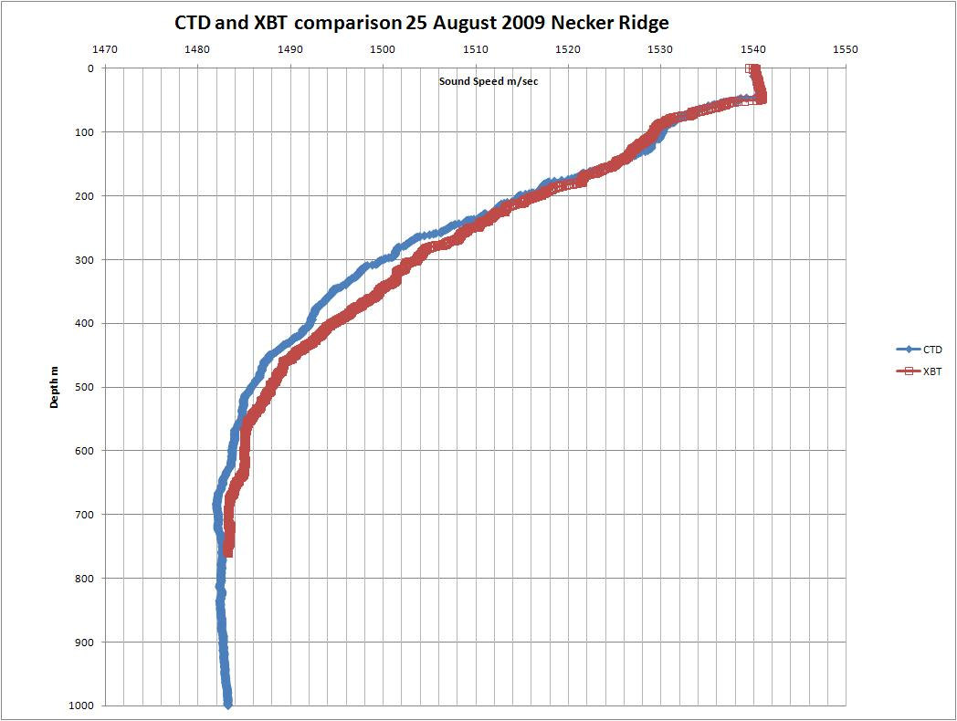

Figure 5b: Comparison of XBT and CTD derived sound speed casts.

26 August 2009
Continue mapping Necker Ridge. Observed a lot of ribbing which seem to be residual roll artifacts in the data. The artifacts are more pronounced in the flatter areas. The IVS Fledermaus depiction of the data show the artifacts to be between 2-10 m.

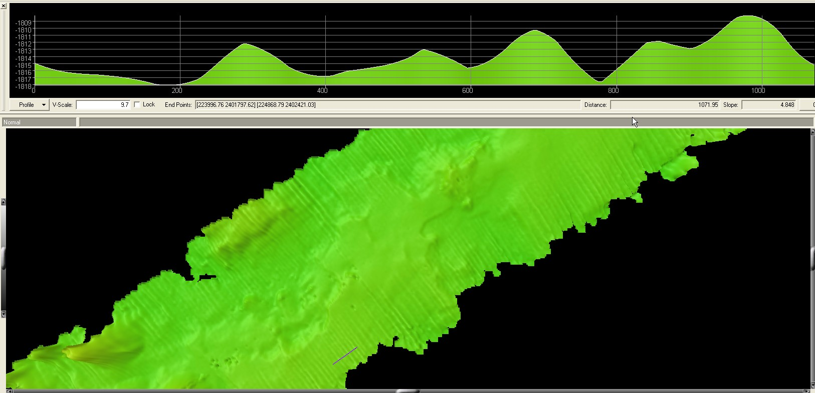

Figure 5c: Ribbing effects in the Fledermaus.

27 August
Reached the southern part of the survey area in the morning. Turned now to go up to North in an adjacent line with line spacing of 6000 m. Recorded True heave from the POS but applying TrueHeave during post processing in HIPS did not help with the artifacts. Line going towards north (Heading 055) the swell is coming from STBD bow and the ship is rolling much less. As a result the data are looking really well in this direction. Checked POS installation settings, POS out put settings and verified the SIS version numbers. All seems to be in order. Dr. Jim Gardner upon contact advised the following:

“…. something is clearly not right. It could be the POS or it could be something got changed in the lever arm values, or it could be some strange effect of the bad transmit board. Whatever is causing the ribbing, it's a severe problem. My suggestion is, if you are still seeing that ribbing artifact, to stop mapping and concentrate on finding the cause of the artifact. Reboot the POS. Then do another patch test on very flat seafloor. If you still have ribbing after that, swap positions of the transmit boards. If the artifacts persist, swap positions of the receive boards. Something has changed pretty dramatically from the setup we had on Mendocino and you've got to figure out what has changed. What are the seas like? Is the ship rolling a lot? Do the artifacts change when you run perpendicular to the course on the images? What happens to the artifacts if you slow to 5 kts? Check what version of the acquisition firmware you're running and make certain it's the same as was installed by Simrad on the Mendocino cruise. Try to isolate what makes no difference and what makes some difference. That might help you isolate the cause….”

28 August, 2009
Continuing to work in the northern small section of ECS area. After the initial ribbing issues, the data quality has improved a lot. The system including attitude sensor (POS-MV) and navigation system (C-NAV) were restarted. The C-NAV reception from WAAS satellite is poor and the POS_MV was reporting to cross the threshold of position accuracy of 2 m. ETs were notified about the situation. However, the area that we are working in has limited coverage for the satellite. Although the position is somewhat degraded, it is not expected to affect the multibeam data quality adversely as we are still able to achieve accuracy levels around 2.2 m.

29 August, 2009
Continuing to collect data. Line spacing of 6000 m has been providing good quality data in depths less than ~ 4000 m. In deeper waters the swath coverage is degraded. Had to move the lines to decrease the line spacing to 5000 m while working in the deep water.

30 August, 2009
Continuing to collect data around the Necker ridge. After reaching the southern edge of the survey, will have enough time to cover one more line. After discussing this with Dr. Gardner over the email, it was decided that the next line will be run to the north of the ridge to get the boundary between the sloping Necker ridge and the adjacent flat seafloor.
In parts of the souther edge of the ridge, the boundary is still not clearly defined.

31 August, 2009

Finished the main survey lines ~ 1130 HDT. The ship conducted additional trouble shooting maneuvers to ascertain the reasons for the ribbing problem. Several lines in several different directions were run with changing Angular offsets including roll bias and heading offsets. No apparent improvement in the ribbing was observed by changing different settings. Reverting back to normal settings.

1 Sept, 2009

In transit to Honolulu, HI. The weather has picked up a lot and the ship is pitching > 5-7 degrees, resulting in severe bubble sweep down episodes results in complete loss of bottom track for several minutes.

2 Sept, 2009

Weather is picking up. Data quality continues to degrade. Switched off EM 302 at 2330 (HDT) .

3 Sept, 2009

Arrived Honolulu, HI

6. Tables of data files collected

Table 6a: XBT / CTD locations

Date  (GMT) | Time (GMT) | XBT/CTD Filename | Latitude | Longitude | Remarks
082209 | 23:20:55 | XBT_082209_01.asvp | 21.248333 | 158.498333 | Transit
082309 | 04:45:11 | XBT_082209_02.asvp | 21.248840 | 159.540202 | Transit
082309 | 21:33:03 | XBT_082309_03.asvp | 21.659553 | 162.612630 | Transit
082409 | 04:10:18 | XBT_082309_04.asvp | 21.912350 | 163.843718 | Transit
082509 | 04:13:56 | XBT_082409_05.asvp | 21.886167 | 163.888666 | Transit
082509 | 10:29:00 | XBT_082509_06.asvp | 22.111805 | 165.069368 | Transit
082509 | 16:17:12 | XBT_082509_07.asvp | 22.275208 | 166.000455 | Transit
082509 | 18:36:12 | CTD_082509_01.hex | 22.342000 | 166.316833 | CTD/XBT comparison
082509 | 21:19:32 | XBT_082509_08.asvp | 22.360718 | 166.326171 | CTD/XBT comparison
082609 | 05:04:38 | XBT_082509_09.asvp | 22.636295 | 166.543718 | Patch Test
082609 | 07:20:32 | XBT_082509_10.asvp | 22.704971 | 166.315266 | Transit
082609 | 12:06:42 | XBT_082609_11.asvp | 22.333271 | 166.788671 | Necker Ridge
082609 | 16:31:21 | XBT_082609_12.asvp | 21.950833 | 167.342966 | Necker Ridge
082609 | 23:20:39 | XBT_082609_13.asvp | 21.380033 | 168.16700 | Necker Ridge
082709 | 04:16:20 | XBT_082609_14.asvp | 21.084216 | 168.594766 | Necker Ridge
082709 | 10:23:20 | XBT_082709_15.asvp | 20.570935 | 169.328938 | Necker Ridge
082709 | 16:12:06 | XBT_082709_16.asvp | 21.046700 | 168.16700 | Necker Ridge
082709 | 22:48:06 | XBT_082709_17.asvp | 19.994373 | 170.248275 | Necker Ridge
082709 | 23:16:22 | XBT_082709_18.asvp | 20.034081 | 170.191635 | Necker Ridge
082809 | 04:07:46 | XBT_082709_19.asvp | 20.442383 | 169.608105 | Necker Ridge
082809 | 10:09:16 | XBT_082809_20.asvp | 20.971973 | 168.848926 | Necker Ridge
082809 | 16:20:14 | XBT_082809_21.asvp | 21.515086 | 168.06694 | Necker Ridge
082809 | 22:40:41 | XBT_082809_22.asvp | 22.040198 | 167.309081 | Necker Ridge
082909 | 04:11:20 | XBT_082909_23.asvp | 22.490820 | 166.656151 | Necker Ridge
082909 | 10:16:39 | XBT_082909_24.asvp | 22.549283 | 166.669081 | Necker Ridge
082909 | 16:19:10 | XBT_082909_25 | 22.146416 | 167.440811 | Necker Ridge
082909 | 22:49:39 | XBT_082909_26 | 21.447685 | 168.250358 | Necker Ridge
083009 | 04:07:35 | XBT_083009_27 | 21.660888 | 167.658268 | Necker Ridge
083009 | 10:10:11 | XBT_083009_28 | 22.196265 | 166.901595 | Necker Ridge
083009 | 16:02:26 | XBT_083009_29 | 22.610216 | 166.212500 | Necker Ridge
083009 | 22:47:59 | XBT_083009_30 | 21.931978 | 167.186295 | Necker Ridge
083109 | 04:06:41 | XBT_083109_31 | 21.410633 | 167.931510 | Necker Ridge
083109 | 10:19:02 | XBT_083109_32 | 21.722558 | 167.486148 | Necker Ridge
083109 | 16:10:22 | XBT_083109_33 | 21.629080 | 167.619828 | Necker Ridge
090109 | 00:18:12 | XBT_090109_34 | 21.470333 | 167.846500 | Necker Ridge Roll & Yaw Patch Test
090109 | 05:11:13 | XBT_090109_35 | 22.594128 | 166.410871 | Necker Ridge Transit
090109 | 10:26:28 | XBT_090109_36 | 22.267835 | 165.717676 | Necker Ridge Transit
090109 | 16:07:16 | XBT_090109_37 | 22.105533 | 164.862435 | Necker Ridge Transit
090109 | 22:33:18 | XBT_090109_38 | 21.871586 | 164.055696 | Necker Ridge Transit
090209 | 04:33:57 | XBT_090109_39 | 21.739896 | 163.222151 | Necker Ridge Transit
090209 | 10:14:48 | XBT_090209_40 | 21.579223 | 162.407536 | Necker Ridge Transit
090209 | 14:05:12 | XBT_090209_41 | 21.462083 | 161.846550 | Necker Ridge Transit
090309 | 04:18:58 | XBT_090309_43 | 21.215812 | 160.670573 | Necker Ridge Transit

Table 6b: Multibeam files collected during the cruise:

Cruise Day No. | Date | File Name | Location | Remarks
234 | 082209 | 0000_20090822_210611_EX | Transit Line | Transit
235 | 082309 | 0001_20090823_003942_EX | Transit Line | Transit
235 | 082309 | 0002_20090823_063936_EX | Transit Line | Transit
235 | 082309 | 0003_20090823_085737_EX | Transit Line | Transit
235 | 082309 | 0004_20090823_104217_EX | Transit Line | Transit
235 | 082309 | 0005_20090823_164216_EX | Transit Line | Transit
235 | 082309 | 0006_20090823_181257_EX | Transit Line | Transit
235 | 082309 | 0007_20090823_190553_EX | Transit Line | Transit
235 | 082309 | 0008_20090823_200418_EX | Transit Line | Transit
235 | 082309 | 0009_20090823_201255_EX | Transit Line | Transit
235 | 082309 | 0010_20090823_021300_EX | Transit Line | Transit
235 | 082309 | 0011_20090823_081259_EX | Transit Line | Transit (Started line 12 too early)
235 | 082309 | 0012_20090823_081414_EX | Transit Line | Transit
236 | 082409 | 0013_20090824_193922_EX | Transit Line | Transit
237 | 082509 | 0014_20090825_011530_EX | Transit Line | Transit
237 | 082509 | 0015_20090825_015203_EX | Transit Line | Transit
237 | 082509 | 0016_20090825_023358_EX | Transit Line | Transit
237 | 082509 | 0017_20090825_063050_EX | Transit Line | Transit
237 | 082509 | 0018_20090825_080244_EX | Transit Line | Transit
237 | 082509 | 0019_20090825_140244_EX | Transit Line | Transit
237 | 082509 | 0020_20090825_214437_EX | Transit Line | Transit
238 | 082609 | 0000_20090826_060627_EX | Transit Line | Transit from Patch Test
238 | 082609 | 0001_20090826_074756_EX | Survey Line | Necker Ridge
238 | 082609 | 0002_20090826_134758_EX | Survey Line | Necker Ridge
238 | 082609 | 0003_20090826_194800_EX | Survey Line | Necker Ridge
239 | 082709 | 0004_20090827_014801_EX | Survey Line | Necker Ridge, Should have broken line at GMT midnight(8/27)
239 | 082709 | 0005_20090827_022422_EX | Survey Line | Necker Ridge Turn Line into wind
239 | 082709 | 0006_20090827_040207_EX | Survey Line | Necker Ridge Line Start
239 | 082709 | 0007_20090827_100209_EX | Survey Line | Necker Ridge Line
239 | 082709 | 0008_20090827_160209_EX | Survey Line | Started Logging True heave at end of Line 8
239 | 082709 | 0009_20090827_194711_EX | Survey Line | Turn
239 | 082709 | 0010_20090827_201019_EX | Survey Line | Switched Files for true heave logging  True Heave file for Line 10: 0827NeckerRidge_THeave.000
240 | 082809 | 0011_20090828_000005_EX | Survey Line | Necker Ridge Line
240 | 082809 | 0012_20090828_060009_EX | Survey Line | Necker Ridge Line
240 | 082809 | 0013_20090828_120001_EX | Survey Line | Necker Ridge Line
240 | 082809 | 0014_20090828_180003_EX | Survey Line | Necker Ridge Line
240 | 082809 | 0015_20090828_235954_EX | Survey Line | Necker Ridge Line
241 | 082909 | 0016_20090829_060000_EX | Survey Line | Necker Ridge Line
241 | 082909 | 0017_20090829_071403_EX | Turn Line | Turn Line to get onto next line after MB/POS reboot
241 | 082909 | 0018_20090829_075708_EX | Survey Line | Necker Ridge Line
241 | 082909 | 0019_20090829_135707_EX | Survey Line | Necker Ridge Line
241 | 082909 | 0020_20090829_195712_EX | Survey Line | Necker Ridge Line
241 | 082909 | 0021_20090829_225506_EX | Turn Line | Turn Line
242 | 083009 | 0022_20090830_001857_EX | Survey Line | Necker Ridge Line
242 | 083009 | 0023_20090830_105121_EX | Survey Line | Necker Ridge
242 | 083009 | 0024_20090830_105121_EX | Survey Line | Necker Ridge
242 | 083009 | 0025_20090830_152556_EX | Turn Line | Turn Line
242 | 083009 | 0026_20090830_155314_EX | Survey Line | Necker Ridge
242 | 083009 | 0027_20090830_215315_EX | Survey Line | Necker Ridge
243 | 083109 | 0028_20090831_000200_EX | Survey Line | Necker Ridge
243 | 083109 | 0029_20090831_053021_EX | Turn Line | Necker Ridge Turn Line
243 | 083109 | 0030_20090831_071142_EX | Survey Line | Necker Ridge Survey Line was leaving holidays so had to shift
243 | 083109 | 0031_20090831_074507_EX | Turn Line | Turn Line 1000m to starboard to avoid holidays
243 | 083109 | 0032_20090831_075255_EX | Survey Line | Necker Ridge
243 | 083109 | 0033_20090831_135248_EX | Survey Line | Necker Ridge
243 | 083109 | 0034_20090831_195248_EX | Survey Line | Necker Ridge
243 | 083109 | 0035_20090831_212522_EX | Survey Line | Necker Ridge
244 | 090109 | 0021_20090901_053501_EX | Transit Line | Transit Line
244 | 090109 | 0022_20090901_074524_EX | Transit Line | Transit Line
244 | 090109 | 0022_20090901_083014_EX | Transit Line | Transit Line
244 | 090109 | 0023_20090901_143015_EX | Transit Line | Transit Line
244 | 090109 | 0024_20090901_170652_EX | Transit Line | Turn to southern transit line
244 | 090109 | 0025_20090901_174506_EX | Transit Line | Transit Line
244 | 090109 | 0026_20090901_234500_EX | Transit Line | Transit Line
245 | 090209 | 0027_20090902_054501_EX | Transit Line | Transit Lineuser13

7. Table of Cruise Statistics

Dates | 8/21/09 – 09/03/2009
Weather delays | 0
Total non-mapping days | 2
Total survey mapping days | 6
Total transit mapping days | 6
Line kilometers of Necker Ridge survey | 2194 (1184 nm)
Beginning draft | 15.0 inches(fwd)14.75 (aft)
Average ship speed for survey | 8.2 Kts
Appendices:

Appendix A: EM 302 PU Parameters
Appendix A

#// Database Parameters

#// Seafloor Information System
#// Kongsberg Maritime AS
#// Saved: 2009.08.28 20:32:34

#// Build info:
#* SIS: [Version: 3.6.1, Build: 174, DBVersion 16.0 CD generated: Tue Nov 11 15:39:05 2008]
[Fox ver = 1.6.29]
[db ver = 16, proc = 16.0]
[OTL = 4.0.-95]
[ACE ver = 5.5]
[Coin ver = 2.4.4]
[Simage ver = 1.6.2a]
[Dime ver = DIME v0.9]
[STLPort ver = 513]
[FreeType ver = 2.1.9]
[TIFF ver = 3.8.2]
[GeoTIFF ver = 1230]
[GridEngine ver = 2.3.0]

#* Language [3] #// Current language, 1-Norwegian, 2-German,3-English, 4-Spanish

#* Type [302]
#* Serial no. [101]
#* Number of heads [2]
#* System descriptor [50331648] #// 03000000

#// *********************************************************************
#// Installation parameters

#{ Input Setup #// All Input setup parameters

#{ COM1 #// Link settings.

#{ Com. settings #// Serial line parameter settings.
#* Baud rate: [9600]
#* Data bits [8]
#* Stop bits: [1]
#* Parity: [NONE]
#} Com. settings

#{ Position #// Position input settings.
#* None [1] [0]
#* GGK [1] [0]
#* GGA [1] [1]
#* GGA_RTK [1] [0]
#* SIMRAD90 [1] [0]
#} Position

#{ Input Formats #// Format input settings.
#* Attitude [0] [0]
#* MK39 Mod2 Attitude, [0] [0]
#* ZDA Clock [1] [1]
#* HDT Heading [0] [0]
#* SKR82 Heading [0] [0]
#* DBS Depth [1] [0]
#* DBT Depth [1] [0]
#* EA500 Depth [0] [0]
#* ROV. depth [1] [0]
#* Height, special purp [1] [0]
#* Ethernet AttVel [0] [0]
#} Input Formats

#} COM1

#{ COM2 #// Link settings.

#{ Com. settings #// Serial line parameter settings.
#* Baud rate: [19200]
#* Data bits [8]
#* Stop bits: [1]
#* Parity: [NONE]
#} Com. settings

#{ Position #// Position input settings.
#* None [0] [1]
#* GGK [0] [0]
#* GGA [0] [0]
#* GGA_RTK [0] [0]
#* SIMRAD90 [0] [0]
#} Position

#{ Input Formats #// Format input settings.
#* Attitude [1] [1]
#* MK39 Mod2 Attitude, [0] [0]
#* ZDA Clock [0] [0]
#* HDT Heading [0] [0]
#* SKR82 Heading [0] [0]
#* DBS Depth [0] [0]
#* DBT Depth [0] [0]
#* EA500 Depth [0] [0]
#* ROV. depth [0] [0]
#* Height, special purp [0] [0]
#* Ethernet AttVel [0] [0]
#} Input Formats

#} COM2

#{ COM3 #// Link settings.

#{ Com. settings #// Serial line parameter settings.
#* Baud rate: [4800]
#* Data bits [8]
#* Stop bits: [1]
#* Parity: [NONE]
#} Com. settings

#{ Position #// Position input settings.
#* None [1] [1]
#* GGK [1] [0]
#* GGA [1] [0]
#* GGA_RTK [1] [0]
#* SIMRAD90 [1] [0]
#} Position

#{ Input Formats #// Format input settings.
#* Attitude [0] [0]
#* MK39 Mod2 Attitude, [1] [0]
#* ZDA Clock [0] [0]
#* HDT Heading [1] [1]
#* SKR82 Heading [0] [0]
#* DBS Depth [1] [0]
#* DBT Depth [1] [0]
#* EA500 Depth [0] [0]
#* ROV. depth [1] [0]
#* Height, special purp [1] [0]
#* Ethernet AttVel [0] [0]
#} Input Formats

#} COM3

#{ COM4 #// Link settings.

#{ Com. settings #// Serial line parameter settings.
#* Baud rate: [9600]
#* Data bits [8]
#* Stop bits: [1]
#* Parity: [NONE]
#} Com. settings

#{ Position #// Position input settings.
#* None [1] [1]
#* GGK [1] [0]
#* GGA [1] [0]
#* GGA_RTK [1] [0]
#* SIMRAD90 [1] [0]
#} Position

#{ Input Formats #// Format input settings.
#* Attitude [0] [0]
#* MK39 Mod2 Attitude, [0] [0]
#* ZDA Clock [0] [0]
#* HDT Heading [0] [0]
#* SKR82 Heading [0] [0]
#* DBS Depth [1] [0]
#* DBT Depth [1] [0]
#* EA500 Depth [0] [0]
#* ROV. depth [1] [0]
#* Height, special purp [1] [0]
#* Ethernet AttVel [0] [0]
#} Input Formats

#} COM4

#{ UDP2 #// Link settings.

#{ Com. settings #// Serial line parameter settings.
#// N/A
#} Com. settings

#{ Position #// Position input settings.
#* None [1] [1]
#* GGK [1] [0]
#* GGA [1] [0]
#* GGA_RTK [1] [0]
#* SIMRAD90 [1] [0]
#} Position

#{ Input Formats #// Format input settings.
#* Attitude [0] [0]
#* MK39 Mod2 Attitude, [0] [0]
#* ZDA Clock [0] [0]
#* HDT Heading [0] [0]
#* SKR82 Heading [0] [0]
#* DBS Depth [0] [0]
#* DBT Depth [0] [0]
#* EA500 Depth [1] [0]
#* ROV. depth [0] [0]
#* Height, special purp [0] [0]
#* Ethernet AttVel [0] [0]
#} Input Formats

#} UDP2

#{ UDP3 #// Link settings.

#{ Com. settings #// Serial line parameter settings.
#// N/A
#} Com. settings

#{ Position #// Position input settings.
#* None [0] [1]
#* GGK [0] [0]
#* GGA [0] [0]
#* GGA_RTK [0] [0]
#* SIMRAD90 [0] [0]
#} Position

#{ Input Formats #// Format input settings.
#* Attitude [0] [0]
#* MK39 Mod2 Attitude, [0] [0]
#* ZDA Clock [0] [0]
#* HDT Heading [1] [0]
#* SKR82 Heading [0] [0]
#* DBS Depth [1] [0]
#* DBT Depth [1] [0]
#* EA500 Depth [0] [0]
#* ROV. depth [1] [0]
#* Height, special purp [1] [0]
#* Ethernet AttVel [0] [0]
#} Input Formats

#} UDP3

#{ UDP4 #// Link settings.

#{ Com. settings #// Serial line parameter settings.
#// N/A
#} Com. settings

#{ Position #// Position input settings.
#* None [0] [1]
#* GGK [0] [0]
#* GGA [0] [0]
#* GGA_RTK [0] [0]
#* SIMRAD90 [0] [0]
#} Position

#{ Input Formats #// Format input settings.
#* Attitude [1] [0]
#* MK39 Mod2 Attitude, [0] [0]
#* ZDA Clock [0] [0]
#* HDT Heading [1] [0]
#* SKR82 Heading [0] [0]
#* DBS Depth [1] [0]
#* DBT Depth [1] [0]
#* EA500 Depth [0] [0]
#* ROV. depth [1] [0]
#* Height, special purp [1] [0]
#* Ethernet AttVel [0] [0]
#} Input Formats

#} UDP4

#{ UDP5 #// Link settings.

#{ Com. settings #// Serial line parameter settings.
#// N/A
#} Com. settings

#{ Position #// Position input settings.
#* None [0] [0]
#* GGK [0] [0]
#* GGA [0] [0]
#* GGA_RTK [0] [0]
#* SIMRAD90 [0] [0]
#} Position

#{ Input Formats #// Format input settings.
#* Attitude [0] [0]
#* MK39 Mod2 Attitude, [0] [0]
#* ZDA Clock [0] [0]
#* HDT Heading [0] [0]
#* SKR82 Heading [0] [0]
#* DBS Depth [0] [0]
#* DBT Depth [0] [0]
#* EA500 Depth [0] [0]
#* ROV. depth [0] [0]
#* Height, special purp [0] [0]
#* Ethernet AttVel [1] [1]
#} Input Formats

#{ Attitude Velocity settings #// Only relevant for UDP5 on EM122, EM302 and EM710, currently
#* Attitude 1 [1] [1]
#* Attitude 2 [1] [0]
#* Use Ethernet 2 [1] [1]
#* Port: [5602]
#* IP addr.: [192.168.2.20]
#* Net mask: [255.255.255.0]
#} Attitude Velocity settings

#} UDP5

#{ Misc. #// Misc. input settings.
#* External Trigger [1] [0]
#} Misc.

#} Input Setup

#{ Output Setup #// All Output setup parameters

#* PU broadcast enable [1] [1]
#* Log watercolumn to s [1] [1]

#{ Host UDP1 #// Host UDP1 Port: 16100

#{ Datagram subscription #//
#* Depth [0] [0]
#* Raw range and beam a [0] [0]
#* Seabed Image [0] [0]
#* Central Beams [0] [0]
#* Position [0] [0]
#* Attitude [0] [0]
#* Heading [0] [0]
#* Height [0] [0]
#* Clock [0] [0]
#* Single beam echosoun [0] [0]
#* Sound Speed Profile [0] [1]
#* Runtime Parameters [0] [1]
#* Installation Paramet [0] [1]
#* BIST Reply [0] [1]
#* Status parameters [0] [1]
#* PU Broadcast [0] [0]
#* Stave Display [0] [0]
#* Water Column [0] [0]
#* Internal, Range Data [0] [0]
#* Internal, Scope Data [0] [0]
#} Datagram subscription

#} Host UDP1

#{ Host UDP2 #// Host UDP2 Port: 16101

#{ Datagram subscription #//
#* Depth [1] [1]
#* Raw range and beam a [1] [1]
#* Seabed Image [1] [1]
#* Central Beams [1] [0]
#* Position [1] [1]
#* Attitude [1] [1]
#* Heading [1] [1]
#* Height [1] [1]
#* Clock [1] [1]
#* Single beam echosoun [1] [1]
#* Sound Speed Profile [0] [1]
#* Runtime Parameters [0] [1]
#* Installation Paramet [0] [1]
#* BIST Reply [1] [1]
#* Status parameters [0] [1]
#* PU Broadcast [1] [0]
#* Stave Display [0] [1]
#* Water Column [0] [1]
#* Internal, Range Data [1] [0]
#* Internal, Scope Data [1] [0]
#} Datagram subscription

#} Host UDP2

#{ Host UDP3 #// Host UDP3 Port: 16102

#{ Datagram subscription #//
#* Depth [0] [1]
#* Raw range and beam a [0] [0]
#* Seabed Image [0] [0]
#* Central Beams [0] [0]
#* Position [0] [0]
#* Attitude [0] [1]
#* Heading [0] [0]
#* Height [0] [1]
#* Clock [0] [0]
#* Single beam echosoun [0] [1]
#* Sound Speed Profile [0] [1]
#* Runtime Parameters [0] [0]
#* Installation Paramet [0] [1]
#* BIST Reply [0] [0]
#* Status parameters [0] [0]
#* PU Broadcast [0] [0]
#* Stave Display [0] [0]
#* Water Column [0] [0]
#* Internal, Range Data [0] [0]
#* Internal, Scope Data [0] [1]
#} Datagram subscription

#} Host UDP3

#{ Host UDP4 #// Host UDP4 Port 16103

#{ Datagram subscription #//
#* Depth [1] [0]
#* Raw range and beam a [1] [0]
#* Seabed Image [1] [0]
#* Central Beams [1] [0]
#* Position [1] [0]
#* Attitude [1] [0]
#* Heading [1] [0]
#* Height [1] [0]
#* Clock [1] [0]
#* Single beam echosoun [1] [0]
#* Sound Speed Profile [1] [0]
#* Runtime Parameters [1] [0]
#* Installation Paramet [1] [0]
#* BIST Reply [1] [0]
#* Status parameters [1] [0]
#* PU Broadcast [1] [0]
#* Stave Display [1] [0]
#* Water Column [1] [0]
#* Internal, Range Data [1] [0]
#* Internal, Scope Data [1] [0]
#} Datagram subscription

#} Host UDP4

#{ Watercolumn #// Host UDP4 Port 16103

#{ Datagram subscription #//
#* Depth [1] [0]
#* Raw range and beam a [1] [0]
#* Seabed Image [1] [0]
#* Central Beams [1] [0]
#* Position [1] [0]
#* Attitude [1] [0]
#* Heading [1] [0]
#* Height [1] [0]
#* Clock [1] [0]
#* Single beam echosoun [1] [0]
#* Sound Speed Profile [1] [0]
#* Runtime Parameters [1] [0]
#* Installation Paramet [1] [0]
#* BIST Reply [1] [0]
#* Status parameters [1] [0]
#* PU Broadcast [1] [0]
#* Stave Display [1] [0]
#* Water Column [1] [1]
#* Internal, Range Data [1] [0]
#* Internal, Scope Data [1] [0]
#} Datagram subscription

#} Watercolumn

#} Output Setup

#{ Clock Setup #// All Clock setup parameters

#{ Clock #// All clock settings.
#* Source: [1] #// External ZDA Clock
#* 1PPS Clock Synch. [1] [1]
#* Offset (sec.): [0]
#} Clock

#} Clock Setup

#{ Settings #// Sensor setup parameters

#{ Positioning System Settings #// Position related settings.

#{ COM1 #// Positioning System Ports:
#* P1T [1] #// Datagram
#* P1M [0] #// Enable position motion correction
#* P1D [0.000] #// Position delay (sec.):
#* P1G [WGS84] #// Datum:
#* P1Q [1] #// Enable
#* Pos. qual. indicator [] #//
#} COM1

#} Positioning System Settings

#{ Motion Sensor Settings #// Motion related settings.

#{ COM2 #// Motion Sensor Ports:
#* MRP [RP] #// Rotation (POSMV/MRU)
#* MSD [0] #// Motion Delay (msec.):
#* MAS [1.00] #// Motion Sensor Roll Scaling:
#} COM2

#} Motion Sensor Settings

#{ Active Sensors #//
#* APS [0] [COM1] #// Position:
#* ARO [2] [COM2] #// Motion:
#* AHE [2] [COM2] #// Motion:
#* AHS [3] [COM3] #// Heading:
#} Active Sensors

#} Settings

#{ Locations #// All location parameters

#{ Location offset (m) #//

#{ Pos, COM1: #//
#* P1X [0.00] #// Forward (X)
#* P1Y [0.00] #// Starboard (Y)
#* P1Z [0.00] #// Downward (Z)
#} Pos, COM1:

#{ Pos, COM3: #//
#* P2X [0.00] #// Forward (X)
#* P2Y [0.00] #// Starboard (Y)
#* P2Z [0.00] #// Downward (Z)
#} Pos, COM3:

#{ Pos, COM4/UDP2: #//
#* P3X [0.00] #// Forward (X)
#* P3Y [0.00] #// Starboard (Y)
#* P3Z [0.00] #// Downward (Z)
#} Pos, COM4/UDP2:

#{ TX Transducer: #//
#* S1X [6.147] #// Forward (X)
#* S1Y [1.822] #// Starboard (Y)
#* S1Z [6.796] #// Downward (Z)
#} TX Transducer:

#{ RX Transducer: #//
#* S2X [2.497] #// Forward (X)
#* S2Y [2.481] #// Starboard (Y)
#* S2Z [6.790] #// Downward (Z)
#} RX Transducer:

#{ Attitude 1, COM2: #//
#* MSX [0.00] #// Forward (X)
#* MSY [0.00] #// Starboard (Y)
#* MSZ [0.00] #// Downward (Z)
#} Attitude 1, COM2:

#{ Attitude 2, COM3: #//
#* NSX [0.00] #// Forward (X)
#* NSY [0.00] #// Starboard (Y)
#* NSZ [0.00] #// Downward (Z)
#} Attitude 2, COM3:

#{ Waterline: #//
#* WLZ [1.838] #// Downward (Z)
#} Waterline:

#} Location offset (m)

#} Locations

#{ Angular Offsets #// All angular offset parameters

#{ Offset angles (deg.) #//

#{ TX Transducer: #//
#* S1R [0.0] #// Roll
#* S1P [0.00] #// Pitch
#* S1H [359.98] #// Heading
#} TX Transducer:

#{ RX Transducer: #//
#* S2R [0.0] #// Roll
#* S2P [0.00] #// Pitch
#* S2H [.03] #// Heading
#} RX Transducer:

#{ Attitude 1, COM2: #//
#* MSR [0.00] #// Roll
#* MSP [-0.70] #// Pitch
#* MSG [0.00] #// Heading
#} Attitude 1, COM2:

#{ Attitude 2, COM3: #//
#* NSR [0.00] #// Roll
#* NSP [0.00] #// Pitch
#* NSG [0.00] #// Heading
#} Attitude 2, COM3:

#{ Stand-alone Heading: #//
#* GCG [0.00] #// Heading
#} Stand-alone Heading:

#} Offset angles (deg.)

#} Angular Offsets

#{ ROV. Specific #// All ROV specific parameters

#{ Depth/Pressure Sensor #//
#* DSF [1.00] #// Scaling:
#* DSO [0.00] #// Offset:
#* DSD [0.00] #// Delay:
#* DSH [NI] #// Disable Heave Sensor
#} Depth/Pressure Sensor

#} ROV. Specific

#{ System Parameters #// All system parameters

#{ System Gain Offset #//
#* GO1 [0.0] #// BS Offset (dB)
#} System Gain Offset

#{ Opening angles #//
#* S1S [0] #// TX Opening angle:
#* S2S [1] #// RX Opening angle:
#} Opening angles

#} System Parameters

#// *********************************************************************
#// Runtime parameters

#{ Sounder Main #//

#{ Sector Coverage #//

#{ Max. angle (deg.): #//
#* MPA [70] #// Port
#* MSA [70] #// Starboard
#} Max. angle (deg.):

#{ Max. Coverage (m): #//
#* MPC [5000] #// Port
#* MSC [5000] #// Starboard
#} Max. Coverage (m):

#* ACM [1] #// Angular Coverage mode: AUTO
#* BSP [2] #// Beam Spacing: HIDENS EQDIST

#} Sector Coverage

#{ Depth Settings #//
#* FDE [4700] #// Force Depth (m)
#* MID [500] #// Min. Depth (m):
#* MAD [6000] #// Max. Depth (m):
#* DSM [0] #// Dual swath mode: OFF
#* PMO [0] #// Ping Mode: AUTO
#* FME [1] #// FM enable
#} Depth Settings

#{ Stabilization #//
#* YPS [1] #// Pitch stabilization
#* TXA [3] #// Along Direction (deg.):

#{ Yaw Stabilization #//
#* YSM [2] #// Mode: REL. MEAN HEADING
#* YMA [300] #// Heading:
#* HFI [1] #// Heading filter: MEDIUM
#} Yaw Stabilization

#} Stabilization
#} Sounder Main

#{ Sound Speed #//

#{ Sound Speed at Transducer #//
#* SHS [0] #// Source SENSOR
#* SST [14672] #// Sound Speed (dm/sec.):
#* Sensor Offset (m/sec [0.0] #//
#* Filter (sec.): [5] #//
#} Sound Speed at Transducer

#} Sound Speed

#{ Filter and Gains #//

#{ Filtering #//
#* SFS [2] #// Spike Filter Strength: MEDIUM
#* PEF [2] #// Penetration Filter Strength: MEDIUM
#* RGS [1] #// Range Gate: NORMAL
#* SLF [1] #// Slope
#* AEF [1] #// Aeration
#* STF [1] #// Sector Tracking
#* IFF [1] #// Interference
#} Filtering

#{ Absorption Coefficient #//
#* ABC [5.718] #// 31.5 kHz
#} Absorption Coefficient

#{ Normal incidence sector #//
#* TCA [12] #// Angle from nadir (deg.):
#} Normal incidence sector

#{ Mammal protection #//
#* TXP [0] #// TX power level (dB): Max.
#* SSR [0] #// Soft startup ramp time (min.):
#} Mammal protection
#} Filter and Gains

#{ Data Cleaning #//
#* Active rule: [AUTOMATIC1] #//
#{ AUTOMATIC1 #//
#* PingProc.maxPingCountRadius [10]
#* PingProc.radiusFactor [0.050000]
#* PingProc.medianFactor [1.500000]
#* PingProc.beamNumberRadius [3]
#* PingProc.sufficientPointCount [40]
#* PingProc.neighborhoodType [Elliptical]
#* PingProc.timeRule.use [false]
#* PingProc.overhangRule.use [false]
#* PingProc.medianRule.use [false]
#* PingProc.medianRule.depthFactor [0.050000]
#* PingProc.medianRule.minPointCount [6]
#* PingProc.quantileRule.use [false]
#* PingProc.quantileRule.quantile [0.100000]
#* PingProc.quantileRule.scaleFactor [6.000000]
#* PingProc.quantileRule.minPointCount [40]
#* GridProc.minPoints [8]
#* GridProc.depthFactor [0.200000]
#* GridProc.removeTooFewPoints [false]
#* GridProc.surfaceFitting.surfaceDegree [1]
#* GridProc.surfaceFitting.tukeyConstant [6.000000]
#* GridProc.surfaceFitting.maxIteration [10]
#* GridProc.surfaceFitting.convCriterion [0.010000]
#* GridProc.surfaceDistanceDepthRule.use [false]
#* GridProc.surfaceDistanceDepthRule.depthFactor [0.050000]
#* GridProc.surfaceDistancePointRule.use [false]
#* GridProc.surfaceDistancePointRule.scaleFactor [1.000000]
#* GridProc.surfaceDistanceUnitRule.use [false]
#* GridProc.surfaceDistanceUnitRule.scaleFactor [1.000000]
#* GridProc.surfaceDistanceStDevRule.use [false]
#* GridProc.surfaceDistanceStDevRule.scaleFactor [2.000000]
#* GridProc.surfaceAngleRule.use [false]
#* GridProc.surfaceAngleRule.minAngle [20.000000]
#* SonarProc.use [false]
#* SonarProc.gridSizeFactor [4]
#* SonarProc.mergerType [Average]
#* SonarProc.interpolatorType [TopHat]
#* SonarProc.interpolatorRadius [1]
#* SonarProc.fillInOnly [true]
#} AUTOMATIC1

#{ Seabed Image Processing #//
#* Seabed Image Process [1] [0]
#} Seabed Image Processing
#} Data Cleaning

#{ Advanced param. #//
#} Advanced param.

