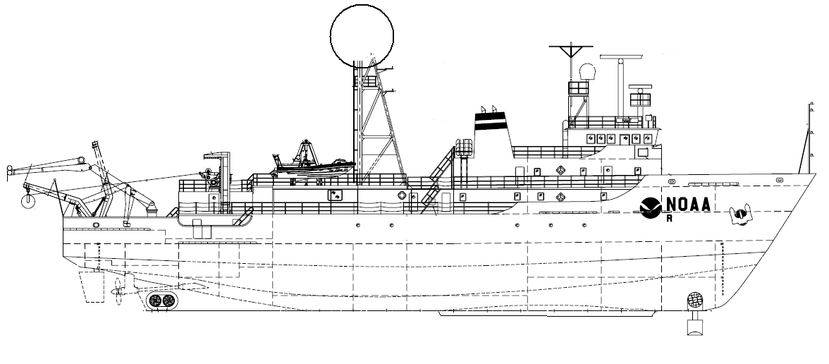
NOAA SHIP OKEANOS EXPLORER R-337
“America’s Ship for Ocean Exploration”

EX0909 Mapping Field Trials
Leg 3
Hawaiian Islands

Oct 1, 2009 to Oct 21, 2009
Honolulu, HI to Honolulu, HI

CRUISE REPORT
By
Mashkoor Malik, Nicola Verplanck, Elaine Stuart, Lillian Stuart, Kelly Elliot, Melissa Johnson, Megan Nadeau and Adam Lemire

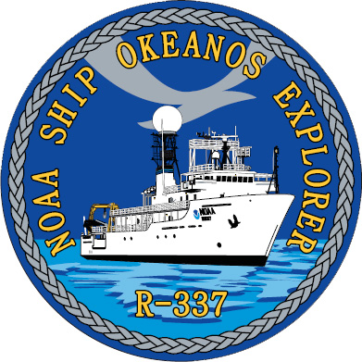

Table of Contents

1. Purpose 3
2. Participating personnel 3
3. Mapping sonar setup 3
4. Data acquisition summary 4
5. Data processing 7
6. Results 7
6.1. Mapping Areas 7
HMRG multibeam sonar synthesis holiday mapping 7
Wini and adjacent seamounts 9
Kealakekua Bay mapping area 10
PMNM priority area mapping 11
6.2. System analysis 12
Evaluation of best course for optimal EM 302 data collection 12
Evaluation of multibeam bathymetric data variability during DP test 13
6.3. Wreck investigation: 14
USS SS-28 and USS Queenfish 14
USS Bluegill 16
7. Table of Cruise Statistics 17
8. Cruise Calendar 18
9. Daily cruise log 19
10. Tables of data files collected 24
XBT / CTD Files Collected during the cruise 24
Multibeam files collected during the cruise 26
11. Acknowledgements 32
12. References 33
Appendix A: EM 302 PU Parameters 35
Appendix B: Map sheets 49

1. Purpose

The purpose of this cruise report is to briefly describe the data acquisition and processing with out going into very detailed setup of the multibeam and ancillary sensors. For details about setup of the various equipment / sensors please refer to ‘NOAA Ship Okeanos Explorer Readiness Report’ which can be obtained from the ship [1].

This report provides details about mapping operations of EX0909 Leg 3 field trial cruise run from Oct 1 – 21, 2009. The objectives of the cruise have been outlined in details in the cruise plan [2] which included primary objectives to test, troubleshoot, refine and evaluate EX mapping systems, sensors, protocols and processes to support systematic exploration and secondary objective to map the areas in vicinity of Hawaiian Island which are of national and regional interest.

2. Participating personnel

CDR Joe Pica | Ship’s Master | OMAO
LT Nicola Verplanck | Field Operations Officer | OMAO
Mashkoor Malik | Expedition coordinator | OER
Elaine Stuart | Senior Survey Technician | OMAO
Lillian Stuart | Survey Technician | OMAO
LT Megan Nadeau | Mapping watch stander | OER
Kelly Elliot | Mapping watch stander | OER
Melissa Johnson | Mapping watch stander | OER Intern
Adam Lemire | Mapping watch stander | OER Intern
Webb Pinner | Telepresence lead | OER

3. Mapping sonar setup

NOAA Okeanos Explorer (EX) is equipped with a 30 kHz Kongsberg EM 302 multibeam sonar and a 3.5 kHz Knudsen sub-bottom profiler (SBP 3260). During this cruise EM 302 bottom bathymetric and backscatter data were collected. Additionally water column data logging for EM 302 was turned on where interesting features were observed in the water column, however no notable water column targets were picked up during this cruise.

The ship used a POS MV ver. 4 to record and correct the multibeam data for any motion. C-NAV GPS system provided DGPS correctors with position accuracy expected to be better than 2.0m.

All the corrections (motion, sound speed profile, sound speed at sonar head, draft, sensor offsets) are applied during real time data acquisition in SIS ver. 1.04. XBT casts (Deep Blue, max depth 760 m) were taken every 6 hours (0000, 0600, 1200 and 1800 local time). XBT cast data were converted to SIS compliant format using NOAA Velociwin ver. 8.92 Plus. Also when the time allowed, the CTD casts up to 800 m were conducted to provide training to the deck and survey departments in lieu of 1200 XBT cast. Complete list of XBT and CTD casts conducted is provided in Section 10.

During July 2009 the ship reported one of the transmit boards defective (TX 36 # 16). The board was replaced on 4 Sept, 2009 by a spare board sent in by Kongsberg, Inc. However, the same board (TX 36 # 16) failed a BIST on 3 October, 2009. The EM 302, in spite of one defective transmit board provided good quality data during the initial tests soon after departing Honolulu, HI. Based on these initial tests it was decided that ship will continue its mapping mission. The affects of the defective transmit board on the data quality was assessed through out the cruise by comparing this cruise data with earlier cruises. In presence of heavy seas, the data showed residual motion artifacts but it could not be determined conclusively if these artifacts are due to the defective transmit board. The ship expects to receive the replacement board once back in Honolulu, HI and further tests are being planned to ensure that these data quality issues are addressed after replacement of the defective TX board.

4. Data acquisition summary
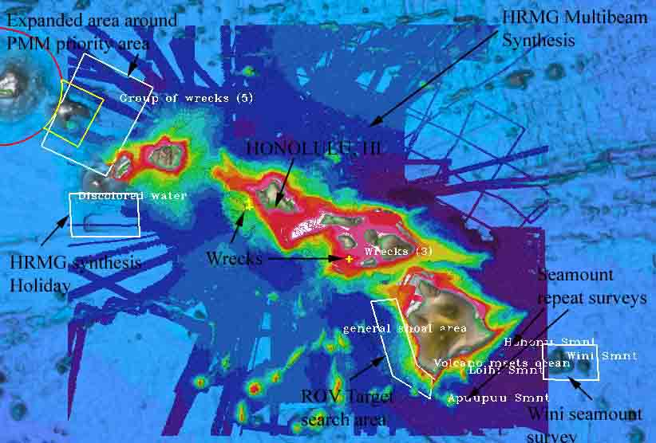

Figure 1: Over view of planned mapping areas during EX0909_Leg 3 cruise (shown as white boxes).

The ship departed Honolulu, HI on 1 October, 2009. The data were collected during transit from Honolulu, HI to working grounds (Oct 1 - 3) in vicinity of Wini Seamount. During the transit the ship collected data over the Hawaii Mapping Research Group (HMRG) identified holidays. The ship worked around Wini Seamount from Oct 3 – 6 mapping the extent of Wini seamount. The weather in this area provided some serious challenges to the data quality. The lines were being run ~ 30 degrees off the swell and still a lot of bubble sweep down episodes were degrading the bathymetric and backscatter data quality severely. It was decided to devote some time to determine the best possible course for the multibeam operations. On 4 Oct, a star line pattern was run over Wini seamount which enable the ship to collect the multibeam data in several different directions with respect to swell. The details of the results are provided in following sections. Four distinct peaks were mapped around Wini Seamount. No craters were observed on the Wini seamount. The ship then transited to the west of Big Island. During the transit several seamounts including Apuupu, Loihi and Hononu seamounts were mapped. The ship reached west of Big Island mapping area on 7 Oct and started collecting data in support of future ROV dives. The ship conducted mapping operations in this area till 10 Oct. On 11 Oct the ship started 72 hrs long dynamic positioning (DP) test to test the endurance of DP system and its ability to hold station and conduct maneuvers necessary in support of ROV operations. A separate report is being generated for these tests [7]. While holding station ~ 1 hrs of multibeam sonar data were collected to help identify the variability of multibeam bathymetric and backscatter data on 11 October. However, due to several factors including large seafloor slope and variations in ship’s heading the preliminary processing of these data indicate that this experiment will need to be repeated again with more favorable conditions (most importantly - relatively flat seafloor)

The ship concluded DP test on 14 Oct ~ 1200 and anchored off Kona waiting for the steering pump spare part. The ship stayed at anchor from 14 Oct 1500 – 15 Oct 1530 off Kona, HI. During this time the spare part for the steering pump was picked up and also the crew enjoyed few hours of liberty in Kona, HI. The ship commenced her transit to the PMM working grounds. During the transit a wreck site was investigated to detect wreck of USS Blue Gill (SS- 242). In spite of detecting several features both in backscatter and bathymetric data, with comparable sizes to the reported size of the wreck, the multibeam data was not able to conclusively detect the wreck. More work with ROV is recommended to determine the location of this wreck. The ship arrived in the working areas around Papahanaumokuakea Marine National Monument (PMNM) on 16 Oct ~ 2300.

As a result of addition of DP evolution (~ 4 days) in the cruise schedule planned mapping of HMRG holidays off Kauai Is was cancelled and also PMNM expanded mapping area was reduced to cover only PMNM priority area. The shallow regions in this area showed a depth between 65-600 m and therefore due to time constrains not all the holidays were covered in the shallow area. EM 302 suffered a malfunction where it stopped forming received beams on 19 Oct for ~ 4 hours. Several restarts of SIS computer and TRU did not bring back the multibeam system. The problem was resolved as the system was put in simulator mode and angular coverage settings were changed. Kongsberg is being contacted to record this problem. The ship wrapped up mapping operations in PMNM area on 20 Oct 0730 and commenced transit towards Honolulu, HI. The ship arrived Honolulu, HI on 21 Oct, 2009 at ~ 1000.

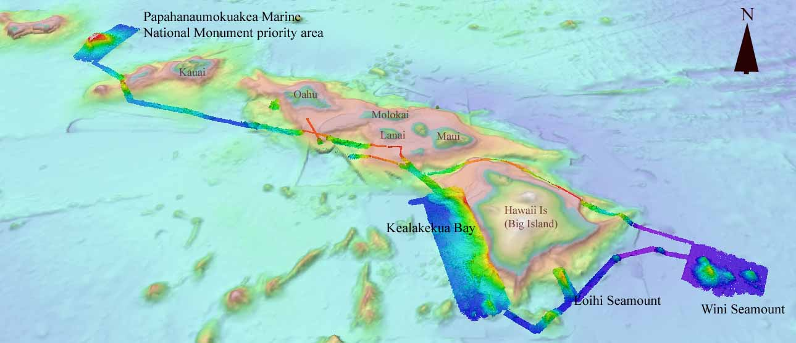

Figure 2: Over view of the EX0909 Leg mapping areas overlaid with bathymetry from ETOPO 1 [8].

5. Data processing

Angular offsets used during this cruise in the multibeam system are tabulated as below. For complete processing unit setup (PU Setup) utilized for the cruise, please refer to Appendix A.

 | Roll | Pitch | Heading
Tx Transducer | 0.0 | 0.0 | 359.98
Rx Transducer | 0.0 | 0.0 | 0.03
Attitude | 0 | -0.7 | 0.0

Table 1: Angular offsets for Transmit (TX) and Receive (RX) transducer.

Onboard processing of bathymetric data was done in CARIS HIPS ver. 6.1 during which the data were cleaned in ‘Swath Editor’ and ‘Subset Editor’. No tidal corrections were applied during post processing, however, no appreciable differences were observed between different lines by not applying tidal corrections.

Onboard processing of bottom backscatter data were conducted using UNH research tool ‘Geocoder’. The results obtained during fair weather are encouraging but during the days when the weather was choppy, a lot of bubble sweep down episodes degraded bottom backscatter data quality severely. At the time of filing of this report, we are not sure whether the weather effects can be taken care of during post processing. Also the ship is expected to contact Kongsberg, Inc regarding these backscatter artifacts.

6. Results

This section describes briefly the results of the data collected during this cruise. This section has been divided into three main sub-sections: (1) Mapping areas (2) System analysis and (3) Wreck investigation.

6.1. Mapping Areas

HMRG multibeam sonar synthesis holiday mapping

University of Hawaii, Hawaii Mapping Research Group (HMRG) has compiled a synthesis of multibeam sonar data around Hawaiian Islands [5], however, there are few areas around the Island where there are only minimal multibeam data available. During transit from Honolulu, HI to Wini seamount the transit line was planned to pass over several of the HMRG holidays passing north of the Hawaii Island (Big Island). Major data holidays in HMRG multibeam synthesis that were targeted during this cruise are tabulated below:

Longitude (W) Latitude (N) Depth (m)
157.811 20.871 -529.55
157.044 20.418 -676.20
156.393 20.251 -3013.54
155.670 20.396 -1251.46
155.073 19.951 -339.75
Following images show the data holiday areas that were filled by EM 302 data.
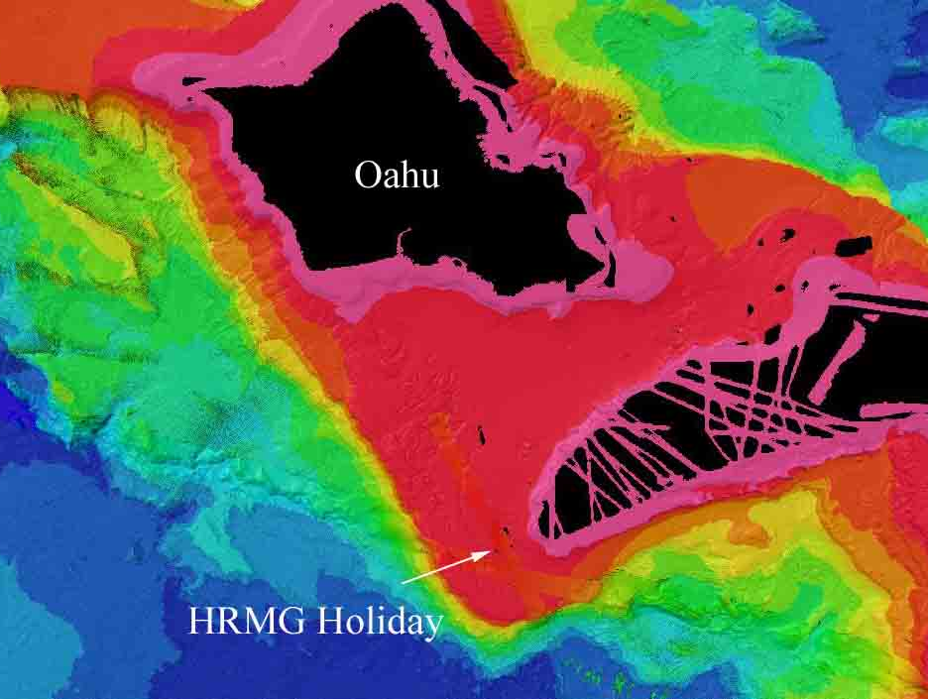
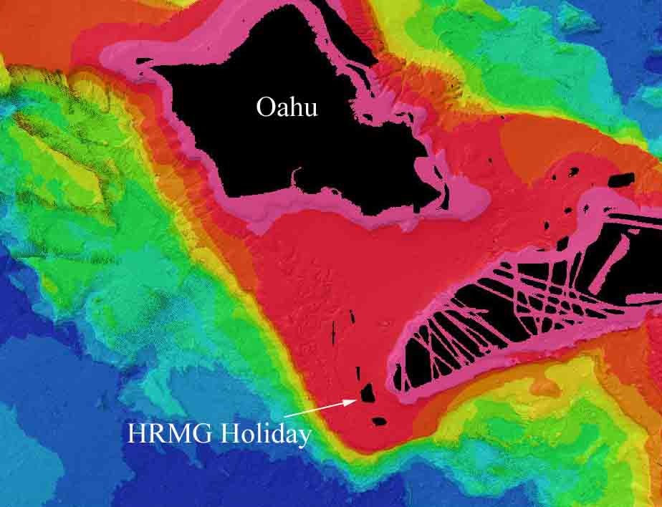

Figure 3: (Left) HRGM holiday (Right) EM 302 track line over the HMRG holidays in vicinity of Oahu.
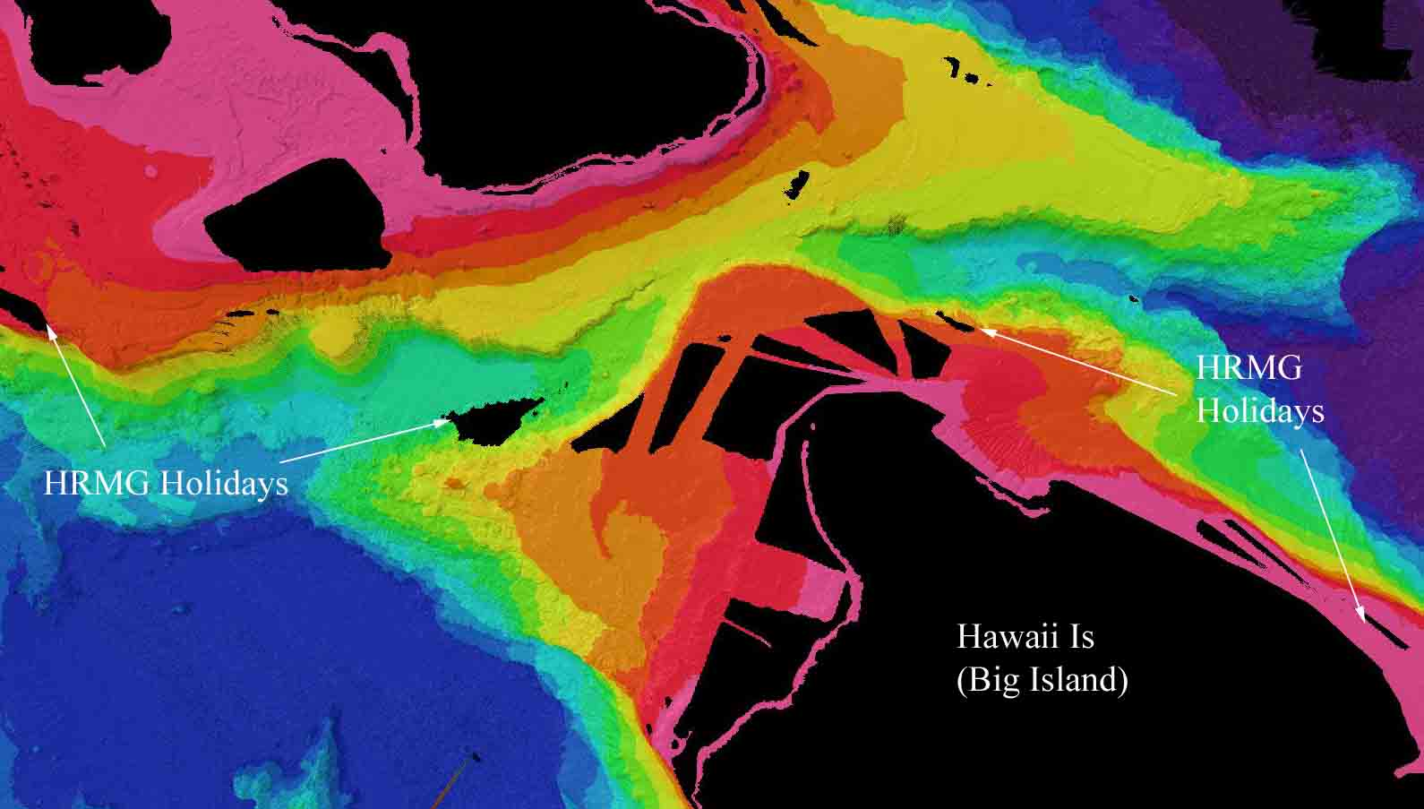
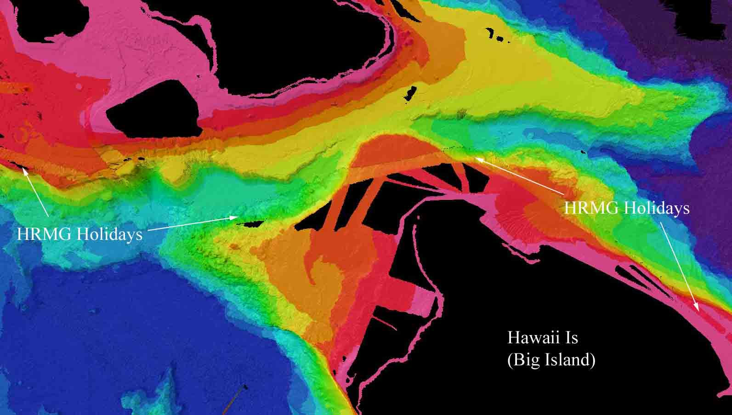

Figure 4: (Left) Image showing HMRG holidays in vicinity of Big Island (Right) EM 302 track lines over the HMRG holidays in vicinity of Big Island.

Wini and adjacent seamounts

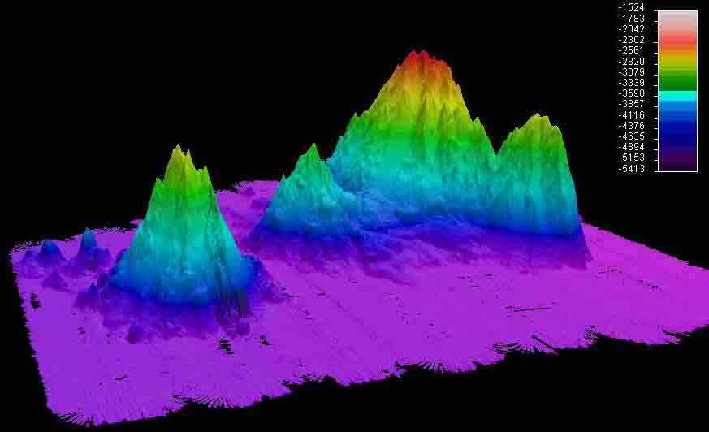

Figure 5: Image showing Wini seamount with view in direction of South West after preliminary processing of raw data. The image shows the three pinnacles in the background that form the Wini seamount. The seamount in the foreground is Alexander Seamount.

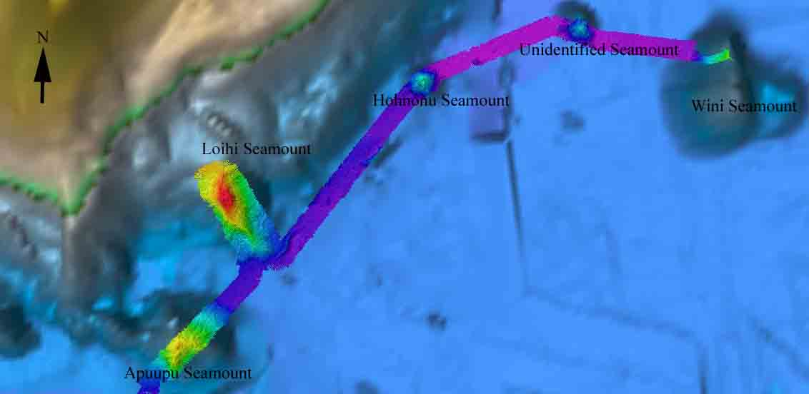

Figure 6: Seamounts that were mapped partially while in transit from Wini Seamount to the mapping area west of Big Island. The seamounts which were mapped included unidentified (but known), Hohnonu, Loihi and Apuupu Seamount.

During the transit from Wini Seamount to west of Big Island few lines were run over Loihi seamount. The data appears to show detailed structure over Loihi seamount including 3 distinct calderas on top of the Loihi seamount. No water column targets were picked up on top of the Loihi seamount.

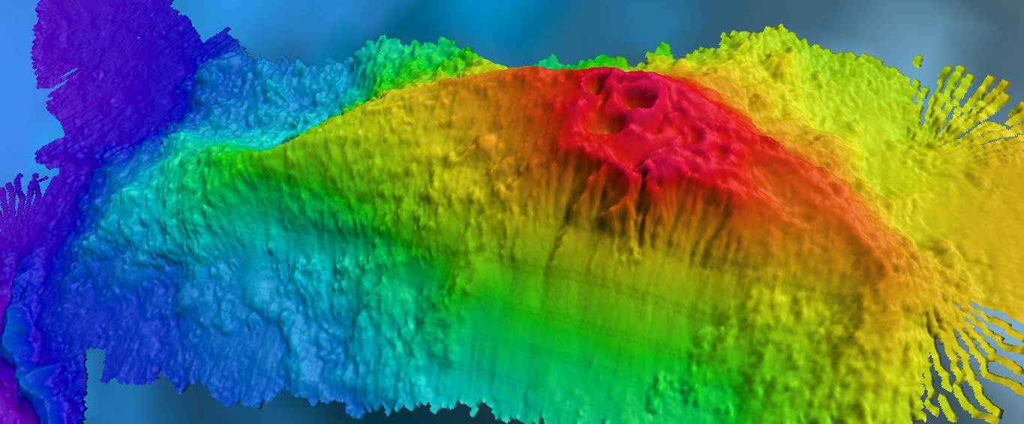

Figure 7: Bathymetric results over Loihi seamount.

Kealakekua Bay mapping area

This area has been well mapped and documented in the literature [e.g. 4] and provides a good opportunity to test the EM 302 performance against existing data sets. Also for 2010 planned engineering dives for ROV from the ship this provides a good test bed area which is also in relatively protected waters.

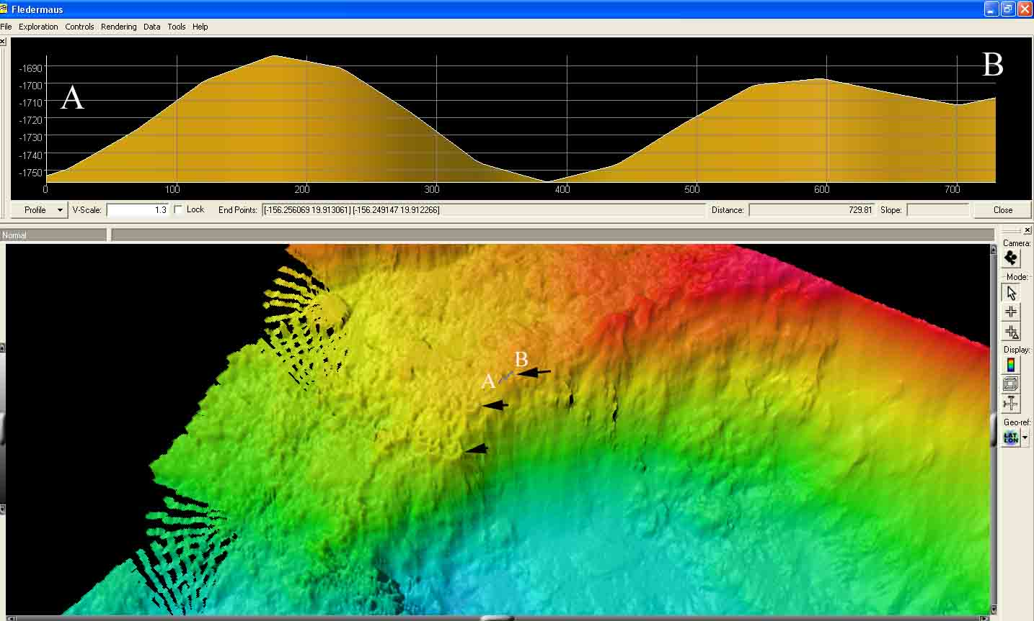
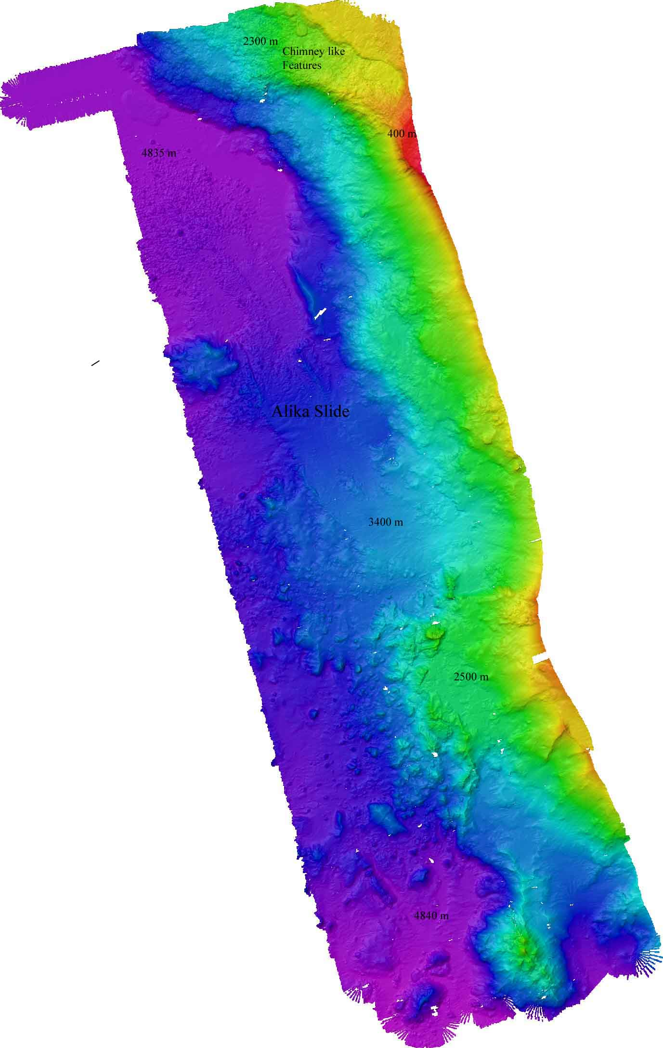

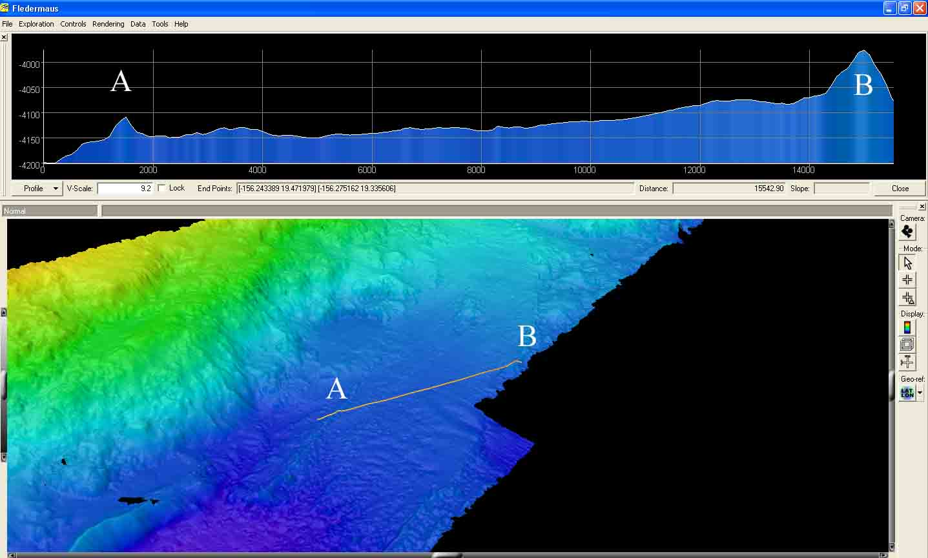

Figure 8: Left: Over view of the area mapped in the area west of Big Island. Right top: Chimney like features observed in the northern section of mapping area, provided with a depth profile across one of these features showing a crater with depth of 60 m with a diameter of ~ 200 m. Right bottom: Debris flow from the shallow part to the deeper regions forms a well defined region of ~ 9 km width which is very smooth with its boundary clearly marked (Alika slide [4]).

PMNM priority area mapping

Papahanaumokuakea Marine National Monument (PMNM) area was mapped from Oct 18 – Oct 20 2009. The preliminary processing of the data show a shallow feature of ~ 65 m with several slides visible around the feature. The depths fall off to ~ 4500 on the side of the feature.
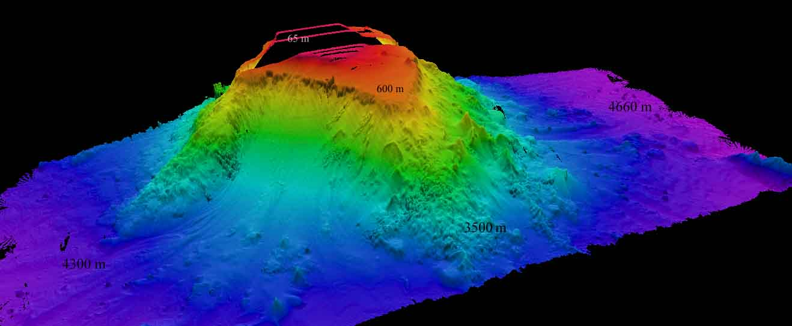

Figure 9: Preliminary results of the EM 302 bathymetric data over the PMNM priority
area.

6.2. System analysis

Evaluation of best course for optimal EM 302 data collection

It has been realized that EM 302 multibeam sonar seems to perform better when the ship is not heading into the swell / sea right ahead. This experiment was meant to provide data to quantitatively analyze the effect of ship heading with respect to the sea waves and swells.
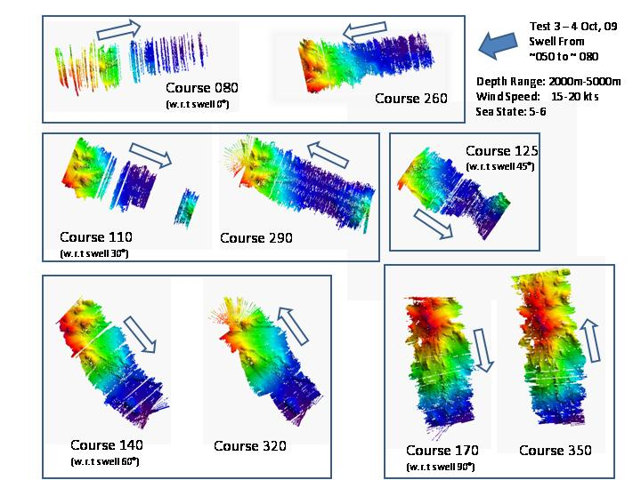

Figure 10: Image showing mapping results with lines run over Wini seamount in different directions

Track lines over ~ 10 miles were collected while running the ship in directions of 000, 180, 030, 210, 060, 240, 090 and 270 with respect to the swell. The results indicate that the best direction to run the survey lines is beyond 30 degrees from the swell. However, for the perpendicular to the swell lines, although the data quality was observed to be the best but the ship rolled violently.

Apart from serious design modifications, the ship is expected to continue to have the bubble sweep down issues. It is suggested that weather conditions should be considered while laying out the mapping plan to avoid track directions less than 30 degrees with respect to swell directions to avoid severe bubble sweep down related degradation of data.

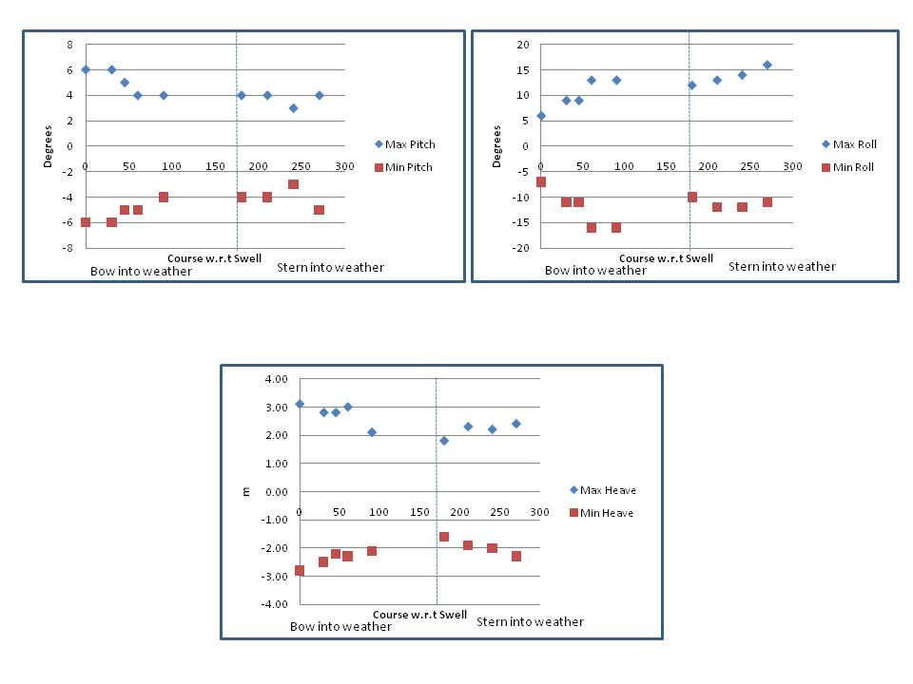

Figure 11: Results of heave, roll and pitch observed while running mapping lines in different directions with respect to swell.

Evaluation of multibeam bathymetric data variability during DP test

Dynamic Positioning (DP) system onboard enables the ship to hold station within few meters with the help of a bow thruster and 2 stern thrusters. Three sets of 100 pings were collected over a period of ~ 1 hour. In ideal conditions (calm conditions, no heading and position variations), the same beam is expected to be sampled over 100 pings and therefore enables a computation to infer uncertainty due to the sonar system itself. Field evaluations of multibeam sonar bathymetric data variability by keeping a close station using DP system has been attempted by de Moustier [6]. A strict requirement described by [6] is to have a relatively flat seafloor so as to enable ping to ping comparison in presence of small variations in ship’s heading. EM 302 system compensates for ship’s motion (pitch and roll stabilization) therefore the same beam may not be falling over the same part of the seafloor. If the seafloor is relatively flat these variations will have minimal impact but during this experiment the seafloor depth varied (across track) by more than 1000 m. It is expected that further processing of these results will be carried on shore and it is recommended that this experiment be repeated to assess uncertainty of the EM 302 bathymetric data which is an essential component of over sonar uncertainty.
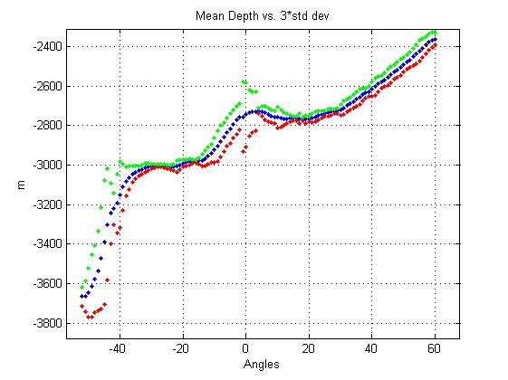
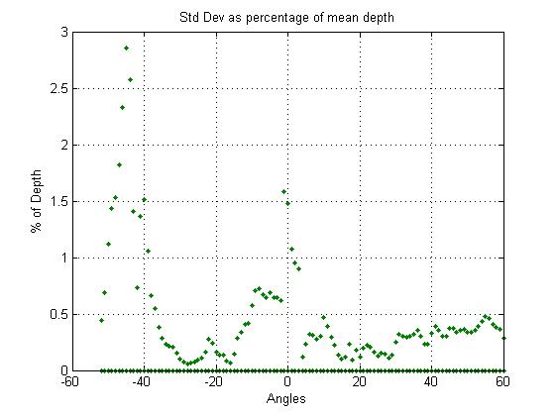

Figure 12: (Left) Mean depth plotted against transmit angle (Blue). Red and green points show the 3 x Std deviations of bathymetric data. (Right) Standard deviation plotted as percentage of mean depth plotted against transmit angle. Please note that the plot on the right is not symmetrical. Also the percentage of std deviation seems to be exceptionally large beyond 40 degrees transmit angle.

6.3. Wreck investigation:

Three wrecks’ location was provided by Kayleen Keller (http://papahanaumokuakea.gov/). The locations of these wrecks are listed below:

Ship Name | Latitude | Longitude | Depth (m) | Dimensions*
SS 133 – S-28 | 21.3333 | -158.333 | 2300 | 66.8 (L), 6.3 (B), 4.9 (D)
SSk 242 Bluegill | 20.59166 | -156.90829 | 500 | 95 (L), 8.3 (B), 5.2 (D)
SS 393 Queenfish | 21.43167 | -158.345 | 2600 | 94.9 (L), 8.3 (B), 5.1 (D)
* L – Length; B – Beam, D- Draft. Source: wikipedia.org

All of these wrecks are of WW II submarines.

USS SS-28 and USS Queenfish

USS SS-28 and USS Queenfish wrecks were investigated during EX0909-Leg 2 (Sept 2009). The wreck sites were mapped for several hours running several lines over the wreck sites, however, no features mimicking wrecks were observed in the bathymetric and backscatter data. Images showing the bathymetric data collected over these expected wreck sites are provided below:

NOTE: These two wrecks were explored during EX0909-Leg 2. For complete list of multibeam lines that were collected over these features please consult the cruise report for EX0909-Leg 2 cruise [3].

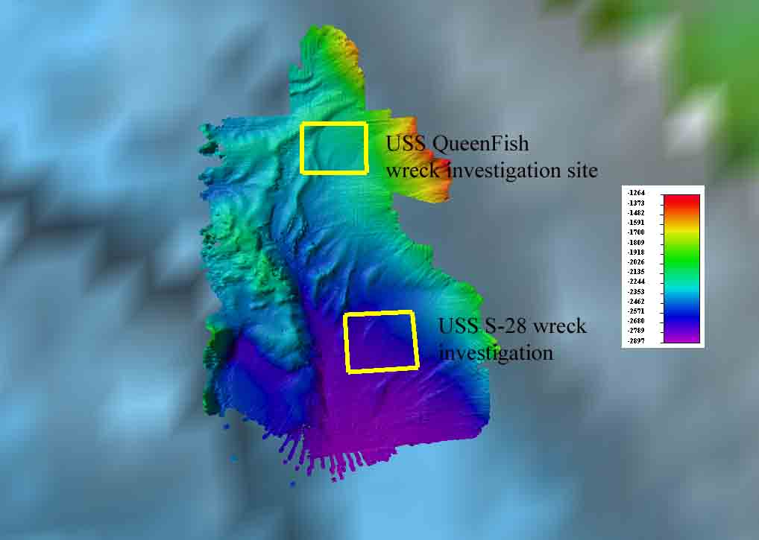

Figure 13: Overview of the EM 302 data collected in vicinity of wreck sites of SS-133 and USS Queenfish.

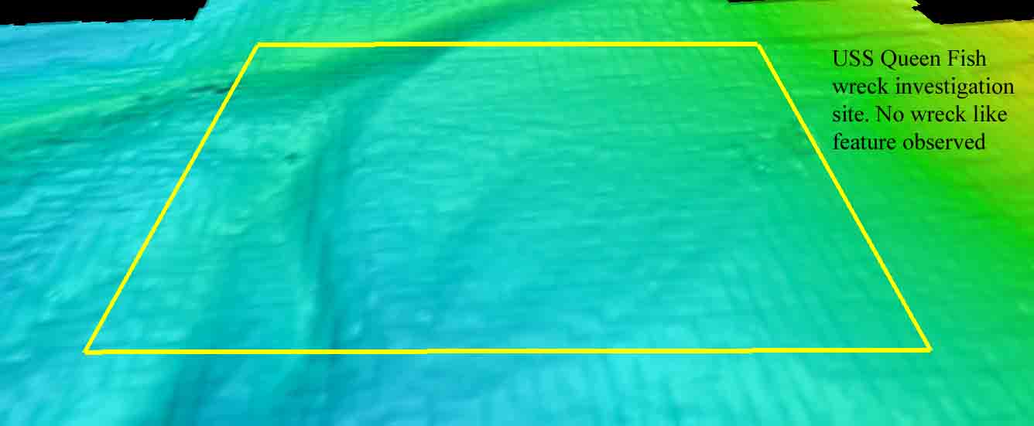

Figure 14: An oblique view of bathymetric data collected over reported wreck site of USS Queenfish. The area is marked with a square with 3000 m dimensions.

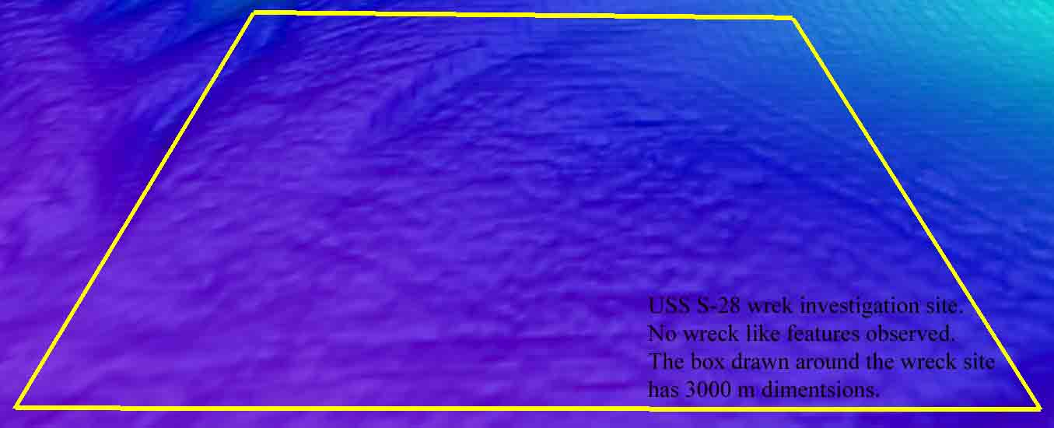

Figure 15: An oblique view looking north over the expected wreck site of USS S-28. No wreck like features were observed in the EM 302 bathymetric and backscatter data.

USS Bluegill

The ship investigated USS Bluegill wreck site location during night of 15/16 October, 2009. A total of 4 passes were made in an area ~ 2-3 km around the reported position of the wreck. Several features, with comparable sizes to the wreck, were discernable in both bathymetric and backscatter data. Due to a large number of geological features, around the reported position of the wreck, on the seafloor it was not possible to conclusively determine the location of the wreck by the EM 302 data alone. Future work is recommended to investigate the targets detected by EM 302. Following images show the results of EM 302 data around the wreck location.

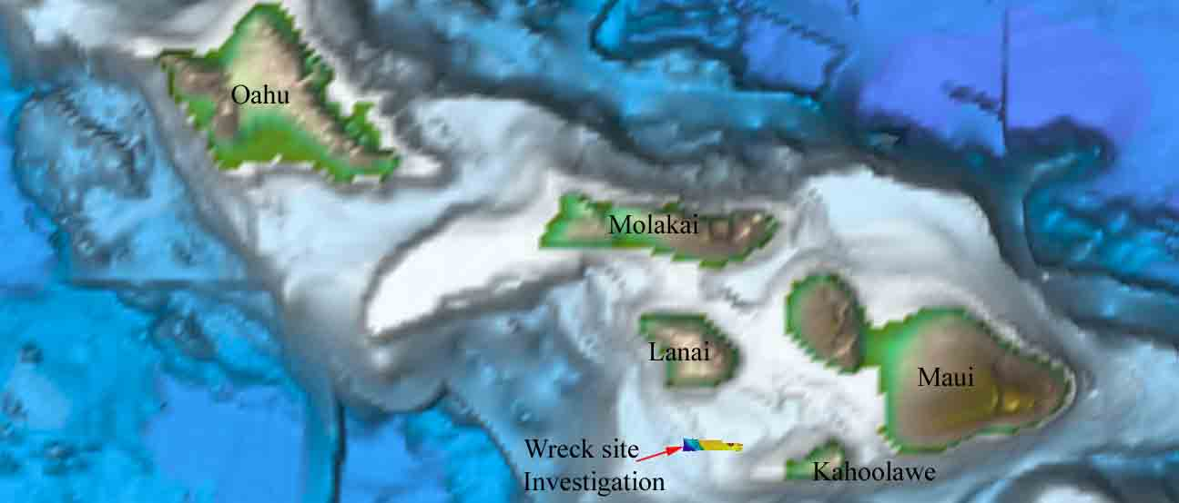

Figure 16: Over view of the USS Bluegill wreck investigation site.

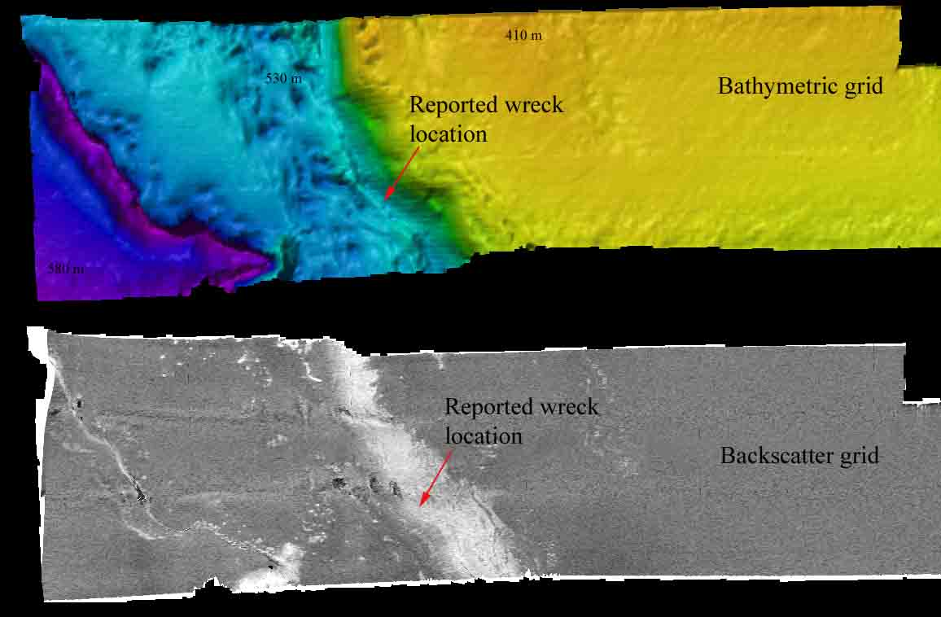

Figure 17: Bathymetric and backscatter grid around the USS Bluegill wreck site.

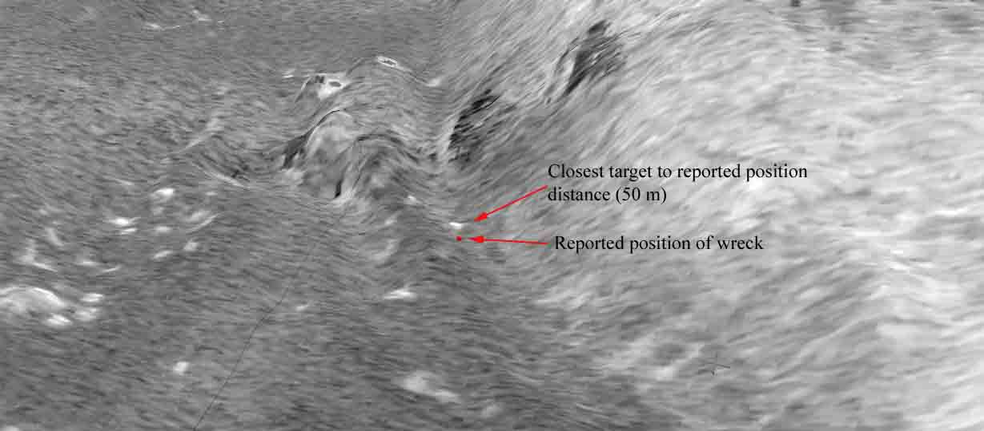

Figure 18: Zoomed in view around the reported wreck position of USS Bluegill. Several bathymetric and backscatter targets were identified close to the reported wreck position with closest backscatter target ~ 50 m from the reported wreck position.

7. Table of Cruise Statistics

Dates | 10/1/09 – 10/21/2009
Weather delays | 0
Total non-mapping days | 5
Total survey mapping days | 15
Total transit mapping days | 2
Line kilometers of survey | 5855
Beginning draft | 13’11”(fwd)14’3.5” (aft)
Average ship speed for survey | 8.7 Kts

8. Cruise Calendar

October 2009
Mon | Tue | Wed | Thu | Fri | Sat | Sun
 |  |  | 1  Ship departed Honolulu, HI ~ 1500.  Intern training, Heavy weather | 2  Ship in transit to Wini Seamount. Going north or Big Island trying to cover HMRG holidays | 3  Arrived Wini Seamount.  Conducted star lines to assess best course w.r.t to swell | 4  Continue running main-scheme lines over Wini seamount
5  Continue running main-scheme lines over Wini Seamount.  CTD cast at 1215 to 800 m | 6  Finished Main scheme lines. Transiting towards other seamounts. CTD cast at 1215 to 800 m | 7  Arrived west of Big Island mapping site.  Conducted CTD cast to 800 m at 1215 | 8  Continue running main scheme lines in area west of Big Island. CTD cast to 800 conducted  Small boat ops | 9  Keleakekua  Bay survey.  CTD cast to 800 m.  Small boat ops. | 10  Kealeakekua  Bay survey. CTD cast to 800 m. Small boat ops. | 11  72 hrs DP test in progress, started 1200. Multibeam remains secured
12  72 hrs DP test in progress | 13  72 hrs DP test in progress | 14  Concluded 72 hrs DP test ~ 1200.  Anchor Kealakekua Bay | 15  Lifted anchor 1530. Commenced  transit towards the wreck site | 16  Investigation of USS Bluegill wreck.  Continue transit towards the wreck site | 17  Commenced working in PMNM area | 18  Continue mapping ops in PMNM area  CTD cast to 800 m
19  Continue mapping ops in PMNM area  CTD cast to 800 m. EM302 malfunction for ~ 4 hrs | 20  Commenced transit towards Honolulu, HI | 21  Arrived Honolulu, HI

9. Daily cruise log

(ALL TIMES LOCAL HDT)

1 October 2009

Departed from Honolulu, HI ~ 1500. Got into heavy weather with lot of pitching and heaving during the night. The multibeam was not performing well due to a lot of bubble sweep down problems.

2 October 2009.

Continue transit towards Wini seamount covering HMRG holidays west and north of the Big Island. Weather conditions are sea-state 5-6 with 6-8 feet of swell. Multibeam performance remains degraded due to heavy weather.

3 October 2009

Arrived Wini seamount working grounds ~0700. Started the main scheme lines. Sea-state is 4-5 with wind 15-20 kts. Swell direction: From ~ 050 ~ 080.

Plan to run a star pattern to find out the best course in heavy weather. It has been realized that multibeam seem to perform better when the ship is not heading into the swell / sea right ahead. This experiment is meant to provide data to quantitatively analyze the effect of ship heading with respect to the sea waves and swells.

The ship stopped to fix the CNAV comport connection. Ets physically removed the comport and tightened the connection. During this stop the multibeam was stopped also and a BIST test showed that transmit board # 16 is bad. The board was then swapped with board # 18 and another BIST showed that board # 18 is now bad – confirming that it is the board and not the slot. Upon verification from OPSO it was learnt that the same board (Board # 16) failed in August and was replaced by a spare sent in from Kongsberg. The boards were then placed in their respective places (non-functioning board is now at slot # 16 again).

4 October 2009

Continue to run the main scheme lines. Finished acquisition of star lines 04 Oct 0100. Collected lines in directions of 000, 180, 030, 210, 060, 240, 090 and 270 with respect to the swell. The results indicate that the best direction to run the survey lines is beyond 30 degrees from the swell. However, for the perpendicular to the swell lines, although the data quality was observed to be best but the ship rolled violently.

5 October 2009

Continue running lines over Wini seamount. CTD cast conducted 1215-1300 to train survey, deck and bridge to a depth of 800 m.

6 October, 2009

Finished running main scheme lines over Wini Seamount in the morning. Transiting towards other Seamounts.

1210-1325 – Conducted CTD cast

The ship transited to the west of Big Island mapping area over night going over the seamounts which were identified in the existing satellite derived and HMRG data sets.

The ship also transited over features which appear to have a shape of horse shoe. These features rise ~ 45 - 60 m above the seafloor and have a diameter of ~ 800 - 1100 m.

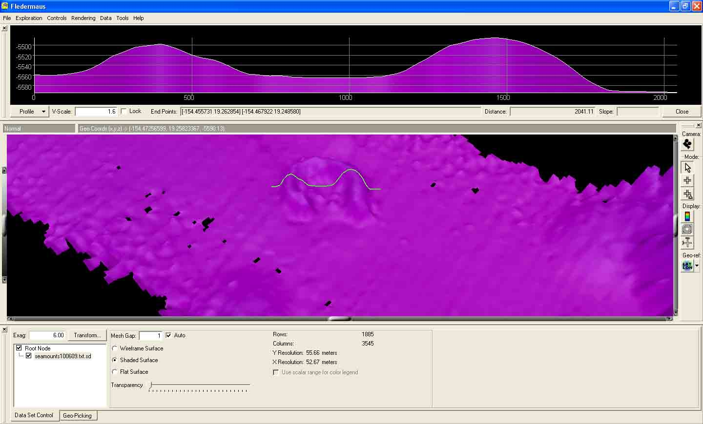

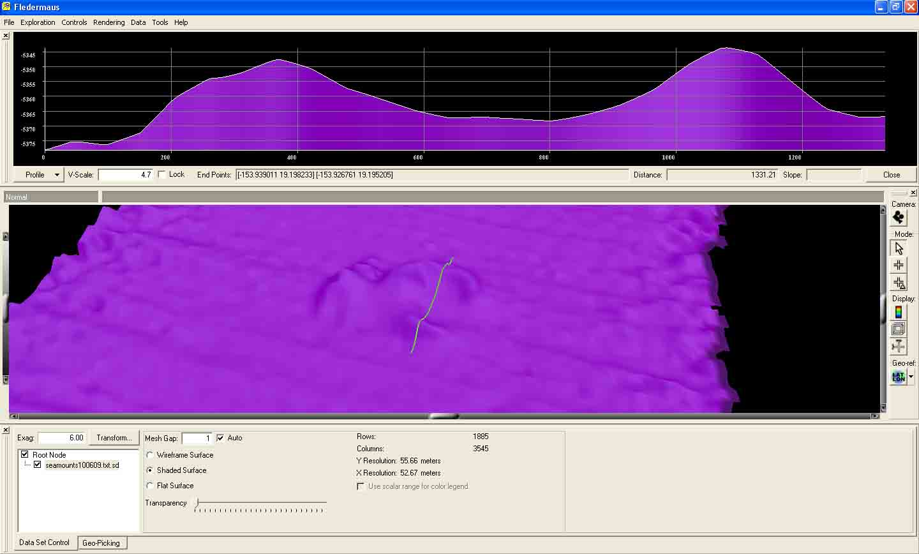

The information about these features was sent to Dr. Hammond which initiated following reply:

“* "Stephen R. Hammond" <Stephen.R.Hammond@noaa.gov> [Fri 09 Oct 2009 01:23:55 AM EDT]:

> Craig (and Mashkoor),
>
The first feature, and possibly the second, look like small, sedimented volcanic cones of the type I discussed in that paper I sent to you a while back. The breached crater/caldera morphology is very common along the Juan de Fuca Ridge as well as elsewhere along the East Pacific Rise. I suspect these are quite old features that are roughly the age of the crust on which they lie, i.e., that they formed on, or in close proximity, to a spreading center. ----Steve”

7 October

The ship started running main scheme line in the area west of Big Island. A CTD cast was conducted to 800 m of water depth at 1215.

8 October

The ship continued running main scheme lines in the Kealakekua Bay area west of Big Island. CTD cast up to 800 m water depth conducted at 1215.

9 October

The ship continues to run the lines over Kealakekua Bay area. Lavolvo was contacted today to provide input for the mapping areas to find suitable targets for ROV engineering dives. Some of the interesting features that were found in this area are:

10 October

Small boat operations were conducted to run the small boat to break in the engine. CTD cast was conducted to 800 m water depth. Continue mapping ops in Kealeakekua Bay.

11 October, 2009

72 hrs DP test continues. ~ 45 minutes of data while the ship held station (in water depths of 2400 – 3600 m) were collected to assess the variability of bathymetric and backscatter data. The preliminary results however indicate that further processing will be required to determine the usability of these data sets for assessing the variability of multibeam bathymetric data.

12-14 Oct – 72 hrs DP test concluded on 14 Oct ~ 1500. The ship then transited towards Kona to anchor from 14 Oct 1500 – 15 Oct 1500.

15 October – The ship commenced transit towards the USS Bluegill wreck ~ 1530 and reached the reported location ~ 2300. The ship then ran 3 track lines around the wreck. But the multibeam sonar was not able to positively identify the location of the wreck. More details about the data processing are provided in the data acquisition and processing section.

16 Oct Continue transit towards PMNM mapping area west of Kauai.

17 Oct – Arrived PMNM working grounds ~ 0130. Commenced mapping in the area.

18 Oct – Secured TSG pump due to large swells. Multibeam performance also degraded. Continue working in PMNM priority area. The area gets very shallow near the boundary of PMNM and swath coverage decreases to ~ few hundred meters. Therefore the top of the shallow feature was not covered to full extent leaving considerable holidays. Several small lines were run over the feature but it is inevitable that there will be holidays on top of the feature. The reported least depth (on the NOAA chart) is 19 fathoms (~ 40 m). The least depth observed during the mapping over the feature was observed to be ~ 65 m.

19 Oct – Ship continues to work in PMNM priority area. EM 302 suffered a major failure ~ 1800 when it stopped forming receive beams. The system (TRU, HWS) was restarted several times. This problem happened earlier during mapping season in May 2009 while working in similar depths (~ 1000 – 2000 m). A BIST test did not show any thing malfunctioning. It is thought that this problem is related to the overloading of SIS computer while working in shallower waters where the ping rate is high enough to overload the SIS computer. The system restarted working after putting the system in PU simulator mode and also changing the minimum and maximum angular coverage.

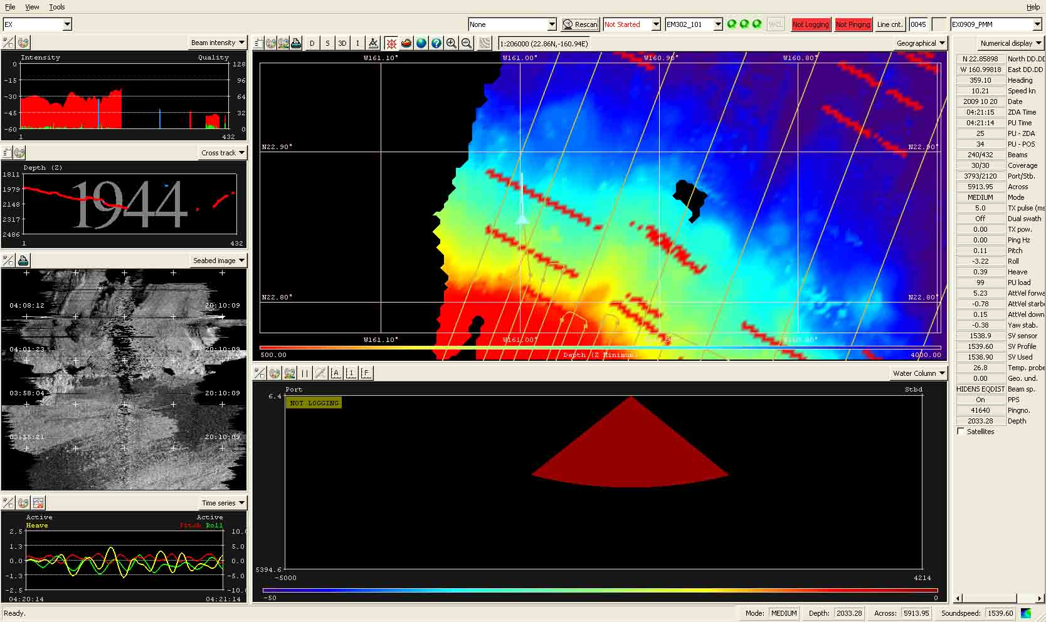

Screen shot of EM 302 malfunction showing a red triangle in the water column data indicating that no receive beam are being formed.

Overnight ship wrapped up mapping operations around PMNM working area and started transit towards Honolulu, HI.

20 Oct – Continued transit towards Honolulu, HI. Last science watch 1600 – 0000. Multibeam was left on unattended from 21 Oct 0000 – 0730. Arrived off Honolulu, HI ~ 0730 and multibeam operations were ceased.

21 Oct – Arrived Honolulu, HI.

10. Tables of data files collected

XBT / CTD Files Collected during the cruise

Date  (GMT) | Time (GMT) | XBT/CTD Filename | Latitude | Longitude | Remarks
10/02/2009 | 02:30:11 | XBT_100109_01 | 21 11.950N | 157 55.740W | Transit
10/02/2009 | 11:02:36 | XBT_100209_02 | 20 25.8N | 157 5.4W | Transit
10/02/2009 | 16:04:07 | XBT_100209_03 | 20 16.2N | 156 34.2W | Transit/Rough sea state
10/02/2009 | 22:45:33 | XBT_100209_04 | 20 23.068N | 155 58.026W | Transit
10/03/2009 | 04:12:41 | XBT_100309_05 | 20 11.58N | 155 21.57W | Transit
10/03/2009 | 10:15:04 | XBT_100309_06 | 19 40.2N | 154 35.4W | Transit
10/03/2009 | 16:09:16 | XBT_100309_07 | 19 22.2N | 153 52.2W | Transit
10/03/2009 | 23:11:59 | XBT_100309_08 | 19 2.300N | 153 54.780W | Wini Seamount/ Sea state test
10/04/2009 | 04:24:48 | XBT_100409_09 | 19 1.254N | 153 45.825W | Wini Seamount/ Sea state test
10/04/2009 | 10:28:59 | XBT_100409_10 | 18 58.2N | 153 58.2W | Wini Seamount/ Preceding line 1
10/04/2009 | 15:52:29 | XBT_100409_11 | 19 17.4N | 153 46.8W | Wini Seamount line 2
10/04/2009 | 22:07:27 | XBT_100409_12 | 19 11.530N | 153 47.180W | Wini Seamount/ Preceding line 7
10/05/2009 | 04:09:03 | XBT_100509_13 | 18 51.890N | 153 55.310W | Wini Seamount/
10/05/2009 | 10:22:35 | XBT_100509_14 | 18 52.2N | 153 48.6W | Wini Seamount
10/05/2009 | 16:03:29 | XBT_100509_15 | 19 1.8N | 123 36.6W | Wini Seamount on line 0020
10/05/2009 | 22:15:11 | CTD_100509_01 | 19 03.94N | 153 29.01W | Wini Seamount preceding line 0025
10/06/2009 | 04:42:17 | XBT_100509_16 | 18 59.664 N | 153 25.309 W | Wini Seamount on line 0030
10/06/2009 |  | XBT_100609_17 |  |  | Bad Cast
10/06/2009 | 10:17:52 | XBT_100609_18 | 18 50.4N | 153 24W | Wini Seamount line 0034
10/06/2009 | 16:11:39 | XBT_100609_19 | 18 58.188N | 154 1.24W | Wini Seamount line 0042
10/06/2009 | 22:22:41 | CTD_100609_02 | 19 14.74N | 154 07.15W | Transit from Wini Smt to Loihi
10/07/2009 | 04:27:58 | XBT_100709_20 | 18 15.398 N | 154 53.059 W | Transit from Wini Smt to Loihi
10/07/2009 | 09:53:27 | XBT_100709_21 | 18 53.24 N | 155 15.56 W | Above Lo’ihi Crater
10/07/2009 | 16:27:14 | XBT_100709_22 | 18 39.797 N | 155 52.022 W | Kealakekua Bay
10/07/2009 | 22:18:32 | CTD_100709_03 | 19 32.37N | 156 05.89W | Kealakekua Bay
10/08/2009 | 04:06:30 | XBT_100809_23 | 19 39.412N | 156 10.488W | Kealakekua Bay
10/08/2009 | 10:24:17 | XBT_100809_24 | 18 37.276N | 155 54.261W | Kealakekua Bay
10/08/2009 | 16:05:21 | XBT_100809_25 | 19 24.390N | 156 9.452W | Kealakekua Bay
10/08/2009 | 22:12:59 | CTD_100809_04 | 19 34.44N | 156 14.34W | Kealakekua Bay
10/09/2009 | 04:30:50 | XBT_100909_26 | 19 2.210 N | 156 6.576 W | Kealakekua Bay
10/09/2009 | 10:22:42 | XBT_100909_27 | 19 2.224N | 156 9.483W | Kealakekua Bay
10/09/2009 | 16:16:00 | XBT_100909_28 | 19 54.800N | 156 26.22W | Kealakekua Bay
10/09/2009 | 22:17:25 | CTD_100909_05 | 19 21.99N | 156 17.44W | Kealakekua Bay
10/10/2009 | 04:11:40 | XBT_101009_29 | 18 35.151N | 156 5.302W | Kealakekua Bay
10/10/2009 | 10:11:14 | XBT_101009_30 | 19 29.138N | 156 22.374W | Kealakekua Bay
10/10/2009 | 16:06:12 | XBT_101009_31 | 19 26.982N | 156 24.727W | Kealakekua Bay
10/10/2009 | 22:21:39 | CTD_101009_06 | 18 5.86N | 156 16.44W | Kealakekua Bay
10/11/2009 | 04:10:35 | XBT_101109_32 | 18 44.718N | 156 49.700W | Kealakekua Bay
10/11/2009 | 10:21:50 | XBT_101109_33 | 19 44.587N | 156 5.824W | Kealakekua Bay
10/11/2009 | 16:05:41 | XBT_101109_34 | 19 55.901N | 156 31.481 W | Kealakekua Bay
10/16/2009 | 04:09:38 | XBT_101609_35 | 19 55.585N | 156 20.019W | Kealakekua Bay/Transit
10/16/2009 | 10:22:55 | XBT_101609_36 | 20 36.134N | 156 53.584W | Wreck site
10/16/2009 | 10:27:23 | XBT_101609_37 | 20 36.139N | 156 52.967W | Wreck site
10/16/2009 | 16:02:54 | XBT_101609_38 | 20 47.993N | 157 43.419W | Transit
10/16/2009 | 22:42:51 | XBT_101609_39 | 21 9.41309N | 158 57.7187W | Transit
10/17/2009 | 04:18:36 | XBT_101709_40 | 21 26.644N | 159 59.208W | Transit
10/17/2009 | 10:21:47 | XBT_101709_41 | 22 10.425N | 160 45.382W | Transit
10/17/2009 | 16:11:38 | XBT_101709_42 | 22 57.535N | 160 37.892W | PMM
10/17/2009 | 22:20:05 | CTD_101709_07 | 22 20.05N | 160 56.36W | PMM
10/18/2009 | 04:11:59 | XBT_101809_43 | 23 02.041N | 160 42.278W | PMM
10/18/2009 | 10:21:24 | XBT_101809_44 | 22 22.828N | 161 1.632W | PMM
10/18/2009 | 16:14:14 | XBT_101809_45 | 22 55.443N | 160 51.274W | PMM
10/18/2009 | 22:21:50 | CTD_101809_08 | 22 34.87N | 161 02.81W | PMM
10/19/2009 | 04:19:57 | XBT_101909_46 | 22 52 830N | 160 58.599W | PMM
10/19/2009 | 10:20:28 | XBT_101909_47 | 22 35.172N | 161 7.621W | PMM
10/19/2009 | 15:57:21 | XBT_101909_48 | 22 44.374N | 160 54.552W | PMM
10/19/2009 | 22:39:03 | CTD_101909_09 | 22 35.14N | 161 03.35W | PMM
10/20/2009 | 04:17:25 | XBT_102009_49 | 22 50.937N | 160 59.801W | PMM
10/20/2009 | 10:26:04 | XBT_102009_50 | 22 47.419N | 160 41.196W | PMM
10/20/2009 | 16:04:43 | XBT_102009_51 | 22 29.135N | 160 46.490W | PMM
10/20/2009 | 22:44:20 | XBT_102009_52 | 21 37.876N | 160 19.3457W | PMM
10/21/2009 | 04:27:31 | XBT_102109_53 | 21 24.823N | 159 30.272W | Transit Home

Multibeam files collected during the cruise

JD |  | Date (GMT) | File Name | Location | Survey Name | Remarks
275 |  | 100209 | 0000_20091002_030850_EX | In Transit | EX0909_HawaiiIs_Transit | Rough seas
275 |  | 100209 | 0001_20091002_085816_EX | In Transit | EX0909_HawaiiIs_Transit | Not as rough seas beginning of line/ towards end of line rough seas- bad data
275 |  | 100209 | 0002_20091002_145817_EX | In Transit | EX0909_HawaiiIs_Transit | Rough seas, data very bad
275 |  | 100209 | 0003_20091002_171952_EX | In Transit | EX0909_HawaiiIs_Transit | Rough seas
275 |  | 100209 | 0004_20091002_192920_EX | In Transit | EX0909_HawaiiIs_Transit | Moderate seas
275 |  | 100209 | 0005_20091002_211445_EX | In Transit | EX0909_HawaiiIs_Transit | Sea state 6
276 |  | 100309 | 0006_20091003_010549_EX | In Transit | EX0909_HawaiiIs_Transit | Moderate seas
276 |  | 100309 | 0007_20091003_034436_EX | In Transit | EX0909_HawaiiIs_Transit | Rough seas
276 |  | 100309 | 0008_20091003_074325_EX | In Transit | EX0909_HawaiiIs_Transit | Rough seas
276 |  | 100309 | 0009_20091003_133005_EX | In Transit | EX0909_HawaiiIs_Transit | Rough Seas
276 |  | 100309 | 0000_20091003_164419_EX | Wini SeaMnt | Wini SeaMnt | Swells >5 ft
276 |  | 100309 | 0000_20091003_232450_EX | Wini SeaMnt | SeaStateLines | Moderate seas
277 |  | 100409 | 0001_20091004_000003_EX | Wini SeaMnt | SeaStateLines | Moderate seas
277 |  | 100409 | 0002_20091004_010542_EX | Wini SeaMnt | SeaStateLines | Moderate seas
277 |  | 100409 | 0003_20091004_021816_EX | Wini SeaMnt | SeaStateLines | Moderate seas
277 |  | 100409 | 0004_20091004_034252_EX | Wini SeaMnt | SeaStateLines | Swells 4-6 ft
277 |  | 100409 | 0005_20091004_045101_EX | Wini SeaMnt | SeaStateLines | Swells 4-6 ft
277 |  | 100409 | 0006_20091004_061112_EX | Wini SeaMnt | SeaStateLines | Swells 4-6 ft
277 |  | 100409 | 0007_20091004_071114_EX | Wini SeaMnt | SeaStateLines | Swells 4-6 ft
277 |  | 100409 | 0008_20091004_082301_EX | Wini SeaMnt | SeaStateLines | Swells 4-6 ft
277 |  | 100409 | 0001_20091004_110818_EX | Wini SeaMnt | Wini Sea Mnt | 10 ft seas, wind 20 kts
277 |  | 100409 | 0002_20091004_111226_EX | Wini SeaMnt | Wini Sea Mnt | 10 ft seas, wind 20 kts
277 |  | 100409 | 0003_20091004_151508_EX | Wini SeaMnt | Wini Sea Mnt | Turn line
277 |  | 100409 | 0004_20091004_154255_EX | Wini SeaMnt | Wini Sea Mnt | Line heading SW with following seas
277 |  | 100409 | 0005_20091004_185006_EX | Wini SeaMnt | WiniSeamnt | Turn line
277 |  | 100409 | 0006_20091004_191628_EX | Wini SeaMnt | WiniSeamnt | Swells 3-5ft
277 |  | 100409 | 0007_20091004_230428_EX | Wini SeaMnt | WiniSeamnt | Turn Line
277 |  | 100409 | 0008_20091004_23374_EX | Wini SeaMnt | WiniSeamnt | Swells 3-5ft
277 |  | 100409 | 0009_20091004_235955_EX | Wini SeaMnt | WiniSeamnt | Swells 3-5ft
278 |  | 100409 | 0009_20091005_012123_EX | Wini SeaMnt | SeaStateLines | Swells 3-5ft
278 |  | 100509 | 0010_20091005_023244_EX | Wini SeaMnt | WiniSeamnt | Moderate seas
278 |  | 100509 | 0011_20091005_035853_EX | Wini SeaMnt | WiniSeamnt | Moderate seas
278 |  | 100509 | 0012_20091005_040454_EX | Wini SeaMnt | WiniSeamnt | Moderate seas
278 |  | 100509 | 0013_20091005_053210_EX | Wini SeaMnt | WiniSeamnt | Moderate seas
278 |  | 100509 | 0014_20091005_055847_EX | Wini SeaMnt | WiniSeamnt | Moderate seas
278 |  | 100509 | 0015_20091005_072326_EX | Wini SeaMnt | WiniSeamnt | Moderate seas
278 |  | 100509 | 0016_20091005_074748_EX | Wini SeaMnt | WiniSeamnt | Moderate seas
278 |  | 100509 | 0017_20091005_104617_EX | Wini SeaMnt | Wini SeaMnt | Moderate seas – turn line
278 |  | 100509 | 0018_20091005_110734_EX | Wini SeaMnt | Wini SeaMnt | Moderate/heavy seas
278 |  | 100509 | 0019_2091005_144142_EX | Wini SeaMnt | Wini SeaMnt | Moderate seas-turn line
278 |  | 100509 | 0020_20091005_150654_EX | Wini SeaMnt | Wini SeaMnt | Moderate seas
278 |  | 100509 | 0021_20091005_175313_EX | Wini SeaMnt | Wini SeaMnt | Moderate seas
278 |  | 100509 | 0022_20091005_181631_EX | Wini SeaMnt | Wini SeaMnt | Moderate seas
278 |  | 100509 | 0023_20091005_210604_EX | Wini SeaMnt | Wini SeaMnt | Moderate seas
278 |  | 100509 | 0024_20091005_213244_EX | Wini SeaMnt | Wini SeaMnt | Moderate seas
278 |  | 100509 | 0025_20091005_225335_EX | Wini SeaMnt | Wini SeaMnt | Moderate seas
279 |  | 100609 | 0026_20091006_000004_EX | Wini SeaMnt | Wini SeaMnt | Moderate seas
279 |  | 100609 | 0027_20091006_004606_EX | Wini SeaMnt | Wini SeaMnt | Moderate seas
279 |  | 100609 | 0028_20091006_011302_EX | Wini SeaMnt | Wini SeaMnt | Moderate seas
279 |  | 100609 | 0029_200091006_033347_EX | Wini SeaMnt | Wini SeaMnt, Turn Line | Moderate seas
279 |  | 100609 | 0030_20091006_035641_EX | Wini SeaMnt | Wini SeaMnt | Moderate seas
279 |  | 100609 | 0031_20091006_060127_EX | Wini SeaMnt | Wini SaMnt, Turn line | Moderate seas
279 |  | 100609 | 0032_20092006_062541_EX | Wini SeaMnt | Wini SeaMnt | Moderate seas
279 |  | 100609 | 0033_20092006_082543_EX | Wini SeaMnt | Wini SaMnt, Turn line | Moderate seas
279 |  | 100609 | 0034_20091006_084543_EX | Wini SeaMnt | Wini SeaMnt | Moderate seas
279 |  | 100609 | 0035_20091006_103404_EX | Wini SeaMnt | Wini SeaMnt | Moderate seas-transit to holiday lines
279 |  | 100609 | 0036_20091006_115856_EX | Wini SeaMnt | Wini SeaMnt | Holiday lines – Mod. Seas
279 |  | 100609 | 0037_20091006_134224_EX | Wini SeaMnt | Wini SeaMnt | Holiday line - turn
279 |  | 100609 | 0038_20091006_134727_EX | Wini SeaMnt | Wini SeaMnt | Holiday line
279 |  | 100609 | 0039_20091006_153116_EX | Wini SeaMnt | Wini SeaMnt | Holiday line - turn
279 |  | 100609 | 0040_20091006_153451_EX | Wini SeaMnt | Wini SeaMnt | Holiday line
279 |  | 100609 | 0041_20091006_155736_EX | Wini SeaMnt | Wini SeaMnt | Holiday line – turn
279 |  | 100609 | 0042_20091006_155958_EX | Wini SeaMnt | Wini SeaMnt | Holiday line
279 |  | 100609 | 0043_20091006_184004_EX | Wini SeaMnt | Wini SeaMnt | Holiday Line – Turn
279 |  | 100609 | 0044_20091006_184228_EX | Wini SeaMnt | Wini SeaMnt | Holiday line
279 |  | 100609 | 0045_20091006_191619_EX | Wini SeaMnt | Wini SeaMnt | Holiday line - Turn
279 |  | 100609 | 0046_20091006_191904_EX | Wini SeaMnt | Wini SeaMnt | Holiday line
279 |  | 100609 | 0047_20091006_201542_EX | Wini SeaMnt | Wini SeaMnt | Holiday line
279 |  | 100609 | 0010_20091006_202029_EX | In Transit | EX0909_HawaiiIs_Transit | Transit to Loihi
279 |  | 100609 | 0011_20091006_232300_EX | In Transit | EX0909_HawaiiIs_Transit | Transit to Loihi
280 |  | 100709 | 0012_20091007_000115_EX | In Transit | EX0909_HawaiiIs_Transit | Transit to Loihi
280 |  | 100709 | 0013_20091007_003715_EX | In Transit | EX0909_HawaiiIs_Transit | Strange ‘C’ structure in the backscatter data
280 |  | 100709 | 0014_20091007_023923_EX | In Transit | EX0909_HawaiiIs_Transit | Transit to Loihi
280 |  | 100709 | 0015_20091007_003715s_EX | In Transit | EX0909_HawaiiIs_Transit | Transit to Loihi
280 |  | 100709 | 0016_20091007_031453_EX | In Transit | EX0909_HawaiiIs_Transit | Turn line before Loihi
280 |  | 100709 | 0017_20091007_063801_EX | Loihi SeaMnt | EX0909_HawaiiIs_Transit | First Loihi line/wcd file
280 |  | 100709 | 0018_20091007_081733_EX | Loihi SeaMnt | EX0909_HawaiiIs_Transit | Loihi – turn line
280 |  | 100709 | 0019_20091007_083336_EX | Loihi SeaMnt | EX0909_HawaiiIs_Transit | Second Loihi MS line
280 |  | 100709 | 0020_20091007_090038_EX | Loihi SeaMnt | EX0909_HawaiiIs_Transit | Broke line to turn into center of crater
280 |  | 100709 | 0021_20091007_090225_EX | Loihi SeaMnt | EX0909_HawaiiIs_Transit | Line over crater west to east
280 |  | 100709 | 0022_20091007_091744_EX | Loihi SeaMnt | EX0909_HawaiiIs_Transit | Turn line
280 |  | 100709 | 0023_20091007_092107_EX | Loihi SeaMnt | EX0909_HawaiiIs_Transit | Second line over crater east to west
280 |  | 100709 | 0024_20091007__093603_EX | Loihi SeaMnt | EX0909_HawaiiIs_Transit | Loihi Seamount turn line
280 |  | 100709 | 0025_20091007_093958_EX | Loihi SeaMnt | EX0909_HawaiiIs_Transit | Leaving Loihi Seamount south
280 |  | 100709 | 0026_20091007_104833_EX | In Transit | EX0909_HawaiiIs_Transit | Turn line to transit Big Island
280 |  | 100709 | 0027_20091007_111954_EX | In Transit | EX0909_HawaiiIs_Transit | Transit line to Kealakekua Bay
280 |  | 100709 | 0028_20091007_135205_EX | In Transit | EX0909_HawaiiIs_Transit | Transit line to Kealakekua Bay
280 |  | 100709 | 0029_20091007_135701_EX | In Transit | EX0909_HawaiiIs_Tranist | Transit line to Kealakekua Bay
280 |  | 100709 | 0000_20091007_160407_EX | Kealakekua | EX0909_Kealakekua_Bay | Kealakekua Bay Survey
280 |  | 100709 | 0001_20091007_16656_EX | Kealakekua | EX0909_Kealakekua_Bay | Kealakekua Bay Survey
280 |  | 100709 | 0002_20091007_190019_EX | Kealakekua | EX0909_Kealakekua_Bay | Kealakekua Bay Survey
280 |  | 100709 | 0003_20091007_220612_EX | Kealakekua | EX0909_Kealakekua_Bay | This line is a mistake and does not need to be converted into Caris.
280 |  | 100709 | 0004_20091007_230029_EX | Kealakekua | EX0909_Kealakekua_Bay | Kealakekua Bay Survey
281 |  | 100809 | 0005_20091008_000010_EX | Kealakekua | EX0909_Kealakekua_Bay | Kealakekua Bay Survey
281 |  | 100809 | 0006_20091008_014330_EX | Kealakekua | EX0909_Kealakekua_Bay | Kealakekua Bay Survey
281 |  | 100809 | 0007_20091008_021104_EX | Kealakekua | EX0909_Kealakekua_Bay | Kealakekua Bay Survey
281 |  | 100809 | 0008_20091008_081106_EX | Kealakekua | EX0909_Kealakekua_Bay | Kealakekua Bay Survey
281 |  | 100809 | 0009_20091008_102720_EX | Kealakekua | EX0909_Kealakekua_Bay | Kealakekua Bay Survey
281 |  | 100809 | 0010_20091008_105404_EX | Kealakekua | EX0909_Kealakekua_Bay | Kealakekua Bay Survey
281 |  | 100809 | 0011_20091008_124815_EX | Kealakekua | EX0909_Kealakekua_Bay | Kealakekua Bay Survey
281 |  | 100809 | 0012_20091008_184814_EX | Kealakekua | EX0909_Kealakekua_Bay | Kealakekua Bay Survey
281 |  | 100809 | 0013_20091008_191801_EX | Kealakekua | EX0909_Kealakekua_Bay | Kealakekua Bay Survey
281 |  | 100809 | 0014_20091008_193905_EX | Kealakekua | EX0909_Kealakekua_Bay | Kealakekua Bay Survey
281 |  | 100809 | 0015_20091008_230002_EX | Kealakekua | EX0909_Kealakekua_Bay | Kealakekua Bay Survey
282 |  | 100909 | 0016_20091008_011123_EX | Kealakekua | EX0909_Kealakekua_Bay | Kealakekua Bay Survey
282 |  | 100909 | 0017_20091009_071120_EX | Kealakekua | EX0909_Kealakekua_Bay | Kealakekua Bay Survey
282 |  | 100909 | 0018_20091009_072235_EX | Kealakekua | EX0909_Kealakekua_Bay | Kealakekua Bay Survey
282 |  | 100909 | 0019_20091009_074514_EX | Kealakekua | EX0909_Kealakekua_Bay | Kealakekua Bay Survey
282 |  | 100909 | 0020_20091009_134514_EX | Kealakekua | EX0909_Kealakekua_Bay | Kealakekua Bay Survey
282 |  | 100909 | 0021_20091009_154908_EX | Kealakekua | EX0909_Kealakekua_Bay | Kealakekua Bay Survey
282 |  | 100909 | 0022_20091009_160954_EX | Kealakekua | EX0909_Kealakekua_Bay | Kealakekua Bay Survey
282 |  | 100909 | 0023_20091009_215324_EX | Kealakekua | EX0909_Kealakekua_Bay | Kealakekua Bay Survey
282 |  | 100909 | 0024_20091009_231111_EX | Kealakekua | EX0909_Kealakekua_Bay | Kealakekua Bay Survey
283 |  | 101009 | 0025_20091010_004934_EX | Kealakekua | EX0909_Kealakekua_Bay | Kealakekua Bay Survey
283 |  | 101009 | 0026_20091010_042454_EX | Kealakekua | EX0909_Kealakekua_Bay | Kealakekua Bay Survey
283 |  | 101009 | 0027_20091010_044701_EX | Kealakekua | EX0909_Kealakekua_Bay | Kealakekua Bay Survey
283 |  | 101009 | 0028_20091010_104655_EX | Kealakekua | EX0909_Kealakekua_Bay | Kealakekua Bay Survey
283 |  | 101009 | 0029_20091010_124116_EX | Kealakekua | EX0909_Kealakekua_Bay | Kealakekua Bay Survey
283 |  | 101009 | 0030_20091010_130233_EX | Kealakekua | EX0909_Kealakekua_Bay | Kealakekua Bay Survey
283 |  | 101009 | 0031_20091010_203311_EX | Kealakekua | EX0909_Kealakekua_Bay | Kealakekua Bay Survey
283 |  | 101009 | 0032_20091010_231004_EX | Kealakekua | EX0909_Kealakekua_Bay | Kealakekua Bay Survey
284 |  | 101109 | 0033_20091011_000052_EX | Kealakekua | EX0909_Kealakekua_Bay | Kealakekua Bay Survey
284 |  | 101109 | 0034_20091011_010527_EX | Kealakekua | EX0909_Kealakekua_Bay | Kealakekua Bay Survey
284 |  | 101109 | 0035_20091011_010858_EX | Kealakekua | EX0909_Kealakekua_Bay | Kealakekua Bay Survey
284 |  | 101109 | 0036_20091011_032930_EX | Kealakekua | EX0909_Kealakekua_Bay | Kealakekua Bay Survey
284 |  | 101109 | 0037_20091011_034014_EX | Kealakekua | EX0909_Kealakekua_Bay | Kealakekua Bay Survey
284 |  | 101109 | 0038_20091011_094011_EX | Kealakekua | EX0909_Kealakekua_Bay | Kealakekua Bay Survey
284 |  | 101109 | 0039_20091011_115910_EX | Kealakekua | EX0909_Kealakekua_Bay | Kealakekua Bay Survey
284 |  | 101109 | 0040_20091011_120131_EX | Kealakekua | EX0909_Kealakekua_Bay | Kealakekua Bay Survey
284 |  | 101109 | 0041_20091011_144946_EX | Kealakekua | EX0909_Kealakekua_Bay | Kealakekua Bay Survey
284 |  | 101109 | 0042_20091011_150651_EX | Kealakekua | EX0909_Kealakekua_Bay | Kealakekua Bay Survey
284 |  | 101109 | 0043_20091011_180317_EX | Kealakekua | EX0909_Kealakekua_Bay | Kealakekua Bay Survey
284 |  | 101109 | 0044_20091011_180339_EX | Kealakekua | EX0909_Kealakekua_Bay | Kealakekua Bay Survey
284 |  | 101109 | 0045_20091011_180933_EX | Kealakekua | EX0909_Kealakekua_Bay | Kealakekua Bay Survey
284 |  | 101109 | 0046_20091011_183548_EX | Kealakekua | EX0909_Kealakekua_Bay | Kealakekua Bay Survey
284 |  | 101109 | 0047_20091011_190247_EX | Kealakekua | EX0909_Kealakekua_Bay | Kealakekua Bay Survey
284 |  | 101109 | 0048_20091011_205902_EX | Kealakekua | EX0909_Kealakekua_Bay | Kealakekua Bay Survey
284 |  | 101109 | 0049_20091011_213954_EX | Kealakekua | EX0909_Kealakekua_Bay | Disregard this line; no need to convert in Caris.
289 |  | 101609 | 0030_20091016_021714_EX | In Transit | EX0909_HawaiiIs_Transit | Kealakekua Bay/Transit
289 |  | 101609 | 0031_20091016_044349_EX | In Transit | EX0909_HawaiiIs_Transit | In Transit to wreck site
289 |  | 101609 | 0032_20091016_084814_EX | In Transit | USS Bluegill | Wreck Line
289 |  | 101609 | 0033_20091016_090241_EX | In Transit | USS Bluegill | Wreck Line
289 |  | 101609 | 0034_20091016_095123_EX | In Transit | USS Bluegill | Wreck Line
289 |  | 101609 | 0035_20091016_095906_EX | In Transit | USS Bluegill | Wreck Line
289 |  | 101609 | 0036_20091016_104045_EX | In Transit | USS Bluegill | Wreck Line
289 |  | 101609 | 0037_20091016_105229_EX | In Transit | USS Bluegill | Wreck Line
289 |  | 101609 | 0038_20091016_111927_EX | In Transit | USS Bluegill | Wreck Line
289 |  | 101609 | 0039_20091016_112255_EX | In Transit | USS Bluegill | Wreck Line
289 |  | 101609 | 0040_20091016_113131_EX | In Transit | USS Bluegill | Wreck Line
289 |  | 101609 | 0041_20091016_113616_EX | In Transit | USS Bluegill | Wreck Line
289 |  | 101609 | 0042_20091016_113937_EX | In Transit | USS Bluegill | Wreck Line
289 |  | 101609 | 0043_20091016_115727_EX | In Transit | USS Bluegill | Wreck Line
289 |  | 101609 | 0044_20091016_175732_EX | In Transit | EX0909_HawaiiIs_Transit | Transit to PMM area
290 |  | 101709 | 0045_20091017_235734_EX | In Transit | EX0909_HawaiiIs_Transit | Transit to PMM area
290 | 101709 |  | 0046_20091017_055728_EX | In Transit | EX0909_HawaiiIs_Transit | Transit to PMM area
290 | 101709 |  | 0000_20091017_100629_EX | In Transit | EX0909_PMM | Transit to PMM
290 | 101709 |  | 0001_20091017_112609_EX | PMM | EX0909_PMM | PMM Survey
290 | 101709 |  | 0002_20091017_165214_EX | PMM | EX0909_PMM | PMM Survey
290 | 101709 |  | 0003_20091017_170909_EX | PMM | EX0909_PMM | PMM Survey
290 | 101709 |  | 0004_20091017_231225_EX | PMM | EX0909_PMM | PMM Survey
290 | 101709 |  | 0005_20091017_232952_EX | PMM | EX0909_PMM | PMM Survey
291 | 101809 |  | 0006_20091018_000009_EX | PMM | EX0909_PMM | PMM Survey
291 | 101809 |  | 0007_20091018_043845_EX | PMM | EX0909_PMM | PMM Survey
291 | 101809 |  | 0008_20091018_045509_EX | PMM | EX0909_PMM | PMM Survey
291 | 101809 |  | 0009_20091018_103849_EX | PMM | EX0909_PMM | PMM Survey
291 | 101809 |  | 0010_20091018_110243_EX | PMM | EX0909_PMM | PMM Survey
291 | 101809 |  | 0011_20091018_170246_EX | PMM | EX0909_PMM | PMM Survey
291 | 101809 |  | 0012_20091018_175051_EX | PMM | EX0909_PMM | PMM Survey
291 | 101809 |  | 0013_20091018_181201_EX | PMM | EX0909_PMM | PMM Survey
291 | 101809 |  | 0014_20091018_230544_EX | PMM | EX0909_PMM | PMM Survey
291 | 101809 |  | 0015_20091018_235958_EX | PMM | EX0909_PMM | PMM Survey
292 | 101909 |  | 0016_20091019_003110_EX | PMM | EX0909_PMM | PMM Survey
292 | 101909 |  | 0017_20091019_005604_EX | PMM | EX0909_PMM | PMM Survey
292 | 101909 |  | 0018_20091019_060601_EX | PMM | EX0909_PMM | PMM Survey
292 | 101909 |  | 0019_20091019_062409_EX | PMM | EX0909_PMM | PMM Survey
292 | 101909 |  | 0020_20091019_113100_EX | PMM | EX0909_PMM | PMM Survey
292 | 101909 |  | 0021_20091019_113609_EX | PMM | EX0909_PMM | PMM Survey
292 | 101909 |  | 0022_20091019_123731_EX | PMM | EX0909_PMM | PMM Survey
292 | 101909 |  | 0023_20091019_124748_EX | PMM | EX0909_PMM | PMM Survey
292 | 101909 |  | 0024_20091019_140045_EX | PMM | EX0909_PMM | PMM Survey
292 | 101909 |  | 0025_20091019_140330_EX | PMM | EX0909_PMM | PMM Survey
292 | 101909 |  | 0027_20091019_152025_EX | PMM | EX0909_PMM | PMM Survey
292 | 101909 |  | 0028_20091019_154345_EX | PMM | EX0909_PMM | PMM Survey
292 | 101909 |  | 0029_20091019_164028_EX | PMM | EX0909_PMM | PMM Survey
292 | 101909 |  | 0030_20091019_171403_EX | PMM | EX0909_PMM | PMM Survey
292 | 101909 |  | 0031_20091019_182611_EX | PMM | EX0909_PMM | PMM Survey
292 | 101909 |  | 0032_20091019_183402_EX | PMM | EX0909_PMM | PMM Survey
292 | 101909 |  | 0033_20091019_194052_EX | PMM | EX0909_PMM | PMM Survey
292 | 101909 |  | 0034_20091019_194833_EX | PMM | EX0909_PMM | PMM Survey
292 | 101909 |  | 0035_20091019_205041_EX | PMM | EX0909_PMM | PMM Survey
292 | 101909 |  | 0036_20091019_210018_EX | PMM | EX0909_PMM | PMM Survey
292 | 101909 |  | 0037_20091019_222454_EX | PMM | EX0909_PMM | PMM Survey
292 | 101909 |  | 0038_20091019_232558_EX | PMM | EX0909_PMM | PMM Survey
293 | 102009 |  | 0039_20091020_000002_EX | PMM | EX0909_PMM | PMM Survey
293 | 102009 |  | 0040_20091020_005159_EX | PMM | EX0909_PMM | PMM Survey
293 | 102009 |  | 0041_20091020_010120_EX | PMM | EX0909_PMM | PMM Survey
293 | 102009 |  | 0042_20091020_023445_EX | PMM | EX0909_PMM | PMM Survey
293 | 102009 |  | 0043_20091020_024431_EX | PMM | EX0909_PMM | PMM Survey
293 | 102009 |  | 0044_20091020_040645_EX | PMM | EX0909_PMM | PMM Survey
293 | 102009 |  | 0045_20091020_080513_EX | PMM | EX0909_PMM | PMM Survey
293 | 102009 |  | 0046_20091020_104036_EX | PMM | EX0909_PMM | PMM Survey
293 | 102009 |  | 0047_20091020_104305_EX | PMM | EX0909_PMM | PMM Survey
293 | 102009 |  | 0048_20091020_123937_EX | PMM | EX0909_PMM | PMM Survey
293 | 102009 |  | 0047_20091020_172824_EX | In Transit | EX0909_HawaiiIs_Transit | Moderate seas
293 | 102009 |  | 0048_20091020_173451_EX | In Transit | EX0909_HawaiiIs_Transit | Moderate seas
293 | 102009 |  | 0049_20091020_233451_EX | In Transit | EX0909_HawaiiIs_Transit | Moderate seas
294 | 102109 |  | 0050_20091021_000002_EX | In Transit | EX0909_HawaiiIs_Transit | Moderate seas
294 | 102109 |  | 0051_20091021_060006_EX | In Transit | EX0909_HawaiiIs_Transit | Moderate seas
294 | 102109 |  | 0052_20091021_100157_EX | In Transit | EX0909_HawaiiIs_Transit | Moderate seas

11. Acknowledgements

Several personnel and organizations contributed heavily towards successful completion of this cruise. The efforts of ship board mapping team and ship’s staff and crew is greatly appreciated in running day to day operations effectively, efficiently and most importantly safely. Mapping team will specially like to thank CO (CDR Pica), OPSO (Lt Verplanck) and crew of Okeanos Explorer for their guidance, help and assistance to run the mapping operations during this cruise. Margo Edwards (University of Hawaii, Hawaii Mapping Research Group), Joyce Miller (Joint Institude for Marine and Atmospheric Research), John Rooney (The Pacific Islands Benthic Habitat Mapping Center), Kayleen Keller (The Papahānaumokuākea Marine National Monument ) and Jonathan Weiss (University of Hawaii) contributions to identify the areas that were mapped during this cruise are appreciated. Steve Hammond (NOAA), Jim Gardner (University of New Hampshire) and Elizabeth Lobecker (NOAA) provided necessary shore support.

12. References

[1] Mashkoor Malik, Nicola Verplanck, Elaine Stuart and Colleen Peters, Internal report, NOAA ship Okeanos Explorer Mapping systems readiness report, 2009.

[2] John McDonough and Capt Michael S. Davany, EX 0909 – Legs 1-4, Mapping field trials V-VIII, Hawaiian Islands Cruise instructions, NOAA Ship Okeanos Explorer August 21 – November 15, 2009.

[3] Elaine Stuart , Catalina Martinez, Nicola Verplanck, Colleen Peters, Andrea LeBarage, Tyanne Faulkes, Heather Jackson, Frederico Garcia-Uribe and Jack Payyete, 2009, NOAA Ship Okeanos Explorer Cruise report, EX0909-Leg 2 Sept 12-26, 2009, Honolulu, HI to Honolulu, HI.

[4] Julia E. Hammer, Michelle L. Coombs, Patrick J. Shamberger, Jun-Ichi Kimura, 2006. Submarine sliver in North Kona: A window into the early magmatic and growth history of Hualalai Volcano, Hawaii. Journal of Volcanology and Geothermal Research, Volume 151, Issues 1-3, 1 March, Pages 157-188

[5] Hawaii Research Mapping Group (HMRG) multibeam data synthesis around Hawaiian islands. http://www.soest.hawaii.edu/HMRG/index.php. Accessed August 2009.

[6] Christian de Moustier, 2001, Field evaluation of sounding accuracy in deep water multibeam swath bathymetry, Oceans 2001, MTS/IEEE conference and exhibition, Honolulu, HI.

[7] Webb Pinner, NOAA Internal report, Dynamic Positioning Report, October 14, 2009.

[8] Amante, C. and B. W. Eakins, ETOPO1 1 Arc-Minute Global Relief Model: Procedures, Data Sources and Analysis. NOAA Technical Memorandum NESDIS NGDC-24, 19 pp, March 2009. http://www.ngdc.noaa.gov/mgg/global/global.html. Accessed August , 2009.
13. Appendices:

Appendix A: EM 302 PU Parameters

Appendix B: Map sheets

Appendix A: EM 302 PU Parameters

#// Database Parameters

#// Seafloor Information System
#// Kongsberg Maritime AS
#// Saved: 2009.08.28 20:32:34

#// Build info:
#* SIS: [Version: 3.6.1, Build: 174, DBVersion 16.0 CD generated: Tue Nov 11 15:39:05 2008]
[Fox ver = 1.6.29]
[db ver = 16, proc = 16.0]
[OTL = 4.0.-95]
[ACE ver = 5.5]
[Coin ver = 2.4.4]
[Simage ver = 1.6.2a]
[Dime ver = DIME v0.9]
[STLPort ver = 513]
[FreeType ver = 2.1.9]
[TIFF ver = 3.8.2]
[GeoTIFF ver = 1230]
[GridEngine ver = 2.3.0]

#* Language [3] #// Current language, 1-Norwegian, 2-German,3-English, 4-Spanish

#* Type [302]
#* Serial no. [101]
#* Number of heads [2]
#* System descriptor [50331648] #// 03000000

#// *********************************************************************
#// Installation parameters

#{ Input Setup #// All Input setup parameters

#{ COM1 #// Link settings.

#{ Com. settings #// Serial line parameter settings.
#* Baud rate: [9600]
#* Data bits [8]
#* Stop bits: [1]
#* Parity: [NONE]
#} Com. settings

#{ Position #// Position input settings.
#* None [1] [0]
#* GGK [1] [0]
#* GGA [1] [1]
#* GGA_RTK [1] [0]
#* SIMRAD90 [1] [0]
#} Position

#{ Input Formats #// Format input settings.
#* Attitude [0] [0]
#* MK39 Mod2 Attitude, [0] [0]
#* ZDA Clock [1] [1]
#* HDT Heading [0] [0]
#* SKR82 Heading [0] [0]
#* DBS Depth [1] [0]
#* DBT Depth [1] [0]
#* EA500 Depth [0] [0]
#* ROV. depth [1] [0]
#* Height, special purp [1] [0]
#* Ethernet AttVel [0] [0]
#} Input Formats

#} COM1

#{ COM2 #// Link settings.

#{ Com. settings #// Serial line parameter settings.
#* Baud rate: [19200]
#* Data bits [8]
#* Stop bits: [1]
#* Parity: [NONE]
#} Com. settings

#{ Position #// Position input settings.
#* None [0] [1]
#* GGK [0] [0]
#* GGA [0] [0]
#* GGA_RTK [0] [0]
#* SIMRAD90 [0] [0]
#} Position

#{ Input Formats #// Format input settings.
#* Attitude [1] [1]
#* MK39 Mod2 Attitude, [0] [0]
#* ZDA Clock [0] [0]
#* HDT Heading [0] [0]
#* SKR82 Heading [0] [0]
#* DBS Depth [0] [0]
#* DBT Depth [0] [0]
#* EA500 Depth [0] [0]
#* ROV. depth [0] [0]
#* Height, special purp [0] [0]
#* Ethernet AttVel [0] [0]
#} Input Formats

#} COM2

#{ COM3 #// Link settings.

#{ Com. settings #// Serial line parameter settings.
#* Baud rate: [4800]
#* Data bits [8]
#* Stop bits: [1]
#* Parity: [NONE]
#} Com. settings

#{ Position #// Position input settings.
#* None [1] [1]
#* GGK [1] [0]
#* GGA [1] [0]
#* GGA_RTK [1] [0]
#* SIMRAD90 [1] [0]
#} Position

#{ Input Formats #// Format input settings.
#* Attitude [0] [0]
#* MK39 Mod2 Attitude, [1] [0]
#* ZDA Clock [0] [0]
#* HDT Heading [1] [1]
#* SKR82 Heading [0] [0]
#* DBS Depth [1] [0]
#* DBT Depth [1] [0]
#* EA500 Depth [0] [0]
#* ROV. depth [1] [0]
#* Height, special purp [1] [0]
#* Ethernet AttVel [0] [0]
#} Input Formats

#} COM3

#{ COM4 #// Link settings.

#{ Com. settings #// Serial line parameter settings.
#* Baud rate: [9600]
#* Data bits [8]
#* Stop bits: [1]
#* Parity: [NONE]
#} Com. settings

#{ Position #// Position input settings.
#* None [1] [1]
#* GGK [1] [0]
#* GGA [1] [0]
#* GGA_RTK [1] [0]
#* SIMRAD90 [1] [0]
#} Position

#{ Input Formats #// Format input settings.
#* Attitude [0] [0]
#* MK39 Mod2 Attitude, [0] [0]
#* ZDA Clock [0] [0]
#* HDT Heading [0] [0]
#* SKR82 Heading [0] [0]
#* DBS Depth [1] [0]
#* DBT Depth [1] [0]
#* EA500 Depth [0] [0]
#* ROV. depth [1] [0]
#* Height, special purp [1] [0]
#* Ethernet AttVel [0] [0]
#} Input Formats

#} COM4

#{ UDP2 #// Link settings.

#{ Com. settings #// Serial line parameter settings.
#// N/A
#} Com. settings

#{ Position #// Position input settings.
#* None [1] [1]
#* GGK [1] [0]
#* GGA [1] [0]
#* GGA_RTK [1] [0]
#* SIMRAD90 [1] [0]
#} Position

#{ Input Formats #// Format input settings.
#* Attitude [0] [0]
#* MK39 Mod2 Attitude, [0] [0]
#* ZDA Clock [0] [0]
#* HDT Heading [0] [0]
#* SKR82 Heading [0] [0]
#* DBS Depth [0] [0]
#* DBT Depth [0] [0]
#* EA500 Depth [1] [0]
#* ROV. depth [0] [0]
#* Height, special purp [0] [0]
#* Ethernet AttVel [0] [0]
#} Input Formats

#} UDP2

#{ UDP3 #// Link settings.

#{ Com. settings #// Serial line parameter settings.
#// N/A
#} Com. settings

#{ Position #// Position input settings.
#* None [0] [1]
#* GGK [0] [0]
#* GGA [0] [0]
#* GGA_RTK [0] [0]
#* SIMRAD90 [0] [0]
#} Position

#{ Input Formats #// Format input settings.
#* Attitude [0] [0]
#* MK39 Mod2 Attitude, [0] [0]
#* ZDA Clock [0] [0]
#* HDT Heading [1] [0]
#* SKR82 Heading [0] [0]
#* DBS Depth [1] [0]
#* DBT Depth [1] [0]
#* EA500 Depth [0] [0]
#* ROV. depth [1] [0]
#* Height, special purp [1] [0]
#* Ethernet AttVel [0] [0]
#} Input Formats

#} UDP3

#{ UDP4 #// Link settings.

#{ Com. settings #// Serial line parameter settings.
#// N/A
#} Com. settings

#{ Position #// Position input settings.
#* None [0] [1]
#* GGK [0] [0]
#* GGA [0] [0]
#* GGA_RTK [0] [0]
#* SIMRAD90 [0] [0]
#} Position

#{ Input Formats #// Format input settings.
#* Attitude [1] [0]
#* MK39 Mod2 Attitude, [0] [0]
#* ZDA Clock [0] [0]
#* HDT Heading [1] [0]
#* SKR82 Heading [0] [0]
#* DBS Depth [1] [0]
#* DBT Depth [1] [0]
#* EA500 Depth [0] [0]
#* ROV. depth [1] [0]
#* Height, special purp [1] [0]
#* Ethernet AttVel [0] [0]
#} Input Formats

#} UDP4

#{ UDP5 #// Link settings.

#{ Com. settings #// Serial line parameter settings.
#// N/A
#} Com. settings

#{ Position #// Position input settings.
#* None [0] [0]
#* GGK [0] [0]
#* GGA [0] [0]
#* GGA_RTK [0] [0]
#* SIMRAD90 [0] [0]
#} Position

#{ Input Formats #// Format input settings.
#* Attitude [0] [0]
#* MK39 Mod2 Attitude, [0] [0]
#* ZDA Clock [0] [0]
#* HDT Heading [0] [0]
#* SKR82 Heading [0] [0]
#* DBS Depth [0] [0]
#* DBT Depth [0] [0]
#* EA500 Depth [0] [0]
#* ROV. depth [0] [0]
#* Height, special purp [0] [0]
#* Ethernet AttVel [1] [1]
#} Input Formats

#{ Attitude Velocity settings #// Only relevant for UDP5 on EM122, EM302 and EM710, currently
#* Attitude 1 [1] [1]
#* Attitude 2 [1] [0]
#* Use Ethernet 2 [1] [1]
#* Port: [5602]
#* IP addr.: [192.168.2.20]
#* Net mask: [255.255.255.0]
#} Attitude Velocity settings

#} UDP5

#{ Misc. #// Misc. input settings.
#* External Trigger [1] [0]
#} Misc.

#} Input Setup

#{ Output Setup #// All Output setup parameters

#* PU broadcast enable [1] [1]
#* Log watercolumn to s [1] [1]

#{ Host UDP1 #// Host UDP1 Port: 16100

#{ Datagram subscription #//
#* Depth [0] [0]
#* Raw range and beam a [0] [0]
#* Seabed Image [0] [0]
#* Central Beams [0] [0]
#* Position [0] [0]
#* Attitude [0] [0]
#* Heading [0] [0]
#* Height [0] [0]
#* Clock [0] [0]
#* Single beam echosoun [0] [0]
#* Sound Speed Profile [0] [1]
#* Runtime Parameters [0] [1]
#* Installation Paramet [0] [1]
#* BIST Reply [0] [1]
#* Status parameters [0] [1]
#* PU Broadcast [0] [0]
#* Stave Display [0] [0]
#* Water Column [0] [0]
#* Internal, Range Data [0] [0]
#* Internal, Scope Data [0] [0]
#} Datagram subscription

#} Host UDP1

#{ Host UDP2 #// Host UDP2 Port: 16101

#{ Datagram subscription #//
#* Depth [1] [1]
#* Raw range and beam a [1] [1]
#* Seabed Image [1] [1]
#* Central Beams [1] [0]
#* Position [1] [1]
#* Attitude [1] [1]
#* Heading [1] [1]
#* Height [1] [1]
#* Clock [1] [1]
#* Single beam echosoun [1] [1]
#* Sound Speed Profile [0] [1]
#* Runtime Parameters [0] [1]
#* Installation Paramet [0] [1]
#* BIST Reply [1] [1]
#* Status parameters [0] [1]
#* PU Broadcast [1] [0]
#* Stave Display [0] [1]
#* Water Column [0] [1]
#* Internal, Range Data [1] [0]
#* Internal, Scope Data [1] [0]
#} Datagram subscription

#} Host UDP2

#{ Host UDP3 #// Host UDP3 Port: 16102

#{ Datagram subscription #//
#* Depth [0] [1]
#* Raw range and beam a [0] [0]
#* Seabed Image [0] [0]
#* Central Beams [0] [0]
#* Position [0] [0]
#* Attitude [0] [1]
#* Heading [0] [0]
#* Height [0] [1]
#* Clock [0] [0]
#* Single beam echosoun [0] [1]
#* Sound Speed Profile [0] [1]
#* Runtime Parameters [0] [0]
#* Installation Paramet [0] [1]
#* BIST Reply [0] [0]
#* Status parameters [0] [0]
#* PU Broadcast [0] [0]
#* Stave Display [0] [0]
#* Water Column [0] [0]
#* Internal, Range Data [0] [0]
#* Internal, Scope Data [0] [1]
#} Datagram subscription

#} Host UDP3

#{ Host UDP4 #// Host UDP4 Port 16103

#{ Datagram subscription #//
#* Depth [1] [0]
#* Raw range and beam a [1] [0]
#* Seabed Image [1] [0]
#* Central Beams [1] [0]
#* Position [1] [0]
#* Attitude [1] [0]
#* Heading [1] [0]
#* Height [1] [0]
#* Clock [1] [0]
#* Single beam echosoun [1] [0]
#* Sound Speed Profile [1] [0]
#* Runtime Parameters [1] [0]
#* Installation Paramet [1] [0]
#* BIST Reply [1] [0]
#* Status parameters [1] [0]
#* PU Broadcast [1] [0]
#* Stave Display [1] [0]
#* Water Column [1] [0]
#* Internal, Range Data [1] [0]
#* Internal, Scope Data [1] [0]
#} Datagram subscription

#} Host UDP4

#{ Watercolumn #// Host UDP4 Port 16103

#{ Datagram subscription #//
#* Depth [1] [0]
#* Raw range and beam a [1] [0]
#* Seabed Image [1] [0]
#* Central Beams [1] [0]
#* Position [1] [0]
#* Attitude [1] [0]
#* Heading [1] [0]
#* Height [1] [0]
#* Clock [1] [0]
#* Single beam echosoun [1] [0]
#* Sound Speed Profile [1] [0]
#* Runtime Parameters [1] [0]
#* Installation Paramet [1] [0]
#* BIST Reply [1] [0]
#* Status parameters [1] [0]
#* PU Broadcast [1] [0]
#* Stave Display [1] [0]
#* Water Column [1] [1]
#* Internal, Range Data [1] [0]
#* Internal, Scope Data [1] [0]
#} Datagram subscription

#} Watercolumn

#} Output Setup

#{ Clock Setup #// All Clock setup parameters

#{ Clock #// All clock settings.
#* Source: [1] #// External ZDA Clock
#* 1PPS Clock Synch. [1] [1]
#* Offset (sec.): [0]
#} Clock

#} Clock Setup

#{ Settings #// Sensor setup parameters

#{ Positioning System Settings #// Position related settings.

#{ COM1 #// Positioning System Ports:
#* P1T [1] #// Datagram
#* P1M [0] #// Enable position motion correction
#* P1D [0.000] #// Position delay (sec.):
#* P1G [WGS84] #// Datum:
#* P1Q [1] #// Enable
#* Pos. qual. indicator [] #//
#} COM1

#} Positioning System Settings

#{ Motion Sensor Settings #// Motion related settings.

#{ COM2 #// Motion Sensor Ports:
#* MRP [RP] #// Rotation (POSMV/MRU)
#* MSD [0] #// Motion Delay (msec.):
#* MAS [1.00] #// Motion Sensor Roll Scaling:
#} COM2

#} Motion Sensor Settings

#{ Active Sensors #//
#* APS [0] [COM1] #// Position:
#* ARO [2] [COM2] #// Motion:
#* AHE [2] [COM2] #// Motion:
#* AHS [3] [COM3] #// Heading:
#} Active Sensors

#} Settings

#{ Locations #// All location parameters

#{ Location offset (m) #//

#{ Pos, COM1: #//
#* P1X [0.00] #// Forward (X)
#* P1Y [0.00] #// Starboard (Y)
#* P1Z [0.00] #// Downward (Z)
#} Pos, COM1:

#{ Pos, COM3: #//
#* P2X [0.00] #// Forward (X)
#* P2Y [0.00] #// Starboard (Y)
#* P2Z [0.00] #// Downward (Z)
#} Pos, COM3:

#{ Pos, COM4/UDP2: #//
#* P3X [0.00] #// Forward (X)
#* P3Y [0.00] #// Starboard (Y)
#* P3Z [0.00] #// Downward (Z)
#} Pos, COM4/UDP2:

#{ TX Transducer: #//
#* S1X [6.147] #// Forward (X)
#* S1Y [1.822] #// Starboard (Y)
#* S1Z [6.796] #// Downward (Z)
#} TX Transducer:

#{ RX Transducer: #//
#* S2X [2.497] #// Forward (X)
#* S2Y [2.481] #// Starboard (Y)
#* S2Z [6.790] #// Downward (Z)
#} RX Transducer:

#{ Attitude 1, COM2: #//
#* MSX [0.00] #// Forward (X)
#* MSY [0.00] #// Starboard (Y)
#* MSZ [0.00] #// Downward (Z)
#} Attitude 1, COM2:

#{ Attitude 2, COM3: #//
#* NSX [0.00] #// Forward (X)
#* NSY [0.00] #// Starboard (Y)
#* NSZ [0.00] #// Downward (Z)
#} Attitude 2, COM3:

#{ Waterline: #//
#* WLZ [1.838] #// Downward (Z)
#} Waterline:

#} Location offset (m)

#} Locations

#{ Angular Offsets #// All angular offset parameters

#{ Offset angles (deg.) #//

#{ TX Transducer: #//
#* S1R [0.0] #// Roll
#* S1P [0.00] #// Pitch
#* S1H [359.98] #// Heading
#} TX Transducer:

#{ RX Transducer: #//
#* S2R [0.0] #// Roll
#* S2P [0.00] #// Pitch
#* S2H [.03] #// Heading
#} RX Transducer:

#{ Attitude 1, COM2: #//
#* MSR [0.00] #// Roll
#* MSP [-0.70] #// Pitch
#* MSG [0.00] #// Heading
#} Attitude 1, COM2:

#{ Attitude 2, COM3: #//
#* NSR [0.00] #// Roll
#* NSP [0.00] #// Pitch
#* NSG [0.00] #// Heading
#} Attitude 2, COM3:

#{ Stand-alone Heading: #//
#* GCG [0.00] #// Heading
#} Stand-alone Heading:

#} Offset angles (deg.)

#} Angular Offsets

#{ ROV. Specific #// All ROV specific parameters

#{ Depth/Pressure Sensor #//
#* DSF [1.00] #// Scaling:
#* DSO [0.00] #// Offset:
#* DSD [0.00] #// Delay:
#* DSH [NI] #// Disable Heave Sensor
#} Depth/Pressure Sensor

#} ROV. Specific

#{ System Parameters #// All system parameters

#{ System Gain Offset #//
#* GO1 [0.0] #// BS Offset (dB)
#} System Gain Offset

#{ Opening angles #//
#* S1S [0] #// TX Opening angle:
#* S2S [1] #// RX Opening angle:
#} Opening angles

#} System Parameters

#// *********************************************************************
#// Runtime parameters

#{ Sounder Main #//

#{ Sector Coverage #//

#{ Max. angle (deg.): #//
#* MPA [70] #// Port
#* MSA [70] #// Starboard
#} Max. angle (deg.):

#{ Max. Coverage (m): #//
#* MPC [5000] #// Port
#* MSC [5000] #// Starboard
#} Max. Coverage (m):

#* ACM [1] #// Angular Coverage mode: AUTO
#* BSP [2] #// Beam Spacing: HIDENS EQDIST

#} Sector Coverage

#{ Depth Settings #//
#* FDE [4700] #// Force Depth (m)
#* MID [500] #// Min. Depth (m):
#* MAD [6000] #// Max. Depth (m):
#* DSM [0] #// Dual swath mode: OFF
#* PMO [0] #// Ping Mode: AUTO
#* FME [1] #// FM enable
#} Depth Settings

#{ Stabilization #//
#* YPS [1] #// Pitch stabilization
#* TXA [3] #// Along Direction (deg.):

#{ Yaw Stabilization #//
#* YSM [2] #// Mode: REL. MEAN HEADING
#* YMA [300] #// Heading:
#* HFI [1] #// Heading filter: MEDIUM
#} Yaw Stabilization

#} Stabilization
#} Sounder Main

#{ Sound Speed #//

#{ Sound Speed at Transducer #//
#* SHS [0] #// Source SENSOR
#* SST [14672] #// Sound Speed (dm/sec.):
#* Sensor Offset (m/sec [0.0] #//
#* Filter (sec.): [5] #//
#} Sound Speed at Transducer

#} Sound Speed

#{ Filter and Gains #//

#{ Filtering #//
#* SFS [2] #// Spike Filter Strength: MEDIUM
#* PEF [2] #// Penetration Filter Strength: MEDIUM
#* RGS [1] #// Range Gate: NORMAL
#* SLF [1] #// Slope
#* AEF [1] #// Aeration
#* STF [1] #// Sector Tracking
#* IFF [1] #// Interference
#} Filtering

#{ Absorption Coefficient #//
#* ABC [5.718] #// 31.5 kHz
#} Absorption Coefficient

#{ Normal incidence sector #//
#* TCA [12] #// Angle from nadir (deg.):
#} Normal incidence sector

#{ Mammal protection #//
#* TXP [0] #// TX power level (dB): Max.
#* SSR [0] #// Soft startup ramp time (min.):
#} Mammal protection
#} Filter and Gains

#{ Data Cleaning #//
#* Active rule: [AUTOMATIC1] #//
#{ AUTOMATIC1 #//
#* PingProc.maxPingCountRadius [10]
#* PingProc.radiusFactor [0.050000]
#* PingProc.medianFactor [1.500000]
#* PingProc.beamNumberRadius [3]
#* PingProc.sufficientPointCount [40]
#* PingProc.neighborhoodType [Elliptical]
#* PingProc.timeRule.use [false]
#* PingProc.overhangRule.use [false]
#* PingProc.medianRule.use [false]
#* PingProc.medianRule.depthFactor [0.050000]
#* PingProc.medianRule.minPointCount [6]
#* PingProc.quantileRule.use [false]
#* PingProc.quantileRule.quantile [0.100000]
#* PingProc.quantileRule.scaleFactor [6.000000]
#* PingProc.quantileRule.minPointCount [40]
#* GridProc.minPoints [8]
#* GridProc.depthFactor [0.200000]
#* GridProc.removeTooFewPoints [false]
#* GridProc.surfaceFitting.surfaceDegree [1]
#* GridProc.surfaceFitting.tukeyConstant [6.000000]
#* GridProc.surfaceFitting.maxIteration [10]
#* GridProc.surfaceFitting.convCriterion [0.010000]
#* GridProc.surfaceDistanceDepthRule.use [false]
#* GridProc.surfaceDistanceDepthRule.depthFactor [0.050000]
#* GridProc.surfaceDistancePointRule.use [false]
#* GridProc.surfaceDistancePointRule.scaleFactor [1.000000]
#* GridProc.surfaceDistanceUnitRule.use [false]
#* GridProc.surfaceDistanceUnitRule.scaleFactor [1.000000]
#* GridProc.surfaceDistanceStDevRule.use [false]
#* GridProc.surfaceDistanceStDevRule.scaleFactor [2.000000]
#* GridProc.surfaceAngleRule.use [false]
#* GridProc.surfaceAngleRule.minAngle [20.000000]
#* SonarProc.use [false]
#* SonarProc.gridSizeFactor [4]
#* SonarProc.mergerType [Average]
#* SonarProc.interpolatorType [TopHat]
#* SonarProc.interpolatorRadius [1]
#* SonarProc.fillInOnly [true]
#} AUTOMATIC1

#{ Seabed Image Processing #//
#* Seabed Image Process [1] [0]
#} Seabed Image Processing
#} Data Cleaning

#{ Advanced param. #//
#} Advanced param.

Appendix B: Map sheets

Several products were constructed based on the data collected during this cruise. The map sheets are provided below:

