NOAA Okeanos Explorer Program

MAPPING DATA REPORT

CRUISE EX0909 Leg 1
Mapping Field Trials
Necker Ridge

August 21 to September 3, 2009
Honolulu, HI to Honolulu, HI

Report Contributors:
Mashkoor Malik, LT Nicola VerPlanck, Meme Lobecker, Elaine Stuart, Jessica Sheehan, Andrea LeBarge, Jonathan Hunt and Benjamin Colello

NOAA Office of Ocean Exploration and Research
1315 East-West Hwy, SSMC3, #10210
Silver Spring, MD 20910




Introduction




The Okeanos Explorer Program

Commissioned in August 2008, the NOAA Ship Okeanos Explorer is the nation’s only federal vessel dedicated to ocean exploration. With 95% of the world’s oceans left unexplored, the ship’s combination of scientific and technological tools uniquely positions it to systematically explore new areas of our largely unknown ocean. These exploration cruises are explicitly designed to generate hypotheses and lead to further investigations by the wider scientific community.

Using a high-resolution multibeam sonar with water column capabilities, a deep water remotely operated vehicle, and telepresence technology, Okeanos Explorer provides NOAA the ability to foster scientific discoveries by identifying new targets in real time, diving on those targets shortly after initial detection, and then sending this information back to shore for immediate near-real-time collaboration with scientists and experts at Exploration Command Centers around the world. The subsequent transparent and rapid dissemination of information-rich products to the scientific community ensures that discoveries are immediately available to experts in relevant disciplines for research and analysis

Through the Okeanos Explorer Program, NOAA’s Office of Ocean Exploration and Research (OER) provides the nation with unparalleled capacity to discover and investigate new oceanic regions and phenomena, conduct the basic research required to document discoveries, and seamlessly disseminate data and information-rich products to a multitude of users. The program strives to develop technological solutions and innovative applications to critical problems in undersea exploration and to provide resources for developing, testing, and transitioning solutions to meet these needs.

Okeanos Explorer Management – a unique partnership within NOAA

The Okeanos Explorer Program combines the capabilities of the NOAA Ship Okeanos Explorer with shore-based high speed networks and infrastructure for systematic telepresence-enabled exploration of the world ocean. The ship is operated, managed and maintained by NOAA’s Office of Marine and Aviation Operations, which includes commissioned officers of the NOAA Corps and civilian wage mariners. OER owns and is responsible for operating and managing the cutting-edge ocean exploration systems on the vessel (ROV, mapping and telepresence) and ashore including Exploration Command Centers and terrestrial high speed networks. The ship and shore-based infrastructure combine to be the only federal program dedicated to systematic telepresence-enabled exploration of the planet’s largely unknown ocean.

Table of Contents
1. Introduction 2
2. Report Purpose 3
3. Cruise Objectives 3
4. Participating personnel 3
5. Cruise Statistics 4
6. Mapping sonar setup 4
7. Data acquisition plan 5
8. Data acquisition and processing 6
9. Cruise Calendar 9
10. Daily cruise log 10
11. Appendices 14
Appendix A: Tables of data files collected 14
Appendix B: List of acronyms 17
Appendix C: EM302 description and operational specs 19
Appendix D: EM302 PU Parameters in use during cruise 21

Report Purpose

The purpose of this report is to briefly describe the mapping data collection and processing methods, and to report the results of the cruise. For a detailed description of the Okeanos Explorer mapping capabilities, see appendix C and the ship’s readiness report, which can be obtained by contacting the ships operations officer (ops.explorer@noaa.gov).

Cruise Objectives
The objectives of the cruise have been outlined in detail in the cruise instructions [2] which included primary objectives to test, troubleshoot, refine and evaluate EX mapping systems, sensors, protocols and procedures to support systematic exploration and secondary objective to map the areas in vicinity of Hawaiian Islands which are of national and regional interest.

Participating personnel

NAME | ROLE | AFFILIATION
CDR Joseph Pica | Commanding Officer | NOAA Corps
LT Nicola VerPlanck | Field Operations Officer | NOAA Corps
Mashkoor Malik | Cruise Coordinator/Mapping Team Lead | NOAA OER
Meme Lobecker | Mapping Watchstander | NOAA OER (ERT Inc.)
Elaine Stuart | Senior Survey Technician | NOAA OMAO
Jessica Sheehan | Senior Survey Technician | NOAA OMAO
Andrea LeBarge | Mapping Watchstander
Jonathan Hunt | Mapping Watchstander
Benjamin Colello | Mapping Watchstander

Cruise Statistics

Dates | 8/21/09 – 09/03/2009
Weather delays | 0
Total non-mapping days | 2
Total survey mapping days | 6
Total transit mapping days | 6
Line kilometers of Necker Ridge survey | 2194 (1184 nm)
Beginning draft | 15.0 inches (fwd)14.75 (aft)
Average ship speed for survey | 8.2 kts

Mapping sonar setup

NOAA Okeanos Explorer (EX) is equipped with a 30 kHz Kongsberg EM 302 multibeam sonar and a 3.5 kHz Knudsen sub-bottom profiler (SBP 3260). During this cruise EM 302 bottom bathymetric and backscatter data were collected. Additional water column data logging was turned on where interesting features were observed in the water column.

The ship used a POS MV ver. 4 to record and correct the multibeam data for any motion. C-NAV GPS system provided DGPS correctors with position accuracy expected to be better than 2.0 m.

All the corrections (motion, sound speed profile, sound speed at sonar head, draft, sensor offsets) are applied during real time data acquisition in SIS ver. 1.04. XBT casts (Deep Blue, max depth 760 m) were taken every 6 hours (0000, 0600, 1200 and 1800 local time) and in between if needed. XBT cast data were converted to SIS compliant format using NOAA Velocwin ver. 8.92 Plus.

During July 2009, the ship reported one of the transmit boards defective. Until the departure of the ship from Honolulu, HI on 22 August, 2009, the replacement board was not available, therefore for the duration of the cruise one of the transmit boards remained non-operational. The Built In System Test (BIST) results conducted before departure show the transmit board #15 as non-functional. The EM 302, in-spite of one defective transmit board, provided good quality data during the initial tests soon after departing Honolulu, HI. Based on these initial tests it was decided that ship will continue its mapping mission over Necker Ridge. The affects of the defective transmit board on the data quality was assessed throughout the cruise by comparing this cruise data with earlier cruises. In the presence of heavy seas, the data showed residual motion artifacts but it could not be determined conclusively if these artifacts are due to the defective transmit board. The ship expects to receive the replacement board once back in Honolulu, HI and further tests are being planned to ensure that these data quality issues are addressed after replacement of the defective TX board.

Data acquisition plan

The data were collected during transit from Honolulu, HI to working grounds (22-23 August) in vicinity of Necker Ridge. Active data acquisition in the working grounds was carried out 24 August to 31 August, 2009.

The lines were planned to run parallel to Necker Ridge with nominal line spacing of 6000 m.

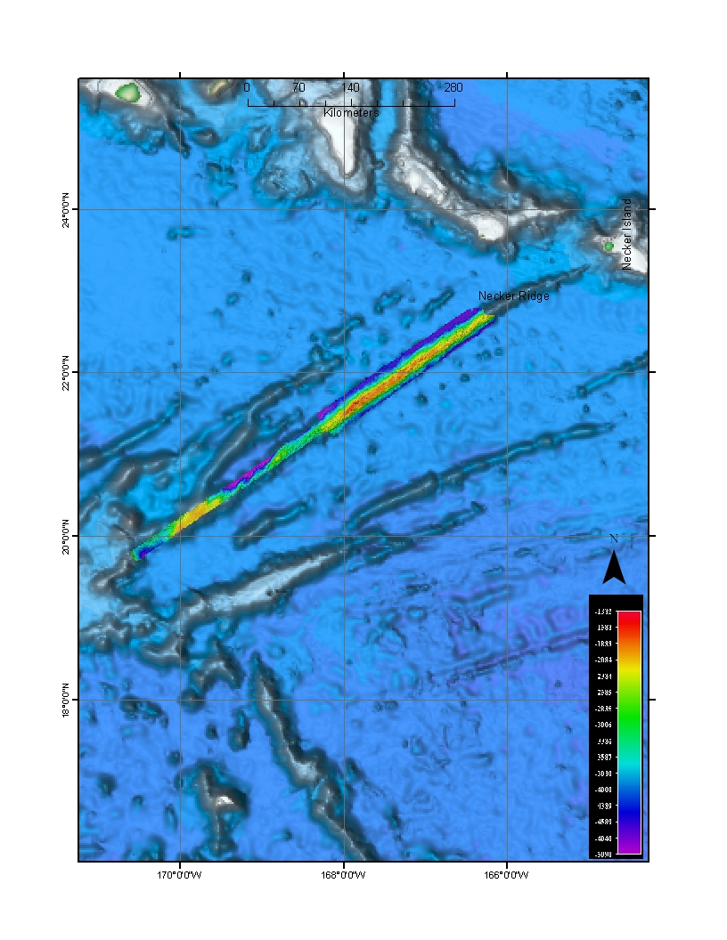
Figure 1. Overview of the Necker Ridge Extended Continental Shelf (ECS) mapping area. Images compiled in ArcMap, 50 m grid and background Sandwell and Smith image compiled in Fledermaus.

A patch test was completed on 25 August in the northern section of Necker Ridge. The last patch test was carried out in May 2009 and similar results were obtained for this patch test. The track lines used for the patch test are tabulated in table 1. Only roll, pitch and navigation time delay offsets were checked during current patch test, see the patch test results in table 2.

Table 1. Survey lines utilized for the Patch Test.
Date | Line | SOG (Knots) | Hdg | Seas | Comments
082509 | 0000_20090825_214655_EX | 8 | 324 | 4-6 | Flat / Up-slope
082509 | 0001_20090825_233851_EX | - | Turn | 4-6 | Turn data
082509 | 0002_20090825_234647_EX | 8 | 143 | 4-6 | Down-slope / Flat
082509 | 0003_20090826_014019_EX | 8 | Turn | 4-5 | Turn data
082509 | 0004_20090826_015042_EX | 8 | 324 | 4-5 | Flat
082509 | 0005_20090826_022217_EX | 4 | 337 | 4-6 | Up-Slope

Table 2. Patch Test results
 | Roll | Pitch | Navigation time
May 2009 results | 0 | -0.7 | 0
August 2009 results | 0 | -0.7 | 0

A cross line was collected over the ridge after the completion of the patch test.

Data acquisition and processing

The data quality was observed to degrade in depths greater than 3500 m where excessive artifacts were observed. Different settings were changed to see if the data quality could be improved including increasing the beam width for transmit beam to 1 deg from 0.5 deg. 1 deg transmit beam with high density equidistant mode (HIDENSQDIST) mode provided the best quality data in depths greater than 3500 m. In areas over the ridge where the depth was < 3500 m, 0.5 degree transmit beam was utilized to improve the resolution of the resulting bathymetric data.

Angular offsets are tabulated as below. For complete processing unit setup (PU Setup) utilized for the cruise, please refer to Appendix A.

Table 3. Angular offsets for Transmit (TX) and Receive (RX) transducers.
 | Roll | Pitch | Heading
Tx Transducer | 0.0 | 0.0 | 359.98
Rx Transducer | 0.0 | 0.0 | 0.03
Attitude | 0 | -0.7 | 0.0

Onboard processing of bathymetric data was done in CARIS HIPS ver. 6.1 where the data were cleaned in ‘Swath Editor’ and ‘Subset Editor’. No tidal corrections were applied during post processing; however, no appreciable differences were observed between different lines by not applying tidal corrections. A nominal grid cell size of 50 m was chosen for the bathymetric grids.

The cross lines yielded a favorable comparison between main scheme lines and cross lines.
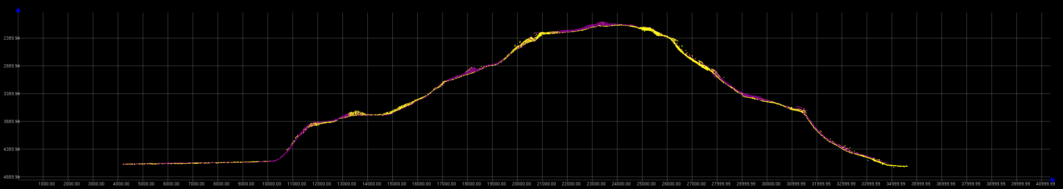
Figure 2. Screen grab of subset editor in CARIS HIPS showing agreement of cross lines (yellow) with main scheme lines (Purple). Image credit: NOAA.

Onboard processing of bottom backscatter data was conducted using the University of New Hampshire research tool ‘Geocoder’. The results obtained during fair weather are encouraging but during the days when the weather was choppy, a lot of bubble sweep down issues degraded bottom backscatter data quality severely. At the time of filing of this report, we are not sure whether the weather effects can be taken care of during post processing. The ship also is expected to contact Kongsberg, Inc. regarding these backscatter artifacts. There was also some degradation of backscatter data quality in the outer STBD beams (Figure 4). This cruise is the first time EX has used ‘Geocoder’ to process backscatter data and it is not yet determined whether this degradation of data quality in outer STBD beams is due to data acquisition problems or an artifact of how data are being processed in Geocoder.

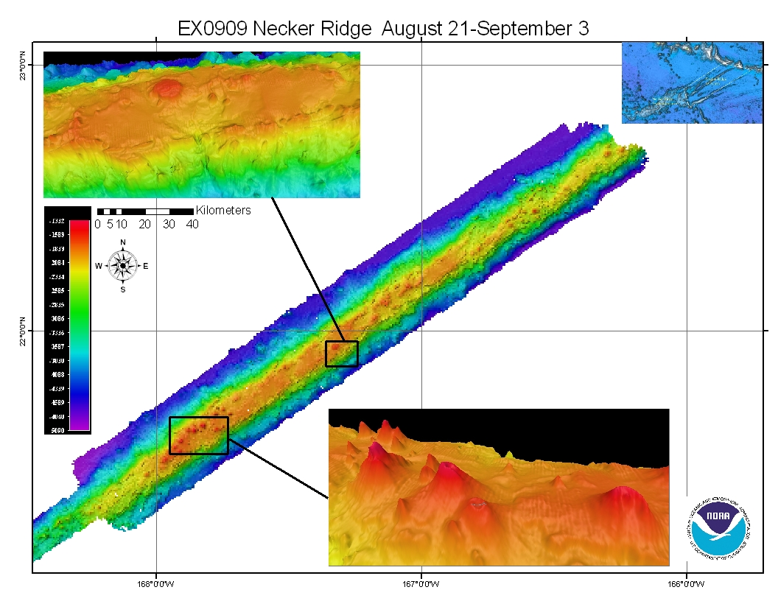
Figure 3. Images of the final grids (at 50 m) cell size resolution, compiled in Fledermaus, including the overview area in the top right, taken from Sandwell and Smith. Shown as insets few of the interesting features observed in northern Necker Ridge area. Small volcanoes with ~ 500 m diameter visible above is one of the few volcanoes observed in the data. Above product compiled in ArcMap.

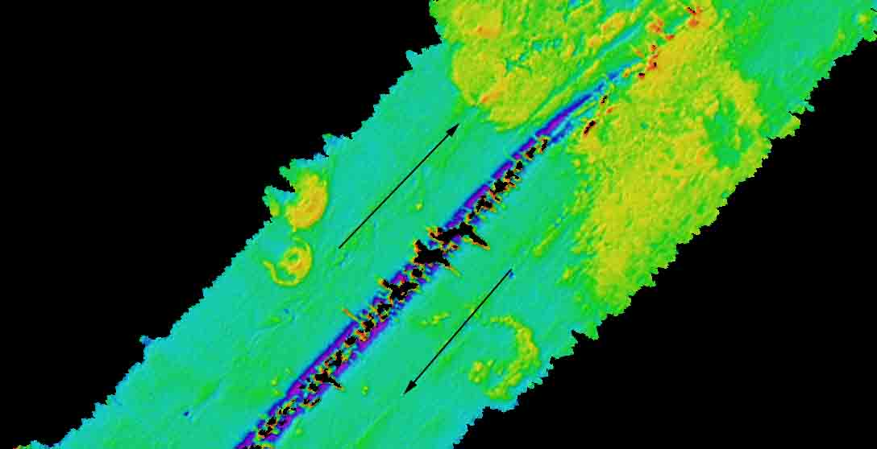
Figure 4. Backscatter mosaic results with 40 m grid cell size. Degradation of backscatter data in STBD outer beams is clearly visible which is more severe in the deeper areas (depth > 3500 m). The direction of track-lines is shown with arrows. Image compiled in Geocoder.

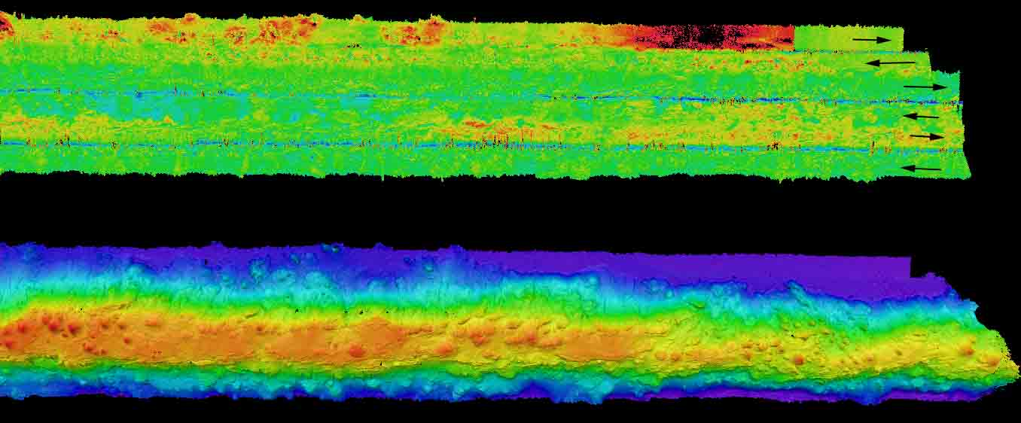

Figure 5: Co-located backscatter (upper panel) and depth (lower panel) showing the Northwestern part of Necker Ridge. The directions of six lines run in this area are shown in the upper panel. STBD beam along track artifacts and bubble sweep down artifacts (visible in the upper most track line) are apparent in the backscatter data. Upper panel is a 40m grid compiled in Geocoder and the lower panel is a 50 m grid compiled in Fledermaus.

Cruise Calendar

August 2009
Mon | Tue | Wed | Thu | Fri | Sat | Sun
 |  | 19  Mission party boarded the ship | 20  Orientation and training for the mission party | 21  Steering gear test offshore Honolulu. Returned to dock for fueling | 22  0900 Departed Honolulu, HI | 23  Transit to Necker Ridge patch test site
24  Steering gear failure. Trouble shooting; back track to Honolulu for 1 day | 25  CTD cast ~ 4700 m  Patch test on Necker Ridge  Commence main scheme lines | 26  Continue mapping Necker Ridge. | 27  Continue mapping Necker Ridge | 28  Continue mapping Necker Ridge | 29  Continue mapping Necker Ridge | 30  Continue mapping Necker Ridge
31
Completed main-scheme survey over Necker Ridge.
Conducted Trouble shooting tests to determine cause of ribbings
September 2009
Mon | Tue | Wed | Thu | Fri | Sat | Sun
 | 1  Transit to Honolulu | 2  Transit to Honolulu | 3  Arrival Honolulu | 4 | 5 | 6

Daily cruise log

(ALL TIMES LOCAL HDT)

19 August 2009
Mission party boarded the ship

August 21, 2009
Ship left harbor ~ 0945 to conduct steering gear test offshore Honolulu, HI. Ship returned ~ to Pearl Harbor Fueling dock for fueling. Fueling operations continued until 1830.

August 22, 2009
Ship left harbor ~ 0900 for Necker Ridge. The data quality was determined to be deteriorating with increasing depths. A lot of data artifacts were observed. Different settings were tested to determine best possible data quality achievable. It was found that 1 deg transmit beam width provided best possible data in deep water.

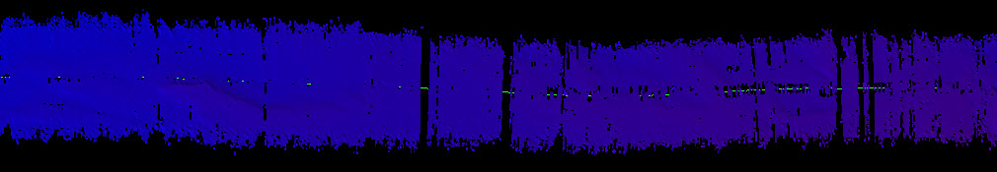

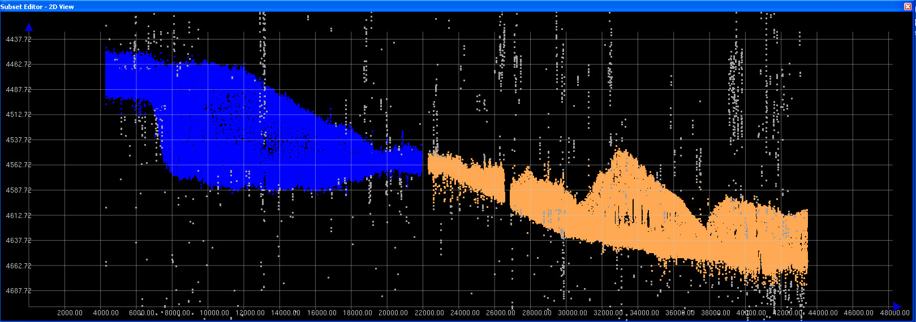

Figure 6: Screen grabs of the grids (upper panel). The line on the right side of the panel was run by 0.5 deg (consider writing out degree where used unless this is the proper abbreviation for ‘degree’. transmit opening angle. The line on the left side of the panel was run by 1 deg transmit opening angle. The panel on the bottom show a screen capture from the Subset editor showing that line with 0.5 deg transmit opening angle appears to be more noisier. The orange, blue and grey colors show sounding points from line with 0.5 deg transmit opening angle, 1 deg transmit opening angles and the points that were manually rejected in the HIPS subset editor (water depth approximately 4500m).

August 23, 2009
2230 Steering gear failed. Ship unable to maintain control of rudders; Ship holding station over night

August 24, 2009
Ship moving towards east to be closer to Honolulu, HI in case there is a need to go back to harbor. In the evening the ship decided to turn back towards Necker Ridge to test the steering gear. The decision whether the ship will continue her mapping operations will depend on the performance of the steering gear for next 24 hrs.

August 25, 2009
The steering gear continued to perform satisfactorily and therefore a decision was made by ship’s command to proceed with the mapping operations. A CTD cast to a depth of 4500 m was carried out in the morning. A XBT cast was conducted soon after the CTD cast and the results compared favorable except for the depth range between 300 and 400m where a 3-4 m/s sound speed difference was observed.

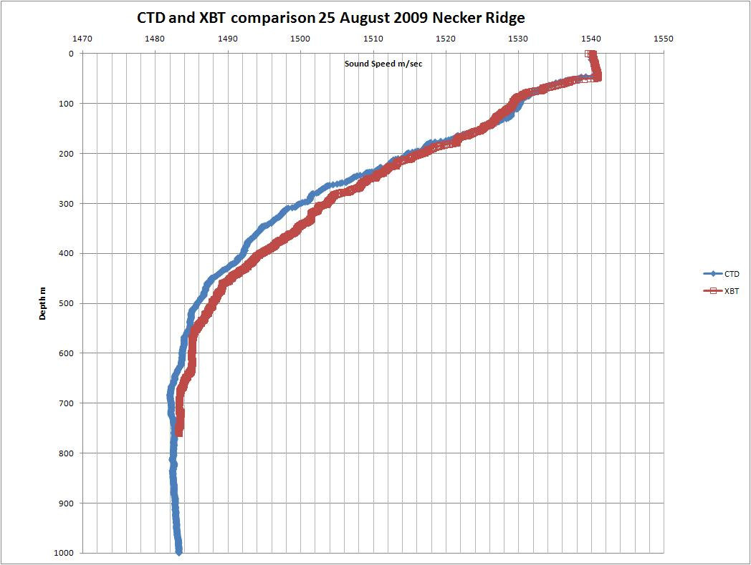
Figure 75. Comparison of XBT and CTD derived from sound speed casts taken on 25 August.

August 26, 2009
Continue mapping Necker Ridge. Observed a lot of ribbing which seem to be residual roll artifacts in the data. The artifacts are more pronounced in the flatter areas. Figure 6 shows the IVS Fledermaus depiction of the data show the artifacts to be between 2-10 m.

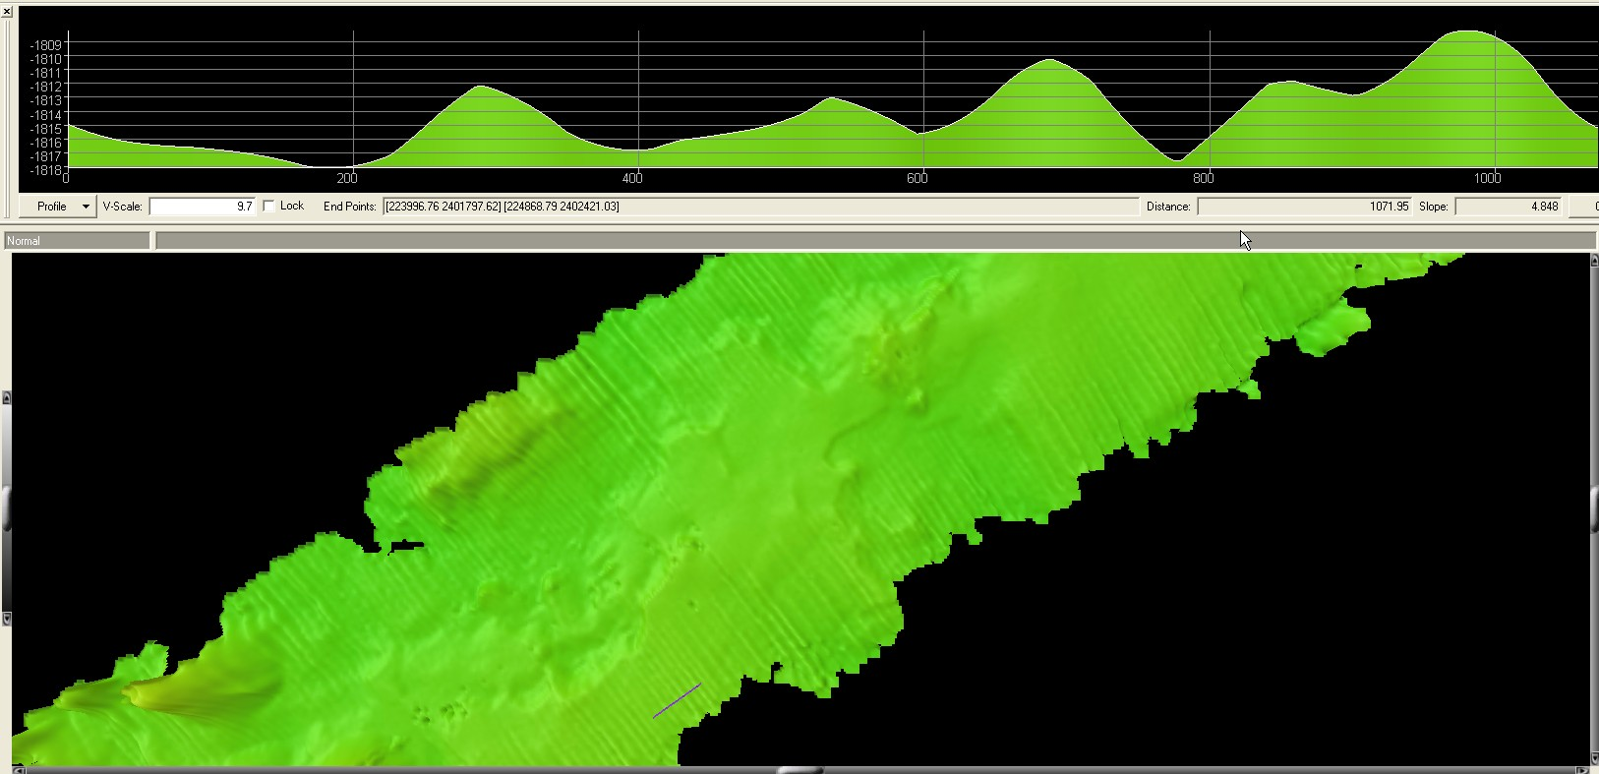
Figure 86. Fledermaus screen grab showing 2 to 10 meter ribbing data artifact with a 50m grid.

August 27, 2009
Reached the southern part of the survey area in the morning. Turned now to go up to north in an adjacent line with line spacing of 6000 m. Recorded True heave from the POS but applying TrueHeave during post processing in HIPS did not help with the artifacts. Line going towards north (Heading 055) the swell is coming from STBD bow and the ship is rolling much less. As a result the data are looking really well in this direction. Checked POS installation settings, POS out put settings and verified the SIS version numbers. All seems to be in order. Dr. Jim Gardner upon contact advised the following:

“…. something is clearly not right. It could be the POS or it could be something got changed in the lever arm values, or it could be some strange effect of the bad transmit board. Whatever is causing the ribbing, it's a severe problem. My suggestion is, if you are still seeing that ribbing artifact, to stop mapping and concentrate on finding the cause of the artifact. Reboot the POS. Then do another patch test on very flat seafloor. If you still have ribbing after that, swap positions of the transmit boards. If the artifacts persist, swap positions of the receive boards. Something has changed pretty dramatically from the setup we had on Mendocino and you've got to figure out what has changed. What are the seas like? Is the ship rolling a lot? Do the artifacts change when you run perpendicular to the course on the images? What happens to the artifacts if you slow to 5 kts? Check what version of the acquisition firmware you're running and make certain it's the same as was installed by Simrad on the Mendocino cruise. Try to isolate what makes no difference and what makes some difference. That might help you isolate the cause….”

August 28, 2009
Continuing to work in the northern small section of ECS area. After the initial ribbing issues, the data quality has improved a lot. The system including attitude sensor (POS-MV) and navigation system (C-NAV) were restarted. The C-NAV reception from WAAS satellite is poor and the POS_MV was reporting to cross the threshold of position accuracy of 2 m. ETs were notified about the situation. However, the area that we are working in has limited coverage for the satellite. Although the position is somewhat degraded, it is not expected to affect the multibeam data quality adversely as we are still able to achieve accuracy levels around 2.2 m.

August 29, 2009
Continuing to collect data. Line spacing of 6000 m has been providing good quality data in depths less than ~ 4000 m. In deeper waters the swath coverage is degraded. Had to move the lines to decrease the line spacing to 5000 m while working in the deep water.

August 30, 2009
Continuing to collect data around the Necker Ridge. After reaching the southern edge of the survey, will have enough time to cover one more line. After discussing this with Dr. Gardner over the email, it was decided that the next line will be run to the north of the ridge to get the boundary between the sloping Necker Ridge and the adjacent flat seafloor.
In parts of the southern edge of the ridge, the boundary is still not clearly defined.

August 31, 2009

Finished the main survey lines ~ 1130 HDT. The ship conducted additional trouble shooting maneuvers to ascertain the reasons for the ribbing problem. Several lines in several different directions were run with changing Angular offsets including roll bias and heading offsets. No apparent improvement in the ribbing was observed by changing different settings. Reverting back to normal settings.

Sept 1, 2009

In transit to Honolulu, HI. The weather has picked up a lot and the ship is pitching > 5-7 degrees, resulting in severe bubble sweep down episodes results in complete loss of bottom track for several minutes.

Sept 2, 2009

Weather is picking up. Data quality continues to degrade. Switched off EM 302 at 2330 (HDT).

Sept 3, 2009

Arrived Honolulu, HI

Appendices

Appendix A: Tables of data files collected

SOUND VELOCITY FILES
Date  (GMT) | Time (GMT) | XBT/CTD Filename | Latitude | Longitude | Remarks
082209 | 23:20:55 | XBT_082209_01.asvp | 21.248333 | 158.498333 | Transit
082309 | 04:45:11 | XBT_082209_02.asvp | 21.248840 | 159.540202 | Transit
082309 | 21:33:03 | XBT_082309_03.asvp | 21.659553 | 162.612630 | Transit
082409 | 04:10:18 | XBT_082309_04.asvp | 21.912350 | 163.843718 | Transit
082509 | 04:13:56 | XBT_082409_05.asvp | 21.886167 | 163.888666 | Transit
082509 | 10:29:00 | XBT_082509_06.asvp | 22.111805 | 165.069368 | Transit
082509 | 16:17:12 | XBT_082509_07.asvp | 22.275208 | 166.000455 | Transit
082509 | 18:36:12 | CTD_082509_01.hex | 22.342000 | 166.316833 | CTD/XBT comparison
082509 | 21:19:32 | XBT_082509_08.asvp | 22.360718 | 166.326171 | CTD/XBT comparison
082609 | 05:04:38 | XBT_082509_09.asvp | 22.636295 | 166.543718 | Patch Test
082609 | 07:20:32 | XBT_082509_10.asvp | 22.704971 | 166.315266 | Transit
082609 | 12:06:42 | XBT_082609_11.asvp | 22.333271 | 166.788671 | Necker Ridge
082609 | 16:31:21 | XBT_082609_12.asvp | 21.950833 | 167.342966 | Necker Ridge
082609 | 23:20:39 | XBT_082609_13.asvp | 21.380033 | 168.16700 | Necker Ridge
082709 | 04:16:20 | XBT_082609_14.asvp | 21.084216 | 168.594766 | Necker Ridge
082709 | 10:23:20 | XBT_082709_15.asvp | 20.570935 | 169.328938 | Necker Ridge
082709 | 16:12:06 | XBT_082709_16.asvp | 21.046700 | 168.16700 | Necker Ridge
082709 | 22:48:06 | XBT_082709_17.asvp | 19.994373 | 170.248275 | Necker Ridge
082709 | 23:16:22 | XBT_082709_18.asvp | 20.034081 | 170.191635 | Necker Ridge
082809 | 04:07:46 | XBT_082709_19.asvp | 20.442383 | 169.608105 | Necker Ridge
082809 | 10:09:16 | XBT_082809_20.asvp | 20.971973 | 168.848926 | Necker Ridge
082809 | 16:20:14 | XBT_082809_21.asvp | 21.515086 | 168.06694 | Necker Ridge
082809 | 22:40:41 | XBT_082809_22.asvp | 22.040198 | 167.309081 | Necker Ridge
082909 | 04:11:20 | XBT_082909_23.asvp | 22.490820 | 166.656151 | Necker Ridge
082909 | 10:16:39 | XBT_082909_24.asvp | 22.549283 | 166.669081 | Necker Ridge
082909 | 16:19:10 | XBT_082909_25 | 22.146416 | 167.440811 | Necker Ridge
082909 | 22:49:39 | XBT_082909_26 | 21.447685 | 168.250358 | Necker Ridge
083009 | 04:07:35 | XBT_083009_27 | 21.660888 | 167.658268 | Necker Ridge
083009 | 10:10:11 | XBT_083009_28 | 22.196265 | 166.901595 | Necker Ridge
083009 | 16:02:26 | XBT_083009_29 | 22.610216 | 166.212500 | Necker Ridge
083009 | 22:47:59 | XBT_083009_30 | 21.931978 | 167.186295 | Necker Ridge
083109 | 04:06:41 | XBT_083109_31 | 21.410633 | 167.931510 | Necker Ridge
083109 | 10:19:02 | XBT_083109_32 | 21.722558 | 167.486148 | Necker Ridge
083109 | 16:10:22 | XBT_083109_33 | 21.629080 | 167.619828 | Necker Ridge
090109 | 00:18:12 | XBT_090109_34 | 21.470333 | 167.846500 | Necker Ridge Roll & Yaw Patch Test
090109 | 05:11:13 | XBT_090109_35 | 22.594128 | 166.410871 | Necker Ridge Transit
090109 | 10:26:28 | XBT_090109_36 | 22.267835 | 165.717676 | Necker Ridge Transit
090109 | 16:07:16 | XBT_090109_37 | 22.105533 | 164.862435 | Necker Ridge Transit
090109 | 22:33:18 | XBT_090109_38 | 21.871586 | 164.055696 | Necker Ridge Transit
090209 | 04:33:57 | XBT_090109_39 | 21.739896 | 163.222151 | Necker Ridge Transit
090209 | 10:14:48 | XBT_090209_40 | 21.579223 | 162.407536 | Necker Ridge Transit
090209 | 14:05:12 | XBT_090209_41 | 21.462083 | 161.846550 | Necker Ridge Transit
090309 | 04:18:58 | XBT_090309_43 | 21.215812 | 160.670573 | Necker Ridge Transit

EM302 MULTIBEAM FILES

Cruise Day No. | Date | File Name | Location | Remarks
234 | 082209 | 0000_20090822_210611_EX | Transit Line | Transit
235 | 082309 | 0001_20090823_003942_EX | Transit Line | Transit
235 | 082309 | 0002_20090823_063936_EX | Transit Line | Transit
235 | 082309 | 0003_20090823_085737_EX | Transit Line | Transit
235 | 082309 | 0004_20090823_104217_EX | Transit Line | Transit
235 | 082309 | 0005_20090823_164216_EX | Transit Line | Transit
235 | 082309 | 0006_20090823_181257_EX | Transit Line | Transit
235 | 082309 | 0007_20090823_190553_EX | Transit Line | Transit
235 | 082309 | 0008_20090823_200418_EX | Transit Line | Transit
235 | 082309 | 0009_20090823_201255_EX | Transit Line | Transit
235 | 082309 | 0010_20090823_021300_EX | Transit Line | Transit
235 | 082309 | 0011_20090823_081259_EX | Transit Line | Transit (Started line 12 too early)
235 | 082309 | 0012_20090823_081414_EX | Transit Line | Transit
236 | 082409 | 0013_20090824_193922_EX | Transit Line | Transit
237 | 082509 | 0014_20090825_011530_EX | Transit Line | Transit
237 | 082509 | 0015_20090825_015203_EX | Transit Line | Transit
237 | 082509 | 0016_20090825_023358_EX | Transit Line | Transit
237 | 082509 | 0017_20090825_063050_EX | Transit Line | Transit
237 | 082509 | 0018_20090825_080244_EX | Transit Line | Transit
237 | 082509 | 0019_20090825_140244_EX | Transit Line | Transit
237 | 082509 | 0020_20090825_214437_EX | Transit Line | Transit
238 | 082609 | 0000_20090826_060627_EX | Transit Line | Transit from Patch Test
238 | 082609 | 0001_20090826_074756_EX | Survey Line | Necker Ridge
238 | 082609 | 0002_20090826_134758_EX | Survey Line | Necker Ridge
238 | 082609 | 0003_20090826_194800_EX | Survey Line | Necker Ridge
239 | 082709 | 0004_20090827_014801_EX | Survey Line | Necker Ridge, Should have broken line at GMT midnight(8/27)
239 | 082709 | 0005_20090827_022422_EX | Survey Line | Necker Ridge Turn Line into wind
239 | 082709 | 0006_20090827_040207_EX | Survey Line | Necker Ridge Line Start
239 | 082709 | 0007_20090827_100209_EX | Survey Line | Necker Ridge Line
239 | 082709 | 0008_20090827_160209_EX | Survey Line | Started Logging True heave at end of Line 8
239 | 082709 | 0009_20090827_194711_EX | Survey Line | Turn
239 | 082709 | 0010_20090827_201019_EX | Survey Line | Switched Files for true heave logging  True Heave file for Line 10: 0827NeckerRidge_THeave.000
240 | 082809 | 0011_20090828_000005_EX | Survey Line | Necker Ridge Line
240 | 082809 | 0012_20090828_060009_EX | Survey Line | Necker Ridge Line
240 | 082809 | 0013_20090828_120001_EX | Survey Line | Necker Ridge Line
240 | 082809 | 0014_20090828_180003_EX | Survey Line | Necker Ridge Line
240 | 082809 | 0015_20090828_235954_EX | Survey Line | Necker Ridge Line
241 | 082909 | 0016_20090829_060000_EX | Survey Line | Necker Ridge Line
241 | 082909 | 0017_20090829_071403_EX | Turn Line | Turn Line to get onto next line after MB/POS reboot
241 | 082909 | 0018_20090829_075708_EX | Survey Line | Necker Ridge Line
241 | 082909 | 0019_20090829_135707_EX | Survey Line | Necker Ridge Line
241 | 082909 | 0020_20090829_195712_EX | Survey Line | Necker Ridge Line
241 | 082909 | 0021_20090829_225506_EX | Turn Line | Turn Line
242 | 083009 | 0022_20090830_001857_EX | Survey Line | Necker Ridge Line
242 | 083009 | 0023_20090830_105121_EX | Survey Line | Necker Ridge
242 | 083009 | 0024_20090830_105121_EX | Survey Line | Necker Ridge
242 | 083009 | 0025_20090830_152556_EX | Turn Line | Turn Line
242 | 083009 | 0026_20090830_155314_EX | Survey Line | Necker Ridge
242 | 083009 | 0027_20090830_215315_EX | Survey Line | Necker Ridge
243 | 083109 | 0028_20090831_000200_EX | Survey Line | Necker Ridge
243 | 083109 | 0029_20090831_053021_EX | Turn Line | Necker Ridge Turn Line
243 | 083109 | 0030_20090831_071142_EX | Survey Line | Necker Ridge Survey Line was leaving holidays so had to shift
243 | 083109 | 0031_20090831_074507_EX | Turn Line | Turn Line 1000m to starboard to avoid holidays
243 | 083109 | 0032_20090831_075255_EX | Survey Line | Necker Ridge
243 | 083109 | 0033_20090831_135248_EX | Survey Line | Necker Ridge
243 | 083109 | 0034_20090831_195248_EX | Survey Line | Necker Ridge
243 | 083109 | 0035_20090831_212522_EX | Survey Line | Necker Ridge
244 | 090109 | 0021_20090901_053501_EX | Transit Line | Transit Line
244 | 090109 | 0022_20090901_074524_EX | Transit Line | Transit Line
244 | 090109 | 0022_20090901_083014_EX | Transit Line | Transit Line
244 | 090109 | 0023_20090901_143015_EX | Transit Line | Transit Line
244 | 090109 | 0024_20090901_170652_EX | Transit Line | Turn to southern transit line
244 | 090109 | 0025_20090901_174506_EX | Transit Line | Transit Line
244 | 090109 | 0026_20090901_234500_EX | Transit Line | Transit Line
245 | 090209 | 0027_20090902_054501_EX | Transit Line | Transit Lineuser13

Appendix B: List of acronyms

BIST – Built In System Test CO – Commanding Officer
CIMS – Cruise Information Management System
CTD – conductivity temperature and depth
CW – continuous wave
dB – decibels
DGPS –Differential Global Positioning System
DTM – digital terrain model
ECS – Extended Continental Shelf
ET – Electronics Technician
EX – NOAA Ship Okeanos Explorer
FM – frequency modulation
FOO – Field Operations Officer
kHz - kilohertz
Km – kilometers
KM – Kongsberg Maritime AS
Kt(s) – knots
Ma – megaannum
MBES – multibeam echosounder
NCDDC – National Coastal Data Development Center
NGDC – National Geophysical Data Center
NOAA – National Oceanic and Atmospheric Administration
NODC – National Oceanographic Data Center
OER – Office of Ocean Exploration and Research
OMAO – Office of Marine and Aviation Operations
ROV – Remotely Operated Vehicle
SST – Senior Survey Technician
SV – sound velocity
TRU – transmit and receive unit
TSG - thermosalinograph
UNCLOS – United Nations Convention on the Law of the Sea
UNH-CCOM/JHC – University of New Hampshire Center for Coastal and Ocean Mapping / Joint Hydrographic Center
UPS – uninterruptable power supply
US EEZ – United States Exclusive Economic Zone
USBL – ultra-short base line
WD – water depth
XBT – expendable bathythermograph

Appendix C: EM302 description and operational specs

EM 302 : Ideal for Ocean Exploration
There are several features of the Okeanos Explorer’s 30 kHz multibeam that make it an excellent tool for ocean exploration. The following is a brief description of these features.

Depth Range
The system is designed to map the seafloor in water depths of 10 to 7000 meters. This leaves only the deepest parts of the deeper ocean trenches out of the EM 302’s reach. Moreover, operational experience on the Okeanos Explorer has shown consistent EM 302 bottom detection at depth ranges in excess of 8000m.

High Density Data
In multibeam data, the denser the data, the finer resolution maps you can produce. The system can operate in dual swath, or multiping mode, which results in increased along track data density. This is achieved by detecting two swaths per ping cycle, resulting in up to 864 beams per ping.

The Okeanos Explorer mapping team typically operates the multibeam in high density equidistant ping mode, which results in up to 864 soundings on the seafloor per ping.

Full Suite of Data Types Collected
The system collects seafloor backscatter data, which provides information about the character of the seafloor in terms of bottom type.

The system also collects water column backscatter data, which has the ability to detect gaseous plumes in the water column. The full value of this feature is still being realized.

FM chirp mode is utilized in water depths greater than 1000 meters, and allows for the detection of the bottom further out from nadir than with previous 30 kHz systems.

Multibeam Primer
The area of the seafloor covered, or ensonified, by a single beam within a pulse of sound, or ping, is called the beam footprint. This beam footprint is defined in terms of the across track and along track values. Both of these values are dependent on water depth and the beam width at which the sound pulse is transmitted and received. The across track beam width value is also dependent on the receive angle, or “listening” angle, of the system, and the angle from nadir which it is received from. The receive angle for the receive transducer on the Okeanos Explorer EM302 is 1°, which is the smallest possible angle currently available for the EM302 system. The further out from nadir a sounding occurs, the larger the footprint will be. For example, as seen in Table 1 below, in 2000 meters of water, a beam footprint will have a radius of 18 meters at nadir but 25 meters by the time it hits the seafloor at an angle 140 degrees out from nadir.

Calculated acrosstrack acoustic beam footprint for EM 302
(high density ping mode, 432 soundings/profile)
Water depth (m) | Angle from nadir
50 | 1 deg RX center | 90 deg | 120 deg | 140 deg
100 | 1 | 0.5 | 1 | 1
200 | 2 | 1 | 2 | 3
400 | 4 | 2 | 3 | 5
1000 | 7 | 4 | 6 | 10
2000 | 18 | 9 | 16 | 25
4000 | 35 | 19 | 32 | -
6000 | 70 | 37 | - | -
7000 | 105 | 56 | - | -

Table 4. Calculated across track EM 302 beam footprint. Reference: Kongsberg Product description, Kongsberg document 302675 Rev B, Date 14/06/06, p. 17.

Calculated acrosstrack sounding density for EM 302
(high density ping mode, 432 soundings/profile)
Water depth (m) | Swath Width
50 | 90 deg | 120 deg | 140 deg
100 | 0.2 | 0.4 | 0.9
200 | 0.5 | 0.8 | 1.7
400 | 0.9 | 1.6 | 3.5
1000 | 1.9 | 3.2 | 6.9
2000 | 4.6 | 8.1 | 17.4
4000 | 9.3 | 16.2 | -
Table 5. Calculated across track EM 302 sounding density. Reference: Kongsberg Product description, Kongsberg document 302675 Rev B, Date 14/06/06, p. 17.
Acrosstrack sounding density describes the spacing between individual soundings on the seafloor in the acrosstrack direction. The maximum swath of the EM 302 is 150 degrees. At this swath, the sounding density will be the least dense, since the beams will be spread out over a larger horizontal distance over the seafloor. As the swath angle (width) is decreased, the sounding density will increase, as the same number of beams are now spread out over a smaller horizontal distance over the seafloor.

Calculated ping rate and alongtrack resolution for EM 302
140 deg swath, one profile per ping
 |  |  | Alongtrack distance between profiles (m)
Water depth (m) | Swath Width (m) | Ping Rate (pings/second) | @4 kts | @8 kts | @12 kts
50 | 275 | 3.2 | 0.7 | 1.2 | 1.9
100 | 550 | 1.8 | 1.1 | 2.2 | 3.3
200 | 1100 | 1 | 2.1 | 4.2 | 6.3
400 | 2200 | 0.5 | 4.1 | 8.2 | 12.2
1000 | 5500 | 0.2 | 10 | 20 | 30
2000 | 8000 | 0.1 | 15.2 | 30.5 | 45.7
4000 | 8000 | 0.06 | 19.2 | 38.5 | 57.7
6000 | 8000 | 0.04 | 24.5 | 49 | 73.4
Table 6. Calculated ping rate and along track EM 302 sounding density, one profile per ping. Reference: Kongsberg Product description, Kongsberg document 302675 Rev B, Date 14/06/06, p. 15.

Calculated ping rate and alongtrack resolution for EM 302
140 deg swath, two profiles per ping
Water depth (m) | Swath Width (m) | Ping Rate | Alongtrack distance between profiles (m)
Water depth (m) | Swath Width (m) | Ping Rate | @4 kts | @8 kts | @12 kts
50 | 275 | 3.2 | 0.3 | 0.6 | 0.9
100 | 550 | 1.8 | 0.6 | 1.1 | 1.7
200 | 1100 | 1 | 1.1 | 2.1 | 3.2
400 | 2200 | 0.5 | 2 | 4.1 | 6.1
1000 | 5500 | 0.2 | 5 | 10 | 15
2000 | 8000 | 0.1 | 7.6 | 15.2 | 22.8
Table 7. Calculated ping rate and along track EM 302 sounding density, two profiles per ping. Reference: Kongsberg Product description, Kongsberg document 302675 Rev B, Date 14/06/06, p. 15.

Reference: Kongsberg Product Description: EM 302 multibeam echosounder

Appendix D: EM302 PU Parameters in use during cruise

#// Database Parameters

#// Seafloor Information System
#// Kongsberg Maritime AS
#// Saved: 2009.08.28 20:32:34

#// Build info:
#* SIS: [Version: 3.6.1, Build: 174, DBVersion 16.0 CD generated: Tue Nov 11 15:39:05 2008]
[Fox ver = 1.6.29]
[db ver = 16, proc = 16.0]
[OTL = 4.0.-95]
[ACE ver = 5.5]
[Coin ver = 2.4.4]
[Simage ver = 1.6.2a]
[Dime ver = DIME v0.9]
[STLPort ver = 513]
[FreeType ver = 2.1.9]
[TIFF ver = 3.8.2]
[GeoTIFF ver = 1230]
[GridEngine ver = 2.3.0]

#* Language [3] #// Current language, 1-Norwegian, 2-German,3-English, 4-Spanish

#* Type [302]
#* Serial no. [101]
#* Number of heads [2]
#* System descriptor [50331648] #// 03000000

#// *********************************************************************
#// Installation parameters

#{ Input Setup #// All Input setup parameters

#{ COM1 #// Link settings.

#{ Com. settings #// Serial line parameter settings.
#* Baud rate: [9600]
#* Data bits [8]
#* Stop bits: [1]
#* Parity: [NONE]
#} Com. settings

#{ Position #// Position input settings.
#* None [1] [0]
#* GGK [1] [0]
#* GGA [1] [1]
#* GGA_RTK [1] [0]
#* SIMRAD90 [1] [0]
#} Position

#{ Input Formats #// Format input settings.
#* Attitude [0] [0]
#* MK39 Mod2 Attitude, [0] [0]
#* ZDA Clock [1] [1]
#* HDT Heading [0] [0]
#* SKR82 Heading [0] [0]
#* DBS Depth [1] [0]
#* DBT Depth [1] [0]
#* EA500 Depth [0] [0]
#* ROV. depth [1] [0]
#* Height, special purp [1] [0]
#* Ethernet AttVel [0] [0]
#} Input Formats

#} COM1

#{ COM2 #// Link settings.

#{ Com. settings #// Serial line parameter settings.
#* Baud rate: [19200]
#* Data bits [8]
#* Stop bits: [1]
#* Parity: [NONE]
#} Com. settings

#{ Position #// Position input settings.
#* None [0] [1]
#* GGK [0] [0]
#* GGA [0] [0]
#* GGA_RTK [0] [0]
#* SIMRAD90 [0] [0]
#} Position

#{ Input Formats #// Format input settings.
#* Attitude [1] [1]
#* MK39 Mod2 Attitude, [0] [0]
#* ZDA Clock [0] [0]
#* HDT Heading [0] [0]
#* SKR82 Heading [0] [0]
#* DBS Depth [0] [0]
#* DBT Depth [0] [0]
#* EA500 Depth [0] [0]
#* ROV. depth [0] [0]
#* Height, special purp [0] [0]
#* Ethernet AttVel [0] [0]
#} Input Formats

#} COM2

#{ COM3 #// Link settings.

#{ Com. settings #// Serial line parameter settings.
#* Baud rate: [4800]
#* Data bits [8]
#* Stop bits: [1]
#* Parity: [NONE]
#} Com. settings

#{ Position #// Position input settings.
#* None [1] [1]
#* GGK [1] [0]
#* GGA [1] [0]
#* GGA_RTK [1] [0]
#* SIMRAD90 [1] [0]
#} Position

#{ Input Formats #// Format input settings.
#* Attitude [0] [0]
#* MK39 Mod2 Attitude, [1] [0]
#* ZDA Clock [0] [0]
#* HDT Heading [1] [1]
#* SKR82 Heading [0] [0]
#* DBS Depth [1] [0]
#* DBT Depth [1] [0]
#* EA500 Depth [0] [0]
#* ROV. depth [1] [0]
#* Height, special purp [1] [0]
#* Ethernet AttVel [0] [0]
#} Input Formats

#} COM3

#{ COM4 #// Link settings.

#{ Com. settings #// Serial line parameter settings.
#* Baud rate: [9600]
#* Data bits [8]
#* Stop bits: [1]
#* Parity: [NONE]
#} Com. settings

#{ Position #// Position input settings.
#* None [1] [1]
#* GGK [1] [0]
#* GGA [1] [0]
#* GGA_RTK [1] [0]
#* SIMRAD90 [1] [0]
#} Position

#{ Input Formats #// Format input settings.
#* Attitude [0] [0]
#* MK39 Mod2 Attitude, [0] [0]
#* ZDA Clock [0] [0]
#* HDT Heading [0] [0]
#* SKR82 Heading [0] [0]
#* DBS Depth [1] [0]
#* DBT Depth [1] [0]
#* EA500 Depth [0] [0]
#* ROV. depth [1] [0]
#* Height, special purp [1] [0]
#* Ethernet AttVel [0] [0]
#} Input Formats

#} COM4

#{ UDP2 #// Link settings.

#{ Com. settings #// Serial line parameter settings.
#// N/A
#} Com. settings

#{ Position #// Position input settings.
#* None [1] [1]
#* GGK [1] [0]
#* GGA [1] [0]
#* GGA_RTK [1] [0]
#* SIMRAD90 [1] [0]
#} Position

#{ Input Formats #// Format input settings.
#* Attitude [0] [0]
#* MK39 Mod2 Attitude, [0] [0]
#* ZDA Clock [0] [0]
#* HDT Heading [0] [0]
#* SKR82 Heading [0] [0]
#* DBS Depth [0] [0]
#* DBT Depth [0] [0]
#* EA500 Depth [1] [0]
#* ROV. depth [0] [0]
#* Height, special purp [0] [0]
#* Ethernet AttVel [0] [0]
#} Input Formats

#} UDP2

#{ UDP3 #// Link settings.

#{ Com. settings #// Serial line parameter settings.
#// N/A
#} Com. settings

#{ Position #// Position input settings.
#* None [0] [1]
#* GGK [0] [0]
#* GGA [0] [0]
#* GGA_RTK [0] [0]
#* SIMRAD90 [0] [0]
#} Position

#{ Input Formats #// Format input settings.
#* Attitude [0] [0]
#* MK39 Mod2 Attitude, [0] [0]
#* ZDA Clock [0] [0]
#* HDT Heading [1] [0]
#* SKR82 Heading [0] [0]
#* DBS Depth [1] [0]
#* DBT Depth [1] [0]
#* EA500 Depth [0] [0]
#* ROV. depth [1] [0]
#* Height, special purp [1] [0]
#* Ethernet AttVel [0] [0]
#} Input Formats

#} UDP3

#{ UDP4 #// Link settings.

#{ Com. settings #// Serial line parameter settings.
#// N/A
#} Com. settings

#{ Position #// Position input settings.
#* None [0] [1]
#* GGK [0] [0]
#* GGA [0] [0]
#* GGA_RTK [0] [0]
#* SIMRAD90 [0] [0]
#} Position

#{ Input Formats #// Format input settings.
#* Attitude [1] [0]
#* MK39 Mod2 Attitude, [0] [0]
#* ZDA Clock [0] [0]
#* HDT Heading [1] [0]
#* SKR82 Heading [0] [0]
#* DBS Depth [1] [0]
#* DBT Depth [1] [0]
#* EA500 Depth [0] [0]
#* ROV. depth [1] [0]
#* Height, special purp [1] [0]
#* Ethernet AttVel [0] [0]
#} Input Formats

#} UDP4

#{ UDP5 #// Link settings.

#{ Com. settings #// Serial line parameter settings.
#// N/A
#} Com. settings

#{ Position #// Position input settings.
#* None [0] [0]
#* GGK [0] [0]
#* GGA [0] [0]
#* GGA_RTK [0] [0]
#* SIMRAD90 [0] [0]
#} Position

#{ Input Formats #// Format input settings.
#* Attitude [0] [0]
#* MK39 Mod2 Attitude, [0] [0]
#* ZDA Clock [0] [0]
#* HDT Heading [0] [0]
#* SKR82 Heading [0] [0]
#* DBS Depth [0] [0]
#* DBT Depth [0] [0]
#* EA500 Depth [0] [0]
#* ROV. depth [0] [0]
#* Height, special purp [0] [0]
#* Ethernet AttVel [1] [1]
#} Input Formats

#{ Attitude Velocity settings #// Only relevant for UDP5 on EM122, EM302 and EM710, currently
#* Attitude 1 [1] [1]
#* Attitude 2 [1] [0]
#* Use Ethernet 2 [1] [1]
#* Port: [5602]
#* IP addr.: [192.168.2.20]
#* Net mask: [255.255.255.0]
#} Attitude Velocity settings

#} UDP5

#{ Misc. #// Misc. input settings.
#* External Trigger [1] [0]
#} Misc.

#} Input Setup

#{ Output Setup #// All Output setup parameters

#* PU broadcast enable [1] [1]
#* Log watercolumn to s [1] [1]

#{ Host UDP1 #// Host UDP1 Port: 16100

#{ Datagram subscription #//
#* Depth [0] [0]
#* Raw range and beam a [0] [0]
#* Seabed Image [0] [0]
#* Central Beams [0] [0]
#* Position [0] [0]
#* Attitude [0] [0]
#* Heading [0] [0]
#* Height [0] [0]
#* Clock [0] [0]
#* Single beam echosoun [0] [0]
#* Sound Speed Profile [0] [1]
#* Runtime Parameters [0] [1]
#* Installation Paramet [0] [1]
#* BIST Reply [0] [1]
#* Status parameters [0] [1]
#* PU Broadcast [0] [0]
#* Stave Display [0] [0]
#* Water Column [0] [0]
#* Internal, Range Data [0] [0]
#* Internal, Scope Data [0] [0]
#} Datagram subscription

#} Host UDP1

#{ Host UDP2 #// Host UDP2 Port: 16101

#{ Datagram subscription #//
#* Depth [1] [1]
#* Raw range and beam a [1] [1]
#* Seabed Image [1] [1]
#* Central Beams [1] [0]
#* Position [1] [1]
#* Attitude [1] [1]
#* Heading [1] [1]
#* Height [1] [1]
#* Clock [1] [1]
#* Single beam echosoun [1] [1]
#* Sound Speed Profile [0] [1]
#* Runtime Parameters [0] [1]
#* Installation Paramet [0] [1]
#* BIST Reply [1] [1]
#* Status parameters [0] [1]
#* PU Broadcast [1] [0]
#* Stave Display [0] [1]
#* Water Column [0] [1]
#* Internal, Range Data [1] [0]
#* Internal, Scope Data [1] [0]
#} Datagram subscription

#} Host UDP2

#{ Host UDP3 #// Host UDP3 Port: 16102

#{ Datagram subscription #//
#* Depth [0] [1]
#* Raw range and beam a [0] [0]
#* Seabed Image [0] [0]
#* Central Beams [0] [0]
#* Position [0] [0]
#* Attitude [0] [1]
#* Heading [0] [0]
#* Height [0] [1]
#* Clock [0] [0]
#* Single beam echosoun [0] [1]
#* Sound Speed Profile [0] [1]
#* Runtime Parameters [0] [0]
#* Installation Paramet [0] [1]
#* BIST Reply [0] [0]
#* Status parameters [0] [0]
#* PU Broadcast [0] [0]
#* Stave Display [0] [0]
#* Water Column [0] [0]
#* Internal, Range Data [0] [0]
#* Internal, Scope Data [0] [1]
#} Datagram subscription

#} Host UDP3

#{ Host UDP4 #// Host UDP4 Port 16103

#{ Datagram subscription #//
#* Depth [1] [0]
#* Raw range and beam a [1] [0]
#* Seabed Image [1] [0]
#* Central Beams [1] [0]
#* Position [1] [0]
#* Attitude [1] [0]
#* Heading [1] [0]
#* Height [1] [0]
#* Clock [1] [0]
#* Single beam echosoun [1] [0]
#* Sound Speed Profile [1] [0]
#* Runtime Parameters [1] [0]
#* Installation Paramet [1] [0]
#* BIST Reply [1] [0]
#* Status parameters [1] [0]
#* PU Broadcast [1] [0]
#* Stave Display [1] [0]
#* Water Column [1] [0]
#* Internal, Range Data [1] [0]
#* Internal, Scope Data [1] [0]
#} Datagram subscription

#} Host UDP4

#{ Watercolumn #// Host UDP4 Port 16103

#{ Datagram subscription #//
#* Depth [1] [0]
#* Raw range and beam a [1] [0]
#* Seabed Image [1] [0]
#* Central Beams [1] [0]
#* Position [1] [0]
#* Attitude [1] [0]
#* Heading [1] [0]
#* Height [1] [0]
#* Clock [1] [0]
#* Single beam echosoun [1] [0]
#* Sound Speed Profile [1] [0]
#* Runtime Parameters [1] [0]
#* Installation Paramet [1] [0]
#* BIST Reply [1] [0]
#* Status parameters [1] [0]
#* PU Broadcast [1] [0]
#* Stave Display [1] [0]
#* Water Column [1] [1]
#* Internal, Range Data [1] [0]
#* Internal, Scope Data [1] [0]
#} Datagram subscription

#} Watercolumn

#} Output Setup

#{ Clock Setup #// All Clock setup parameters

#{ Clock #// All clock settings.
#* Source: [1] #// External ZDA Clock
#* 1PPS Clock Synch. [1] [1]
#* Offset (sec.): [0]
#} Clock

#} Clock Setup

#{ Settings #// Sensor setup parameters

#{ Positioning System Settings #// Position related settings.

#{ COM1 #// Positioning System Ports:
#* P1T [1] #// Datagram
#* P1M [0] #// Enable position motion correction
#* P1D [0.000] #// Position delay (sec.):
#* P1G [WGS84] #// Datum:
#* P1Q [1] #// Enable
#* Pos. qual. indicator [] #//
#} COM1

#} Positioning System Settings

#{ Motion Sensor Settings #// Motion related settings.

#{ COM2 #// Motion Sensor Ports:
#* MRP [RP] #// Rotation (POSMV/MRU)
#* MSD [0] #// Motion Delay (msec.):
#* MAS [1.00] #// Motion Sensor Roll Scaling:
#} COM2

#} Motion Sensor Settings

#{ Active Sensors #//
#* APS [0] [COM1] #// Position:
#* ARO [2] [COM2] #// Motion:
#* AHE [2] [COM2] #// Motion:
#* AHS [3] [COM3] #// Heading:
#} Active Sensors

#} Settings

#{ Locations #// All location parameters

#{ Location offset (m) #//

#{ Pos, COM1: #//
#* P1X [0.00] #// Forward (X)
#* P1Y [0.00] #// Starboard (Y)
#* P1Z [0.00] #// Downward (Z)
#} Pos, COM1:

#{ Pos, COM3: #//
#* P2X [0.00] #// Forward (X)
#* P2Y [0.00] #// Starboard (Y)
#* P2Z [0.00] #// Downward (Z)
#} Pos, COM3:

#{ Pos, COM4/UDP2: #//
#* P3X [0.00] #// Forward (X)
#* P3Y [0.00] #// Starboard (Y)
#* P3Z [0.00] #// Downward (Z)
#} Pos, COM4/UDP2:

#{ TX Transducer: #//
#* S1X [6.147] #// Forward (X)
#* S1Y [1.822] #// Starboard (Y)
#* S1Z [6.796] #// Downward (Z)
#} TX Transducer:

#{ RX Transducer: #//
#* S2X [2.497] #// Forward (X)
#* S2Y [2.481] #// Starboard (Y)
#* S2Z [6.790] #// Downward (Z)
#} RX Transducer:

#{ Attitude 1, COM2: #//
#* MSX [0.00] #// Forward (X)
#* MSY [0.00] #// Starboard (Y)
#* MSZ [0.00] #// Downward (Z)
#} Attitude 1, COM2:

#{ Attitude 2, COM3: #//
#* NSX [0.00] #// Forward (X)
#* NSY [0.00] #// Starboard (Y)
#* NSZ [0.00] #// Downward (Z)
#} Attitude 2, COM3:

#{ Waterline: #//
#* WLZ [1.838] #// Downward (Z)
#} Waterline:

#} Location offset (m)

#} Locations

#{ Angular Offsets #// All angular offset parameters

#{ Offset angles (deg.) #//

#{ TX Transducer: #//
#* S1R [0.0] #// Roll
#* S1P [0.00] #// Pitch
#* S1H [359.98] #// Heading
#} TX Transducer:

#{ RX Transducer: #//
#* S2R [0.0] #// Roll
#* S2P [0.00] #// Pitch
#* S2H [.03] #// Heading
#} RX Transducer:

#{ Attitude 1, COM2: #//
#* MSR [0.00] #// Roll
#* MSP [-0.70] #// Pitch
#* MSG [0.00] #// Heading
#} Attitude 1, COM2:

#{ Attitude 2, COM3: #//
#* NSR [0.00] #// Roll
#* NSP [0.00] #// Pitch
#* NSG [0.00] #// Heading
#} Attitude 2, COM3:

#{ Stand-alone Heading: #//
#* GCG [0.00] #// Heading
#} Stand-alone Heading:

#} Offset angles (deg.)

#} Angular Offsets

#{ ROV. Specific #// All ROV specific parameters

#{ Depth/Pressure Sensor #//
#* DSF [1.00] #// Scaling:
#* DSO [0.00] #// Offset:
#* DSD [0.00] #// Delay:
#* DSH [NI] #// Disable Heave Sensor
#} Depth/Pressure Sensor

#} ROV. Specific

#{ System Parameters #// All system parameters

#{ System Gain Offset #//
#* GO1 [0.0] #// BS Offset (dB)
#} System Gain Offset

#{ Opening angles #//
#* S1S [0] #// TX Opening angle:
#* S2S [1] #// RX Opening angle:
#} Opening angles

#} System Parameters

#// *********************************************************************
#// Runtime parameters

#{ Sounder Main #//

#{ Sector Coverage #//

#{ Max. angle (deg.): #//
#* MPA [70] #// Port
#* MSA [70] #// Starboard
#} Max. angle (deg.):

#{ Max. Coverage (m): #//
#* MPC [5000] #// Port
#* MSC [5000] #// Starboard
#} Max. Coverage (m):

#* ACM [1] #// Angular Coverage mode: AUTO
#* BSP [2] #// Beam Spacing: HIDENS EQDIST

#} Sector Coverage

#{ Depth Settings #//
#* FDE [4700] #// Force Depth (m)
#* MID [500] #// Min. Depth (m):
#* MAD [6000] #// Max. Depth (m):
#* DSM [0] #// Dual swath mode: OFF
#* PMO [0] #// Ping Mode: AUTO
#* FME [1] #// FM enable
#} Depth Settings

#{ Stabilization #//
#* YPS [1] #// Pitch stabilization
#* TXA [3] #// Along Direction (deg.):

#{ Yaw Stabilization #//
#* YSM [2] #// Mode: REL. MEAN HEADING
#* YMA [300] #// Heading:
#* HFI [1] #// Heading filter: MEDIUM
#} Yaw Stabilization

#} Stabilization
#} Sounder Main

#{ Sound Speed #//

#{ Sound Speed at Transducer #//
#* SHS [0] #// Source SENSOR
#* SST [14672] #// Sound Speed (dm/sec.):
#* Sensor Offset (m/sec [0.0] #//
#* Filter (sec.): [5] #//
#} Sound Speed at Transducer

#} Sound Speed

#{ Filter and Gains #//

#{ Filtering #//
#* SFS [2] #// Spike Filter Strength: MEDIUM
#* PEF [2] #// Penetration Filter Strength: MEDIUM
#* RGS [1] #// Range Gate: NORMAL
#* SLF [1] #// Slope
#* AEF [1] #// Aeration
#* STF [1] #// Sector Tracking
#* IFF [1] #// Interference
#} Filtering

#{ Absorption Coefficient #//
#* ABC [5.718] #// 31.5 kHz
#} Absorption Coefficient

#{ Normal incidence sector #//
#* TCA [12] #// Angle from nadir (deg.):
#} Normal incidence sector

#{ Mammal protection #//
#* TXP [0] #// TX power level (dB): Max.
#* SSR [0] #// Soft startup ramp time (min.):
#} Mammal protection
#} Filter and Gains

#{ Data Cleaning #//
#* Active rule: [AUTOMATIC1] #//
#{ AUTOMATIC1 #//
#* PingProc.maxPingCountRadius [10]
#* PingProc.radiusFactor [0.050000]
#* PingProc.medianFactor [1.500000]
#* PingProc.beamNumberRadius [3]
#* PingProc.sufficientPointCount [40]
#* PingProc.neighborhoodType [Elliptical]
#* PingProc.timeRule.use [false]
#* PingProc.overhangRule.use [false]
#* PingProc.medianRule.use [false]
#* PingProc.medianRule.depthFactor [0.050000]
#* PingProc.medianRule.minPointCount [6]
#* PingProc.quantileRule.use [false]
#* PingProc.quantileRule.quantile [0.100000]
#* PingProc.quantileRule.scaleFactor [6.000000]
#* PingProc.quantileRule.minPointCount [40]
#* GridProc.minPoints [8]
#* GridProc.depthFactor [0.200000]
#* GridProc.removeTooFewPoints [false]
#* GridProc.surfaceFitting.surfaceDegree [1]
#* GridProc.surfaceFitting.tukeyConstant [6.000000]
#* GridProc.surfaceFitting.maxIteration [10]
#* GridProc.surfaceFitting.convCriterion [0.010000]
#* GridProc.surfaceDistanceDepthRule.use [false]
#* GridProc.surfaceDistanceDepthRule.depthFactor [0.050000]
#* GridProc.surfaceDistancePointRule.use [false]
#* GridProc.surfaceDistancePointRule.scaleFactor [1.000000]
#* GridProc.surfaceDistanceUnitRule.use [false]
#* GridProc.surfaceDistanceUnitRule.scaleFactor [1.000000]
#* GridProc.surfaceDistanceStDevRule.use [false]
#* GridProc.surfaceDistanceStDevRule.scaleFactor [2.000000]
#* GridProc.surfaceAngleRule.use [false]
#* GridProc.surfaceAngleRule.minAngle [20.000000]
#* SonarProc.use [false]
#* SonarProc.gridSizeFactor [4]
#* SonarProc.mergerType [Average]
#* SonarProc.interpolatorType [TopHat]
#* SonarProc.interpolatorRadius [1]
#* SonarProc.fillInOnly [true]
#} AUTOMATIC1

#{ Seabed Image Processing #//
#* Seabed Image Process [1] [0]
#} Seabed Image Processing
#} Data Cleaning

#{ Advanced param. #//
#} Advanced param.

