EX0909 - Legs 1 - 4

Mapping Field Trials V-VIII

Hawaiian Islands

CRUISE INSTRUCTIONS

NOAA Ship Okeanos Explorer
August 21 – November 15, 2009

__________________________________________ | ___________________________________________
John McDonough, Deputy Director | CAPT Michael S. Devany , Commanding Officer
Office of Ocean Exploration and Research | Marine Operations Center Atlantic
NOAA Office of Oceanic and Atmospheric Research | NOAA Office of Marine and Aviation Operations

CRUISE INSTRUCTIONS

These cruise instructions cover the proposed cruises in vicinity of Hawaiian Islands and encompass four cruises.

Cruise Title: Mapping Field Trials

Cruise Number: EX-0909 legs 1-4

Cruise Dates

Cruise Number | Depart date | Arrival date | From | To | Work area
EX 0909 Leg 1 | 08/21/2009 | 09/03/2009 | Honolulu, HI | Honolulu, HI | Necker Ridge
EX 0909 Leg 2 | 09/08/2009 | 09/26/2009 | Honolulu, HI | Honolulu, HI | Mauna Kea
EX 0909 Leg 3 | 10/01/2009 | 10/21/2009 | Honolulu, HI | Honolulu, HI | Necker Ridge
EX 0909 Leg 4 | 10/26/2009 | 11/15/2009 | Honolulu, HI | Honolulu, HI | Repeat Surveys

Operating Area

Areas in vicinity of Hawaiian Islands are scarcely known for bottom morphology. Based on existing data, transit times for the ship, and US / NOAA interest’s three primary areas are selected to be mapped in these series of cruises.

An over view of the mapping area is shown in the figure below with Papahanaumokuakea Marine National Monument (PMNM) boundary. The focus will be to work in vicinity of Necker Ridge, Mauna Kea and repeat surveying over the areas mapped already in the vicinity of Penguin Bank. Please note that no mapping operations area being planned within PMNM boundary due to unavailability of permits to work inside the monument.

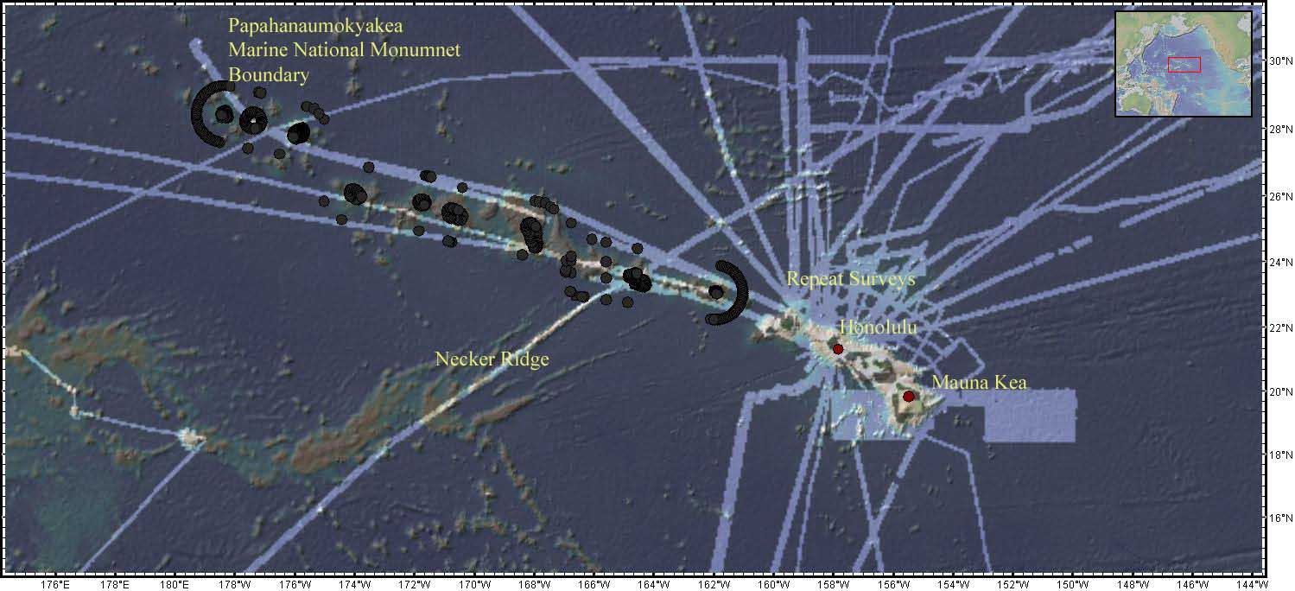

Figure 1: Image showing best available existing high resolution bathymetric data in the area overlain with the PMNM boundary.

CRUISE OVERVIEW

Background

The series of cruises are designed to test and refine operations for conducting mapping operations for exploration using NOAA Ship Okeanos Explorer (EX) mapping and related systems and sensors.

Goals and Objectives

The goals of these field trial cruises are more operational than exploratory. Like previous field trials, these cruises have primary and secondary goals and objectives. Completion of primary goals and objectives will make these cruises a success. The primary goal and objectives will be achieved in the context of mapping in the vicinity of Hawaiian Islands predominantly around Mauna Kea and Necker Ridge. Following are the primary and secondary goals objectives of this cruise:

Primary Goal: Test, troubleshoot, refine and evaluate EX mapping systems, sensors, protocols and processes to support systematic exploration.

Assess bottom backscatter data quality

EM 302 in addition to bathymetric data provides bottom backscatter data- which constitute amount of sound energy scattered in the direction of the sonar. Backscattering is a function of the sonar frequency, seafloor hardness and roughness. Over last few years, several research initiatives have focused on using bottom backscatter to identify different habitat types. Onboard EX, bottom backscatter have been collected in recent cruises but affects of bubble sweep down on the bottom backscatter data have been noted during EX0907 (July 14-23, 2009) cruise and earlier cruises. These cruises will continue to focus on processing bottom backscatter data while at sea and will try to identify any issues that need to be focused in refining data processing pipeline for bottom backscatter.

Develop protocols to collect and process sub-bottom profiler data

During earlier cruises, Knudsen SBP was observed to interfere with EM 302 and EA 600. Efforts in collaboration with OMAO, Knudsen and Kongsberg, have resulted in resolution of interference issues between EM302 and Knudsen, however, SBP has not been integrated fully into data acquisition and processing protocols. During these cruises, efforts will continue to focus on SBP issues identified during earlier cruises including resolution of very high chirping noise on the mess deck, data acquisition and processing SOPs, optimal use of SBP to explore sub-bottom regions.

Continue refining data products pipeline, documentation and sensor integration

A major focus of these cruises will be to continue to develop and improve methodologies to acquire, process, analyze and archive mapping data. Ancillary documentations in regards to standard operating procedures, system and wiring diagrams and operational reports will continue to be developed through out the cruises with special emphasis on bottom and water column backscatter data.

Continue refining operational protocols to analyze, disseminate and vet any new discoveries using mapping sonars’ data.

During this year field trials, the EX sensors have demonstrated their ability to detect interesting features and processes. However, adequate attention has not been focused on developing protocols to analyze, disseminate and vet any new discoveries. During earlier field trials, it was noticed that there was some uncertainty as how ship should share the information with shore. Who should be contacted to provide an independent review of the data collected by the ship? Also a need of a website where ship can post daily products, images of interesting features observed etc. During these cruise, EX will work with OER / UNH to establish these protocols.

Continue working on preparations for future ROV operations

As of August 2009, the availability of ROV for these cruises remains uncertain. However, for the future ROV operations, the ship will continue to prepare in terms of identifying probable targets for ROV dive sites, ship staff training to handle heavy weights over the side and identify any short comings in the material and personnel readiness to operate ROV efficiently and safely once the ROV becomes operational.

Continue refining protocols to conduct exploration missions combining all the ship resources including mapping sensors, telepresence, ROV, shore support etc. Refine protocols for different modes of exploration

Telepresence with ability to transfer data will be available for these cruises. This opportunity can be used to run exploration mission in a manner– as we would like them to be run starting next year once ship is fully operational. Although, ROV availability still remains uncertain, however, SOPs, and operational protocols to conduct missions will be a valuable help to ship staff to understand the operational details and develop protocols

Continue efforts to synthesize the lessons learnt, discrepancies noted, during field trial year.

As the ship is progressing towards end of the field trial year, it is pertinent to document the lessons learnt, discrepancies noted during the field trial year.

Continue efforts to improve and refine telepresence operations.

Telepresence Objective Include

- Resolving issues with Tandberg Encoder 2
- Configure video router presets to configure the video for the different modes of operations (i.e. CTD casts, Multibeam surveys.)
- Update EVS software IPDirector and the XT2 Server (XFile)
- Migrate video format from EVS proprietary to Apple ProRES422
- Install Fiber Channel network to Video Editing Station, Video Server and NexSAN.
- Deploy prototype event logging system.
- Install hardware for real-time data dissemination
- Get remote HD PTZ camera remote control
- Setting up of video and audio router presets. Work with survey department to create preset buttons
- Identify discrepancies in brining ECCs on line e.g., getting SSMC console operational, migrate PMEL to software decoder, working with ISC to ensure intercom capability is improved long-term.

Secondary Goal: Map the areas in vicinity of Hawaiian Island which are of interest to national and regional interest.

Necker Ridge

Necker Ridge has been identified as a potential site of expansion of continental shelf for USA. The efforts will be focused on developing detailed maps of Necker Ridge region. However, the eastern part of the survey region which falls inside the PMNM boundary will not be mapped.

Mauna Kea

Areas around Mauna Kea hold several potential sites for future ROV dive sites. Mapping in this area will help identify the sites to plan future ROV dives.

Repeat surveys in vicinity of Penguin Bank

Several sites around Northern Hawaiian Islands have been mapped earlier with high resolution Multibeam sonars. Repeat surveys over these areas will provide data which will be helpful in assessing EX EM 302 data quality in addition to providing additional data sets to conduct change analysis. Software and hard ware updates will be brought up to date before this cruise so as to assess any adverse effects of the software and hard ware changes.

Refine and improve data management onboard

In collaboration with NCDDC the ship will focus on stream lining the data management protocols to create meta data, data transmittal from the ship to NCDDC and archival centers (NGDC). NCDDC is also spear heading efforts in developing innovative data products (e.g. Google maps etc.). Through out the cruises, NCDDC personnel will work closely with the ship staff to develop and improve these data management protocols.

Media / outreach / education / website

As the ship becomes operational, other elements apart from data collection and processing will become important. In terms of web presence, media, outreach and education the ship staff will need to be trained to deal with these issues e.g. the ship staff and program will attempt to establish blogging policy and OEAR media / outreach personnel will attempt communications/media training for messaging from the ship; and identify the vehicles available to ship staff already. Efforts will focus on identifying roles of different personnel as authors, imagery processing, deciding what is easy and appropriate to transmit, video processing, etc. The ship’s personnel involvement will be necessary to establish these protocols. Material generated earlier by OEAR staff will help the ship staff to jump start. The Web team and principals will go over the materials already available to the EX and will help develop a plan.

Other partners and activities (e.g. Exploratorium, local Hawaii universities / research institutes) may be incorporated later as the plans to achieve these goals are formalized.

Training

These cruises will continue to provide opportunity to the ship staff to train them selves to operate, maintain and trouble shoot salient systems including but not limited to the mapping sensors, small boat operations, handling of heavy weights over the side, telepresence, VSAT etc. Attempts will be made to engage innovative training tools (e.g. telepresence, Go To Meetings) to tap into shore based resources for training.

Participating Organizations

NOAA – Office of Ocean Exploration and Research (OER)
1315 East-West Hwy, Silver Spring, Maryland 20910

NOAA – Pacific Marine Environmental Laboratory (PMEL)
7600 Sand Point Way N.E., Seattle, Washington 98115-6439

UNH – University of New Hampshire, Center for Coastal and Ocean Mapping (CCOM)
Jere A. Chase Ocean Engineering Lab, 24 Colovos Road, Durham, NH 03824 USA

NOAA – National Coastal Data Development Center (NCDDC)
Building 1100, Suite 101 Stennis Space Center, MS 39529

Hawaiian local research institutes and scientific collaborators – TBD

PERSONNEL

It is envisioned that EX will carry out 24 hours mapping operations during these cruise. Therefore, the requirement is for 6 watch keepers (2 for each watch) for mapping sensors data acquisition and data processing. However currently there are only 2 watch keepers (SSTs Stuart and Peters) are available onboard, requiring to bring additional mapping personnel for each cruise.

The expedition coordinators, listed as below, will provide the details about personnel participating in the cruise 1-2 weeks before to the ship and will ensure that participating personnel comply with NOAA guidelines to participate in cruises onboard NOAA vessels.

EX 0909 Leg 1 (August 21 - Sept 3): SST Peters on leave for this leg. One ST from the augmentation pool

Name | Affiliation | Role | M/F | Status
Malik, Mashkoor | OER | Expedition Coordinator | M | US Permanent Resident
Lobecker, Meme | OER | Mapping | F | US citizen
Benjamin J Colello | OER Intern | Mapping | M | US citizen
Jonathan Hunt | OER Intern | Mapping | M | US citizen
Andrea LeBarge | OER Intern | Mapping | F | US citizen

EX 0909 Leg 2 (Sept 8 - Sept 26):

Name | Affiliation | Role | M/F | Status
Catalina Martinez | OER | Expedition Coordinator | F | US citizen
Andrea LeBarge | OER intern | Mapping | F | US citizen
Heather Jackson | OER intern | Mapping | F | US citizen
Tyanne Faulkes | OCS / PHB | Mapping | F | US citizen
Federico García-Uribe | OER intern | Mapping | M | Permanent resident

EX 0909 Leg 3 (Oct 1 - Oct 21): SST Peters on leave for this leg. One ST from the augmentation pool

Name | Affiliation | Role | M/F | Status
Malik, Mashkoor | OER | Expedition Coordinator | M | US Permanent Resident
Kelley Elliott | OER | Mapping | F | US citizen
Megan Nadeau | OER | Mapping | F | US citizen
Mapping watch stander TBD |  | Mapping
Mapping watch stander TBD |  | Mapping
Mapping watch stander TBD |  | Mapping

EX 0909 Leg 4 (Oct 26 - Nov 15):

Name | Affiliation | Role | M/F | Status
Lobecker, Meme | OER | Expedition Coordinator | F | US citizen
Emily McDonald | OER | Mapping | F | US citizen
Mapping watch stander TBD |  | Mapping
Mapping watch stander TBD |  | Mapping
Mapping watch stander TBD |  | Mapping
Mapping watch stander TBD |  | Mapping
Webb Pinner | OER | Telepresence | M | US citizen

Remotely Participating Personnel

The following personnel will participate or be available to participate from shore via limited communications at Exploration Command Centers.

Name | Affiliation | Role | Dates | M/F | Status | ECC
Russell, Craig | OER (ERT) | EX Program Planner | 21 August to 15 November | M | US | PMEL
McDonough, John | OER | Deputy Director, Backup Expedition Coordinator | 21 Augsut to 15 November | M | US | SSMC

Participating Organization Acronyms

OER – NOAA OAR Office of Ocean Exploration and Research
ERT – ERT, Inc, a NOAA Contractor
UNH CCOM – University of New Hampshire Center for Coastal and Ocean Mapping
NCDDC - National Coastal Data Development Center
NGDC – National Geophysical Data Center

Foreign Nationals – No foreign nationals are expected to participate in these cruises

See Section 8.2 for details regarding foreign nationals, including the responsibilities of the OER Expedition Coordinator, Commanding Officer and foreign national sponsor.

ADMINISTRATION

Ship’s Location

The ship will complete the scheduled in port periods at the NOAA Pacific Regional Center located on Ford Island at Naval Station Pearl Harbor. The ship will be berthed at either pier F9 or F10 during these in port periods.

Key Points of Contact

Ship Operations

Marine Operations Center, Atlantic (MOA)  439 West York Street  Norfolk, VA 23510-1145  Telephone: (757) 441-6776  Fax: (757) 441-6495 | Marine Operations Center, Pacific (MOP)  1801 Fairview Avenue East  Seattle, WA 98102-3767  Telephone: (206) 553-4548  Fax: (206) 553-1109
Chief, Operations Division, Atlantic (MOA1)  LCDR Keith Roberts  Telephone: 757-441-6842  E-mail: ChiefOps.MOA@noaa.gov | Chief, Operations Division, Pacific (MOP1)  LCDR Demian Bailey  Telephone: 206-553-8705  Email: ChiefOps.MOP@noaa.gov

Mission Operations

Mashkoor Malik, Physical Scientist  NOAA Ocean Exploration & Research (ERT, Inc.)  Phone: 603-862-4332 / 603-377-6319  E-mail: mamalik@cisunix.unh.edu | Catalina Martinez, Expedition Coordinator  NOAA Ocean Exploration & Research  Phone : 401-874-6250(o)/401-330-9662(c)  E-mail : catalina.martinez@noaa.gov
LT Nicola Verplanck, Field Operations Officer
NOAA Ship Okeanos Explorer
Phone: 321-960-3726
E-mail: Ops.Explorer@noaa.gov

Other Mission Contacts

Craig Russell, EX Program Planner  NOAA Ocean Exploration & Research (ERT, Inc.)  Phone: 206-526-2803 / 206-518-1068  E-mail: Craig.Russell@noaa.gov | John McDonough, Deputy Director  NOAA Ocean Exploration & Research  Phone: 301-734-1023 / 240-676-5206  E-mail: John.McDonough@noaa.gov

Shipments

For all shipments to the ship please coordinate with OPS and cruise coordinator. Be sure to send an email to the EX Ops Officer OPS.Explorer@noaa.gov indicating the size and number of items being shipped.

The following is the ship’s shipping address in Hawaii:

NOAA Ship Okeanos Explorer
1897 Ranger Loop
Building 184
Honolulu, HI 96818

Shipboard Meetings

Daily Safety meeting will be held at 0800 local time on the bridge to discuss the current day operations. Daily Operations Briefing meetings will be held at 1530 Local time in the forward lounge to review the current day, and define operations, associated requirements and staffing needs for the following day. A Plan of the Day (POD) will be posted each evening for the next day in specified locations through out the ship. Daily Situation Reports (SITREPS) will be posted as well and shared daily through e-mail and/or the EX PLONE site (http://terra.gso.uri.edu/NOAAShipOkeanosExplorer)

Medical Clearance

All personnel will satisfy NOAA Health and Safety requirements, completing and providing NHSQ and PPD (Tuberculosis test) test results before boarding.

The revised NHSQ can be found at http://www.omao.noaa.gov/medical.html. Clearances
are valid for 2 years for personnel under age 50 and 1 year for age 50 and over. All PPD’s expire after one year from the date of administration.

Cruise participants will follow standard protocols described in the NHSQ, and will fax completed forms to CDR Pelkey as follows:

CDR Michelle Pelkey
Fax: 206-553-1112
Phone: 206-553-2298

OPERATIONS

Following is a description of the data to be collected, including: specific sensors or systems used; the operations implementation plan, including staging, conducting operations (on-station, underway) and de-staging; station or trackline geographic information, and any other operations requirements.

Data to be collected

As field trial cruises, the primary data collected are evaluation and assessment information of operations, protocols, systems and processes. The secondary data collection objective is acquiring mapping data useful to NOAA OER and other users. Following is a list of sensor measurements that will be required to accomplish the primary and secondary objectives:

Primary Systems and Sensors
- Kongsberg Simard EM302 Multibeam Echosounder (MBES)
- Kongsberg Simrad EA600 Deepwater Echosounder
- Knudsen 320BR Sub-bottom profiler (SBP)
- LHM Sippican XBT (various probes)
- Seabird SBE 911 Plus CTD
- Seabird SBE 50 CTD Stand
- CNAV GPS
- POS/MV
- Seabird SBE-45 (Micro TSG)
- Kongsberg Dynamic Positioning-1 System
- NetApp mapping storage system
- CARIS HIPS Software
- SIS Software
- Hypack Software
- Scientific Computing System (SCS)
- ECDIS
- Met/Wx Sensor Package

Secondary Systems and Sensors
- Telepresence System
- VSAT High-Speed link (Comtech 20 Mbps and 10 Mbps ship to shore)

Staging Plan

For each individual cruise, mission party is expected to embark on the EX and begin preparations. All additional equipment to be brought aboard by the mission party will be shipped to the address provided by the ship. This equipment shall be loaded by the mission party onto EX no later than 24 hrs prior departure time and placed in the wet lab or other appropriate destination location aboard the EX and ensure proper stowage, installation and securing of the material. The mission party is responsible for arranging all necessary transportation of material and personnel to and from the ship. Mission personnel will coordinate with the Ship Operations Officer for any ship services required to assist with loading mission materials. Crane service requests must be requested by the mission party 24 hours in advance of the required loading time.

De-Staging Plan

Upon return to port at end of each cruise, the mission party shall dismantle any additional equipment brought aboard for removal no later than 24 hrs after arrival time. The mission party is responsible for arranging all necessary transportation of material and personnel to and from the ship. Mission personnel will coordinate with the Ship Operations Officer for any ship services required to assist with unloading transient mission materials. Crane service requests must be requested by the mission party 24 hours in advance of the required loading time.

Cruise Implementation Plan

The shipboard EM 302 and Knudsen SBP will be operated around the clock (24 hours per day) during these cruises. Multibeam data will be processed, and digital terrain maps will be developed to assist in day to day planning and operational decisions. XBT/CTD data will be collected in survey regions to improve the quality of the multibeam data acquisition.

Detailed day to day planning of operations will be accomplished with discussions between respective cruise coordinators and OPS and expected to be available to the ship no later than 10 days prior planned departure date.

Table 1: List of projected major operations associated with EX0909 Legs 1-4 cruises.
 | Dates (mm/dd) | Location | Operations | Time (Days)  Approx. | Distance (nm)  Approximate
EX 0909 Leg 1 | 08/21 | Honolulu, HI | Departure
 | 08/21-08/23 | Transit to Necker Ridge | Transit | 2.0 | 430
 | 08/23 | Necker Ridge | CTD cast | 0.5 | -
 | 08/24 | Necker Ridge | EM 302 patch test | 0.5 | 100
 | 08/25-08/31 | Map Necker Ridge | EM 302 Mapping | 7.0 | 1600
 | 09/01-09/02 | Transit to Honolulu | Transit | 2.0 | 430
 | 09/03 | Honolulu | Arrive Honolulu
Total |  |  |  | 12 | 2560
EX 0909 Leg 2 | 09/08 | Depart Honolulu | Departure
 | 09/8-09/09 | Transit to Mauna Kea mapping area | Transit | 1 | 200
 | 09/09-09/12 | Mauna Kea mapping area 1 | Mapping | 3 | 600
 | 09/12-09/16 | Mauna Kea mapping area 2 | Mapping | 4 | 750
 | 09/16-09/16 | Investigation of potential ROV targets | Mapping | 3 | 600
 | 09/16-09/25 | Mapping area TBD  (Potential target areas: Penguin Bank, Repeat surveys) | Mapping | 9 | TBD
 | 09/26 | Arrive Honolulu
Total |  |  |  | 18 | TBD
EX 0909 Leg 3 | 10/01 | Depart Honolulu
 | 10/01-10/02 | Transit to Necker Ridge | Transit | 2 | 430
 | 10/03-10/19 | Map western Necker Ridge | Mapping in reconnaissance mode Actual areas TBD | 16 | TBD
 | 10/19-10/21 | Transit to Honolulu | Transit | 2 | 430
 | 10/21 | Arrive Honolulu
Total |  |  |  | 21 | TBD
EX 0909 Leg 4 | 10/26 | Depart Honolulu
 | 10/26-10/27 | Transit to Hawaiian North western area already mapped area  Actual area TBD | Transit | TBD | TBD
 | 10/27-11/13 | Map operations TBD | Mapping | 17
 |  | Transit to Honolulu | Transit | TBD | TBD
 |  | Arrive Honolulu
Total |  |  |  | 21 | TBD

Table 2. Approximate mapping locations for this cruise.
 | Approx Depths (m) | Bounding box location  (Not to be used for Navigation)  Long (-W) Lat (+N)
CTD cast | 4500 | -165.805 22.76
Necker Ridge ECS  Mapping (EX 0909 Leg 1) | 2000 – 4500 | -163.08363546 23.06008504  -166.54783630 23.72700806  -170.92014516 20.82562256  -170.29351298 18.60740967
Mauna Kea Mapping area 1 (EX 0909 Leg 2) | > 4500 | In vicinity of  -154.813 20.331
Mauna Kea Mapping area 2 (EX 0909 Leg 2) | > 4000 | In vicinity of  -154.219 19.382
Penguin Bank and other previously Mapped areas  (EX 0909 Leg 2) | 100-2000 | Exact locations TBD
Necker Ridge Exploration  (EX 0909 Leg 3) |  | TBD based on EX0909 Leg 1 cruise data
EX 0909 Leg 4 |  | TBD

Figures showing the planned areas to be mapped:

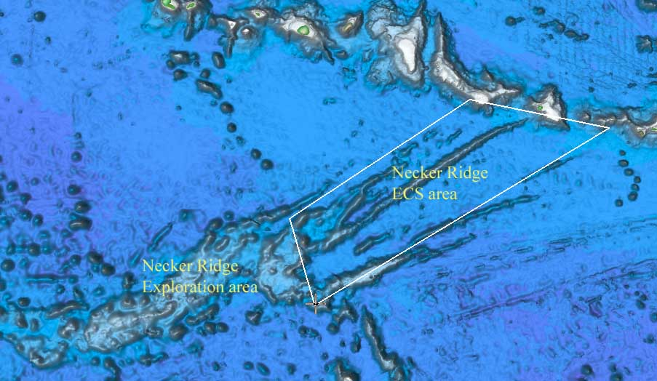

Figure 2: Image showing EX 0909 Leg 1 focus area located inside Necker Ridge ECS area. A few lines during EX 0909 Leg 1 will be run in Necker Ridge exploration area during EX 0909 Leg 1 which will define the areas to be focused during EX 0909 Leg 3 cruise.

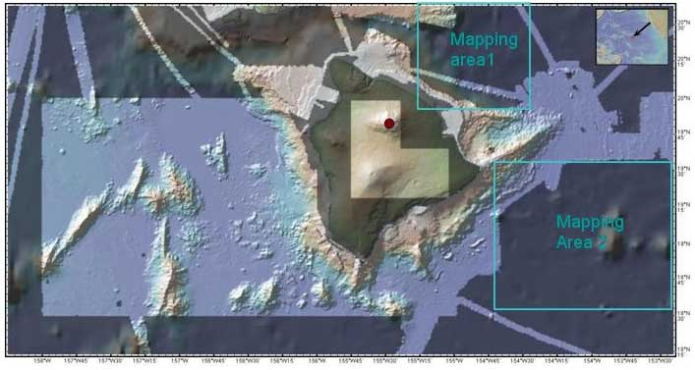

Figure 3: Image showing the areas planned to be mapped during EX 0909 Leg 2 in vicinity of Mauna Kea area. Mapping operations will focus on the areas where no existing high resolution data exist i.e. Mapping area 1 and Mapping area 2.

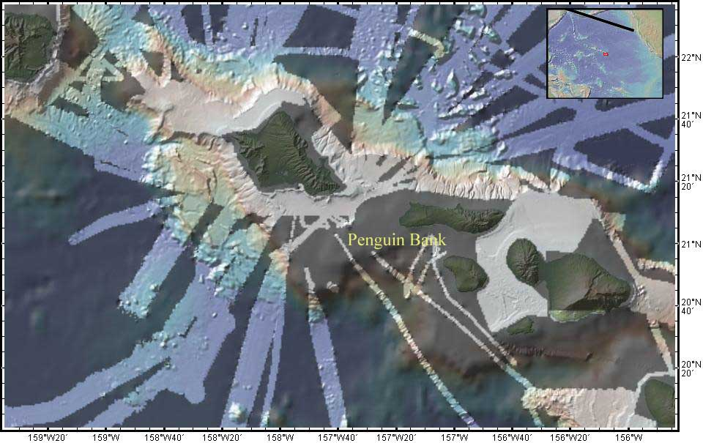

Figure 4: Image showing data holdings in vicinity of Penguin Bank being planned to be mapped during EX 0909 Leg 3 cruise.

Station Operations

The following station operations will be conducted during this cruise. The procedures for these operations can be found in Standard Operating Procedures aboard the EX.

- CTD casts
- XBT casts (various probes)

Underway Operations

The following underway operations will be conducted during this cruise. The procedures for these operations can be found in Standing Operating Procedures aboard the EX.

- Mapping operations using EM302, EA600 and Knudsen 320BR
- XBT casts (various probes)
- TSG Monitoring
- SCS Data Acquisition
- Meteorological Data Acquisition
- Data processing of EM 302 data

Applicable Restrictions

None.

Small Boat Operations

No small boat transfers or operations are requested at this time.

FACILITIES

Equipment and Capabilities Provided by the EX

- EM302 Mapping System
- EA600 Echosounder System
- Knudsen 320 BR Subbottom profiler system
- POS/MV
- CNAV DGPS
- SCS System
- Dynacon Hydrographic Winch with .32” 8000m electromechanical conductor cable terminated for CTD operations, positioned for use with the starboard J-Frame.
- Starboard J-Frame rigged to Dynacon Hydrographic Winch.
- Manual Wire Angle indicator for CTD casts
- Sea-Bird Electronics’ SBE 911plus CTD system with stand, including underwater CTD, weights, pinger and deck unit.
- Conductivity and temperature sensor package to provide dual sensors on the CTD (primary)
- LHM Sippican XBT system and probes
- Telepresence System
- NetApp network storage devices
- Color copier and printer
- Mission party computer and network access
- Desk and workspace in the dry and wet-labs
- Adequate deck lighting for night-time operations
- Navigational equipment including GPS and radar
- Safety harnesses for working on quarterdeck and fantail
- Ship’s crane(s) used for loading and/or deploying
- Limited rain gear for inclement weather
- Hard hats for deck operations
- Berthing and meals for embarked personnel

Equipment and Capabilities Provided by the Mission Party

- Ancillary mission laptop computers
- Ancillary mapping processing workstation
- Specialized water column and bottom backscatter data processing tool

OPERATIONAL RISK MANAGEMENT

For every operation to be conducted aboard the ship (NOAA-wide initiative), risk management procedures will be followed. For each operation, risks will be identified and assessed for probability and severity. Risk mitigation strategies / measures will be investigated and implemented where possible. After mitigation, the residual risk will have to be assessed to make Go-No Go decisions for the operations. Particularly with new operations, risk assessment will be ongoing and updated as necessary. This does not only apply to over-the-side operations, but to everyday tasks aboard the vessel that pose risk to personnel and property.

- CTD (and other pertinent) ORM documents will be followed by all personnel working on board the EX
- All personnel on board are in the position of calling a halt to operations/activities in the event of a safety concern.

MISCELLENEOUS

Communications

Specific information on how to contact the NOAA Ship Okeanos Explorer and all other fleet vessels can be found at:

http://www.moc.noaa.gov/phone.htm

Important Telephone and Facsimile Numbers and E-mail Addresses

Ocean Exploration and Research (OER):
OER Program Administration:
Phone: (301) 734-1010
Fax: (301) 713-4252
E-mail: Firstname.Lastname@noaa.gov

University of New Hampshire, Center for Coastal and Ocean Mapping

Phone: (603) 862-3438
Fax: (603) 862-0839

NOAA Ship Okeanos Explorer - Telephone methods listed in order of increasing expense:

EX Cellular:
OOD (401) 378-7414

EX Iridium:
808-659-9179

EX INMARSAT B

Line 1: 011-872-764-852-328
Line 2: 011-872-764-852-329

Voice over IP (VoIP) Phone:

301-713-7772 (expect a delay once picked up by directory)

Mission personnel may obtain access to these systems with permission from the Commanding Officer on a cost-reimbursable basis.

E-Mail: Ops.Explorer@noaa.gov (mention the person’s name in SUBJECT field)

expeditioncoordinator.explorer@noaa.gov

For dissemination of all hands emails by Expedition Coordinator while on board. See ET for password.

Foreign Nationals

Not Applicable

DISPOSITION OF DATA

All data acquired on the EX will be provided to the public archives without proprietary rights.

9.1 Responsibilities

9.1.1 Ship
The Commanding Officer is responsible for all data collected for missions until those data have been transferred to mission party designees. Data transfers will be documented on NOAA Form 61-29. Reporting and sending copies of project data to NESDIS (ROSCOP form) is the responsibility of OER.

9.1.2 NOAA OE
The Expedition Coordinator will work with the EX Operations Officer to ensure data pipeline protocols are followed for final archive of all data acquired on the EX without proprietary rights.

9.2 Deliverables
  - At sea
      - Daily plans of the Day (POD)
      - Daily situation reports (SITREPS)
  - Post cruise
      - Assessments of all activities.
      - Cruise report
      - One pager overview
  - Archive
- The Program and ship will work together to ensure proper archive of metadata and acquired data sets, and that all metadata and data formats meet FGDC compliance. Details TBD.

ADDITIONAL PROJECTS

Definition - Ancillary and piggyback projects are secondary to the objectives of the cruise and should be treated as additional investigations. The difference between the two types of secondary projects is that an ancillary project does not have representation aboard and is accomplished by the ship's force.

NONE

HAZARDOUS MATERIALS

The field party chief shall be responsible for complying with MOCDOC 15, Fleet Environmental Compliance #07, Hazardous Material and Hazardous Waste Management Requirements of Visiting Scientists, July 2002

NONE

