NOAA Okeanos Explorer Program

MAPPING DATA REPORT

CRUISE EX0907

Mapping Field Trials IV
Habitat Characterization
Cordell Bank & Gulf of the Farallones National Marine Sanctuaries Expansion Areas

July 14 23, 2009
Astoria, OR to San Francisco, CA

Report Contributors:
Mashkoor Malik, Colleen Peters, Lorraine Anglin, Christopher Paul, Elena Crete, Gregory Beadle, Samuel Baldwin and Andrea LeBarge

NOAA Office of Ocean Exploration and Research
1315 East-West Hwy, SSMC3, #10210
Silver Spring, MD 20910




Introduction

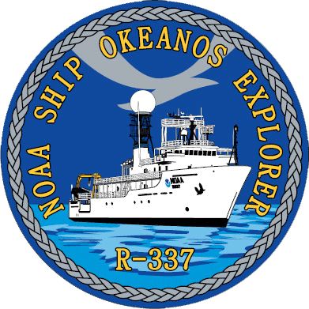


The Okeanos Explorer Program

Commissioned in August 2008, the NOAA Ship Okeanos Explorer is the nation’s only federal vessel dedicated to ocean exploration. With 95% of the world’s oceans left unexplored, the ship’s combination of scientific and technological tools uniquely positions it to systematically explore new areas of our largely unknown ocean. These exploration cruises are explicitly designed to generate hypotheses and lead to further investigations by the wider scientific community.

Using a high-resolution multibeam sonar with water column capabilities, a deep water remotely operated vehicle, and telepresence technology, Okeanos Explorer provides NOAA the ability to foster scientific discoveries by identifying new targets in real time, diving on those targets shortly after initial detection, and then sending this information back to shore for immediate near-real-time collaboration with scientists and experts at Exploration Command Centers around the world. The subsequent transparent and rapid dissemination of information-rich products to the scientific community ensures that discoveries are immediately available to experts in relevant disciplines for research and analysis

Through the Okeanos Explorer Program, NOAA’s Office of Ocean Exploration and Research (OER) provides the nation with unparalleled capacity to discover and investigate new oceanic regions and phenomena, conduct the basic research required to document discoveries, and seamlessly disseminate data and information-rich products to a multitude of users. The program strives to develop technological solutions and innovative applications to critical problems in undersea exploration and to provide resources for developing, testing, and transitioning solutions to meet these needs.

Okeanos Explorer Management – a unique partnership within NOAA

The Okeanos Explorer Program combines the capabilities of the NOAA Ship Okeanos Explorer with shore-based high speed networks and infrastructure for systematic telepresence-enabled exploration of the world ocean. The ship is operated, managed and maintained by NOAA’s Office of Marine and Aviation Operations, which includes commissioned officers of the NOAA Corps and civilian wage mariners. OER owns and is responsible for operating and managing the cutting-edge ocean exploration systems on the vessel (ROV, mapping and telepresence) and ashore including Exploration Command Centers and terrestrial high speed networks. The ship and shore-based infrastructure combine to be the only federal program dedicated to systematic telepresence-enabled exploration of the planet’s largely unknown ocean.

Table of Contents
1. Introduction 2
2. Purpose 3
3. Cruise Objectives 3
5. Cruise Statistics 4
6. Mapping sonar setup 4
7. Data acquisition plan 4
9. Cruise Calendar 9
10. Daily cruise log 9
11. Appendices 12
Appendix A. Tables of data files collected 12
Appendix B: List of Acronyms 15
Appendix C: EM302 description and operational specs 16
Appendix D: Field products showing data results: Overview of Exploration Area 19

Purpose

The purpose of this report is to briefly describe the mapping data collection and processing methods, and to report the results of the cruise. For a detailed description of the Okeanos Explorer mapping capabilities, see appendix C and the ship’s readiness report, which can be obtained by contacting the ships operations officer (ops.explorer@noaa.gov).

Cruise Objectives

Cruise EX0907 had two separate objectives. The primary cruise objective was to test, troubleshoot, refine, and evaluate Okeanos Explorer mapping systems, sensors, protocols, and processes as they related to the systematic exploration mission of the ship. Specific goals pertaining to this objective were:
- Assessment of bottom backscatter data quality
- Resolution of interference between EM302, EA600, and Knudsen Sub-bottom sonars
- Continued refinement of data products, pipeline, documentation, and sensor integration
The secondary cruise objective was to continue preparation, personnel training, and evaluation of non-mapping Okeanos Explorer systems and sensors. Specific goals pertaining to this objective were:
- VSAT system trial
- Preparation for the 24 July public relations event
- CIMS trial

Both objectives were completed within the context of mapping in the vicinity of Cordell Bank and the Gulf of the Farallones, which are of national and regional interest.

- Participating personnel

NAME | ROLE | AFFILIATION
CDR Joseph Pica | Commanding Officer | NOAA Corps
Mashkoor Malik | Cruise Coordinator/Mapping Team Lead | NOAA OER
LTJG Kyle Byers | Acting Field Operations Officer | NOAA Corps
Colleen Peters | Senior Survey Technician | NOAA OMAO
Lorraine Anglin | ONMS Representative | ONMS
Andrea LeBarge | Mapping Watchstander | NOAA OER Intern
Christopher Paul | Mapping Watchstander | NOAA OER Intern
Elena Crete | Mapping Watchstander | NOAA OER Intern
Gregory Beadle | Mapping Watchstander | NOAA OER Intern
Samuel Baldwin | Mapping Watchstander | NOAA OER Intern
Denise Gordon | NCDDC CIMS team | NCDDC
McKinley Freeman | NCDDC CIMS team | NCDDC

Cruise Statistics

Dates | JD197 to JD203
Weather delays | 0 days
Total non-mapping days | 0 days
Total survey mapping days | 7 days
Total transit mapping days | 2.5 days
Line kilometers of survey | 2477 km
Beginning draft | 4.34 m (bow) 4.42 m (stern)
Average ship speed for survey | 7.9 kts

Mapping sonar setup

NOAA Okeanos Explorer (EX) is equipped with a 30 kHz Kongsberg EM 302 multibeam sonar and a 3.5 kHz Knudsen sub-bottom profiler (SBP 3260). During this cruise EM 302 bottom bathymetric / backscatter along with water column data were collected. The Knudsen Sub-bottom profiler was only operated for the purposes of testing interference between EM 302 and Knudsen on 15-16 July 2009 up to depth of ~ 2000 m and was found to work satisfactorily at the same time with the EM 302 with no interference observed in EM 302.

The ship used a POS-MV ver. 4 to record and correct the multibeam data for any motion. C-NAV GPS system provided DGPS correctors with position accuracy expected to be better than 2.0 m.

All the corrections (motion, sound speed profile, sound speed at sonar head, draft, sensor offsets) are applied during real time data acquisition in SIS ver. 1.04. XBT casts (Deep Blue, max depth 760 m) were taken every 6 hours (0000, 0600, 1200 and 1800 local time). XBT cast data were converted to a SIS compliant format using NOAA Velocwin ver. 8.92 Plus.

Data acquisition plan

The data were collected during transit from Astoria, OR, to working grounds (15-16 July) in the vicinity of Cordell bank National Marine Sanctuary. Active data acquisition in the working grounds was carried out 16 – 22 July.

Due to large depth variations, the lines were planned to run parallel to the contour lines and the whole area was divided into four sub areas with line spacing of 750 m, 1500 m, 3000 m and 6000 m respectively.

Most of the shallow water areas (with depths < 400 m) demanded line spacing of 750 m. Throughout the survey, the EM 302 data provided 3-5 times water depth coverage.
The weather got worse on 18 July with 7-12 ft swells from the north and remained rough until the end of the survey. As the northbound lines caused the ship to pitch heavily, a lot of bubble sweep down episodes were observed in the northbound lines, which caused the sonar to loose bottom track. During heavy weather the sonar also suffered from decreased swath coverage and therefore a lot of additional lines were run to fill in the data holidays.

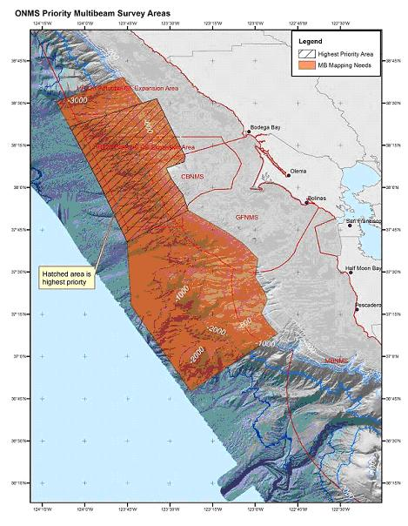
Figure 1. Survey areas showing priorities.

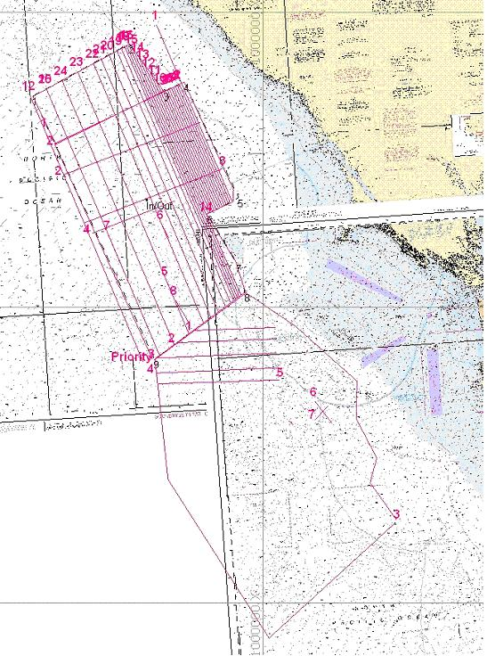
Figure 2. Screen shot of HYPACK showing different lines run during the survey. Image credit: NOAA.

- Multibeam Data Quality Assessment and Data Processing

Onboard processing of bathymetric data was done in CARIS HIPS ver. 6.1 during which the data were cleaned in ‘Swath Editor’ and ‘Subset Editor’. No tidal corrections were applied during post processing; however, no appreciable differences were observed between different lines by not applying tidal corrections.

The cross lines yielded a favorable comparison between main scheme lines and cross lines.
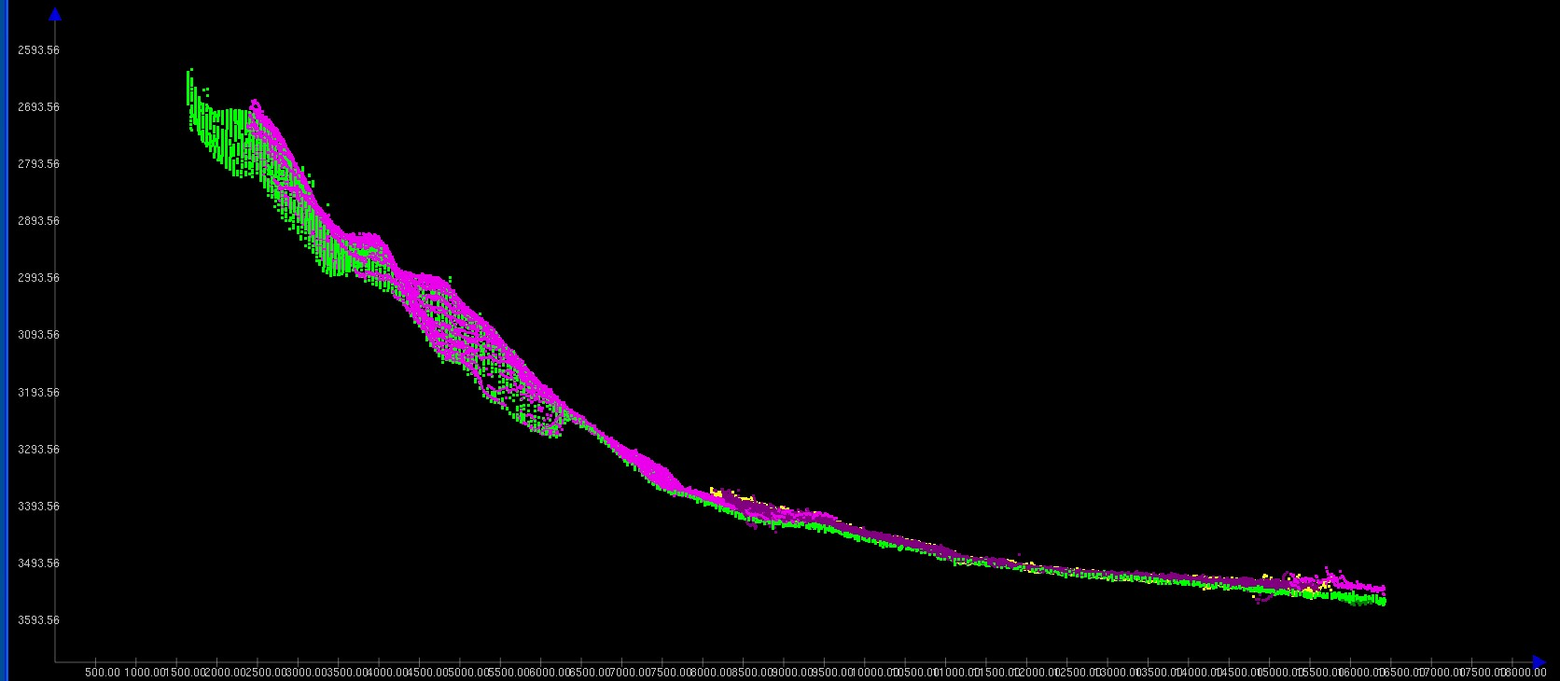
Figure 3. Screen grab of subset editor in CARIS HIPS showing agreement of cross lines (pink) with main scheme lines. Image credit: NOAA.

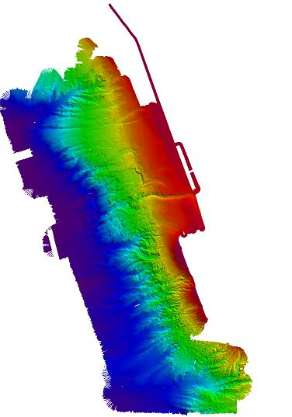
Figure 4. Images of the final grids (at 50 m) cell size resolution of the priority area 1 and 2. Image created in CARIS HIPS 6.1.

Onboard processing of water column data remained minimal due to the difficulty in discerning biological targets from noise in the water column data. Water column data from the survey have been provided with the cruise data.

Onboard processing of bottom backscatter data were conducted using the University of New Hampshire research tool ‘Geocoder’. The results obtained during fair weather are encouraging but during the days when the weather was choppy, a lot of bubble sweep down issues degraded bottom backscatter data quality severely. At the time of filing of this report, we are not sure whether they weather effects can be taken care of during post processing. The ship is also expected to contact Kongsberg, Inc. regarding these backscatter artifacts.

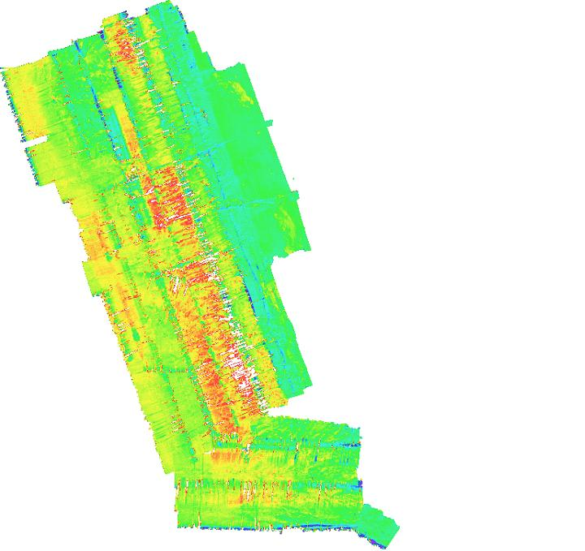
Figure 5. Backscatter mosaic results with 40 m grid cell size. Severe degradation of backscatter data due to bubble sweep down is clearly visible in the central region of the survey.

The latest patch test for the EM 302 was performed in May 2009 which showed only a pitch bias of 0.7 degrees. These patch test values were used during data acquisition throughout this cruise.

Cruise Calendar

July 2009
Mon | Tue | Wed | Thu | Fri | Sat | Sun
13  Mission party onboard the ship except Baldwin and Crete | 14  Baldwin and Crete arrived 1030.  Left Astoria, OR 1230 | 15  In transit to the working grounds. | 16  Arrived at working grounds ~ 1400 | 17  Mapping in Priority 1 and 2 of expansion areas | 18  Weather getting worse with very little useable data in north bound line | 19  Weather still preventing data collection northbound
20  Mapping in ONMS areas wrapping up. Running cross lines | 21  Mapping in ONMS areas wrapping up | 22  Mapping in Dump site. USS Independence  investigation | 23  Return to San Francisco | 24 | 25 | 27

Daily cruise log

(ALL TIMES LOCAL PACIFIC DAYLIGHT TIME)

July 14, 2009

Ship sailed at 1230. Original sailing at 0900 was delayed due to flight cancellation of Baldwin and Crete who spent ~ 36 hrs traveling from Durham, NH, to Astoria, OR. Mission party met with Peters and Malik to discuss briefly cruise objectives and introductions. Lt Byers also welcomed the mission party and briefed about essential safety issues. Initial orientation with mission control room and mapping operations along with XBT operations was provided by Peters.

July 15, 2009

Ship is in transit to working grounds off the coast of CA.

July 16, 2009

Ship passed over several plume sites during 15/16 night. The ship was directed to make another pass and resulted in finding more than 3 plume sites in addition to the one detected in the May 2009 mapping field trial cruise. Arrived at working grounds and started mapping.

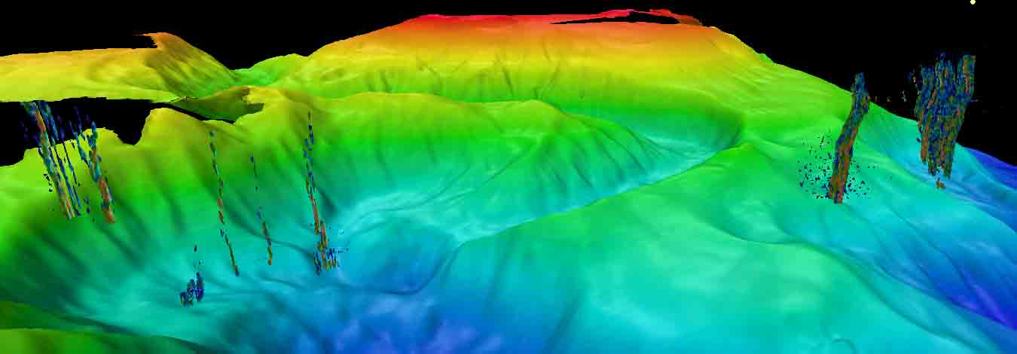
Figure 6. At least five plume sites visible with multibeam—50 m grid, compiled in Fledermaus.

July 17, 2009

Ship continued to work in the sanctuary expansion areas priority 1 and 2.

July 18, 2009

The weather has been progressively getting worst. Large swells (~ 5-10 ft) are causing ship to pitch and the bubble sweep down is causing EM 302 to loose bottom track. Reducing survey speed to 5 kts helped little bit but still the data quality during north bound lines is degraded severely. Discussions are in progress to rerun these north bound lines at the end of the survey.

July 19, 2009

The weather is still bad for the north bound lines and north bound lines have to be run again to make useable data. The survey was broken off to fill in few holidays left in the shallow part of the survey. Resumed main scheme lines.

July 20, 2009

Mapping in the area with lot of bubble sweep down episodes.

July 21, 2009

Finished with running main scheme lines. Now running lines to fill in the holidays. Over night the ship transited to the ammunition dump site and started mapping in the dump site, located in priority 3 area. No noticeable items were detected in the dump site. The backscatter data were processed but due to bad weather did not provide any useful information about the type of the material.

July 22, 2009

After finishing dump site, the ship made few passes over reported wreck of USS Independence and located an object which seemed to be a wreck of a ship ~ 190 m long.

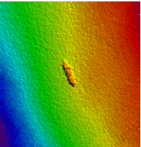
Figure 7. A plan view of USS Independence located in position 123.1346 W, 37.4779 N, compiled in Fledermaus.

Appendices

Appendix A. Tables of data files collected

XBT Locations:

Date | Time (GMT) | XBT/CTD Filename | Lat | Long | Remarks
071409 | 21:54 | TD_00001 | 46 5.28N | 124 12.19W
071509 | 18:04 | T6_00002 | 42 38.31N | 124 55.33W
071609 | 04:07 | TD_00003 | 40 54.43N | 124 44.95W
071609 | 20:48 | T6_00004 | 38 45.17N | 123 43.38W
071709 | 01:22 | T6_00005 | 38 10.94N | 123 26.78W
071709 | 07:28 | T6_00006 | 3819.26N | 123 31.69W
071709 | 13:08 | T6_00007 | 38 23.64 N | 123 34.79 W
071709 | 20:22 | TD_00008 | 38 13.50N | 123 31.77W
071809 | 01:05 | TD_00009 | 38 29.28N | 123 41.20W
071809 | 07:13 | TD_00010 | 38 9.85N | 123 33.38W
071809 | 13:03 | TD_00011 | 38 19.17N | 123 38.75W
071809 | 19:04 | TD_00012 | 38 2.30N | 123 33.91W
071909 | 01:24 | TD_00013 | 38 33.1N | 123 47.89W
071909 | 07:12 | TD_00014 | 37 51.51N | 123 31.21W
071909 | 13:00 | TD_00015 | 38 9.53N | 123 41.54W
072009 | 01:07 | TD_00016 | 37 55.23N | 123 29.21W
072009 | 12:52 | TD_00017 | 38 34.04N | 123 53.85W
072009 | 21:17 | TD_00018 | 40 54.50N | 124 44.95W
072109 | 01:13 | TD_00019 | 38 29.77N | 124 01.68W
072109 | 07:10 | TD_00020 | 37 55.27 N | 123 45.97W
072109 | 12:57 | TD_00021 | 37 55.27N | 123 45.97W
072109 | 21:22 | T6_00022 | 38 13.63N | 123 29.87W
072209 | 01:30 | TD_00024 | 38 7.48N | 123 44.23W
072209 | 08:07 | TD_00025 | 37 45.03N | 123 25.23W
072209 | 13:01 | TD_00026 | 37 40.36N | 123 30.00W
072209 | 20:37 | TD_00027 | 37 31.19N | 123 09.03W

Multibeam files collected during the cruise:

Cruise DayNo. | Date | File Name | Location | Remarks
2 | 071509 | 0000_20090715_003242_EX | Transit | Transit
 |  | 0001_20090715_012502_EX |  | Transit
 |  | 0002_20090715_072501_EX |  | Transit
 |  | 0003_20090715_132502_EX |  | Transit
 |  | 0004_20090715_164528_EX |  | Transit
 |  | 0005_20090715_183657_EX |  | Transit
 |  | 0006_20090715_223507_EX | Plume site | Transit
3 | 071609 | 0007_20090716_034420_EX | Plume site | Transit
 |  | 0008_20090716_063022_EX | Plume site | Transit
 |  | 0009_20090716_064152_EX | Plume site | Transit
 |  | 0010_20090716_081122_EX | Plume site | Transit
 |  | 0011_20090716_081931_EX | Plume site | Transit
 |  | 0012_20090716_083615_EX | Plume site | Transit
 |  | 0013_20090716_085824_EX |  | Transit
 |  | 0000_20090716_202221_EX |  | Transit
 |  | 0001_20090716_211442_EX |  | Transit
 |  | 0002_20090716_222054_EX | Priority 1 & 2 | Start of box
4 | 071709 | 0003_20090717_000030_EX | Bodega Canyon head | Start of new day (GMT)
 |  | 0004_20090717_004209_EX |  | End line, start turn
 |  | 0005_20090717_010429_EX |  | End turn, start line
 |  | 0006_20090717_033320_EX |  | End line, start turn
 |  | 0007_20090717_034453_EX |  | End turn, start line
 |  | 0008_20090717_060129_EX |  | End line, start turn
 |  | 0009_20090717_060513_EX |  | End turn, start line
 |  | 0010_20090717_084137_EX |  | End line, start turn
 |  | 0011_20090717_985053_EX |  | End turn, start line
 |  | 0012_20090717_110840_EX |  | End line, start turn
 |  | 0013_20090717_111704_EX |  | End turn, start line
 |  | 0014_20090717_134258_EX |  | End line, start turn
 |  | 0015_20090717_134952_EX |  | End turn, start line
 |  | 0016_20090717_160823_EX |  | End line, start turn
 |  | 0017_20090717_161358_EX |  | End turn, start line
 |  | 0018_20090717_183849_EX |  | End line, start turn
 |  | 0019_20090717_184336_EX |  | End turn, start line
 |  | 0020_20090717_210151_EX |  | End line, start turn
 |  | 0021_20090717_211503_EX |  | End turn, start line
5 | 071809 | 0022_20090718_000317_EX |  | End line, start turn
 |  | 0023_20090718_003452_EX |  | End turn, start line
 |  | 0024_20090718_032527_EX |  | Begin turn line
 |  | 0025_20090718_032911_EX |  | Begin main line  Water column targets
 |  | 0026_20090718_045943_EX |  | End line, start turn
 |  | 0027_20090718_050646_EX |  | End turn, start line
 |  | 0028_20090718_103400_EX |  | End line, start turn
 |  | 0029_20090718_110310_EX |  | End turn, start line
 |  | 0030_20090718_155921_EX |  | End line, start turn
 |  | 0031_20090718_162109_EX |  | End turn, start line
 |  | 0032_20090718_172547_EX |  | End line, start turn
 |  | 0033_20090718_173446_EX |  | End turn, start line
 |  | 0034_20090718_174629_EX |  | End line, start turn
 |  | 0035_20090718_234628_EX |  | End turn, start line
6 | 071909 | 0036_20090719_020554_EX |  | End line, start turn
 |  | 0037_20090719_023945_EX |  | End turn, start line
 |  | 0038_20090719_073214_EX |  | End line, start turn
 |  | 0039_20090719_075741_EX |  | End turn, start line
 |  | 0040_20090719_130932_EX |  | Preserve file size, same line as line 39
 |  | 0041_20090719_184643_EX |  | Turn to S/B to fill holiday
 |  | 0042_20090719_200343_EX |  | End turn, start line to fill holiday
 |  | 0043_20090719_214422_EX
 |  | 0044_20090719_220557_EX |  | End south bound fill line.
7 | 072009 | 0045_20090720_014232_EX |  | Begin transit to next holiday.
 |  | 0046_20090720_023807_EX |  | Filling in holiday northward
 |  | 0047_20090720_030330_EX |  | Transit line.
 |  | 0048_20090720_033345_EX |  | Filling in holiday northward
 |  | 0049_20090720_040012_EX |  | Transit line.
 |  | 0050_20090720_043814_EX |  | Filling in holiday southward
 |  | 0051_20090720_051109_EX |  | Transit line.
 |  | 0052_20090720_053458_EX |  | Filling in holiday northward
 |  | 0053_20090720_061144_EX |  | Filling in random holidays while heading north to begin next full line
 |  | 0054_20090720_071947_EX |  | New line to preserve data file size.
 |  | 0055_20090720_131949_EX |  | Transit, 6 hours elapsed
 |  | 0056_20090720_133514_EX |  | End transit, new line south
 |  | 0057_20090720_133519_EX |  | End line, start turn
 |  | 0058_20090720_194029_EX |  | Northbound
8 | 072109 | 0059_20090721_014033_EX |  | Turn line
 |  | 0060_20090721_014240_EX |  | Turn line continued
 |  | 0061_20090721_022001_EX |  | New line southward
 |  | 0062_20090721_072105_EX |  | End line, start turn
 |  | 0063_20090721_082212_EX |  | End turn, start line
 |  | 0064_20090721_130342_EX |  | Line continued, incremented to conserve file size.
 |  | 0065_20090721_151048_EX
 |  | 0066_20090721_153809_EX |  | POS malfunction- POSMV rebooted
 |  | 0067_20090721_163536_EX |  | End turn, start line
 |  | 0068_20090721_170928_EX |  | End line, start turn
 |  | 0069_20090721_171824_EX |  | End turn, start cross line;  Water column data
 |  | 0070_20090721_200807_EX |  | End cross line, start turn-transit-turn
 |  | 0071_20090721_210251_EX |  | End turn, start cross line
9 | 072209 | 0072_20090722_000108_EX |  | start turn line
 |  | 0073_20090722_001537_EX |  | Start cross line eastward
 |  | 0074_20090722_015726_EX |  | Turn line
 |  | 0075_20090722_022727_EX |  | Survey line south
 |  | 0076_20090722_024527_EX |  | Transit line
 |  | 0077_20090722_040717_EX |  | Survey line south
 |  | 0078_20090722_045949_EX |  | Transit line
 |  | 0079_20090722_054732_EX |  | Survey line south
 | 072209 | 0000_20090722_065138_EX | Munitions Dump Site | Dump site line 0
 |  | 0001_20090722_072053_EX |  | Transit to dump site line 1
 |  | 0002_20090722_073000_EX |  | Beginning line 1
 |  | 0003_20090722_073009_EX |  | Dump site line 1
 |  | 0004_20090722_084538_EX |  | Turn from line 1 line 2
 |  | 0005_20090722_090147_EX |  | Dump site line 2
 |  | 0006_20090722_111113_EX |  | Transit from line 2 to line 3
 |  | 0007_20090722_114947_EX |  | Dump site line 3
 |  | 0008_20090722_140255_EX |  | Transit from line 3 to line 4
 |  | 0009_20090722_142455_EX |  | Dump site line 4
 |  | 0010_20090722_170333_EX |  | End line, start turn
 |  | 0011_20090722_171901_EX |  | End turn, start Dump site line 5
 |  | 0012_20090722_192918_EX |  | Transit to USS Independence
 | 072209 | 0000_20090722_200531_EX | USS Independence | Continue transit to USS Independence
 |  | 0001_20090722_203850_EX |  | 1st Independence survey line
 |  | 0002_20090722_210542_EX |  | Broke line, continue line
 |  | 0003_20090722_211805_EX |  | Turn line
 |  | 0004_20090722_212738_EX |  | NW/b detect target
 |  | 0005_20090722_215904_EX |  | Turn line
 |  | 0006_20090722_221848_EX |  | SW/b line-  bubble sweepdown-  lost bottom
 |  | 0007_20070722_223056_EX |  | N/b detect target  S/b detect target
 |  | 0008_20090722_225705_EX

Appendix B: List of Acronyms

BIST – Built In System Test
CBNMS – Cordell Bank Marine National Sanctuary
CO – Commanding Officer
CIMS – Cruise Information Management System
CTD – conductivity temperature and depth
CW – continuous wave
dB – decibels
DGPS –Differential Global Positioning System
DTM – digital terrain model
ECS – Extended Continental Shelf
ET – Electronics Technician
EX – NOAA Ship Okeanos Explorer
FM – frequency modulation
FOO – Field Operations Officer
GFNMS – Gulf of the Farallones National Marine Sanctuary
kHz - kilohertz
Km – kilometers
KM – Kongsberg Maritime AS
Kt(s) – knots
Ma – megaannum
MBES – multibeam echosounder
NCDDC – National Coastal Data Development Center
NGDC – National Geophysical Data Center
NMS – National Marine Sanctuary
NOAA – National Oceanic and Atmospheric Administration
NODC – National Oceanographic Data Center
OER – Office of Ocean Exploration and Research
OMAO – Office of Marine and Aviation Operations
OCNMS – Olympic Coast National Marine Sanctuary
ROV – Remotely Operated Vehicle
SST – Senior Survey Technician
SV – sound velocity
TRU – transmit and receive unit
TSG - thermosalinograph
UNH-CCOM/JHC – University of New Hampshire Center for Coastal and Ocean Mapping / Joint Hydrographic Center
UPS – uninterruptable power supply
US EEZ – United States Exclusive Economic Zone
USBL – ultra-short base line
WD – water depth
XBT – expendable bathythermograph

Appendix C: EM302 description and operational specs

EM 302 : Ideal for Ocean Exploration
There are several features of the Okeanos Explorer’s 30 kHz multibeam that make it an excellent tool for ocean exploration. The following is a brief description of these features.

Depth Range
The system is designed to map the seafloor in water depths of 10 to 7000 meters. This leaves only the deepest parts of the deeper ocean trenches out of the EM 302’s reach. Moreover, operational experience on the Okeanos Explorer has shown consistent EM 302 bottom detection at depth ranges in excess of 8000m.

High Density Data
In multibeam data, the denser the data, the finer resolution maps you can produce. The system can operate in dual swath, or multiping mode, which results in increased along track data density. This is achieved by detecting two swaths per ping cycle, resulting in up to 864 beams per ping.

The Okeanos Explorer mapping team typically operates the multibeam in high density equidistant ping mode, which results in up to 864 soundings on the seafloor per ping.

Full Suite of Data Types Collected
The system collects seafloor backscatter data, which provides information about the character of the seafloor in terms of bottom type.

The system also collects water column backscatter data, which has the ability to detect gaseous plumes in the water column. The full value of this feature is still being realized.

FM chirp mode is utilized in water depths greater than 1000 meters, and allows for the detection of the bottom further out from nadir than with previous 30 kHz systems.

Multibeam Primer
The area of the seafloor covered, or ensonified, by a single beam within a pulse of sound, or ping, is called the beam footprint. This beam footprint is defined in terms of the across track and along track values. Both of these values are dependent on water depth and the beam width at which the sound pulse is transmitted and received. The across track beam width value is also dependent on the receive angle, or “listening” angle, of the system, and the angle from nadir which it is received from. The receive angle for the receive transducer on the Okeanos Explorer EM302 is 1°, which is the smallest possible angle currently available for the EM302 system. The further out from nadir a sounding occurs, the larger the footprint will be. For example, as seen in Table 1 below, in 2000 meters of water, a beam footprint will have a radius of 18 meters at nadir but 25 meters by the time it hits the seafloor at an angle 140 degrees out from nadir.

Calculated acrosstrack acoustic beam footprint for EM 302
(high density ping mode, 432 soundings/profile)
Water depth (m) | Angle from nadir
50 | 1 deg RX center | 90 deg | 120 deg | 140 deg
100 | 1 | 0.5 | 1 | 1
200 | 2 | 1 | 2 | 3
400 | 4 | 2 | 3 | 5
1000 | 7 | 4 | 6 | 10
2000 | 18 | 9 | 16 | 25
4000 | 35 | 19 | 32 | -
6000 | 70 | 37 | - | -
7000 | 105 | 56 | - | -

Table 1. Calculated across track EM 302 beam footprint. Reference: Kongsberg Product description, Kongsberg document 302675 Rev B, Date 14/06/06, p. 17.

Calculated acrosstrack sounding density for EM 302
(high density ping mode, 432 soundings/profile)
Water depth (m) | Swath Width
50 | 90 deg | 120 deg | 140 deg
100 | 0.2 | 0.4 | 0.9
200 | 0.5 | 0.8 | 1.7
400 | 0.9 | 1.6 | 3.5
1000 | 1.9 | 3.2 | 6.9
2000 | 4.6 | 8.1 | 17.4
4000 | 9.3 | 16.2 | -
Table 2. Calculated across track EM 302 sounding density. Reference: Kongsberg Product description, Kongsberg document 302675 Rev B, Date 14/06/06, p. 17.
Acrosstrack sounding density describes the spacing between individual soundings on the seafloor in the acrosstrack direction. The maximum swath of the EM 302 is 150 degrees. At this swath, the sounding density will be the least dense, since the beams will be spread out over a larger horizontal distance over the seafloor. As the swath angle (width) is decreased, the sounding density will increase, as the same number of beams are now spread out over a smaller horizontal distance over the seafloor.

Calculated ping rate and alongtrack resolution for EM 302
140 deg swath, one profile per ping
 |  |  | Alongtrack distance between profiles (m)
Water depth (m) | Swath Width (m) | Ping Rate (pings/second) | @4 kts | @8 kts | @12 kts
50 | 275 | 3.2 | 0.7 | 1.2 | 1.9
100 | 550 | 1.8 | 1.1 | 2.2 | 3.3
200 | 1100 | 1 | 2.1 | 4.2 | 6.3
400 | 2200 | 0.5 | 4.1 | 8.2 | 12.2
1000 | 5500 | 0.2 | 10 | 20 | 30
2000 | 8000 | 0.1 | 15.2 | 30.5 | 45.7
4000 | 8000 | 0.06 | 19.2 | 38.5 | 57.7
6000 | 8000 | 0.04 | 24.5 | 49 | 73.4
Table 3. Calculated ping rate and along track EM 302 sounding density, one profile per ping. Reference: Kongsberg Product description, Kongsberg document 302675 Rev B, Date 14/06/06, p. 15.

Calculated ping rate and alongtrack resolution for EM 302
140 deg swath, two profiles per ping
Water depth (m) | Swath Width (m) | Ping Rate | Alongtrack distance between profiles (m)
Water depth (m) | Swath Width (m) | Ping Rate | @4 kts | @8 kts | @12 kts
50 | 275 | 3.2 | 0.3 | 0.6 | 0.9
100 | 550 | 1.8 | 0.6 | 1.1 | 1.7
200 | 1100 | 1 | 1.1 | 2.1 | 3.2
400 | 2200 | 0.5 | 2 | 4.1 | 6.1
1000 | 5500 | 0.2 | 5 | 10 | 15
2000 | 8000 | 0.1 | 7.6 | 15.2 | 22.8
Table 4. Calculated ping rate and along track EM 302 sounding density, two profiles per ping. Reference: Kongsberg Product description, Kongsberg document 302675 Rev B, Date 14/06/06, p. 15.

Reference: Kongsberg Product Description: EM 302 multibeam echosounder

Appendix D: Field products showing data results: Overview of Exploration Area

