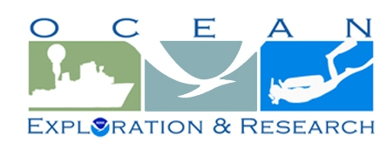

EX-0906

Mapping Field Trial III

Blanco Fracture Zone and Seamounts West of Gorda Ridge

CRUISE INSTRUCTIONS

NOAA Ship Okeanos Explorer
July 1 – July 10, 2009

__________________________________________ | ___________________________________________
John McDonough, Deputy Director | CAPT Michael S. Devany
Office of Ocean Exploration and Research | Marine Operations Center Atlantic
NOAA Office of Oceanic and Atmospheric Research | NOAA Office of Marine and Aviation Operations

CRUISE INSTRUCTIONS

Cruise Title: Mapping Field Trial III

Cruise Number: EX-0906

Cruise Dates

Departure: July 1, 2009, Depart Astoria, OR

Arrival: July 10, 2009, San Francisco, CA

Operating Area

A seamount chain shown in the satellite derived bathymetric maps in Section 5.3 of this cruise plan. This seamount chain is located west or Gorda Ridge and has not been mapped previously at high resolution.

CRUISE OVERVIEW

Background

This cruise is a mapping field trial cruise, designed to test and refine operations for conducting exploration using NOAA Ship Okeanos Explorer (EX) systems and sensors associated with mapping and CTD operations.

Goals and Objectives

The goals of this cruise are to refine the protocol of the EX mapping systems and CTD operations, and to acquire high resolution bathymetric data of a previously unmapped area of interest. The primary and secondary objectives are listed below.

Primary Goal: Test, troubleshoot, refine and evaluate EX mapping systems, sensors, protocols and processes to support systematic exploration.

Develop protocols for mapping shore support

One of the major long term goals of the EX Program is to establish protocols and capabilities to work with mapping support personnel on shore. The ship has high bandwidth capability, but there remain NOAA security roadblocks in the network that must be resolved before this goal can be achieved. We will continue to test and refine our protocols as we do our best to work through these issues and barriers.

Continue refining data products pipeline, documentation and sensor integration

A major focus of this cruise will be to continue to develop and improve methodologies to acquire, process, analyze and archive bathymetric data based on protocols developed by the NGDDC data management team on previous cruises. Associated documentation, such as standard operating procedures, system and wiring diagrams and operational reports will continue to be developed throughout this cruise.

Establish and refine protocols to handle discoveries/anomalies/interesting finds

Exploration may result in new discoveries, anomalies and interesting features. During earlier field trials, it was noticed that there was some uncertainty as to how personnel on board the ship might share this information with the shore. We need to determine points of contact for this purpose and a Web site or some other access portal to post daily products, images of interesting features observed etc. During this cruise, EX will work with OER / UNH to establish these protocols.

2.2.1.4 Live interaction with UNH (July 7 or 8 date/time TBD)

The Center for Costal and Ocean Mapping (CCOM) is hosting the annual OCS review July 7 and 8th. CCOM is OER’s main mapping support partner and is outfitted with an Exploration Command Center (ECC). Three video feeds (2 from cameras, 1 from the mapping acquisition computer) from the EX will be viewed using VLC software and the RTS units will be used for audio, with VoIP phone on ship as backup.

Secondary Goal: Continue preparations, training, testing and evaluating of other EX systems and sensors.

Mapping intern training

Three interns will participate in the cruise. At sea training will be provided and the interns will participate as part of the mapping team to acquire and process data.

Exercise the CTD rosette in vertical station casts to refine SOPs, deploy and recover equipment, utilize and evaluate laboratory and computer processes.

CTD operations will occur at locations depicted in Figure 2, Section 5.3, depending on weather conditions. Conducting CTD operations allows the bridge crew, deck crew, and survey techs the opportunity to continue practicing their newly acquired skills associated with deploying and recovering the CTD, remaining on station without use of DP for the duration of casts, acquiring new sensor data, and collecting seawater samples for later Helium and trace metal analysis by PMEL. Seawater samples collected during station casts will be stored onboard in unrefrigerated space in the wet lab. The data and sample pipeline will be evaluated to ensure broad public access. Samples will be returned to PMEL for analysis and all data will be provided to the public archives without proprietary rights.

Media Acquisition and Workflow Testing

Stock photos and B-Roll video will be acquired by (name TBD) of NOAA’s Ocean Media Center to be used for education, outreach, PR and media associated with the ship and OER program, and Ocean Explorer Web site. If weather permits, small boat operations to obtain film and photos of the ship from the water will be conducted. See Section 5.7 for more information. Videographer/photographer will require use of ship’s video and photo acquisition and processing system and components (video camera, ship-mounted HD video cameras and recording equipment, still photo camera, Apple processing station and accessories). Imagery collected will be put through a test workflow to refine workflow operations and protocols (to be defined).

……….

Participating Organizations

National Oceanic and Atmospheric Administration (NOAA) – Office of Ocean Exploration and Research (OER)
1315 East-West Hwy, Silver Spring, Maryland 20910

NOAA – Pacific Marine Environmental Laboratory (PMEL)
7600 Sand Point Way N.E., Seattle, Washington 98115-6439

University of New Hampshire (UNH), Center for Coastal and Ocean Mapping (CCOM)
Jere A. Chase Ocean Engineering Lab, 24 Colovos Road, Durham, NH 03824 USA

NOAA Ocean Media Center, Seattle, WA

Pacific Marine Environmental Laboratory (PMEL), Newport, OR

PERSONNEL

All embarking personnel are required to arrive at and report to the ship no later than 24-hours prior to the scheduled departure time. Personnel embarking via small boat are required to arrive at the originating city no later than 24-hours prior to the scheduled small boat departure time. Personnel shall depart their origin leaving sufficient time to allow for travel delays.

It is envisioned that EX will carry out 24 hours mapping operations during this cruise. Therefore, the requirement is for 6 watch keepers (2 for each watch) for mapping sensors data acquisition and data processing. Watches will be defined at sea.

Onboard Personnel

Name | Affiliation | Role | Dates | M/F | Status
Catalina Martinez | OER | Expedition Coordinator | 1 July to 10 July | F | US
Megan Nadeau | OER | Mapping | 1 July to 10 July | F | US
Emily McDonald | OER | Mapping | 1 July to 10 July | F | US
Christopher Paul | Texas A & M | Mapping | 1 July to 10 July | M | US
Jack Payette | UNH | Mapping | 1 July to 10 July | M | US
Federico García-Uribe | UNH | Mapping | 1 July to 10 July | M | Permanent resident
TBD | OMC | Media | 1 July to 10 July | TBD

Remotely Participating Personnel

The following personnel will participate or be available to participate from shore via limited communications at Exploration Command Centers.

Name | Affiliation | Role | Dates | M/F | Status | ECC
Russell, Craig | OER (ERT) | EX Program Planner | 1 July to 10 July | M | US | PMEL
McDonough, John | OER | Deputy Director, Backup Expedition Coordinator | 1 July to 10 July | M | US | SSMC
Mashkoor Malik | OER(ERT) | Mapping shore support | 1 July to 10 July | M | US permanent resident | UNH

Foreign Nationals – NOT APPLICABLE TO THIS CRUISE

ADMINISTRATION

Ship’s Location

The ship will be docked at Pier 1 in Astoria, OR, next to the Maritime Memorial Park, on the SE side of the bridge starting June 27, 2009.
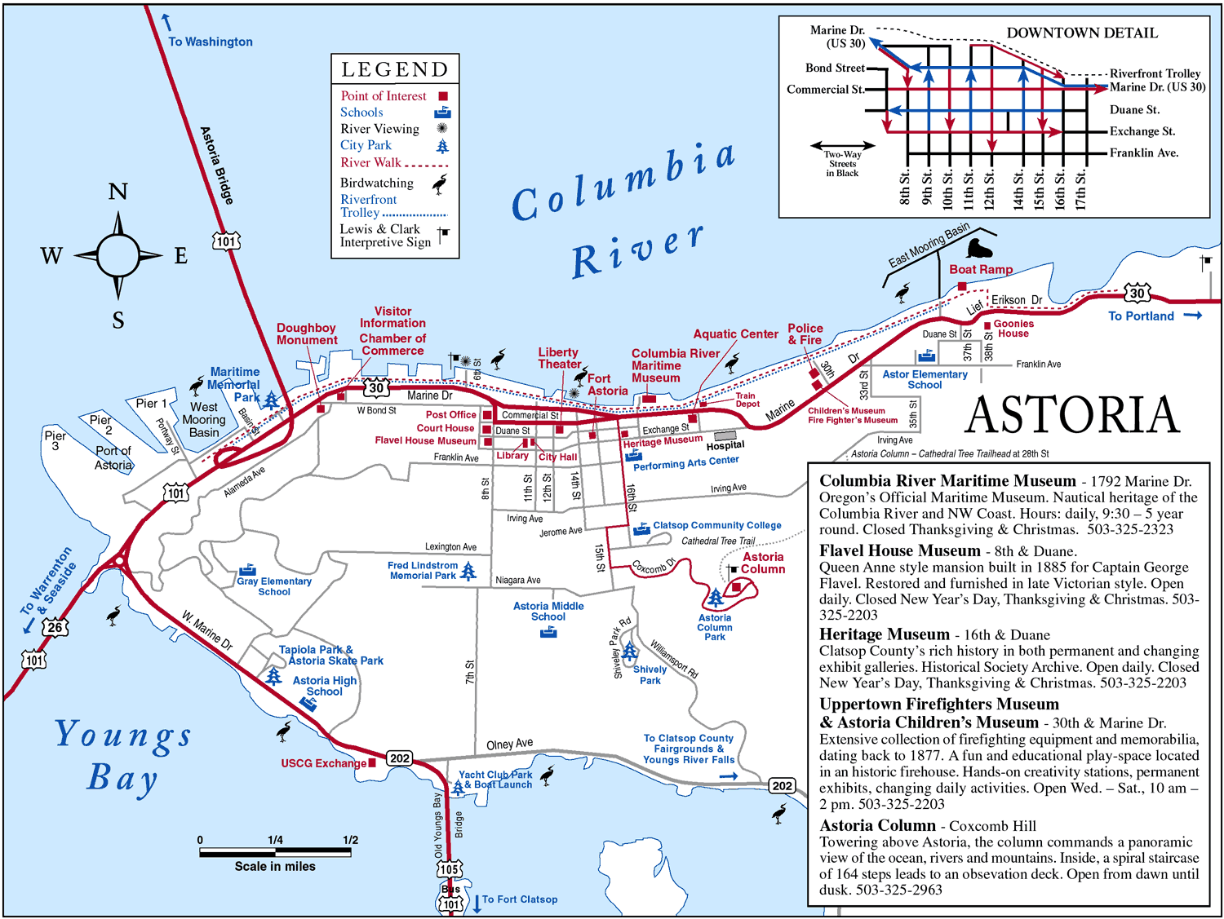

Figure 1. Map of Astoria, OR.

The ship will dock in San Francisco, CA, starting July 10, 2009. Pier TBD.

Key Points of Contact

Ship Operations

Marine Operations Center, Atlantic (MOA)  439 West York Street  Norfolk, VA 23510-1145  Telephone: (757) 441-6776  Fax: (757) 441-6495 | Marine Operations Center, Pacific (MOP)  1801 Fairview Avenue East  Seattle, WA 98102-3767  Telephone: (206) 553-4548  Fax: (206) 553-1109
Chief, Operations Division, Atlantic (MOA1)  CDR Keith Roberts  Telephone: 757-441-6842  E-mail: ChiefOps.MOA@noaa.gov | Chief, Operations Division, Pacific (MOP1)  CDR Mike Francisco  Telephone: 206-553-8705  Email: ChiefOps.MOP@noaa.gov

Mission Operations

Catalina Martinez, Expedition Coordinator  NOAA Ocean Exploration & Research  Phone : 401-874-6250(o)/401-330-9662(c)  E-mail : catalina.martinez@noaa.gov | Mashkoor Malik, Mapping Lead  NOAA Ocean Exploration & Research (ERT, Inc.)  Phone: 603-862-4332/ 603-377-6319  E-mail: mamalik@cisunix.unh.edu
Nicola VerPlanck, Field Operations Officer
NOAA Ship Okeanos Explorer
Phone: 321-960-3726
E-mail: OPS.Explorer@noaa.gov

Other Mission Contacts

Craig Russell, EX Program Planner  NOAA Ocean Exploration & Research (ERT, Inc.)  Phone: 206-526-2803 / 206-518-1068  E-mail: Craig.Russell@noaa.gov | John McDonough, Deputy Director  NOAA Ocean Exploration & Research  Phone: 301-734-1023 / 240-676-5206  E-mail: John.McDonough@noaa.gov

Shipments

Be sure to send an email to the EX Ops Officer OPS.Explorer@noaa.gov indicating the size and number of items being shipped.

For shipments to be delivered to the ship prior to June 30, 2009, ship to Astoria, OR:

NOAA Ship Okeanos Explorer
c/o Port of Astoria
422 Gateway Ave., Suite 100
Astoria, Oregon 97103
(503) 325-4521

For shipments to be delivered to the ship after June 30, 2009, ship to San Francisco, CA (this shipping address will likely change, so check with ops officer prior to shipping anything to this address):

NOAA Ship Okeanos Explorer
c/o San Francisco Bay NERR
Romberg Tiburon Center- SFSU
3152 Paradise Drive
Tiburon, CA 94920

Shipboard Meetings

Daily Operations Briefing meetings will be held at 1530 in the forward lounge to review the current day, and define operations, associated requirements and staffing needs for the following day. A Plan of the Day (POD) will be posted each evening for the next day in specified locations throughout the ship. A safety brief and overview of POD will occur on the Bridge each morning at 0800. Daily Situation Reports (SITREPS) will be posted as well and shared daily through e-mail and/or the EX PLONE site (http://terra.gso.uri.edu/NOAAShipOkeanosExplorer).

Medical Clearance

All personnel will satisfy NOAA Health and Safety requirements, completing and providing NHSQ and PPD (Tuberculosis test) test results before boarding.

The revised NHSQ can be found at http://www.omao.noaa.gov/medical.html. Clearances
are valid for 2 years for personnel under age 50 and 1 year for age 50 and over. All PPD’s expire after one year from the date of administration.

Cruise participants will follow standard protocols described in the NHSQ, and will fax completed forms to CDR Pelkey as follows:

CDR Michelle Pelkey
Fax: 206-553-1112
Phone: 206-553-2298

OPERATIONS

Following is a description of the data to be collected, including: specific sensors or systems used; the operations implementation plan, including staging, conducting operations (on-station, underway) and de-staging; station or trackline geographic information, and any other operations requirements.

Data to be collected

As a field trial cruise, the primary data collected is evaluation and assessment information of operations, protocols, systems and processes. The secondary data collection objective is mapping and CTD data in support of reconnaissance mode of ocean exploration. Following is a list of sensor measurements that will be required to accomplish the primary and secondary objectives:

Primary Systems and Sensors
- Hypack Positioning Computer and Software
- Kongsberg Simrad EM302 Multibeam Echosounder (MBES)
- Kongsberg Simrad EA600 Deepwater Echosounder
- Knudsen 320BR Sub-bottom profiler (SBP)
- LHM Sippican XBT (various probes)
- Seabird 911Plus CTD (with LSS and ORP sensors provided by PMEL)
- Seabird 32 Carousel
- General Oceanics 2.5L water sampling bottles
- Altimeter (provided by PMEL)
- CNAV GPS
- POS/MV
- Seabird 45 (Micro TSG)
- Seabird 38 remote temperature sensor
- Kongsberg Dynamic Positioning-1 System
- NetApp mapping storage system
- CARIS HIPS Software
- SIS Software
- Hypack Software
- MapInfo Software
- Fledermaus Software
- ArcMap Software
- Scientific Computing System (SCS)
- ECDIS
- Met/Wx Sensor Package

Secondary Systems and Sensors
- Telepresence System
- VSAT High-Speed link (Comtech 10 Mbps ship-to-shore; 1.5 Mbps shore-to-ship)
- Canon HD Video Camera and Accessories
- Nikon D-80 Photo Camera and Accessories
- Sony PTZ HD Cameras
- EVS Video Logging System
- Apple Video Processing Station with Final Cut Pro

Staging Plan

On June 30, 2009 the mission party will embark on the EX and begin preparations. All additional equipment to be brought aboard by the mission party will be shipped to the address provided in Section 4.3. This equipment shall be loaded by the mission party onto EX no later than COB 30 June-2009 and placed in the wet lab or other appropriate location aboard the EX and ensure proper stowage, installation and securing of the material. The mission party is responsible for arranging all necessary transportation of material and personnel to and from the ship. Mission personnel will coordinate with the Ship Operations Officer for any ship services required to assist with loading or shipping mission samples or materials. Crane service requests must be requested by the mission party 24 hours in advance of the required loading time.

De-Staging Plan

Upon return to port in San Francisco, CA on 10-July-2009, the following items will be shipped to Ron Greene at the Newport, OR address below.

- Crimper Case......39x24x21" wt 140 lbs
- Sample Case (with seawater samples)......27x16x17" wt about 60 lbs
- Cardboard Box with spare Enerpac tool.......20x11x11" wt 14 lbs
- Cardboard Boxes taped together with copper tubing....24x24x3" wt about 25 lbs
- Data CDs

Ron Greene/John Lupton
NOAA/PMEL
2115 SE OSU Drive
Newport, OR 97365
Phone: 541-867-0274

The ORP sensor, LSS sensor, altimeter with cables, and data CDs will be shipped to Sharon Walker at PMEL in Seattle at the end of the cruise. Sharon will provide an address and Fed Ex number.

Cruise Implementation Plan

The shipboard EM 302 and EA 600 will be operated 24 hours per day during this cruise. SBP will also be operated simultaneously provided interference issues between the EM 302 and EA 600 are resolved before the cruise. Multibeam data may be processed, and digital terrain maps may be developed to assist in day to day planning and operational decisions. XBT/CTD data will be collected in survey regions to improve the quality of the multibeam data acquisition. CTD and associated PMEL sensor data will be acquired at three predetermined locations (Figure 2).

Mapping the seamount chain

Mapping area extent

Reconnaissance mode of exploration will be tested during this cruise in context of operating in the region of previously unmapped seamount chain. This seamount chain is located west of Gorda Ridge and north of Mendocino Ridge. The extent of the area where interesting data can be expected is marked in the Figure 2. Not all the area is expected to be mapped during this cruise but this bounding box is provided as guidelines of reconnaissance operations.

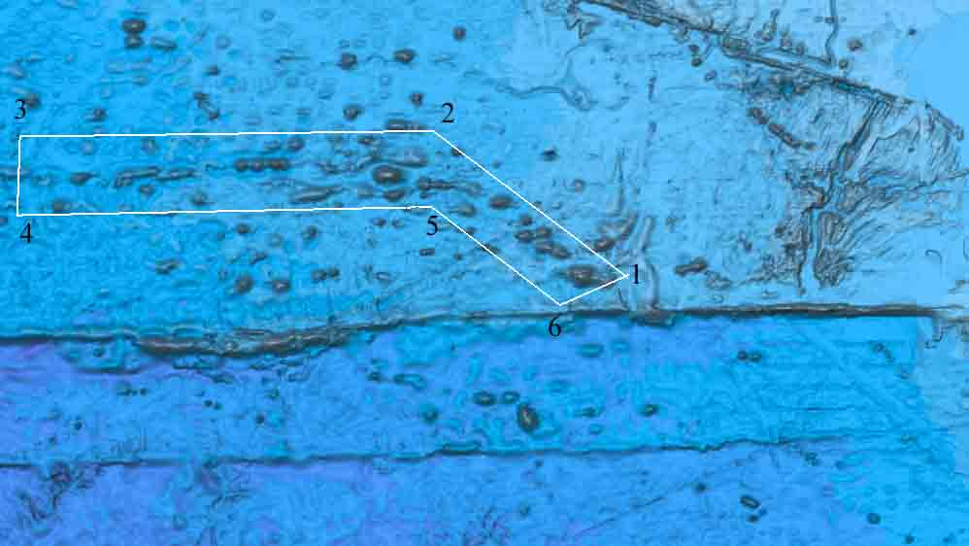

Figure 2: Map showing the extent of mapping area that includes numerous unmapped seamounts.

Point ID | Longitude (W) | Latitude (N)
1 | -129.84516500 | 40.82050832
2 | -132.25711060 | 42.60345052
3 | -137.47143307 | 42.54252828
4 | -137.47148854 | 41.56846263
5 | -132.24796193 | 41.65542704
6 | -130.62868601 | 40.42044322

Table 1: Location of bounding box as depicted in Figure 2.

Mapping line plans

As realized during this year cruises, the line plans will need to be changed based on the observations of mapping data. A tentative line plan is being passed on the ship which fills in the lines in the mapping extent area shown in the above figure.

Continue working on data products pipeline, documentation and sensor integration

The EX and OER teams collaborated over the last year to develop, refine and document the mapping data products pipeline, documentation (SOPs) and sensor integration. All cruise activities will result in additional information to be captured in these ongoing documents and activities.

Detailed Operations Schedule

The following tables and figures provide a detailed representation of the planned schedule and cruise track. Any revised locations will be provided prior to the arrival of the mission party to the EX. Mapping operations presume a vessel speed of 8-9 knots. Transit operations presume a maximum vessel speed of 10 knots and average or likely speed of 8 knots. CTD operations will be conducted while holding station. XBT operations presume a vessel speed of 8 knots.
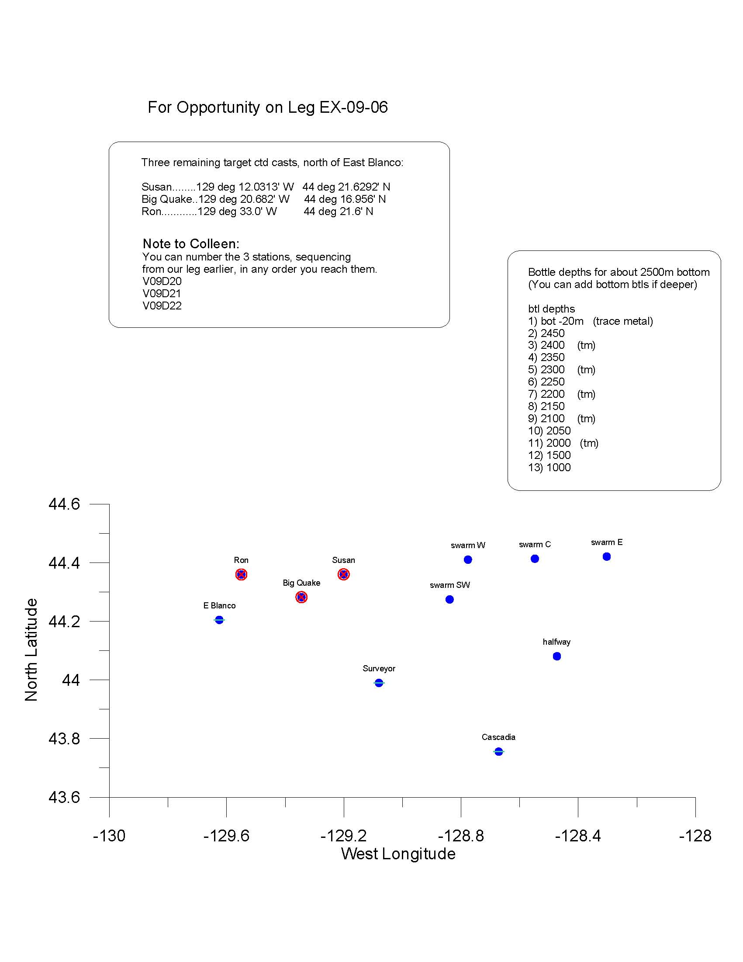
Figure 3. Station cast locations for the East Blanco Fracture Zone water column field trial casts. The highest priority is station Big Quake. Provided by R. Greene, PMEL.

Table 2. List of projected major operations associated with projected CTD operations and performance evaluation of mapping sensors. Operating dates and locations are subject to change based on sequential satisfactory performance of the mapping sensors and/or weather. CTD operations listed are in addition to the daily XBT/CTD casts. Opportunistic filming from the small boat may occur on any day weather and operations permit.
Dates (mm/dd) | Location | Operations | Time (Days)  Approximate | Distance (nm)  Approximate
07/01 | Astoria, OR | Departure
07/1-07/02 | Transit to Blanco Fracture Zone | CTD ops; mapping | 2 | 430
07/2-07/03 | Transit to mapping area | Mapping; Staff training;  Actual track locations TBD | 2 | 430
07/03-07/08 | Seamount chain | Mapping; live event with UNH (date/time TBD) | 5 | 900
07/08-07/10 | Transit to San Francisco, CA | Mapping | 2 | 430
07/10 | San Francisco, CA | Arrival
Total |  |  | 9 | 1760
The following figures (Figures 4-5) show planned areas for mapping ops for the cruise. Detailed mapping track lines will be provided to the ship before start of the cruise:
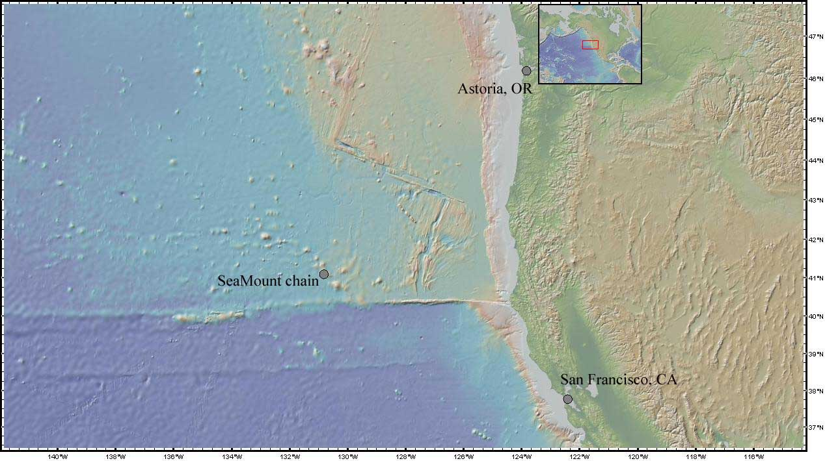
Figure 4: Map showing overview of the departure and arrival port and mapping ops areas labeled as Seamount chain.
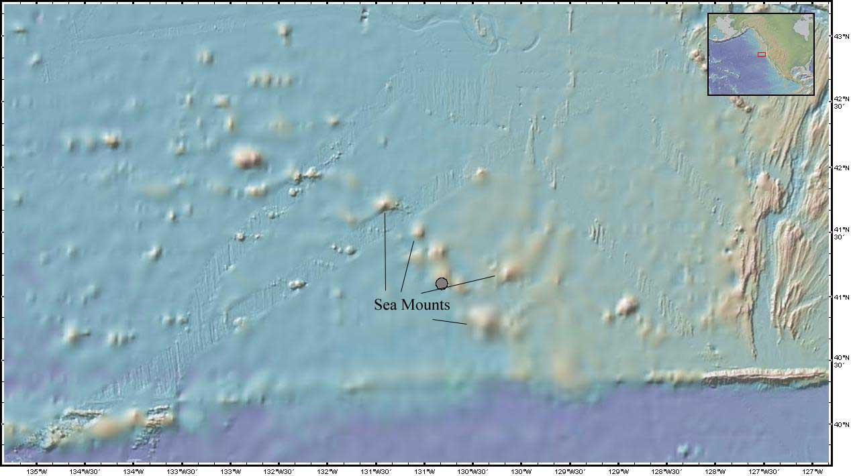
Figure 5: Zoomed in view of the Seamounts derived from satellite bathymetry. No high resolution mapping data are available for this location.

Station Operations

The following station operations will be conducted during this cruise. The procedures for these operations can be found in Standard Operating Procedures aboard the EX.

- CTD casts
- Seawater collections for PMEL in specific locations (as opportunity allows)
- XBT casts (various probes)

Underway Operations

The following underway operations will be conducted during this cruise. The procedures for these operations can be found in Standing Operating Procedures aboard the EX.

- Mapping operations using EM302, EA600 and Knudsen 320BR
- XBT casts (various probes)
- TSG Monitoring
- SCS Data Acquisition
- Meteorological Data Acquisition

Applicable Restrictions

None.

Small Boat Operations

Small boat operations are requested on a good weather day to obtain photos and video of the ship from the water. Operations would include embarking one Ocean Media Center staff member and one additional mission person to provide photography/filming assistance. Video and still photo cameras will be brought onboard and utilized to film and photograph the ship. Small boat would be driven alongside and around the EX at various distances from the EX to obtain the imagery. Small boat based filming and photography could occur as weather permits while the ship is underway, conducting operations (CTD/Mapping), and as the ship departs or arrives port. A shot list of desired photos and videos will be provided prior to sailing.

FACILITIES

Equipment and Capabilities Provided by the EX

- EM302 Mapping System
- EA600 Echosounder System
- Knudsen 320 BR Subbottom profiler system
- POS/MV
- CNAV DGPS
- SCS System
- Dynacon Hydrographic Winch with .32” 8000m electromechanical conductor cable terminated for CTD operations, positioned for use with the starboard J-Frame.
- Starboard J-Frame rigged to Dynacon Hydrographic Winch.
- Manual Wire Angle indicator for CTD casts
- Sea-Bird Electronics’ SBE 911plus CTD system with stand, including include underwater CTD, weights, pinger and deck unit.
- Conductivity and temperature sensor package to provide dual sensors on the CTD (primary)
- LHM Sippican XBT system and probes
- Telepresence System
- NetApp network storage devices
- Color copier and printer
- Mission party computer and network access
- Desk and workspace in the dry and wet-labs
- Adequate deck lighting for night-time operations
- Navigational equipment including GPS and radar
- Safety harnesses for working on quarterdeck and fantail
- Ship’s crane(s) used for loading and/or deploying
- Limited rain gear for inclement weather
- Hard hats for deck operations
- Berthing and meals for embarked personnel

Equipment and Capabilities Provided by the Mission Party

- Ancillary mission laptop computers
- Ancillary mapping processing workstation
- Copper crimper equipment for seawater sample collection
- Copper tubing and ancillary materials for seawater sample collection
- LSS sensor, ORP sensor, altimeter, and associated cables
- Ancillary video and photographic equipment

OPERATIONAL RISK MANAGEMENT

For every operation to be conducted aboard the ship (NOAA-wide initiative), risk management procedures will be followed. For each operation, risks will be identified and assessed for probability and severity. Risk mitigation strategies / measures will be investigated and implemented where possible. After mitigation, the residual risk will have to be assessed to make Go-No Go decisions for the operations. Particularly with new operations, risk assessment will be ongoing and updated as necessary. This does not only apply to over-the-side operations, but to everyday tasks aboard the vessel that pose risk to personnel and property.

- CTD (and other pertinent) ORM documents will be followed by all personnel working on board the EX
- All personnel on board are in the position of calling a halt to operations/activities in the event of a safety concern.

MISCELLANEOUS

Communications

Specific information on how to contact the NOAA Ship Okeanos Explorer and all other fleet vessels can be found at:

http://www.moc.noaa.gov/phone.htm

Important Telephone and Facsimile Numbers and E-mail Addresses

Ocean Exploration and Research (OER):
OER Program Administration:
Phone: (301) 734-1010
Fax: (301) 713-4252
E-mail: Firstname.Lastname@noaa.gov

University of New Hampshire, Center for Coastal and Ocean Mapping

Phone: (603) 862-3438
Fax: (603) 862-0839

NOAA Ship Okeanos Explorer - Telephone methods listed in order of increasing expense:

United States Coast Guard – San Francisco, California:
Primary Phone: (415) 399-3547
Emergency Phone: (415) 556-2103
Fax Number: (415) 399-3521

EX Cellular:
OOD (401) 378-7414

EX Iridium:
(808) 659-9179

EX INMARSAT B
Line 1: 011-872-764-852-328
Line 2: 011-872-764-852-329

Voice Over IP (VoIP) Phone:
301-713-7772 (expect a delay once picked up by directory)

Mission personnel may obtain access to these systems with permission from the Commanding Officer on a cost-reimbursable basis.

E-Mail: Ops.Explorer@noaa.gov (mention the person’s name in SUBJECT field)

expeditioncoordinator.explorer@noaa.gov
For dissemination of all hands emails by Expedition Coordinator while on board. See ET for password.

Marine Operations Center, Pacific (MOP):

Operations Division (MOP1)
Phone: (206) 553-4548
Fax: (206) 553-1109

E-Mail: FirstName.LastName@noaa.gov
E-Mail to Radio Room: Radio.Room@noaa.gov

Marine Operations Center, Atlantic (MOA):

Operations Division (MOA1)
Phone: (757) 441-6206
Fax: (757) 441-6495

DISPOSITION OF DATA
All data acquired on the EX will be provided to the public archives without proprietary rights.

Responsibilities

Shipboard

Ship
The Commanding Officer is responsible for all data collected for missions until those data have been transferred to mission party designees. Data transfers will be documented on NOAA Form 61-29. Reporting and sending copies of project data to NESDIS (ROSCOP form) is the responsibility of OER.

NOAA OE
The Expedition Coordinator will work with the EX Operations Officer to ensure data pipeline protocols are followed for final archive of all data acquired on the EX without proprietary rights.

Deliverables
  - At sea
      - Daily plans of the Day (POD)
      - Daily situation reports (SITREPS)
  - Post cruise
      - Refined SOPs for all pertinent operational activities
      - Assessments of all activities
  - Science
- CTD data and multibeam data from CTD cast locations on CDs

Archive

- The Program and ship will work together to ensure proper archive of metadata and acquired data sets, and that all metadata and data formats meet FGDC compliance. Details TBD.

ADDITIONAL PROJECTS

Definition - Ancillary and piggyback projects are secondary to the objectives of the cruise and should be treated as additional investigations. The difference between the two types of secondary projects is that an ancillary project does not have representation aboard and is accomplished by the ship's force.
None.

HAZARDOUS MATERIALS

The field party chief shall be responsible for complying with MOCDOC 15, Fleet Environmental Compliance #07, Hazardous Material and Hazardous Waste Management Requirements of Visiting Scientists. July 2002.
None.

