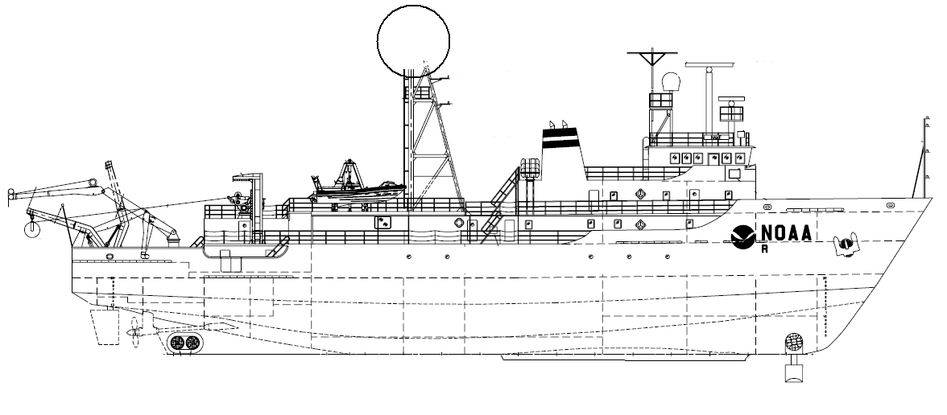
NOAA SHIP OKEANOS EXPLORER R-337
“America’s Ship for Ocean Exploration”

EX0905 Mapping Field Trials II
Mendocino Volcano Field I and II

June 17, 2009 to June 27, 2009
Newport, OR to Astoria, OR

CRUISE REPORT
By
Nicola Verplanck, Mashkoor Malik, Elaine Stuart, Colleen Peters, Michelle Heller, Sylvia Rodriguez-Abudo, David Armstrong, Joel DeMello

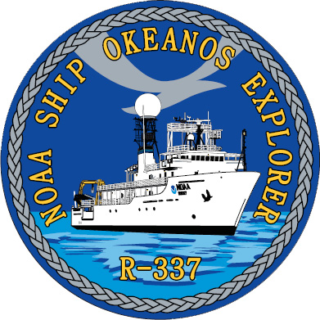

1. Purpose

The purpose of this report is to document various mapping data sets collected during this cruise. This report is only a descriptive report for the data collection methodology considered sufficient to process and further analyze these data sets. For details about the mapping sensor setup onboard, please refer to “NOAA Okeanos Explorer mapping readiness report, 2009”, available from ship upon request.

2. Participating personnel

Name | Position | Affiliation
CDR Joe Pica | Ship’s Master | EX
Mashkoor Malik | Cruise coordinator | OER
LT Nicola Verplanck | Field Operations Officer | EX
Elaine Stuart | Senior Survey Technician | EX
Colleen Peters | Senior Survey Technician | EX
Michelle Heller | Mapping watch stander | UNH Intern
Sylvia Rodriguez-Abudo | Mapping watch stander | UNH Intern
David Armstrong | Mapping watch stander | UNH Intern
Joel DeMello | Mapping watch stander | UNH Intern

3. Mapping sonar setup

NOAA Okeanos Explorer (EX) is equipped with a30 kHz Kongsberg EM 302 multibeam sonar and a 3.5 kHz Knudsen sub-bottom profiler (SBP 3260). Due to ongoing interference problems only the EM 302 was used to collect data during this cruise.

EM 302 is also capable of recording bottom and water column backscatter. The water column backscatter data were only recorded during the times when an interesting feature was observed in the water column. For most of the cruise the EM 302 only recorded bottom bathymetric and backscatter. The ship used a POS/MV ver 4 to record and correct the multibeam data for any motion. C-NAV GPS system provided DGPS correctors with position accuracy expected to be better than 2.0m.

All the corrections (motion, sound speed profile, sound speed at sonar head, draft, sensor offsets) are applied during real time data acquisition in SIS ver. 1.04. XBT casts (Deep blue Max depth 760 m) were taken every 8 hours (0000, 0800 and 1600 local time). XBT cast data were converted to SIS complaint format using NOAA Velociwin ver. 8.92 Plus.

Onboard processing of bathymetric data was done in CARIS HIPS ver. 6.1 during which the data were cleaned in ‘Swath Editor’ and ‘Subset Editor’.

The latest patch test for the EM 302 was performed in May 2009 which showed only a pitch bias of 0.7 degrees. These patch test values were used during data acquisition throughout this cruise.

4. Cruise Calendar

June 2009
Mon | Tue | Wed | Thu | Fri | Sat | Sun
15 | 16  Mission party boarded | 17  Departure  Newport, OR | 18  Mapping Gorda Ridge | 19  Mapping  Gorda Ridge | 20  Mapping volcanic Field II | 21  Small boat operations  Mapping volcanic Field II
22  Small boat operations  Transit to volcanic field I | 23  DP Training Transit to volcanic field I | 24  Mapping volcanic Field I | 25  Mapping volcanic Field I  Transit to Astoria, OR | 26  Transit to Astoria, OR | 27  Arrival Astoria, OR | 28

5. Daily cruise log

(ALL TIMES LOCAL PDT)

17 June 2009

Set sail at 1400 PDT from Newport, OR to northern edge of Gorda Ridge earlier mapping with ETA 18 June 0800 PDT. Mapping ops will commence tomorrow morning to supplement the data collected during EX0904.

Mission party boarded the ship on 16 June 0330 PDT. June 16 and 17 was spent to orient the visiting student interns with ship operations. Also SST Stuart and SST Peters ran training sessions on using mission control room and operating Multibeam acquisition system. PS Malik did a training session on general mapping principles and mapping objectives of this cruise.

Over night transit to the Gorda Ridge.

18 June 2009 – Continued mapping filling in data holidays left during the EX0904 cruise. Observed some interesting features in the EM 302. Not having sufficient scientific information available onboard, the images were sent to Dr. Jim Gardner (UNH)
for further scientific investigation.

Email Replies from Dr. Gardner:
“The main structure you transited over is called Heceta Bank. It is indeed a big fold caused by the Juan de Fuca plate under thrusting the North American plate. MBARI mapped it with an EM300, but their resolution only allows girding at 30 m/pixel; consequently, their data don't show all that beautiful fold structure. MBARI and Chris Goldfinger at Oregon State Univ. have both published on Heceta Bank and a USGS guy named Park Snavely published on seismic data from the bank. As for the strange pattern on the SW part of your line; their data do show a lot of surface texture in that area. I'm guessing the texture is reflecting outcrops, again caused by compression between the two plates. So, that transit line is beautiful, but I don't think it qualifies as a "discovery". I put an sd file I made from the MBARI EM300 data on the ccom anonymous server in a folder called "For_Mashkoor". Perhaps you can download it. It's 51.6 mb.”

Due to slow speed internet connection the ship was not able to download the file.

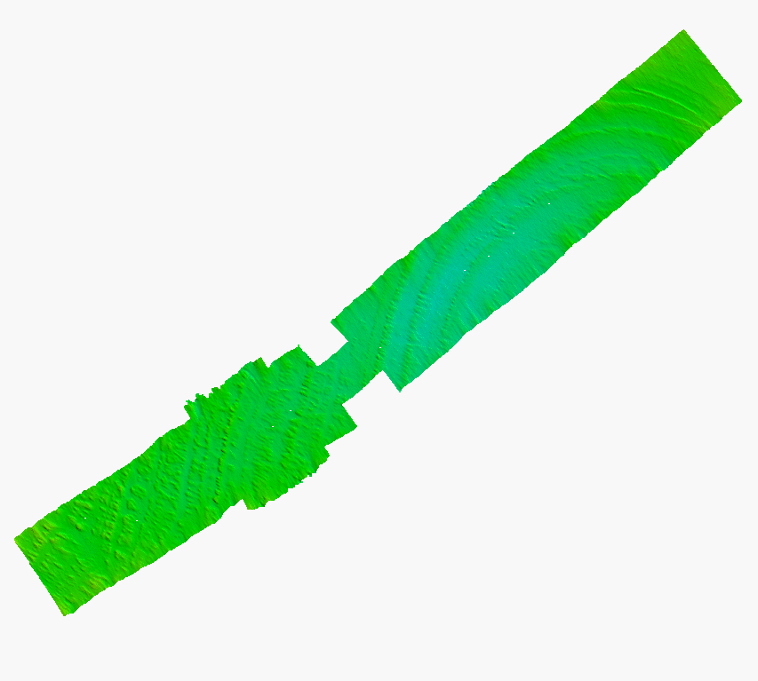
Figure1: Interesting circular features observed during transit from
Newport, OR to Gorda Ridge.

19 June 2009 – Completed the mapping in the Gorda Ridge and now transiting to Volcanic field # 2. During transit to the Volcanic field, an attempt will be made to overlap the existing data.

XBT cast #5 at 1600. At 1950 changed Alond direction from 3 to 0 to help sonar keep bottom track. Had to force depth routinely before the shift change. XBT cast #6 conducted at 2345.

20 June 2009 - mapping in transit to Mendocino ridge volcano site #1. Had to force depth few times to help sonar find ocean floor. UPS malfunctioned during night and now operating in by-pass mode. Over night mapping in the southern section of volcanic field to find the extent of volcanism.

XBT cast #7 at 0800. XBT cast #8 at 1600. At 1855, all lights in POS turned red but bounced back after a few seconds. First bulb in SIS also went red. Corrected itself.

21 June 2009 - 1400 stopped mapping to start small boat operations drill. The small rescue boat is a new addition to EX inventory and its engine needs to be broken in to make it fully operational.

2100 XBT cast #11 (XBT_062109_ 11_thinned.asvp). Small boat ops until 5pm. At 1850 Pos/MV dropout ~ around similar time as yesterday. All lights turned red but went back to normal after a few minutes.

22 June 2009 – Overnight transited to the northern side of volcanic field II and now heading towards east. Small boat ops started 0900 PDT and will continue till afternoon.
Once finished with boat operations started transit to volcanic field I.

1743 XBT cast #14 (XBT_062209_14_thinned.asvp). XBT cast #15 conducted at 2100 (XBT_062209_15_thinned.asvp) because of the large difference (~4 deg.) between the last probe and the temperature probe.

23 June 2009 - 0000 XBT cast #16 (XBT_062309_16_thinned.asvp). It was repeated because of a jump in temperature around 200m. The file was overwritten.
At 0620 the ballast tanks were emptied, changes in depth may have impact on data.
0800 XBT cast #17 (XBT_062309_17_thinned.asvp).

1100 – 1600 Bridge DP training was carried out for bridge watch keepers. Collected ~ 1 hours of data at a single location (Line#0035_20090623_204327_EX) which can be useful for calculating standard deviations on the data.

1856 XBT cast #18 (XBT_062309_18_thinned.asvp). At 2006, experienced “red triangle of death” which corrected itself within a few seconds.

24 June 2009 – 0000 XBT cast #19 (XBT _062409_19_thinned.asvp). Everything normal.

0900 – 1115 CTD cast over new volcano/ seamount.

1600 XBT #20 (XBT_062409_20_thinned.asvp). Rough seas causing system to regularly lose the bottom (seas 6-10ft). PV-POS dropouts during turn at 2050. UPS alarm went off at 2145.

25 June 2009 – Due to very rough sea conditions the ship was unable to maintain speeds higher than 7 kts.

0200 – Ship decided to break off the survey to start heading for Astoria, OR. Did not finish the extent of volcanic field I fully.

6. Table of XBT/ CTD casts

Date | Time (Local Time) | XBT/CTD Filename | Lat | Long | Remarks
061809 | 0800 | TD_0001 | 43.0 N | 126.67 W
061809 | 1600 | TD_0002 | 42.0 N | 127.17 W
061909 | 0000 | TD_0003 | 40.9 N | 127.8 W
061909 | 0800 | TD_0004 | 40.39 N | 128.75 W
061909 | 1600 | TD_0005 | 40.2 N | 130.35 W
062009 | 0000 | TD_0006 | 40.1 N | 131.804 W
062009 | 0800 | TD_0007 | 39.993 N | 133.46 W
062009 | 1600 | TD_0008 | 39.89 N | 134.28 W
062109 | 0000 | TD_0009 | 39.92 N | 132.77 W
062109 | 0800 | TD_0010 | 39.81 N | 134.38 W
062109 | 2100 | TD_0011 | 40.1 N | 134.64 W
062209 | 0000 | TD_0012 | 40.14 N | 133.98 W
062209 | 0800 | TD_0013 | 40.25 N | 133.68 W
062209 | 1743 | TD_0014 | 40.33 N | 132.46 W
062209 | 2100 | TD_0015 | 40.38 N | 131.56 W
062309 | 0000 | TD_0016 | 40.42 N | 130.94 W
062309 | 0800 | TD_0017 | 40.45N | 129.66W
062309 | 1856 | TD_0018 | 40.98 N | 129.69 W
062409 | 0000 | TD_0019 | 41.43 N | 129.63W
062409 | 0900 | EX0905_NewSeamount_01.hex | 40.62 N | 129.649 W
062409 | 1600 | TD_0020 | 41.1 N | 129.55 W
062509 | 0000 | TD_0021 | 41.1 N | 129.48 W

7. Table of data files collected during the cruise

S.No. | Date | File Name | Location | Remarks
1 | 061809 | 0001_20090618_012534_ShipName | Transit
2 |  | 0004_20090618_020102_ShipName | Transit | Interesting features < 100 m depth
3 |  | 0003_20090618_015219_ShipName | Transit
4 |  | 0005_20090618_080102_ShipName | Transit
5 |  | 0006_20090618_140111_ShipName | Transit
6 |  | 0000_20090618_151922_EX | Gorda Ridge
7 |  | 0001_20090618_211919_EX | Gorda Ridge
8 | 061909 | 0002_20090619_031924_EX | Gorda Ridge
9 |  | 0003_20090619_091922_EX | Gorda Ridge
10 |  | 0000_20090619_104840_EX | Mendocino
11 |  | 0001_20090619_140050_EX | Mendocino
12 |  | 0002_20090619_200044_EX | Mendocino
13 | 062009 | 0003_20090620_020047_EX | Mendocino
14 |  | 0004_20090620_080049_EX | Mendocino
15 |  | 0005_20090620_140049_EX | Mendocino
16 |  | 0006_20090620_200052_EX | Mendocino
17 |  | 0007_20090620_205132_EX | Mendocino | Turn
18 |  | 0008_20090620_205506_EX | Mendocino
19 |  | 0009_20090620_212151_EX | Mendocino | Turn
20 |  | 0010_0090620_212308_EX | Mendocino
21 | 062109 | 0011_20090621_030329.EX | Mendocino
22 |  | 0012_20090621_062817.EX | Mendocino
23 |  | 0013_20090621_065416_EX | Mendocino
24 |  | 0014_20090621_125423_EX | Mendocino
25 |  | 0015_20090621_162918_EX | Mendocino | Turn
26 |  | 0016_20090621_162918_EX | Mendocino
27 |  | 0017_20090621_200225_EX | Mendocino
28 |  | 0018_20090621_214334_EX | Mendocino
29 | 062209 | 0019_20090622_002107_EX | Mendocino
30 |  | 0020_20090622_040501_EX | Mendocino | Turn
31 |  | 0021_20090622_071550_EX | Mendocino
32 |  | 0022_20090622_103748_EX | Mendocino
33 |  | 0023_20090622_155838_EX | Mendocino | Small Boat, Wide turns
34 |  | 0024_20090622_170741_EX | Mendocino
35 |  | 0025_20090622_180126_EX | Mendocino | Small Boat, Wide turns
36 |  | 0026_20090622_185229_EX | Mendocino
37 |  | 0027_20090622_191737_EX | Mendocino | Small Boat, Wide turns
38 | 062309 | 0028_20090622_194139_EX | Mendocino
39 |  | 0029_20090623_014145_EX | Mendocino | Transit to volcano field 1
40 |  | 0030_20090623_074142_EX | Mendocino
41 |  | 0031_20090623_091112_EX | Mendocino
42 |  | 0032_30090623_135501_EX | Mendocino | Multiple turns
43 |  | 0033_20090623_145744_EX |  | Detected a seamount
44 |  | 0034_20090623_170715_EX |  | DP Training
45 |  | 0035_20090623_204327_EX | Mendocino
46 |  | 0036_20090623_232407_EX | Mendocino
47 |  | 0037_20090623_235519_EX | Mendocino
48 |  | 0038_20090624_031053_EX | Mendocino | Turn
49 |  | 0039_20090624_052316_EX | Mendocino | Turn
50 |  | 0040_20090624_055139_EX | Mendocino
51 |  | 0041_20090624_115139_EX | Mendocino
52 |  | 0042_20090624_125159_EX | Mendocino | Turn
53 |  | 0043_20090624_132859_EX | Mendocino v1
54 |  | 0044_20090624_150011_EX | Mendocino v1 | Turning back to go to do a CTD cast at the seamount
55 |  | 0045_20090624_183456_EX | Mendocino | CTD cast + turns
56 |  | 0046_20090624_190302_EX | Mendocino | W-E Cross of seamount
57 |  | 0047_20090624_195623_EX | Mendocino | Transit to original survey line of the day
58 | 062409 | 0048_20090624_204540_EX | Mendocino
59 |  | 0049_20090625_024539_EX | Mendocino
60 |  | 0050_20090625_032609_EX | Mendocino | Turn
61 | 062509 | 0051_20090625_034923_EX | Mendocino
62 |  | 0052_20090625_090147_EX | Mendocino
63 |  | 0007_20090625_091127_EX | Transit | Transit to Astoria, OR
64 |  | 0008_20090625_151121 | Transit | Transit to Astoria, OR
65 |  | 0009_20090625_211121_EX | Transit | Transit to Astoria, OR
66 | 062609 | 0010_20090626_031123_EX | Transit | Water column data collected as well
67 |  | 0011_20090626_091124_EX | Transit | Water column data collected as well
68 |  | 0012_20090626_151121_EX | Transit | Water column data collected as well

8. Table of Cruise Statistics

Dates | JD169 to JD176
Weather delays | 0 days
Total non-mapping days | 0 days
Total mapping days | 10 days
Line kilometers of survey | 2817 km
Beginning draft | 4.62 m (bow) 4.43 m (stern)
Average ship speed for survey | 9.3 kts
Total Volcanic Field 1 & 2 area mapped | 943 & 2, 912 nm²

9. Data results: Please see attached map sheets

8.1. Over view of exploration area

8.2 Detailed views of interesting features observed

8.3 Location of XBTs overlaid with the bathymetric data collected during this cruise

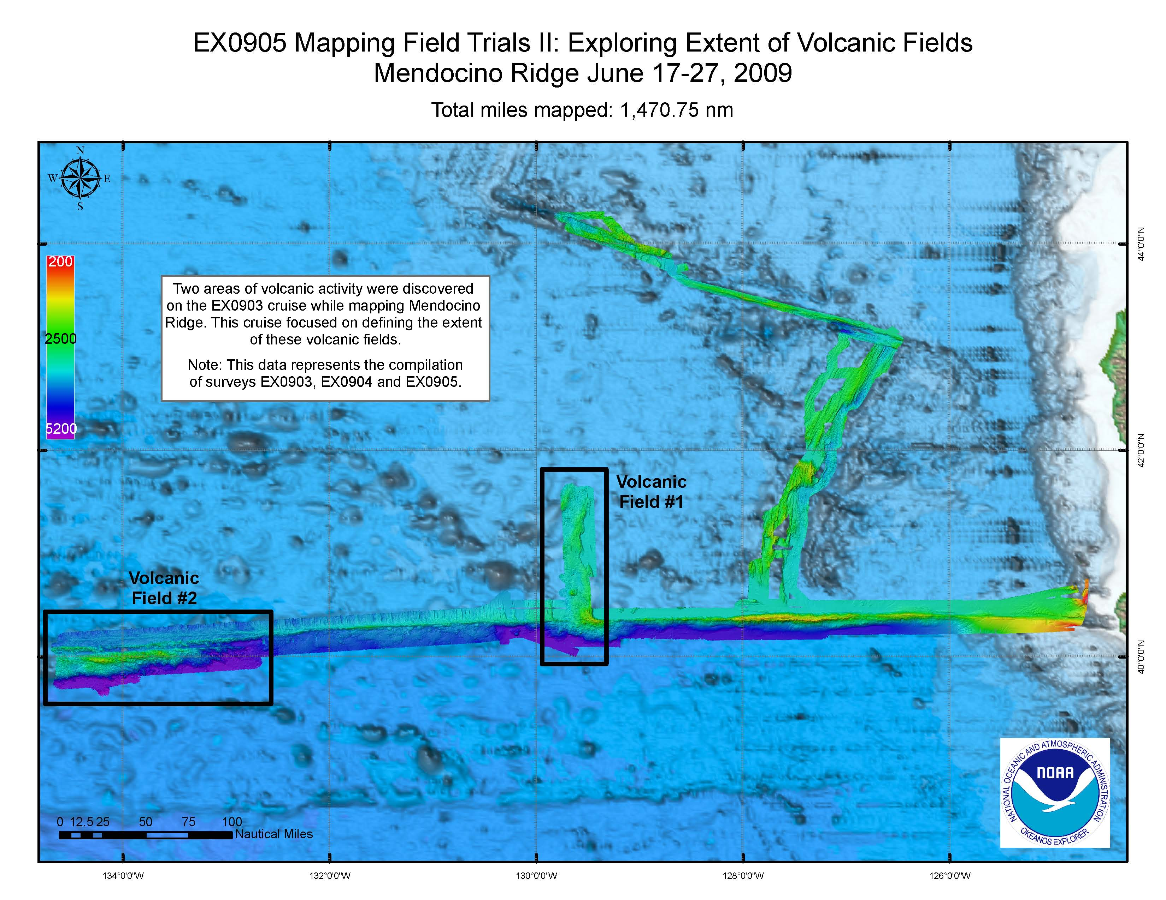

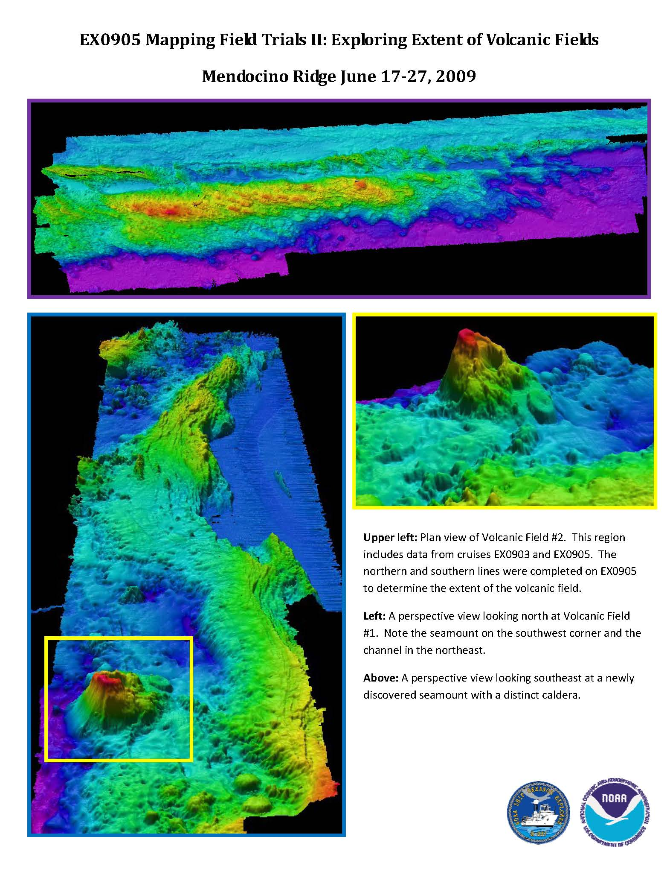

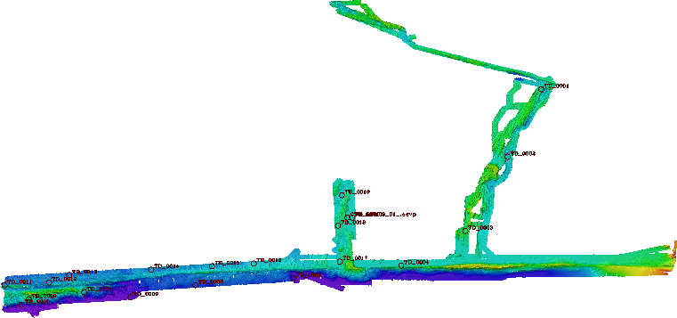

8.3 Bathymetric map overlaid with XBT casts

