===============================================================
OCEAN EXPLORATION AND RESEARCH
DISCO-P Report
2009/06/23
===============================================================
CRUISE: EX0905  Deep water mapping trial-Mendocino ridge | PERSONNEL ON BOARD:  NOAA OER:  1. Mashkoor Malik (ERT Inc for OER)  UCAR interns:  - Sylvia Rodriguez-Abudo (UNH)  - Michele Heller (UNH)  - David Armstrong (UNH)  - Joel R DeMello (UNH)
DATE/TIME FILED:
06-23-09/ 1800 PDT

VESSEL:
NOAA Ship Okeanos Explorer (EX)

Location of potential discovery:
North of Mendocino Ridge in location
129.6469 W, 40.6274 N
===============================================================
SUMMARY:
A structure on the seafloor was detected around 1145 PDT today on 23 June 2009 while mapping in the volcanic field 1 region. The structure appears to be an underwater volcano with top crater of 1800 m across. The height of the top of the volcano rises ~ 1200 m above the seafloor qualifying it as a nameable seamount. No existing data are available onboard to verify if this is a new discovery.

===============================================================
DISCUSSION:
The underwater volcano was found while starting the first line going north in the volcanic field 1 mapping region. The watch keeper (Student intern, Armstrong) notified OPSO about the structure being painted on the seafloor. Upon subsequent completion of mapping line, the data were processed in CARIS HIPS and brought into Fledermaus for visualization and measurements.

No existing data available onboard showed this structure but more detailed scientific vetting is required before this find can be labeled as discovery.

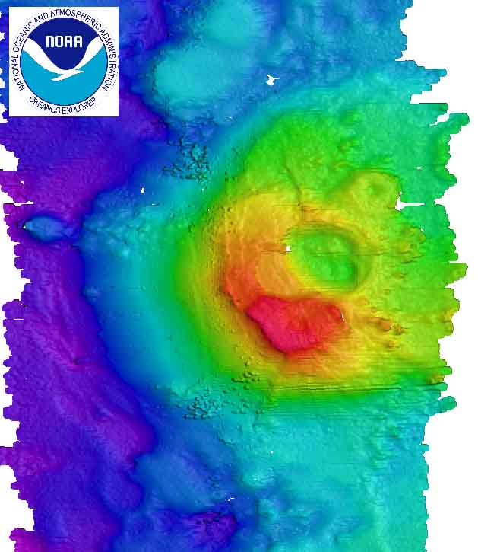
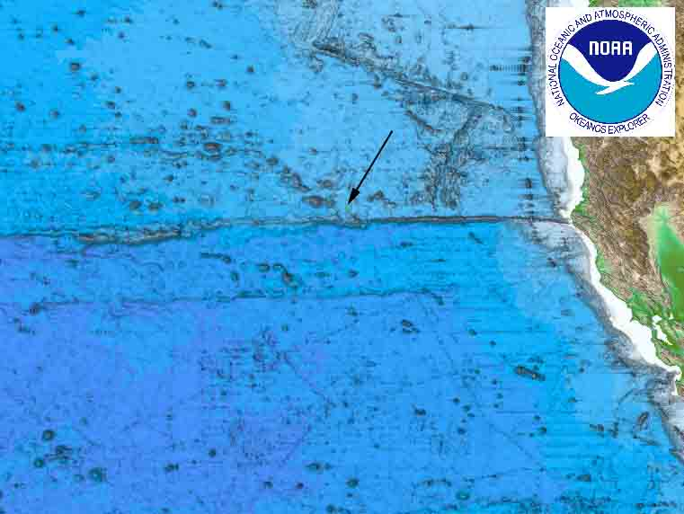

Figure 1: Location map of the potential seamount (left). Plane view of the potential seamount (right).

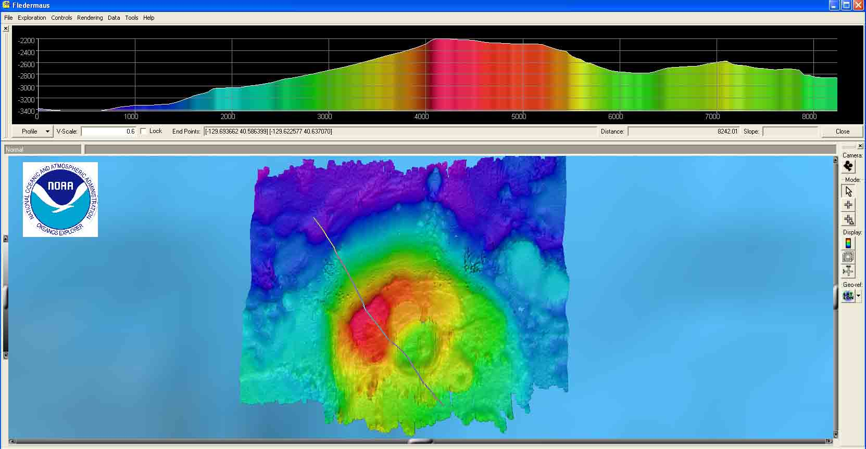
Figure 2: Bathymetric profile across the potential seamount showing a rise of 1200 m from adjacent seafloor and a crater of ~ 1800 m across. Profile drawn from top-left to bottom-right of the picture.

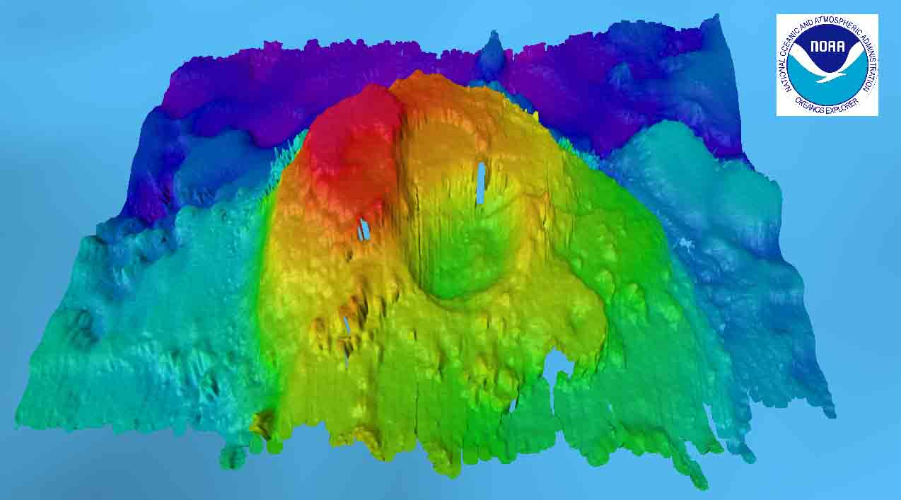
Figure 4: Perspective view of the structure created using IVS Fledermaus. Two craters are visible with possible few smaller volcanoes.

===============================================================
FURTHER WORK BEING PLANNED:
No further data collection at this site is being planned at this time pending instructions from OER. Ship will continue to run the originally planned mapping lines collecting data adjacent to this site.

===============================================================
COMMENTS:
Discoveries are corner stone of EX work. Protocols still need to be decided for breaking the news of discoveries, soliciting pertinent help from shore based scientists, communicating the results to public / scientists, individual responsibilities etc. The ship has taken the initiative to compile a preliminary report describing a new find which has discovery potential (DISCO-P). It is hoped that this report will initialize the chain of events that are required to handle new discoveries.
===============================================================
=========END OF DISCOVERY POTENTIAL REPORT===================
===============================================================

