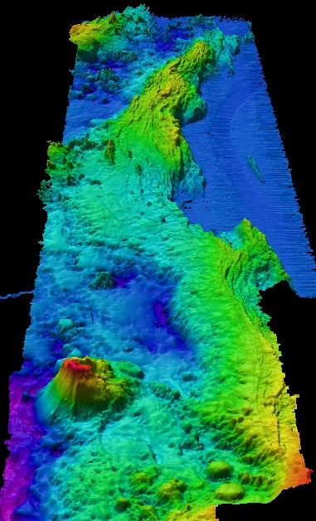
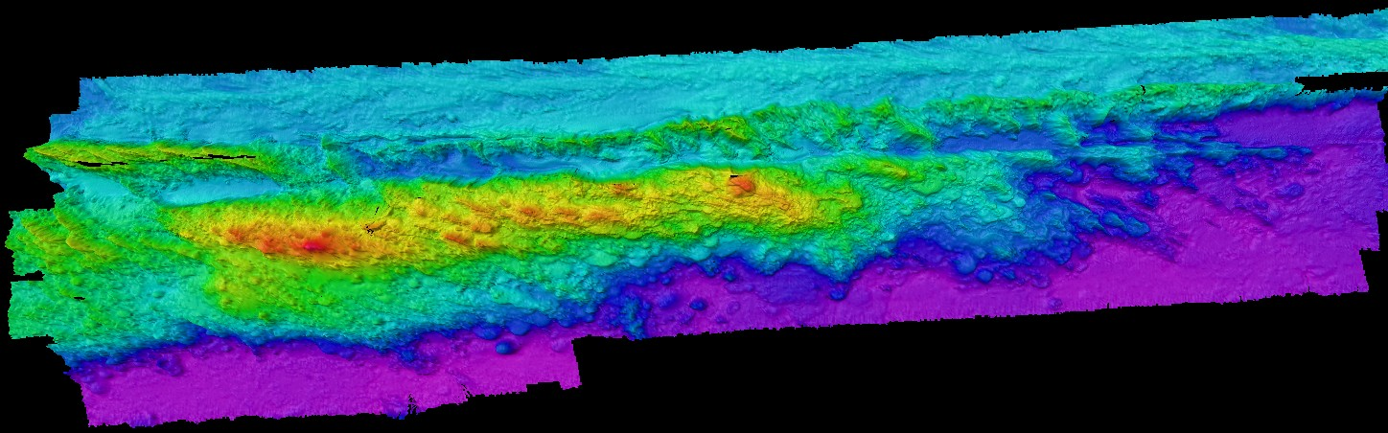
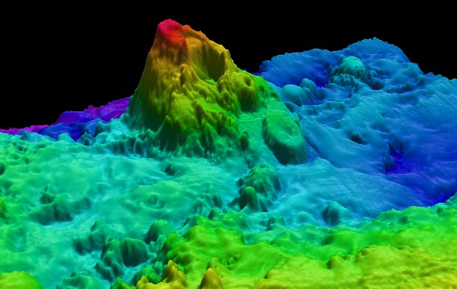


Upper left: Plan view of Volcanic Field #2. This region includes data from cruises EX0903 and EX0905. The northern and southern lines were completed on EX0905 to determine the extent of the volcanic field.
Left: A perspective view looking north at Volcanic Field #1. Note the seamount on the southwest corner and the channel in the northeast.
Above: A perspective view looking southeast at a newly discovered seamount with a distinct caldera.

EX0905 Mapping Field Trials II: Exploring Extent of Volcanic Fields

Mendocino Ridge June 17-27, 2009

