Okeanos Explorer ROV Dive Summary
Site Name |  | Ellis Seamount |  |  |  | 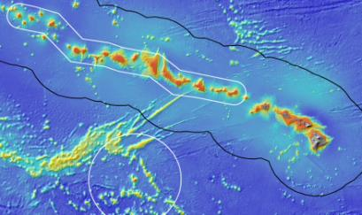
ROV Lead/Expedition Coordinator |  | Brian Bingham  Kelley Elliott
Science Team Leads |  | Frank Parrish (Biology)  Chris Kelley (Biology)
General Area Descriptor |  | Main Hawaiian Islands –  Geologists Seamounts
ROV Dive Name |  | Cruise Season |  | Leg |  |  | Dive Number
 |  | EX1504 |  | 3 |  |  | DIVE06
Equipment Deployed |  | ROV: |  | Deep Discoverer
 |  | Camera Platform: |  | Seirios
ROV Measurements |  | CTD |  | Depth |  |  | Altitude
 |  | Scanning Sonar |  | USBL Position |  |  | Heading
 |  | Pitch |  | Roll |  |  | HD Camera 1
 |  | HD Camera 2 |  | Low Res Cam 1 |  |  | Low Res Cam 2
 |  | Low Res Cam 3 |  | Low Res Cam 4 |  |  | Low Res Cam 2
Equipment Malfunctions
ROV Dive Summary  (From processed ROV data) |  | Dive Summary: EX1504L3_DIVE06  ^^^^^^^^^^^^^^^^^^^^^^^^^^^^^^^^^^^^^^^^^^^^^^^^^^^  In Water: 2015-09-02T18:25:13.234000  19°, 14.075' N ; 157°, 36.733' W  Out Water: 2015-09-03T01:29:03.343000  19°, 13.179' N ; 157°, 37.081' W  Off Bottom: 2015-09-03T00:10:00.031000  19°, 13.642' N ; 157°, 36.956' W  On Bottom: 2015-09-02T19:39:38.812000  19°, 13.889' N ; 157°, 36.712' W  Dive duration: 7:3:50  Bottom Time: 4:30:21  Max. depth: 2153.1 m
Special Notes
Scientists Involved  (please provide name / location / affiliation / email) |  | Frank Parrish, EX, PIFSC PSD, Frank.Parrish@noaa.gov  Chris Kelley, EX, UH, ckelley@hawaii.edu  Amy Baco-Taylor, FL, FSU, abacotaylor@fsu.edu  Asako Matsumoto, Japan, CIT, amatsu@gorgonian.jp  Chris Mah, DC, SI, mahch@si.edu  Nicole Morgan, FL, FSU, nbmorgan11@gmail.com  Scott France, LA, ULL, france@louisiana.edu  Brendan Roark, TX, TAMU, broark@geos.tamu.edu  Michael Garcia, UH ECC, UH, mogarcia@hawaii.edu  Bruce Mundy, IRC ECC, PIFSC, bruce.mundy@noaa.gov  Daniel Warren, TX, C&C Technologies, dan.warren@cctechnol.com  Mary Wicksten, TX, TAMU, wicksten@bio.tamu.edu  Steven Auscavitch, PA, Temple, steven.auscavitch@temple.edu  Michael Parke, IRC ECC, PIFSC, Michael.Parke@noaa.gov  John R. Smith, UH ECC, UH, jrsmith@hawaii.edu
Purpose of the Dive
This was the first dive ever conducted on Ellis Seamount located in the Geologist Seamounts group. The objective of this dive was to survey a rift zone ridge coming off the northern end of the seamount for corals and sponges, testing the hypothesis that high density communities can be found on ridge topography. Discovery of high density communities at this dive site will provide valuable information to NOAA’s Deep Sea Coral and Technology Program (DSCTP).The dive plan was to survey the ridge crest at a depth of approximately 2100m. The survey employed the standard methodology of the D2 with the objectives of 1) making observations and collecting video and 2) collecting rock and biological samples.
Description of the Dive:
All of the dive objectives were completed. The full planned distance of the dive track was achieved for a total distance of roughly 800 m travel. From beginning to end the dive observed high densities of coral colonies with the most dominant taxa being species of Keratoisis, Isidella, and Acanella which was present as full size mature colonies throughout the survey track. Basalt rocks were collected on the flank of the ridge at the start of the dive and on the crest near the end of the dive. One bamboo specimen was collected inadvertently by the skid of the ROV and discovered when the vehicle was brought on deck.

Animals observed during the dive are listed below.

Cnidarians:
Keratoisis sp
Isadella sp
Isadella trichotoma
Acanella weberi
Eknomisis sp
Metallogorgia melanotrichos
Pleurogorgia pinnata
Iridigorgia magnaspiralis
Chrysogorgia sp
Primnoid
Isididae unbranched
Anthomastus sp. red
Metallogorgia melanotrichos
Zoanthidae
Bathypathes cf alternate
Stauropathes sp
Unbranched isidid
Pseudoanthomastus steepstrupi
Candidella gigantea
Narella bowersi
Trissopathes sp
Chrysogorgia stellata

Sponges
Hexactinellida
Tretopleura sp
Caulophacus (Caulodiscus) sp
Bolosoma sp A and B
Farreidae
Saccocalyx cf pedunculatus
Poliopogon sp
Walteria cf flemmingi
Farrea nr occa erecta

Echinoderms
Hippasteria sp
Ophiuroids
Holothurian
Brisinga sp
Evoplosoma forcipifera

Arthropods
Nematocarcinus tenuirostris
Uroptychus sp
Chirostylidae
Lebbeus sp
Aristeidae
Red shrimp

Fishes
Ophidiidae
Synaphabranchidae Ilyophine
Macrouridae
Trachonurus/Malacocephalus sp
Bassogigas sp
Basozetus sp
Diplopomacantha sp (Bythididae)

Other
Polynoid polychaete
Overall Map of ROV Dive Area |  |  |  |  | Close-up Map of Main Dive Site
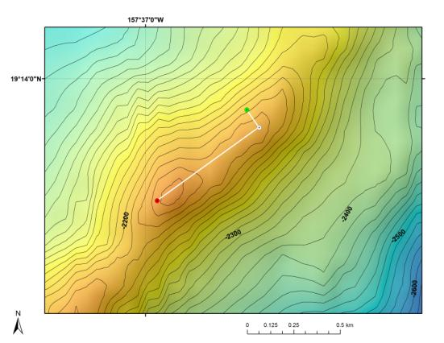 |  |  |  |  | 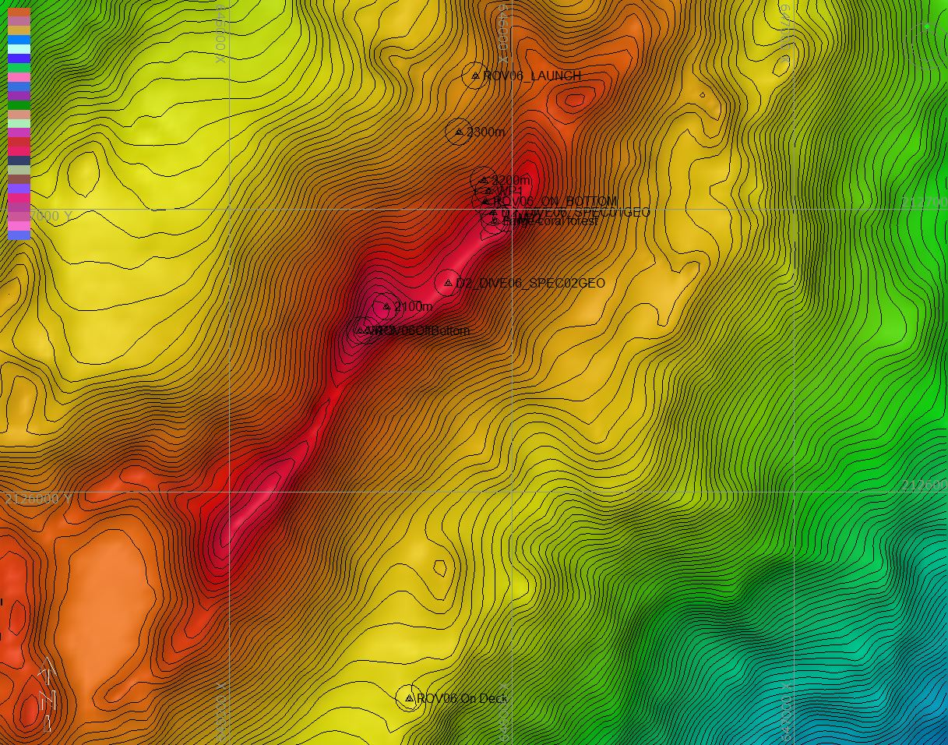
Bathymetry data for the dive site. Planned dive start and end points are shown as green and red dots, respectively. |  |  |  |  | Hypack screen grab showing waypoints dropped during actual ROV dive.
Representative Photos of the Dive
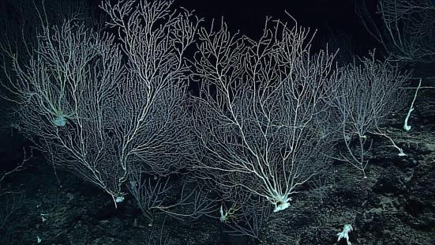 |  |  |  |  | 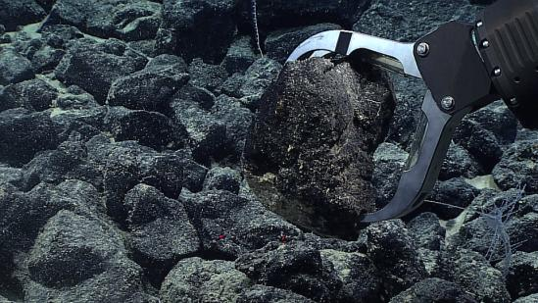
Dense community of bamboo corals (Isididae) found on the dive site from the beginning to the end of the dive. |  |  |  |  | One of the two rock samples obtained during the dive.
Samples Collected
Sample ID | D2_DIVE06_SPEC01GEO |  |  |  | 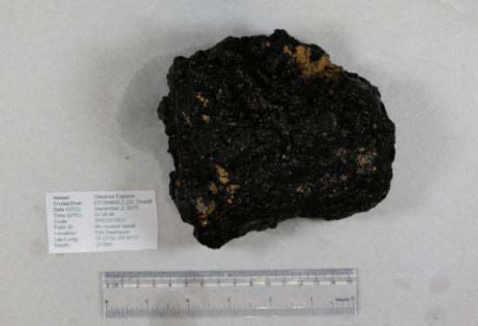
Date (UTC) | September 2, 2015
Time (UTC) | 20:08:46
Depth (m) | 2135
Temperature (ºF) | 1.98
Field ID(s) | Mn crusted basalt
Comments
Sample ID | D2_DIVE06_SPEC02GEO |  |  |  | 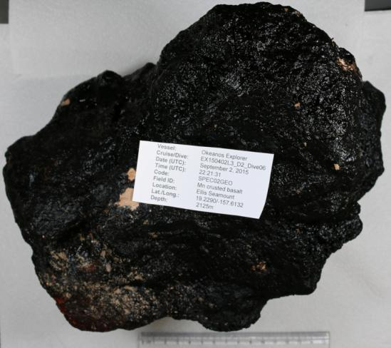
Date (UTC) | September 2, 2015
Time (UTC) | 22:21:31
Depth (m) | 2125
Temperature (ºF) | 1.98
Field ID(s) | Mn crusted basalt
Comments
Sample ID | D2_DIVE06_SPEC03BIO |  |  |  | 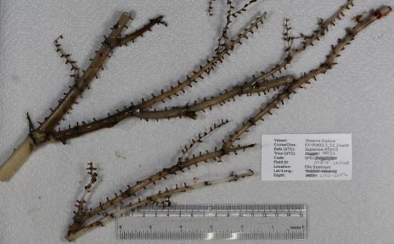
Date (UTC) | September 3, 2015
Time (UTC) | 00:20:00
Depth (m) | 2097-2150
Temperature (ºF) | N/A
Field ID(s) | Isididae
Comments | Specimen was found on the bottom of the ROV after recovery. Time of collection was therefore considered to be the time off bottom.
Please direct inquiries to: |  |  | NOAA Office of Ocean Exploration & Research  1315 East-West Highway (SSMC3 10th Floor)  Silver Spring, MD 20910  (301) 734-1014

