Okeanos Explorer ROV Dive Summary
Site Name |  | Swordfish Seamount |  |  |  | 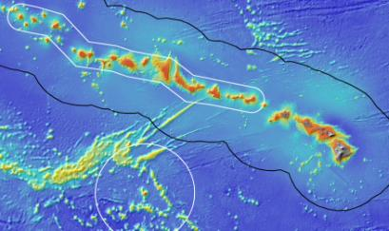
ROV Lead/Expedition Coordinator |  | Brian Bingham  Kelley Elliott
Science Team Leads |  | Frank Parrish (Biology)  Christopher Kelley (Biology)
General Area Descriptor |  | Main Hawaiian Islands
ROV Dive Name |  | Cruise Season |  | Leg |  |  | Dive Number
 |  | EX1504 |  | 3 |  |  | DIVE05
Equipment Deployed |  | ROV: |  | Deep Discoverer
 |  | Camera Platform: |  | Seirios
ROV Measurements |  | CTD |  | Depth |  |  | Altitude
 |  | Scanning Sonar |  | USBL Position |  |  | Heading
 |  | Pitch |  | Roll |  |  | HD Camera 1
 |  | HD Camera 2 |  | Low Res Cam 1 |  |  | Low Res Cam 2
 |  | Low Res Cam 3 |  | Low Res Cam 4 |  |  | Low Res Cam 2
Equipment Malfunctions |  | Minor video and audio issues for shore side teams.
ROV Dive Summary  (From processed ROV data) |  | Dive Summary: EX1504L3_DIVE05  ^^^^^^^^^^^^^^^^^^^^^^^^^^^^^^^^^^^^^^^^^^^^^^^^^^^  In Water: 2015-09-01T18:21:54.968000  18°, 18.684' N ; 158°, 27.399' W  Out Water: 2015-09-02T02:26:53.250000  18°, 18.690' N ; 158°, 27.203' W  Off Bottom: 2015-09-02T01:50:26.796000  18°, 18.351' N ; 158°, 27.271' W  On Bottom: 2015-09-01T18:59:45.453000  18°, 18.754' N ; 158°, 27.332' W  Dive duration: 8:4:58  Bottom Time: 6:50:41  Max. depth: 1077.2 m
Special Notes
Scientists Involved  (please provide name / location / affiliation / email) |  | Frank Parrish, EX, NOAA, Frank.Parrish@noaa.gov  Chris Kelley, EX, UH, ckelley@hawaii.edu  Amy Baco-Taylor, FL, FSU, abacotaylor@fsu.edu  Asako Matsumoto, Japan, CIT, amatsu@gorgonian.jp  Chris Mah, DC, SI, mahch@si.edu  Nicole Morgan, FL, FSU, nbmorgan11@gmail.com  Scott France, LA, ULL, france@louisiana.edu  Tina Molodtsova, Portugal, PPSIO, tina@ocean.ru  Rachel Bassett, SC, DSCRTP, rachel.bassett@noaa.gov  Brendan Roark, TX, TAMU, broark@geos.tamu.edu  Michael Garcia, UH ECC, UH, mogarcia@hawaii.edu  Bruce Mundy, IRC ECC, PIFSC, bruce.mundy@noaa.gov  Andrea Quattrini, CA, USGS, aquattrini@usgs.gov  Mike Ford, MD, NMFS, Michael.ford@noaa.gov  John Smith, UH ECC, UH, jrsmith@hawaii.edu
Purpose of the Dive
This was the first dive ever conducted on Swordfish Seamount located in the Geologist Seamounts group. The objective of this dive was to survey the ridge shaped summit for corals and sponges, testing the hypothesis that high density communities can be found on ridge topography. Discovery of high density communities at this dive site will provide valuable information to NOAA’s Deep Sea Coral and Technology Program (DSCTP).The dive plan was to survey the upper crest at a depth of approximately 1000m, which is within the Hawaii’s oxygen minimum zone although the islands don’t quite reach the strict definition of below 0.5 ml/l to be an OMZ. The survey employed the standard methodology of the D2 with the objectives of 1) making observations and collecting video and 2) collecting rock and biological samples.
Description of the Dive:
All of the dive objectives were completed. The full planned distance of the dive track was achieved and exceed for a total distance of 800 m travel. The dive started on the west flank of the ridge at 1071m where very few animals were encountered. The ROV then proceeded to the crest, still seeing low abundance. A pinnacle feature was present on the ridge crest and as the ROV proceeded up the northern slope of the pinnacle to its summit at 954m, a high density coral community was encountered. As the ROV came over the summit and proceeded down the southern side to a depth of 1074m, abundance again decreased. A basalt rock was collected at the start point of the survey and an unknown white rock and a basalt rock were collected at the summit. In total 3 biological samples (a mushroom coral, a scleractinian coral, and a sponge) were collected.

Animals observed during the dive are listed below.
Cnidarians:
Corallium kishinouyei
Hemicorallium c.f. lauuense
Acanthogorgiidae
Enallopsammia rostrata
Cerianthidae red
Scleractinian single polyp
Victorgorgia nuttingi
Primnoid
Isididae unbranched
Plexauridae various
Anthomastus sp. red
Calyptrophora wyvillei
Madrepora? sp
Clavularia sp
Anthomuricea tenuispina
Paragorgia sp
Narella alata
Actinoscyphia sp
Metallogorgia melanotrichos

Sponges
Hexactinellida
Farrea sp3 nr occa erecta
Bathydorus sp.
Dictyaulus cf starmeri
Tretopleura sp

Echinoderms
Sperosoma obscurum
Tarsastrocles verrilli
Asthenactis papyraceus
Myxasteridae sea star
Hippasteria lateralis
Caenopedina sp?
Pedinidae
Ophiuroids
Glyptometra lateralis

Arthropods
Heterocarpus laevigatus
Amphipods
Munida squat lobster
Nematocarcinus tenuirostris
Lamoha williamsi
Homeryon asper?

Fishes
Ophidiidae
Ogcocephalidae batfish
Sladenia remiger
Synaphabranchid / Histobranchus eel
Unidentified eel in water column

Other
Polychaete

Overall Map of ROV Dive Area |  |  |  |  | Close-up Map of Main Dive Site
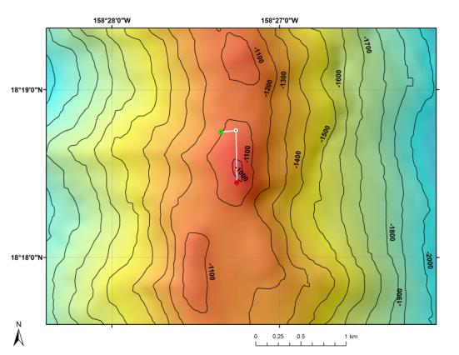 |  |  |  |  | 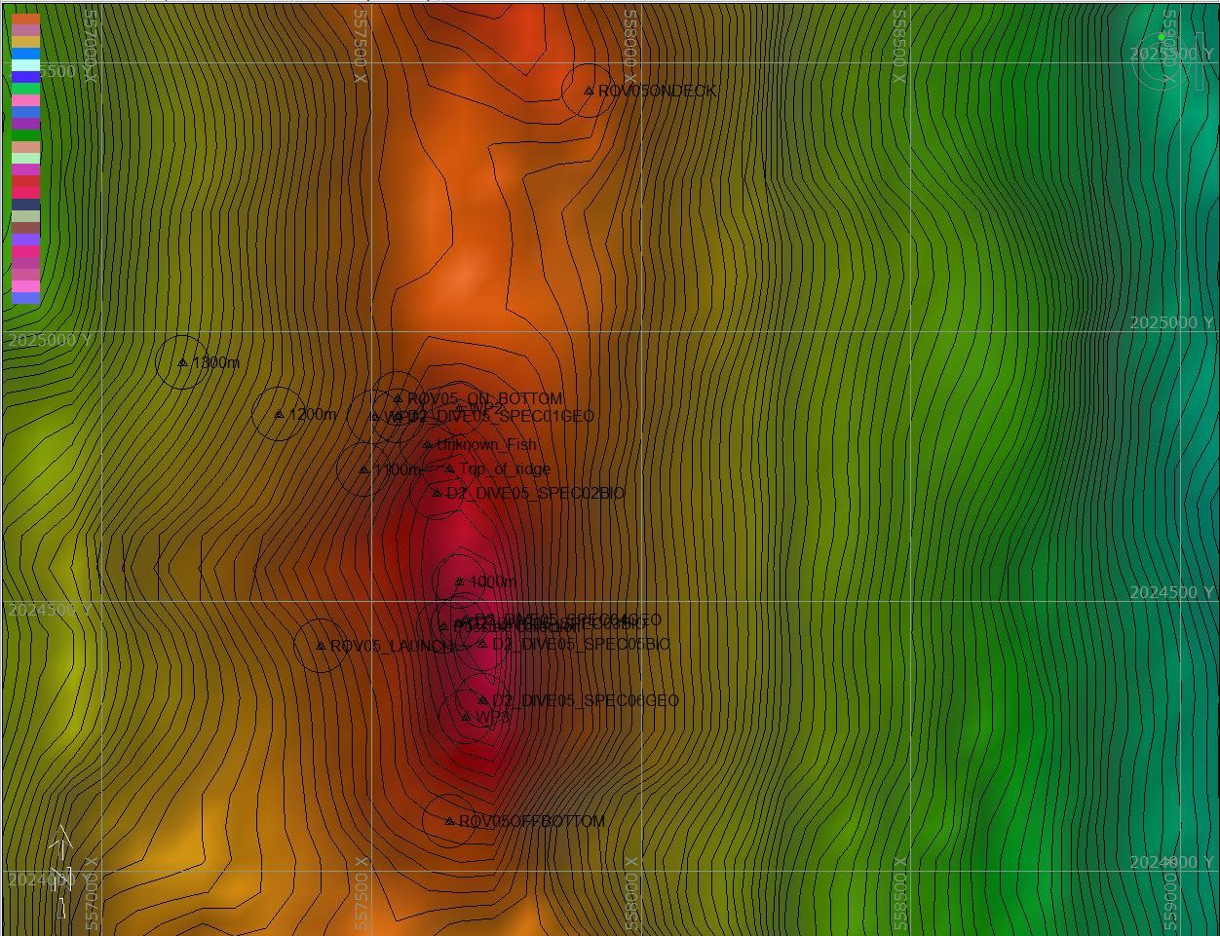
Bathymetry data for the dive site. Planned dive start and end points are shown as green and red dots, respectively. |  |  |  |  | Hypack screen grab showing waypoints dropped during actual ROV dive.
Representative Photos of the Dive
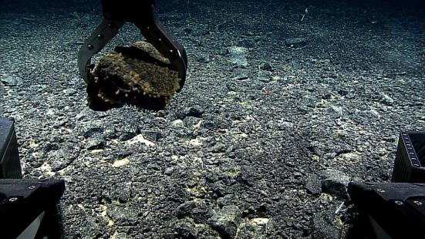 |  |  |  |  | 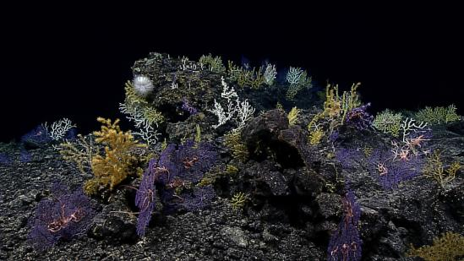
Collecting a rock along the flank of the ridge crest where very few animals were observed. |  |  |  |  | High density coral community encountered as the ROV proceeded up the slope of a pinnacle feature located on the ridge crest.
Samples Collected
Sample ID | EX1504L3_D2_DIVE05_SPEC01GEO |  |  |  | 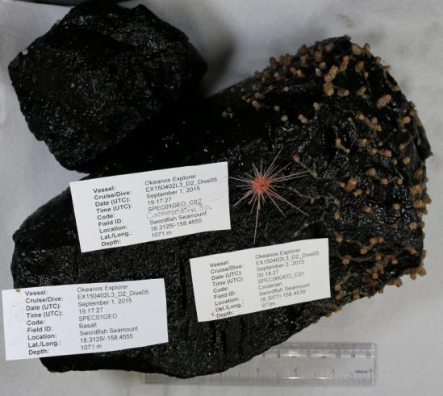
Date (UTC) | September 1, 2015
Time (UTC) | 19:17:27
Depth (m) | 1071
Temperature (ºF) | 3.69
Field ID(s) | Basalt sample w/ commensals
Comments
Sample ID | EX1504L3_D2_DIVE05_SPEC02BIO |  |  |  | 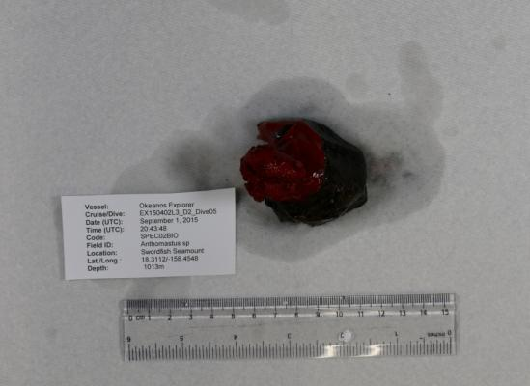
Date (UTC) | September 1, 2015
Time (UTC) | 20:43:48
Depth (m) | 1013
Temperature (ºF) | 3.93
Field ID(s) | Anthomastus sp.
Comments
Sample ID | EX1504L3_ D2_DIVE05_SPEC03BIO |  |  |  | 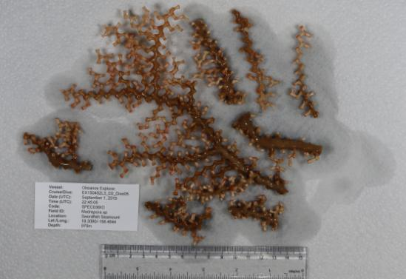
Date (UTC) | September 1, 2015
Time (UTC) | 22:34:00
Depth (m) | 970
Temperature (ºF) | N/A
Field ID(s) | Madrepora sp
Comments | Server was down so no environmental data accompanies this record. Depths and positions manually acquired from monitor displays.
Sample ID | EX1504L3_ D2_DIVE05_SPEC04GEO |  |  |  | 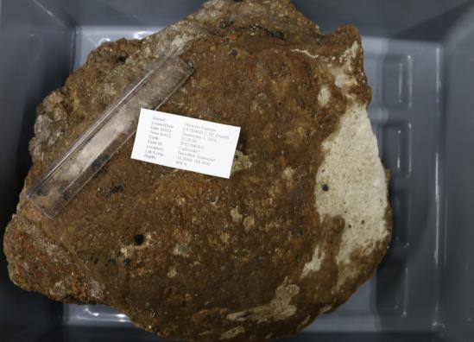
Date (UTC) | September 1, 2015
Time (UTC) | 22:45:05
Depth (m) | 969
Temperature (ºF) | 4.01
Field ID(s) | Carbonate?
Comments | Some type of white conglomerate.
Sample ID | EX1504L3_ D2_DIVE05_SPEC05BIO |  |  |  | 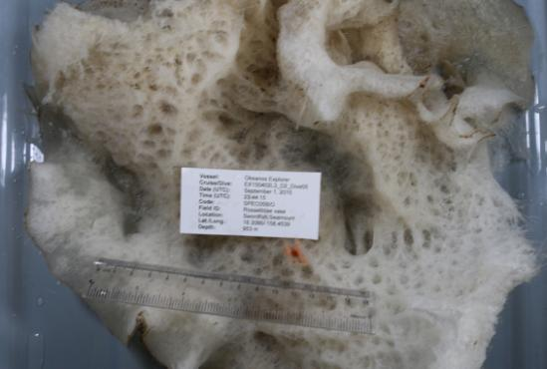
Date (UTC) | September 1, 2015
Time (UTC) | 23:44:15
Depth (m) | 953
Temperature (ºF) | 4.34
Field ID(s) | Rossellidae vase
Comments
Sample ID | EX1504L3_D2_DIVE05_SPEC06GEO |  |  |  | 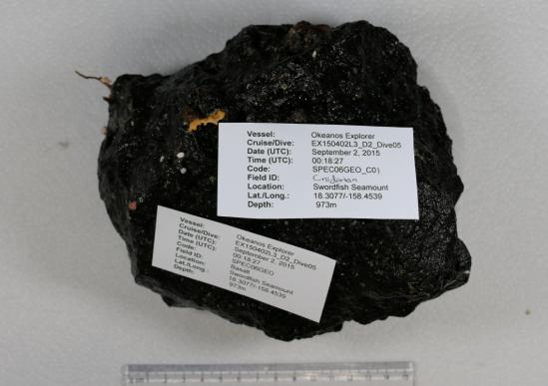
Date (UTC) | September 2, 2015
Time (UTC) | 0:18:27
Depth (m) | 973
Temperature (ºF) | 4.33
Field ID(s) | Basalt
Comments
Please direct inquiries to: |  |  | NOAA Office of Ocean Exploration & Research  1315 East-West Highway (SSMC3 10th Floor)  Silver Spring, MD 20910  (301) 734-1014

