*Please use this as a template for documenting your recommendations for high-priority dive targets. Be sure to include a rationale for the dive as well as specific protocols (if applicable), and any known previous work or potential hazards at the site. Please include only generalized location information for any marine archaeology sites.*

*The form also includes fields for mapping targets and CTD cast locations as well.*

*Please send the completed form to* [*Kelley.Elliott@noaa.gov*](mailto:Kelley.Elliott@noaa.gov) *and* [ckelley@hawaii.edu](mailto:ckelley@hawaii.edu)

**Site Name:** McCall Seamount

**Approximate Location:** 18.982766/-157.111877

**Dive Date (local):** 2015/08/31

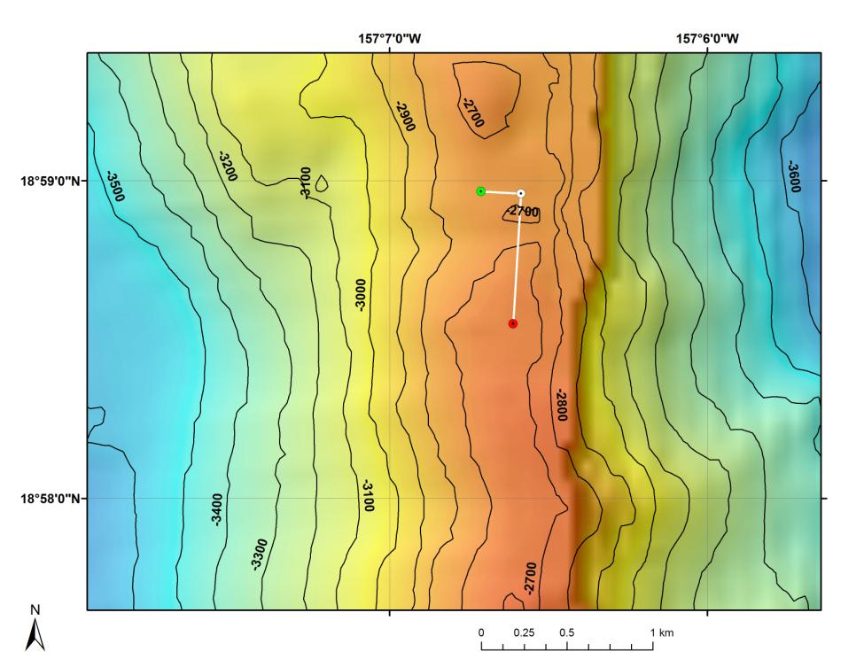

**Fig 1:** Bathymetry data for the dive site. Dive start and end points are shown as green and red dots, respectively.

**Brief Explanation of Exploration Objectives and Rational for the Desired Dive Track:**

This dive will be on a ridge that extends north from McCall seamount. The objectives are to survey a completely unexplored area for corals and sponges, testing the hypothesis that high density communities can be found on ridge topography and that the orientation of the ridge is important. No previous dives have ever been conducted on this site. Discovery of high density communities will provide valuable information to NOAA’s Deep Sea Coral and Technology Program (DSCTP). The target start point of the dive will be just below the crest of the ridge at a depth of 2726m. The ROV will survey east up to the ridge crest at 2714m. The ROV will then turn south and follow the ridge crest up to a final depth of 2655m.

**Has previous work been conducted here? Are there potential hazards in the area?** No previous submersible or ROV dives have been conducted in this area and therefore the terrain covered during this dive has never been explored. No potential hazards are expected at this site.

**ROV Track Waypoints Table:**

|  |  |  |  |  |  |  |  |
| --- | --- | --- | --- | --- | --- | --- | --- |
| *DESIRED WAYPOINTS TO EXPLORE -*  *(COMPLETED BY SHORE-SIDE LEAD SCIENTIST)*  *(not including launch)* | | | | *ACTUAL WAYPOINTS TO EXPLORE-*  *(COMPLETED BY SHIPBOARD EXPEDITION LEADER)* | | | |
| **WAYPOINT NAME/SEQUENCE** | **LATITUDE** | **LONGITUDE** | **APPROX DEPTH** | **WAYPOINT NAME/SEQUENCE** | **LATITUDE** | **LONGITUDE** | **APPROX**  **DEPTH** |
| LaunchWP1 | 18.982765 | -157.111877 | 2726 | LaunchWP1 |  |  |  |
| WP2 | 18.982653 | -157.109776 | 2714 | WP2 |  |  |  |
| Recovery/WP3 | 18.975818 | -157.110177 | 2655 | Recovery/WP3 |  |  |  |