++

*Please use this as a template for documenting your recommendations for high-priority dive targets. Be sure to include a rationale for the dive as well as specific protocols (if applicable), and any known previous work or potential hazards at the site. Please include only generalized location information for any marine archaeology sites.*

*The form also includes fields for mapping targets and CTD cast locations as well.*

*Please send the completed form to* [*Kelley.Elliott@noaa.gov*](mailto:Kelley.Elliott@noaa.gov) *and* [ckelley@hawaii.edu](mailto:ckelley@hawaii.edu)

**Site Name:** SITE B-1868 Mauna Loa Lava Flow

**Approximate Location:** 18.9453 / -155.71323

**Dive Date (local):** 2015/08/30

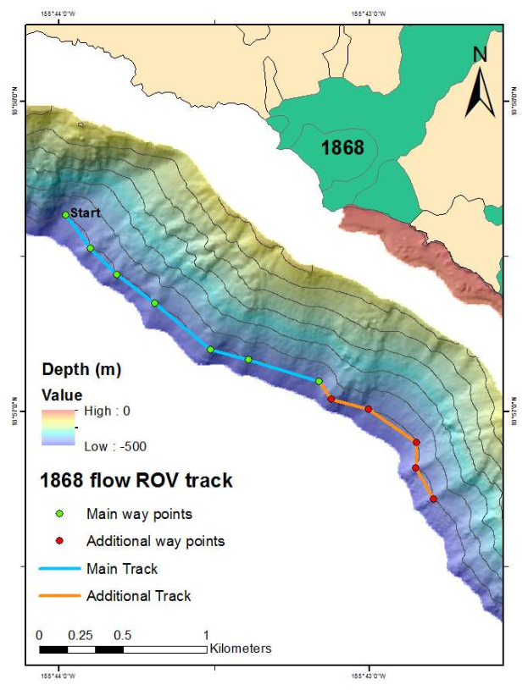

Last updated: May 21, 2015

**NOAA *Okeanos* *Explorer* Program ROV Dive Planning Form**

Last updated: May 21, 2015

**NOAA *Okeanos* *Explorer* Program ROV Dive Planning Form**

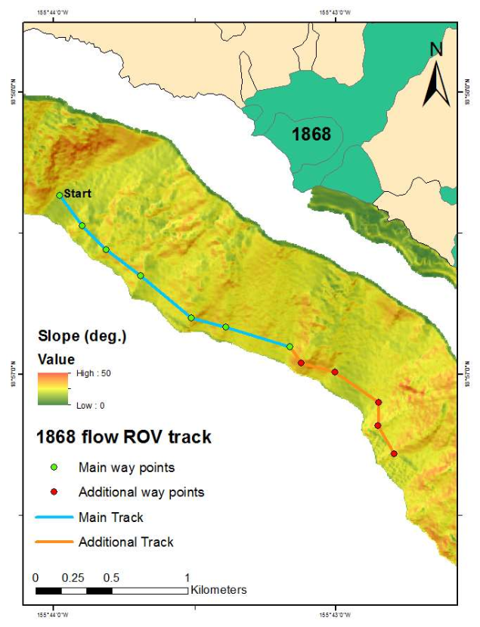

Last updated: May 21, 2015

**Brief Explanation of Exploration Objectives and Rational for the Desired Dive Track:**

The dive is located on the 1868 lava flow from Mauna Loa which was a high volume flow that extended to depths greater than 500 m off the southwest coast of Hawaii. The purpose of this study is to investigate the deep-water precious coral community that has developed since its formation 147 years ago. The data will supplement data collected on other Mauna Loa flows at this depth using the Pisces V submersible in 2011. This dive will focus on the western branch. The ROV track is intended to transect at mean depth of 450 m from west to east. In the event that more time is available for transecting additional way points have been included in the dive plan (orange).

**Has previous work been conducted here? Are there potential hazards in the area?**

There are no known hazards. There has been previous mapping, submersible and ROV dives at the target depth this location. In 2002 there was a Pisces IV dive to the east of the western branch of the 1868 flow. Both the Pisces V and ROV transected across the eastern branch of the 1868 flow in 2011.

**ROV Track Waypoints Table:**

|  |  |  |  |  |  |  |  |
| --- | --- | --- | --- | --- | --- | --- | --- |
| *DESIRED WAYPOINTS TO EXPLORE -*  *(COMPLETED BY SHORE-SIDE LEAD SCIENTIST)*  *(not including launch)* | | | | *ACTUAL WAYPOINTS TO EXPLORE-*  *(COMPLETED BY SHIPBOARD EXPEDITION LEADER)* | | | |
| **WAYPOINT NAME/SEQUENCE** | **LATITUDE** | **LONGITUDE** | **APPROX DEPTH** | **WAYPOINT NAME/SEQUENCE** | **LATITUDE** | **LONGITUDE** | **APPROX**  **DEPTH** |
| Launch/WP1 | 18.945307150 | 155.713230499 | 450m | Launch/WP1 |  |  |  |
| WP2 | 18.9469525480 | 155.714168006 | 450m | WP2 |  |  |  |
| WP3 | 18.9483064613 | 155.714138263 | 450m | WP3 |  |  |  |
| WP4 | 18.9501172312 | 155.716702132 | 450m | WP4 |  |  |  |
| WP5 | 18.9506585585 | 155.718700880 | 450m | WP5 |  |  |  |
| WP6 | 18.9515924970 | 155.719379026 | 450m | WP6 |  |  |  |
| WP7 | 18.9527524842 | 155.723168318 | 450m | WP7 |  |  |  |
| WP8 | 18.9533057089 | 155.725196808 | 450m | WP8 |  |  |  |
| WP9 | 18.9557981943 | 155.728183032 | 450m | WP9 |  |  |  |
| WP10 | 18.9573448440 | 155.730229368 | 450m | WP10 |  |  |  |
| Recovery /WP11 | 18.9587487260 | 155.731627302 | 450m | Recovery /WP11 |  |  |  |

**ANCILLARY INFORMATION:**

**Recommended operations in the target area prior to or after ROV dive**

*Please include requests for in situ sensors (LSS, DO, ORP) to be added to the CTD cast here, and specifics on the type of mapping operation requested (multibeam, subbottom, single beam).*

|  |  |  |  |
| --- | --- | --- | --- |
|  | **LATITUDE** | **LONGITUDE** | **APPROX DEPTH** |
| **CTD CASTS** | | | |
| 1 |  |  |  |
| 2 |  |  |  |
| 3 |  |  |  |
| 4 |  |  |  |
| **MAPPING AREA BOUNDING COORDINATES** | | | |
| North |  |  |  |
| East |  |  |  |
| South |  |  |  |
| West |  |  |  |