*Please use this as a template for documenting your recommendations for high-priority dive targets. Be sure to include a rationale for the dive as well as specific protocols (if applicable), and any known previous work or potential hazards at the site. Please include only generalized location information for any marine archaeology sites.*

*The form also includes fields for mapping targets and CTD cast locations as well.*

**Site Name:** Keahole precious coral bed

**Location:** N 19° 48.2831 / W 156° 07.5480

**Dive Date (local):** 2015/08/29

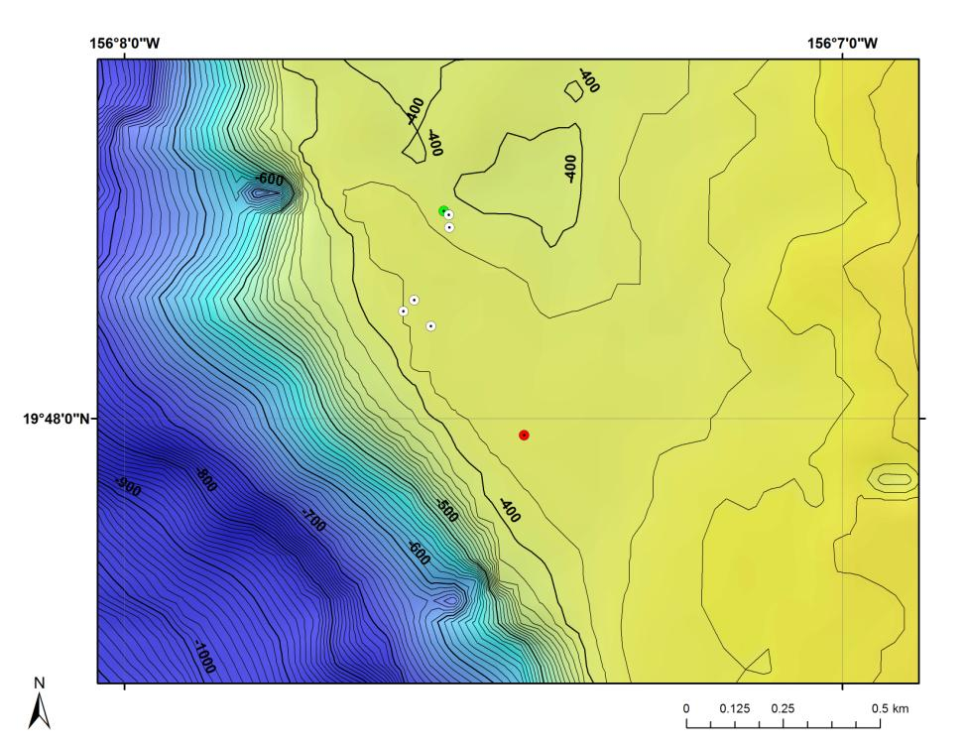

**Fig 1:** Bathymetry data for the dive site. Dive start and end points are shown as green and red dots, respectively.

**Brief Explanation of Exploration Objectives and Rational for the Desired Dive Track:**

This dive will drop in the middle of the Keahole precious coral bed off the Kona Coast of the Big Island of Hawaii. The objectives are to (1) recover an acoustic current meter and three flow meters placed throughout the bed, (2) to make observations on nearby previously marked colonies, and (3) to spend the remaining time exploring the surrounding environment. Most of the Keahole bed is carbonate ledge habitat with much of this dive spent working the top edge of the drop off. The dive will start at the northern most position and then work through the stations proceeding south. The stations are divided into a northern and southern group requiring with transit ~ 400 m of travel.

**Has previous work been conducted here? Are there potential hazards in the area?** Like the Makapuu bed, the Keahole bed has been surveyed a number of times. Its location on the Kona Coast means it is usually calm and therefore launching is more dependable than at Makapuu which has a windward exposure. Currents are a concern but are usually manageable. Being in the Main Hawaiian islands there is higher likelihood of encounters with lost anchor lines or fishing lines. Some deep shrimp trap fishing did occur on the Kona coast in decades past.

**ROV Track Waypoints Table:**

|  |  |  |  |
| --- | --- | --- | --- |
| *WAYPOINTS TO EXPLORE* | | | |
| **WAYPOINT NAME/SEQUENCE** | **LATITUDE** | **LONGITUDE** | **DEPTH** |
| Launch |  |  |  |
| Pot 40 | N 19° 48.2886 | W 156° 07.5552 | -383m |
| -Current meter  Flowmeter 3 | 19° 48.2831 | 156° 07.5480 | -379m |
| Pot 10 | 19° 48.2657 | 156° 07.5471 | -382m |
| Pot 41  Flowmeter A | 19° 48.1645 | 156° 07.5963 | -385m |
| Pot 11  Nearby toppled | 19° 48.1487 | 156° 07.6112 | -387m |
| Flowmeter B | 19° 48.1279 | 156° 07.5731 | -389 m |
| Recovery | 19° 47.9764 | 156° 07.4433 | -380 m |