*Please use this as a template for documenting your recommendations for high-priority dive targets. Be sure to include a rationale for the dive as well as specific protocols (if applicable), and any known previous work or potential hazards at the site. Please include only generalized location information for any marine archaeology sites.*

*The form also includes fields for mapping targets and CTD cast locations as well.*

**Site Name:** Edge of Makapuu precious coral bed

**Location:** N 21° 16.581 / W 157° 32.578

**Dive Date (local):** 2015/08/28

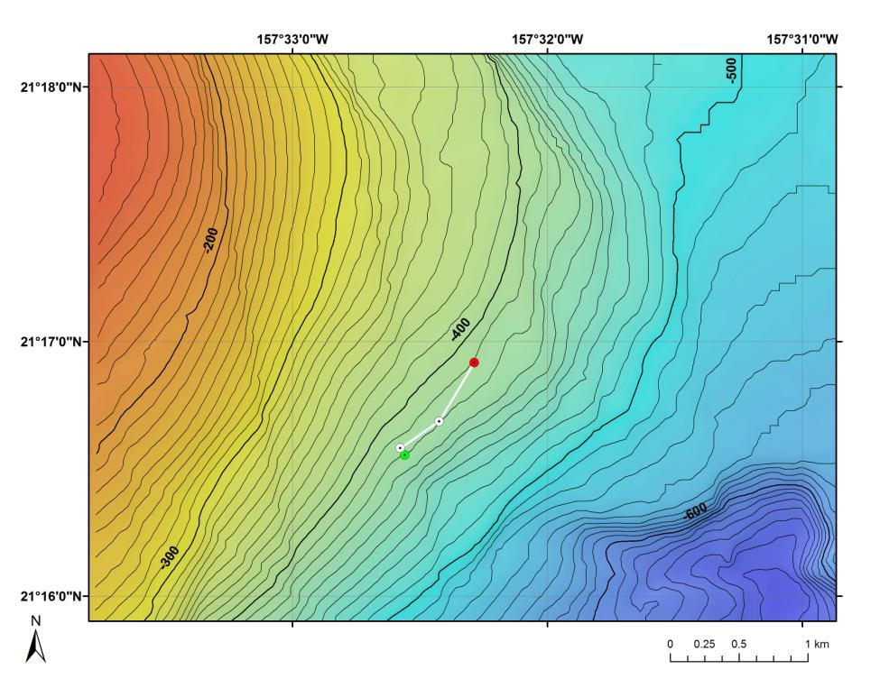

**Fig 1:** Bathymetry data for the dive site. Dive start and end points are shown as green and red dots, respectively.

**Brief Explanation of Exploration Objectives and Rational for the Desired Dive Track:**

This dive will drop at the south edge of the Makapuu precious coral bed. This is the place where the dominant corals of the beds diminish. The objectives are to (1) recover two flow meters placed at the edge of the bed and (2) to proceed into the bed and survey the community along the southern edge. Most of the Makapuu bed is a continuous, even carbonate pavement but roughly half a km inside the southern edge there is a spur of relief that contrasts the rest of the bed. The start position is the location of the flow meters and when instrument recovery is complete we will conduct the survey north into the bed for the remaining time available.

**Has previous work been conducted here? Are there potential hazards in the area?** Surveys at Makapuu are always of interest as this area has been the primary focus of the precious coral fishery throughout its history and the southern edge has received less attention than other areas of the bed. Regarding potential hazards, at the north end of the bed there is a telecommunications cable that runs along the bottom from shore through the bed down slope and out to the east with only a small span off a ledge, (CHRIS ARE THERE ANY OTHER HAZARDS ON RECORD?), being in the Main Hawaiian islands there is higher likelihood of encounters with lost anchor lines or fishing lines.

**ROV Track Waypoints Table:**

|  |  |  |  |
| --- | --- | --- | --- |
| *WAYPOINTS TO EXPLORE* | | | |
| **WAYPOINT NAME/SEQUENCE** | **LATITUDE** | **LONGITUDE** | **DEPTH** |
| Launch | N 21° 16.553 | W 157° 32.559 | -426m |
| Flowmeter 1 | 21° 16.553 | 157° 32.559 | -426m |
| Flowmeter 2 | 21° 16.581 | 157° 32.578 | -425m |
| Survey Midpoint | 21° 16.688 | 157° 32.426 | -422m |
| Recovery | 21° 16.916 | 157° 32.287 | -422m |