Okeanos Explorer ROV Dive Summary
Site Name | Pagan |  |  |  |  | 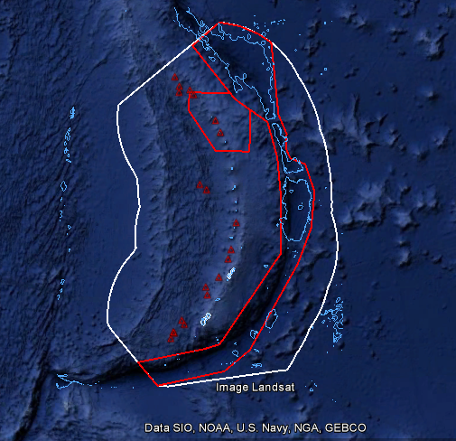
ROV Lead/Expedition Coordinators | Jim Newman/  Kasey Cantwell
Science Team Leads | Shirley Pomponi (HBOI-FAU, CIOERT)  Patty Fryer (UH)
General Area Descriptor | Areas in and around the Marianas Trench Marine National Monument
ROV Dive Name | Cruise |  |  | Leg |  |  | Dive Number
 | EX1605 |  |  | 3 |  |  | DIVE02
Equipment Deployed | ROV: |  |  | Deep Discoverer
 | Camera Platform: |  |  | Seirios
ROV Measurements | CTD |  |  | Depth |  |  | Altitude
 | Scanning Sonar |  |  | USBL Position |  |  | Heading
 | Pitch |  |  | Roll |  |  | HD Camera 1
 | HD Camera 2 |  |  | Low Res Cam 1 |  |  | Low Res Cam 2
 | Low Res Cam 3 |  |  | Low Res Cam 4 |  |  | Low Res Cam 2
Equipment Malfunctions
ROV Dive Summary  (From processed ROV data) | Dive Summary: EX1605L3_DIVE02  ^^^^^^^^^^^^^^^^^^^^^^^^^^^^^^^^^^^^^^^^^^^^^^^^^^^  In Water: 2016-06-18T22:24:46.639000  18°, 10.864' N ; 145°, 49.206' E  Out Water: 2016-06-19T06:24:43.449000  18°, 10.537' N ; 145°, 48.956' E  Off Bottom: 2016-06-19T06:17:15.823000  18°, 10.523' N ; 145°, 48.959' E  On Bottom: 2016-06-18T22:49:01.084000  18°, 10.888' N ; 145°, 49.217' E  Dive duration: 7:59:56  Bottom Time: 7:28:14  Max. depth: 396.9 m
Special Notes
Scientists Involved  (please provide name / location / affiliation / email) | Name Institution Email  Diva Amon University of Hawaii divaamon@hawaii.edu  Amy Baco-Taylor Florida State university abacotaylor@fsu.edu  Maryjo Brounce California Institute of Technology mbrounce@gps.caltech.edu  Robert Carney Louisiana State Univ rcarne1@lsu.edu  William Clancey HBOI/IHMC wclancey@ihmc.us  Scott France University of Louisiana at Lafayette france@louisiana.edu  Patricia Fryer Univ. Hawaiʻi at Mānoa (UHM) pfryer@hawaii.edu  Deborah Glickson FAU-Harbor Branch Oceanographic Institute dglickson@fau.edu  Tara Harmer Luke Stockton University luket@stockton.edu  Chris Kelley University of Hawaii Manoa ckelley@hawaii.edu  Christopher Mah National Museum of Natural History (Smithsonian) brisinga@gmail.com, mahch@si.edu  Asako Matsumoto Chiba Institute of Technology (Chitech) amatsu@gorgonian.jp  Tina Molodtsova P.P.Shirshov Institute of Oceanology RAS tina@ocean.ru, tina.molodtsova@gmail.com  Michael Parke PIFSC michael.parke@noaa.gov  Shirley Pomponi FAU spomponi@fau.edu  Sonia Rowley University of Hawai'i at Manoa srowley@hawaii.edu  Bob Stern U TX Dallas rjstern@utdallas.edu  Hongpeng Tong University of Hawaii hongpeng@hawaii.edu  Verena Tunnicliffe University of Victoria verenat@uvic.ca  Daniel Wagner NOAA Daniel.Wagner@noaa.gov  Mary Wicksten TexasA&M University Wicksten@bio.tamu.edu  Chong Chen JAMSTEC cchen@jamstec.go.jp  Matt Dornback NCEI matt.dornback@noaa.gov  Charlie Wilkins OMAO charles.e.wilkins@noaa.gov  Jason Meyer Meyer Hydrographic jason7seas@gmail.com  Derek Sowers OER derek.sowers@noaa.gov
Purpose of the Dive
This dive explored the northeast side of Pagan on a small ridge feature. The dive addresses the CAPSTONE priority of exploring for high-density communities of deep-sea corals, in this case precious corals that are under the management of NOAA Fisheries. While the precious coral fishery is listed as a managed fishery in Guam and CNMI, no precious coral beds had been identified prior to EX1605L1 and only anecdotal accounts have been published of their presence in this region of the Pacific. This particular site was chosen to also survey bottom fish fishery habitat, which has also not been characterized in Guam/CNMI and determine if there is a depth and site overlap between the two fisheries.

Description of the Dive:
The geology of the dive site on the upper flank of Pagan Island was fascinating from the start and quite diverse. The seafloor that ROV Deep Discoverer (D2) landed on at was a steep knoll covered with subangular blocks of what appeared to be lava fragments. D2 collected rock that turned out to be a block of lava. A rough blocky surface was the dominant geologic feature on the lower part of this narrow ridge, although there were a few patches of small scorria (volcaniclastics) fields. The rock that was collected in this area was a piece of scorria (volcaniclastic). The loose scorria terrain transitioned into a combination of finer ash and blocks of scoriaceous lava, some of them very large boulders. There were also exposures of bedded volcaniclastics. Scorria and spatter were dominant toward the upper part of the ridge, but near the end of the dive the sea floor was covered with finer volcaniclastics.

At each transition from one bottom type to another, the biological communities also changed. D2 touched down on the lat/long numbers, but the depth was shallower than expected, most likely because there are a series of pinnacles and we were on one. The dive track took us up and down the pinnacles. Below are notes on the more common organisms found at each depth:

Depth: 374m. At this site, there were abundant stoloniferous octocorals, at least 3 species (white, pink, and yellow), thinly encrusting on the more than 75% of the rocks. At this depth were several spherical to irregularly massive demosponges (Geodia sp. and Pachastrellidae).

Depth: 366m. We observed one long-tailed red snapper (onaga, or Etelis coruscans), one of the more important commercial fish species. In the crevices were thinly encrusting yellow demosponges, as well as stoloniferous octocorals encrusting on the rocks. We also observed a live slit shell.

Depth: 370m. Thin encrusting yellow sponges with attached hydroids were very abundant. A brown pompom anemone (?Liponema sp.) was collected. Also observed were at least 2 different fish species (one pink and yellow, the other mottled white on red).

Depth: 355m. Pachastrellid demosponges were common—both tube shaped and massive species. A shark and an eel were also observed. There were numerous dead branches of octocorals. (Could they have been killed off during the volcanic activity in the 1980’s?) There were also numerous live stony corals (Enallopsammia sp.)

Depth: 375m. More numerous (but not abundant) octocorals (primnoids—possibly Narella muzikae; Chrysogorgia) and black corals. Scorpaenid fish were observed.

Depth: 355m. An amazing sea star—Coronaster sp. was found in a crevice, its arms wrapped around itself. There were also yellow anemones, and several different species of hydroids, some fan-shaped.

Depth: 316m. Several scorpion fish were observed, and hydroids were common.

Depth: 295m. Two thinly encrusting demosponges were observed on the rocks. One was blue, conulose; the other was cream-colored. Both may be dendroceratid demosponges, but this would likely be a depth range extension.

Depth: 257m. Spherical sponges, similar to Spongosorites siliquaria, appeared to have vermetid snails and were abundant. This is an extreme range extension; the genus is only known from the Atlantic and Mediterranean; the species is only known from the tropical Western Atlantic and Gulf of Mexico. Bottlebrush black corals were common, as were yellow plexaurid octocorals.

Depth: 288m. Common yellow Dendrophyllidae corals.

Depth: 260 m: Common octocorals: Callogorgia, Narella, ?Paracalyptrophora; also black corals. The most abundant organism was a solitary ascidian, covered with epibionts. This was by far the most dominant species observed at this depth and habitat. Amberjacks were also observed.

Overall Map of ROV Dive Area |  |  |  |  | Close-up Map of Main Dive Site
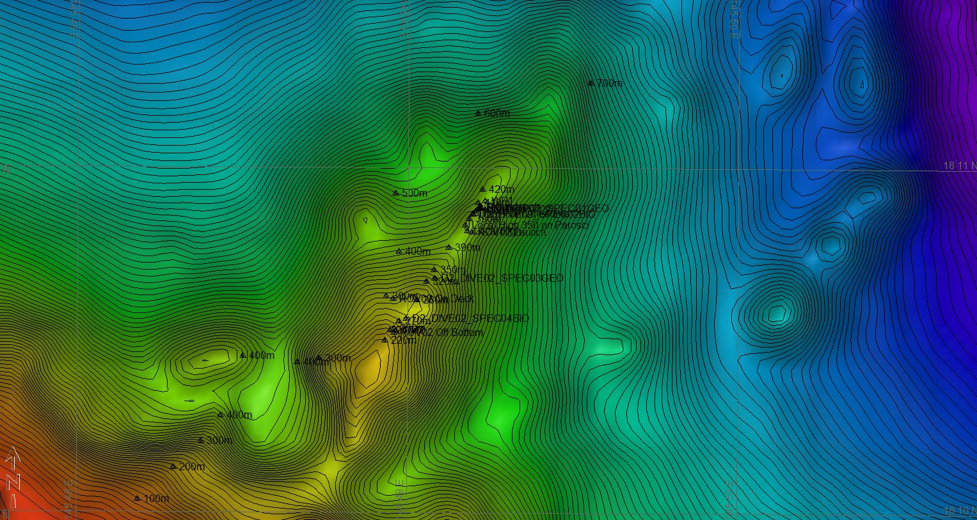 |  |  |  |  | 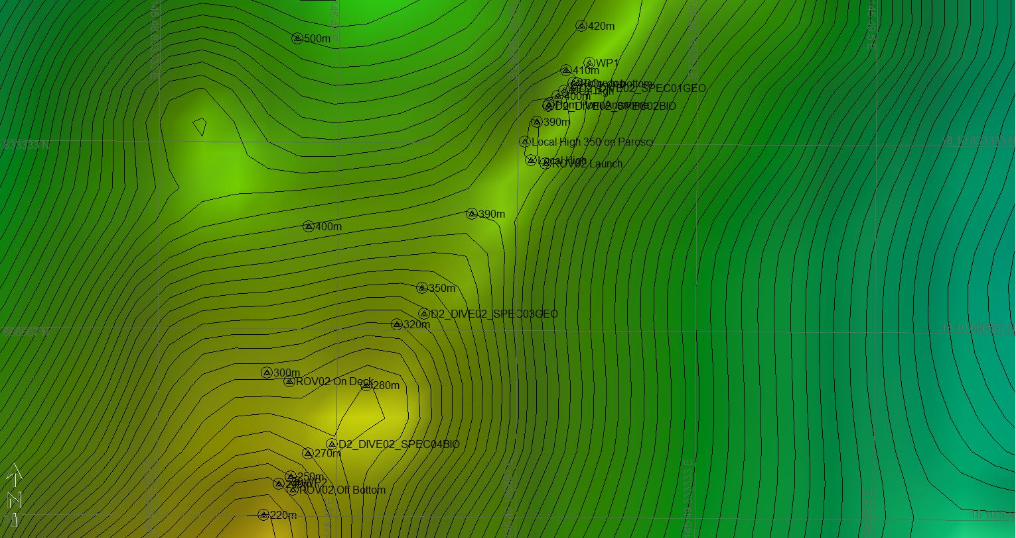
Representative Photos of the Dive
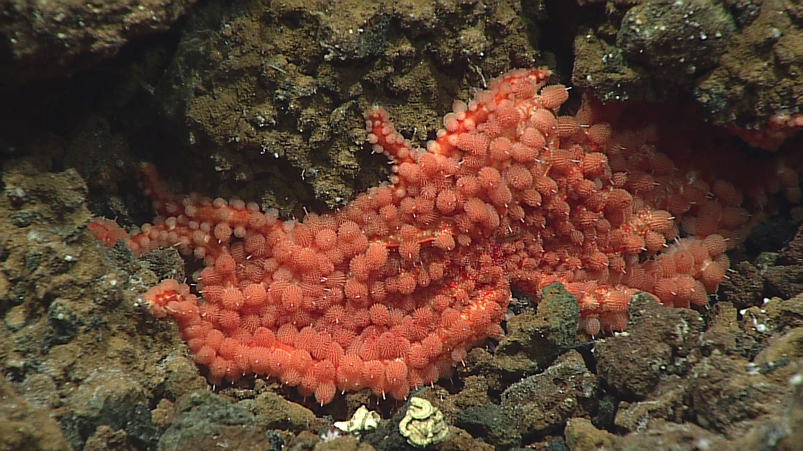 |  |  |  |  | 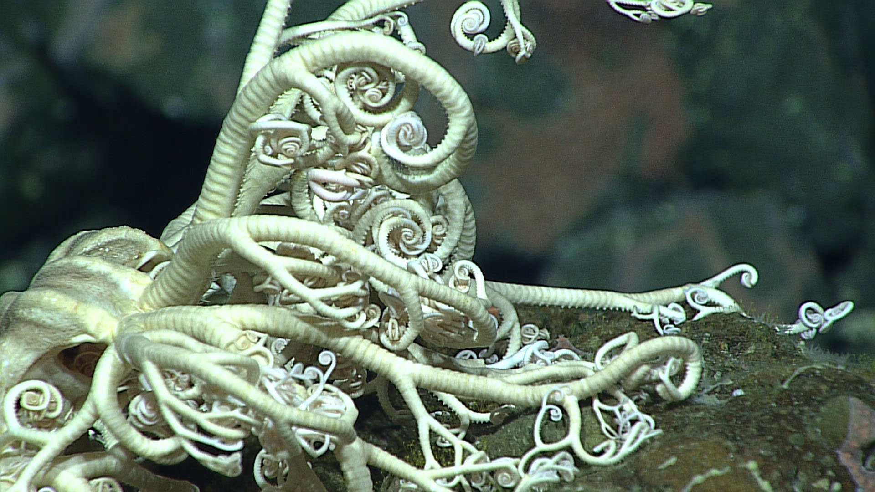
The multiarmed seastar, Coronaster sp., hunkers down in a crevice, using its pedicellariae to defend against predators and to capture small prey. As a last resort, it can shed an arm to escape. |  |  |  |  | In contrast to its seastar relative, basket stars attach to sea fans, and spread their arms to capture prey from the water column—especially in areas where there are strong currents.
Samples Collected
Sample ID |  | SPEC01GEO |  |  | 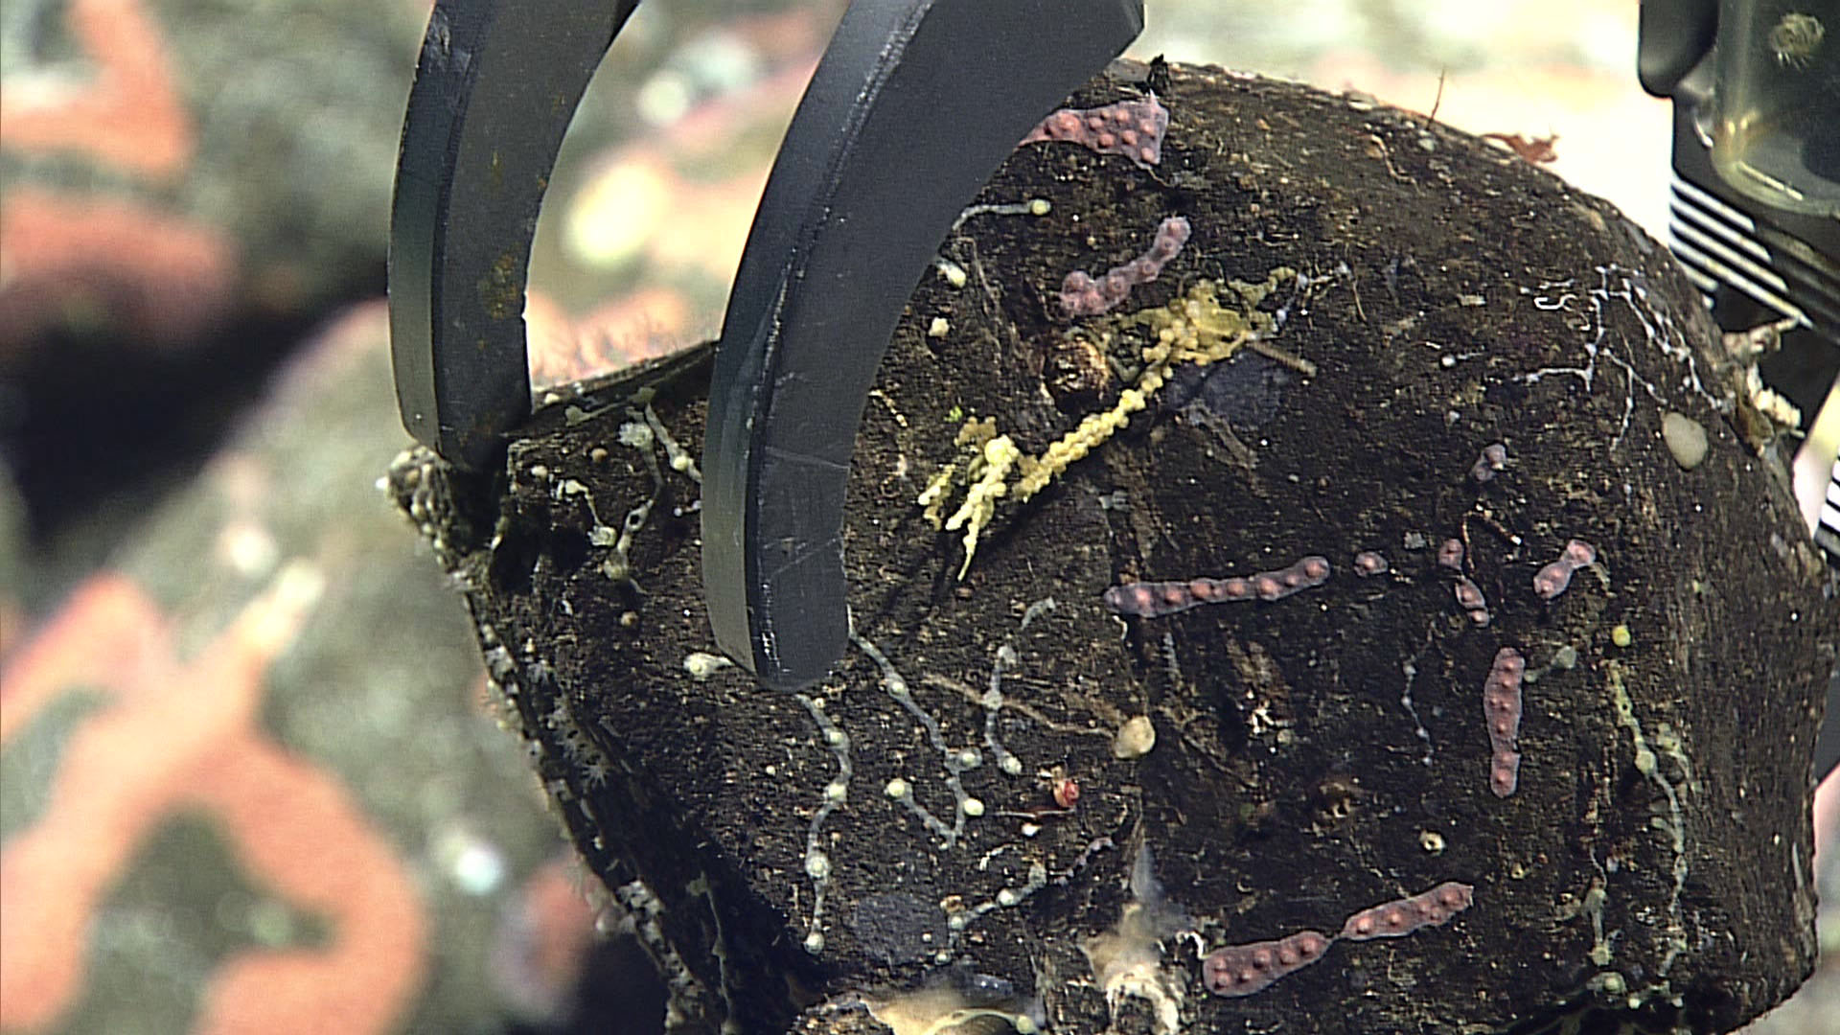
Date (UTC) |  | 20160618
Depth (m) |  | 372.01
Field ID(s) |  | ROCK WITH ENCRUSTING CORAL
Time (UTC) |  | 234428
Temperature (ºC) |  | 10.74
Comments |  | 15x9x13
Sample ID |  | SPEC02BIO |  |  | 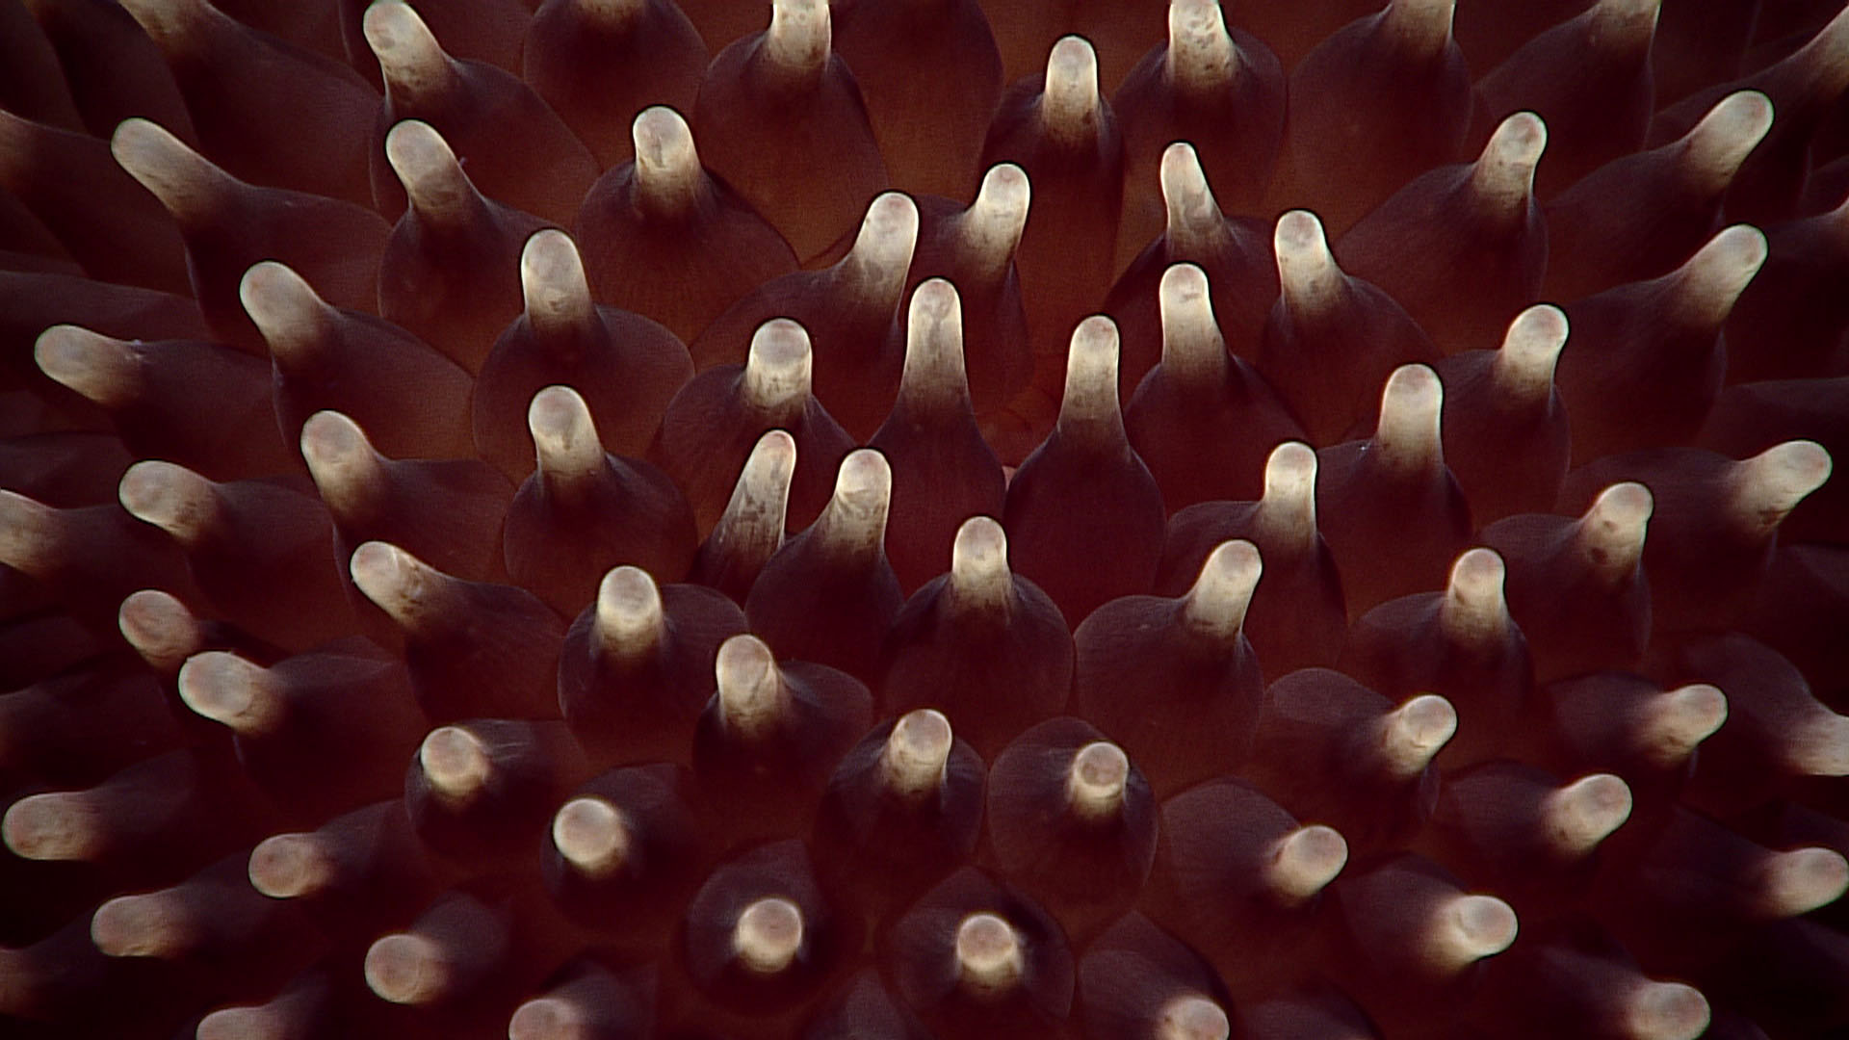
Date (UTC) |  | 20160619
Depth (m) |  | 367.92
Field ID(s) |  | POMPOM ANEMONE
Time (UTC) |  | 010904
Temperature (ºC) |  | 12.68
Comments |  | The pompom anemone, Liponema sp., is also known as the tentacle-shedding anemone. Unlike other anemones, Liponema doesn’t attach itself to hard substrates—it can roll along the bottom, and scavenge for food.
Sample ID |  | SPEC03GEO |  |  | 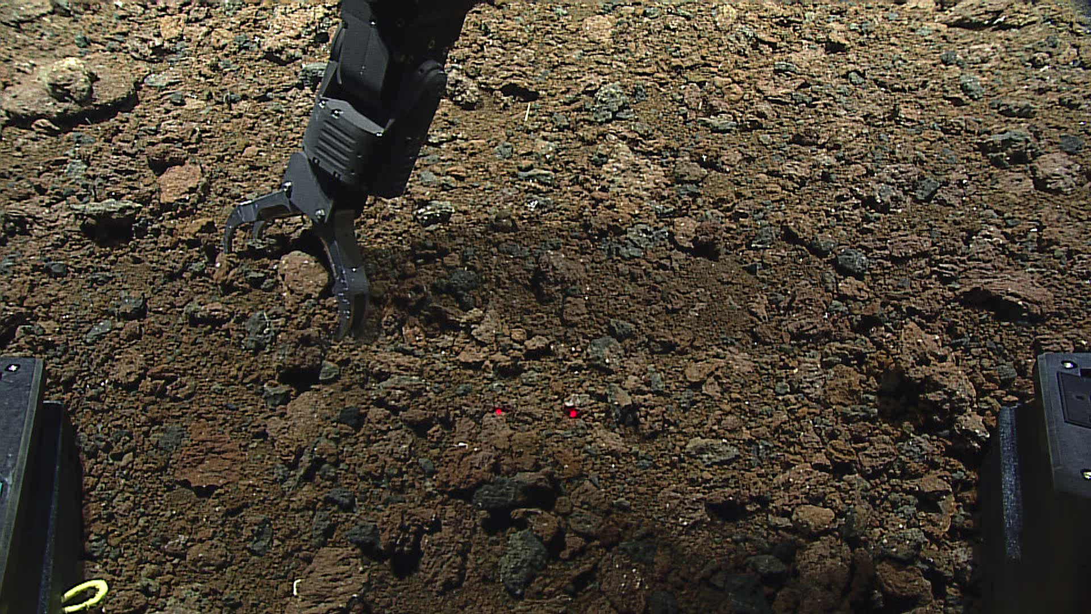
Date (UTC) |  | 20160619
Depth (m) |  | 332.94
Field ID(s) |  | SCORIA (RED ROCK)
Time (UTC) |  | 034805
Temperature (ºC) |  | 13.75
Comments |  | 10x4x3cm, probable pillow fragment that is most like basalt or basaltic adesite.
Sample ID |  | SPEC04BIO |  |  | 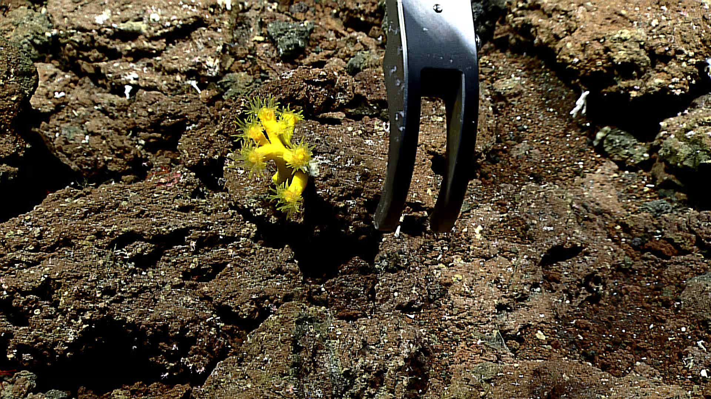
Date (UTC) |  | 20160619
Depth (m) |  | 287.81
Field ID(s) |  | CORAL ATTACHED TO ROCK
Time (UTC) |  | 053825
Temperature (ºC) |  | 14.5
Comments |  | Dendrophyllia
Please direct inquiries to: |  |  | NOAA Office of Ocean Exploration & Research  1315 East-West Highway (SSMC3 10th Floor)  Silver Spring, MD 20910  (301) 734-1014

