Table of Contents

Introduction 1

Purpose 1

Setup Environmental Variables 2

Set up your HIPS Vessel File (HVF) 2

Processing Lines for CUBE 5

Build CUBE surface 6

Appendix 1 – Sources of Uncertainty 9

Appendix 2 – Compute TPU Discussion 10

Appendix 3 – CUBE 12

CUBE SOP

# Introduction

Over, say, a 25mx25m patch of seafloor at 1500m of depth, there may be as many as 30 soundings for the Kongsberg EM302.  We want to know which sounding best represents the depth of the seafloor for that area.  So there's this tool, called CUBE. Based on all the individual soundings that hit any given area, CUBE evaluates the sounding that, statistically, most likely represents the true sea floor depth. To do this, CUBE evaluates each sounding’s vertical and horizontal uncertainty, groups soundings into clusters of significant agreement called hypotheses, and then selects the hypothesis that has the strongest reliability. This has the advantage of allowing the hydrographer to focus, not on killing all noise, but on managing the surface behavior. CUBE also takes subjective guess-timation out of the surface-rendering workflow.

What follows is a step-by-step guide on how to create CUBE surfaces. Additionally, there are appendices that provide a greater level of detail regarding sources of uncertainty, their place in the workflow, and a detailed description of CUBE’s operation.

Purpose: To prepare for generating CUBE surfaces, this document describes how to set up for TPE calculation in CARIS.

# Setup Environmental Variables

1. Before converting raw.all files, set up your CARIS Environmental Variables in CARIS:
2. 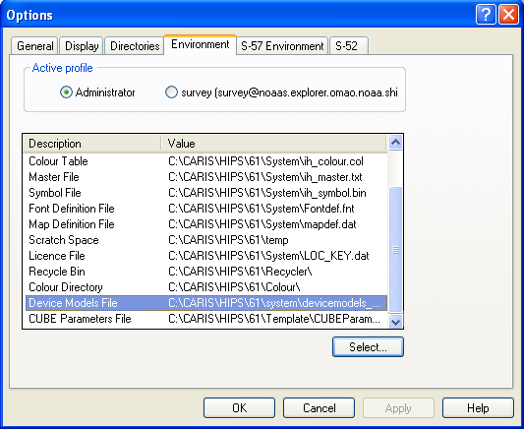Choose device model Tools-> options -> environment
   1. C:->Hips->61> system-> devicemodels-2010.xml
3. Set cube parameter file
   1. C:->HIPS->61> Template->Cube-params-okex.xml (adapted from default file)

# Set up your HIPS Vessel File (HVF)

1. Press this button Or go to CARIS->Edit->Vessel Configuration
   1. Step 1: File -> New
      1. 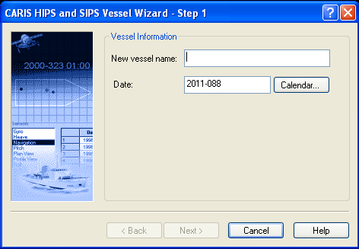Choose a name for this vessel file. When you create a project, later in HIPS, this is the name of the file you will select when you Add Vessel.
      2. Choose a date that precedes your survey, or there will be a timestamp conflict later, when converting lines with this device model.
   2. Step 2: Choose Multibeam

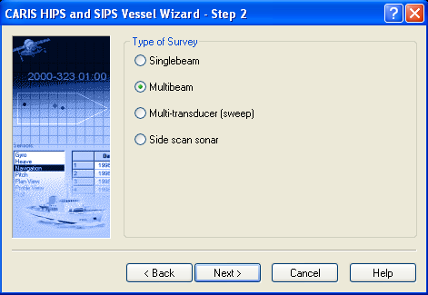

* 1. Step 3: Choose 1 Transducer, 432 beams, Device model Simrad 302 – if the sonar you are using is not listed, contact check to make sure you have selected the most up-to-date devicemodel.xml in your environmental variables. Then start a new HVF.

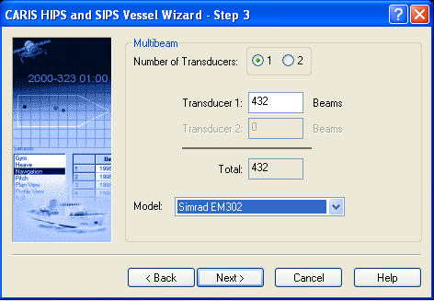

* 1. Step 4 – Check all: Heave, Pitch, Roll. Do not check any “apply in post processing”

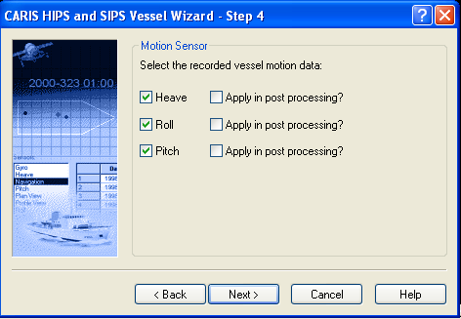

* 1. Step 5 – Select none of these options, and click on Finish

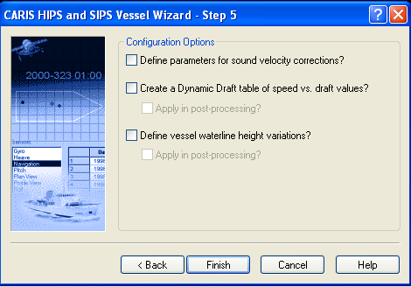

* 1. Step 6 – transducer offset – do not apply pitch here since we already apply in SIS?
     1. But tell TPE w have a pitch offset applied in SIS?
  2. Go to the Edit menu and select – Vessel Shape   
     1. Use the Hydro Readiness Report to determine the dimensions of the vessel and the location of the center of gravity (or equivalent report).



* 1. Go to the Edit menu and select –Active Sensors
     1. Need to configure TPE settings
        1. Offsets
        2. Stnd dev
           1. Use values from NOAA Field Procedures (latest edition), Appendix 4, Table 4-9 with POSMV uncertainty values.

# Processing Lines for CUBE

1. Perform regular steps to convert, QC, tides, merge; No need to Swath Edit
2. New step before creating a surface: Compute TPE

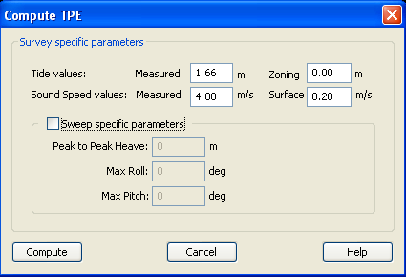

*the Tides Value: Measured should change with each project area. For an explanation on how each of these values are derived, See Appendix (2).

# Build CUBE surface

1. Create a field sheet as per usual, no changes needed for CUBE.
2. Right-click on the fieldsheet, and select New BASE Surface
3. Step 1: Name your surface according to standard EX convention. Click Next.  
   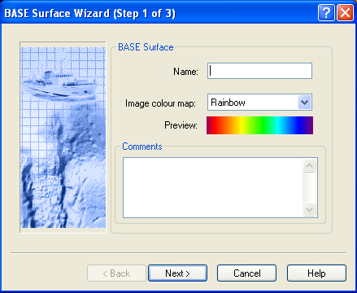
4. Step 2: Define your resolution, as usual. For Surface Type, select CUBE.

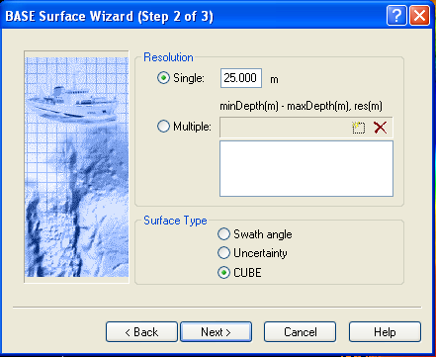

1. Step 3: Select Order 3 from the Drop-down menu. IHO Order 3 is appropriate for all data collected where water depth exceeds 200m.  
   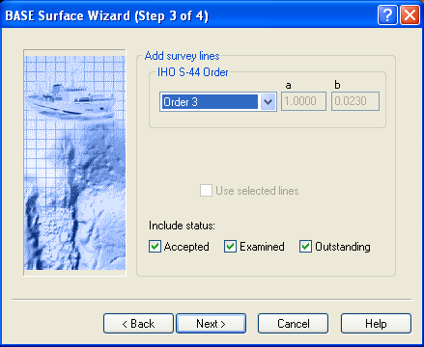
2. Step 4: Define CUBE parameters for your surface. Select the Disambiguation Method of “Density & Locale.” Then, click on the “Advanced” button.  
   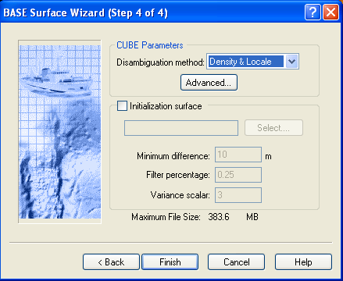

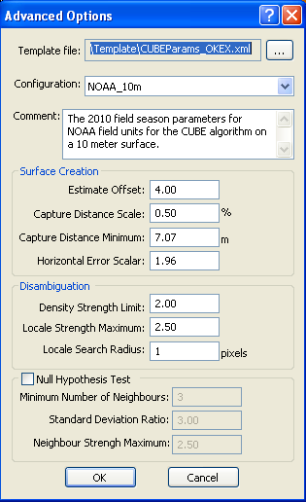

1. Select the Template File: If the Environmental Variable for CUBE Parameters was set correctly, this file should already be correctly selected
2. Select Configuration: There are a few pre-set depth resolutions available for use. If the resolution you need is not available in the Configuration pull-down, you can create a new one for yourself. All resolutions share the same parameters, as shown below, with a single exception. The Capture Distance Minimum is resolution-dependent and can be calculated by dividing the intended resolution by the root of two (i.e. Xm / √2). All other values should be identical to those shown below.
3. Once you have the correct resolution selected, click OK, to return to the BASE Surface Wizard, Step 4 of 4. Then click Finish, your CUBE-variety BASE Surface will render.

## Appendix 1 – Sources of Uncertainty

In Order of Relative Magnitude

***Sound Velocity***

* Okeanos Explorer (EX) relies heavily on Expendable bathythermographs for Sound Velocity Profiling (SVP), salinity and density of the water column is not directly measured. In addition to this, SVP profiles change as a function of both distance and time, even when well known. How much they vary from time and place depends on local weather conditions (i.e. currents, winds, storms, freshwater inputs such as rain or rivers, upwelling events).

***Tide***

* Tidal Uncertainty develops as a result of estimated shifts between predicted phase and amplitude, and those observed, in coastal regions due to topography. Depending on the latitude of survey, this could be significant or negligible, in the depths that are typically surveyed by the EX.

***Positional I***

* **GPS Positioning**. Course acquisition has accuracies of up t 1m or so, usually on the order of 5m. Using DPGS can reduce positional uncertainty to about .5m. Using post-processed kinematics can reduce positional uncertainty to deci-metric levels.
* From GPS antennae to POS/MV. From POS/MV to EM302. From EM302 to hydro software.

***Positional II***

* **Offsets**. Also called lever arms, these establish a network of distances between the sonar face, the reference point, the IMU, and the antennae. A ship’s survey will have been done, and documentation regarding the offsets (and positional accuracy of the survey) will be included in the report. Also can be found in the HSRR.
* Stored in CARIS HIPS Vessel File (HVF) file used for calculating Total Propagated Uncertainty TPU during Compute TPE stage.

***Attitude***

* **IMU**. Uncertainties (accuracy) will be given by the manufacturer. These uncertainties will be put into the HVF and used for calculating Total Propagated Uncertainty TPU during Compute TPE stage.

***Sonar***

* **EM302**. Uncertainties (accuracy) will be given by the manufacturer. These uncertainties are placed into the HVF (??) and used for calculating Total Propagated Uncertainty TPU during Compute TPE stage

## Appendix 2 – Compute TPU Discussion

*** The Okeanos Explorer will not typically receive tide files or tide zones from COOPS, as a result, the tidal zone error for TPU will be input as zero. The Measured Tide Value will be input as, in meters, the tidal variation for the project area multiplied by 1.66 (one standard deviation). What follows is directly from the section 4.2.3.6 - Compute TPU - of NOAA’s Field Procedure Manual, April 2010:

Tide zoning uncertainty values at the 95% confidence level for discrete zoning are provided by COOPS in the tide requirements document on the project CD. All error value components entered in CARIS for TPE calculation are assumed to be 1 sigma; therefore, the value provided by CO-OPS should be divided by 1.96.

Tide zoning uncertainty values for TCARI tides are loaded on a line-by-line basis using NOAA’s Pydro-TCARI software. Pydro’s Tides->CARIS TCARI Tide->"Load TCARI Tide in HIPS PVDLs" is used in place of CARIS HIPS Process->Load Tide. This operation in Pydro-TCARI loads both tide corrector and tide uncertainty data (HDCS "Tide" and "TideErrorFile", respectively) into a given survey line. During HIPS Compute TPU, if TideErrorFile data exists in a line, then it replaces the Measured tide uncertainty and sets the Zoning uncertainty value to zero. That is, any values the user has entered in the Compute TPU dialog are irrelevant when TideErrorFile data is present.

The sound speed component of total propagated uncertainty is a function of environmental variability with respect to space and time and instrument/calibration uncertainty. Of the two, environmental variability has the greatest influence. Sound speed has a complicated dependence on salinity, temperature and pressure with the greatest change in acoustic propagation speed occurring with the change in temperature between the surface and the lower limit of the thermocline.

HSD has determined that the measured sound speed uncertainty may range from 0.5 to 4 m/s. This range depends on the spatial and temporal environmental variability and the frequency at which sound speed casts are taken. Casts taken at a high frequency (i.e. every 15 minutes or less) will capture the spatial variability better and lower the uncertainty values. HSD requires platforms to use the measured uncertainty values (i.e. TPU) for sound speed listed in the CARIS HVF Uncertainty Values.pdf in the Appendix 4.

Field Units should note the 4 m/s uncertainty estimate (listed in the table from HTD-2 and HTD-10) for additional sound speed casts is a conservative estimated variability value determined via Velocipy. Hydrographers can lower this uncertainty by increasing the number of casts for a given areas. Thus, field units are strongly encouraged to utilize a high frequency cast system (e.g., MVP) whenever possible and especially in highly variable areas.

Sound speed uncertainty is the subject of continuing research and investigation at UNH CCOM/JHC. Velocipy has incorporated some of this research such as the Uncertainty Wedge Analysis (UWA) and statistically estimating sound speed uncertainty (ESS). See the Velocipy Operations Manual (included on the Hydrosoft website) for more information. Future research is underway to create an algorithm to estimate the sound speed uncertainty value more accurately using temporal and spatial separation between the sound speed profiles and soundings.

Field units which have not been trained in the proper use of the UWA and ESS within the Velocipy software should use the uncertainty values listed in the CARIS HVF Uncertainty Values .pdf in the Appendix 4 but are welcome to test out the program. All MBES platforms can expect to use this algorithm by the 2011 field season.

The TPU values associated with surface sound speed have a smaller range and magnitude than measured sound speed (0.2 m/s to 2 m/s) because sound speed is continually measured at the transducer. The sound speed uncertainty, therefore, is dictated by the sound speed gradient at the velocimeter’s sensor head.

If field units wish to deviate from the sound speed uncertainty values listed here, a review of the variability in the surface sound speed will be necessary to estimate the sound speed uncertainty for a given survey. If the field unit can prove through detailed documentation and calculation that their calculated uncertainty is lower than those stated in the CARIS HVF Uncertainty Values.pdf (see Appendix 4), then the lower value may be used. As with any deviation from procedures specified in the HTD’s, FPM or the HSSD, methods for estimating uncertainty, and justification for this deviation, should be clearly described in the Descriptive Report as well

as the Data Acquisition and Processing Report. The field should be aware, however, that if the processing branches disagree with the method used, any corresponding surveys using these uncertainty values may be returned to the vessel. Therefore, HSD strongly recommends that field units communicate to the branch their proposed approach. If the branch feels the method is adequate, a detailed description of the method, corresponding calculations and data will need to be sent to HSD for verification (and dissemination to other field units if approved).

NOAA does not currently conduct sweep surveys, and the lower section of the TPU dialog

box is not utilized.

The TPU values for each sounding (σV and σH) will be computed at the 95% confidence interval.

## Appendix 3 – CUBE

